<Back to Table of Contents>
<Back to Nutrition Table of Contents>

Folic Acid

Biochemical Functions:
- DNA metabolism (cellular replication)
- central nervous system function,
- immune function
- homocysteine→Muscle energy technique

take from: http://www.hscbklyn.edu/SUNY/Biochem/ALCOHOL/alcohol_folate_bkgd.html#folate_overview

Folic acid is a methyl donor or carrier of one-carbon fragments to be transferred to biochemical targets. Two forms of folic acid are important from a medical point of view: methyl-tetrahydrofalate (methyl-THF) and methylene-THF.

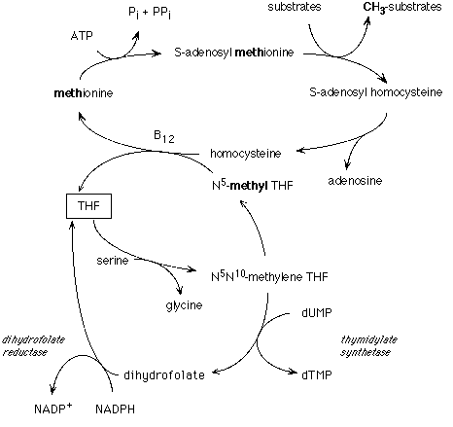

- 5-methyl-THF is more actively involved in methylation reactions
- 5-formylte-THF is more actively involved in DNA-base synthesis and maintenance

THF gets a methylene group from serine creating 5,10-methylene-THF via methylene-THF reductase. A polymorphism of methylene-THF reductase (dehydrogenase) may affect the conversion of 5,10-methylene-THF to 5-methyl-THF resulting in deficiency of methylation from folate. MTHFR utilizes FAD as a prosthetic group; thus riboflavin is also necessary for the function of this enzyme.

Folate deficiency shows up with the absence of the methylene form, the precise form of the compound is 5,10-methylene tetrahydrofolate.
An important conversion of 5,10-methylene tetrahydrofolate is the methylation of deoxyuridine monophosphate (dUMP) to generate thymidylate (dTMP). dTMP is necessary for DNA synthesis and the consequences of this deficiency is megaloblastic anemia:

dUMP + methylene-THF → (thymidylate synthase)→ dTMP + dihydrofolate (DHF)

DHF must then be re-reduced to THF:
DHF + NADPH →(dihydrofolate reductase)→ THF+ NADP

Inhibit of dihydrofolate reductase (DHFR), is the therapeutic target of methotrexate and other chemotherapeutics.

The cyclic process involving methyl-THF is as follows:
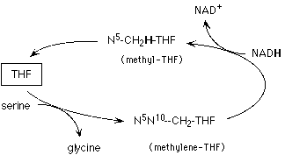

A second important area where folate is important in nutritional biochemistry is in methylation reactions.
The most important carrier of methyl groups is S-adenosyl-methionine (SAM). The S adenosyl group is an active group as ATP is required for generatation. Some of the important reactions in which SAM is involved are:
- Methylation of DNA and RNA. DNA- and RNA-methylases use SAM as a source of methyl groups. A major target of methylases is the 5 position of cytosine of DNA. The degree of methylation correlates with transcriptional activity. (Globin genes, for example, are highly methylated in non-erythroid cells but not in erythroid cells.)
- The conversion of epinephrine to norepinephrine is also catalyzed by an N-methyl transferase that uses SAM. Note that because methionine is an essential amino acid, if it is limiting, choline could also become a nutritional requirement

The product after the methyl group istransferred is S-adenosyl-homocysteine. Hydrolysis gives homocysteine (and adenosine).
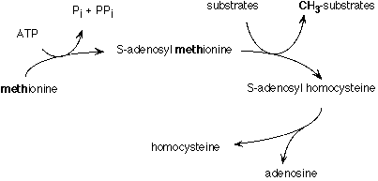
In order to regenerate the methionine, homocysteine must be methylated. The methylating agent is the methyl form of THF:
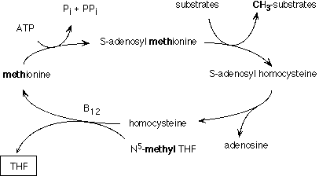

The regeneration of methionine requires vitamin B12 (cobalmin). In vitamin B12 deficiency there is a buildup 5-methyl-THF which cannot be recycled. This causes a deficiency of the other forms of THF which are needed for other reactions, particularly in DNA synthesis. The loss of THF forms due to the inability to use methyl-THF is referred to as "the methyl trap."

Overview of key reactions involving one-carbon transfer.
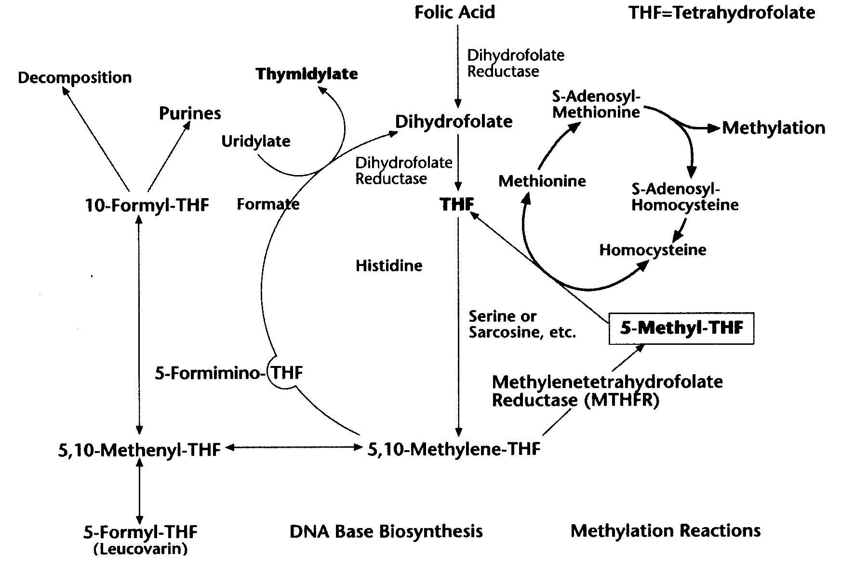

DIGESTION | ABS. Loc. | ABSORPTION  HIGH CONC. | ABSORPTION  LOW CONC. | TRANSPORT | CELLULAR UPTAKE | METABOLISM | STORAGE | EXCRETION
γ-glutamyl carboxy-peptidase  (FBP in milk protects from bacterial digestion) | duo-denum;  if milk source: ileum/ jejunum | diffusion | saturable pH/ Na⁺ dep active transport, | monoglutamate- 33%: free  66%: FBP, albumin, α2-macroglobulin | Na⁺ dependent, carrier mediated  transport | tetrahydrofolate (THF) →polyglutamate or 5methyl THF | 50% as poly-glutamate in liver | bile or urine with little or no catabolism

FACTORS THAT ↑ ABSORPTION | FACTORS THAT ↓ ABSORBTION | Nutrient Interaction | Drug Interaction
- vit C  - glutamate  - Zn dependent  exopeptidases,  glucose | - conjugase  inhibitors  - zinc  - food | - ethanolamine→ choline  - niacin →NANM  - required for niacin for conversion to TRP  - B12 prevents entrapment in methylated  form  - vit C protects folate from oxidation  *large doses may promote a deficiency of zinc or vitamin B 12 (as in pernicous anemia). In turn, large doses of zinc, vitamin B6 or B12 may increase the need for folic acid. If treatment requires >5 mg folic acid, administer a multiple vitamin with zinc. | - Sulfasalazine, OCP’s, trimethoprim and tobacco  deplete folic acid  - Large doses (15 mg/day) interfere with the anticonvulsant  effect of dilantin (phenytoin) and may also have a mild  epileptogenic effect. Conversely, adminstration of dilantin promotes folic acid deficiency as seen with the development of gingival hyperplasia. Smaller doses of 1mg/day do not appear to promote seizures in paitens taking dilantin and may, in fact, improve their clinical condition  - Folic acid may interfere with the anti-cancer effect of  methotrexate. However, when methotrexate is being  used to treat rheumatoid arthritis, administration of 1 mg  for 5 days out of the week and methotrexate given  the other two has been shown to reduce methotrexate  toxicity without diminishing its efficacy.
Folate metabolism is the target for two therapeutic groups:
- folate antagonists (methotrexate)
- thymidylate synthase inhibitors (5-flyourouracil)
Long term use of these medications can lead to folate depletion. In turn, the susceptibility to folate depletion caused by these drugs may be due to single nucleotide polymorphisms in the enzymes involved in folate metabolism. 5-formylmethyltetrahydrofolate may be a form of folic acid that can reduce toxicity of methotrexate as well as improve efficacy.

Dosage and Administration: RDA: 200 μg; pregnancy 400 μg; lactation 300 μg. In regard to available dosages, 1 mg is the limit for manufacture. However, compounding pharmacies can produce and dose requested. Folirinse (Scientific Botanicals) is another method for achieving higher doses easily.

Food Sources: beer, wheat germ, yeast, liver, kidney, asparagus, Brussels sprouts, green leafies, legumes, seed oils.

In foods, folic acid is found as pteroyl polyglutamate, which requires hydrolyzation prior to absorption. Folic acid supplements are single pteroyl glutamate molecule and are absorbed well on an empty stomach. Thus, supplements appear to be better utilized than folic acid from food.

Deficiency Signs
- atrophic lingual papillae, glossitis
- tachycardia and pallor secondary to macrocytic anemia

Toxicity Signs: Large doses may promotes seizures in epileptics.

Clinical Indications
Behavioral and Psychiatric Conditions
Depression |  | Folic acid levels have been demonstrated to be low in depressed individuals. Low folic acid levels are associated with poor drug response including Prozac.

Cardiovascular Conditions
Atheroscerlosis |  | Intervention trial: prevention of AS through regulation of homocysteine

Dermatologic Conditions
Gingivitis | 0.1% solution of folic acid as mouthwash, 5ml bid for 2 months | Controlled trial: Reduced the severity of gingivitis. Research on oral dose is conficliting

Gynecological Conditions
Cervical Dysplasia | 10 mg/day  (recommend to use with vitamin A , vitamin C) | Controlled studies: Improved cervical dysplasia and cervcial intraepithelial neoplasia in women taking oral contraceptives. Folic acid was not effective in a controlled study of women who were not taking OCP’s.
Cervical Dysplasia | 400 μg/day | Theoretical, based on observational study: May help prevent cervical dysplasia resulting form HPV infection. HPV increases risk of dysplasia x 5 w/ decreased folic acid

Musculoskeletal Conditions
Osteoporosis | 0.4-5 mg/day | theoretical: prevention of osteoporosis through regulation of homocysteine
Gout | 40-80 mg/day when combined w/ vitamin C 500+ mg/day | May reduce serum uric acid levels through inhibition of xanthine oxidase (clinical observation: K. Oster)

Neurological Conditions
Prevention of neural tube defects | 400 μg qd | Women of childbearing age should use folic acid to prevent spina bifida and other neural tube defects.
Restless legs syndrome | 5-30 mg/day | Uncontrolled trial: Effective for some individuals with familial restless legs syndrome and other familial neurologic problems

Bland, J. Improving Health Outcomes Through Nutritional Support for Metabolic Transformation. Metagenics Educational Programs, 2003. p. 40.

