Nutrition-fats-cho-proteins:
PROTEINS OVERVIEW
Proteins are of crucial importance in more or less all organs and processes in organisms. Fibrous proteins are the major components of muscles as well as of skin, bones, tendons, blood-vessels, teeth, and hair. Blood contains various proteins that are responsible for the storage and transport of biologically important substances such as oxygen, metal ions, glucose, lipids, and many other molecules. Furthermore, proteins called enzymes participate in all the different chemical reactions that an organism performs to generate energy from the diet and to synthesize its building blocks, which are summarized with the term metabolism. Also, the regulation of the metabolism as well as of growth and development is performed by proteins: hormones and their receptors. Proteins are involved in the acquisition of sensory information and in the generation and transmission of nerve impulses. The protection of the organism against external invasion is mediated by the proteins of the immune system.
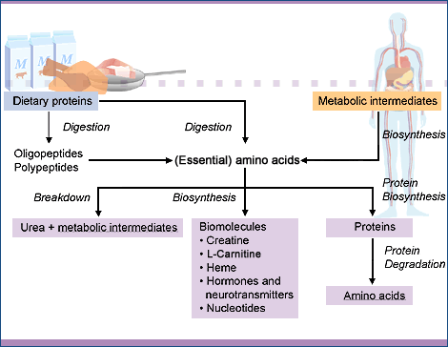
All those different proteins are composed of only 20 monomeric units known as amino acids. Dietary proteins are cleaved to short chains of amino acids – oligopeptides – and amino acids during digestion. A major difference between amino acids and most of the other building blocks of the body is that amino acids contain nitrogen. Nitrogen from the air can be converted to metabolically useful forms only by a few strains of bacteria that live in symbiotic relationships with certain plants. Humans and animals, however, have to take in metabolically useful nitrogen with their food. The intake of protein with the diet is therefore essential and the amino acids that are released from those proteins are not only a source of energy to the organism but deliver the building blocks for the synthesis of proteins and serve as precursors for all nitrogen containing compounds. In addition to amino acids, nitrogen containing compounds include nucleotides (the building blocks of the genes), some hormones and neurotransmitters, various intermediates in metabolic processes, as well as heme, a complex molecule that is involved in the oxygen-binding property of red blood cells and in energy generation by the respiratory chain.
Proteins, like all the components of living cells, are constantly turning over. They are broken down to their constituents and rebuilt. The function of this process is twofold. Abnormal molecules whose accumulation would be harmful to the cell are eliminated. And the processes in the body can be regulated by the speed with which enzyme and other regulatory molecules are broken down and rebuild. Proteins have life spans that range from as short as a few minutes to weeks or more. Cells continuously synthesize proteins from and degrade them to their component amino acids.

Unlike carbohydrates and lipids, amino acids – the nitrogen-containing building blocks of proteins – cannot be synthesized from other, non-nitrogenous compounds by humans and animals. Rather, amino acids have to be taken in with the diet. Dietary proteins are not only the source of nitrogen-containing building blocks. In addition, they directly contribute to the flavor of food and are precursors for aroma compounds and colors formed during the production, processing, and storage of food. Proteins also contribute significantly to the physical properties of food through their ability to build or stabilize gels, foams, emulsions, and fibrillar structures.
PROTEINS: AMINO ACIDS
Proteins are composed of 20 “standard” amino acids, organic molecules with an amino group as well as a carboxylic acid group at the a-C-atom.
Of the 20 standard amino acids, 10 are essential. Humans and mammals cannot synthesize them by themselves and must obtain them in sufficient quantities from their diet. The essential amino acids occur in dietary proteins of animal as well as of plant origin.
The 20 amino acids vary considerably in their physico-chemical properties, which gives rise to the great range of properties and functions of proteins. Commonly, they are classified into three groups according to the polarities, i.e. the distribution of electrons, of their side chains (residues):
- amino acids with non-polar side chains
- amino acids with uncharged polar side chains
- amino acids with charged polar side chains
After a protein has been synthesized it has to fold in a specific way to achieve its characteristic properties. The structure of a protein is determined by the side chains or residues of its amino acids. Non-polar side chains prefer non-aqueous environments and are found usually inside the protein whereas polar and charged side chains are found on the outside where they interact with the water molecules of their liquid environment.
Besides the standard amino acids also nonstandard amino acids are found in proteins. They result from the specific modification of a standard amino acid residue after the polypeptide chain has been synthesized. Examples are 4-hydroxyproline and 5-hydroxylysine found in collagen and g-carboxyglutamic acid found in proteins involved in blood clotting.
Other nonstandard amino acids and derivatives of standard amino acids are not components of proteins but have various biologically important functions:
- as building blocks of the genes: the nucleotides
- as chemical messengers (hormones and neurotransmitters) in the communication between cells, e.g. g-aminobutyric acid (GABA), dopamine, epinephrine, histamine, thyroxine
- as important intermediates in various metabolic processes, e.g. citrulline and ornithine (urea cycle), homocysteine (amino acid metabolism), S-adenosylmethionine (biological methylating reagent), creatine (energy reservoir in muscles), carnitine (fatty acid metabolism), glutathione (detoxification reactions)
- as oxygen-binding substance in red blood cells and the electron-transport chain: heme
PROTEINS: PROTEIN BIOSYNTHESIS
DNA is the carrier of genetic information in all cellular life. The information that is stored in the DNA serves as templates for the synthesis of proteins from amino acids.
Protein biosynthesis involves two major steps, transcription (DNA-directed synthesis of mRNA) and translation (mRNA-directed synthesis of proteins).
In the first step (transcription), the information that is encoded in the DNA and that is necessary to synthesize a specific protein, is copied from the DNA onto another nucleic acid molecule, messenger-RNA (mRNA). Afterwards, mRNA is used as the template for protein synthesis in the second step (translation). Transfer-RNAs (tRNAs) serve as suppliers of amino acids. There are 20 different tRNAs, one for each standard amino acid. The tRNAs recognize the genetic code and deliver the amino acid that corresponds to the information on the mRNA.
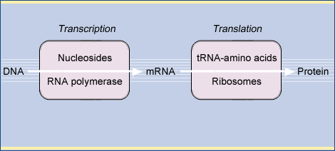
Protein biosynthesis is performed by ribosomes, complex molecular machines consisting of ribosomal-RNA (rRNA) and proteins that catalyze peptide bond formation between the amino acids delivered by the tRNAs
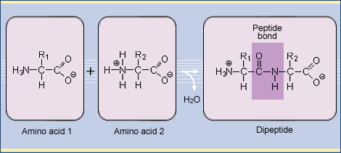
Molecules composed of two, a few (3-10), or many amino acids are called dipeptides, oligopeptides, or polypeptides,respectively. Polypeptides are linear polymers: each amino acid is linked to the next in a head-to-tail fashion. No branches are formed. Proteins consist of one or more polypeptide chains.
After the linear amino acid chain of a protein has been synthesized it has to fold in a specific way. The three-dimensional structure resulting from the protein folding process is of crucial importance for the specific properties of a protein. It is determined by the side chains of its amino acid constituents. Non-polar side chains prefer non-aqueous environments and are found usually inside the protein whereas polar and charged side chains are found on the outside where they interact with the water molecules of the aqueous environment. For transmembrane proteins, which occur in lipid membranes, the situation is different. Here, polar side chains interact with each other inside the protein and non-polar side chains are found on the outer surface.
PROTEINS: PROTEIN DEGRADATION
All the components of living cells are constantly turning over. The function of this process is twofold:
- Elimination of abnormal molecules whose accumulation would be harmful to the cell
- Regulation of cellular metabolism by increasing or decreasing the number of enzyme molecules and regulatory substances
Proteins have life spans that range from as short as a few minutes to weeks or more. Cells continuously synthesize and degrade proteins from and to their component amino acids. Many metabolic enzymes have very short life spans of only a few minutes or hours whereas for example hemoglobin lasts about 120 days.
Most abnormal proteins arise from the chemical modification and/or spontaneous denaturation in the reactive environment of the cell. Less frequent reasons for abnormal proteins are mutations or errors during the process of protein biosynthesis.
In cells, two mechanisms for protein degradation exist:
- Lysosomal mechanism Lysosomes are membrane-encapsulated organelles that contain hydrolytic enzymes including proteases known as cathepsins. Those enzymes cleave peptide bonds and break down proteins to their constituent amino acids.
- ATP-dependent cytosolically-based mechanism Cytosolic proteins selected for degradation are labeled by covalently linking them to the protein ubiquitin. The ubiquitin-labeled proteins are recognized by proteosomes (multiprotein complexes) and degraded to the amino acids.
The criteria by which cells select defective proteins for degradation are not yet fully understood.
PROTEINS: AMINO ACID DERIVATIVES
Amino acids are not only the building blocks of proteins but also the precursors of various nitrogen-containing molecules in the body. Major examples for amino acid derivatives with important functions in the body are
- Creatine
- Heme
- S-Adenosylmethionine (SAMe)
- Biogenic amines: hormones and neurotransmitters
- Glutathione
- Nucleotides and nucleosides
CARBOHYDRATES: OVERVIEW
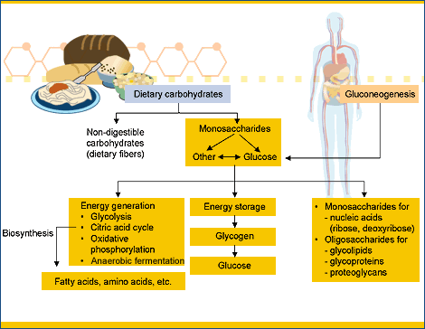
Dietary carbohydrates are an important source of energy for humans. They include sugars and polysaccharides. Sugars are small molecules that consist of either one (monosaccharides) or two (disaccharides) carbohydrate units. They are responsible for the sweet taste of food. Polysaccharides consist of long, frequently branched chains of sugar units. Starch and glycogen, the storage polysaccharides of plants and animals, respectively, as well as disaccharides are broken down to their constituent monosaccharides during digestion and the monosaccharides are absorbed by the body. Non-digestible carbohydrates (dietary fibers) are not broken down to monosaccharides by the enzymes of the digestive tract. Therefore, they are not absorbed by the body and do not contribute to the energy and nutrient requirements of the body. Nevertheless, they are of importance in maintaining the health and functioning of the digestive tract.
The most important utilization of carbohydrates in the body is their conversion to energy. Glucose is the preferred fuel molecule for the brain. The liver takes care that there is a constant level of glucose in the blood and that thereby the brain is supplied with sufficient energy at all times. When your diet provides the body with excess glucose in the form of sugar or carbohydrates, it is stored in the form of glycogen – long branched chains of glucose molecules – in liver and muscle cells. When the level of glucose in the blood drops below a certain value and your brain might run out of fuel, glycogen is broken down to its glucose units in the liver and the optimum level of glucose in the blood is restored. When your food does not contain enough carbohydrates to fill up the glycogen reservoirs and maintain the blood glucose level, the liver is also able to synthesize glucose from smaller units in a process called gluconeogenesis. The hormones insulin and glucagon are involved in the regulation of the level of glucose in the blood.
Being suppliers and reservoirs of energy is not the only role of sugars and carbohydrates in the body. In addition, single sugar unit as well as short chains of sugars – oligosaccharides – are part of the lipids and proteins that constitute the cell membranes. These glycolipids and glycoproteins form a coating on the outer surface of cells that acts as protective shield for the cell. They mediate the interactions of cells with other cells as well as with molecules such as hormones. Very complex molecules consisting of proteins and carbohydrates – proteoglycans – form the water-binding matrix of the connective tissue that fills the space between the cells. The monosaccharides ribose and deoxyribose are constituents of the nucleic acids DNA – the carrier of the genetic information – and RNA.
CARBOHYDRATES: DIETARY CARBOHYDRATES
Carbohydrates are the most frequent organic compounds on earth and the major component of the human nutrition, in particular of food of plant origin. The biosynthesis of carbohydrates by plants from carbon dioxide, water, and the energy of light – a process called photosynthesis – is the basic principle that supports life on earth. Dietary carbohydrates supply about 50% of the body’s energy requirement and include monosaccharides, disaccharides, and polysaccharides.
Most of the carbohydrates in the diet are plant based. Grains, vegetables, fruits and legumes are typical sources of carbohydrates. Dairy products are the only animal-based foods with significant amounts of carbohydrates. However, many adults do not have the enzyme that is necessary to utilize lactose, the carbohydrate in dairy products.
Disaccharides and digestible polysaccharides are broken down to monosaccharides during digestion and the monosaccharides are absorbed by the body. Humans have no dietary requirement for any specific type of carbohydrate. Carbohydrates, therefore, are not essential nutrients since the body can synthesize all its carbohydrate building blocks from glucose. Similarly, all dietary monosaccharides can be converted to glucose or one of its breakdown products. In addition, the body can synthesize glucose from metabolic intermediates in a process called gluconeogenesis.
Non-digestible carbohydrates – dietary fibers – cannot be broken down because we lack the enzymes that are necessary for the breakdown processes. Nevertheless, the intake of dietary fiber with the diet is important for maintaining the health of the digestive tract.
CARBOHYDRATES: ENERGY GENERATION FROM GLUCOSE
Glucose oxidation, i.e. the breakdown of glucose in the body, is an important source of energy in many organisms including humans. The breakdown of glucose starts with a process called glycolysis during which glucose – a molecule with six carbon atoms – is split into two identical molecules with three carbon atoms called pyruvate in a complex series of ten reactions.
Under aerobic conditions, i.e. in the presence of oxygen, pyruvate is converted to acetyl-CoA which enters the citric acid cycle. In the citric acid cycle, acetyl-CoA is oxidized to carbon dioxide (CO₂). The energy that is released during this process is stored in the form of NADH and FADH₂ and converted to ATP by oxidative phosphorylation. At the same time, the electrons that were generated by the oxidation of acetyl-CoA and captured in NADH and FADH₂ are transferred to oxygen (O₂), yielding water (H₂O).
Under anaerobic conditions, i.e. in the absence of oxygen, pyruvate can be converted to different products in a process called anaerobic fermentation or anaerobic glycolysis. Anaerobic fermentation yields less energy per molecule of glucose than aerobic oxidation but the energy is available to the body much faster. In humans and mammals, the end product of this process is lactate, whereas in yeast the end product is alcohol.
Hexoses other than glucose present in the diet such as fructose, galactose and mannose are converted to intermediates of glycolysis and their further breakdown is identical to glucose breakdown.
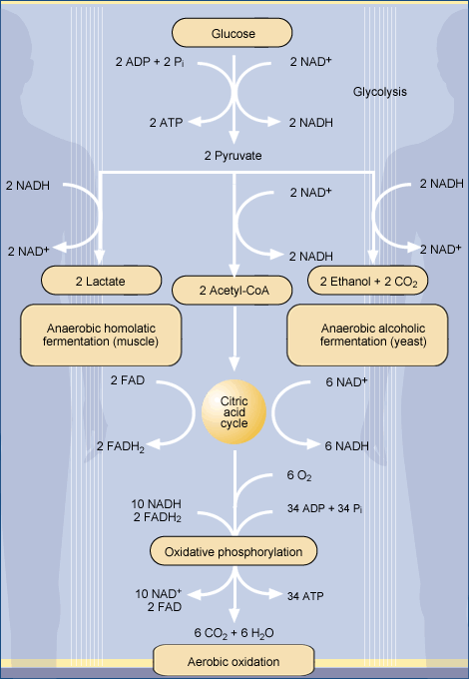

CARBOHYDRATES: ENERGY GENERATION FROM GLUCOSE
ANAEROBIC FERMENTATION
Under aerobic conditions, i.e. in the presence of oxygen, pyruvate enters the citric acid cycle and is converted to CO₂ and H₂O. The electrons released during glycolysis and the citric acid cycle reactions are stored in NADH and FADH₂. The transfer of the electrons to oxygen (O₂) restores NAD⁺ and FAD.
In the absence of oxygen, i.e. under anaerobic conditions, the electrons released during glycolysis and stored in NADH cannot be transferred to oxygen (O₂). Therefore, pyruvate has to enter a different pathway that restores NAD⁺. This pathway is called anaerobic fermentation. In humans and mammals, the end product of anaerobic (homolactic) fermentation is lactate. Yeast produces a different end product in anaerobic (acoholic) fermentation: alcohol. This property of yeast has been used by mankind for a quite a while to produce alcoholic beverages from plants that contain sugar or starch.
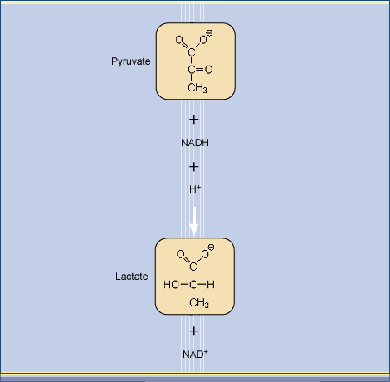
Homolactic fermentation occurs in muscle cells during vigorous activity when the demand for ATP is high and oxygen (O₂) has been depleted. Pyruvate reduces NADH enzymatically, leading to lactate and restoring NAD⁺

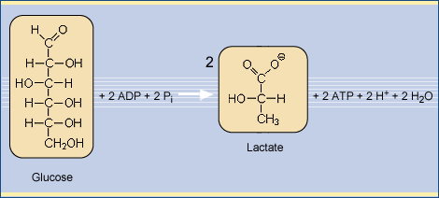
The overall process of anaerobic glycolysis in muscle is:

CARBOHYDRATES: ENERGY STORAGE – GLYCOGEN
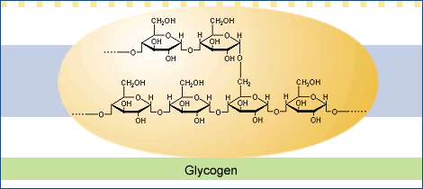
Glucose is the preferred fuel molecule of the brain. To protect the brain from a potential fuel shortage, the body tries to maintain a constant level of glucose in the blood. Excess dietary glucose is therefore polymerized to the polysaccharide glycogen that is stored in liver and muscle cells. When the level of glucose in the blood starts to drop, this reservoir of glucose can be mobilized quickly.
The primary structure of glycogen resembles that of amylopectin but glycogen is more highly branched, with branch points occurring every 8 to 12 glucose residues.
Glycogen is stored in cytoplasmic granules of muscle and liver cells that contain up to 120,000 glucose units. Glycogen granules also contain the enzymes that catalyze glycogen synthesis and degradation as well as some of the enzymes that regulate these processes. Glycogen has several advantages as a short-term energy reservoir compared to fat (triglycerides): Muscles can mobilize the energy stored in the glucose units of glycogen much faster than they can mobilize the energy stored in fat. Glucose, in contrast to fatty acids, can be metabolized anaerobically (anaerobic fermentation) and thereby provides a very fast pathway of energy generation. Additionally, humans and animals cannot convert fatty acids to glucose. Therefore, fat metabolism alone cannot adequately maintain blood glucose levels.
Glycogen breakdown is triggered either by high energy demand in muscle cells or by low blood glucose concentration in liver cells. Liver cells release glucose units in the bloodstream to maintain the proper blood glucose level. Glycogen’s glucose units are mobilized by their sequential removal from the chain’s ends. The highly branched structure therefore permits the rapid degradation of glycogen through the simultaneous release of the glucose units at the end of every branch. Glycogen breakdown requires the activity of different enzymes that cleave glucose units from the chains and remove the branch points.
When glucose is not needed as a source of metabolic energy, glycogen is synthesized enzymatically from glucose-6-phosphate in most cell types, in particular by liver and muscle cells. There are specific enzymes that catalyze the formation of chain elongating a(1®4)-glycosidic bonds while a different enzyme introduces the (1,4®1,6)-branch points. The rates at which glycogen is synthesized or degraded are controlled by the hormones glucagon, insulin, and epinephrine, as well as by Ca²⁺ ions. Glucagon, epinephrine, and Ca²⁺ stimulate glycogen breakdown whereas insulin activates glycogen synthesis. A deficiency of insulin or insulin receptors leads to the disease diabetes that is characterized by abnormal high levels of glucose in the blood.
CARBOHYDRATES: GLUCONEOGENESIS
Glucose is the most important fuel for the brain and red blood cells and is normally obtained from the diet. When fasting, however, the body’s glucose needs must be met by gluconeogenesis, the biosynthesis of glucose from non-carbohydrate precursors. Gluconeogenesis occurs in the liver and, to a smaller extent, in the kidneys.
The non-carbohydrate precursors that can be converted to glucose include the glycolysis products lactate and pyruvate, the intermediates of the citric acid cycle, and the carbon skeletons of all amino acids except for leucine and lysine. All non-carbohydrate precursors must be converted to oxaloacetate, the starting material for gluconeogenesis. Fatty acids cannot serve as glucose precursors in humans and animals: fatty acid breakdown leads to acetyl-CoA and there is no pathway in humans and animals for the conversion of acetyl-CoA to oxaloacetate.
Whereas most non-carbohydrate precursors can be converted to oxaloacetate in the citric acid cycle, pyruvate is converted to oxaloacetate in the mitochondria by an enzyme with biotin as prosthetic group that functions as a CO₂ carrier.
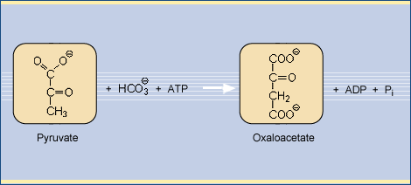
Oxaloacetate is converted to phosphoenolpyruvate. Phosphoenolpyruvate is one of the intermediates of glycolysis, the breakdown pathway of glucose to pyruvate. The synthesis of glucose from phosphoenolpyruvate occurs via the same intermediates but in reversed order as glucose breakdown by glycolysis. However, the enzymes that catalyze gluconeogenesis are located in the cytosol whereas the breakdown of glucose occurs in the mitochondria, thus separating the synthesis and breakdown of glucose from another.
Glycolysis and gluconeogenesis are reciprocally regulated so as to consume glucose when the demand for ATP is high and synthesize it when the demand is low. When the blood glucose level is high, fuel conservation is predominant. Glucose is either polymerized to glycogen or converted via acetyl-CoA to fatty acids, which are stored in the adipose tissue. When the blood glucose level is low, the liver maintains the blood glucose level by stimulating glycogen breakdown and by gluconeogenesis. The maintenance of a constant blood glucose level is very important to ensure a proper supply of the brain, which prefers glucose as source of energy, with fuel molecules. The hormones insulin, glucagon, and epinephrine are involved in regulating the blood glucose level. A deficiency of insulin or insulin receptors leads to the disease diabetes
CARBOHYDRATES: BIOSYNTHETIC PATHWAYS FROM CARBOHYDRATE PRECURSORS
Carbohydrates serve not only as fuel molecules but they and their breakdown products are also important precursors for biosynthetic pathways.
In addition to the citric acid cycle’s catalytic role in the oxidation of acetyl-CoA, several biosynthetic pathways utilize citric acid cycle intermediates as starting materials.
- Glucose biosynthesis (gluconeogenesis) utilizes oxaloacetate
- The biosynthesis of fatty acids and cholesterol starts with acetyl-CoA that is obtained by the breakdown of citrate
- Amino acid biosynthesis utilizes either α-ketoglutarate and oxaloacetate to synthesize glutamate and aspartate
- Porphyrin biosynthesis utilizes succinyl-CoA as starting material.
The pentose phosphate pathway is an alternative to glycolysis and yields ribose-5-phosphate, an important precursor of the sugar component of nucleotides, the building blocks of the genes.
Many lipids of biological membranes as well as many proteins both attached to membranes and in the cytosol carry oligosaccharides. Those oligosaccharides play important roles in the interaction of cells with their environment as well as in determining the fate of proteins within the cell.
Complex polysaccharides called glycosaminoglycans are a major component of the gel-like matrix that fills the extracellular space of connective tissue. The glycosaminoglycans aggregate with proteins to proteoglycans that give connective tissues their specific mechanical properties.

LIPIDS: FATTY ACIDS, FATTY ACID OXIDATION
Fatty acids are converted to energy in a process called fatty acid oxidation that takes place in liver cells. Basically, in this process the fatty acids that consist of long chains of carbon atoms are cleaved successively to units that consist of two carbon atoms. The resulting units – activated acetic acid termed acetyl-CoA – are converted to energy in a process called citric acid cycle or Krebs cycle. The citric acid cycle is a process that is common to all energy generating processes in cells, no matter whether carbohydrates, proteins or lipids are converted to energy.
Fatty acid oxidation occurs in the mitochondria, the “power stations” of the cell. Therefore, as a first step of fatty acid oxidation, fatty acids have to be transported from the cytosol into the mitochondria by a mechanism that involves activation of a fatty acid with coenzyme A and coupling to the molecule L-carnitine.
Fatty acids (acyl_{n}⁻) are activated by coenzyme A in the cytosol of the cells:
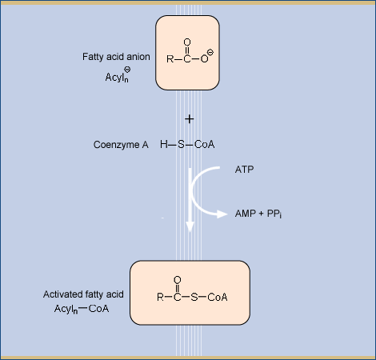
Since the oxidation of fatty acids occurs inside the mitochondria, the fatty acids have to be transported through the mitochondrial membrane. The transport through the mitochondrial membrane requires the transfer of the activated fatty acid to the molecule L-carnitine to form acyl-carnitine. Acyl-carnitine is transported into the mitochondria by a transmembrane protein called carnitine carrier protein. Carnitine therefore is crucial for the utilization of fatty acids in energy generation.
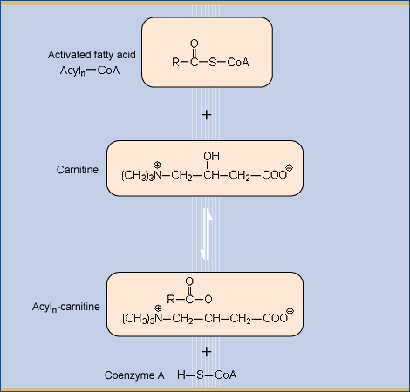
Inside the mitochondria the fatty acids are transferred back to coenzyme A and carnitine is transported back outside to the cytosol. The activated fatty acids are then cleaved into the two-carbon atom unit acetyl-CoA in the mitochondrial matrix. The two-carbon atom unit next to the coenzyme A is removed enzymatically from the fatty acid, yielding acetyl-CoA and an activated fatty acid acyl_{n-2}-CoA that is shorter by two carbon atoms
This process is repeated until the fatty acid is completely cleaved to acetyl-CoA.
The resulting acetyl-CoA enters the citric acid cycle where it generates FADH₂ and NADH. The energy stored in FADH₂ and NADH is converted to ATP – molecules that provide the energy for many energy consuming processes in cells – through oxidative phosphorylation. Also, the molecules of FADH₂ and NADH that are formed during the cleavage of the fatty acid to acetyl-CoA are used to produce ATP through oxidative phosphorylation.
As an example, one molecule of palmitic acid (which has a 16-carbon atom chain) yields 129 molecules of ATP. One molecule of glucose, by comparison, only yields 38 molecules of ATP.
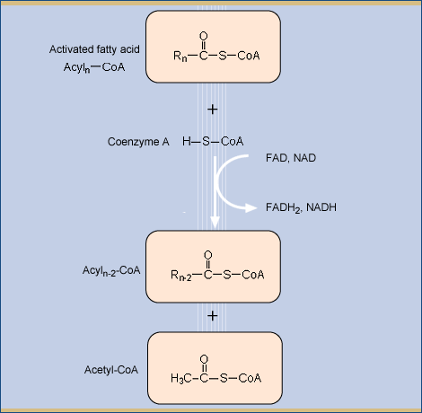
Alternatively, instead of the conversion of acetyl-CoA in the citric acid cycle, ketone bodies can be produced from acetyl-CoA. Ketone bodies serve as the major source of energy in many peripheral tissues, in particular in the heart and skeletal muscles.

LIPIDS: DIETARY LIPIDS
Lipids, also known as fats and oils, are a heterogeneous class of food constituents. Rather than having similar structures, their common characteristic is their limited solubility in water. The most important role of lipids in plants and animals is their function as energy depot. Plants contain lipids primarily in the seeds and nuts where they serve as a source of energy for the growth of the seedling. In animals, fat is stored in specialized tissue and serves as an energy depot for times when food supply is low. Animal products such as meat, milk and dairy products and eggs are in general richer in fat than most food of plant origin except for seed oils, nuts and some fruits such as olives or avocados. Lipids can be isolated and refined from their plant or animal source and are available to the consumer as edible oils or fats. Lipids that are solid at room temperature are called fats, while liquid lipids are called oils. Since fats and oils are high in calories, their intake should be limited to prevent overweight. However, they are important since they contain essential fatty acids and fat-soluble vitamins. Furthermore, lipids are responsible for the pleasant creamy or oily mouthfeel of food and contain many aroma constituents of food as well as fat-soluble pigments. These properties are important for the texture, specific mouthfeel, taste, and color of food.
The major lipid components of fats and oils are:
- Fatty acids
- Triglycerides
- Phospholipids
- Glycolipids
- Sphingolipids
- Steroids: cholesterol and phytosterols
- Lipoproteins
Additionally, fats and oils contain smaller lipid soluble molecules. The most important are vitamins, carotenoids, and aroma compounds. Of all the vitamins, vitamin A, vitamin D, vitamin E, and vitamin K are lipid soluble. Carotenoids, which are only synthesized by plants, provide the color of many fruits and are precursors of aroma compounds. Additionally, carotenoids taken in with the diet can be stored in animal tissue. An example is the yellow color of egg yolk. Carotenoids are important antioxidants and some of them, in particular b-carotene, can be converted to vitamin A.
LIPIDS: FATTY ACIDS
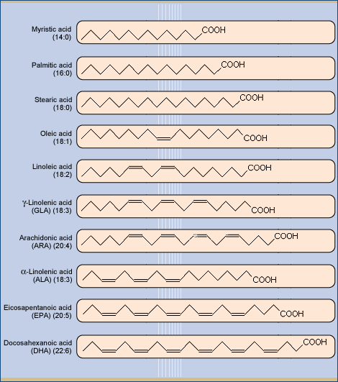
Fatty acids are straight-chain carbon acids usually with an even number of carbon atoms that may contain isolated cis-double bonds. Fatty acids without double bonds are called saturated fatty acids. Those with one double bond are called monounsaturated fatty acids (MUFAs) and those with more than one double bond are known as polyunsaturated fatty acids (PUFAs).
Examples for saturated fatty acids are myristic acid, palmitic acid, and stearic acid. The most common MUFA is oleic acid. PUFAs include linoleic acid, α-and γ-linolenic acids (ALA, GLA), arachidonic acid (ARA), eicosapentanoic acid (EPA), and docosahexanoic acid (DHA). Fatty acids are characterized by the number of carbon atoms n and the number of double bonds m as (n:m).
Omega-3 and omega-6 fatty acids are members of the PUFA family. The terms omega-3 and omega-6 are derived from the position of the double bond within the carbon atom chain. The carbon atom in the chain that is furthest away from the carbon acid group is labeled “omega” because it is at the end of the molecule. The numbers 3 and 6 denote the number of the C-atom, counted from the omega-C-atom, at which the first double bond occurs. Linoleic acid, GLA, and ARA are omega-6 fatty acids, whereas ALA, EPA, and DHA are omega-3 fatty acids. Humans and mammals cannot synthesize omega-3 and omega-6 fatty acids themselves. Therefore, linoleic acid and ALA, which can be converted to the various other omega-3 and omega-6 fatty acids, are essential fatty acids.
Fatty acids are used as a source of energy in a process called fatty acid oxidation. Additionally, fatty acids are the major components of triglycerides, which serve as the body’s long-term energy reservoir. Triglycerides usually contain saturated fatty acids. Unsaturated fatty acids are the predominant building blocks of phospholipids, important constituents of cell membranes, and the precursors of eicosanoid hormones.

Fatty acids taken in with diet influence the level of cholesterol-containing lipoproteins in the blood serum and thus effect the risk for atherosclerosis and cardiovascular disease. Saturated fatty acids increase the level of LDL (“bad cholesterol”) in the blood serum, while MUFAs and PUFAs decrease the level of LDL and increase the level of HDL (“good cholesterol”).
Natural fats contain almost exclusively unsaturated fatty acids with cis-double bonds. Processed fats, for example the hydrogenated fats in some margarines, frequently contain trans-fatty acids that increase the level of LDL and decrease the level of HDL and therefore raise the risk of atherosclerosis and cardiovascular disease.

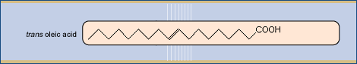

LIPIDS: ENERGY STORAGE – TRIGLYCERIDES
Fats (triglycerides or triacylglyceroles) are the most important long-term energy reservoirs in the body of animals because they represent a highly efficient form of energy storage. Due to their chemical structure (they are “less oxidized” than other dietary molecules), they yield significantly more energy than carbohydrates or proteins when they are broken down. Because fats do not mix with water, they, unlike carbohydrates, are stored without attached water molecules. Since water cannot be converted to energy, carbohydrates yield less energy than the same volume of fats.
The body stores triglycerides in specialized cells called adipocytes that can be almost entirely filled with fat globules. They are located in the adipose tissue that occurs in particular under the skin and in the abdominal cavity. The energy reservoir in the adipose tissue is sufficient for normal (non-obese) humans to survive starvation for 2 to 3 months.

Adipocytes take up triglycerides that are synthesized in the liver and transported by the bloodstream. In addition, the adipocytes can synthesize triglycerides themselves from fatty acids and glycerol-3-phosphate when the level of nutrients in the body is high. On the other hand, when the body needs nutrients, the energy reserves are mobilized by breaking down triglycerides to fatty acids and glycerol by lipase enzymes. The fatty acids and glycerol are released from the adipocytes into the bloodstream and transported to the liver where they can be converted directly into energy. Alternatively, glycerol can be converted to glucose and fatty acids to ketone bodies that can be utilized for energy generation by other organs and tissues.
The synthesis and breakdown of triglycerides is regulated by hormones that influence the number and the activity of the lipase enzymes that break down the triglycerides to glycerol and free fatty acids:
The hormones epinephrine, norepinephrine, glucagon, and ACTH (adrenocorticotropic hormone) increase the number and activity of lipase enzymes and therefore stimulate the energy generation from triglycerides. The hormone insulin, on the other hand, suppresses lipase enzymes and slows down the utilization of the body’s energy reservoir in the adipocytes.

LIPIDS: CHOLESTEROL
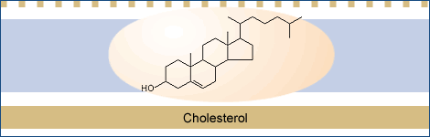
Cholesterol is an important component of cell membranes and the precursor of steroid hormones and bile acids. Although it is therefore essential to life, excess cholesterol can lead to atherosclerosis, cardiovascular disease, and stroke.
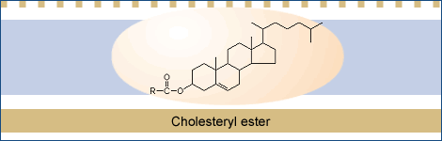
Cholesterol is synthesized by the body and therefore completely dispensable in the diet. Biosynthesis of cholesterol occurs in the liver. It is either converted to bile acids for use in the digestive process or coupled to fatty acids to form cholesteryl esters. Cholesteryl esters are packaged together with triglycerides into very-low-density lipoproteins (VLDL) to be shipped to other tissues outside the liver, and secreted into the bloodstream. As the VLDL circulate in the blood system, the triglycerides are taken up by the cells in muscle and adipose tissue after cleavage to fatty acids and monoglycerides. The VLDLs are thereby converted to cholesterol-rich intermediate-density lipoproteins (IDLs) and low-density lipoproteins (LDLs). Peripheral tissues usually obtain most of their need for cholesterol not by synthesis but by taking up LDL particles. Inside the cell, the cholesterol is incorporated into the various membranes inside or surrounding the cell or stored as cholesteryl ester droplets.
Cholesterol travels back and forth between the liver and peripheral tissues. Corrupted membranes from dead cells are taken up by high-density lipoproteins (HDL) and transported back to the liver. Surplus cholesterol is disposed of by the liver as bile acids to protect the body from an overaccumulation of this water-insoluble substance. However, the excretion of surplus cholesterol as bile acids is slow because they are efficiently reabsorbed in the intestines and recycled by the liver. Therefore one strategy to reduce a high cholesterol level is the ingestion of resins that bind bile acids and are excreted with the feces, thereby removing cholesterol from the body.
Since cholesterol is necessary for the formation and maintenance of biological membranes on the one hand, but dangerous on the other as it may deposit in and eventually narrow the arteries, its biosynthesis, utilization, and transport have to be carefully regulated. One mechanism of regulation involves the synthesis of cholesterol in the liver: The amount of cholesterol depends on the amount of one of the enzymes that are involved in the synthesis. The body can vary the activity and amount of this enzyme with the level of cholesterol in the body. The second mechanism involves the receptors of cells for cholesterol. Cholesterol is delivered to the cells by LDL that has to bind to receptors at the cell membrane prior to be taken up by the cell. Therefore, the serum concentration of LDL depends on the number of receptors on the cell surfaces, in particular on liver cells. The number of LDL receptors and therefore the rate of removal of cholesterol from the blood are influenced by the amount of cholesterol in the diet. A high level of cholesterol in the diet increases the level of cholesterol in liver cells because chylomicrons transport the dietary cholesterol to the liver. As a consequence, the number of receptors for LDL on the liver cell membranes decrease, the uptake of LDL from the blood into the liver cells slows down and the level of LDL in the blood plasma increases. This increases the probability of cholesterol deposits on artery walls and thus the risk of atherosclerosis and cardiovascular disease.
LIPIDS: PHOSPHOLIPIDS, GLYCOLIPIDS AND SPHINGOLIPIDS
Phospholipids, glycolipids and sphingolipids – together with cholesterol and proteins – are the building blocks of biological membranes.
The common feature of membrane building blocks is their amphiphilic nature: they consist of a hydrophilic (water-soluble) part called head and a hydrophobic (water-repelling) part called tail. When amphiphilic molecules are brought into an aqueous environment, they assemble themselves into a membrane, a two-dimensional structure that consists of two layers (a lipid bilayer) of the molecules. In this structure, the hydrophilic heads point to the outside while the hydrophobic tails are found on the inside, thereby avoiding their interaction with the water molecules of the surrounding solution. In the membrane, the molecules are not fixed at their position but are able to move around in the plane of the bilayer.
The properties of membranes vary with their composition. The capabilities of a membrane depend in particular on their fluidity, which is influenced by the content of cholesterol and unsaturated fatty acids as well as the chain length of the fatty acids. Membranes, therefore, differ in their constituents depending on the function of a specific cell or intracellular membrane. The most abundant and structurally most important phospholipid is phosphatidylcholine. It is particularly important for the liver because the liver is the organ with the highest content of membrane structures. Phosphatidylserine is more frequent in brain cell membranes than in other organs. Sphingolipids, in particular sphingomyelin, are other major components of brain cell membranes.
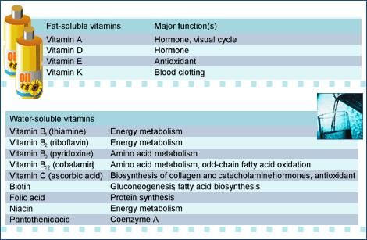
MICRONUTRIENTS AND WATER: VITAMINS
Vitamins are organic compounds that are required in the diet in only small amounts. 13 vitamins have been identified. Vitamins are needed for normal growth, digestion, mental alertness, resistance to infections, and reproduction. Most of the vitamins are cofactors of enzymes. They are not metabolized themselves but enable organisms to convert carbohydrates, lipids, and proteins to energy or building blocks. Two of the vitamins – the vitamins A and D – are converted to hormones. Vitamin A also functions as a cofactor in the visual cycle. Most of the vitamins absorbed from the diet must be converted or modified to obtain the active form.
The body strives to maintain an optimal level of each vitamin and keep the amount circulating in the bloodstream constant. Nine of the 13 vitamins – B₁, B₂, B₆, B₁₂, C, niacin, pantothenic acid, biotin, folic acid - are water-soluble and are not stored in the body in appreciable amounts. Therefore, they have to be supplied regularly with the diet. Surplus water-soluble vitamins are excreted in the urine and thus are most likely not harmful to the body. The remaining four vitamins – A, D, E, and K – are fat-soluble and can be stored in the body fat. Because they are stored, excess fat-soluble vitamins can accumulate in the body and become toxic. The human body is especially sensitive to too much vitamin A and D. Taking in more vitamins than recommended is therefore not necessarily better and can even be harmful.
MICRONUTRIENTS AND WATER: MINERALS
Minerals are inorganic ions. They are essential nutrients, i.e. they cannot be synthesized by the body and have to be obtained from the diet. Lack of a mineral for a prolonged period can cause deficiency diseases, which can usually be reversed when the mineral is re-supplied.
The body needs about 15 different minerals for proper functioning. Minerals are part of the building materials for bones and teeth, act as enzyme constituents and participate in enzyme regulation and activation. They influence the activity of neurons and are involved in the maintenance of electrolytic and osmotic equilibriums in the body.
Main minerals include sodium, potassium, chloride, calcium, phosphor, and magnesium. The body contains between several grams (magnesium) and up to more than a kilogram (calcium) of each of the main minerals. Main minerals are mainly important for electrolytic equilibriums and as building materials. In addition to the main elements, the body needs smaller amounts of so-called trace minerals that comprise chromium, copper, fluoride, iodine, iron, manganese, molybdenum, selenium, and zinc. The trace mineral content of the body amounts to a few milligrams (e.g. iodine) up to a few grams (e.g. iron). Trace minerals are components of hormones, enzymes, and other proteins that have distinct biological roles. A deficiency in essential trace elements results in metabolic disorders that are primarily associated with the absence or decreased activity of metabolic enzymes. Most of the trace elements may have toxic effects at higher concentrations. Some minerals are stored in a reservoir in the body and can be released during periods of a dietary deficiency, e.g. iron, calcium, and phosphate. Most minerals, however, tend not to be stored in usable, mobilizable forms and have to be taken in with the diet regularly.
Minerals are not only important food components because of their physiological roles. They also contribute to the flavor and texture of food and influence the reactions that take place during food processing as well as the degradation of food.
Sodium and potassium:Sodium and potassium are present in high concentrations in all fluids inside and outside the cells of the body and play important roles in maintaining the osmotic pressure and in nutrient and signal transport across membranes. Sodium is present mostly as an extracellular constituent and maintains the osmotic pressure of the extracellular fluid. Potassium is localized mostly within cells and regulates the osmotic pressure within the cell.
Chloride: Chloride ions serve as counter ions for sodium ions in the extracellular fluid and for hydrogen ions in gastric juice.
Calcium: Calcium is the most frequent mineral in the body and accounts for 1.5% - 2% of the body weight. Most of the calcium occurs in the skeleton and calcium is therefore crucial for building and maintaining bones and teeth. However, calcium plays also very important roles in blood clotting and muscle contraction as well as in the transmission of signals to cells. Good sources of calcium are milk, dairy products, nuts, legumes, whole-grain cereals, and soy.
A sufficient supply of calcium to the body is in particular important during pregnancy and growth and helps to prevent osteoporosis.
Phosphor: Phosphate plays an important role in energy metabolism as component of the rechargeable battery molecule ATP of the body. About 85% of the phosphate in the body are bound in the bones where it acts as the counter ion for calcium. Good sources of phosphate are milk, dairy products, cereals, and meat.
Magnesium: Magnesium serves as constituent and activator of many enzymes, particularly those associated with the conversion of energy-rich phosphate compounds, and as a stabilizer of cell membranes, intracellular membranes, and nucleic acids. Good sources of magnesium are milk, bread, cereals, green vegetables, and potatoes. Chromium: Chromium participates in the utilization of glucose through the activation of enzymes and the hormone insulin. Good sources of chromium are whole-grain cereals and vegetables.
Copper: Copper occurs in the body as component of a number of enzymes that are involved in the formation of blood and bones. Good sources of copper are meat and whole-grain cereals.
Fluoride: Fluorine has a positive effect on growth and reproduction as well as in the prevention of caries. Good sources of fluorine are fish, crustaceans, algae, and tea.
Iodine: Most of the iodine in the body is bound in the thyroid gland where it is used in the biosynthesis of the hormone thyroxine that is essential for regulating metabolic rate and heat production. An iodine deficiency results in the enlargement of the thyroid gland (goiter), and as the most serious complication, cretinism. As a prophylactic measure, in iodine-deficient countries table salt is iodized. Higher amounts of iodine, on the other hand, are toxic, disturb reproduction and lactation and can lead to diseases of the thyroid gland.
Iron: The iron content of the body is 4 – 5 g. Most of it is present in the hemoglobin and myoglobin pigments of blood and muscle tissue, respectively. Iron is stored in the liver. Good sources of iron are meat, liver, poultry, fatty sea fish, dark green vegetables, nuts, and seeds. Iron deficiency is called anemia and occurs mainly in infants, children, and fertile women.
Manganese: Manganese serves as activator for many enzymes. Good sources are whole-grain cereals, green leafy vegetables, and legumes.
Molybdenum: Molybdenum serves as a cofactor for enzymes involved in amino acid breakdown. Good sources are vegetables and legumes.
Selenium: Selenium serves as a cofactor for enzymes involved in fatty acid oxidation and amino acid breakdown. Good sources are meat and crustaceans.
Zinc: Zinc is a component and activator of many enzymes. Zinc deficiency causes serious disorders such as delayed wound healing and impairment of the immune system, while high zinc intake is toxic. Good sources are oysters, red meat, and whole-grain cereals.

MICRONUTRIENTS AND WATER: PHYTOCHEMICALS
Phytochemicals are micronutrients that occur in small amounts in food of plant origin. They contribute to the color and taste of plant-derived foods. Additionally, many phytochemicals can positively influence human health. They have antioxidant properties and therefore act as free radical scavengers. Free radicals contribute to the process of aging as well as to degenerative diseases such as cancer and atherosclerosis.
Carotenoids
Carotenoids are a class of approximately 500 naturally occurring, fat-soluble pigments that give many fruits and vegetables their yellow, orange, red, and purple color. b-Carotene plays a major role as a vitamin A precursor, as do about 10 percent of other carotenoids. Carotenoids – e.g. lutein, lycopene, a-, b-, and g-carotene, b-cryptoxanthin, zeaxanthin, and xanthophylls – protect plants against the damage from free radicals formed by UV radiation. Similarly, carotenoids from the diet possess antioxidant properties and help to prevent damage from free radicals in humans.
Phenolic compounds
- Plant phenols and polyphenols are derivatives of hydroxycinnamic acid and hydroxybenzoic acid. Polyesters of hydroxybenzoic derivaties with glucose form tannins. Some plant phenols have antioxidant properties while others are oxidants.
- Flavonoids have strong antioxidant properties and include proanthocyanidins, anthocyanidins, flavanols, flavanones, flavones, and isoflavons.
Good sources of phenolic compounds include citrus fruits, berries, onions, parsley, legumes, green tea, and red wine.
Alkyl- and allyl sulfides and disulfides
Sulfur-containing compounds occur predominantly in onions and garlic. They have antithrombotic properties, lower the plasma cholesterol level, and may prevent cancer.
Isothiocyanates
Isothiocyanates are major aroma compounds in radish, cabbage, cauliflower, and broccoli. They also have antioxidant properties.

