Phospho-creatine:
INCREASE POWER, STRENGTH, & STAMINA
This advanced formulation delivers greater ATP production, increased lean muscle gains, shortened recovery times, and increased cell volume over supplementing with pure creatine monhydrate alone. Phosphocreatine is a high energy bond between creatine and phosphates. When the energy for a muscle contraction is released from ATP (adenosine triphosphate) it loses a phosphate molecule and becomes ADP (adenosine diphosphate). As the ATP stores are used up phosphocreatine delivers the phosphate and energy to reform ATP for ADP. The storage capacity of phosphocreatine is many times that of APT and can be increased through the supplementation of creatine and phospahtes.
Break through research has proven that the benefits fo oral supplementation of creatine can be maximized by the addition of key substances, phosphates, tauring, glutamine and other nutrients found in PHOSPHOCREATINE POWER.
At Prolab we have applied nutritional research to develop the most advanced creatine and phosphate product to deliver results way beyond creatine alone. Take your workouts and your body to incredible new levels of strength, power, and stamina with this revolutionary product. Maximize your power output with PHOSPHOCREATINE POWER! The power to go beyond!
- Increased storage of ATP & Phosphocreatine energy molecules
- Greater anaerobic power capacity - more powerful workouts
- Reduced lactic acid build-up - More reps before the "burn-out"
- Reduce the onset of muscular fatigue - train longer and harder

Phosphocreatine Circuit System and
Benzaldehyde Derivatives
Phosphocreatine circuit system is the supplier of Adenosine triphosphate (ATP), to the body, during anaerobic conditions. Competition between countries has encouraged a great amount of research into how the energy systems of the body work. One of the systems studied is the Phosphocreatine system.
Structures of Creatine and Creatinine
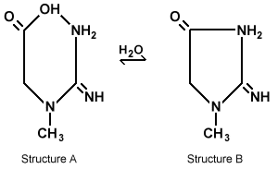
PhosphoCreatine/ADP Equilibrium with Creatinine/ATP
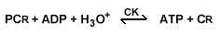
The PCr circuit system has five main functions in the body. First, it is considered a "temporal energy buffer" (Wallimann p. 23.) The system always has energy or can provide energy for use by the bodies' biological systems. The second main function is that of an "energy transport" system that can provide PCr to the low-level areas of the body to produce ATP. With the build up of free ADP the PCr circuit system converts it to ATP to avoid inactivation of cellular ATPases also avoiding production of AMP. This reduction of the ADP concentration is another main function of the PCr circuit system. The system also prevents acidification of the cells by preventing the buildup of the [H+] The final function of the PCr circuit system is to keep the ATP/ADP ratios constant so the proper levels of ATP in the muscles are present. The PCr circuit system is a self-buffering system with a biological pH that keeps an almost constant amount of energy available for the body's biological systems.
Creatine monohydrate and creatine phosphate are supplements used to enhance strength, muscle mass, and speed. The use of creatine monohydrate from my teammates and myself have shown increase in strength, muscle mass, and speed which lead to this research to better under stand how the creatine phosphate system works

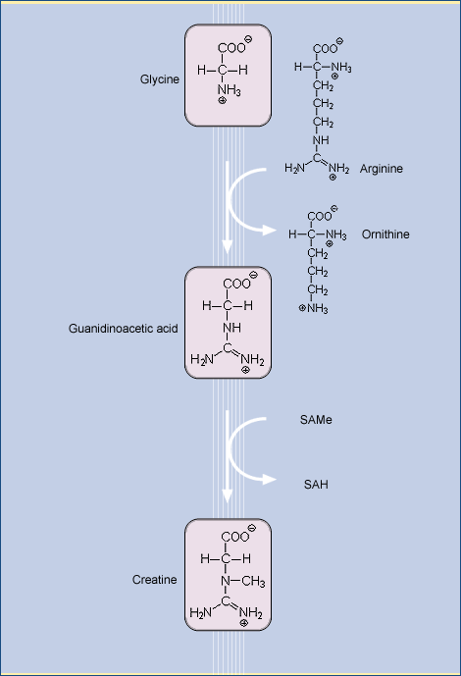
PROTEINS, AMINO ACID DERIVATIVES, CREATINE
Phosphocreatine serves as a rapidly available energy reservoir in muscle tissue. The immediate energy source for skeletal muscle is ATP. ATP is converted to ADP during muscle contraction and ATP has to be restored. Phosphocreatine plays a major role in the regeneration of ATP. It helps maintain a constant concentration of ATP in the muscle during sudden bursts of exercise that would otherwise deplete ATP concentration in the muscle cells. Also, during high intensity exercise, the stock of phosphocreatine will be depleted within ten seconds and other available sources of energy have to be activated. Although glucose from the blood serum is a readily available energy source which may be used either during sudden or exhaustive exercise, the muscle prefers to generate ATP from its reserve of glycogen. A decrease in the glucose level in the blood serum is not desirable, because glucose is required by the central nervous system.
Creatine is synthesized via guanidinoacetate that is formed in the kidneys from arginine and glycine. Guanidinoacetate is methylated by S-adenosylmethionine (SAMe) in the liver to form creatine that is transported by the blood to the muscle cells.
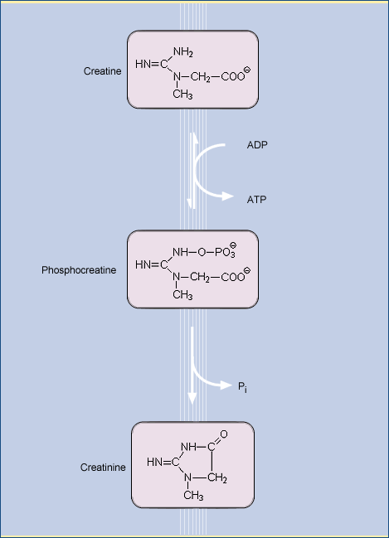
In the resting muscle, creatine is converted to phosphocreatine by ATP.
Eventually, creatine is degraded by non-enzymatic cyclization to creatinine that is renally excreted. This process leads to the loss of about 2 – 4 grams of the total creatine pool (about 140 grams) per day that have to be replaced by creatine synthesized by the liver or taken in with the diet. Although the human body is able to synthesize creatine, additional intake of creatine may be necessary for athletes who have a higher turnover of creatine, vegetarians whose diet may not supply sufficient creatine, and elderly people.

