"Nutrition For Optimum Health"
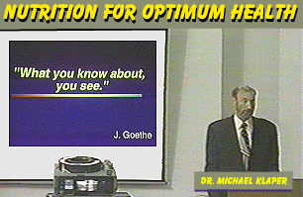
by Michael Klaper, M.D.
Dr. Klaper presents important facts about Heart Disease, Fat,
Nutritional Needs, Calories, Milk, Osteoporosis, and Vitamin B-12.
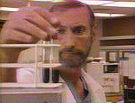
edicine fascinates me because it constantly teaches me something new. Back in the 1850's, the German philosopher Goethe said, "what you know about you see." Once you know about something you start seeing it everywhere, and this is certainly true about medicine and nutrition. I want to increase your understanding of diet and nutrition so you start seeing things differently, especially when it comes time to order your next meal in a restaurant or when you are pushing your cart down the supermarket aisles trying to decide what to bring home for dinner.
Nutritional Awakening
It began when I was on the cardiovascular anesthesia service (a service that deals with people's hearts and blood vessels). One evening I was making a round to see a patient who was scheduled for a four-vessel coronary by-pass in the next few days. The man had been out on a day-pass with his family before surgery, quite a common practice and had returned to the hospital rather late. The nurse notified me that there were several blood tests - missing from his chart, so we promptly performed another blood draw and -brought it to the nurse's station. I let it sit there while I got busy with some work in the ward. An hour and a half later I went back to the nurse's station to take the blood tube down to the laboratory. What I saw in the blood tube gave me a rude awakening as to the condition of this patient's coronary health.
When you draw blood into a glass tube and allow it to sit there for a couple of hours, it separates out into two parts.

Here is normal blood on the left. You see the red clot on the bottom and the clear liquid serum has risen up to the top? The serum should be transparent; you should be able to see through normal serum. However, the blood in my patient's tube looked very different. The serum that was floating on top of his clot was thick and greasy white. When I shook the tube, the serum stuck to the sides of the glass - like glue.
I went back into the room and said, "Sir, before you came back to the hospital tonight, did you stop off anywhere from dinner?"
He said, "Yes."
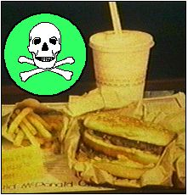
"Where?" I asked, and he said he had stopped at his local gourmet restaurant and he had his usual fare. And I said, "What did have?"
"Well, I had a double-bacon steerburger with extra cheese and a milkshake" (a common offering at such institutions).
And at that point I realized what was all the floating on top of his blood tube. It was all the beef-fat from the burger, the butter-fat from the cheese ice cream, and the egg yolk fat from the mayonnaise that was slathered on the bun. All the fat that this man had eaten had oozed out into his bloodstream and turned his blood fatty.
Day after day, month after month
This is a well known phenomenon called lipima. Every time you eat a fatty meal, a wave of fat goes through your bloodstream. Not everybody shows it this optically densely, but it happens to everyone nonetheless. There's an old saying, "out of sight, out of mind." Might be out of your sight, might be out of your mind, but it's certainly not out of your bloodstream after such a meal. Your body is never "not looking." There's no fooling your body. You can't tell your body, "Look over there!" and then have a cheeseburger, and then your body says, "What was that, what was that?" Your body knows exactly what you eat. Your bloodstream and your liver have to deal with the choices you make at each meal.
These consequences build up day after day, month after month, year after year. The face you see looking in the mirror is the result of the decisions you've made throughout your life. Should I eat this? Should I not eat that? Should I smoke this? Should I not smoke that? Should I drink this? Should I not drink this? Health is not something the doctor can apply to you like calamine lotion. Health is something you do on a daily basis, and making wise decisions at the dinner table is one of the best things you can do to assure your good health.
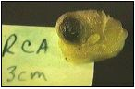
I went back to my patient to discuss his dinner, but unfortunately there was not much to say because the damage was already done - the fat was circulating in his blood. What especially disturbed me, however, was what I saw during his surgery several days later. I gave the man a thousand micrograms of pheontonel and put him to sleep, after which the surgeon opened up his chest and his coronary arteries. From this man's coronary arteries he began pulling yellow, greasy, waxy, fatty deposits that look like this:
What you are looking at is the plug of fat that built up in this man's right coronary artery. The artery was a tube coming out at you from the picture. The artery wall was cut away and you are looking at the plug of fat that built up. The fat started out at the outer edges of the artery wall. As the months and years go by of these repeated tides of fat flowing through the arteries, the fat starts building up on the inside of the arteries like scale builds up in the inside of a hot water pipe. And as the months and years went by, the fat had crowded in and crowded in on his blood flow channel until finally only a small dark area was left for the blood to flow through. When a clot formed here, it stopped the blood flow to his heart and bought him a ticket to the autopsy table. This is the number one cause of death in western societies.
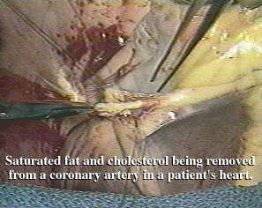
In North America every thirty seconds someone grabs their chest and falls over with a heart attack because this greasy material is clogging up their arteries. This disease is called atheriosclerosis, and it is the number one cause of death and disease in western societies.
This material is quite remarkable. When you send it down to the pathologist and you ask him to do a chemical analysis, the report always comes back the same: "saturated fat and cholesterol." Essentially, it's animal fat. The report from the pathologist never, ever, ever contains the words "remnants of broccoli, rice and tofu."
The good news is this condition can not only be prevented, but also be reversed. If you clean up your diet and start taking a walk everyday, and you get rid of some of the stress that builds up within you, this is a reversible disease and the artery-clogging fat and cholesterol will melt away.
Reversing Heart Disease
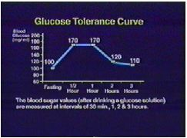
I want to tell you some things about this process so you can make better choices when it comes time to decide what you're going to have for lunch or dinner. Here's a simple analogy from clinical medicine.
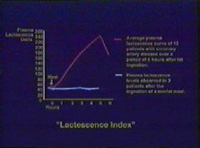
This is a rather famous curve in medicine called the glucose tolerance curve. It just says if you give someone a hundred grams of glucose (that's a sugary drink that you swallow -- sugar is a very small molecule which moves through your bloodstream very rapidly) within a half an hour their blood sugar goes up to a 170 or 180 milligrams. But immediately the pancreas senses the sugar in the blood, and puts out insulin. So the blood sugar comes down fairly rapidly, and by two or certainly three hours, the blood sugar should be back to normal again.
This is not the case with fats in your diet. Fats are a much larger molecule and they move into the bloodstream much more slowly and they come out of the bloodstream much more slowly. If you eat a fatty meal and have someone draw blood on you every hour for the next six hours, and you look at those six blood tubes, you will see them becoming milkier, and milkier, and milkier as the fat moves into the bloodstream. In fact if you take those six tubes and you put them into an instrument that measures how milky the serum is becoming (that instrument is called a spectrophotometer), you will generate a milkiness index. It's called the Lactescence index.
And here you see a classic curve: someone has a bacon and egg breakfast say, and over the next 1, 2, 3, 4, 5 hours you see the blood becoming milkier and milkier as the fat moves in. This is a very significant time curve. With the sugar, the sugar was up and down within three hours. At 5 hours the fat is just reaching it's peak. This has grave consequences (pun intended), for people eating in the western dietary style. Let's take this same curve and let's extend it out throughout the day on someone who is eating in a standard western style and what you will generate is a figure that looks like this:
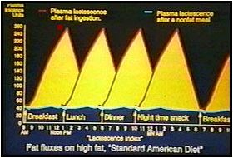
Let's say at breakfast time, a person has bacon and eggs and the fat moves into the bloodstream at 9:00, 10:00, 11:00, 12 o'clock. So at 12:30 in the afternoon, the fat from breakfast is just reaching it's peak. What happens at 12:30?
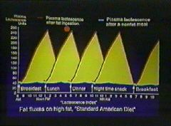
The person heads off to his favorite fast-food restaurant and orders his double-bacon steerburger' with extra cheese, and another wave of fat goes through the bloodstream: 1:00, 2:00, 3:00, 4:00, 5:00, and 6 o'clock in the evening the fat from lunch is just reaching it's peak. What happens at 6 o'clock in the evening? If your a working person you may stop off at your favorite fried chicken institution on the way home and order some extra crispy thighs dipped in bacon grease and you take that home.
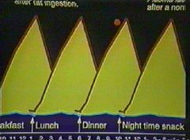
And another wave of fat goes through the bloodstream, 6:00, 7:00, 8:00, 9:00, 10 o'clock at night . . . the fat from dinner is just reaching it's peak. And what happens at 10 o'clock at night?
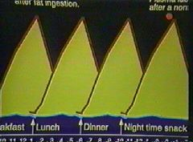
Usually one spouse turns to the other and says, "Dear, do you have any ice cream in the freezer?" and another wave of fat goes through the bloodstream. 10:00, 11:00, 12:00 and so on, and around 3 o'clock in the morning the fat from the snack is just reaching it's peak. The liver, the arteries are swimming with fat. The fat deposits out in the arteries, deposits out in your fat stores, finally it starts leaving the bloodstream and the fat level comes down in the bloodstream just as the dawn is breaking, just in time for the whole fatty circus to start all over again.
When we see the diseases that western human beings suffer from, the clogged arteries, the high blood pressure, the obesity, the diabetes -- these are not random events. These are not curses from a wrathful god punishing us. These are the inevitable consequences of running fat through your bloodstream, hour after hour, day after day, month after month.
How to lower your cholesterol
It's my humble assertion that the best way to lower your cholesterol is: stop eating it.
Only animals make cholesterol. No plant makes cholesterol. And you have no metabolic requirement for animal products whatsoever. Let me underline that again. The human body, the very one your sitting in right now, has absolutely no nutritional requirements for the flesh of animals or for the milk of cows.
When you are reversing heart disease, as you clean up your diet, and this clogging starts melting away, the blood flow will increase. Just a little regression in these plaques means a big increase in blood flow and that's why angina will go away so quickly, that's why people can walk further, that's why their blood pressures go down so quickly, it's one of the major reasons. There's another which I will share with you in a minute. But this gives you hope if you or a relative have clogged arteries. Rather than signing right up for that artero surgery, it is certainly worth, if your life is not in immediate danger, to try a low-fat, pure vegetarian diet and a walking program. Expect good things to happen, because they usually do -- and quickly.
Here's another reason why people feel so good, so quickly. When you eat a fatty meal, imagine what happens to a red blood cell floating in all that fat.
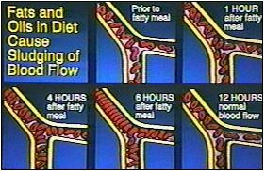
Well, here you see it represented schematically. As the hours go by, blood cells get coated with fat. Here is a capillary, a tiny little blood vessel, let's say it's in your brain, or in your heart. As the blood cells that are carrying oxygen become coated with fat, they become stickier and they start sticking together. As a result the blood vessels start clogging up. We say there is "slugging" of the blood flow. It looks like at freeway a rush hour and the blood cells start moving slower and slower. You can see this through a microscope, these normally rapidly moving blood cells start moving very, very slowly. And that's why so many heart attacks happen after dinner, because the blood is flowing so thickly.
Well, the good news is that if you consume foods that don't have a lot of fat, you can expect the blood to stay free-flowing, which is another reason why blood pressures go down; the heart doesn't have to pump this thick blood through the arteries. And so blood pressures go down and blood flows more free-flowing, and for that reason angina frequently goes away. All sorts of advantages happen as we eat less and less fats.
Slimming down
I have been a physician for over twenty-two years. I have never admitted anyone to the coronary care unit with a diagnosis of olive oil embolism. We are talking about saturated animal fats. Some of the heavier, denser, saturated plant oils; palm oil, coconut oil, avocado oil, play a tiny role in contributing to this problem. But have no illusions: the majority of people suffering heart attacks and strokes, and the other diseases I showed you, are suffering largely from the large amount of animal-fats they have consumed. 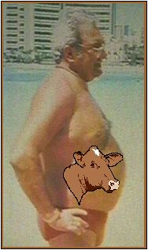
Animal-fat also sticks to you. When you turn your blood fatty and that fatty blood goes through the fat stores underneath your skin, the fat deposits out there. This is not a random event.
Those people who are angry because they are still carrying excess weight and they can't figure out why that fat is sticking there, they need to take an honest look at what is on their plate. As this person changes their diet, as they move toward lower fat, whole foods, whole grains, whole potatoes, whole fruits, whole vegetables, they will become leaner. It certainly happened to me.
I began to change my diet and I felt. "If I do not run all this fat through my arteries, I'm going to be spared this problem." So I stopped eating meats and dairy products. I was concerned that I may not get enough protein or vitamin B-6, or vitamin B-2, so I checked my nutrition books to see what might possibly be a deficiency showing up. It turns out that there is absolutely no nutrient, no vitamin, no mineral, no protein that is found in animal foods (in meats and dairy products) that can not be obtained out of plant-based foods, that includes vitamin B-12 and we'll be talking about that shortly.
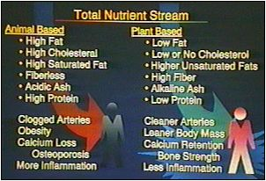
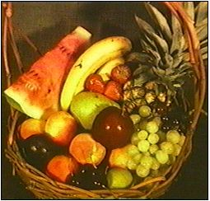
So, as I went to more plant-based foods, I found a wonderful change happening. My cholesterol level fell sharply. My blood pressure, which had been slightly elevated, fell to normal levels. But most impressive to me, I had almost a 24 pound! That's, I guess, almost a two stone spare tire around of fat around my waist, which I could not get rid of even though I had been running five miles a day. Within 12 weeks that 24 pounds of fat melted right away. I found myself waking up in a nice, lean light body. And this was not through deprivation -- I was eating tremendous amounts of Italian food, and Chinese food, and East Indian food, and Thai food, and potatoes, and pastas.
I highly recommend that at least half your diet be composed of fresh, live, uncooked fruits or vegetables. The more you cook food, the deader it gets. The more the vitamins are destroyed, the more the proteins denature. So a good general rule is make sure that half the food you're eating on a given day is food as grown. Eat lots of fresh vegetables, fresh fruits, fresh salads. Lightly steam them for 3 or 4 minutes in a vegetable steamer, but avoid overcooking them. Also avoid overly processed foods.
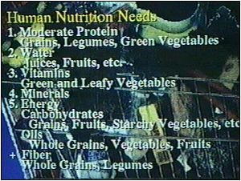
What do you really need to run a human body?
You need six nutrients.
ENERGY- Comes from carbohydrates and fats. Those abound in grains, legumes, fruits, vegetables, starches, and oils.
PROTEIN- Abounds in grains, legumes, and green vegetables.
VITAMINS and MINERALS- used to metabolize all these nutrients and are found in green and yellow vegetables.
WATER- And of course, water is freely available.
This is all you need to run a human body, and all of these are available in the plant foods that grow out of the ground.
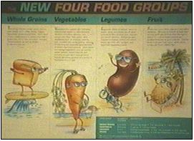
Four Food Groups
We have the new four food groups these days, based on whole grains, vegetables, legumes and fruits. They will supply you with all your requirements for proteins, vitamins, and minerals without burdening the body with extra fats.
All calories are not created equal. Calories are just units of heat measurement -remember those calorie experiments from physics class. This experiment didn't tell you whether those calories were from clean-burning carbohydrates or stick-to-your-waist fats.
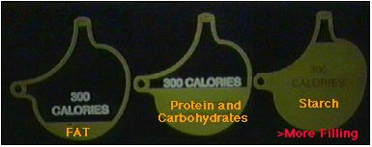
Here are 300 fat calories in a stomach -- you can see the don't take up very much room probably won't fully satisfy someone after a meal. On the other hand, here are 300 calories of potatoes that will fill a stomach up and yet do it with very little . So when my patients want an extra helping of rice and vegetables, I say "By all means, go ahead and don't even worry about how many calories are on your plate" Again, what was sticking to that obese man's abdomen was not rice and vegetables, it was all of the fat he had eaten. So, go ahead and enjoy the whole foods, without worrying about calories.
Dairy Dangers
I will no longer drink the milk from cows or consume products made from that milk. Cow's milk is a superbly engineered fluid that will turn a 65 pound calf into a 500 pound cow in a year. That is what cow's milk is for.
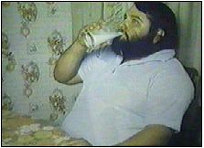
Unfortunately, it often has that same effect on human beings. And people who are trying to get themselves leaner and who are still consuming dairy products should have an honest look at this fluid. Even if the fat is extracted and you are eating low-fat cheeses and low-fat yogurts, there are still many substances in cow's milk that clearly cause problems when they enter the human system. Cow's milk has bovine proteins in it. It has casein and a whole number of other cow proteins. When these proteins get out into the bloodstream, they flow through joint membranes. In some people this can cause rheumatoid arthritis to flare up. When these cow proteins flow through bronchial membranes, they can cause asthma to get worse.
Bovine proteins are notorious for setting off inflammatory reactions throughout the body. Not only are there the bovine proteins to be concerned about, but cow's milk -- whether it is non-fat or not -- has lactose sugar, which many people can not digest. Lactose will give these people cramps and diarrhea when they consume cow's milk products. Cow's milk products also contain substantial amounts of pesticides and herbicides, which have been sprayed on the feed grains and then fed to the cows. These are all deposited in the milk. Cows are fed large amounts of antibiotics to keep the cows from getting infections, and these are frequently found in commercial cow's milk.
Whole milk is filled with artery clogging fat, allergenic proteins, indigestible milk sugars, antibiotics, herbicides, pesticides, and cow pus. That last item is enough to make me not want to pour it on my cereal. I don't want to eat cheese made from cow's milk. In fact, I'll do anything to avoid dairy products. I will pour soy or rice milk, apple juice, and just about anything besides cow's milk on my cereal, When my patients come in with rheumatoid arthritis or asthma, the very first dietary maneuver I do is ask them to pull the dairy products out of their diet. I am repeatedly amazed how quickly so many of these symptoms resolve with the simple expedient of removing cow's milk from the diet.
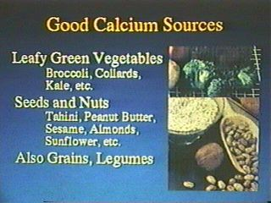
There are a lot of other sources of calcium besides cow's milk. Think about this: where to cows get their calcium? Cows do not drink milk after infancy. Where do they get all that calcium to develop their big, strong bones? They get it from green plants of course. Green plants are loaded with calcium, as are grains, nuts, seeds, fruits, and vegetables. The plant kingdom has many sources of calcium available. You certainly don't have to drink the milk of cow to obtain the necessary calcium for strong bones as the Dairy Council has led us to believe. And I submit to you that many health problems you have may well respond after the removal of dairy products from your diet.
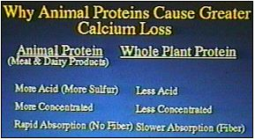
Another problem with animal products is the high protein content. When animal proteins are metabolized, they leave acids, , sulfur, and sulfuric acids, all of which have detrimental effects. The chief effect is that these acids help calcium dissolve out of the bones. It's one of the major contributing factors to osteoporosis -- the tremendous amounts of chicken and fish, and high protein diets that so many of us consume are very detrimental, even though we may be eating less red meat.
Osteoporosis is not a disease of calcium deficiency, it's a disease of calcium loss. Calcium will be excreted by the kidneys for a number of reasons: a sedentary lifestyle, to much animal protein in the diet, caffeine, sugar, salt, and alcohol. All of these substances cause you excrete calcium through urination. If you want to avoid osteoporosis, look on your dinner plate and see that you are avoiding chicken, fish, beef, pork, and dairy. These animal foods are the prime culprit in causing osteoporosis.
If you are not convinced that animal foods cause osteoporosis, consider this: the ethnic group on the planet with the worst osteoporosis are the Eskimos, who live up in the Arctic. They eat all this fish, and all this seal meat, resulting in excess amounts of protein racing through their bloodstream. They have horrific incidences of osteoporosis from the steady drain of calcium from their bodies.
When I ask my patients (especially the women) "what are you eating these days?" they often reply "chicken and fish I am now convinced that these two items are actually one food: chicken-and-fish.
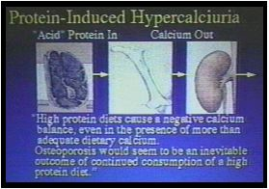
"What are we having for dinner tonight, dear?"
"Oh, we're having chicken and fish."
"Oh good, make mine medium rare!"
You are not doing yourself a favor if you think, "Well, this chicken-and-fish is lower fat food. It looks white, it's not red and bloody, it looks white, so it's cleaner."
Kid yourself not: animal muscle is animal muscle. It doesn't matter if it flaps a wing, moves a shoulder, or wiggles a tail. Animal muscle is essentially the same stuff from species to species. It all contains essentially identical amounts of protein and fat, very little carbohydrates, and lots of cholesterol.
Researchers have done studies taking people eating red meats and changing their diet to one consisting of chicken and fish. Surprise! Their cholesterol levels did not drop a bit. There's no reason that they would --the only difference between chicken/fish and beef is the color of the meat. Changing the color of the meat does not change the amount of cholesterol of in the meat.
Something's fishy
Fish has many problems, despite it's reputation as a "health" food. I know a lot of people on the following continuum: as their diet evolves, many people go from red meat, to chicken, to fish, to dairy products, and finally to a vegetarian diet, and then a vegan diet with no animal products.
If you are on this continuum of moving towards a pure vegetarian diet, bless you. I do not want to make you feel uneasy.
But if you are in chicken and fish land, I urge you -- do not linger there too long.
Fish these days, besides being very concentrated protein, is by far the most polluted of all the flesh foods. For this reason I feel that fish does not offer much at all in the way of a health food,. And if it's the last animal product in your diet -- again, have no worries about letting it swim off your plate all together.
Vitamin B.-12

One issue that we need to cover is vitamin B-12 and its roll in a vegan diet Vitamin B-12 is an essential nutrient that you need for healthy blood and healthy nerves. There is a prevailing feeling that only animal products contain vitamin B-12
. Let me be very clear about this, cows do not make vitamin B-12. They never have, they never will. Pigs don't make vitamin B-12, chickens don't make vitamin B-12, no animal makes vitamin B-12. They never have, they never will.
Vitamin B-12 is synthesized by single-celled microbes (bacteria) that live in the soils of the earth. And long ago when the earth and soils were healthy, before we put all sorts of chemicals on them, the surface of the earth was covered with vitamin B-12. There used to be lots of vitamin B-12 in our lives. Even if you were a pure vegetarian 300 years ago, you could open up the back door of your cottage and outside would be a beautiful organic garden. Every carrot you pulled out of the ground would have little particles of vitamin B-12 sticking to it. When it came time to get your water, you'd take a bucket of water out of the stream, and there too you would find vitamin B-12. There would be B-12 under your finger nails from working in the garden. There would be plenty of B-12 in your life, and since you needed so little of it, concerns about deficiency would not be an issue.
We've become very isolated from the earth and we've lost our natural sources of B-12. Cows have B-12 in their muscles because they're eating grass all day and their pulling up clumps of dirt that have B-12 producing organisms clinging to the root of the grass. They eat the B-12 producing organisms who produce the B-12, which gets absorbed into their bloodstream, goes out into the muscles, and is deposited into their muscles and livers. But that is bacterial B-12 in the cow's muscle. The cow did not make it, nor did the pig or chicken.
Those same organisms are now cultured in big vats, producing their B-12 that is eventually separated out. It is then added to breakfast cereals, soy milks soy burgers, nutritional yeast, and vitamin tablets. It's easy to get vitamin B-12 without consuming animal products and I suggest if you really want to lighten up your diet, find a non-animal source of B-12.
We are evolving as a species. What our caveman ancestors ate is of little import to us now. The question is what is the best diet for modern human beings? Medical literature is clearly showing that the less animal fat and animal protein you put in your system, the healthier you are going to be.

