Return to Table of Contents
Return to Oncology Table of Contents

Conventional Therapeutics

Therapeutic Drug Trials
Phase 1: carried out on a small number of patients to determine the maximum dose of the drug tolerated. No emphasis is placed on efficacy (Does it make you sick?)

Phase 2: determines if any activity against a variety of malignancies usually 15-30 patients. Does it increase survival or quality of life (Does it do any good?)

Phase 3: a controlled trial compared to standard therapy, usually on a larger scale on a specific malignancy (Does it really work?)

Response to chemotherapy:
Response Rate (RR) or Response = CR + PR
CR = Complete Response = Absence of clinically detectable tumor for at least 1 month
+
PR = Partial Response = reduction of 50% or more of tumor volume for 28 days or more
(FDA definition)
The Sum = "Response Rate" (Unfortunately, patients tend to think this is "cure" .)

Partial response is primarily a research concept and can be misleading to patients. Response Rate does not predict survival, only tumor detestability. Quality of life is determined by the kind of chemotherapy used.

Adjuvant therapies may be limited by factors including:
- cancer cell heterogeneity: populations of cells within a given cancer resistant to therapy
- inhibition of therapeutic delivery: lack of microvasculature, hypoxia relative to ionizing radiation.

the concept of buying time: all oncologists understand that in metastatic cancer all treatments are essentially only buying time. Thus, the age and vitality of the patient is of concern when deciding if treatment should be administered.

NEOPLASTIC DISEASES AND THEIR RESPONSE TO CHEMOTHERAPY
 | % Therapeutic
 | Response
Type of cancer | (PR + CR) | Survival of Responders
Prolonged survival or cure
Gestational trophoblastic tumors | 70-95 | 60% cured with high tumor burden
 |  | 90% cured with moderate tumor burden
Burkitt's tumor | >50-60 | 50% cured
Seminoma | 95 | 90% cured
Nonseminomatous testicular | 90 | 90% cured
Wilms' tumor | 60-S0 | 65% cured with adjuvant CT
Osteogenic sarcoma | 60-80 | 65% cured with adjuvant CT
Neuroblastoma | 50-80 | >20% cured
Acute lymphocytic leukemia (adults) | 50-60 | 30% cured
Acute lymphoblastic leukemia (children) | 90 | 70% cured
Non-Hodgkin's lymphoma (children) | 90 | 60% cured
Non-Hodgkin's (OLC) lymphoma (adults) | 75 | 50% cured
Rhabdomyosarcoma | 90 | 70% cured with adjuvant CT
Hodgkin's disease | 90 | 50% cured
Acute myelogenous leukemia | 50-80 | 15% cured
Palliation and prolongation of
survival
Prostate cancer | 70 | Increased
Breast cancer | 60 | Increased with adjuvant CT
Chronic lymphocytic leukemia | 50 | Slightly increased
Non-Hodgkin's indolent lymphoma (adults) | 60 | Increased
Multiple myeloma | 60 | Slightly increased
Small-cell carcinoma of the lung | 60 | 2-5% cured
Chronic myelocytic leukemia | 90 | Increased
Palliation with uncertain
prolongation of life
Ovarian cancer | 30-50 | Probably increased
Endometrial cancer | 25 | Probably increased
Soft tissue sarcoma | 30-50 | Probably increased with adjuvant CT
Gastric cancer | 30 | Probably increased
Colorectal cancer | 30-40 | Increased with adjuvant CT
Anal cancer (CT + RT) | 70 | Probably increased
Bladder cancer | 30-40 | Probably increased
Uncertain palliation
Pancreatic cancer | 10-15 | Brief
Liver cancer | 10-15 | Brief
Cervical cancer | 20 | Brief
Melanoma (cutaneous) | 20 | Brief
Adrenal cortical cancer | 20 | Brief
Kidney cancer | 10-20 | Brief
Abbreviations: CT. chemotherapy; RT. radiation therapy; PR, partial response; CR, complete response; OLe, diffuse large cell.

Late Toxicity of Cancer Therapy
In the treatment of cancer, three major modalities are used: surgery, radiation, and chemotherapy. Each has its
benefits and liabilities, and we utilize them, consciously or subconsciously, based on estimates of cost-benefit ratios. The immediate toxicities are well known, but we often forget or do not know the late toxicity of some of the modalities we use.

Surgery
- The consequences of surgery are fairly obvious:
- loss of a limb or organ
- impairment of function(s)
- scarring at the operative site
- the need for a prosthesis in some cases (artificial arm, leg, etc, breast implant, or need for reconstruction, etc, colostomy, ureterostomy, gastrostomy, etc).
- Less obvious late effects
- decreased immune competence after splenectomy
- delayed (and controversial) effects of silicone breast prostheses
- greater tendency for infection at sites of foreign body implantation.

Radiation Therapy
- The immediate effects of radiation therapy (RT) are:
- erythema
- pruritis
- swelling
- local tissue destruction at the therapy site
- Systemic toxicity includes: (these generally improve with time in most cases)
- nausea, vomiting, diarrhea
- mucositis, stomatitis
- marrow suppression with leukopenia, anemia and thrombocytopenia
- hair loss
- profound fatigue and anorexia.
- The late consequences of RT include:
- late secondary malignancies
- acute or chronic myelogenous leukemia 3 to 7 years or even 12 years later
- solid malignancies 15 to 30 years and even 40 years later, especially involving the breast, lung, stomach, thyroid, and connective tissues.
The risk of RT-induced solid neoplasms is particularly high under the age of 10 years. Overall, it has been
estimated that 5% of second neoplasms are due to ionizing radiation. This is one reason for considering another
therapeutic modality if it can give equivalent results at lesser toxicity and even for using MRI instead of CT
imaging when either will give equally useful information. However, they frequently do not give equivalent
information and the clinician will have to weigh the cost-benefit ratios in consultation with the radiologist when
choosing between them and when deciding on their frequency of usage.

- Nonmalignant late toxicities of RT include:
- cataracts and dry eye syndrome
- permanent xerostomia, dental caries, taste change or loss
- bone necrosis, scoliosis, and growth retardation (especially in children)
- skin fibrosis, necrosis, telangiectasia, and permanent alopecia
- pulmonary fibrosis and insufficiency (especially when used in conjunction with chemotherapy [CT] with bleomycin, methotrexate, carmustine, and busulfan)
- GI strictures and malabsorption
- radiation nephritis
- vaginal stenosis, dyspareunia, ovarian insufficiency with infertility and sterility
- testicular insufficiency with sterility and often with impotence
- hypothyroidism, pituitary insufficiency, and hypothalamic changes
- loss of muscle bulk with fibrosis
- chronic pericarditis and fibrosis, cardiomyopathy (especially when RT is used with anthracycline CT)
- liver insufficiency and fibrosis (especially when RT is used in conjunction with CT with an anthracycline)
- long-term marrow impairment after total-body RT
- radiation myelitis, impaired cognition, and learning disabilities (especially when RT is used with systemic methotrexate)
- lymphedema with swelling of arms and legs (especially when RT is used after lymphadenectomy)
- Other late sequellae are less common, and there may be some we have not yet recognized.

Delayed and Late Toxicity of Chemotherapy
It is well recognized that CT has many side effects of greater or lesser consequence.
- Acute toxicities are well known and the most important are:
- bone marrow depression
- nausea, vomiting, diarrhea, mucositis, stomatitis
- rash, fever, hair loss
- anaphylaxis
- tissue necrosis due to vesicant drug extravasation
- drowsiness, dizziness, and confusion.
These are generally seen on the day of therapy or in the following weeks and are handled by the treating medical oncologist
- Less well known are the delayed toxicities that are seen a month or more after therapy or the late toxicities that occur months or even years later. It is important for the primary physician to recognize them in order to ameliorate their symptoms and improve the patient's quality of life. The toxicities of standard drugs are listed in readily available textbooks, handbooks, and manuals of oncology and CT (see Bibliography). To help identify the probably offending drugs, since many patients do not know or recall the specific drugs they received, the listing of toxicities in the following table is by organ or system primarily affected. Recognition of the agent that caused one toxicity may alert the physician to other toxicities of the same drug, which if discerned early, may be ameliorated. Drugs are listed by their official generic name. The list is neither complete nor does it reflect degrees of severity or incidence. There may be some difference of opinion whether a toxicity is acute, late, or truly delayed.

CHEMOTHERAPY SUSPECTED OF CAUSING TOXICITY TO ORGANS OR SYSTEMS
Organ or system |  | Toxicity | Suspected drugs
Auditory |  | Hearing loss, tinnitus | Cisplatin, carboplatin
Bladder |  | Hemorrhagic cystitis | Cyclophosphamide, ifosfamide, mitotane
Bone marrow |  | Prolonged pancytopenia | Alkylating agents (altretamine, busulfan,
 |  |  | carmustine, chlorambucil, carboplatin,
 |  |  | cisplatin, cyclophosphamide, dacarbazine,
 |  |  | ifosfamide, lomustine, mechlorethamine,
 |  |  | melphalan, mitomycin, procarbazine,
 |  |  | streptozocin, thiotepa); intercalating
 |  |  | agents (dactinomycin, daunorubicin,
 |  |  | doxorubicin, idarubicin, mitoxantrone)
Bone, joint, muscle |  | Arthralgia, myalgia | Cytarabine, levamisole, paclitaxel,
 |  |  | pentostatin
Cardiovascular |  | Cardiomyopathy | Daunorubicin, doxorubicin, idarubicin,
 |  |  | mitoxantrone
 |  | Raynaud's phenomenon | Bleomycin, cisplatin
Eye |  | Cataracts | Busulfan, mitotane
 |  | Corneal changes and | Tamoxifen
 |  | retinopathy
 |  | Optic atrophy | Vincristine
 |  | Visual disturbances | Altretamine, fludarabine, mitotane,
 |  |  | tamoxifen
 |  | .
Hematopoietic |  | Agranulocytosis | levamisole
 |  | Coagulation defects | Asparaginase, plicamycin
 |  | Hemolytic-uremic syndrome | Mitomycin
Kidney |  | Nephrogenic diabetes insipidus | Streptozocin
 |  | Nephrotic syndrome | Aldesleukin
 |  | Renal toxicity | Carboplatin, cisplatin, dacarbazine,
 |  |  | fludarabine, interferon, lomustine,
 |  |  | methotrexate, mitomycin, mitoxantrone,
 |  |  | pentostatin, plicamycin, streptozocin
Liver |  | Cirrhosis, fibrosis, necrosis | Chlorambucil, cytarabine, dacarazine,
 |  |  | etretinate, floxuridine, flutamide,
 |  |  | mercaptopurine, methotrexate,
 |  |  | mitomycin, mitoxantrone, plicamycin,
 |  |  | streptozocin, thioguanine
 |  | Veno-occlusive disease | Busulfan, carmustine
 |  | (Table continued on overleaf)

Organ or system | Toxicity |  | Suspected drugs
Lung | Pulmonary fibrosis, infiltrates, |  | Bleomycin, busulfan, carmustine,
 | insufficiency |  | chlorambucil, cyclophosphamide,
 |  |  | estramustine, fludarabine, lomustine,
 |  |  | melphalan, methotrexate, mitomycin,
 |  |  | pentostatin, procarbazine
Nervous system | Ataxia |  | Altretamine
 | Cerebellar ataxia |  | Fluorouracil
 | Encephalopathy |  | Aldesleukin, cytarabine, fludarabine,
 |  |  | methotrexate (with RT)
 | Neuropsychiatric disorders |  | Aldesleukin, asparaginase, flutamide,
 |  |  | ifosfamide, pentostatin, plicamycin,
 |  |  | tamoxifen
 | Peripheral neuropathy |  | Altretamine, carboplatin, cisplatin,
 |  |  | cytarabine, paclitaxel, procarbazine,
 |  |  | teniposide, vinblastine, vincristine
 | Pseudotumor cerebri |  | Etretinate
Ovary | Diminished function, |  | Alkylating agents, methotrexate
 | amenorrhea, infertility
 | Masculinization |  | Aminoglutethimide
Pancreas | Pancreatitis |  | Asparaginase, cytarabine
Second malignancies | Acute myelogenous leukemia |  | Alkylating agents, etoposide. teniposide
 | Solid tumors-bladder cancer |  | Cyclophosphamide, ifosfamide
Skin and appendages | Extravasation injury |  | Carmustine, dactinomycin. daunorubicin,
 |  |  | doxorubicin, idarubicin, mechlorethamine,
 |  |  | mitomycin, mitoxantrone, plicamycin,
 |  |  | vinblastine, vincristine
 | Hyperkeratosis |  | Bleomycin
 | Hyperpigmentation |  | Bleomycin, busulfan, daunorubicin,
 |  |  | doxorubicin, fluorouracil
Systemic | Drug fever |  | Aminoglutethimide
Fetus | Teratogenesis |  | Etretinate. Many other drugs can cause
 |  |  | abnormalities, especially if administered
 |  |  | between the 8th and 15th weeks of
 |  |  | gestation, but there is little exact human
 |  |  | data so far. A registry of pregnancies
 |  |  | exposed to cancer therapy is maintained
 |  |  | by the National Cancer Institute at the
 |  |  | University of Pittsburgh.
Testes | Impotence and/or infertility |  | Alkylating agents, goserelin. leuprolide
 | Gynecomastia |  | Busulfan, estramustine, flutamide
Thyroid | Hypothroidism |  | Aldesleukin, aminoglutethimide

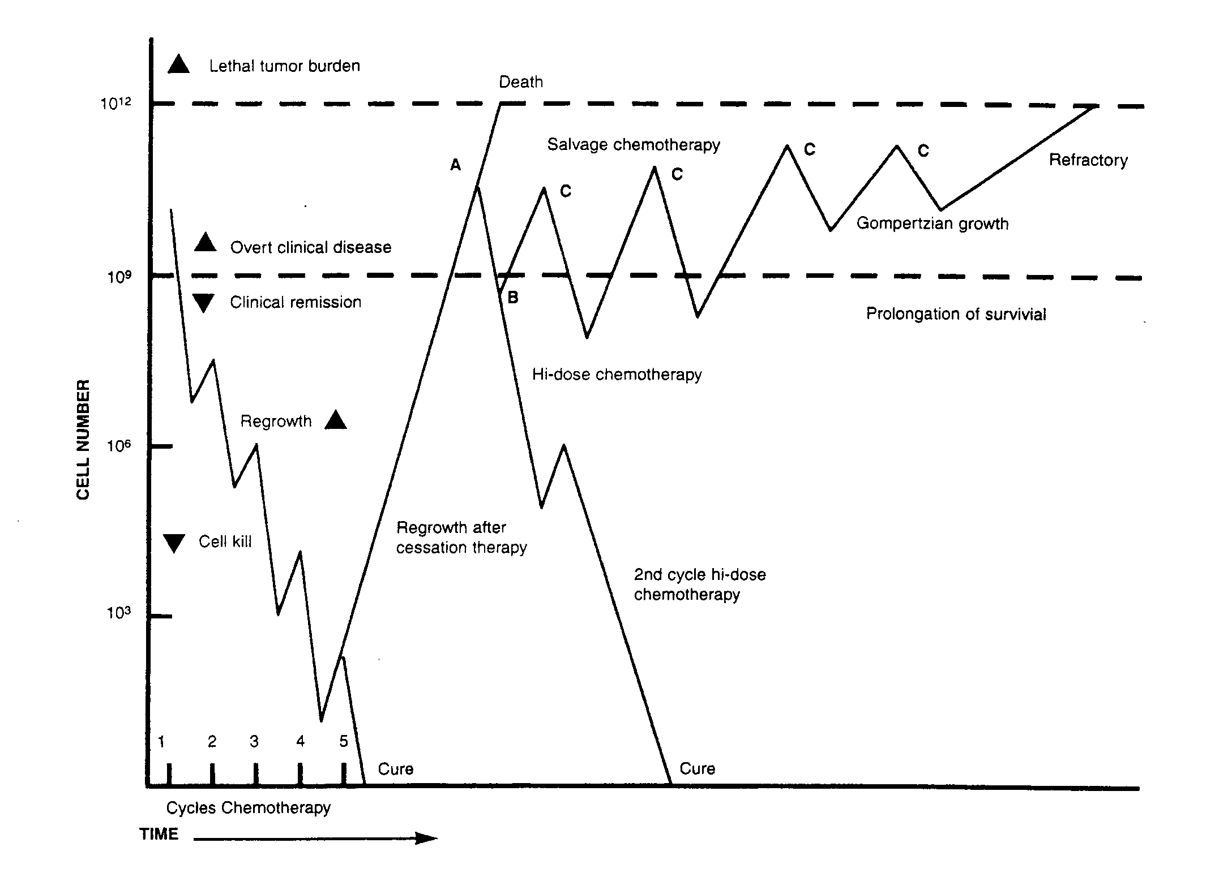FIGURE I. The relationship between tumor burden and chemotherapy and the potential for increased survival or cure is illustrated. If a patient with a clinically overt neoplasm (non-Hodgkin's disease in this hypothetical example) is treated for four cycles of chemotherapy, the tumor burden decreases by a roughly standard amount with each treatment and regrows a little between each treatment, but the patient remains in clinical remission with no evidence of disease, If therapy ceases at this point in time, before the patient IS cured, the tumor will regrow, and in the continued absence of therapy, will lead to death as it exceeds the lethal tumor burden. If the patient is treated for a fifth cycle, when the tumor burden is very low and the immune system is still not significantly impaired, cure is possible. If the patient had treatment interrupted until disease was clinically overt (A), and was retreated with the same or a similar regimen, then the tumor might shrink (B) but regrow, With salvage chemotherapy, cycles of shrinkage and gro.wth would continue (C) until the tumor burden became large and began to grow more slowly (Gompei-tzlan growth), but with less response to therapy until it became refractory and the patient died, If at '.:he point of recurrent overt clinical disease (A) the patient were tre2.ted with highdose (ablative) therapy with stem cell (bone marr:Jw) support, a much larger cell deaTh would occur and CKe might occur directly, or more likely with a second high-dose cou:-se of chemotnerapy. In either case, the follow-up to detect the recurrence would have led to either cure or prolongation of survival. (Modified and expanded from Cooper MR, Cooper MR, in Holleb fA, Fink OJ, Murphy GP. eds, Textbook of Clinical Oncology. Atlanta: American Cancer Society, 199 I , 53,)

Follow-Up of Cancer, 4th edition, David Fischer, 1996
Follow-Up of Cancer, 4th edition, David Fischer, 1996

