r

"Pathologic conditions ranging from a benign muscle or tendon strain to a potentially catastrophil.. femqral n~l..k stress fracture can have similar clinical presentations",23

Clinical assessments or the hi s
I Selected assessments Positive findin ImoH.cationllnterpretation/ DDX-detai/s
SIJ extension test,' . Pain in SIJ Pain in the SIJ suggests SIJ
pelvic torsion test, . Tightness dysfunction/lesion/infection
Gaenslen's test- Pain in the hip suggests hip dysfunction/lesion supine patient brings Pain/contracture at the psoas suggests unaffected thigh to tightness/lesion (e.g., abscess, contracture) abdomen (hip of the psoas hyperf1exion) while
affected/tested leg/SIJ is allowed to go into
extension off the edge of the table

2

Thomas test-supine
patient brings unaffected thigh to abdomen (hip hyperflexion) while affected/tested leg remains on table

3. Range of motion . Flexion
. Extension
.. Internal rotation . External rotation . Circumduction

4. Ober's test-side posture patient with superior leg extended off table, with or without knee flexion

Leg that should remain on table lifts off with hyperflexion of the contralateral hip

5. I

-~-~
Patrick's test, FABER-supine
patient, Dr passively moves thigh into flexion, abduction, external rotation

Pain
Limited motion

Suggests hip flexion contracture

Superior leg remains suspended in air without support

Pain
Limited motion

Joint pathology
Soft tissue/muscle tightness/contracture"

Tightness of the ITS

. Hip joint pathology
. Muscle tightness, i.e., psoas

23 O'Kane JW. Anterior hip pain. Am Fam Physician 1999 Oct 15;60(6):1687-96

Copyright @ Alex Vasquez Alex Vasquez, D.C., N.D. Bastyr University Orthopedics NM8302 Lumbar spine and low back (continued), pelvis, sacroiliac joints, hip, and thigh. Page 11

Selected orthopedic andfunctionalproblems of the hip seen in infants, children, and adolescents

Problem

Typical Dresen ta tion

Avascular necrosis of the femoral head, Perthe's disease,
Legg-Calve-Perthe's disease -idiopathic ischemic necrosis of
the femoral head

Assessment

Management

Hip dysplasia or congenital hip dislocation- congenital acetabular deformity; completely reversible if detected early but can otherwise lead to permanent deformity and impairment

Usually diagnosed
in infants before age 6 weeks.

.

. Ortolani test ["anterior- open"] supine infant with
flexed and aBducted hip, the physician gently pulls the femur anteriorly while
) palpating at the
~ trochanter for hints of
anterior glide/dislocation.
. Barlow test
["backwards-closed"] supine infant with flexed
~ and aOOucted hip.
Allis's sign ["altitude"] supine infant with flexed hips and knees; the inferior knee has the dislocated hi . Radiographs; if normal and clinical suspicion is high order MRI or bone scan

j1t~t~~Z aj tJJII!iI

Apophysitis, apophyseal
fracture-"ln the
adolescent, acute
muscle contraction about the hip can result in avulsion of an apophysis (an ossification center at the attachment of tendon to bone)." 27

80% occur in children generally between ages of 4-9 years
More common in boys
Unilateral hip pain May have knee pain May have limp History of trauma is common

Confirm your suspicion of congenital hip dysplasia with ultrasound imaging before progressing to radiography.24 Treatment is with splinting of the hip in flexion and moderate abduction and is best supervised by a pediatric orthopedic surgeon25

Adolescent with hip pain following ~udden or forceful hip muscle contraction Localized pain and swelling
Muscle weakness

~::;t.l;:!

Radiographs

-
Orthopedic referral is recommended although not all patients will require surgery and some may be managed conservativel/6
,,~ -AJ~ WB

Treatment may be conservative or surgical depending on severity of displacement as visualized radiographically

24 Review pages 705-6 in Hay WW, Groothuis JR, Hayward AR, Levin ML. Current Pediatric Diagnosis and Treatment. 13"' edition.
Stamford: Appleton and Lange, 1997
25 Review pages 705-6 in Hay WW, Groothuis JR, Hayward AR, Levin ML. Current Pediatric Diagnosis and Treatment. 13"' edition.
Stamford: Appleton and Lange, 1997
26 Souza T A. Differential Diagnosis for the Chiro~ractor: Protocols and Alaorithms. Gaithersberg, Maryland: Aspen Publications. 1997 ~age 263
7 O'Kane JW. Anterior hip pain. Am Fam Physician 1999 Oct 15;60(6):1687-96

Copyright @ Alex Vasquez Alex Vasquez, D.C., N.D. Bastyr University Orthopedics NM8302
Lumbar spine and low back (continued), pelvis, sacroiliac joints, hip, and thigh. Page 12

""""

"*' JllfJ If)Il/I?f -T (..,ti4JUtttJ p~~l. -
~ J<R.rt'15 ~ '
Selected orthopedic and functional problems of the hip seen in infants,
children, and adolescents (continued)

--
Slipped capital femoral epiphysis-
. " Slipped femoral
capital epiphysis is a developmental injury that must
be considered in any adolescent who presents with hip pain."28
. The most
common cause of hip pain in adolecents29

~iCa7presentation I
. Seen in adolescents generally 8-17 yo
. Classic presentation is a tall overweight boy with hip pain, knee
pain, and/or a painful limp.

Assessment

Radiographs of both hips
(bilateral SCFE in 40%)-" AP and
frog lateral views are recommended in all children over age of 9 years
with hip pain," 3?

Manaaement

---~~--
Orthopedic referral-"...the patient should be referred immediately to an orthopedist for surgical
stabilization." 31

I Problem

Transient synovitis, irritable hi p-non-specific short-term inflammation and effusion of the hip joint

Acute onset of painful hip and limp Decreased pain with hip in flexion and abduction
Considered the most common cause of hip pain in children32 More common in boys, age 3-6 years and generally younger than 10 years
May have recent history of viral infection, and some children (1.5-10%) eventually develop RA or A VN33

.

.

May have slight elevation of ESR
Normal WBC NQ fever The child appears health~ ".. .radiography is indicated to exclude' osseous pathological
conditions.. .,,34 Joint aspiration is indicated if septic arthritis is susQected.35.
.. (tt¥J{ ~ 1J1~

.
.
.

.

Conservative treatment, restricted exertion and weight-bearing for several weeks.

.

28 O'Kane JW. Anterior hip pain. Am Fam Physician 1999 Oct 15;60(6):1687-96
29 Maroo S. Diagnosis of hip pain in children. Hosp Med 1999 Nov;60(11 ):788-93
30 Maroo S. Diagnosis of hip pain in children. Hosp Med 1999 Nov;60(11 ):788-93
31 O'Kane JW Anterior hip pain. Am Fam Physician 1999 Oct 15;60(6):1687-96 32 Maroo S. Diagnosis of hip pain in children. Hosp Med 1999 Nov;60(11 ):788-93 33 Souza TA. Differential Diaanasis far the Chiraoractor: Protocols and Alaorithms Gaithersberg, Maryland: Aspen Publications. 1997
~age 265 Maroo S. Diagnosis of hip pain in children. Hosp Med 1999 Nov;60(11 ):788-93 35 Maroo S. Diagnosis of hip pain in children. Hosp Med 1999 Nov;60(11 ):788-93

Copyright @ Alex Vasquez Alex Vasquez, D.C., N.D. Bastyr University Orthopedics NM8302 Lumbar spine and low back (continued), pelvis, sacroiliac joints, hip, and thigh. Page 13

Selected orthopedic and functional problems of the hip seen in infants, children, and adolescents (continued)

I Problem

Septic arthritis

Hip pain in a child or adolecent

Apophysitis. apophyseal
fracture

Slipped capital femoral epiphysis

Radiographs

Transient synovitis,
irritable hip

Septic arthritis

radiographs are
recommended to exclude
bone pathology

Avascular necrosis of the femoral head,
Perthe's disease
. """,,'

'"

"-.

'"

""'"

postive for
significant bone pathology
/

"'"

'\.

"- normal

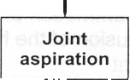
Joint aspiration

Conservative treatment
and monitoring; consider additional imaging if
clinical suspicion is high

u

~

36 Maroo S. Diagnosis of hip pain in children. Hosp Med 1999 Nov;60(11 ):788-93

Copyright @ Alex Vasquez Alex Vasquez, D.C., N.D. Bastyr University Orthopedics NM8302 Lumbar spine and low back (continued), pelvis, sacroiliac joints, hip, and thigh. Page 14

-

~

Selected orthooedl

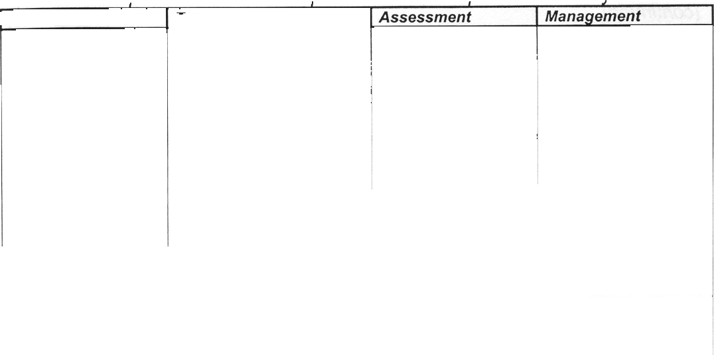
~,
Assessment

Manaqement

'-Problem -

c and functional Droblems of the hiD seen in mostlv in adults

-,.ypical presentation

.8 Overtraining athlete with
deep pain in anterior hip and proximal thigh
8 Risk is increased with !
malnutrition, overtraining, I corticosteroid treatment, postmenopausal, hypoestrogenism

~~,I1dl4-

Bursitis'--
. Ischial bursitis
. Subtrochanteric bursitis
. Iliopectineal and ilioosoas bursitis

Joint pain due to leg length inequality- increased compressive forces on the hip joint due to anatomic leg length inequality.

Pain with weight- bearing, jumping Evaluate initially with radiographs Bone scan has been the assessment of choice, but MRI is now recognized as having a similar
~An~itivitv with

Caused by
. Compression . Direct injury . Overuse

Orthopedic referral is generally advised39 since the many different types of stress fractures require specific and often surgical treatment. Rest, crutches, conservative treatment is appropriate in the interim but may necessitate a long duration of non- weight bearing, up to 14 weeks. Conservative care, rest, antiinflammatories, rest, etc.

Usually the "shorter" leg
is the one with the painful hip

Traumatic synovitis-
inflammation of the hipj
joint following trauma 1

greater specificity38

Pain with palpation and provocation

Painful hip after a fall or direct injury

Use your tape measure from trochanter to lateral maleoli and compare to opposite side. Alternatively, order a scanogram or weight-bearing acetabulum-in-view hip/low back r~dinqraDh.

Foot lift

-
.

Conservative treatment

(fl R I

37 O'Kane JW. Anterior hip pain. Am Fam Physician 1999 Oct 15:60(6):1687-96
38 O'Kane JW. Anterior hip pain Am Fam Physician 1999 Oct 15:60(6):1687-96
39 O'Kane JW. Anterior hip pain. Am Fam Physician 1999 Oct 15:60(6):1687-96
40 Souza T A. Differential Diaanasis for the Chirooractor: Protocols and Alaorithms. Gaithersberg, Maryland: Aspen Publications. 1997
page 263-4
1 Sculco TP. Diagnosis: common hip problems. Hospital Medicine 1996: June: 23-44

Copyright @ Alex Vasquez Alex Vasquez, D.C., N.D. Bastyr University Orthopedics NM8302 Lumbar spine and low back (continued), pelvis, sacroiliac joints, hip, and thigh. Page 15

Selected orthopedic and functional problems of the hip seen in mostly in adults
(continued)

--~-,- - -
Tear of the acetabular labrum

Hernia, "sports hernia"-"sports hernia" refers to non-
palpable hern}as

~~;;

Femoral neuropathy

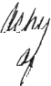
!If .i?t ?Jll"

-""-- Activity-related pain worse with extension associated with deep "clicking" and subjective joint instability

-~
Worse with heavy lifting, bearing down, Valsalva, etc.
Exercise related groin pain

Neurogenic anterior thigh pain
Most commonly seen in diabetics
May also have manifestations of lumbar radiculopathy which mimic lumbar disc herniation and present with severe pain, muscle weakness,and decreased reflexes42

.

Palpation of clicking with motion of hip into extension with Thomas test Failure of conservative treatment for 6 months in association with characteristic
clinical presentation suggests diagnosis Specialized MR imaging is 90% accurate for the diaanosis

-
Hernia examination: generally femoral in women, and
inguinal in men Herniography- radiography with contrast medium Ultrasound imaging Consider strangulated avascular intestine if severe.

Fasting serum glucose

.

Conservative treatment can be attempted Surgical arthroscopic assessment "and treatment is recommended for severe or recalcitrant cases

Conservative care
Surgery for severe, complicated, or recalcitrant cases

Treat the underlying problem and help the nerves to heal

42 Naftulin S, Fast A, Thomas M. Diabetic lumbar radiculopathy: sciatica without disc herniation. Spine 1993 Dec; 18{16):2419-22

Copyright @ Alex Vasquez Alex Vasquez, D.C., N.D. Bastyr University Orthopedics NM8302 Lumbar spine and low back (continued), pelvis, sacroiliac joints, hip, and thigh. Page 16

~

~

Selected orthopedic and functional problems of the hip seen in mostly in adults
(continued)

Meralgia paresthetica-
(compression of the lateral femoral cutaneous nerve, often at the inguinal liqament

Patient presents with numbness/tingling in the lateral thigh
Often due to prolonged sitting
Associated with obesity

Fracture-most commonly at the femoral shaft or neck

Muscle strain,
overuse injury, tendonitis

-
Predisposing factors: . Elderly
. History of cancer . Multiple myeloma
. Renal osteodystrophy . Osteogenic sarcoma . Hemochromatosis43 . Bone cyst
. Osteoporosis . Trauma
. Erosive joint disease (RA)
. Alcoholism
. Corticosteroid use

Direct compression on nerve 1 inch inferior to ASIS Sensory changes on anterolateral thiah

Avascular necrosis
of the femoral head, osteonecrosis- ischemic necrosis of the femoral head

Radiographs

Conservative treatment
Avoid sitting Loose weight if necessary

Recent history of physical activity or overuse

.filIlt! jl(:! 1lIt/t iJ
tI~~~fdtt/ -

. Ages 20-40 years . Unilateral hip pain
. May have knee pain - tf.lj
. May have limp . . History of trauma is common
Diseases associated with AVN:
. Steroid use
. Hyperlipidemia . Alcoholism
. Pancreatitis
. Hemoglobinopathies . Smoking
. "fat globules from the liver,,44

Referral to orthopedic surgeon

~c1 &n.k
/JUJt~~~~/

Pain is worse with active contraction or passive stretching of the affected muscle/tendon.

. limited ROM
. Radiographs'
!tttlf ~ 'I,ull.

~

Orthopedic referral is recommended although not all patients will require surgery and some may be managed conservatively45

J

43 Eyres KS, McCloskey EV, Fem ED, et al. Osteoporotic fractures: an unusual presentation of hemochromatosis. Bone 1992; 13: 431-3
44 Skinner HB, Scherger JE. Identifying structural hip and knee problems. Patient age, history, and limited examination may be all that's
needed. Postgrad Med 1999 Dec;106(7):51-2, 55-6, 61-4

Copyright @ Alex Vasquez Alex Vasquez, D.C., N.D. Bastyr University Orthopedics NM8302 Lumbar spine and low back (continued), pelvis, sacroiliac joints, hip, and thigh. Page 17

Selected orthopedic and functional problems of the hip seen in mostly in adults
(continued)

-:...,.

Generally older patient or history of trauma Pain with walking and weight-bearing
Bilateral or unilateral Restricted motion

Adult patient
Pain with walking and weight-bearing Bilateral or unilateral Restricted motion

ff1 rtr I L v .b<4tJ~ ~
r~~
I ~ if- II{II

,').

Osteoarthrosis, osteoarthritis-

~\;

Iron overload, hemochromatosis- the most common hereditary disorders in the human population

Pain and limited range of mction: weighted circumduction and anvil test
Bilateral or unilateral Restricted motion Radiographic changes Normal ESR, CRP, and ferritin.

Snapping tendon, internal snapping hip, iliopsoas tendonitis-sound made by the tendon of the iliopsoas as it slides over the femoral head or iliopectineal eminence.

Pain and limited range of motion: weighted
circumduction and anvil test
Radiographic changes Normal ESR, CRP, with high ferritin and/or high % saturation. '159;
Clinically and "
radiographically indistinguishable from so-called "osteoarthritis.~7

~nap or deep clunk- at the hip or flexor crease with extension of the hip Most patients do not
have pain

- Rule out
hemochromatosis by assessing ferritin and transferrin saturation46 Conservative treatment

~ :1i~~M, f!t/1
"" '~~ - vi It/J(J;f

-(J) Therapeutic phlebotomy is the treatment of choice;
rj) deferox.amine is an
"- expensive l!J
cumbersome and less effective alternative.
. Conservative care does not replac:J,J~ iron removal ~:! thera .
. Conservative
treatment,
beginning with strengthening of the affected muscle-tendon and then progressing to stretching if necessary48

Snap or deep clunk at the hip or flexor crease with extension of the hip
Localize and reproduce snapping sensation by contraction of the problematic muscle/tendon.
DDX with an intra- articular osteophyte which is radiographically visible and which is characteristically reproducible with
oassive joint motion

...~/)t!t
')IIV
- llyJl 1('

iJ1l11t! vM' - ~---O
~~.~ .
'V Iia Lf/JtJ .y ,Jt c l:t::t ) x. hu.t

:f

--

45 Souza T A. Differential Diagnosis for the Chirogractor: Protocols and Algorithms. Gaithersberg, Maryland: Aspen Publications. 1997
Eage 263
6 Vasquez A. Musculoskeletal disorders and iron overload disease: comment on the American College of Rheumatology guidelines for the
initial evaluation of the adult patient with acute musculoskeletal symptoms. Arthritis Rheum 1996 Oct; 39(10):1767-8
47 Axford JS, Bomford A, Revell P, Watt I, Williams R, Hamilton EBD. Hip arthropathy in genetic hemochromatosis: radiographic and
histologic features. Arthritis Rheum 1991; 34: 357-61
48 Souza TA. Differential Diagnosis for the Chirogractor: Protocols and Algorithms. Gaithersberg, Maryland: Aspen Publications. 1997
page 265

Copyright @ Alex Vasquez Alex Vasquez, D.C., N.D. Bastyr University Orthopedics NM8302
Lumbar spine and low back (continued), pelvis, sacroiliac joints, hip, and thigh. Page 18

Common hip problems in infants, children, and adolescents: general expectation of prevalence and probability by age in years

~

Congenital hip
d s lasia1

Transient synovitis, irritable hip-most common between ages 3-6 years and generally vounqer than 10 years

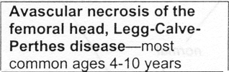
Apophysitis, apophyseal fracture-no specific age range; generally seen in adolescents
followin forceful muscle contraction at the hi
pital femoral epiphysis-generally 8-17 e

~

~

Congenital hip dysplasia should be diagnosed and treated before age 6 weeks.

Alex Vasquez, D.C., N.D. Bastyr University Orthopedics NM8302
Copyright @ Alex Vasquez Hip: addenda. Page 1

~

,.-.

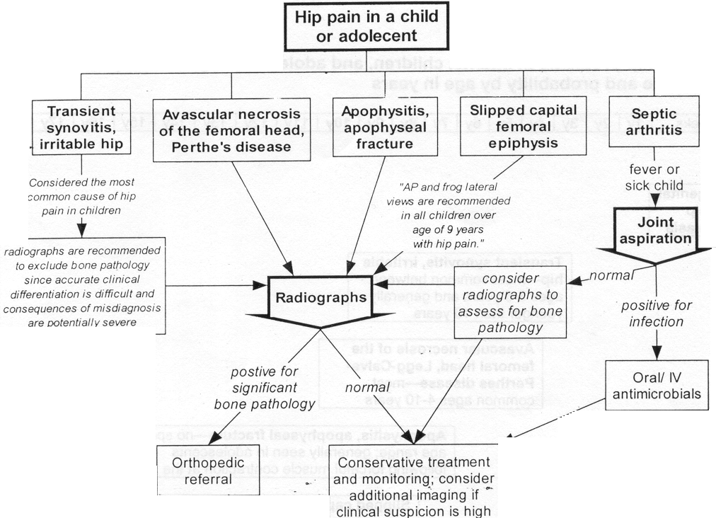
Alex Vasquez, D.C., N.D. Bastyr University Orthopedics NM8302
Copyright @ Alex Vasquez Hip: addenda. Page 2

