A New European Prostate Therapy

Prostate problems become common as men move into middle age and beyond. A new European formula is showing impressive results in clinical studies.
During the 1980s, the Life Extension Foundation introduced European herbal therapies, such as saw palmetto extract, for the treatment of benign prostate enlargement. These therapies, available only as drugs in Europe, are sold as dietary supplements in the United States at much lower prices. The cost of saw palmetto, for example, is about 60 percent lower than the identical product sold as a drug in Europe.
In 1991, The Foundation introduced another herbal therapy called pygeum that works differently from saw palmetto. Men with severe prostate enlargement often use a combination of saw palmetto and pygeum to improve urine flow and bladder voiding. These men usually wake up less frequently at night to urinate.
Although more than 80 percent of men report improvement after using saw palmetto and/or pygeum extracts, some prostate enlargement often remains that continues to interfere with urinary flow and bladder evacuation.
The good news is that the Life Extension Foundation has discovered a new herbal extract, Urtica dioica, which has been shown to reduce the symptoms of benign prostatic hypertrophy (enlargement) by 86 percent after three months of use. For the first time, Americans can enjoy the benefits of the identical Urtica dioica extract used in Germany to treat the symptoms of benign prostate disease.
Urtica extract has been added to a prostate formula that already contains pharmaceutical extracts of saw palmetto and pygeum, in a product called Natural Prostate Formula.
The availability of these herbs has been a great relief to many men. Before saw palmetto and pygeum were available to Americans, those with benign prostate enlargement often required expensive and painful transurethral resection surgery, but the widespread use of saw palmetto and pygeum extracts, along with the availability of drugs that work via different mechanisms, has reduced the need for this mutilating surgery. It is unfortunate that in the 1970s, while European men used safe herbal extracts to shrink their enlarged prostate glands, American men had to submit to barbaric surgical procedures. Throughout that period, the Food and Drug Administration aggressively blocked the importation of these herbal therapies into the United States. Unfortunately, the FDA continues to spend millions of taxpayer dollars to deny Americans access to other effective therapies from Europe and Asia.
Before we discuss Natural Prostate Formula, let's take a look at how herbal extracts act to improve the health of the prostate gland.
Enlargement of the prostate gland, which occurs in most men with advancing age, is accompanied by reduced urinary flow and increased residual urine volume. Hormonal imbalances have previously been blamed for age-related prostate disorders, but other factors have been identified as causes of the benign proliferation of prostate cells and accompanying urinary impairment.
Phytosterol extracts from saw palmetto interfere with conversion of testosterone to dihydrotestosterone. New studies are showing that saw palmetto also reduces smooth muscle contraction, thereby relaxing the bladder and sphincter muscles that cause urinary urgency.
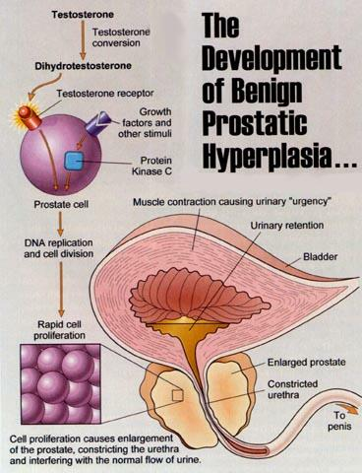
Pygeum originally was shown to reduce prostate swelling (edema) and block dihydrotestosterone binding to prostate cells. New studies show that pygeum also interferes with protein kinase C activity to inhibit the proliferation of prostate cells. Rapidly growing benign and malignant cells both require the protein kinase C enzyme. Soy genistein is one of the most potent inhibitors of protein kinase C. Inhibition of protein kinase C by pygeum and soy may help to prevent cancer, slow the growth of existing cancers, and reduce the proliferation of benign prostate cells.
Adding to this herbal arsenal against enlarged prostate is the Urtica dioica extract.
One study showed that, after eight weeks of treatment with four capsules of urtica extract, patients experienced improvement of disorders associated with prostate enlargement ranging from 82 to 100 percent. Another study showed that those patients suffering from prostate enlargement with stage I to III hyperplasia-the abnormal multiplication of normal cells, which can lead to prostate cancer-experienced improvement by 86 percent after three months treatment with standardized urtica extract.
After learning the results of these studies, researchers at St. Luke's/ Roosevelt Hospital in New York conducted a study to discover the mechanism by which standardized urtica extract relieves the symptoms of benign prostate hyperplasia. In their study, published in 1995, these scientists showed that urtica extract inhibits the binding of a testosterone-related protein to its receptor site on prostate cell membranes.
Prostate cells grow out of control when the hormone metabolite dihydrotestosterone binds to prostate cell membranes, which induces the prostate cells to start dividing. If cell membrane receptors are blocked, the dihydrotestosterone cannot latch on to the cell. Urtica extract appears to work by preventing the binding of testosterone metabolites to membrane receptor sites on prostate cells.
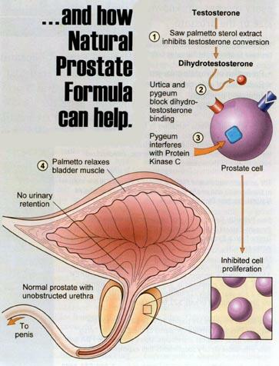
Saw palmetto and Urtica dioica are approved drugs in Germany for the treatment of benign prostate enlargement. While urtica may be new to Americans, it has been safely and successfully used in Germany for more than a decade.
Make Sure Prostate Extracts Are Standardized
Soon after the Foundation introduced standardized saw palmetto extract, many companies began selling saw palmetto "berry" capsules at very low prices. Saw palmetto berries do not provide the standardized fatty acid sterols needed for therapeutic benefits. What's surprising is that there are major, name-brand supplement companies that sell both standardized saw palmetto extract and saw palmetto berry capsules.
These commercial companies know there are no prostate benefits from taking saw palmetto berry capsules, but they sell them anyway just to offer a lower-priced product. We believe it is immoral to sell a supplement whose name (saw palmetto) implies therapeutic benefits, but which doesn't actually deliver such benefits.
It has taken the Foundation more than five years to obtain a pharmaceutical Urtica dioica extract that duplicates the extract used in Europe. This standardized extract has been added to saw palmetto and pygeum extracts to comprise the unique product called Natural Prostate Formula.
In response to this article, there will likely be commercial companies that will begin to offer urtica supplements. We believe that many of these supplements will not contain the standardized urtica extract researched in Europe for the past 20 years. Please read the label of these products before you consider purchasing them. Make sure you are obtaining standardized extracts of saw palmetto, pygeum, and Urtica dioica.

