
Younger, Healthier
SKIN
Skin does not seem like the most exciting part of the body, but it's actually a dynamic, complex organ. Understanding its chemistry can help keep your skin youthful and healthy.
So much hormonal activity occurs in skin that it has been called another endocrine gland. Skin has its own immune system and specialized enzymes that no other part of the body has. It is, in short, a very special part of you.
According to research, skin cannot function without hormones. The anti-stress hormone DHEA, and the sleep hormone melatonin, are both found in human skin. Both are converted to other entities with important jobs to do. DHEA is converted into estrogen and androgen-type metabolites found only in skin. Melatonin is synthesized in skin, and in low concentrations can stimulate cell growth. This type of on-site, organ-specific production of hormones, called intracrine biosynthesis, allows different organs to manufacture the substances they need without flooding the entire body with growth factors.
Importantly, studies show that both DHEA and melatonin are absorbed by skin when applied topically. A study from CHUL Research Center, at Laval University in Quebec, shows that the activity of DHEA applied topically to rodents is 85 to 90 percent greater than when taken orally.
No special carriers are needed to get DHEA and melatonin into skin. A properly formulated topical preparation of melatonin and DHEA will contain just enough hormone to benefit skin without providing enough to escape into the rest of the body. In addition, it makes sense to apply the hormones directly to the skin if skin protection is the goal, since ingested hormones may end up everywhere in the body.
Estrogen's skin-enhancing effects are well-known. It stimulates collagen production and a moisture factor known as hyaluronic acid. Aging decreases both estrogen and collagen, and enzymes that convert DHEA to estrogen also decline. Not surprisingly, women who take synthetic estrogen have thicker, healthier skin, and women who take both estrogen and testosterone have skin that is 48 percent thicker (and healthier) than women who don't take either hormone.
DHEA is converted into estrogen and testosterone, providing the benefits of both hormones.
While the exact roles of DHEA and melatonin in human skin are still under scrutiny, researchers have identified several mechanisms through which these hormones protect against aging, maintain the health of skin, and affect how sunlight reacts with skin cells. All three are connected. For example, sunlight and aging suppress immunity; immunity affects health, and melatonin and DHEA affect them all.
Skin is such a specialized organ that it has its own immune system. In fact, it has been proposed that faulty skin immunity affects the body's entire immune system. Sunlight can penetrate deep into skin and alter immunity directly, or it can cause changes in the dermis and epidermis that in turn provoke immune changes. Sunlight also affects hormones...it decreases melatonin, norepinephrine and acetylcholine, and increases cortisol, serotonin, GABA and dopamine.
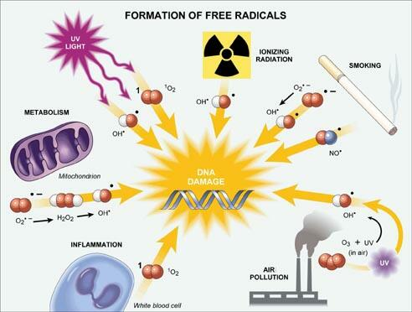
DHEA has beneficial effects beyond its conversion into skin-friendly hormones-DHEA also has powerful skin-protective effects. A study in the Journal of Surgical Research demonstrates the extraordinary ability of topically applied DHEA to protect skin's delicate blood vessels. Researchers found that if DHEA is applied after a serious burn, the blood vessels underlying the burned area are protected, and protected blood vessels save the skin.
Skin that would otherwise die and peel off can be saved by DHEA. No one knows for sure how DHEA saves skin in this way, but its anti-inflammatory action has something to do with it. In particular, DHEA affects a destructive cytokine known as "tumor necrosis factor." At the same time that DHEA is inhibiting this destructive process, it appears to prolong healing: DHEA causes edema (swelling) to last longer, which apparently saves tissue.
DHEA also protects against everyday insults. By maintaining skin immunity, DHEA preserves the ability of skin to react to cancer-causing, skin-destroying pollutants in air, food and water. DHEA also has antioxidant action against peroxyl and superoxide free radicals.
Superoxide defense may have a lot to do with DHEA's ability to prevent skin cancer and papillomas (benign tumors). According to a mouse study, topically applied DHEA keeps oxidant-loving enzymes at bay. Chemicals with carcinogenic potential depend on oxidases for transformation. DHEA's antioxidant action stops them. DHEA provides another important defense: it keeps chemical carcinogens from binding to DNA. According to some very interesting rodent studies conducted at Fels Research Institute and Temple University, in Philadelphia, cancers simply cannot get started if enough DHEA is present.
If this research holds up in humans, topically applied DHEA is an exciting prospect for skin cancer.
Another interesting finding is that cancer-causing chemicals are more likely to cause carcinogenesis at certain times of the day, indicating that some hormones that are only active at particular times give cancer protection. Unfortunately, this exciting research is only in its infancy.
Melatonin is another antioxidant that protects against UV radiation. Scientists at the University of Zurich have shown that topical melatonin gives excellent protection against sunburn if applied before sun exposure. Melatonin also appears to play a role in repairing burned skin. In a study in Brain Research Bulletin, melatonin levels rose six hours after burn injury, then fell to normal.
In small amounts, melatonin causes skin cells to proliferate. (In large amounts, it stops proliferation). People with psoriasis and atopic eczema do not have normal melatonin secretion. With psoriasis, for example, melatonin peaks in the day when it shouldn't, and there's little at night.
It may seem surprising that a hormone connected to sleep has a lot to do with skin health. But maybe not to those researchers who consider skin another endocrine gland.

