
How we
rot
and
rust-!

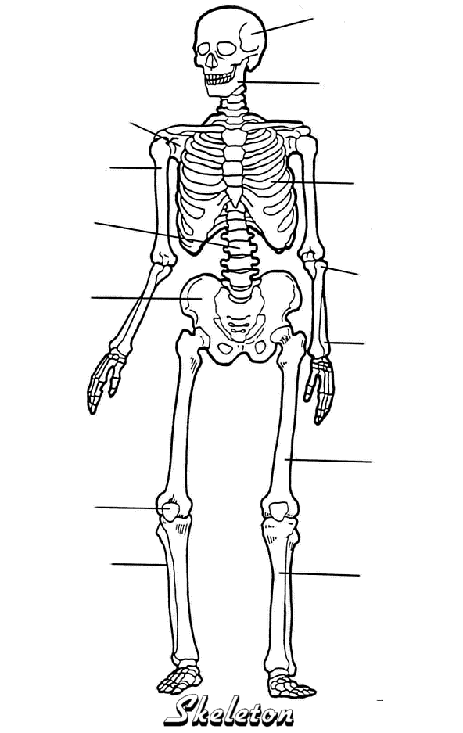
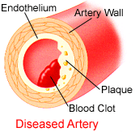

Taken from the Biomed-x
web site
biomedx.com
-------------------------
CHICAGO, ILLINOIS
1-847-299-0236

webmaster@biomedx.com

