Carnosine:
A Remarkable Multipurpose Anti-Aging Nutrient
November 2000
by Daniel Bourassa, D.C., and Ward Dean, M.D.
Carnosine (beta-alanyl-L-histidine) (Fig. 1) is a naturally-occurring dipeptide that was discovered in Russia in 1900. Because much of the research with carnosine was performed in Russia, it has been largely unavailable to Western scientists until recently. Carnosine, not to be confused with L-carnitine, is now becoming increasingly recognized for its tremendous potential as a highly effective anti-aging nutrient. Carnosine contains the amino acids alanine and histidine, and is found in highest concentrations in long-lived tissues such as skeletal muscle, cardiac muscle and brain (Jackson and Lenney 1996), and has antioxidant, buffering, free radical scavenging and even neurotransmitter properties.
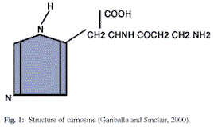
Carnosine Declines with Age
Stuerenburg and Kunze (1999) report that in human subjects with neuromuscular disease, muscle concentrations of carnosine decline 63% from age 10 to 70 (Fig. 2). These authors report that with increasing age, the antioxidant effect of carnosine decreases by half. This marked reduction in muscle carnosine concentration may be a cause of the age-related decline in muscle mass, strength and function. Stress and trauma also cause a reduction in carnosine levels, which may help explain the increased mortality in the elderly following stressful events.
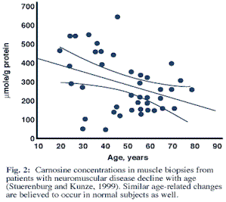
Carnosine's Multiple Anti-aging Mechanisms
The metabolic pathway of carnosine is shown in Fig. 3. This illustrates several biological roles in which carnosine participates, including methylation (giving rise to anserine or ophidine), hydrolysis (leading to histidine and beta-alanine), and decarboxylation (resulting in histamine formation, which interacts with beta-alanine to result in the formation of carnicine). Carnicine, a stable analog of carnosine, has been used experimentally to reverse cataracts. Carnosine's two amino acids, histidine and alanine, are metabolized in the citric acid cycle. Alanine enters through the Co-enzyme A pathway and histidine through (alpha)-ketoglutarate pathway.
Aging is associated with damage to cellular proteins, resulting in inter- and intra-molecular cross-linking. Carnosine protects cellular proteins from such metabolic damage in at least two ways. First, as an antioxidant, carnosine prevents the formation of oxidized sugars, or glycosyl radicals, also called advanced glycosylation end-products (AGEs) (Hipkiss, et al, 1998). Second, carnosine bonds with potentially harmful carbonyl groups that attack and bind with proteins imbedded in the cellular membrane, and neutralizes them. Both of these processes have important implications for anti-aging therapy, in that carnosine not only prevents damaging cross-links from forming, it eliminates cross-links that have previously formed, thus restoring normal membrane function (Hipkiss and Brownson, 2000).
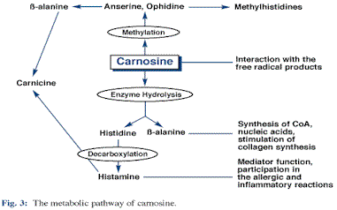
Therapeutic Uses for Carnosine
A wide range of therapeutic uses have been proposed for this remarkable substance (Table I). As early as 1935, carnosine was recognized as a treatment for polyarthritis. Carnosine has the remarkable ability to down-regulate cellular and enzymatic processes when in excess, and up-regulate them when suppressed. For example, carnosine decreases platelet aggregation in patients with abnormal clotting tendencies ("thins the blood"), and increases platelet aggregation in patients with low clotting indices (Nititenko, et.al., 1995).
Closely related to this auto-regulation ability are carnosine's effects on anti-inflammatory and immunoregulatory processes. Carnosine suppresses excess immunoreaction in immature mice, and stimulates immunoreaction in aged mice. Carnosine activates both B and T lymphocytes (Nagai and Suda, 1986). Carnosine increased the respiratory burst and interleukin-1 beta production of human neutrophils (Tan and Candlish, 1998,) indicating an important up-regulation of the immune response. Carnosine also has protective effects on blood cell membranes, enhancing their survival, and has demonstrated cell membrane-stabilizing effects, offering protection against chemical-induced hemolytic anemia (Nagai, et al., 1990)
Table I: Therapeutic uses for carnosine
Therapeutic Effects Time of Discovery
1. Treatment of polyarthritis  2. Stomach and duodenal ulcers  3. Wound healing  4. Human essential hypertension  5. Bactericidal, bacteriostatic effects  6. Adrenal cortical function  7. Suppression of passive sleep apnea  8. Treatment of trauma  9. Hyperbaric-induced convulsions  10. Ischemic heart damage  11. Anti-inflammatory agent  12. Treatment of cataracts  13. Anti-neoplastic agent  14. Immunomodulation  15. Radioprotective effects | 1935  1936  1940, 1978  1941  1969, 1971  1976  1977  1980  1989  1989  1971, 1986  1989  1989  1986 - 1989  1990
Carnosine for Vision
Carnosine-containing eye drops have demonstrated efficacy in treating a variety of ophthalmic conditions, including corneal diseases, cataracts, as well as glaucoma and increased intraocular pressure. In 1997, clinical trials were conducted on 109 ophthalmic patients with carnosine-containing eye drops. The results confirmed accelerated healing of corneal erosions, trophic keratitis, post-herpetic epitheliopathy, primary and secondary corneal dystrophy, and bullous keratopathy (Maichuk et. al., 1997). Most striking, however, was the ability of carnosine to eliminate existing cataracts (Yuneva, et. al., 1999). Carnosine actually restores the proteins in the lens by removing the carbonyl groups, as described earlier. Furthermore, carnosine is thought to function as a "molecular water pump" (Baslow, 1998). In earlier experiments it was demonstrated that applying carnosine to the conjunctiva (the membrane covering the eye) caused a decrease in normal intraocular pressure and reduced prostaglandin-induced ocular hypertension (related to glaucoma).
Enhanced Healing and Anti-Ulcer Effects of Carnosine
Carnosine also accelerates wound healing, modulates immune responses, and increases immunocompetence (Nagai and Suda, 1988). As far back as 1936, carnosine was found to be of help in the treatment and prevention of gastric ulcers. In a more recent study, oral carnosine significantly inhibited erosions in both the stomach and duodenum (Truitsina, et. al., 1997). Those with gastric and duodenal ulcers thus might benefit from supplementing with this amazing dipeptide.
Visible Anti-aging Benefits
In a recent article in International Anti-Aging Systems' "Anti-Aging Bulletin", Dr Marios Kyriazis reported that his patients who take carnosine supplements often receive comments that they simply look younger. This may be a reflection of the phenomenon observed in 'in vitro' experiments which show that carnosine actually rejuvenates older cells in culture (McFarland and Holliday, 1994), and 'in vivo' animal experiments in which carnosine prevented the development of visible features of aging (Boldyrev, et. al., 1999). In that study, carnosine significantly delayed the appearance of skin ulcers, periopthalmic lesions, spinal lordokyphosis and behavioral responses such as activity and passive avoidance (all characteristic of aged animals). In another recent article, Russian scientists reported that not only did the carnosine-fed SAMP1 mice appear much more youthful than controls, but experienced a 20% increase in lifespan (Fig. 4) (Yuneva, et al, 1999).
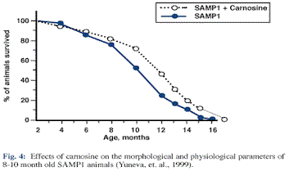
Conclusion
Carnosine is generally considered an extremely non-toxic and safe substance. Boldyrev and other authors have reported that absorption of carnosine is excellent, perhaps greater than 70%. As with other antioxidants, carnosine acts synergistically when taken with other antioxidants. (For example, when vitamin E was taken with carnosine, levels of both substances were higher in cardiac muscle than when either was taken alone.)
Dr. Kyzarias, recommends 50–100 mg/day to his patients. He reports that noticeable benefits have been reported at this intake level. He also indicated that these levels were felt to be adequate by Alan Hipkiss, a top British and world researcher on carnosine at the University of London.

