Preventing heart attacks and strokes is highly influenced by:
1-following a Biogenic Nutrition Program, which briefly suggests eliminating [acid] junk food, animal products, processed food and all-cooked food, replacing those with [alkaline] fresh, raw fruit, veges, seeds, nuts, grains, potatoes, brown rice, beans, lentils, sprouts, raw vege juices and some concentrated food supplements.
See: Biogenic Daily Nutrition Guide
2-Biological supplements, such as: green powders, enzymes, ginger , ginkgo, Thyrodine, Catumaca and Circulo herbs, full 8-factor Vitamin E and carotenoids, to support heart function.
3-Co-enzyme Q-10 for production of ATP [energy]
4-Acid base balancing to avoid acidic deterioration
5-Natural antibiotics to eliminate pathogenic micro-organisms which cause blood clots that occlude the arteries leading to the heart and brain.
6-EDTA suppositories…that clear blood vessels of arterial plaque
7-Exercise: moderate aerobic, outdoor play or dance or sport or walking or mini-trampolines.
8-Attitude: optimists seldom become ill, pessimists are always down. The pictures you hold in mind tend to become reality.
9-Spiritual: an intimate meditative association with the Cosmic Energy and Intelligence, reverence for Mother Earth and empathy for our fellow travellers create a sense of belonging, caring and good will that enhances the immune funtion..
10-Having a...mission, task, destiny, or meaningful project [s] has provided many folks with a sense of purpose, achievement, fulfilment and a reason for remaining healthy and energetic into advanced ages.
11-Heart attacks and strokes need have no place in our lives by simply following a few discerning guide lines as indicated above.

Waiora Mara Clinic

Graham Valley, R.D.1, Motueka, New Zealand 7161
Phone / Fax: 643 526-8827
e-mail: waiorama@ihug.co.nz

Your Heart
and

Your

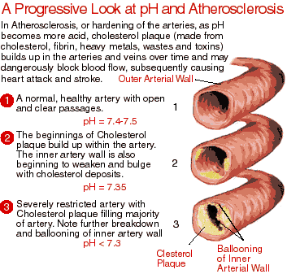
Blood Pressure

;

Use this chart to determine the biological age of your heart.
Take your blood pressure and subtract the lower number (diastolic) for the higher number (systolic) . Take that number, and locate on the left (vertical) part of the chart. Go across from that line, and make a mark where it intersects the curve on the graph. Now draw a straight line down from that point to find your heart's biological age. This may be years younger or older than your actual age.
Example: Let's say that your blood pressure is 140 over 80. 140-80 = 60.
Find 60 0n the left part of the graph, then go across to the curve, then down to find your hearts biological age of 62.
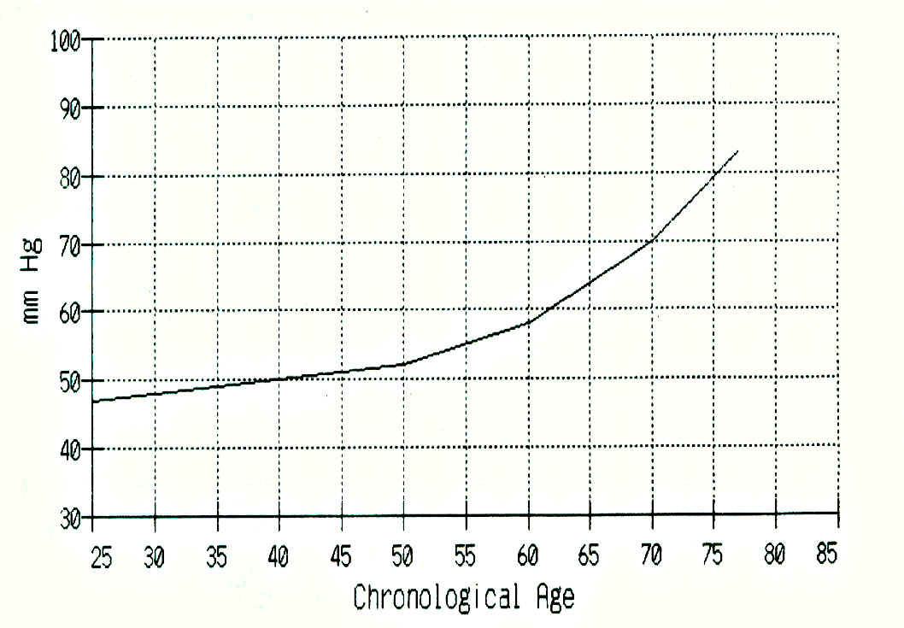

Blood

Diastole: arteries

Systole: liver

Pulse: thyroid/adrenals

Preessure

Blood Pressure: is an indicator of the condition of your arteries. If the wall of the blood vessel is hardened [atherosclerosis] due to deposition of calcium, lipoprotein a, fibrin, homocysteine…as a result of Vitamin C deficiency [sub-clinical scurvy…according to Dr. Linus Pauling] then it indicates that therapy should be directed toward eliminating the Vitamin C deficiency which would then reverse the hardening of the arteries and very likely avoid a heart attack or stroke.

In numerous studies it was indicated that people who had heart attacks measured low blood levels of Vitamin C, magnesium and oxygen.
Those who died from the heart attacks had the least amount of Vitamin C, magnesium and oxygen present in their blood.

Avoiding Heart Attacks and Strokes:
It seems logical then that to avoid serious cardiovascular problems it would be wise to insure adequate intake of Vitamin C, magnesium and to increase the oxygen content of the blood and cells.
This can be accomplished by the clinic Cardiovascular Rehab Protocol. which is available on request.

Name: Age: Date:

