Cancer, Living water and Bio-energy
By Grahame Whitehead

Dedicated to Tribhuvannatha Prabhu and George Harrison. Both life long servants of Lord Krishna. (My sweet Lord)


The following information is provided for all those who are actively seeking the health that is their birthright. "Let their be Light" OM TAT SAT. Hari Krishna. Summery. "What is cancer" How do chronic metabolic disorders occur?
One recent theory for the nature of cancer advanced in 1998 by Professor P.T. Pappas relates a simple and fundamental principle for cancer to the physical energy condition of a cell and hence to its cell membrane potential.
Cancer is a state of low energy of a cell in which the cell is being "trapped" or entrained into a specific lower vibratory frequency for various reasons. This low energy state is manifested by a low transmembrane potential, which causes a "chain" of specific malfunctions for the cell and a general state of ischemia
( low energy ) for the organism.
When a cell is in this particular low energy state and below 15 mvolts
( Refer to the work of Nobel Laureate Albert Szent-Gyorgyi, Cone and others )
it proliferates or divides into two or more identical parts in a attempt to survive in large numbers.
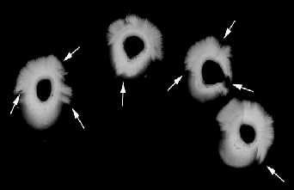  Cancer is the most general phenomenon of missing energy and proliferation in biological systems and is found in all forms of life, humans, plants and animals.  For more detailed photographs click here  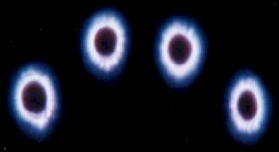 | Kirlian photograph of four finger energy emissions from a sick person.  The spiky damage, low energy and missing energy areas all relate to problems in the Aura,  Chronic Dehydration results in a depleted Bio-magnetic field causing a lack of life force or "energy" and physical damage at a cellular level  A similar picture of a second person with a more vibrant and less damaged Aura.  This person is drinking Living Water and wearing a personal Harmoniser.
The above can be demonstrated with a common example taken from agriculture and known practically to farmers. Let us suppose that we have two plants, which we water every day. The plants stay healthy, but do not produce flowers and seeds to multiply. However when one of the plants is deprived of the life-giving water and as a result becomes stressed with low energy just as the top photograph, it then flowers and reproduces to survive by extension. This means that as soon as the plant is placed into a stressful state, i.e. without sunlight, water nutrition hence without energy, it immediately produces seeds in order to multiply and tries to survive as a species, via a large number of successors, following an “instinct” or a survival programme which is ever present and deeply encoded into the DNA of every cell.
This is a general phenomenon of reproduction known for almost all plants.
Exactly the same holds true for a more advanced organism, which secures its food fairly easily versus a primitive one, which strives every day for food. Indeed a primitive organism is in a continuous state of stress for finding food and energy.
In order to counter this and overcome its daily battle for food and to survive as a species, it multiplies very fast and in large numbers.
On the contrary, an advanced organism or animal multiplies slowly and in smaller numbers. For example big animals such as elephants or humans multiply very slowly compared to birth-rates of smaller animals such as rabbits and likewise with primitive organisms. The same is true for people in a poor versus a rich society.
Proliferating cells in a state of energy crisis cause a similar “energy crisis” through sympathetic vibration or resonance in neighbouring cells. In other words, the energy crisis of a small area of cells is diffused or extended to a broader area because of the most fundamental principle in physics, the principle of conservation in a limited area.
This crisis of low energy (Cellular dehydration) is reflected in the following general chain reactions and results: - Low transmembrane potential leads to increased accumulation of sodium ions inside the cell with resulting inflammation increase of volume of the cell and osmotic pressure inside the cell.
The above conditions when found below 15mVolts for the transmembrane potential lead to cell proliferation and eventually cell overpopulation which enhances and diffuses the existing energy crisis through resonance from the cell to the next cell and so on. Proliferation is then generalised for the body or system as a whole with the characteristics of low energy and ischemia for the system itself. We may say that the cells with low energy get into a “panic” state of feverish multiplication in order to preserve their species following an inherent program encoded in the most fundamental part of their DNA for survival.
As an example of the above we may consider the current medical technique of genetic engineering, that of cloning living cells. The technique of cloning living cells consists of forcing a just fertilised egg to duplicate into more than one copy so that more than one identical embryo develops. This technique, even as simply reported widely in the public media, consists in isolating a just fertilised egg and in putting it in a very low nutrition / water / bio energy environment. When the egg is in such a low nutrition environment and has little bio-energy, prana or life force it proliferates in identical copies, in exact agreement to the ideas expressed above. The just fertilised egg is stressed to extinction, its survival programme encoded in its DNA is automatically activated and tries to survive by multiplication into large numbers.
After a number of proliferating cell copies have appeared, biologists then return the cell copies to a proper nutrition and energy environment (re-hydration and hence ambient energy or prana) where cell proliferation stops.
The billions of nerve cells in our body communicate not only with each other, but also with faraway muscles and sense organs by a combination of electrical impulses and chemical signals. Most nerve cells project a long fibre known as an axon. These axons are provided with very special ionic channels or aqueous pores in the cell membrane which allow specific ions, mainly sodium, potassium, calcium and chloride to diffuse in and out of the cell. In doing so the ions generate tiny electrical currents which scientists and medical researchers can measure with a microelectrode. Ions are driven through these channels because nerve and muscle cells contain much higher concentrations of sodium and calcium than the bodily fluids or "Terrain" which surround them. So there is a concentration gradient for each of these ions across the cell membrane, these gradients are thought to be the driving forces for the movement of ions through open channels. This voltage is called the Membrane Potential.
The above brief explanation is a considerable simplification of the known scientific facts. It has been established that a young healthy cell has a membrane potential of about 70 millivolts, whereas under conditions of poor health / bodily dehydration, poor nutrition, stress, invisible electromagnetic and microwave pollution, and old age, the cell potential is reduced to 15 or even 10 millivolts.
General Guidelines
A Young and healthy cell has a transmembrane potential in the order of 70 milliVolts
An aged cell or a ill cell has a transmembrane potential considerably lower, as low as 50mVolts.
A Cancer Tumour cell has a transmembrane potential as low as 15mVolts
A Cancer cell is a cell showing signs of electrical / energy / Prana /light deficiency
At the same time cells with low transmembrane potential are in a inflammatory state and are the sources of the signals which normally cause a sense of strong pain.
The transmembrane potential is the measure of the Internal Energy,
Hydration / Nutrition level or Bioenergy of a cell
(similar to the voltage of an ordinary electrical battery )
)

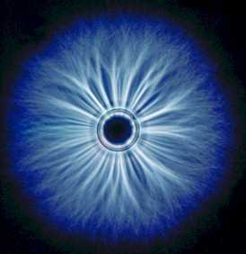 | LIVING WATER  "The greatest health discovery in the world" Samual Biser,  The university of Natural Healing  "It is the bodys water content that controls all cellular functions and not the chemicals that are dissolved in it" Dr F Batmanghelidj  Your Bodies Many cries for water

