What is Fibromyalgia?
by William Hennen, Ph.D. (Condensed Version

Fibromyalgia is a syndrome characterized by wide spread pain and tenderness at specified sites, fatigue, and unrefreshing sleep. There is abnormally high pain sensitivity. The cause(s) of Fibromyalgia is not known, though it may be different in different patients. Fibromyalgia is a clinical entity, but should be regarded as a syndrome rather than a disease.
The difference between a syndrome and a disease is that a disease is a health condition with a clearly identifiable cause while a syndrome is a set of symptoms which define the health condition without a single cause on which to place the blame. Thus a cold is a disease because a viral infection can be identified as the cause.
The Immune System in Fibromyalgia
Immune system dysfunction either leading to or resulting from viral infections has been associated with chronic fatigue syndrome and Fibromyalgia. Using advanced analytical techniques a defect in T-cell activation was found in Fibromyalgia patients. Research findings of immunologic dysfunction and neuroendocrine changes suggest the possible dysregulation of interactions between the nervous system and the immune system. For a report showing the Natural Killer cell levels of Fibromyalgia sufferers, please browse in vivo Study.
Other Problems
Among the physiological imbalances observed in-patients with Fibromyalgia are immunologic dysfunction including defects in T-cell activation, possible viral injury to cellular calcium channels, neuroendocrine dysregulation including sleep disturbances, and possible serotonin deficiency. It has been postulated that the role of viral infection in Fibromyalgia may involve viral damage to calcium channels in the cellular membrane. Calcium is critically involved in the cellular death process called apoptosis. Significant muscle abnormalities including Type-II fiber atrophy and a moth eaten appearance in Type-I fibers are present in Fibromyalgia. Many have hypothesized that skeletal muscle is the "end organ" responsible for the pain of Fibromyalgia, but it is becoming increasingly apparent that the nervous system, immune, and hormonal systems are involved as well.
With so many correlations and contributing factors it is hard to determine which is the cause and which is the effect in analyzing Fibromyalgia. It may also be the case that each of these factors may contribute slightly and in an additive manner resulting in overall poor performance and pain. Such an additive relationship may not be apparent especially when tests show that the individual parameters are all within the normal range albeit on the lower end of the range.
There is Help
Chronic conditions like Fibromyalgia are difficult to manage and frustrating for both the patient and the caregiver. But when patience can be applied and confidence achieved, a positive relationship can result and the patient can be helped.
There is not likely to be any one factor that is affecting us but rather a multitude of small contributions. None of these are necessarily significant by themselves, but taken together they can be a tremendous burden. Through a comprehensive, holistic program of diet, exercise, stress management including adequate deep refreshing sleep, and supplementation, small additive changes can culminate in an optimal personal wellness

Fibromyalgia Symptoms and Diagnosis
Fibromyalgia Diagnosis
1. Wide spread pain for at least 3 months' duration (this rules out viruses or traumatic insults that resolve on their own).
2. Pain in all four quadrants of the body: Right side, left side, above the waist, below the waist.
3. Pain that occurs in at least 11 of the 18 "tender" points that are specified in a Fibromyalgia exam.
4. Pain defined, in this context, as discomfort when 8 pounds of pressure are applied to the tender point
Frequently Observed Symptoms in Fibromyalgia
 | Wide spread pain with tender points | Subjective numbness, swelling, tingling
 | Overall weakness | Complaints of fever
 | Unrefreshing sleep | Complaints of dry eyes
 | Fatigue | Depression
 | Stiffness | Anxiety
 | Tension Headaches | Restless leg syndrome
 | Painful periods | Irritable bladder
 | Irritable colon | Chronic fatigue
 | Complaints of swollen glands | Subjective soft tissue swelling
 | "Fibro Fog" | Changes in vision
 | Skin redness, mottling | Muscle and joint aches

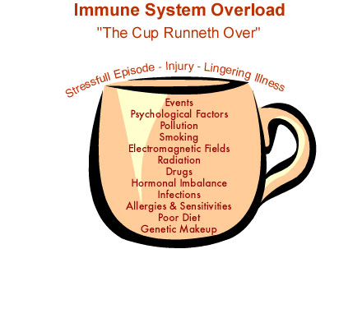
How Fibromyalgia Can Develop
Let's take a look at how a chronic health problem like Fibromyalgia develops. The core problem is immune system dysfunction resulting from an immune system overload. The illustration shows factors contributing to this situation. These factors probably have been accumulating over a period of months or even years. Finally the cup becomes full. Then when extreme stress, injury, or a lingering illness is added to the picture, the cup runs over. over.
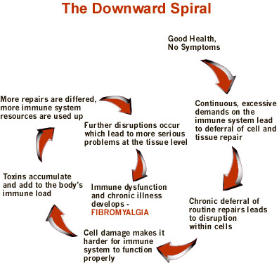
This produces a perfect setup for chronic
health problems to develop.
FIBROMYALGIA
The downward spiral begins.
FIBROMYALGIA AND WHEY:

Hi I'm Susan, I have had fibro about 7 years. I had a very different and extreme case of fibro meaning one day I was normal and the next day it hit me just that quick and to the point that I could not walk.

This was a major deal for me not only was the pain unbearable but I had a GREAT FEAR of Doctors and hospitals. I have always had this fear since I was a child.
To make a very long story short I discovered Whey Protein through my partner at work that was getting into weight lifting to build up his muscles. He had known about my condition for almost a year and when we were talking about all the pills he was taking and powders he was drinking. One day he told me to try it. Well I did, to shut him up mostly....lol, because he bugged me everyday did you get it yet? lol.
I drank 1 scoop a day for 1 week, I told my partner my muscles were hurting more than usual. He said that’s ok the protein was feeding my muscles and to keep drinking it, they would stop hurting when they got use to the protein. Well by the 2nd week my muscles did stop hurting and I told him so. But the real test was when it rained. I had been predicting the rain and snow for the past 6 years and was never wrong. It rained one day and I didn’t feel it. It rained somemore and I still didn’t feel it. I have been drinking this Whey Protein for almost 1 year now and I have no pain.
Well I got on the internet and started to spread the word. A few months later people were emailing me to tell me they too don’t feel the pain anymore..... and other say they still have pain but it has lessened. I don’t sell the stuff. You can buy it at ANY health food store or grocery store. But it’s cheaper in the health food stores.
PS.....If by chance I forget to drink it for more than 5 days I do feel the fibro creeping back into my body, so it is not a cure, but at lease I got my life back as long as I drink it.

