CEREBRAL CORTEX
Frontal Lobe: Most anterior, right under the forehead.
Functions:
How we know what we are doing within our environment (Consciousness).
How we initiate activity in response to our environment.
Judgments we make about what occurs in our daily activities.
Controls our emotional response.
Controls our expressive language.
Assigns meaning to the words we choose.
Involves word associations.
Memory for habits and motor activities.
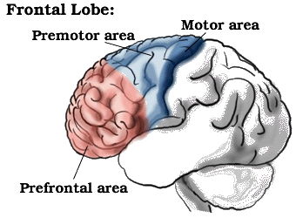
Observed Problems:
Loss of simple movement of various body parts (Paralysis).
Inability to plan a sequence of complex movements needed to complete multi-stepped tasks, such as making coffee (Sequencing).
Loss of spontaneity in interacting with others.
Loss of flexibility in thinking.
Persistence of a single thought (Perseveration).
Inability to focus on task (Attending).
Mood changes (Emotionally Labile).
Changes in social behavior.
Changes in personality.
Difficulty with problem solving.
Inablility to express language (Broca's Aphasia).
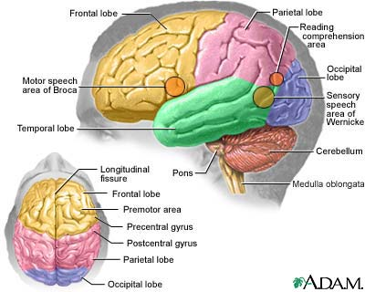
Frontal Lobes:
The frontal lobes are considered our emotional control center and home to our personality. There is no other part of the brain where lesions can cause such a wide variety of symptoms (Kolb & Wishaw, 1990). The frontal lobes are involved in motor function, problem solving, spontaneity, memory, language, initiation, judgement, impulse control, and social and sexual behavior. The frontal lobes are extremely vulnerable to injury due to their location at the front of the cranium, proximity to the sphenoid wing and their large size. MRI studies have shown that the frontal area is the most common region of injury following mild to moderate traumatic brain injury (Levin et al., 1987).
There are important asymmetrical differences in the frontal lobes. The left frontal lobe is involved in controlling language related movement, whereas the right frontal lobe plays a role in non-verbal abilities. Some researchers emphasize that this rule is not absolute and that with many people, both lobes are involved in nearly all behavior.
Disturbance of motor function is typically characterized by loss of fine movements and strength of the arms, hands and fingers (Kuypers, 1981). Complex chains of motor movement also seem to be controlled by the frontal lobes (Leonard et al., 1988). Patients with frontal lobe damage exhibit little spontaneous facial expression, which points to the role of the frontal lobes in facial expression (Kolb & Milner, 1981). Broca's Aphasia, or difficulty in speaking, has been associated with frontal damage by Brown (1972).
An interesting phenomenon of frontal lobe damage is the insignificant effect it can have on traditional IQ testing. Researchers believe that this may have to do with IQ tests typically assessing convergent rather than divergent thinking. Frontal lobe damage seems to have an impact on divergent thinking, or flexibility and problem solving ability. There is also evidence showing lingering interference with attention and memory even after good recovery from a TBI (Stuss et al., 1985).
Another area often associated with frontal damage is that of "behavioral sponteneity." Kolb & Milner (1981) found that individual with frontal damage displayed fewer spontaneous facial movements, spoke fewer words (left frontal lesions) or excessively (right frontal lesions).
One of the most common characteristics of frontal lobe damage is difficulty in interpreting feedback from the environment. Perseverating on a response (Milner, 1964), risk taking, and non-compliance with rules (Miller, 1985), and impaired associated learning (using external cues to help guide behavior) (Drewe, 1975) are a few examples of this type of deficit.
The frontal lobes are also thought to play a part in our spatial orientation, including our body's orientation in space (Semmes et al., 1963).
One of the most common effects of frontal damage can be a dramatic change in social behavior. A person's personality can undergo significant changes after an injury to the frontal lobes, especially when both lobes are involved. There are some differences in the left versus right frontal lobes in this area. Left frontal damage usually manifests as pseudodepression and right frontal damage as pseudopsychopathic (Blumer and Benson, 1975).
Sexual behavior can also be effected by frontal lesions. Orbital frontal damage can introduce abnormal sexual behavior, while dorolateral lesions may reduce sexual interest (Walker and Blummer, 1975).

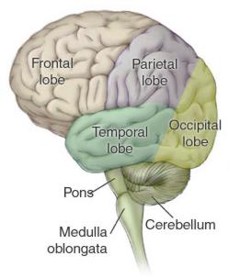
Parietal Lobe: near the back and top of the head.
Functions:
Location for visual attention.
Location for touch perception.
Goal directed voluntary movements.
Manipulation of objects.
Integration of different senses that allows for understanding a single concept.
Observed Problems:
Inability to attend to more than one object at a time.
Inability to name an object (Anomia).
Inability to locate the words for writing (Agraphia).
Problems with reading (Alexia).
Difficulty with drawing objects.
Difficulty in distinguishing left from right.
Difficulty with doing mathematics (Dyscalculia).
Lack of awareness of certain body parts and/or surrounding space (Apraxia) that leads to difficulties in self-care.
Inability to focus visual attention.
Difficulties with eye and hand coordination.
Parietal Lobes:
The parietal lobes can be divided into two functional regions. One involves sensation and perception and the other is concerned with integrating sensory input, primarily with the visual system. The first function integrates sensory information to form a single perception (cognition). The second function constructs a spatial coordinate system to represent the world around us. Individuals with damage to the parietal lobes often show striking deficits, such as abnormalities in body image and spatial relations (Kandel, Schwartz & Jessel, 1991).
Damage to the left parietal lobe can result in what is called "Gerstmann's Syndrome." It includes right-left confusion, difficulty with writing (agraphia) and difficulty with mathematics (acalculia). It can also produce disorders of language (aphasia) and the inability to perceive objects normally (agnosia).
Damage to the right parietal lobe can result in neglecting part of the body or space (contralateral neglect), which can impair many self-care skills such as dressing and washing. Right side damage can also cause difficulty in making things (constructional apraxia), denial of deficits (anosagnosia) and drawing ability.
Bi-lateral damage (large lesions to both sides) can cause "Balint's Syndrome," a visual attention and motor syndrome. This is characterized by the inability to voluntarily control the gaze (ocular apraxia), inability to integrate components of a visual scene (simultanagnosia), and the inability to accurately reach for an object with visual guidance (optic ataxia) (Westmoreland et al., 1994).
Special deficits (primarily to memory and personality) can occur if there is damage to the area between the parietal and temporal lobes.
Left parietal-temporal lesions can effect verbal memory and the ability to recall strings of digits (Warrington & Weiskrantz, 1977). The right parietal-temporal lobe is concerned with non-verbal memory.
Right parietal-temporal lesions can produce significant changes in personality.
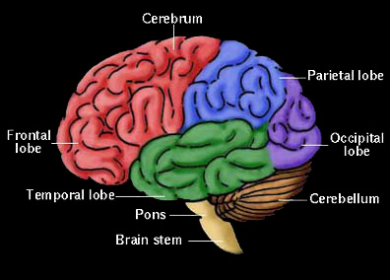
Occipital Lobes: Most posterior, at the back of the head.
Functions:
Vision
Observed Problems:
Defects in vision (Visual Field Cuts).
Difficulty with locating objects in environment.
Difficulty with identifying colors (Color Agnosia).
Production of hallucinations
Visual illusions - inaccurately seeing objects.
Word blindness - inability to recognize words.
Difficulty in recognizing drawn objects.
Inability to recognize the movement of an object (Movement Agnosia).
Difficulties with reading and writing.
Occipital Lobes
The occipital lobes are the center of our visual perception system. They are not particularly vulnerable to injury because of their location at the back of the brain, although any significant trauma to the brain could produce subtle changes to our visual-perceptual system, such as visual field defects and scotomas. The Peristriate region of the occipital lobe is involved in visuospatial processing, discrimination of movement and color discrimination (Westmoreland et al., 1994). Damage to one side of the occipital lobe causes homonomous loss of vision with exactly the same "field cut" in both eyes. Disorders of the occipital lobe can cause visual hallucinations and illusions. Visual hallucinations (visual images with no external stimuli) can be caused by lesions to the occipital region or temporal lobe seizures. Visual illusions (distorted perceptions) can take the form of objects appearing larger or smaller than they actually are, objects lacking color or objects having abnormal coloring. Lesions in the parietal-temporal-occipital association area can cause word blindness with writing impairments (alexia and agraphia) (Kandel, Schwartz & Jessell, 1991).

Our Three Brains
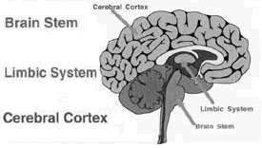

Temporal Lobes: Side of head above ears.
Functions:
Hearing ability
Memory aquisition
Some visual perceptions
Catagorization of objects.
Observed Problems:
Difficulty in recognizing faces (Prosopagnosia).
Difficulty in understanding spoken words (Wernicke's Aphasia).
Disturbance with selective attention to what we see and hear.
Difficulty with identification of, and verbalization about objects.
Short-term memory loss.
Interference with long-term memory
Increased or decreased interest in sexual behavior.
Inability to catagorize objects (Catagorization).
Right lobe damage can cause persistant talking.
Increased aggressive behavior.
Temporal Lobes:
Kolb & Wishaw (1990) have identified eight principle symptoms of temporal lobe damage: 1) disturbance of auditory sensation and perception, 2) disturbance of selective attention of auditory and visual input, 3) disorders of visual perception, 4) impaired organization and categorization of verbal material, 5) disturbance of language comprehension, 6) impaired long-term memory, 7) altered personality and affective behavior, 8) altered sexual behavior.
Selective attention to visual or auditory input is common with damage to the temporal lobes (Milner, 1968). Left side lesions result in decreased recall of verbal and visual content, including speech perception. Right side lesions result in decreased recognition of tonal sequences and many musical abilities. Right side lesions can also effect recognition of visual content (e.g. recall of faces).
The temporal lobes are involved in the primary organization of sensory input (Read, 1981). Individuals with temporal lobes lesions have difficulty placing words or pictures into categories.
Language can be effected by temporal lobe damage. Left temporal lesions disturb recognition of words. Right temporal damage can cause a loss of inhibition of talking.
The temporal lobes are highly associated with memory skills. Left temporal lesions result in impaired memory for verbal material. Right side lesions result in recall of non-verbal material, such as music and drawings.
Seizures of the temporal lobe can have dramatic effects on an individual's personality. Temporal lobe epilepsy can cause perseverative speech, paranoia and aggressive rages (Blumer and Benson, 1975). Severe damage to the temporal lobes can also alter sexual behavior (e.g. increase in activity) (Blumer and Walker, 1975).
Common tests for temporal lobe function are: Rey-Complex Figure (visual memory) and Wechsler Memory Scale - Revised (verbal memory).
Cerebellum:
The cerebellum is involved in the coordination of voluntary motor movement, balance and equilibrium and muscle tone. It is located just above the brain stem and toward the back of the brain. It is relatively well protected from trauma compared to the frontal and temporal lobes and brain stem.
Cerebellar injury results in movements that are slow and uncoordinated. Individuals with cerebellar lesions tend to sway and stagger when walking.
Damage to the cerebellum can lead to: 1) loss of coordination of motor movement (asynergia), 2) the inability to judge distance and when to stop (dysmetria), 3) the inability to perform rapid alternating movements (adiadochokinesia), 4) movement tremors (intention tremor), 5) staggering, wide based walking (ataxic gait), 6) tendency toward falling, 7) weak muscles (hypotonia), 8) slurred speech (ataxic dysarthria), and 9) abnormal eye movements (nystagmus).
Brain Stem:
The brain stem plays a vital role in basic attention, arousal, and consciousness. All information to and from our body passes through the brain stem on the way to or from the brain. Like the frontal and temporal lobes, the brain stem is located in an area near bony protrusions making it vulnerable to damage during trauma.
Limbic System:
Olfactory pathways:
Amygdala and their different pathways.
Hippocampi and their different pathways.
Limbic lobes: Sex, rage, fear; emotions. Integration of recent memory, biological rhythms.
Hypothalamus.
Integration center of Autonomic Nervous System (ANS): Regulation of body temperature and endocrine function.
Anterior Hypothalamus: parasympathetic activity (maintenance function).
Posterior Hypothalamus: sympathetic activity ("Fight" or "Flight", stress response.
Behavioral patterns: Physical expression of behavior.
Appestat: Feeding center, .Pleasure center.

Reticular Activating System (RAS)
Responsible for arousal from sleep, wakefulness, attention.
Brainstem –
The lower extension of the brain where it connects to the spinal cord. Neurological functions located in the brainstem include those necessary for survival (breathing, digestion, heart rate, blood pressure) and for arousal (being awake and alert).
Most of the cranial nerves come from the brainstem. The brainstem is the pathway for all fiber tracts passing up and down from peripheral nerves and spinal cord to the highest parts of the brain.
- Medulla Oblongata - The medulla oblongata functions primarily as a relay station for the crossing of motor tracts between the spinal cord and the brain. It also contains the respiratory, vasomotor and cardiac centers, as well as many mechanisms for controlling reflex activities such as coughing, gagging, swallowing and vomiting. Click Here To Return To Diagram

- Midbrain - The midbrain serves as the nerve pathway of the cerebral hemispheres and contains auditory and visual reflex centers.Click Here To Return To Diagram

- Pons - The pons is a bridge-like structure which links different parts of the brain and serves as a relay station from the medulla to the higher cortical structures of the brain. It contains the respiratory center.

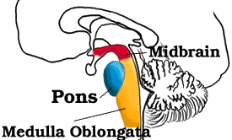
Medulla Oblongata:
Crossing of motor tracts.
Cardiac Center.
Respiratory Center.
Vasomotor (nerves having muscular control of the blood vessel walls) Center
Centers for cough, gag, swallow, and vomit.
Cranial Nerves:
• CN IX - Glossopharyneal (Muscles and mucous membranes of pharynx, the constricted openings from the mouth and the oral pharynx and the posterior third of tongue.), [mixed].
• CN X - Vagus (Pharynx, larynx, heart, lungs, stomach), [mixed].
• CN XI - Accessory (Rotation of the head and shoulder), [motor].
• CN XII - Hypoglossal (Intrinsic muscles of the tongue), [motor

Memory, Learning, and Emotion: the Hippocampus
Emotion and memory are very closely related. You know this from your experience. Go to a party, meet a bunch of new people. Which faces are you going to remember? The woman who made you laugh, the man who made you feel embarrassed, and your new boss -- the ones who had an emotional impact.
So perhaps you would not be surprised to learn that the a portion of the emotion system of the brain (the "limbic system") is in charge of transferring information into memory. From years of experiments and surgical experience, we now know that the main location for this transfer is a portion of the temporal lobe called the hippocampus.
You won't particularly impressed by its appearance. The hippocampus is included here because it is always cited as part of the "limbic system", and because there is striking new "news" about:
- how it works;
- its vulnerability to stress; and
- its rich supply of estrogen and progesterone receptors.
We'll consider each of those in turn, after we look at just what and where it is.
The portion of the brain that helps those names get into memory in the first place, this hippocampus thing we are talking about, is also part of this temporal lobe. But you can't see it here, because it's an inside fold, not these outside folds you see above. To see the hippocampus, we'll have to use x-ray vision. Imagine you could just squint and see right through the temporal lobe to what's underneath. Using some beautiful images from a great medical illustrator, here's what you'd see:
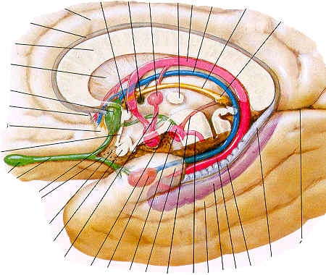
You can ignore the lines, they're for the poor medical students who have to memorize all the latin names of the structures shown. Can you see the temporal lobe, there on the outside, just as before? We're here to look at the purple part at the bottom: that's the hippocampus. For the moment you can ignore all the other limbic system elements shown here; we'll be back to learn more of them in other Tours.
So, there's that purple thing, part of the innermost fold of the temporal lobe. How "inner" is that? To see that, imagine you could look straight down from the top of Harry's head, and use your x-ray vision to see the hippocampus, outlined in purple -- you could see how far toward the middle it sits:
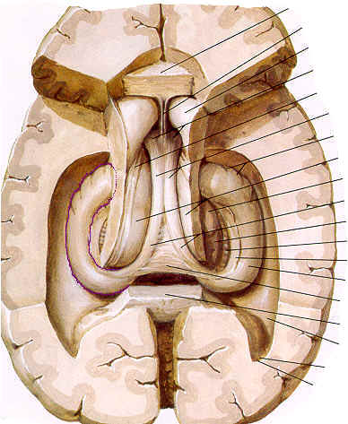
You can see it on the left side, outlined; the right hippocampus is also shown -- see it over there on the right? A few more structures have been deleted on the right so you can really see the entire "body" of the hippocampus there, and the "head" with it's bulging folds.
Why should you care where this thing is? Here are three reasons. First, this part of the brain appears to be absolutely necessary for making new memories. If you didn't have it, you couldn't live in the present: you'd be stuck in the past of old memories. And this is common: Alzheimer's disease affects the hippocampus first and severely, before other parts of the cortex (later, the frontal lobes too). So memory is usually the first thing to start to falter in Alzheimer's -- the ability to make new ones, that is. Who visited yesterday? Where did I put the car keys? Why isn't there any mail today (when you brought it in 3 hours ago)?
Secondly, the hippocampus seems to be involved in severe mental illnesses. In both schizophrenia and some severe depressions, the hippocampus appears to shrink. This is clearly true for schizophrenia and has been shown in many studies. As it now appears to be true for mood disorders as well, we are becoming concerned about actual damage to brain tissue during mood episodes.^{Bremner,Steffens}
There is even some recent evidence that this shrinkage can be prevented in people with depression if they are taking antidepressant medications^{Sheline} and perhaps in those with bipolar disorder if they take lithium.^{Manji}
Third, the hippocampus is known to be directly affected by estrogen.
The hippocampus and memory:
If the amygdala is FEAR, then the hippocampus is MEMORY. To understand exactly how the hippocampus is involved in memory, however, you must first know a little about memory.
There are at least three different types of memory. The most short term is working memory. Working memory is like the RAM of a computer. It is the type of memory that enables you to spit back the last sentence of a coversation when someone accuses you of not listening. Like the RAM of a computer, it is crucial for performing some common operations in your head: adding numbers, composing a sentence, following directions, etc. Also like a computer, the space devoted to that operation is recycled as soon as you turn to something else. It does not become a permanent memory. Working memory does not require the hippocampus; it is probably a cortical phenomenon.
The second type is what we most commonly associate with "memory". This is long-term or declarative memory, and is composed of all the facts, figures, and names you have ever learned. All of your experiences and conscious memory fall into this category. It is analogous to the hard drive of a computer. Although no one knows exactly where this enormous database is stored, it is clear that the hippocampus is necessary to file away new memories as they occur.
The third type is procedural memory, and is probably the most durable form of memory. These are actions, habits, or skills that are learned simply by repetition. Examples include playing tennis, playing an instrument, solving a puzzle, etc. The hippocampus is not involved in procedural memory, but it is likely that the cerebellum plays a role in some instances.
The significance of the hippocampus is driven home by a famous patient named H.M. As part of an epilepsy surgery, doctors removed most of his medial temporal lobes. Since that surgery, in 1953, he has formed no new memories. He can remember his childhood and everything before the surgery, and he still has working memory and the ability to form procedural memories. You can have a normal, lucid conversation with him, but if you leave the room for a moment, when you return he will not remember you or the conversation. He has completely lost the ability to lay down declarative memory.
Therefore, the hippocampus is critical in laying down declarative memory, but is not necessary for working memory, procedural memory, or memory storage. Damage to the hippocampus will only affect the formation of new declarative memories.
The mechanisms of the hippocampus are not entirely understood. The formation of memories probably involves long term potentiation, or LTP. This is a molecular process which strengthens groups of synapses that are repeatedly used. LTP is not sufficient to explain the storage of memory, though.
Diseases of the Hippocampus
The hippocampus can be injured by too little blood flow, Alzheimer's Disease, and epilepsy -- which has some striking similarities to bipolar disorder.
Diseases of the hippocampus:
The hippocampus is particularly vulnerable to several disease processes, including ischemia, which is any obstruction of blood flow or oxygen deprivation, Alzheimer's disease, and epilepsy. These diseases selectively attack CA1, which effectively cuts through the hippocampal circuit. Below is a photograph of a normal hippocampus and one which has been deprived of oxygen.
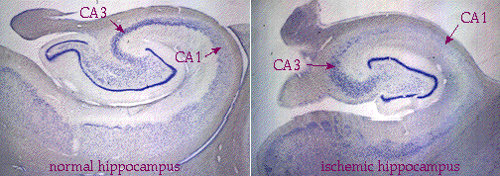
You should be able to see the degeneration of CA1 (labeled) and the absence of cell bodies (stained purple). A stroke can have this effect, but there must be bilateral damage of the hippocampi to affect memory. Therefore only situations that deplete blood or oxygen flow to the entire brain will produce a memory deficit. The pathology of severe temporal lobe epilepsy looks very similar to ischemic damage.
Alzheimer's disease, although it affects the entire brain, is particularly hard on the CA1 region. Below is a photograph of the hippocampus of an Alzheimer's patient, with the CA1 region magnified. Both extracellular plaques and intracellular tangles are visible - these are the pathological hallmarks of the disease.
The amygdala:
If you remember only one word about the amygdala, the word is FEAR. The amygdala is the nucleus responsible for the lurch you feel in your stomach when you turn around in a dark alley and notice someone following you. It couples a learned sensory stimulus (man in ski mask in alley = danger) to an adaptive response (fight or flight). On the basis of this information, you should be able to guess the primary inputs to and outputs from the amygdala.
Inputs: the amygdala must get sensory input, and it must be fairly highly processed input to recognize the elements of a scene that signal danger. The association areas of visual, auditory, and somatosensory cortices are the main inputs to the amygdala.
Outputs: the amygdala must be able to control the autonomic system, to provoke such an instant sympathetic response. The main outputs of the amygdala are to the hypothalamus and brainstem autonomic centers, including the vagal nuclei and the sympathetic neurons.
The amygdala is also involved with mood and the conscious emotional response to an event, whether positive or negative. To this end, the amygdala is also extensively interconnected with frontal cortex, mediodorsal thalamus, and the medial striatum.
Fear
When you are afraid, you are likely to have:
- worried thoughts; and
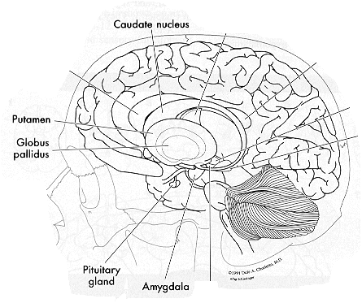
- physical sensations like a faster heart rate, sweating, increased breathing; and
- behaviors, like trying to escape the situation that made you afraid in the first place!
There is a complicated series of events in the nervous system that leads to the physical sensations and behaviors of fear (the thoughts, we can't localize so well). Below you'll find details of the anatomy of this process -- but for a simple look at the "fear circuitry" of the brain, have a look at Joseph LeDoux's lab site. Inside his site you can look at a brief essay on fear, based on their research. After that, come back here if you want a more detailed look at the amygdala (you'll know what that is by the time you come back!)
One of these physical events associated with fear is often called the "fight or flight" reaction: increased heart rate and force of each beat ("pounding heart"); increased muscle tension that can even cause tremors; sweaty but cold palms; and even nausea and diarrhea. Another aspect of fear is a physical "conditioning", so that even a minor stimulus can bring on the whole fear reaction.
The brain structure which appears to be at the very center of most of the brain events associated with fear is the "amygdala" (Greek for "almond", its shape). The amygdala seems to respond to severe traumas with an un-erasable fear response ("post-traumatic stress disorder", or PTSD; click for a superb site by the Madison Institute of Medicine on PTSD). It seems to be genetically different and "wired" for a higher level of fear in some individuals, such as those with panic disorder. And it recently has been shown to be larger in some people with bipolar disorder, though what that means is still a mystery.
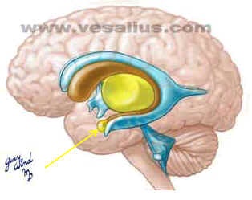
You can see the amygdala clearly in this drawing: it's the small (almond-shaped, almost) bulge at the lower tip of the gold loop (yellow arrow). If you've had the "R Complex" Tour, you'll know the gold loop as the "caudate", so the amygdala is a small bulge at the lower tip of the caudate, if that helps. Here's another way to see it:

There's the caudate again, making that big loop, and at it's lower end there's this thing we're calling the amygdala. This drawing shows the "almond" shape of the bulge. You can see how the amygdala is located within the temporal lobe (see the temporal lobe outline there?) If you've already had the Tour of the hippocampus, you've seen this territory before: the amygdala lies just in front of the hippocampus, in about the same spot on the inside of the temporal lobe.
What does this thing really look like in a real brain? Here are two images: in the first, the amygdala has been circled in yellow; the second is the same picture without the highlight (see #17) :
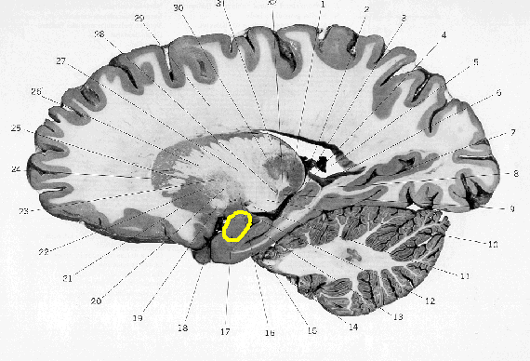
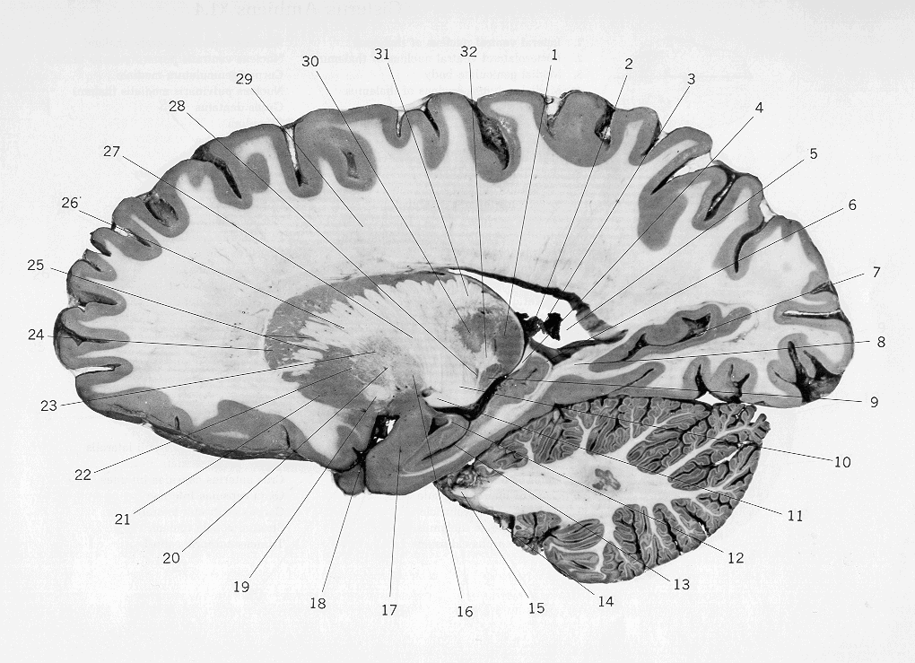
Not much to look at, is it.

