**http://www.shapeyourface.com/**

**Exercise One - Muscles Under Eyes**

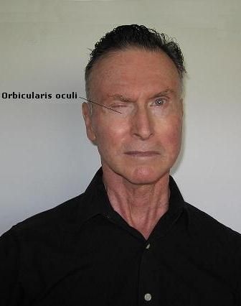

The exercise for the muscles that surround the eyes looks deceptively easy. The basic exercise *is* easy. It's done by just partially winking one eye at a time, and holding the wink for a second, and then repeating the movement. I suggest 50 repetitions. (I do two sets of 50 repetitions.) There is no need to scrunch up the skin in the crow's feet area when doing this exercise, but there is the need to contract firmly both the orbicularis oculi muscles around each eye and the nasalis muscles that are on each side of the nasal bone.

There is an advanced version of this exercise that is more effective but you have to gain control of the occipitalis muscle at the back of the head to do it. I discuss gaining control of this important muscle when I describe [exercise 5](http://www.shapeyourface.com/exercise_five.htm) for the scalp muscles. I'll tell you how to do the advanced exercise then.

I put this exercise first among the five exercises because the first indication that we are getting older is those lines that form in the skin around the eyes. (The skin around the eyes is the thinnest and most delicate of the whole body.) This exercise will definitely not eliminate the fine lines but it will make them less noticeable.

Before doing any facial exercise you should apply some lubricant to the area around the muscles being exercised. I splash some water on my face before doing the exercises. You may want to apply your favorite moisturizer to your skin before you start. Don't do any of these exercises with a dry face.

**Exercise One, Part B**

This exercise for the muscles around the eyes might be even better because you will feel these muscles contract strongly when you do it right.

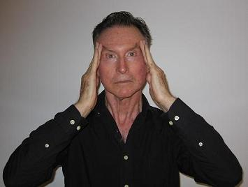

1. Press your fingers onto your temple area and slightly pull them back. This puts tension on the muscles that surround the eyes, and it also prevents lines around the eyes from forming as you do the exercise.

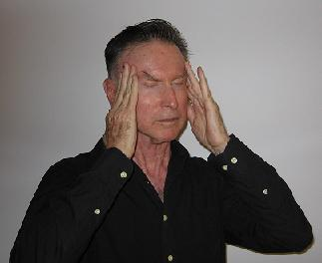

2. Now, with your fingers giving resistance to the muscles around you eyes, close your eyes tightly. You will feel these muscles working strongly as you hold the contraction perhaps a second or even more . Do as many repetitions as you feel comfortable with. I usually do three sets of twenty reps.

This exercise will get rid of any bagginess around the lower eyelids and will probably get rid of any hooded upper eyelids too. But improvement will take time. Don't believe those optimistic statements about rejuvenation in a few weeks. Muscles and skin take time to respond.

## Exercise Two - Muscle Around Mouth

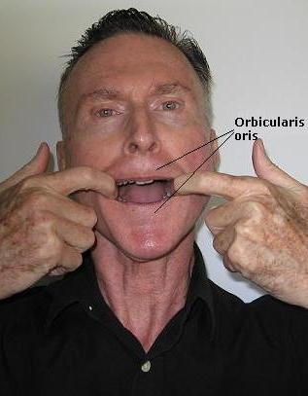

The exercise for the orbicularis oris, the circular muscle around the mouth, is not a gentle one. The gentle ones produce no positive results; this one does.

Although it looks like I'm stretching my mouth and therefore the muscles surrounding the mouth, I am not. Alternating contraction and relaxation develop muscle, not stretching. In fact, stretching of the facial muscles may not be good for the overlying skin.

I do this exercise when I shave in the morning. Before doing it I splash a lot of water on my face. (Never exercise the facial muscles without lubricating the skin either with water or oil.) Now I insert my index fingers into my mouth exerting a steady pull on the corners of the mouth. (Be sure to have clean hands when doing this exercise.)

You do not need to get much extension and contraction of the orbicularis oris muscle. I get less than a quarter inch. This small amount of movement will strengthen the muscles around the mouth and, especially in women, make the lips look fuller. It will in no way, though, change the essential shape of the mouth.

When this exercise is done correctly, it is both an isotonic exercise and an isometric exercise. It is isotonic because there is a change in the length of the muscle; it is isometric because you will hold the contraction of each rep for a second or two - in other words, the muscle will maintain a constant length as you hold the contraction.

To restate all this - you will:

* Pull the mouth with the index fingers getting perhaps a quarter to three/eights of an inch of movement.
* You will hold the contraction of the orbicularis oris muscle for a second or two.
* You will then contract the orbicularis oris even more strongly until the index fingers get closer together.

I usually do two sets of 25 to 50 repetitions. But I suggest starting this exercise slowly, concentrating on form. Don't be in too much of a hurry to do a marathon mouth workout.

**Exercise Three - Chin Muscle**

Don't let my ridiculous expression scare you. I don't advise doing this exercise in public because you'll look like an idiot. The exercise is an effective one, though, because it really does tone up the chin and the front of the neck.

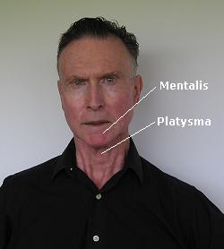

You don't have to look this grim while you're doing the exercise. Still it is not wise to do it in front of your significant other. One does have to keep some semblance of dignity.

Splash some water on your face or apply some lubricant to the skin around the chin and mouth. Now you're ready:

* Elevate the lower lip. This will wrinkle the skin of the chin. If you place your finger firmly on the mentalis muscle you will feel that it is contracted. Hold this contraction for a second.
* Now strongly lower the chin to the position you see in the photo. Hold this contraction for a second. Do not move the head though. The head remains stationary throughout the exercise.
* Do this exercise maintaining good form for ten or twelve repetitions. I usually do two or three sets of ten reps.

While you're doing this exercise, you'll feel the muscles at the front of the neck (the platysma) working hard along with the chin muscle. Keeping these two muscle groups in good shape is important to ward off the dreaded turkey-neck syndrome and platysmal banding.   
  
Go to this thread on the Discussion Forum for more information on Exercise Three - [Link to the message](http://www.shapeyourface.com/forum/show.cgi?tpc=2&post=267#POST267).

**Exercise Four - Front of Neck**

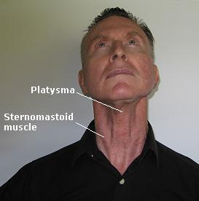

This exercise firms up the area at the front of the neck where aging first leaves its mark of deterioration. Here's how to do it:

* In the sitting (I do it in the sitting) or standing position, tilt your head back the way you see me doing in the photo.
* While tilting your head back, press your tongue into the roof of your mouth. This tightens up all the muscles at the front of your neck.
* Now bring your chin down toward your neck while still holding the tongue against the roof of your mouth.

That's all there is to it. If you are doing it right, you will feel a tightness under the chin and in the front of the neck. Check this out with your fingers. Does your platysma muscle feel tense while you are moving your head up and down? You are doing the exercise right.

**Loose Skin or Excess Skin**

So what if your platysma and sternomastoid muscles are well-developed and tight with little or no overlying fat - but there is still excess skin, a fleshy lobe hanging down from the throat or chin - the turkey wattle. (The neck often ages before the face.)

Cervicoplasty is a surgical procedure that removes excess or loose skin from the front of the neck. It involves a small incision below the chin and perhaps behind the ears. The excess skin is then neatly trimmed and tightened up. The results of this simple procedure can last over ten years, at which point a touch up may be needed.

During the surgery *excess fat* may also be removed with a suction device - liposuction. All this will sharpen up the chin and jawline, taking years off a person's appearance.

The recovery time for these procedures in usually less than two weeks, and there is only a small chance for complications like infection or scarring.

I've never had any cosmetic surgery, but if I had a turkey wattle loosely hanging down from my throat, I certainly would make an appointment with a competent surgeon. I would check on the surgeon's credentials and find out the price before I signed any forms though.

## Exercise Five - Scalp Exercise

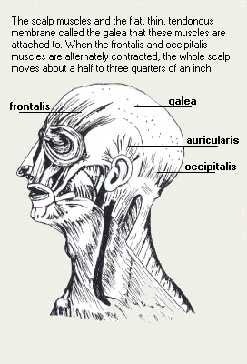

### Introduction

This exercise for the scalp muscles is an effective one for lifting the eyebrows and giving a general lift to the whole upper face. But it is an exceptionally hard exercise for most women to learn and to do correctly. Men seem to have an easier time learning it. This page is going to be long because the scalp exercise (SE) will entail a lot of explanation.

The learning process would be straightforward if the scalp muscles at the back of the head were easy to control. They are not. These muscles, the occipitalis muscles, are technically voluntary but people usually have lost control of them. When they are not used they get small (they atrophy), almost to the point of disappearing. The task now is to regain control of them, to tone them up, and to make them stronger. I think the following suggestions will lessen the difficulty in gaining control of these stubborn occipitalis muscles.

First, a bit of trivia. Twice as many men compared to women can wiggle their ears. This has significance. If a man or a woman can wiggle the ears, it means that there is contraction of the muscles at the back of the head. These are the muscles that must be alternately contracted with the muscles at the front of the head during the scalp exercise.

### The Learning Process

Step number one in the learning process: Stand in front of the mirror and raise your eyebrows (contract the frontalis muscles). Step number two: Try to pull back your ears (contract the occipitalis muscles). There will be only a small, almost imperceptible, movement at first when you are trying to pull back your ears. The contraction of the muscles at the front of the head will be easy. These muscles are fully voluntary; the muscles at the back of the head will require a lot of work.

Try to visualize the muscles at the back of the head by looking at the drawing of the scalp muscles. Now place your fingers over the two muscular slips of the occipitalis muscle at the back of the head and try to detect contraction when you move the scalp.

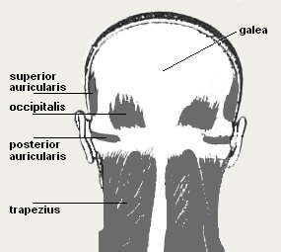

Here's a strategy for gaining control of the occipitalis muscles that many people have found helpful: Lie on a bed with the back of your head resting on a pillow. Now as you attempt to pull your ears back you will feel even the slightest contraction of these muscles. The pillow acts as a monitor giving you sensory biofeedback. This biofeedback will eventually enable you to gain complete control of the occipitalis muscles.

Once even a little control is established, full control will be close behind. The first steps in the learning process of muscle control are the hardest. But after some initial small gains, huge progress will be made in just a few days. Don’t get discouraged. Some people learn how to control the scalp muscles fast; others take a little (or even a lot) longer, but everybody who persists eventually gets it.

### Lines on the forehead

I'm sure the big question many of you will have is this: Will the scalp exercise form horizontal and vertical lines in the forehead? The SE will not form these lines; in fact, it will probably get rid of the lines that already may be there. But just my pronouncement on this will not be enough to allay your fears. I want to give you convincing physiological reasons - reasons that I hope will make sense.

When you look at people who have deep horizontal lines etched into their foreheads, you will notice that their scalp muscles are almost immobile. Look at President Bush or Olympia Snowe, the senator from Maine. Their frontalis muscles are set in stone: they are in a permanent state of contraction. The medical name for this static muscle condition is contracture. This fixed position of groups of facial muscles is responsible for many of the deep expression lines that form on people's faces.

When you do the scalp exercise correctly, your frontalis and occipitalis muscles will become pliable. You will no longer have that fixed rigid appearance on your forehead. It is that fixed rigidity that contributes to the formation of deep lines.

By doing the scalp exercise correctly, I mean getting the full alternate contraction of both the frontalis and occipitalis muscles. When you finally gain control of the occipitals, you will get an additional benefit. A strong, toned-up occipitalis pulls up and back on the upper face, smoothing out any horizontal or vertical lines that may have been in the forehead. This will also give you higher eyebrows. Low eyebrows and drooping hooded eyelids are one of the first signs of aging. These signs of age will be postponed or even reversed when you develop the occipitalis muscles.

### How Many Reps?

I don't worry about repetitions. I do about five minutes - sometimes more, sometimes less. Many facial exercise programs tell you to do five or ten reps of a certain exercise. "A few minutes a day and your face will be rejuvenated." Don't believe it. You'll have to determine for yourself what works and feels comfortable, but don't opt for the easy way out. Doing a few delicate moves won't get the job done.

### A Positive Side Effect

The scalp exercise if it's done correctly and often will make your hair look more luxuriant. This side effect won't be evident for many months though. It takes a lot of time for the hair follicles to respond to any type of program because they have to go through the various stages of the hair cycle. So how long is "a lot of time"? I hope six or eight months does not sound too depressing. If you want faster results, I'm sure you'll find products advertised on the Internet that will guarantee "satisfaction" in just weeks.

### The Advanced Orbicularis Oculi Exercise

In the description for [exercise one](http://www.shapeyourface.com/exercise_one.htm) - muscles under the eyes - I said there was also an advanced form of this exercise. The advanced form is not easy but once mastered it is more effective than the basic exercise. It is effective not just for toning up the muscle around the eyes but for actually building up these expressive muscles.

Contract the occipitalis muscles at the back of the head, and keep them contracted while doing perhaps twenty to thirty reps of winking one eye and then the other. You'll feel the orbicularis oculi muscles working hard as you do this advanced exercise. This means that they are getting stronger. Two sets of twenty reps is sufficient.

Please read the tips on doing the scalp exercise in the sidebar, especially the one about lubricating your forehead before doing the exercise.

Here's a tip from CM in response to a woman on the [Discussion Forum](http://www.shapeyourface.com/forum/discus.cgi). I know this is going to be helpful to people who can't get any action in those tough-to-control muscles at the back of the head.

So this is how it goes: First you raise your eyebrows thus contracting your frontalis. Then you return your eyebrows back to their normal place. Now you contract your occipitalis thus moving your ears back, and then relax the occipitalis before doing the eyebrow movement again. So it's eyebrows up, then down (or back to place). And then ears back then forward (or back to place). Engage frontalis, relax, then engage occipitalis, relax.   
  
I found I had to think aloud and watch myself in the mirror initially to get the rhythm going. But I must confess that for years, (long before I joined the forum or knew of it) I did the scalp exercise without engaging my frontalis. I had no idea this was part of the exercise.   
  
As your muscles get stronger, you'll be able to do what Tom can do. When he contracts his frontalis, not only do his eyebrows move up, but his entire scalp seems to be pulled forward as the muscles of his forehead contract. Then when his occipitalis contract, his scalp is clearly pulled back. His hair moves back and forth so much that if you didn't know he had a thick head of hair, you'd swear he had a furry animal on his head doing a dance he learned from one of Tom's dance classes. http://www.shapeyourface.com/forum/clipart/lol.gif  
  
Pretty cool to see indeed. http://www.shapeyourface.com/forum/clipart/smile.gif  
  
When you do the occipitalis contraction, your forehead will appear to move up a little from the scalp moving back, which at first led me to think I had to raise eyebrows while contracting occipitalis but I found that so hard and really impossible, coz it was antagonistic. I decided to return to only working the occipitalis, never involving the frontalis. But after I got Tom's CD video and saw him do it, I finally, fully got it.   
  
I hope this helps.