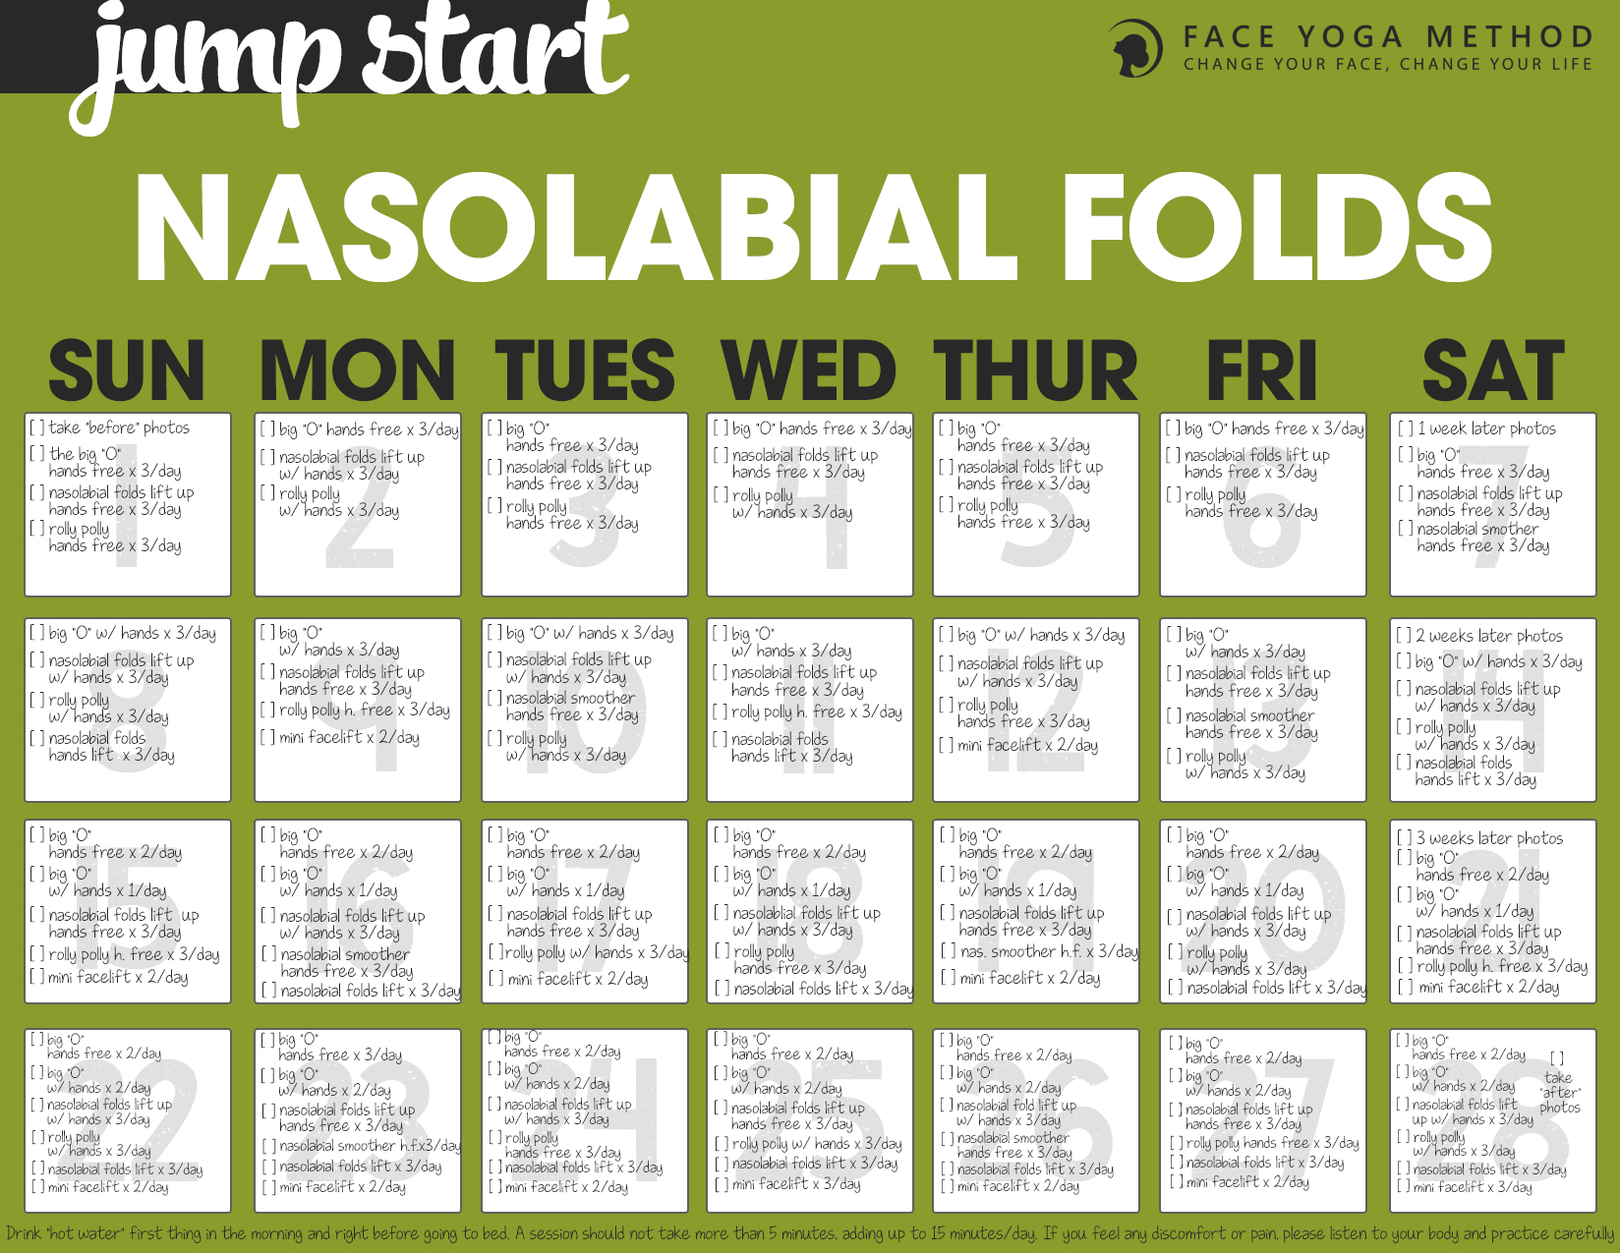

Nasolabial Folds Jump Start

Introduction
After completing the Laugh At Those Laugh Lines – 28 Day Jump Start program, you will learn how to combat nasolabial fold lines throughout the day.
Nasolabial folds are sometimes called smile/laugh lines. As we age, nasolabial fold lines get longer and deeper. Longer and deeper nasolabial lines make you look older. You may think that only surgeries and injections can reduce nasolabial fold lines, but when you train certain face muscles, you can lift up and reduce these lines. If you want to reduce/prevent nasolabial fold lines naturally, this program is for you!
First, look at yourself in the mirror. Without smiling, check your nasolabial fold lines on both sides of your mouth. Do you notice a difference between the two sides of your mouth? Are the lines deeper or longer on one of the sides? Are they symmetrical or asymmetrical?
If you notice asymmetry in the nasolabial fold lines, I suggest you think about how you sleep. Are you a side sleeper? If so, which side do you sleep on?
In my experience, I have noticed that many side sleepers have asymmetrical nasolabial fold lines, which means, one side of the nasolabial fold lines are much longer and/or deeper.
If you’re a side sleeper and sleeping on the same side, your nasolabial fold lines will get deeper and longer and become permanent. For instance, if you sleep on your right side, it is very likely the nasolabial fold lines on the right side of your face are deeper and longer.
I know it can be very hard to change sleeping positions but quite often by paying attention and changing your sleeping position you can dramatically reduce the asymmetry, length and depth of your nasolabial fold lines.
To avoid future damage, I recommend that you check your sleeping patterns and the pillow you use at night before staring this Jump Start.
Please refer to this video blog post where I talk about the relationship between nasolabial fold lines and sleeping pillows.
One of the best ways to decrease and soften the nasolabial fold lines is to strengthen the muscles of the mouth and cheeks (there are 11 muscles). Since gravity pulls these muscles down, it is effective to lift these muscles up so that nasolabial fold lines will be lifted up. It may not be easy at first, but try to relax the rest of the facial muscles and isolate the muscle(s) you use for the exercises. If it is too hard, put your finger on your face and feel the muscles under the skin. Just paying attention to your own facial movements helps you to isolate the muscles.
Try to keep lifting up your cheek muscles during the day. Your cheek area will get more exercise without even doing the actual poses and as a result, your nasolabial folds will become smoother and less visible.
If you want to see results, you need to commit to the following: practice every day for 28 days and keep track of your progress on a daily basis. It has been said that it takes about 28 days to change form a new habit. This means that you need to commit to practicing the Laugh At Those Laugh Lines – 28 Day Jump Start Program every day for 28 days.
Pro tip! Take photos under the same conditions (lighting, same camera, clothing etc.) The before and after photos are essential because it is harder to see changes in the face compared to the body. You need motivation and you need it be fun! Here is the schedule for your photo session:
Start – Take “before” photos (profile and close up on the nasolabial folds area)
Week 1 – Take photos (profile and close up on the nasolabial folds area)
Week 2 – Take photos (profile and close up on the nasolabial folds area)
Week 3 – Take photos (profile and close up on the nasolabial folds area)
Week 4 – Take “after” photos (profile and close up on the nasolabial folds area)
Daily
Drink “hot water” first thing in the morning and right before going to bed. Drinking hot water helps you to detox from the inside out. If your body is dehydrated it shows in your eyes. Drink water throughout the day before you feel thirsty. Healthy skin starts with good hydration.
For best results:
- Check your sleep position
- Check your preference when chewing food/chewing gum
- Pay attention to your cheek muscles and both corners of your mouth.

When practicing these poses make sure you relax your jaw. The purpose of these exercises is not for your jaw area, it is for the nasolabial fold lines. I have seen people tense up the jaw area while doing these exercises and they end up building unwanted jaw muscles. If relaxing the jaw area while performing some exercises listed here is too hard, come out and breathe out deeply and then try the pose again.
For best results, keep breathing and focusing on the muscles you are using to do the poses.
Like any other exercise, if you feel any discomfort/pain or start noticing negative changes, please practice the poses carefully or ask professional help. The poses will build up as the days progress and you will do more poses toward the end of this challenge. In that sense, this program can be little bit intense especially toward the end of 28 days. Don’t get overwhelmed! It should not take more than 15 minutes a session. You don’t need to practice all the poses at one session but rather divide them throughout the day. You can also do some of the poses (especially hands free ones) while doing something else, like driving, cooking and watching TV. As always a good, nutritious diet with plenty of water, and a lot of fresh fruits, vegetables, and protein is important to improve your skin condition. Keep your sugar consumption very very low. Sugar is one of the worst ingredients for your skin.
Caution: You can do most of these poses 3 times a day except The Mini Face Lift, which you can practice up to two times a day. The Mini Face Lift requires you to put your fingers into an exact position so make sure you practice this pose in front of the mirror until you learn the technique. If you place your fingers in the correct position, you can expect instant changes on not only nasolabial fold lines but also your eyelids and face lines.
Let’s get started!
You can do this!
Start by visualizing your end results!
All of us should have an opportunity to feel and look the very best for our age.
Fumiko Takatsu

Day 1
1. Take “Before” photos (profile and close up on the mouth area).
2. The Big O – 3 times throughout the day
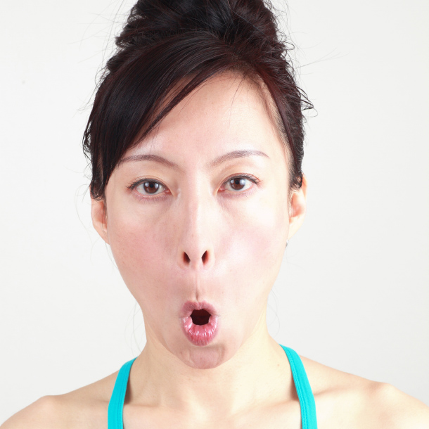

Benefits

Instructions Open the mouth, make an “O” shape with the mouth, make the face long, pressing the upper mouth firmly against the teeth. Feel the stretch in the muscles surrounding the mouth and nose.

Tips You should feel the muscle movement from the corners of the mouth to the corners of the eyes.
Smooths the nasolabial fold lines

3. The Nasolabial Folds Lift Up (hands free) – 3 times throughout the day
THE NASOLABIAL FOLDS LIFT UP – HANDS FREE
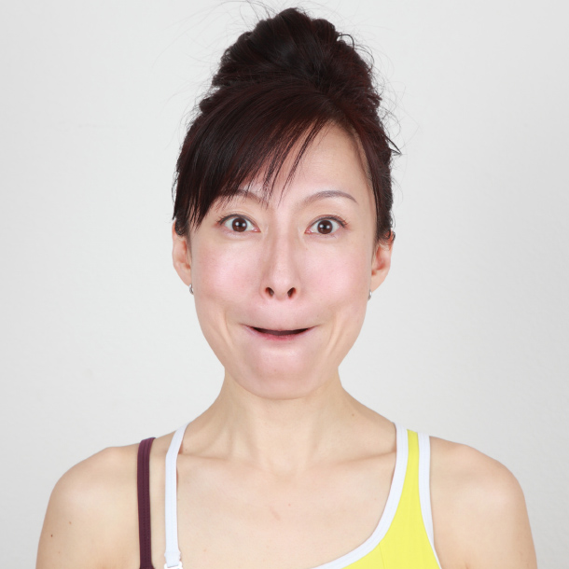
Smooths out the nasolabial fold lines
THE NASOLABIAL FOLDS LIFT UP – WITH HANDS
Benefits: smooths out the nasolabial fold lines and lifts up the lower face lines.
Open the chest, relax the shoulders and push down the shoulder blades. Make sure both corners of the mouth are at the same level.
1. Place both palms on the ears, apply slight pressure, pull hands toward the back of the head.
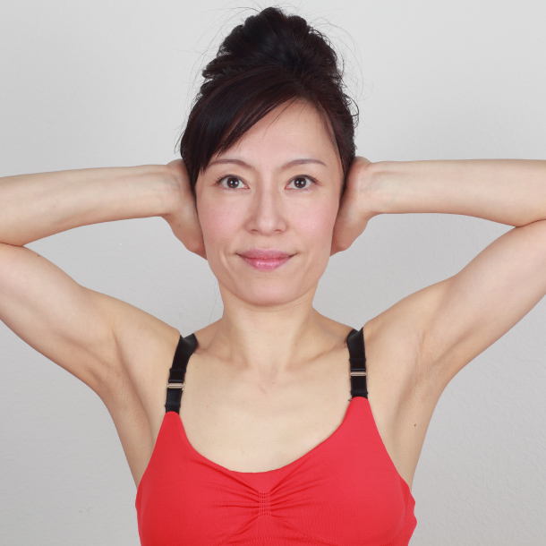
2. Curl the upper and lower lips over the teeth without wrinkling the lips and lift up the corners of the mouth.
3. Hold this position for 5 seconds. Repeat 2 times.
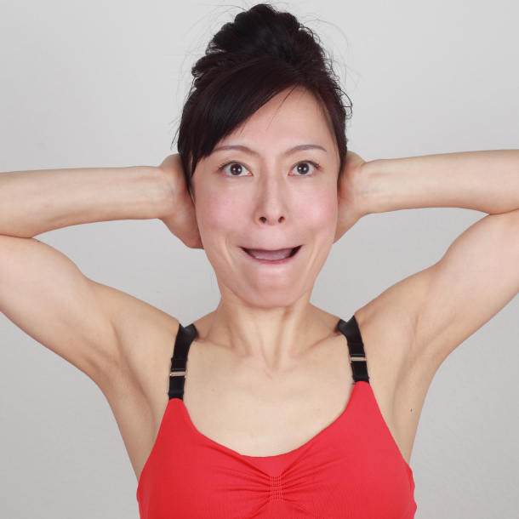
.

4. The Rolly Polly (hands free) – 3 times throughout the day
THE ROLLY POLLY – HANDS FREE
Benefits: firms and strengthens the area around the mouth and reduces the nasolabial folds.
You may feel a strange tightness or stimulation under the chin area or the back of your head at first. Just try to breathe out while moving the tongue. Eventually the pain/discomfort will go away and you will be able to move the tongue much easier.
1. Push the right side of the mouth with the tongue very hard.
2. Move the tongue slowly clock-wise around the mouth, taking about 5 seconds.
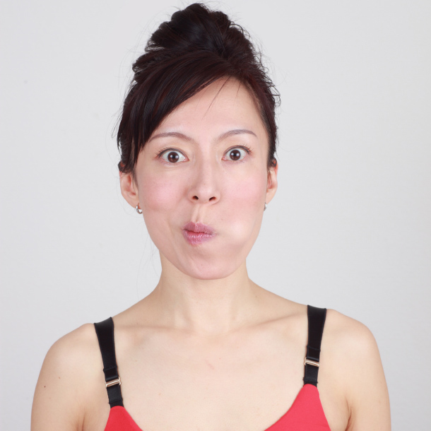
3. Repeat 2 more times.
4. Move the tongue slowly counter clock-wise taking about 5 seconds.
5. Repeat 2 more times.
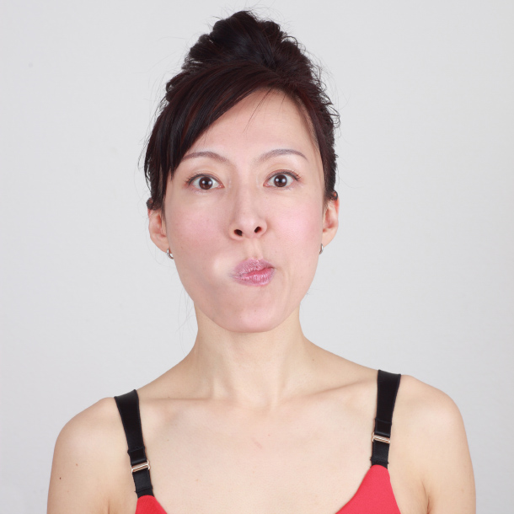

Day 2
1. The Big O – 3 times throughout the day

Benefits

Instructions Open the mouth, make an “O” shape with the mouth, make the face long, pressing the upper mouth firmly against the teeth. Feel the stretch in the muscles surrounding the mouth and nose.

Tips You should feel the muscle movement from the corners of the mouth to the corners of the eyes.
Smooths the nasolabial fold lines

2. The Nasolabial Folds Lift Up (with hands) – 3 times throughout the day
THE NASOLABIAL FOLDS LIFT UP – WITH HANDS
Benefits: smooths out the nasolabial fold lines and lifts up the lower face lines.
Open the chest, relax the shoulders and push down the shoulder blades. Make sure both corners of the mouth are at the same level.
1. Place both palms on the ears, apply slight pressure, pull hands toward the back of the head.
2. Curl the upper and lower lips over the teeth without wrinkling the lips and lift up the corners of the mouth.
3. Hold this position for 5 seconds. Repeat 2 times.

3. The Rolly Polly (with hands) – 3 times throughout the day
THE ROLLY POLLY – WITH HANDS
Benefits: firms the area around the mouth, reduces the folds and lifts up the sides of the face.
You may feel a strange tightness or stimulation under the chin area or the back of your head at first. Just try to breathe out while moving the tongue. Eventually the pain/discomfort will go away and you will be able to move the tongue much easier.
1. Place both hands on the side of the face, thumbs under the ears, index, middle and ring finders on the temple area.
2. Move the hands toward the ears and lift up.
3. Pull the shoulder blades down and relax the shoulders.
4. Push the right side of the mouth with the tongue very hard.
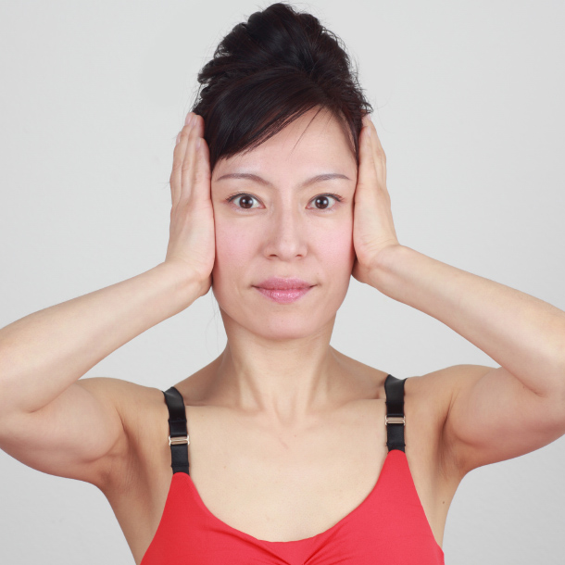
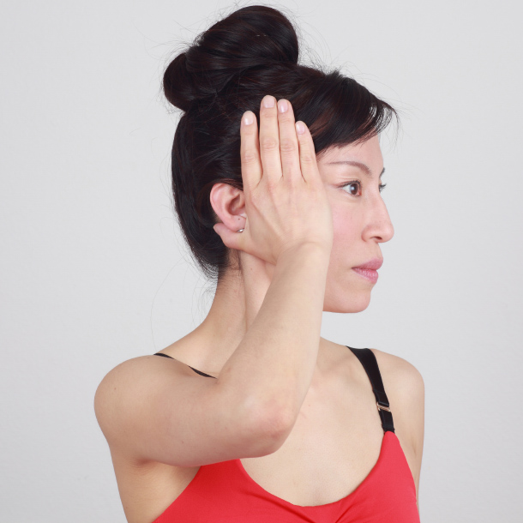
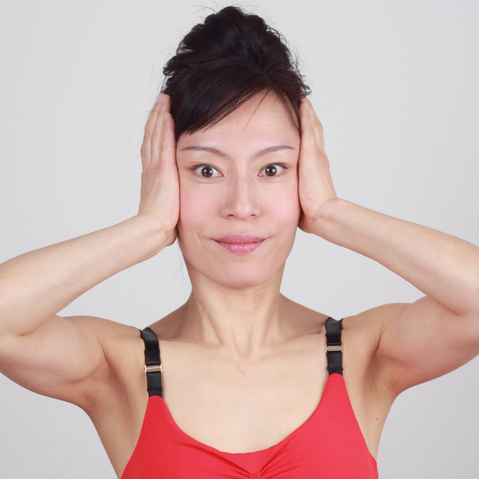

Day 3
1. The Big O – 3 times throughout the day

Benefits

Instructions

Tips
Open the mouth, make an “O” shape with the mouth, make the face long, pressing the upper mouth firmly against the teeth. Feel the stretch in the muscles surrounding the mouth and nose.

2. The Nasolabial Folds Lift Up (hands free) – 3 times throughout the day
THE NASOLABIAL FOLDS LIFT UP – HANDS FREE

Benefits

Instructions

Tips
Curl the upper and lower lips over the teeth without wrinkling the lips and lift up the corners of the mouth. Hold this position for 5 seconds. Repeat 2 times. Mouth slightly open.

3. The Rolly Polly (hands free) – 3 times throughout the day
THE ROLLY POLLY – HANDS FREE
Benefits: firms and strengthens the area around the mouth and reduces the nasolabial folds.
You may feel a strange tightness or stimulation under the chin area or the back of your head at first. Just try to breathe out while moving the tongue. Eventually the pain/discomfort will go away and you will be able to move the tongue much easier. Mouth closed.
1. Push the right side of the mouth with the tongue very hard.
2. Move the tongue slowly clock-wise around the mouth, taking about 5 seconds.
3. Repeat 2 more times.
4. Move the tongue slowly counter clock-wise taking about 5 seconds.
5. Repeat 2 more times.

Day 4
1. The Big O – 3 times throughout the day

Benefits

Instructions

Tips
Open the mouth, make an “O” shape with the mouth, make the face long, pressing the upper mouth firmly against the teeth. Feel the stretch in the muscles surrounding the mouth and nose.

2. The Nasolabial Folds Lift Up (with hands) – 3 times throughout the day
THE NASOLABIAL FOLDS LIFT UP – WITH HANDS
Benefits: smooths out the nasolabial fold lines and lifts up the lower face lines.
Open the chest, relax the shoulders and push down the shoulder blades. Make sure both corners of the mouth are at the same level.
1. Place both palms on the ears, apply slight pressure, pull hands toward the back of the head.
2. Curl the upper and lower lips over the teeth without wrinkling the lips and lift up the corners of the mouth.
3. Hold this position for 5 seconds. Repeat 2 times.

3. The Rolly Polly (with hands) – 3 times throughout the day
THE ROLLY POLLY – WITH HANDS
Benefits: firms the area around the mouth, reduces the folds and lifts up the sides of the face.
You may feel a strange tightness or stimulation under the chin area or the back of your head at first. Just try to breathe out while moving the tongue. Eventually the pain/discomfort will go away and you will be able to move the tongue much easier.
1. Place both hands on the side of the face, thumbs under the ears, index, middle and ring finders on the temple area.
2. Move the hands toward the ears and lift up.
3. Pull the shoulder blades down and relax the shoulders.
4. Push the right side of the mouth with the tongue very hard.
As for the creases in the nasolabial folds area when you perform the “nasolabial fold lift up,” imagine that you are lifting the cheeks (imagine a line connecting at the corners of the mouth to the outer side of the eye) with the cheek muscles and the mouth area should be very relaxed. If you still see a lot of creases in the nasolabial folds lines, adjust the chin position by moving the chin slightly forward. The movement can be very subtle but by doing so you should find the EXACT chin position that you see least nasolabial folds lines.

Day 5
1. The Big O – 3 times throughout the day

Benefits

Instructions

Tips
Open the mouth, make an “O” shape with the mouth, make the face long, pressing the upper mouth firmly against the teeth. Feel the stretch in the muscles surrounding the mouth and nose.

2. The Nasolabial Folds Lift Up (hands free) – 3 times throughout the day
THE NASOLABIAL FOLDS LIFT UP – HANDS FREE

Benefits

Instructions

Tips
Curl the upper and lower lips over the teeth without wrinkling the lips and lift up the corners of the mouth. Hold this position for 5 seconds. Repeat 2 times.

3. The Rolly Polly (hands free) – 3 times throughout the day
THE ROLLY POLLY – HANDS FREE
Benefits: firms and strengthens the area around the mouth and reduces the nasolabial folds.
You may feel a strange tightness or stimulation under the chin area or the back of your head at first. Just try to breathe out while moving the tongue. Eventually the pain/discomfort will go away and you will be able to move the tongue much easier.
1. Push the right side of the mouth with the tongue very hard.
2. Move the tongue slowly clock-wise around the mouth, taking about 5 seconds.
3. Repeat 2 more times.
4. Move the tongue slowly counter clock-wise taking about 5 seconds.
5. Repeat 2 more times.

Day 6
1. The Big O – 3 times throughout the day

Benefits

Instructions

Tips
Open the mouth, make an “O” shape with the mouth, make the face long, pressing the upper mouth firmly against the teeth. Feel the stretch in the muscles surrounding the mouth and nose.

2. The Nasolabial Folds Lift Up (with hands) – 3 times throughout the day
THE NASOLABIAL FOLDS LIFT UP – WITH HANDS
Benefits: smooths out the nasolabial fold lines and lifts up the lower face lines.
Open the chest, relax the shoulders and push down the shoulder blades. Make sure both corners of the mouth are at the same level.
1. Place both palms on the ears, apply slight pressure, pull hands toward the back of the head.
2. Curl the upper and lower lips over the teeth without wrinkling the lips and lift up the corners of the mouth.
3. Hold this position for 5 seconds. Repeat 2 times.

3. The Rolly Polly (hands free) – 3 times throughout the day
THE ROLLY POLLY – HANDS FREE
Benefits: firms and strengthens the area around the mouth and reduces the nasolabial folds.
You may feel a strange tightness or stimulation under the chin area or the back of your head at first. Just try to breathe out while moving the tongue. Eventually the pain/discomfort will go away and you will be able to move the tongue much easier.
1. Push the right side of the mouth with the tongue very hard.
2. Move the tongue slowly clock-wise around the mouth, taking about 5 seconds.
3. Repeat 2 more times.
4. Move the tongue slowly counter clock-wise taking about 5 seconds.
5. Repeat 2 more times.

Day 7
1. Take “1 week later” photo
2. The Big O – 3 times throughout the day

Benefits

Instructions

Tips
Open the mouth, make an “O” shape with the mouth, make the face long, pressing the upper mouth firmly against the teeth. Feel the stretch in the muscles surrounding the mouth and nose.

3. The Nasolabial Folds Lift Up (hands free) – 3 times throughout the day
THE NASOLABIAL FOLDS LIFT UP – HANDS FREE

Benefits

Instructions

Tips
Curl the upper and lower lips over the teeth without wrinkling the lips and lift up the corners of the mouth. Hold this position for 5 seconds. Repeat 2 times.

3. The Nasolabial Smoother (hands free) – 3 times throughout the day
THE NASOLABIAL SMOOTHER – HANDS FREE
Benefits: smooths out and shortens the nasolabial fold lines.
When you move the air to the upper lip you keep that area smoothed out. This exercise is great for getting rid of the vertical lines that occur on the upper lips as you age. These lines are also known as “smoker lines”.
Close the lips tight and fill the mouth with air.
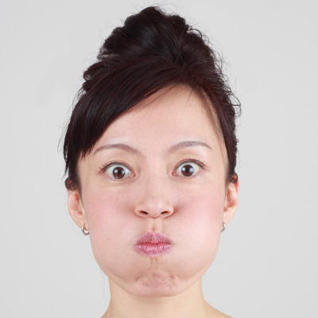
Push the air in front towards the lips and hold for 5 seconds.
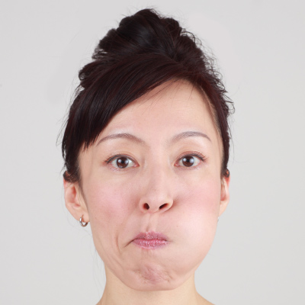
Move the air to the right and hold for 5 seconds.
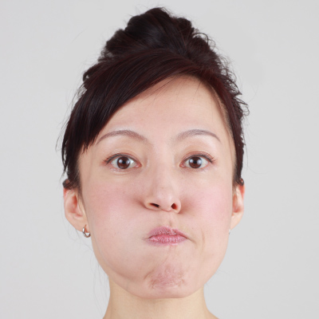
Move the air to the left and hold for 5 seconds.
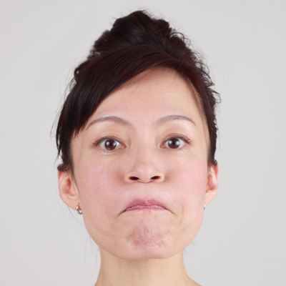
Move the air to the upper mouth and hold for 5 seconds.
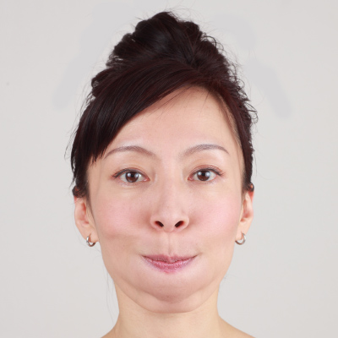
Move the air to the lower mouth and hold for 5 seconds. Repeat 2 times total.
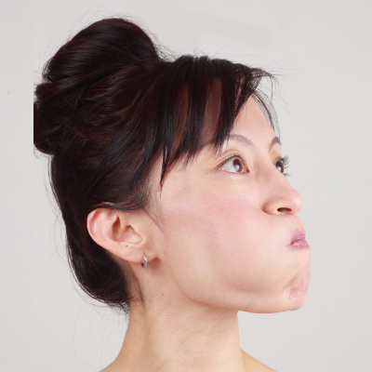

Nasolabial Folds Jump Start

Day 8
1. The Big O – 3 times throughout the day

Benefits

Instructions

Tips
Open the mouth, make an “O” shape with the mouth, make the face long, pressing the upper mouth firmly against the teeth. Feel the stretch in the muscles surrounding the mouth and nose.

2. The Nasolabial Folds Lift Up (with hands) – 3 times throughout the day
THE NASOLABIAL FOLDS LIFT UP – WITH HANDS
Benefits: smooths out the nasolabial fold lines and lifts up the lower face lines.
Open the chest, relax the shoulders and push down the shoulder blades. Make sure both corners of the mouth are at the same level.
1. Place both palms on the ears, apply slight pressure, pull hands toward the back of the head.
2. Curl the upper and lower lips over the teeth without wrinkling the lips and lift up the corners of the mouth.
3. Hold this position for 5 seconds. Repeat 2 times.

3. The Rolly Polly (with hands) – 3 times throughout the day

Yes, you need to do the same on the left side o your mouth. Here is the missing part ; Move the tongue slowly clockwise around the mouth, taking about 5 seconds and push the left side of your mouth with your tongue very hard.

THE ROLLY POLLY – WITH HANDS
Benefits: firms the area around the mouth, reduces the folds and lifts up the sides of the face.
You may feel a strange tightness or stimulation under the chin area or the back of your head at first. Just try to breathe out while moving the tongue. Eventually the pain/discomfort will go away and you will be able to move the tongue much easier.
1. Place both hands on the side of the face, thumbs under the ears, index, middle and ring finders on the temple area.
2. Move the hands toward the ears and lift up.
3. Pull the shoulder blades down and relax the shoulders.
4. Push the right side of the mouth with the tongue very hard.

4. The Nasolabial Folds Hands Lift – 3 times throughout the day

Day 9
1. The Big O – 3 times throughout the day

Benefits

Instructions

Tips
Open the mouth, make an “O” shape with the mouth, make the face long, pressing the upper mouth firmly against the teeth. Feel the stretch in the muscles surrounding the mouth and nose.

2. The Nasolabial Folds Lift Up (hands free) – 3 times throughout the day
THE NASOLABIAL FOLDS LIFT UP – HANDS FREE

Benefits

Instructions

Tips
Curl the upper and lower lips over the teeth without wrinkling the lips and lift up the corners of the mouth. Hold this position for 5 seconds. Repeat 2 times.

3. The Rolly Polly (hands free) – 3 times throughout the day
THE ROLLY POLLY – HANDS FREE
Benefits: firms and strengthens the area around the mouth and reduces the nasolabial folds.
You may feel a strange tightness or stimulation under the chin area or the back of your head at first. Just try to breathe out while moving the tongue. Eventually the pain/discomfort will go away and you will be able to move the tongue much easier.
1. Push the right side of the mouth with the tongue very hard.
2. Move the tongue slowly clock-wise around the mouth, taking about 5 seconds.
3. Repeat 2 more times.
4. Move the tongue slowly counter clock-wise taking about 5 seconds.
5. Repeat 2 more times.

4. The Mini FaceLift – 2 times throughout the day
Benefits: helps to lift up the side of the face, kind of like a mini facelift without all the trauma.
Breathing is very important in this pose. Sit tall, open your chest and relax your shoulders for maximum results.
1. Raise the right arm at a 45º angle and the left hand up to the ceiling.
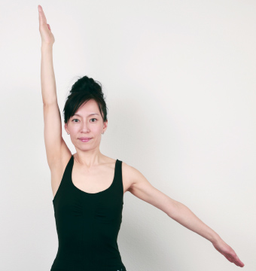
2. Place the left ring finger at the corner of your right eye and the middle finger on the temple.
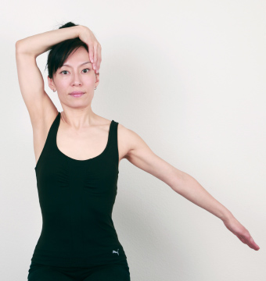
3. Bend your head to the left.
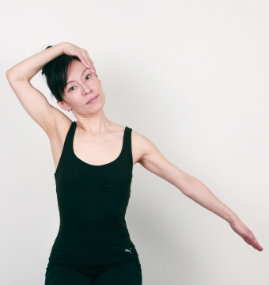
4. Stick your tongue out to the left toward the floor and breathe out completely through your mouth saying “haaa”
5. Repeat twice on each side.
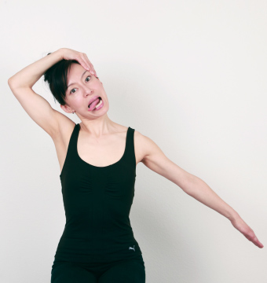

Day 10
1. The Big O – 3 times throughout the day

Benefits

Instructions

Tips
Open the mouth, make an “O” shape with the mouth, make the face long, pressing the upper mouth firmly against the teeth. Feel the stretch in the muscles surrounding the mouth and nose.

2. The Nasolabial Folds Lift Up (with hands) – 3 times throughout the day
THE NASOLABIAL FOLDS LIFT UP – WITH HANDS
Benefits: smooths out the nasolabial fold lines and lifts up the lower face lines.
Open the chest, relax the shoulders and push down the shoulder blades. Make sure both corners of the mouth are at the same level.
1. Place both palms on the ears, apply slight pressure, pull hands toward the back of the head.
2. Curl the upper and lower lips over the teeth without wrinkling the lips and lift up the corners of the mouth.
3. Hold this position for 5 seconds. Repeat 2 times.

3. The Nasolabial Smoother (hands free) – 3 times throughout the day
THE NASOLABIAL SMOOTHER – HANDS FREE
Benefits: smooths out and shortens the nasolabial fold lines.
When you move the air to the upper lip you keep that area smoothed out. This exercise is great for getting rid of the vertical lines that occur on the upper lips as you age. These lines are also known as “smoker lines”.
Close the lips tight and fill the mouth with air.
Push the air in front towards the lips and hold for 5 seconds.
Move the air to the right and hold for 5 seconds.
Move the air to the left and hold for 5 seconds.
Move the air to the upper mouth and hold for 5 seconds.
Move the air to the lower mouth and hold for 5 seconds. Repeat 2 times total.

4. The Rolly Polly (with hands) – 2 times throughout the day
THE ROLLY POLLY – WITH HANDS
Benefits: firms the area around the mouth, reduces the folds and lifts up the sides of the face.
You may feel a strange tightness or stimulation under the chin area or the back of your head at first. Just try to breathe out while moving the tongue. Eventually the pain/discomfort will go away and you will be able to move the tongue much easier.
1. Place both hands on the side of the face, thumbs under the ears, index, middle and ring finders on the temple area.
2. Move the hands toward the ears and lift up.
3. Pull the shoulder blades down and relax the shoulders.
4. Push the right side of the mouth with the tongue very hard.

Nasolabial Folds Jump Start

Day 11
1. The Big O hands free – 3 times throughout the day

Benefits

Instructions

Tips
Open the mouth, make an “O” shape with the mouth, make the face long, pressing the upper mouth firmly against the teeth. Feel the stretch in the muscles surrounding the mouth and nose.

2. The Nasolabial Folds Lift Up (hands free) – 3 times throughout the day
THE NASOLABIAL FOLDS LIFT UP – HANDS FREE

Benefits

Instructions

Tips
Curl the upper and lower lips over the teeth without wrinkling the lips and lift up the corners of the mouth. Hold this position for 5 seconds. Repeat 2 times.

3. The Rolly Polly (hands free) – 3 times throughout the day
THE ROLLY POLLY – HANDS FREE
Benefits: firms and strengthens the area around the mouth and reduces the nasolabial folds.
You may feel a strange tightness or stimulation under the chin area or the back of your head at first. Just try to breathe out while moving the tongue. Eventually the pain/discomfort will go away and you will be able to move the tongue much easier.
1. Push the right side of the mouth with the tongue very hard.
2. Move the tongue slowly clock-wise around the mouth, taking about 5 seconds.
3. Repeat 2 more times.
4. Move the tongue slowly counter clock-wise taking about 5 seconds.
5. Repeat 2 more times.

4. The Nasolabial Folds Hands Lift – 3 times throughout the day

Day 12
1. The Big O – 3 times throughout the day

Benefits

Instructions

Tips
Open the mouth, make an “O” shape with the mouth, make the face long, pressing the upper mouth firmly against the teeth. Feel the stretch in the muscles surrounding the mouth and nose.

2. The Nasolabial Folds Lift Up (with hands) – 3 times throughout the day
THE NASOLABIAL FOLDS LIFT UP – WITH HANDS
Benefits: smooths out the nasolabial fold lines and lifts up the lower face lines.
Open the chest, relax the shoulders and push down the shoulder blades. Make sure both corners of the mouth are at the same level.
1. Place both palms on the ears, apply slight pressure, pull hands toward the back of the head.
2. Curl the upper and lower lips over the teeth without wrinkling the lips and lift up the corners of the mouth.
3. Hold this position for 5 seconds. Repeat 2 times.

3. The Rolly Polly (hands free) – 3 times throughout the day
THE ROLLY POLLY – HANDS FREE
Benefits: firms and strengthens the area around the mouth and reduces the nasolabial folds.
You may feel a strange tightness or stimulation under the chin area or the back of your head at first. Just try to breathe out while moving the tongue. Eventually the pain/discomfort will go away and you will be able to move the tongue much easier.
1. Push the right side of the mouth with the tongue very hard.
2. Move the tongue slowly clock-wise around the mouth, taking about 5 seconds.
3. Repeat 2 more times.
4. Move the tongue slowly counter clock-wise taking about 5 seconds.
5. Repeat 2 more times.

4. Mini FaceLift – 3 times throughout the day
Benefits: helps to lift up the side of the face, kind of like a mini facelift without all the trauma.
Breathing is very important in this pose. Sit tall, open your chest and relax your shoulders for maximum results.
1. Raise the right arm at a 45º angle and the left hand up to the ceiling.
2. Place the left ring finger at the corner of your right eye and the middle finger on the temple.
3. Bend your head to the left.
4. Stick your tongue out to the left toward the floor and breathe out completely through your mouth saying “haaa”
5. Repeat twice on each side.

If my lips get lines in them when doing the rolly polly and (3) nasolabial smoother, should I not do them, I feel like it's exaggerating my lines on and around my lips.


CarissaCooper
October 2, 2016 Reply
What should I do?
- 

Fumiko Takatsu
October 26, 2016
Hi Carissa,
First, try to isolate all the muscles you are working on when you perform the poses so that you can prevent unwanted wrinkles. And after each pose, smile and hold it for awhile until you “feel” the tightness. Also right after you perform the poses, drink a cup of hot water if available so that you improve blood circulation.
If you still think the lines are exaggerating, you can skip the poses but I think if you apply the suggestions above, you can reduce the lines.

Day 13
1. The Big O– 3 times throughout the day

Benefits

Instructions

Tips
Open the mouth, make an “O” shape with the mouth, make the face long, pressing the upper mouth firmly against the teeth. Feel the stretch in the muscles surrounding the mouth and nose.

2. The Nasolabial Folds Lift Up (hands free) – 3 times throughout the day
THE NASOLABIAL FOLDS LIFT UP – HANDS FREE

Benefits

Instructions

Tips
Curl the upper and lower lips over the teeth without wrinkling the lips and lift up the corners of the mouth. Hold this position for 5 seconds. Repeat 2 times.

3. The Nasolabial Smoother (hands free) – 3 times throughout the day
THE NASOLABIAL SMOOTHER – HANDS FREE
Benefits: smooths out and shortens the nasolabial fold lines.
When you move the air to the upper lip you keep that area smoothed out. This exercise is great for getting rid of the vertical lines that occur on the upper lips as you age. These lines are also known as “smoker lines”.
Close the lips tight and fill the mouth with air.
Push the air in front towards the lips and hold for 5 seconds.
Move the air to the right and hold for 5 seconds.
Move the air to the left and hold for 5 seconds.
Move the air to the upper mouth and hold for 5 seconds.
Move the air to the lower mouth and hold for 5 seconds. Repeat 2 times total.

4. The Rolly Polly (with hands) – 3 times throughout the day
THE ROLLY POLLY – WITH HANDS
Benefits: firms the area around the mouth, reduces the folds and lifts up the sides of the face.
You may feel a strange tightness or stimulation under the chin area or the back of your head at first. Just try to breathe out while moving the tongue. Eventually the pain/discomfort will go away and you will be able to move the tongue much easier.
1. Place both hands on the side of the face, thumbs under the ears, index, middle and ring finders on the temple area.
2. Move the hands toward the ears and lift up.
3. Pull the shoulder blades down and relax the shoulders.
4. Push the right side of the mouth with the tongue very hard.

Day 14
1. Take “2 weeks later” photo
2. The Big O – 3 times throughout the day

Benefits

Instructions

Tips
Open the mouth, make an “O” shape with the mouth, make the face long, pressing the upper mouth firmly against the teeth. Feel the stretch in the muscles surrounding the mouth and nose.

3. The Nasolabial Folds Lift Up (with hands) – 3 times throughout the day
THE NASOLABIAL FOLDS LIFT UP – WITH HANDS
Benefits: smooths out the nasolabial fold lines and lifts up the lower face lines.
Open the chest, relax the shoulders and push down the shoulder blades. Make sure both corners of the mouth are at the same level.
1. Place both palms on the ears, apply slight pressure, pull hands toward the back of the head.
2. Curl the upper and lower lips over the teeth without wrinkling the lips and lift up the corners of the mouth.
3. Hold this position for 5 seconds. Repeat 2 times.

4. The Rolly Polly (with hands) – 3 times throughout the day
THE ROLLY POLLY – WITH HANDS
Benefits: firms the area around the mouth, reduces the folds and lifts up the sides of the face.
You may feel a strange tightness or stimulation under the chin area or the back of your head at first. Just try to breathe out while moving the tongue. Eventually the pain/discomfort will go away and you will be able to move the tongue much easier.
1. Place both hands on the side of the face, thumbs under the ears, index, middle and ring finders on the temple area.
2. Move the hands toward the ears and lift up.
3. Pull the shoulder blades down and relax the shoulders.
4. Push the right side of the mouth with the tongue very hard.

5. The Nasolabial Folds Hands Lift – 3 times throughout the day

Day 15
1. The Big O (with hands) – 1 times throughout the day
THE BIG “O” – WITH HANDS
Benefits: smooths the nasolabial fold lines and lifts up the upper face lines.
You should feel the muscle movement from the corners of the mouth to the corners of the eyes. By pressing the upper mouth firmly against the teeth, you should feel more stretches.
1. Place both palms on the temples.

2. Push the hands upward, lifting the sides of the face.

3. Open the mouth, make an “O” shape with the mouth and make the face long.
4. Press the upper mouth firmly against the teeth.


2. The Big O (hands free) – 2 times throughout the day

Benefits

Instructions

Tips
Open the mouth, make an “O” shape with the mouth, make the face long, pressing the upper mouth firmly against the teeth. Feel the stretch in the muscles surrounding the mouth and nose.

3. The Nasolabial Folds Lift Up (hands free) – 3 times throughout the day
THE NASOLABIAL FOLDS LIFT UP – HANDS FREE

Benefits

Instructions

Tips
Curl the upper and lower lips over the teeth without wrinkling the lips and lift up the corners of the mouth. Hold this position for 5 seconds. Repeat 2 times.

4. The Rolly Polly (hands free) – 3 times throughout the day
THE ROLLY POLLY – HANDS FREE
Benefits: firms and strengthens the area around the mouth and reduces the nasolabial folds.
You may feel a strange tightness or stimulation under the chin area or the back of your head at first. Just try to breathe out while moving the tongue. Eventually the pain/discomfort will go away and you will be able to move the tongue much easier.
1. Push the right side of the mouth with the tongue very hard.
2. Move the tongue slowly clock-wise around the mouth, taking about 5 seconds.
3. Repeat 2 more times.
4. Move the tongue slowly counter clock-wise taking about 5 seconds.
5. Repeat 2 more times.

5. The Mini FaceLift – 2 times throughout the day
Benefits: helps to lift up the side of the face, kind of like a mini facelift without all the trauma.
Breathing is very important in this pose. Sit tall, open your chest and relax your shoulders for maximum results.
1. Raise the right arm at a 45º angle and the left hand up to the ceiling.
2. Place the left ring finger at the corner of your right eye and the middle finger on the temple.
3. Bend your head to the left.
4. Stick your tongue out to the left toward the floor and breathe out completely through your mouth saying “haaa”
5. Repeat twice on each side.

Day 16
1. The Big O (with hands) – 1 times throughout the day
THE BIG “O” – WITH HANDS
Benefits: smooths the nasolabial fold lines and lifts up the upper face lines.
You should feel the muscle movement from the corners of the mouth to the corners of the eyes. By pressing the upper mouth firmly against the teeth, you should feel more stretches.
1. Place both palms on the temples.
2. Push the hands upward, lifting the sides of the face.
3. Open the mouth, make an “O” shape with the mouth and make the face long.
4. Press the upper mouth firmly against the teeth.

2. The Big O (hands free) – 2 times throughout the day

Benefits

Instructions

Tips
Open the mouth, make an “O” shape with the mouth, make the face long, pressing the upper mouth firmly against the teeth. Feel the stretch in the muscles surrounding the mouth and nose.

3. The Nasolabial Folds Lift Up (with hands) – 3 times throughout the day
THE NASOLABIAL FOLDS LIFT UP – WITH HANDS
Benefits: smooths out the nasolabial fold lines and lifts up the lower face lines.
Open the chest, relax the shoulders and push down the shoulder blades. Make sure both corners of the mouth are at the same level.
1. Place both palms on the ears, apply slight pressure, pull hands toward the back of the head.
2. Curl the upper and lower lips over the teeth without wrinkling the lips and lift up the corners of the mouth.
3. Hold this position for 5 seconds. Repeat 2 times.

4. The Nasolabial Smoother (hands free) – 3 times throughout the day
THE NASOLABIAL SMOOTHER – HANDS FREE
Benefits: smooths out and shortens the nasolabial fold lines.
When you move the air to the upper lip you keep that area smoothed out. This exercise is great for getting rid of the vertical lines that occur on the upper lips as you age. These lines are also known as “smoker lines”.
Close the lips tight and fill the mouth with air.
Push the air in front towards the lips and hold for 5 seconds.
Move the air to the right and hold for 5 seconds.
Move the air to the left and hold for 5 seconds.
Move the air to the upper mouth and hold for 5 seconds.
Move the air to the lower mouth and hold for 5 seconds. Repeat 2 times total.

5. The Nasolabial Folds Hands Lift – 3 times throughout the day

Day 17
1. The Big O (with hands) – 1 times throughout the day
THE BIG “O” – WITH HANDS
Benefits: smooths the nasolabial fold lines and lifts up the upper face lines.
You should feel the muscle movement from the corners of the mouth to the corners of the eyes. By pressing the upper mouth firmly against the teeth, you should feel more stretches.
1. Place both palms on the temples.
2. Push the hands upward, lifting the sides of the face.
3. Open the mouth, make an “O” shape with the mouth and make the face long.
4. Press the upper mouth firmly against the teeth.

2. The Big O (hands free) – 2 times throughout the day

Benefits

Instructions

Tips
Open the mouth, make an “O” shape with the mouth, make the face long, pressing the upper mouth firmly against the teeth. Feel the stretch in the muscles surrounding the mouth and nose.

3. The Nasolabial Folds Lift Up (hands free) – 3 times throughout the day
THE NASOLABIAL FOLDS LIFT UP – HANDS FREE

Benefits

Instructions

Tips
Curl the upper and lower lips over the teeth without wrinkling the lips and lift up the corners of the mouth. Hold this position for 5 seconds. Repeat 2 times.

4. The Rolly Polly (with hands) – 3 times throughout the day
THE ROLLY POLLY – WITH HANDS
Benefits: firms the area around the mouth, reduces the folds and lifts up the sides of the face.
You may feel a strange tightness or stimulation under the chin area or the back of your head at first. Just try to breathe out while moving the tongue. Eventually the pain/discomfort will go away and you will be able to move the tongue much easier.
1. Place both hands on the side of the face, thumbs under the ears, index, middle and ring finders on the temple area.
2. Move the hands toward the ears and lift up.
3. Pull the shoulder blades down and relax the shoulders.
4. Push the right side of the mouth with the tongue very hard.

5. The Mini FaceLift – 2 times throughout the day
Benefits: helps to lift up the side of the face, kind of like a mini facelift without all the trauma.
Breathing is very important in this pose. Sit tall, open your chest and relax your shoulders for maximum results.
1. Raise the right arm at a 45º angle and the left hand up to the ceiling.
2. Place the left ring finger at the corner of your right eye and the middle finger on the temple.
3. Bend your head to the left.
4. Stick your tongue out to the left toward the floor and breathe out completely through your mouth saying “haaa”
5. Repeat twice on each side.

Day 18

1. The Big O (with hands) – 1 times throughout the day
THE BIG “O” – WITH HANDS
Benefits: smooths the nasolabial fold lines and lifts up the upper face lines.
You should feel the muscle movement from the corners of the mouth to the corners of the eyes. By pressing the upper mouth firmly against the teeth, you should feel more stretches.
1. Place both palms on the temples.
2. Push the hands upward, lifting the sides of the face.
3. Open the mouth, make an “O” shape with the mouth and make the face long.
4. Press the upper mouth firmly against the teeth.

2. The Big O (hands free) – 2 times throughout the day

Benefits

Instructions

Tips
Open the mouth, make an “O” shape with the mouth, make the face long, pressing the upper mouth firmly against the teeth. Feel the stretch in the muscles surrounding the mouth and nose.

3. The Nasolabial Folds Lift Up (with hands) – 3 times throughout the day
THE NASOLABIAL FOLDS LIFT UP – WITH HANDS
Benefits: smooths out the nasolabial fold lines and lifts up the lower face lines.
Open the chest, relax the shoulders and push down the shoulder blades. Make sure both corners of the mouth are at the same level.
1. Place both palms on the ears, apply slight pressure, pull hands toward the back of the head.
2. Curl the upper and lower lips over the teeth without wrinkling the lips and lift up the corners of the mouth.
3. Hold this position for 5 seconds. Repeat 2 times.

4. The Rolly Polly (hands free) – 3 times throughout the day
THE ROLLY POLLY – HANDS FREE
Benefits: firms and strengthens the area around the mouth and reduces the nasolabial folds.
You may feel a strange tightness or stimulation under the chin area or the back of your head at first. Just try to breathe out while moving the tongue. Eventually the pain/discomfort will go away and you will be able to move the tongue much easier.
1. Push the right side of the mouth with the tongue very hard.
2. Move the tongue slowly clock-wise around the mouth, taking about 5 seconds.
3. Repeat 2 more times.
4. Move the tongue slowly counter clock-wise taking about 5 seconds.
5. Repeat 2 more times.

5. The Nasolabial Folds Hands Lift – 3 times throughout the day

Day 19
1. The Big O (with hands) – 1 times throughout the day
THE BIG “O” – WITH HANDS
Benefits: smooths the nasolabial fold lines and lifts up the upper face lines.
You should feel the muscle movement from the corners of the mouth to the corners of the eyes. By pressing the upper mouth firmly against the teeth, you should feel more stretches.
1. Place both palms on the temples.
2. Push the hands upward, lifting the sides of the face.
3. Open the mouth, make an “O” shape with the mouth and make the face long.
4. Press the upper mouth firmly against the teeth.

2. The Big O (hands free) – 2 times throughout the day

Benefits

Instructions

Tips
Open the mouth, make an “O” shape with the mouth, make the face long, pressing the upper mouth firmly against the teeth. Feel the stretch in the muscles surrounding the mouth and nose.

3. The Nasolabial Folds Lift Up (hands free) – 3 times throughout the day
THE NASOLABIAL FOLDS LIFT UP – HANDS FREE

Benefits

Instructions

Tips
Curl the upper and lower lips over the teeth without wrinkling the lips and lift up the corners of the mouth. Hold this position for 5 seconds. Repeat 2 times.

4. The Nasolabial Smoother (hands free) – 3 times throughout the day
THE NASOLABIAL SMOOTHER – HANDS FREE
Benefits: smooths out and shortens the nasolabial fold lines.
When you move the air to the upper lip you keep that area smoothed out. This exercise is great for getting rid of the vertical lines that occur on the upper lips as you age. These lines are also known as “smoker lines”.
Close the lips tight and fill the mouth with air.
Push the air in front towards the lips and hold for 5 seconds.
Move the air to the right and hold for 5 seconds.
Move the air to the left and hold for 5 seconds.
Move the air to the upper mouth and hold for 5 seconds.
Move the air to the lower mouth and hold for 5 seconds. Repeat 2 times total.

5. Mini FaceLift – 2 times throughout the day
Benefits: helps to lift up the side of the face, kind of like a mini facelift without all the trauma.
Breathing is very important in this pose. Sit tall, open your chest and relax your shoulders for maximum results.
1. Raise the right arm at a 45º angle and the left hand up to the ceiling.
2. Place the left ring finger at the corner of your right eye and the middle finger on the temple.
3. Bend your head to the left.
4. Stick your tongue out to the left toward the floor and breathe out completely through your mouth saying “haaa”
5. Repeat twice on each side.

Nasolabial Folds Jump Start

Day 20
1. The Big O (with hands) – 1 times throughout the day
THE BIG “O” – WITH HANDS
Benefits: smooths the nasolabial fold lines and lifts up the upper face lines.
You should feel the muscle movement from the corners of the mouth to the corners of the eyes. By pressing the upper mouth firmly against the teeth, you should feel more stretches.
1. Place both palms on the temples.
2. Push the hands upward, lifting the sides of the face.
3. Open the mouth, make an “O” shape with the mouth and make the face long.
4. Press the upper mouth firmly against the teeth.

2. The Big O (hands free) – 2 times throughout the day

Benefits

Instructions

Tips
Open the mouth, make an “O” shape with the mouth, make the face long, pressing the upper mouth firmly against the teeth. Feel the stretch in the muscles surrounding the mouth and nose.

3. The Nasolabial Folds Lift Up (with hands) – 3 times throughout the day
THE NASOLABIAL FOLDS LIFT UP – WITH HANDS
Benefits: smooths out the nasolabial fold lines and lifts up the lower face lines.
Open the chest, relax the shoulders and push down the shoulder blades. Make sure both corners of the mouth are at the same level.
1. Place both palms on the ears, apply slight pressure, pull hands toward the back of the head.
2. Curl the upper and lower lips over the teeth without wrinkling the lips and lift up the corners of the mouth.
3. Hold this position for 5 seconds. Repeat 2 times.

4. The Rolly Polly (with hands) – 3 times throughout the day
THE ROLLY POLLY – WITH HANDS
Benefits: firms the area around the mouth, reduces the folds and lifts up the sides of the face.
You may feel a strange tightness or stimulation under the chin area or the back of your head at first. Just try to breathe out while moving the tongue. Eventually the pain/discomfort will go away and you will be able to move the tongue much easier.
1. Place both hands on the side of the face, thumbs under the ears, index, middle and ring finders on the temple area.
2. Move the hands toward the ears and lift up.
3. Pull the shoulder blades down and relax the shoulders.
4. Push the right side of the mouth with the tongue very hard.

5. The Nasolabial Folds Hands Lift – 3 times throughout the day

Day 21
1. Take “3 weeks later” photo
2. The Big O (with hands) – 1 times throughout the day
THE BIG “O” – WITH HANDS
Benefits: smooths the nasolabial fold lines and lifts up the upper face lines.
You should feel the muscle movement from the corners of the mouth to the corners of the eyes. By pressing the upper mouth firmly against the teeth, you should feel more stretches.
1. Place both palms on the temples.
2. Push the hands upward, lifting the sides of the face.
3. Open the mouth, make an “O” shape with the mouth and make the face long.
4. Press the upper mouth firmly against the teeth.

3. The Big O (hands free) – 2 times throughout the day

Benefits

Instructions

Tips
Open the mouth, make an “O” shape with the mouth, make the face long, pressing the upper mouth firmly against the teeth. Feel the stretch in the muscles surrounding the mouth and nose.

4. The Nasolabial Folds Lift Up (hands free) – 3 times throughout the day
THE NASOLABIAL FOLDS LIFT UP – HANDS FREE

Benefits

Instructions

Tips
Curl the upper and lower lips over the teeth without wrinkling the lips and lift up the corners of the mouth. Hold this position for 5 seconds. Repeat 2 times.

5. The Rolly Polly (hands free) – 3 times throughout the day
THE ROLLY POLLY – HANDS FREE
Benefits: firms and strengthens the area around the mouth and reduces the nasolabial folds.
You may feel a strange tightness or stimulation under the chin area or the back of your head at first. Just try to breathe out while moving the tongue. Eventually the pain/discomfort will go away and you will be able to move the tongue much easier.
1. Push the right side of the mouth with the tongue very hard.
2. Move the tongue slowly clock-wise around the mouth, taking about 5 seconds.
3. Repeat 2 more times.
4. Move the tongue slowly counter clock-wise taking about 5 seconds.
5. Repeat 2 more times.

6. The Mini FaceLift – 2 times throughout the day
Benefits: helps to lift up the side of the face, kind of like a mini facelift without all the trauma.
Breathing is very important in this pose. Sit tall, open your chest and relax your shoulders for maximum results.
1. Raise the right arm at a 45º angle and the left hand up to the ceiling.
2. Place the left ring finger at the corner of your right eye and the middle finger on the temple.
3. Bend your head to the left.
4. Stick your tongue out to the left toward the floor and breathe out completely through your mouth saying “haaa”
5. Repeat twice on each side.

Day 22
1. The Big O (with hands) – 2 times throughout the day
THE BIG “O” – WITH HANDS
Benefits: smooths the nasolabial fold lines and lifts up the upper face lines.
You should feel the muscle movement from the corners of the mouth to the corners of the eyes. By pressing the upper mouth firmly against the teeth, you should feel more stretches.
1. Place both palms on the temples.
2. Push the hands upward, lifting the sides of the face.
3. Open the mouth, make an “O” shape with the mouth and make the face long.
4. Press the upper mouth firmly against the teeth.

2. The Big O (hands free) – 2 times throughout the day

Benefits

Instructions

Tips
Open the mouth, make an “O” shape with the mouth, make the face long, pressing the upper mouth firmly against the teeth. Feel the stretch in the muscles surrounding the mouth and nose.

3. The Nasolabial Folds Lift Up (with hands) – 3 times throughout the day
THE NASOLABIAL FOLDS LIFT UP – WITH HANDS
Benefits: smooths out the nasolabial fold lines and lifts up the lower face lines.
Open the chest, relax the shoulders and push down the shoulder blades. Make sure both corners of the mouth are at the same level.
1. Place both palms on the ears, apply slight pressure, pull hands toward the back of the head.
2. Curl the upper and lower lips over the teeth without wrinkling the lips and lift up the corners of the mouth.
3. Hold this position for 5 seconds. Repeat 2 times.

4. The Rolly Polly (with hands) – 3 times throughout the day
THE ROLLY POLLY – WITH HANDS
Benefits: firms the area around the mouth, reduces the folds and lifts up the sides of the face.
You may feel a strange tightness or stimulation under the chin area or the back of your head at first. Just try to breathe out while moving the tongue. Eventually the pain/discomfort will go away and you will be able to move the tongue much easier.
1. Place both hands on the side of the face, thumbs under the ears, index, middle and ring finders on the temple area.
2. Move the hands toward the ears and lift up.
3. Pull the shoulder blades down and relax the shoulders.
4. Push the right side of the mouth with the tongue very hard.

5. The Nasolabial Folds Hands Lift – 3 times throughout the day

6. The Mini FaceLift – 2 times throughout the day
Benefits: helps to lift up the side of the face, kind of like a mini facelift without all the trauma.
Breathing is very important in this pose. Sit tall, open your chest and relax your shoulders for maximum results.
1. Raise the right arm at a 45º angle and the left hand up to the ceiling.
2. Place the left ring finger at the corner of your right eye and the middle finger on the temple.
3. Bend your head to the left.
4. Stick your tongue out to the left toward the floor and breathe out completely through your mouth saying “haaa”
5. Repeat twice on each side.

Day 23
1. The Big O (with hands) – 2 times throughout the day
THE BIG “O” – WITH HANDS
Benefits: smooths the nasolabial fold lines and lifts up the upper face lines.
You should feel the muscle movement from the corners of the mouth to the corners of the eyes. By pressing the upper mouth firmly against the teeth, you should feel more stretches.
1. Place both palms on the temples.
2. Push the hands upward, lifting the sides of the face.
3. Open the mouth, make an “O” shape with the mouth and make the face long.
4. Press the upper mouth firmly against the teeth.

2. The Big O (hands free) – 2 times throughout the day

Benefits

Instructions

Tips
Open the mouth, make an “O” shape with the mouth, make the face long, pressing the upper mouth firmly against the teeth. Feel the stretch in the muscles surrounding the mouth and nose.

3. The Nasolabial Folds Lift Up (hands free) – 3 times throughout the day
THE NASOLABIAL FOLDS LIFT UP – HANDS FREE

Benefits

Instructions

Tips
Curl the upper and lower lips over the teeth without wrinkling the lips and lift up the corners of the mouth. Hold this position for 5 seconds. Repeat 2 times.

4. The Nasolabial Smoother – 3 times throughout the day
THE NASOLABIAL SMOOTHER – HANDS FREE
Benefits: smooths out and shortens the nasolabial fold lines.
When you move the air to the upper lip you keep that area smoothed out. This exercise is great for getting rid of the vertical lines that occur on the upper lips as you age. These lines are also known as “smoker lines”.
Close the lips tight and fill the mouth with air.
Push the air in front towards the lips and hold for 5 seconds.
Move the air to the right and hold for 5 seconds.
Move the air to the left and hold for 5 seconds.
Move the air to the upper mouth and hold for 5 seconds.
Move the air to the lower mouth and hold for 5 seconds. Repeat 2 times total.

5. The Nasolabial Folds Hands Lift – 3 times throughout the day

6. The Mini FaceLift – 2 times throughout the day
Benefits: helps to lift up the side of the face, kind of like a mini facelift without all the trauma.
Breathing is very important in this pose. Sit tall, open your chest and relax your shoulders for maximum results.
1. Raise the right arm at a 45º angle and the left hand up to the ceiling.
2. Place the left ring finger at the corner of your right eye and the middle finger on the temple.
3. Bend your head to the left.
4. Stick your tongue out to the left toward the floor and breathe out completely through your mouth saying “haaa”
5. Repeat twice on each side.

Day 24
1. The Big O (with hands) – 2 times throughout the day
THE BIG “O” – WITH HANDS
Benefits: smooths the nasolabial fold lines and lifts up the upper face lines.
You should feel the muscle movement from the corners of the mouth to the corners of the eyes. By pressing the upper mouth firmly against the teeth, you should feel more stretches.
1. Place both palms on the temples.
2. Push the hands upward, lifting the sides of the face.
3. Open the mouth, make an “O” shape with the mouth and make the face long.
4. Press the upper mouth firmly against the teeth.

2. The Big O (hands free) – 2 times throughout the day

Benefits

Instructions

Tips
Open the mouth, make an “O” shape with the mouth, make the face long, pressing the upper mouth firmly against the teeth. Feel the stretch in the muscles surrounding the mouth and nose.

3. The Nasolabial Folds Lift Up (with hands) – 3 times throughout the day
THE NASOLABIAL FOLDS LIFT UP – WITH HANDS
Benefits: smooths out the nasolabial fold lines and lifts up the lower face lines.
Open the chest, relax the shoulders and push down the shoulder blades. Make sure both corners of the mouth are at the same level.
1. Place both palms on the ears, apply slight pressure, pull hands toward the back of the head.
2. Curl the upper and lower lips over the teeth without wrinkling the lips and lift up the corners of the mouth.
3. Hold this position for 5 seconds. Repeat 2 times.

4. The Rolly Polly (hands free) – 3 times throughout the day
THE ROLLY POLLY – HANDS FREE
Benefits: firms and strengthens the area around the mouth and reduces the nasolabial folds.
You may feel a strange tightness or stimulation under the chin area or the back of your head at first. Just try to breathe out while moving the tongue. Eventually the pain/discomfort will go away and you will be able to move the tongue much easier.
1. Push the right side of the mouth with the tongue very hard.
2. Move the tongue slowly clock-wise around the mouth, taking about 5 seconds.
3. Repeat 2 more times.
4. Move the tongue slowly counter clock-wise taking about 5 seconds.
5. Repeat 2 more times.

5. The Nasolabial Folds Hands Lift – 3 times throughout the day

6. The Mini FaceLift – 2 times throughout the day
Benefits: helps to lift up the side of the face, kind of like a mini facelift without all the trauma.
Breathing is very important in this pose. Sit tall, open your chest and relax your shoulders for maximum results.
1. Raise the right arm at a 45º angle and the left hand up to the ceiling.
2. Place the left ring finger at the corner of your right eye and the middle finger on the temple.
3. Bend your head to the left.
4. Stick your tongue out to the left toward the floor and breathe out completely through your mouth saying “haaa”
5. Repeat twice on each side.

Day 25
1. The Big O (with hands) – 2 times throughout the day
THE BIG “O” – WITH HANDS
Benefits: smooths the nasolabial fold lines and lifts up the upper face lines.
You should feel the muscle movement from the corners of the mouth to the corners of the eyes. By pressing the upper mouth firmly against the teeth, you should feel more stretches.
1. Place both palms on the temples.
2. Push the hands upward, lifting the sides of the face.
3. Open the mouth, make an “O” shape with the mouth and make the face long.
4. Press the upper mouth firmly against the teeth.

2. The Big O (hands free) – 2 times throughout the day

Benefits

Instructions

Tips
Open the mouth, make an “O” shape with the mouth, make the face long, pressing the upper mouth firmly against the teeth. Feel the stretch in the muscles surrounding the mouth and nose.

3. The Nasolabial Folds Lift Up (hands free) – 3 times throughout the day
THE NASOLABIAL FOLDS LIFT UP – HANDS FREE

Benefits

Instructions

Tips
Curl the upper and lower lips over the teeth without wrinkling the lips and lift up the corners of the mouth. Hold this position for 5 seconds. Repeat 2 times.

4. The Rolly Polly (with hands) – 3 times throughout the day
THE ROLLY POLLY – WITH HANDS
Benefits: firms the area around the mouth, reduces the folds and lifts up the sides of the face.
You may feel a strange tightness or stimulation under the chin area or the back of your head at first. Just try to breathe out while moving the tongue. Eventually the pain/discomfort will go away and you will be able to move the tongue much easier.
1. Place both hands on the side of the face, thumbs under the ears, index, middle and ring finders on the temple area.
2. Move the hands toward the ears and lift up.
3. Pull the shoulder blades down and relax the shoulders.
4. Push the right side of the mouth with the tongue very hard.

5. The Nasolabial Folds Hands Lift – 3 times throughout the day

6. The Mini FaceLift – 2 times throughout the day
Benefits: helps to lift up the side of the face, kind of like a mini facelift without all the trauma.
Breathing is very important in this pose. Sit tall, open your chest and relax your shoulders for maximum results.
1. Raise the right arm at a 45º angle and the left hand up to the ceiling.
2. Place the left ring finger at the corner of your right eye and the middle finger on the temple.
3. Bend your head to the left.
4. Stick your tongue out to the left toward the floor and breathe out completely through your mouth saying “haaa”
5. Repeat twice on each side.

Day 26
1. The Big O (with hands) – 2 times throughout the day
THE BIG “O” – WITH HANDS
Benefits: smooths the nasolabial fold lines and lifts up the upper face lines.
You should feel the muscle movement from the corners of the mouth to the corners of the eyes. By pressing the upper mouth firmly against the teeth, you should feel more stretches.
1. Place both palms on the temples.
2. Push the hands upward, lifting the sides of the face.
3. Open the mouth, make an “O” shape with the mouth and make the face long.
4. Press the upper mouth firmly against the teeth.

2. The Big O (hands free) – 2 times throughout the day

Benefits

Instructions

Tips
Open the mouth, make an “O” shape with the mouth, make the face long, pressing the upper mouth firmly against the teeth. Feel the stretch in the muscles surrounding the mouth and nose.

3. The Nasolabial Folds Lift Up (with hands) – 3 times throughout the day
THE NASOLABIAL FOLDS LIFT UP – WITH HANDS
Benefits: smooths out the nasolabial fold lines and lifts up the lower face lines.
Open the chest, relax the shoulders and push down the shoulder blades. Make sure both corners of the mouth are at the same level.
1. Place both palms on the ears, apply slight pressure, pull hands toward the back of the head.
2. Curl the upper and lower lips over the teeth without wrinkling the lips and lift up the corners of the mouth.
3. Hold this position for 5 seconds. Repeat 2 times.

4. The Nasolabial Smoother – 3 times throughout the day
THE NASOLABIAL SMOOTHER – HANDS FREE
Benefits: smooths out and shortens the nasolabial fold lines.
When you move the air to the upper lip you keep that area smoothed out. This exercise is great for getting rid of the vertical lines that occur on the upper lips as you age. These lines are also known as “smoker lines”.
Close the lips tight and fill the mouth with air.
Push the air in front towards the lips and hold for 5 seconds.
Move the air to the right and hold for 5 seconds.
Move the air to the left and hold for 5 seconds.
Move the air to the upper mouth and hold for 5 seconds.
Move the air to the lower mouth and hold for 5 seconds. Repeat 2 times total.

5. The Nasolabial Folds Hands Lift – 3 times throughout the day

6. The Mini FaceLift – 2 times throughout the day
Benefits: helps to lift up the side of the face, kind of like a mini facelift without all the trauma.
Breathing is very important in this pose. Sit tall, open your chest and relax your shoulders for maximum results.
1. Raise the right arm at a 45º angle and the left hand up to the ceiling.
2. Place the left ring finger at the corner of your right eye and the middle finger on the temple.
3. Bend your head to the left.
4. Stick your tongue out to the left toward the floor and breathe out completely through your mouth saying “haaa”
5. Repeat twice on each side.
After finishing the 28th day, you can repeat the challenge poses from the Day 1, but also pick up the poses you like and also the ones you had hard time performing when you were going through the 28 Day. The key is keep practicing some poses so that you can keep the results you get. Imagine the body exercises. You cannot just stop doing all of sudden and expect the results stay with you
As for the side sleeping, you still get the great benefits by practicing the exercise. Because by practicing the poses, you are readjusting/correcting whatever your side sleeping caused on your face. Key is ‘keep practicing.”

Day 27
1. The Big O (with hands) – 2 times throughout the day
THE BIG “O” – WITH HANDS
Benefits: smooths the nasolabial fold lines and lifts up the upper face lines.
You should feel the muscle movement from the corners of the mouth to the corners of the eyes. By pressing the upper mouth firmly against the teeth, you should feel more stretches.
1. Place both palms on the temples.
2. Push the hands upward, lifting the sides of the face.
3. Open the mouth, make an “O” shape with the mouth and make the face long.
4. Press the upper mouth firmly against the teeth.

2. The Big O (hands free) – 2 times throughout the day

Benefits

Instructions

Tips
Open the mouth, make an “O” shape with the mouth, make the face long, pressing the upper mouth firmly against the teeth. Feel the stretch in the muscles surrounding the mouth and nose.

3. The Nasolabial Folds Lift Up (hands free) – 3 times throughout the day
THE NASOLABIAL FOLDS LIFT UP – HANDS FREE

Benefits

Instructions

Tips
Curl the upper and lower lips over the teeth without wrinkling the lips and lift up the corners of the mouth. Hold this position for 5 seconds. Repeat 2 times.

4. The Rolly Polly (hands free) – 3 times throughout the day
THE ROLLY POLLY – HANDS FREE
Benefits: firms and strengthens the area around the mouth and reduces the nasolabial folds.
You may feel a strange tightness or stimulation under the chin area or the back of your head at first. Just try to breathe out while moving the tongue. Eventually the pain/discomfort will go away and you will be able to move the tongue much easier.
1. Push the right side of the mouth with the tongue very hard.
2. Move the tongue slowly clock-wise around the mouth, taking about 5 seconds.
3. Repeat 2 more times.
4. Move the tongue slowly counter clock-wise taking about 5 seconds.
5. Repeat 2 more times.

5. The Nasolabial Folds Hands Lift – 3 times throughout the day

6. The Mini FaceLift – 2 times throughout the day
Benefits: helps to lift up the side of the face, kind of like a mini facelift without all the trauma.
Breathing is very important in this pose. Sit tall, open your chest and relax your shoulders for maximum results.
1. Raise the right arm at a 45º angle and the left hand up to the ceiling.
2. Place the left ring finger at the corner of your right eye and the middle finger on the temple.
3. Bend your head to the left.
4. Stick your tongue out to the left toward the floor and breathe out completely through your mouth saying “haaa”
5. Repeat twice on each side.

Questions
- 1

Hi Fumiko, after the 28th day, What will be the next? Do It again from the begiinining or just the 28th day everyday. Thanks

haydeereyes
November 24, 2016 Reply
Hi Fumiko I am a side sleeper, Cant sleep well on my back. My question is will my nasolabial folds will not be corrected though I do the exercise? Or it will help a little? Thanks for all your great exercises

Day 28
1. Take “After” photo
2. The Big O (with hands) – 2 times throughout the day
THE BIG “O” – WITH HANDS
Benefits: smooths the nasolabial fold lines and lifts up the upper face lines.
You should feel the muscle movement from the corners of the mouth to the corners of the eyes. By pressing the upper mouth firmly against the teeth, you should feel more stretches.
1. Place both palms on the temples.
2. Push the hands upward, lifting the sides of the face.
3. Open the mouth, make an “O” shape with the mouth and make the face long.
4. Press the upper mouth firmly against the teeth.

3. The Big O (hands free) – 2 times throughout the day

Benefits

Instructions

Tips
Open the mouth, make an “O” shape with the mouth, make the face long, pressing the upper mouth firmly against the teeth. Feel the stretch in the muscles surrounding the mouth and nose.

4. The Nasolabial Folds Lift Up (with hands) – 3 times throughout the day
THE NASOLABIAL FOLDS LIFT UP – WITH HANDS
Benefits: smooths out the nasolabial fold lines and lifts up the lower face lines.
Open the chest, relax the shoulders and push down the shoulder blades. Make sure both corners of the mouth are at the same level.
1. Place both palms on the ears, apply slight pressure, pull hands toward the back of the head.
2. Curl the upper and lower lips over the teeth without wrinkling the lips and lift up the corners of the mouth.
3. Hold this position for 5 seconds. Repeat 2 times.

5. The Rolly Polly (with hands) – 3 times throughout the day
THE ROLLY POLLY – WITH HANDS
Benefits: firms the area around the mouth, reduces the folds and lifts up the sides of the face.
You may feel a strange tightness or stimulation under the chin area or the back of your head at first. Just try to breathe out while moving the tongue. Eventually the pain/discomfort will go away and you will be able to move the tongue much easier.
1. Place both hands on the side of the face, thumbs under the ears, index, middle and ring finders on the temple area.
2. Move the hands toward the ears and lift up.
3. Pull the shoulder blades down and relax the shoulders.
4. Push the right side of the mouth with the tongue very hard.

6. The Nasolabial Folds Hands Lift – 3 times throughout the day

7. The Mini FaceLift – 2 times throughout the day
Benefits: helps to lift up the side of the face, kind of like a mini facelift without all the trauma.
Breathing is very important in this pose. Sit tall, open your chest and relax your shoulders for maximum results.
1. Raise the right arm at a 45º angle and the left hand up to the ceiling.
2. Place the left ring finger at the corner of your right eye and the middle finger on the temple.
3. Bend your head to the left.
4. Stick your tongue out to the left toward the floor and breathe out completely through your mouth saying “haaa”
5. Repeat twice on each side.

Congratulations
You have just completed the Laugh At Those Laugh Lines – 28 Day Jump Start Program! How do you feel? How do you look? Do you see yourself differently? Do you feel more confident when you smile? Look into your smile and see yourself.
I know that it was not an easy journey for you but you did it. Please treat yourself to something nice, pamper yourself with something you love, or something you have always wanted. You deserve the best! I am so happy to share this Jump Start with you. Remember to keep practicing the poses you have learned to maintain the changes you’ve made. If you haven’t see the changes, you had expected, keep practicing and repeat this Jump Start again! Remember, it is never too late to change your face. When you change your face, you change your life. When you change the way you feel about yourself, you change the way you look.
Thank you for believing in me. I love you all.
Fumiko

Questions
- 1

thank you. I am going to start again to day one?

haydeereyes
December 1, 2016 Reply
Thank you so much. All the best.

Fumiko Takatsu
February 2, 2017
Yes, you can start again to day one! You can also change the reps/sets as you like.
Just imagine the body exercise. You need to keep working on the muscles.

