**JUNE 27, 2013 / 09:06**

**Discovering the ancient grains. The Molino Grassi and the farmer Claudio Grossi Parma bring to life and market the grain of the Miracle**

**From the research work of a passionate farmer Parma, supported by an old mill of the land that boasts 80 years of activity, it was born the project of protection and promotion of a variety of ancient wheat that was no longer cultivated the '20s: the grain of Miracle.**

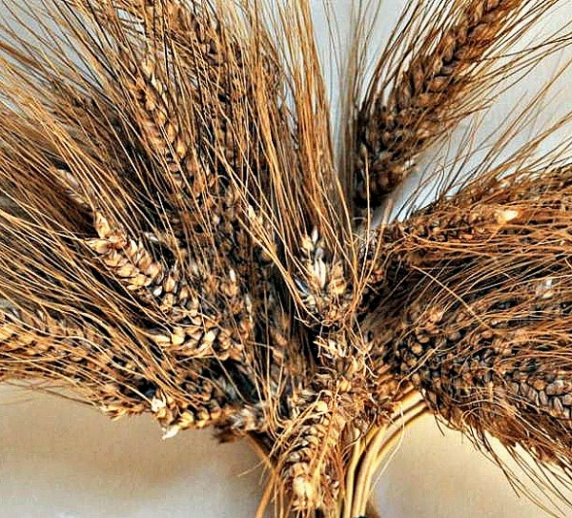

***"Cultivating ancient grains means a return to tradition and enhance production processes processing than once;* *respect nature and plants, that left to their original state, are richer in antioxidants, protein and minerals,* "says Silvio Grassi, one of the owners of the Molino Grassi di Parma" *In addition, the percentage of gluten contained in these grains is less characteristic to be reckoned with in the food intolerance times more and more widespread.* "   
The ancient grains return to be part of our diet. The project to bring on the market these varieties of grain forget started by the farmer Parma Claudio Grossi, who, after having rediscovered some varieties of beans, has chosen to undertake a collaboration with Molino Grassi Parma to bring them back into production. The Molino Grassi, meanwhile, is a company specialized in the manufacturing of soft and hard wheat, which deals with quality grains and possibly biodiverse organic. The research work of Molino Grassi Claudio Grossi has focused in particular on the production of *the Miracle Wheat:* a biodiverse wheat, soft and low glutinico content. Through the analyzes carried out in the laboratories of the Department of Agronomy, Animal, Natural Resources and Environment of the University of Padua it showed that the *grain of the Miracle* contains a greater amount of phosphorus (+ 43%), useful for the health of teeth and bones and iron (+ 25%), essential for transporting oxygen, compared to modern wheat.   
The *Grain of the miracle,* like other ancient grains, has a very high stem that can reach up to two meters in height, also it gives a unique flavor to the flour and the products derived from it. In the company laboratory of Molino Grassi, the *Grain of* the *Miracle* has been analyzed and used for breadmaking both professional and home. Finally it was milled and brought to the final consumer through the bakeries with the intention of spreading the principles of preservation and protection of local products.   
The production of wheat of the Miracle is not a standard agricultural practice, but it depends on the morphological composition of the soil, the weather conditions and the characteristics of the single variety.These types of ancient grains, not being sterile, allow year by year to be selected and improved by the natural adaptability of the plants.   
*"This is not a nostalgic return to the past,"* said Claudio Grossi *"but a conscious and scientific look to the future not to lose that heritage of regional biodiversity in the name of a greater demand and industrial needs."***