Food in Mongolia is affected by its extreme continental climate, because of which the diet primarily comprises of meat, dairy products and animal fats. Spices and vegetables are served but in limitation. Because of the country's history with China and Russia, the cuisine is influenced but both cultures.

#### **Features of Mongolian food:**

The nomads that live in Mongolia sustain primarily from products that are derived from cattle, sheep, horses and yaks, which are domesticated. Meat is mostly cooked or used in soups and dumplings. The large percentage of animal fat in Mongolian diets helps the natives to withstand the cold and also work outdoors.

The milk and cream derived from these animals is used to make diverse beverages, cheese and other such products.

#### **Some traditional dishes:**

Dairy products in Mongolia food variety differ greatly in terms of their taste. These products are called 'tsagaan idee' and include a lot of milk. The inclusion of milk denoted purity, kindness and unselfishness. Other ingredients include aaruul (dried curd) and urum (thick cream), Mongolian butter and kefir or soft yogurt.

#### **Aaruul :**

It is believed by experts that this food item is the reason behind the strong teeth of Mongolian people. It is curdled milk that is dehydrated and dried. The great thing about this food item is that it never goes bad.

#### **Airag :**

The national drink of Mongolia, this is primarily made during summers in Mongolia, especially in the rural regions. The drink is also popularly served during weddings, festivals and other special events. Some Mongolian people are known to consume about 3 liters in just one go.   
Airag has an alcohol content of about 7% and should be consumed with caution. The tastiest versions of this drink originated from the Arkhangai, Bulgan and Ovorkhangai provinces. It improves pathogenic microbes in your body and ensures good health if consumed in moderation.

#### **Horhog:**

This item is made but cutting up sheep meat and baking it. Sometimes vegetables, pepper and salt are also added. The cooking method used here is one employed by soldiers during their camping times.

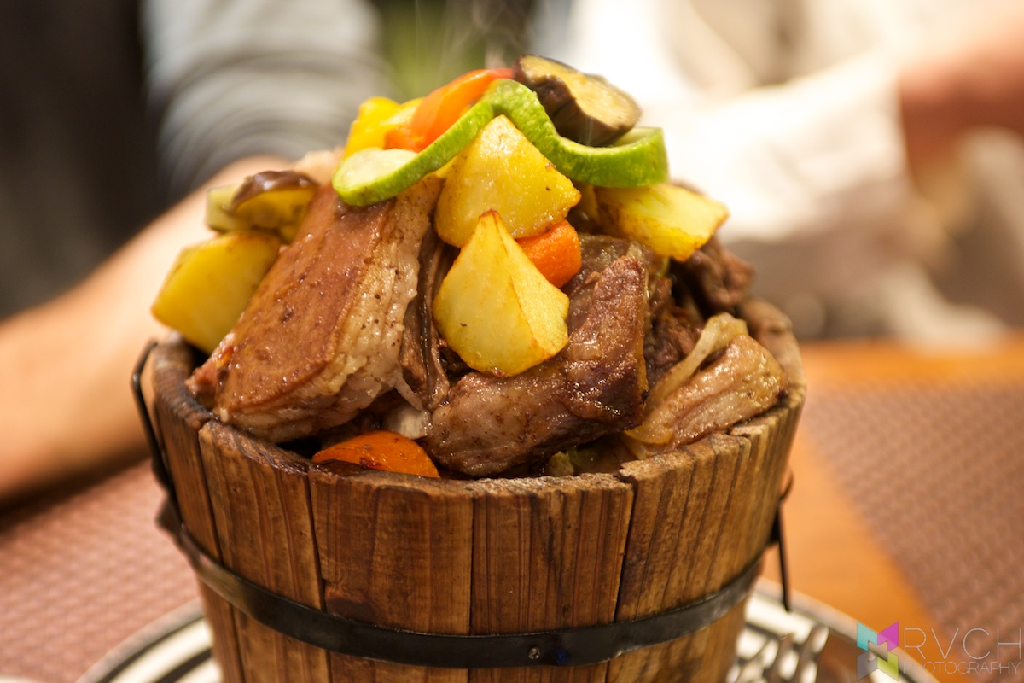

Boodog (bow-dug)

This is Mongolias version of a barbeque where instead the meat is cooked from the inside to the outside of the animal (usually goat or marmot) using hot stones. Boodog is a typical meal for groups of people and is a very popular staple to enjoy when doing camping or outdoor activities. When the cooking is done, the stones are taken out first and given to all boodog eaters which are then used to rub between their palms while they are still warm and greasy and it is believed that this ritual will boost stamina and eliminate fatigue.

Buuz

Buuz is a Mongolian dumpling which is stuffed with meat, onions and sometimes vegetables like cabbage. These are eaten quite frequently throughout the year, but especially during the Mongolian New Year in February.

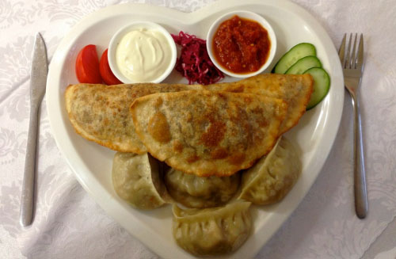

#### **Boortsog**

Boortsog is usually compared to doughnuts as they are deep fried in hot oil. They are usually cut into triangle shapes and are often eaten as a dessert or to dip into tea.

#### **Bantan**

Bantan is a creamy textured soup made of meat and dough crumbs. Bantan is a favorite hangover remedy for many Mongolians.

#### **Suutei tsai**

This is a traditional Mongolian milk tea. It is made by pouring cold water into a kettle, a pinch of salt, crushed green tea, milk and then is brought to the boil. Once the tea is boiled, the mixture is put through a tea strainer to remove the crushed tea. Milk tea has many different tastes, depending on the province area you visit. Some people prefer to drink with a bit more salt and others prefer to drink it with less salt. milk tea is served with many meals and snacks in Mongolia.

**Tsuivan – A noodle stew**

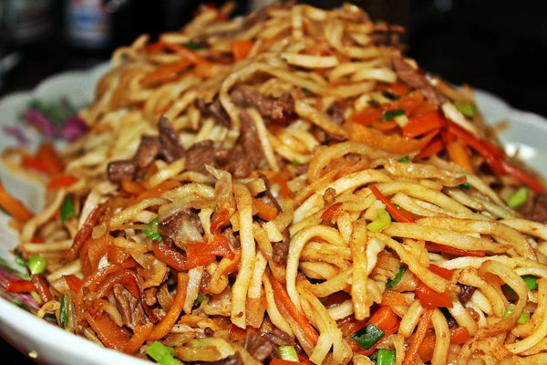

**What is it:**Noodles cooked with pork, beef or mutton and a dash of cabbage, onion, and carrots.

**What does it taste like:**The meatiness of the stew blends in with the unhampered flavor of the vegetables to create a unique taste.

**Guriltai Shul – The Mongolian soupy noodles**

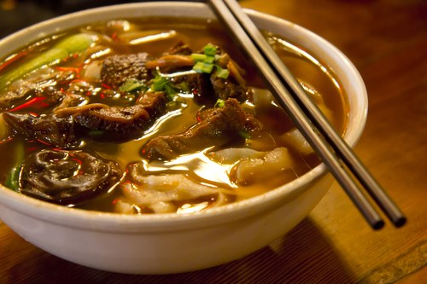

This traditional dish is basically mutton soup or stock served with noodles and veggies. The authentic recipe calls for fatty meat, though loin meat can also be used.

**What does it taste like:**The acidity of the soup, often prepared with curd made from yak’s milk, and the rawness of the mutton makes it a sinful appetizer!

## Budaatai khuurga – An authentic Mongolian rice meal

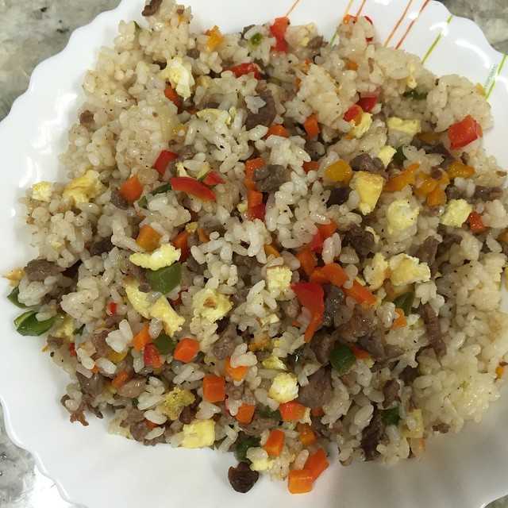

**What is it:**Rice cooked with shredded lamb or beef, onions, cabbage, carrots and bell pepper.

**What does it taste like:**This fulfilling food that can be served both at lunch or dinner has a delightful piquancy to it.

## Chanasan Makh – A typical breakfast item

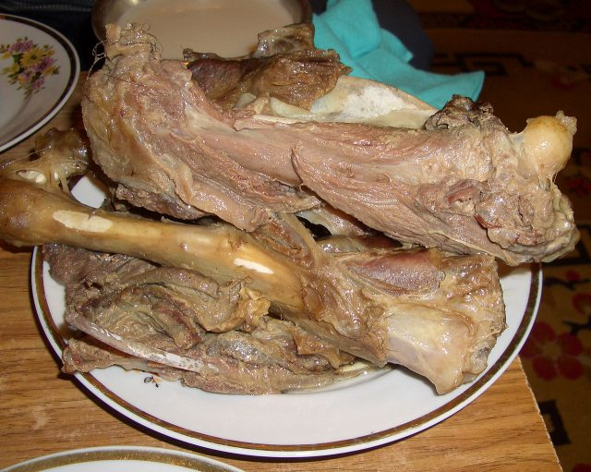

**What is it:**Chunks of mutton are boiled in salted water; commonly made for breakfast.

**What does it taste like:**It has a balanced sapidity, but can be made spicy by dipping in ketchup and sprinkling with pepper.

## Airag – The national drink

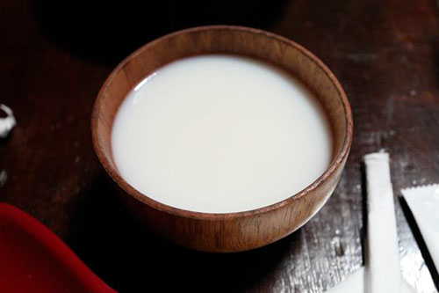

**What is it:**Milk of mare is fermented and served as a mild alcoholic beverage.

**What does it taste like:**Has a bit of a sour tang, but is an excellent source of vitamins and minerals.

## Gambir – A sugary dessert

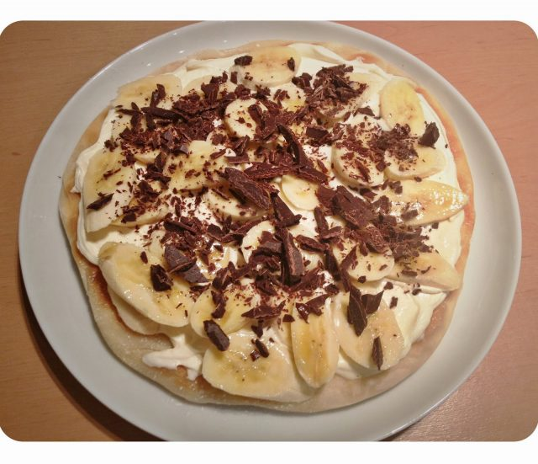

Flour dough filled with butter and sugar, cooked like a pancake and served with jelly or jam.

**What does it taste like:**The best part of this sinful dessert is that you can control the amount of sugar or jam you want. Chocolate or fruits can also be used as a topping.

