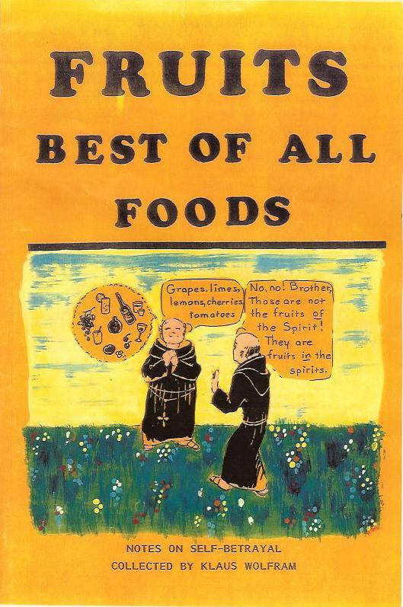

Contents
1 The hungry human
2 Are you surviving the mushroom cave?
3 Man is a hunger creature
4 On what kind of foods do you exist?
5 Fruit eating is least oensive
6 The self-consuming body
7 What to expect from a fruit diet?
8 Food is an instigator, not a life-giver
9 Narcotic food
10 No need for hunger
11 Unnatural activities force unnatural foods
12 Understand cravings
13 The simple rules of eating
14 Fruits speak for themselves
15 Eat with your mind
16 Toleration is a slow death
17 Endorphins
18 The mind cannot save the glutton
19 Pain is a heavenly guide
20 Disease is a soul saver
21 Old wive's tales
22 Not doing but resting heals
23 The house of health
24 Crystallized wants
25 Hershey bars
26 The barroom
27 The castle in the air
28 All food is destructive
29 The world of duality
30 The body is a child of the mind

1 The hungry human
Humans have descended so deeply into the realm of creation that they suddenly gain awareness in a world of animals. They entered it from the underside of a woman. Did they not dive head rst into the center of Mother Earth? They certainly have not come forth from their father's bosom as they would want to believe. No one likes to see that a human begins his life in a state of perversion and journeys continuously deeper into its realms. Humankind as a whole is doomed and will remain so because it has the same drive as the animal to survive in it. How many have ever become aware of their horrible condition? Just to the contrary, humans don't want to see themselves as a symbol of an excrement and thereby they lose all sensing for a higher reality of life.
Men and women have forgotten that they came from a higher world. They do not know what they are supposed to be doing here on Earth, nor are they going to know what will happen when they lose their bodies. To nd out that they alone are responsible for their life must remain hidden because it would expose their hatred for God. Instead they invented a god of innite love who forgives them for all their wrong without having made correction. An all loving God lets them go on with their life in a doomed universe of space and time.
Men as well as women have chosen to serve a lower nature in themselves. They believe that they must get their sustenance from a visible world. But it came as a suggestion from an evil source through the mouth of a woman who enticed the man to eat a material substance. And as he obeyed he became that lost human being he is today.
The lower realm of creation has the existence of death. It gives power to good and bad emotions, it requires a need for food, a desire to procreate and to build an identity of Self. Unconsciously remains the knowledge that all this is a fake existence and the result is fear of death.
Why have people forgotten to see all this and why does rage come up whenever they are reminded of what they are doing? It started far back in Eden of Immortality where history tells of the rst man who disobeyed God by eating the food of the woman. This fatal decision became his death. Now people hide their guilt with an expression of rage whenever they are reminded of it.
There exists a knowledge from ancient scripture, that is not yet emasculated. Adam had made a wrong choice as he decided to feel lonely. He grew an evil (Eve) nature inside himself which came in existence as his lower body. It began at his lowest rib and is represented in his emotions, his need for food, his capacity for procreation, his urge to socialize, move around, play with matter and make a secure home for himself. Adam escaped into Eve. Eventually he will have to live a life as a woman who is caught entirely inside the lower body.
The woman began her life as man fell out of himself. She lends herself as the mouthpiece of the serpent force. Mother Earth's nature is feminine in design and when human kind enters into it, it becomes endowed with the spirit of female. The male is entangled with woman through mother, daughter, mistress and wife and thereby is turning into a female himself. The law says that one becomes what one loves.
Man's Odyssey into a woman's body tells of a journey that leads to greater dependencies with every incarnation. Soon there is no more strength to turn around and one is doomed to enter the animal and plant kingdoms.
Why does Mankind suppress the knowledge of how to get out of his trap? Because it already is on the side of the female, and all of its life is dominated by the serpent force. Every individual had been bonded to it at birth. As long as a man looks to the woman he will not see his doomed existence.
One of the deepest imprints on a human brain is pain when experienced in the infant stage. That determines what his future life will be, because it has cut grooves into the brain and later as a man, he cannot get out of them whenever he thinks and feels. So it comes that early experiences act up throughout all of man's life. Although at birth one came with a freshly impressionable mind, it has hardened with the growth of the body. The process is similar to a concrete slab when a footprint is made upon it, and which later cannot be erased. All early pain, fear, witholds of physical needs are unerasable in the grown up stage and one falls into them whenever an outer experience passes by. A human has reacted to pain with his physical system before he could scream, he screamed before he could speak and spoke before he could communicate. Early pain has been spilling over from one system to the next and did its damage. It has produced a malfunctioning entity. Although a man may be knowing all this, he still stumbles and falls whenever he acts.
The higher world can be reawakened through the practice of self-observation. It will show the wrong direction taken and that it must be reversed. One becomes aware that all evil enters a human being from outside in the form of a hypnotic suggestion. It reigns the world but it cannot aect the one who awakens to a new direction that comes from inside. Only a hypnotized human obeys suggestions that come from outside. Therefore, the cause of all craving is a choice to eat from a world that has its foundation in a serpent's suggestion.
Are you inwardly our outwardly directed? There is a law that says: Whatever controls you will also comfort you. If you are outwardly direted, an outside world will support you. It will maintain you by giving you its life. Now you are controlled by this world's knowledge, by emotion, family and friends, by a need to dominate the environment and to become its ruler. Don't you see that all these are phantoms that have no substance at all? That they all came into existence in support of a rebellion against God's warning not to go into a certain direction?
It all began when Adam decided to disobey God. As a result he became aware of a lower creation of matter, energy, space and time . All this happened so very gradually that it veiled an awareness of it. Instead of instant death, humans are being slowly put to death. Awakening means to see all this. It brings an urge with it to totally reverse one's life. Wouldn't one take the hand out of the re the moment one became aware of it?
In a physical universe, man has surrendered his life to emotionalism (food, sex, music, art, etc) and ego-manifestations, (family, business, prestige and ego-accomplishments). He clings to seeing himself as a successful leader of society. But depression and anger is continuing to molest him, so he resigns himself to a life that deadens the awareness of their existence.
To whatever you attach yourself aects you negatively; and the longer you live with it, the more it enforces its life on you. When at death it is torn away you only want it more. And that's what you get again. You defend your dependencies and believe that they are necessary for your existence. You do not want to find out that this is the animal life, instead you believe that your capability to think makes you different. Again and again you escape into a lower life. When you are told that this is not life you say, \But everyone is the same as me!" Don't fall for this lie because you can be dierent.
There is something about the guilt of disobedience that does not want to be seen and it put out with an escape into a lower world.
What is not known is that with the entrance into Earth everyone has taken the wrong direction. And they are channeling their guilt deeper into their bodies with wrong foods, wrong sex and a megalomanic ego.
So you were little and you were angry. Anger was not given to you, you brought it with you as you entered this Earth, but your parents punished you for expressing it. To escape from pain you suppressed your anger by channeling it inside your little body which later began to malfunction because of the damage it had done. Getting accepted and loved meant everything to you, so you bonded with your parents because you were incapable to change your nature at that time. You lived under the curse of childhood and had no other choice but to conform and become a social being. In your ignorance your drive to survive physically meant life to you because this world's love and acceptance was all you had left as a child and later you escaped your unconscious guilt by indulging in more food, more sex and more ego-acceptance.
Society encourages man to either suppress or express pain because it fears nothing more than to expose the cause of it. To discover that one is a \God Hater" is too much. Society's very essence is to glorify a visible world and for man to break away means death to his known life. He is bonded to it by those rst imprints that were made as he entered Earth.
Earth's population consists of humans who ght for survival in a forever dying world. They traverse a road on which all falsehoods peregrinate. Humans consume their world with a hunger for \news" that reports gossips, accidents and intrigue. They are bound to a phantom life like a stunned animal is caught in the headlight beam of an oncoming car. If told of the danger, they become very angry. They are driven to kill their souls and that's it.
If you are the one out of a multitude who has an awareness of danger, if you really see that you live in a very hazardous and menacing place inside and outside yourself, you will get out fast. Only that gives you back control over body, mind and emotion. They now become your tools for rescue. The whole of society will never know this. Psychiatry, psychology, politics, medicine, religious ministers are making you think you are alright as long as you believe in God. But that is not enough. They don't know anything about themselves and absolutely nothing about the fact that they are living in a dying world that takes everyone along into its abyss. Unconsciousness keeps on building healthy bodies, big families, romantic atmospheres, rened mental concepts, and sterile places. But now you know that all of this is deadly, you will escape.
O generations of vipers, who hath warned you to ee from the wrath to come? | Math

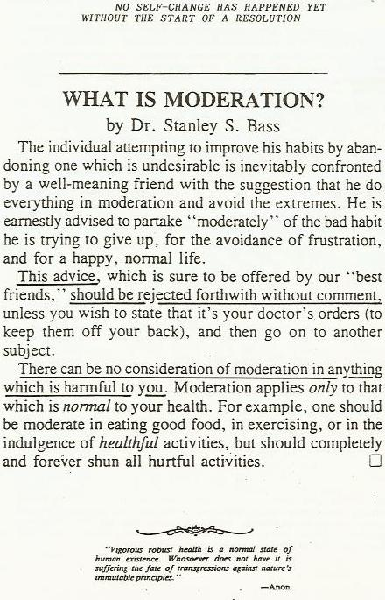

2 Are you surviving the mushroom cave?
This tale tells about a father's son who has made a wrong choice. What follows is not for fainthearted to hear because it takes courage to face the results of one's wrong actions. This story is meant for those who want to return from their journey. It is a story that wakes up the dream.
It all began when a son derived pleasures from opposing his father's will. Thereby he had to live without his blessings and oblige himself to journey into the wilderness.
The physical dream world is such a wild place where a man will fall from one mishap into another. It is a place where one loses his way and ends up in a ditch.
That actually happened to the disobedient son in this story. He was laying in the ditch with an aching body and as he looked around in despair, he suddenly noticed an opening to a vast cave,. As he crawled inside, he found trance-inducing mushrooms growing all over its walls and he thought, \drugging myself would be just right!"
Self-destruction will turn into a pleasurable desire to a resentful man, and what followed became catastrophic | his state of bitterness turned into a hate for his father. From now on, whenever he was confronted with a suggestion that said: \No! You can't have your way," he became angry. And to escape the resulting pain he went deeper into the dream. He disconnected himself from his \guilt feeling conscience" (Soul) and escaped into a \will of his own" (ego). Now at last he could do what he wanted to do | to nd the fulllment of all his hidden desires. It became a life that was experienced apart from his father's will.
But only too soon did he wake up to the awareness that his life was a nightmare and he ate more mushrooms. This went on for a long, long, time.
Planet Earth serves as a mushroom cave where humans can do what they please and get away with it. And when the awareness of their futile lives enters into their dream, they quickly conjure up mushroom-related activities. (smoking, drinking, eating, worshiping, entertaining, working, exercising, etc.)
As the body of the caveman became less able to absorb the poisons, the awakened state began to lter into the dream. The true condition came to the surface. The pain of wrongness was unbearable and he stormed for the opening. But | there was no opening. What was left of the way out had shrunk to the size of a st. He was buried alive and he screamed and hollered.
Had the opening disappeared? It really had not | anger had distorted his perceptions. Unconsciousness had blocked out the pain but not the results of his wrong acts. Eating intoxicating substances had the eect of producing a growing ego-body which now threatened to squeeze him out into a never, never world where escape from pain would become impossible. Contemptuously he ate more mushrooms. The trance that followed came abruptly to an end when his growing body had run out of space | the cave simply squeezed him out of his body. Extreme hate became his only life. Unconsciousness is a deliberate act, but nature came to his rescue and let him escape into the body of a dog. (Dog is a reversed expression of God). At last he could express his life again.
Fighting for survival had always been the ego's greatest accomplishment. But this story could have ended dierently. The Soul can become aware of its growing ego before it is too late for its awakening. The Soul has to bear the pain of self-investigation. Awareness is the beginning of the way out. The shock to see the truth about one's self has to be endured. This will create the ability to \remain awake." The desire to maintain the body by natural means will come back. Now escape becomes possible.
An awakened consciousness will always make a tremendous eort to turn away from the lure of the physical life. The higher will not come down to rescue the lower because it has no connection to it. The physical world began where the spiritual left o.
Self-observation is able to reveal that \cause" is being awake, and \eect" is the CHOICE to fall asleep. An awake man will not accept eects, he remains at cause in every situation. In Heaven there are no eects.
The material universe came into existence as an eect of a choice. There are no choices in Heaven. The dreamworld is real only to the degree the desire for a choice is real. That was the lesson the rebellious son had to learn.
All your life is but a going out to the place of execution, to death.
| John Donne

3 Man is a hunger creature
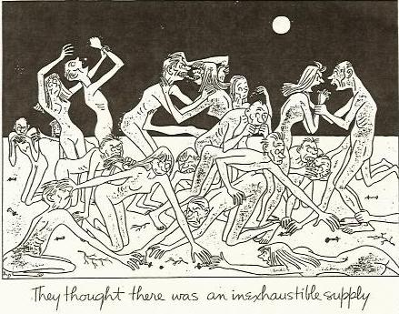
To look at physical man objectively, there can be seen a torso that has an entrance and an exit. Attached to it are two legs that bring the torso to food and two arms that stu it into an opening. The food is processed inside the torso. Such is the man that roams the earth.
Man can never be satisfied with food. After the body has been lled up at dinner time, hunger switches to another level. His ego has to be stroked to satisfy his emotional system, and after that he must entertain his intellect. He needs physical activity to calm down his unrest and to keep his Soul sedated. After he has exhausted himself, he falls asleep. The next day he performs the whole scourge over again.

4 On what kind of foods do you exist?
Examine your food intake. But the question, \Can a mind drugged with food do that?" Can you become aware of what foods do to your body? Here are some dietary facts: When you eat meat and dairy products, know that they do putrefy as do most cooked foods.
- Regular foods putrefy in the body, they turn into acids that destroy the body. Acids are such poisons as skatol, indol, phenol, ascetic and uric acids. They are responsible for the premature wasting away of the body. They aggravate your mind.
- Such foods that consist of carbohydrates ferment in the body and produce alcohol that drug the body. They are your rice, potatoes, breads and cooked vegetable. They will narcotize your mind.
- Only the foods that digest in the body are completely metabolized and thereby eliminate it properly. These are fresh ripe fruits. They allow your mind to remain thinking clearly.
The Soul of man does not need food to exist except that it keeps the body in a physical universe. Only here does the Soul experience pain. Fruits do the least damage to the body. A man's physical life has the purpose to outlast his sleep of perversion. It is the sleep in which he consumes and kills the living cells of other beings to remain in it. To eat living cells from an outside environment is one thing but to imbibe dead food is quite another. Destroyed foods do harm by drawing living cells out of his own body. This is self-consumption and the cause is death.
Minerals are the food for microorganisms; microorganisms are the food for plant cells; plants are the food for animals; fruits are the food for humans; air is the food for saints.
Man surely is a horrible creature; his killing nature provides the meat, his perverting nature cooks it, and his self-consuming nature eats it.
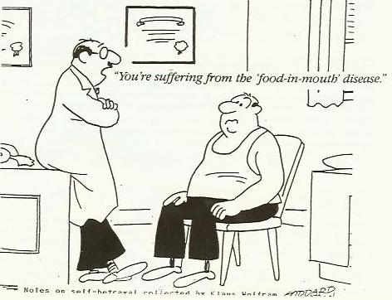

5 Fruit eating is least offensive
Fruits have all the nutrients a human body needs to maintain maximum health, and no other food is needed. They are predigested by nature and take away the least energy while being assimilated by the body.
But to fancy perverted tastebuds, man craves for food that is increasingly adulterated. First he eats apples, but soon they won't satisfy, so he obliterates their food-value in an apple pie. Eating it destroys digestions that results in sickness. He never suspects the cause of it; he just goes on to the next violation.
The greatest hoax mankind lives by is the belief that foods have a healing power, that a particular food can do something, especially when it is high in vitamins or some other \nonsense." But it must become clear that no food is good for a particular kind of deciency or disease, not is it building a healthy body. A food that has a healing power simply does not exist because the body heals itself, and it is done fastest if there is the least interference from any outside source. Every \doing" is damaging and fruits merely do the least of it.
All foods need life-force to be process inside the body, and when that is used up, the body will die regardless of the food eaten. Undereating does not stress the body; it does just the opposite: it extends its life because life-force was saved.
Today, exercising has become such a craze that it has been made into a panacea for health. Exercise is incapable of giving health because it also uses up life-force. To attain health, it would be better to sit still and do nothing. Exercising can be seen as an abreation of unrest and therefore it is more permissible than other vices. Man's soul wastes away on all levels of life, whether these are emotional, mental or physical.

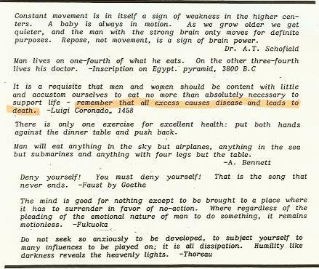

6 The self-consuming body
If a man's (or a woman's) correct diet is delicious ripe fruit only, then how can he exist, yes, even thrive on foods that had been destroyed? There is only one answer: Man does not feed himself, he consumes himself! An unnatural diet makes him draw violently on an inherited essence, and that essence is like the essence of a seed whose inner substance nourishes its sprouting life. For a little while man can live in what he calls \good health" regardless of what he eats.
Foods do not nourish the body nor do they maintain its warmth. And all preconceived ideas about the value of vitamins, minerals, calories, carbohydrates should be highly questioned. Whatever benecial foods is ingested has no benecial value whatsoever, just the opposite is true, it helps to speed up the expenditure of the seed's life substances. A seed sprouts regardless of what foods are eaten. It is its vital energy that keeps it alive and well.
No part of a food is converted into esh. Body substances come into existence when invisible vital energy is coaxed into esh by the eating of foods. Invisible life-energy is changed into body substances while food remains the catalyst. Food is the stimulant that changes invisible life-energy into visible substances.
The universe of matter, energy, space and time belongs to Lucifer and to live there requires self-consumation. One's essence must kill and be killed to take part in it. The body turns living cell structures into unpleasant waste. To kill life to have life is an abomination. But modern man has become worse. His increasing ignorance makes him eat destroyed cell structures. He cooks his food and thereby is condemned to draw life out of his own body to eliminate the waste. He loses his teeth first, then his inner structure and at last his organs. Humans are self-consumers | cannibals of the first degree.
A healthy body can remain active for several months without eating a morsel of food. Foods, medicines, activities, companionships are merely stimulants that draw out the seed's vital energy. In its strictest sense, they serve as a force that draws vital energy into action. Thereby giving the body, intellect, and ego its strength. And the more perverted these stimulants become, the more they draw on vital energy. All stimulants have a steroid eect, they force false growth.
A human is convinced that his body is his life, but this structure of esh and bones is only the seed buried on dark planet earth. Foods are the moisture that stimulate the seed, (the carrier of the Soul) into action. The seed begins to sprout. Man's purpose is to come out of the earth and shake o its dark inuences.
Why is it so hard to abstain from doing wrong? Because the Soul has chosen to hide away in physicalness and fears exposure of having made a wrong choice. But humans resent anyone who practices fasting exercises. As it is well said in Homer's odyssey; \Death in all its shapes is hateful to unhappy man, but the worst is death from hunger."
Every Soul that came through the belly of a woman is just seed (a body), but with a capacity to come to life again. As encapsulated cosmic energy, the average body exists for three score and ten years and dies, never having risen above the earth. This is an unredeemable tragedy. The knowledge that Souls must continue life in the animal realm is still accepted, but only in fairy tales and ancienct myths. Only degenerated Souls will animate the animal kingdom. It is the underworld where they have no purpose and direction other than to make up for misdeeds | \for death in all its forms is unacceptable in heaven."
Earth is a place where the human Soul may raise from its death again which she had experienced in heaven. In a child's body she is an animal, totally without self-awareness. And to remain eating unnatural foods and indulging in animal emotions is like poisonous moisture that chokes the capacity for growth. This kind of Soul remains on its downward path by wasting away her inheritance before a higher contact could have been made. Therefore, abstinence from wrongness is vital, and as painful as it may appear, it must be endured. After all ties have been cut, the body will stop suering while the Soul is able to ascend to a higher level.
Rage and self-defeat are attachments to a dark environment and there exists no human entity who does not suer from it. Therefore clean living, accompanied by a light and sparse diet are absolutely necessary. Why would anyone waste away his body prematurely when it could bring him back to self-awareness?
Man must not extinguish his seed-energy with food, sentimentality, sex, social acceptance and material gain. \ All these are the vile acts that satisfy hunger!" said Maxim Gorky. Man has chosen darkness! But having done it deliberately, he can also choose to return to life deliberately.
Hunger is a cancer, it is a consuming sickness. Humankind has sunk so deeply into the mire of earth that it has lost strength to free itself again. It wastes its energy by helping others while sinking. Who still knows how wrong it is to help those who won't help themselves, or to expect their freedom them? Humankind smothers its guilt with irresponsibility. To help the weak justies wanting to remain weak. All wallow in the same ditch. The statement \physician heal thyself" is entirely ignored.
Man sees his body as the cause of his doom and treats it as if it were an enemy. He attacks it with knives, medicines, radiation and psychic formulas. His ignorance is absolute.
Hunger is the result of having turned away from higherness, and like any disease, it must be healed by non-interference. HE MUST DO NOTHING! That will heal anything, including all the hungers of body, mind, emotion and activity. Let no interferences undermine the process.
If one studies himself he will see that destroyed foods not only use up precious energy but throw the body out of balance. It will die before its time since it must draw life-force from within its own tissues. Young children have already crooked teeth, bad eyesight and deformed bodies.
Man has little time for self-work when he wastes himself away battling self-created sicknesses. This planet's nature will never help him in his struggle because it teaches death. It's rst law is \eat or be eaten." Man lives on a dying planet and only a complete reversal of all his values can bring his release.
To reveal how far down a man has degenerated he may examine the nature of his hunger. Does he extinguish hunger with perverted foods, activities, companionships, and prestige? \You become what you eat" is certainly true. Man turns to woman for sustenance and woman gets it from cats and dogs.
No one can assist the Soul's growth in any way whatsoever except by doing less. That means to maintain a minimum interference with a higher way of healing. It is a command to do nothing. One may begin this path by eating only a few fruits, breathe clean air, choose a quiet and harmonious environment, think right thoughts, and indulge in fewer and fewer activities. These are the steps that will slow down the self-consuming process immediately.

7 What to expect from a fruit diet?
After a man has eaten fruits only, he has a feeling as if he hasn't eaten enough. He is listening to a lie because fruits maintain a body one hundred percent and no other foods are needed. It is dangerous to eat the regular fare of dead foods with broken or fouled cells; it would be better for the body's health to take no food at all, but wait until the right ones become available again.
There remains a feeling of emptiness after a meal of fruits. Hunger has not been satised. But this feeling is a deception because the body has been fed properly. Fruit is not a food that narcotizes emptiness as destroyed foods do; instead, the sublime character of fruits introduces pain inside every unhealthy body, though in this instance pain becomes valuable because it is the signal of a withdrawal symptom. Having eaten garbage foods all during his life, the man expresses a symptom as the start for self healing, and it is a healthy experience.
All stimulating practices are pain-suppressing; it is their only function. And all of man's indulgences in food, wasteful activities and emotional upsets bring him only a temporary escape from pain. After a while it continues to surface until an awareness of it has been suocated to death. This is the process by which man is annihilating his Self.
When a man is able to remain with eating fruits only, he will not experience miracles of health right away because rst, it will bring up the true condition of his body. He may feel sick for many years to come. Besides a very uncomfortable state of pain and unrest, all the results of his past wrong eating habits will surface. Pollutants have permission to come out, and his body will be weak and look emaciated. While enduring the pain, he can be happy that he is getting healthy. At the end a new body will emerge.
There is a simple rule that applies to body weight. When only fruit is eaten and there is weight gain, the body is healthy, but if only fruit is eaten and there is weight loss, the body becomes healthy.
There is a warning. All though an all-fruit diet is the only ecient for any man and should be the goal of all dietary accomplishments, it is not recommeneded for degenerated and depraved bodies, at least not all at once. One would not tell a man with a broken leg to run without his crutches. If an Eskimo who was raised on blubber suddenly ate fruit, he might die of starvation because his system has lost its digestive power. But even he could raise his average life span from thirty years to sixty or more by reeducating his body to a more etheric diet.
It is not only man's physical machinery that can be healed, but also his emotional, intellectual and psychological systems. They need their own kinds of etheric nourishments. No one must separate one system from his other systems which he has built around his physical body because all of them need reeducation.
As fruits maintain the health of the body, so does a simple activity humble the ego. Only a constant determination not to interfere with the inner power for self-healing can return health.
Remember that all tastes are acquired. Once you lose the taste for meat, for articial sweets, and harmful stimulants, it will never return.

8 Food is an instigator, not a life-giver
As a seed sprouts from its own substance, so does the body live from an inherited essence. This essence is limited.
Foods do not give life; they simply goad man to remain alive in a physical body. That is the reason why the body can stay alive on virtually any substance it ingests. Foods are not responsible for growth either; the body grows regardless of how little or how much food is eaten. If minerals, vitamins and fruits gave life, the body would never die.
There are people who have proven that they can maintain their body perfectly on a few ounces of fruits per day. It keeps them sickness-free throughout all of their life. It also is a well-known fact that unnatural foods diminish life-expectancy considerably. Narcotics, alcohols, drugs, medicines and processed foods need an incredible amount of energy for their metabolization and thereby they exhaust the body's life essence. Man's whole system starts acting up in rebellion to the death threat from these substances. Like a country that must raise an army in response to a threat, so is the body forced into defense. Its cells multiply rapidly. Man's ignorant nature interprets this acceleration of body-processes as a show of vitality while it really is a wasteful expenditure of life-essence. Every threat with poisonous substances, whether to plant or animal bodies, is a waste of essence.
Another threat is forced exercise which incites the body into articial health. When discontinued, the body in its economical husbandry reverts back to its former condition. Bodies becomes athletic after every goad, whether it represents a drug (steroid), glutinous eating or exercising. Activities as well as unnecessary foods do not maintain health.
Behind every goad is the urge to survive in an alien world. Therein lies the appearance of strong bodies, which also reinforces the ego.
In his drive to survive, man travels farther and farther away from his spiritual home. Survival-orientation takes away energy that could be used for self-awakening: it maintains the so-called life of a dying man.
Threatening death to living cells with poisonous substances becomes man's thrill of pleasure. He feeds on the zz of his own destruction. Satisfying hunger with food, sex and activity is the urge to celebrate death. Man calls dying \life-giving," but what really gives life, he calls dying.
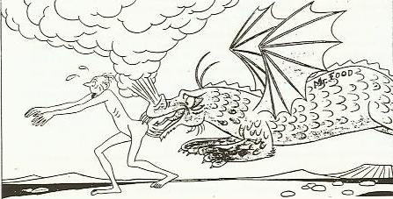

9 Narcotic food
Man has a certain type of diet that is most natural to him, just as every animal has. Man's body established itself in a tropical environment where fruit was most dominant and readily available at all seasons. Any prolonged digression from this natural diet ultimately brought penalties. This is seen in man's many dieases.
The type of food man now eats is unnatural; it conforms to his false life. Man is lost and to cope with it requires intoxication that dulls awareness. Today people smoke, drink alcohol or take drugs whenever the slightest uncomfortableness touches them. But before these pain suppressants were known, it was an adulterated food intake that gave the same results. Fermenting and cooking of food had been an earlier practice by which they tranquilized themselves.
Man must become aware that food which ferments while being digested in the body, sets o various alcohols. The absorption of these alcohols has a similar eect as the drinking of them. It also makes the mind drowsy and sedates the body. Deprive a man of fermenting food and he experiences and emptiness inside; more than that, he feels voraciously hungry. He suddenly is aware that he wants to eat all the time. Unfortunately he never suspects that he is an addict to food-alcohols. Gluttonous people are drunkards, they cannot stand being sober.
After the fermentation-drug, there came another violation and it presented a much greater threat to health. Man began to eat pure proteins, the meats, fats, and other indigestibles. Their destructiveness lay in their putrefying ecacy that produced toxic acids when processed by the body. Acids actually poison it and stupify the mind. Today, man cannot stay away from such foods as cheeses, a product of decomposed milk, and wine, made out of festering grapes.
There are still substances man imbibes that are undoubtedly the worst. These are the inanimates, the vitamins, medicines, drugs, sugars, salts, and spices. They do the greatest harm. It is a fact that \matter" that is not bound within a living cell is poisonous to all sentient beings. Not even plant life can metabolize dead matter without a penalty, much less the animal body. For the digestion of minerals, the vast world of microoganisms was created. Man does not know that, becausee he has already gone too far into the wrong direction. Ironically, feeding on minerals does not in the slightest appear strange to him - so deeply is he in love with the unnatural. He even forces his perverted ideas on everyone and everything he comes in contact with.
Minerals are the food for microorganisms and microorganisms are the food for plants. Men tenaciously believes that mineral substances give life; they do not know the tremendous penalty they pay for this deception. To eat inaminate substances, whether it is man, animal or plant, speeds up the depletion of life-essence. Due to the urge to survive, living organisms must draw on their life-reserves. Plants grow big and produce seeds quickly when given mineralized fertilizers, but they become less in substance and therefore are vulnerable to pests. Minerals act upon plants the same way as drugs act on animal bodies. They force body growth. The body that grows fast dies fast due to wastage of vital energy.
It is as natural for plants to feed on microorganisms as it is natural for man to eat fruits, and naturalness is the formula of health. But man is an alcohol and acid imbiber even if he has never taken alcohol or acids into his mouth. He thrives on his unnatural diet as a homosexual thrives on his perverted sex-practices. Perversions do not renew life.

10 No need for hunger
There can be no hunger in the spiritual realm. The higher man goes, the less food he will need. This holds true for all of his other hungers too. There is his desire for \knowledge" and his indulgence in practices that reward him with \good or bad feelings." All hungers fade away the closer he comes to his home. Really, all a man has to do to return is to stay away from harmful habits long enough until his withdrawal pains have released him for good.
Every sensible man must sooner or later come to this recognition:
What I get into also gets into me. If that is a true principle then what I let into my body and mind becomes me. If I have fed myself on Television, companionship, junkfood, sex and worldly business - that has become part of me. What lives when I live and what talks when I talk? Now I know why I am paining. I observe you and, when you, I know who is talking. Do I want that?

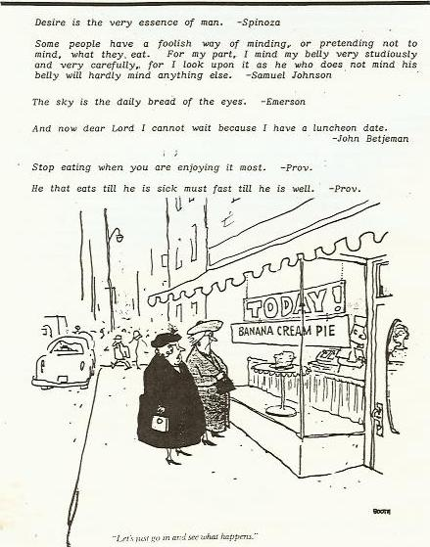

11 Unnatural activities force unnatural foods
Man's purpose on earth is to return to hs father's home. This lies in a spiritual world which does not require a matter, energy, space and time universe, but instead he makes earth his home, chooses a wife, and raises a family. To become accepted he develops an ego. His conquering activities destroyed the environment. Forever in search to advance, he always found himself on the move facing harder living conditions while having a diculty nding his natural diet. So he nourished himself with substitute foods in order to cope with harder conditions. He began to use re to prepare his foods. To push out crowding neighbors he had to arouse himself to anger. He ate aggravating foods as was derived from meats, herbs and minerals. They began to draw excessively on his vital energy and shortened his life.
Man is multiplying himself to extinction. This, of course is in alignment with earth's destiny which is to destruct itself. Man has forever burned down forests that increased the harshness of earth's climate. Right foods became seasonal, making their replacement with inferior foods necessary. Substitute foods sickened not only his body but all of his other faculties. In time, the knowledge of a right diet that could have saved him from all aictions, had been completely forgotten.
One must really wonder why man is driven to do these abominable acts to his life. Redemption comes when man allows himself to see his underlying drive to destroy himself, and that it has spread over all facets of his life.
The greater there is an understanding of life, the less there will be a need for nourishment from an outside world; or, as understanding increases, the need for food decreases.

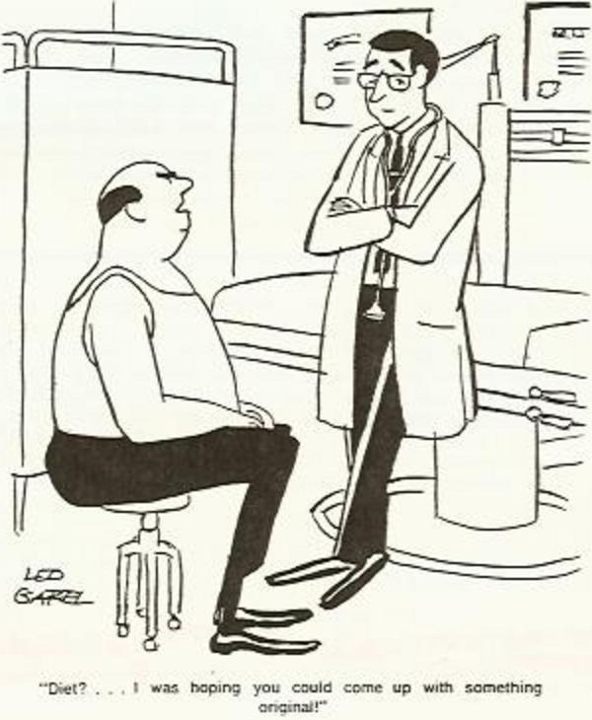

12 Understand cravings
When a person stops taking drugs his craving for them becomes painfully strong. Stimulating foods have the same eect on the body because they are also \pain-suppressants".
A craving must never be satised with what is craved for because it gives a devestating result that is virtually unknown. A craving is not a signal that something must be done but just the opposite, it is a call for no action. Craving is a pain of damaged body cells as they come out from under the narcosis of poisoning substances, and cells need that pain to be healed. Every pain can easily be suppressed with more drugs or food, and be pushed back into its former state of narcosis. Pain tell that life - in the form of a feeling - has been returning to the nerve cells again. Every increase in feeling is an increase of aliveness.
A craving surfaces after every rest. Other words for cravings are - hunger, appetite, desire, emotion, coveting, hope, yearning, stimulation and greed. All are signalling a challenge for man to either destroy himself or heal himself.
Healing starts when man begins to feed his body, mind and emotion very sparingly and only when a wise and sane mind says so, and as long as man sojourns earth, these faculties are most valuable in detecting where he needs correction. It is not the desire for wrong foods that has compelled him to eat them over and over again but the misery of the after-eect. But this misery is valuable because it invites the healing process.
Only a sick man (and that is everyone) experiences hunger and it is particularly strong when he sees a banquet table full of delectable \concoctions". Here is what he must tell himself: \The foods I crave may taste good but they are bad for me, I simply end up with a greater craving. I have observed too many times that after I have eaten them I feel miserable. I just won't do it anymore because I am tired of hurting."
Very few people do understand that undereating is the elixir of life, but the undereating relates to right foods. The only right food for man is fruit and only if one has extensively experimented with a sole fruit diet will he be convinced that this is true. He knows he eliminates them the fastest. Other foods may still taste good to him, but he has paid too high a prize for their indulgence. He would have to give up his gained clear-mindedness and suer from bodily pain again.

13 The simple rules of eating
If God's Kingdom is all there is, then the human entity does not exist; and God proves it by letting it die. Man is the connecting link between a spiritual being and the animal. With man, the invisible has descended and became visible in a physical body. When man takes nourishments from an outside world, he declares \I do exist". To feel alive in this world, he must kill everything that stands in his way. Rarely does he use his existence for nding his way back home again.
Everyone is driven by hate against the voice that calls him home. But he cannot block it out except through anger which pops up at the slightest reminder of his wrong journey. Taking life from his false surrounding, he is driven to defy God by killing his spirit.
When man stills his hunger from an outside world, a payment is demanded. This is experienced as pain.
To become worthy of the higher is to fall out of love with the lower; so, the rst rule of eating is to eat less. It is impossible for man to do that if he is unhealthy, not only on his physical level but also on his emotional and mental levels.
Health returns in degrees. The more man stays away from wrongdoing, the more of his health returns. Health is a journey into simplicity.
Man's physiology and anatomy are still the same today as they were millions of years ago when he lived exclusively on fruits. And still, fruits are abundant everywhere because these delicious manifestations of the loftiest aspect of nature's creation will always remain his most sensible foods.
The closer a food comes to its raw, unheated, uncut form, the less energy will it draw in its digestion; and the simpler and unmixed the meal is, the faster it digests. Foods whose cells have died through fermentation or heating, and all minerals that are not bound within a living cell, are toxic and must not be ingested at all. Every cell that has died becomes a poison to the physical body. Dead organic substances gave to be predigested rst to become digestible. This pre-work is done by the plant kingdom and the vast world of microorganisms who were especially created for feeding the plant kingdom. The same law operates in the rainforest, where trees do not feed directly on soil rich in minerals, rather they need the medium of decaying organic substances processed by microorganisms in order to grow into giants.
It must become clear that the simple diet of \fruits ony" does not heal the body. But fruits are already predigested by nature and thereby unburden digestive work. That leaves enough energy for the body to engage in self-healing processes. The release of vital energy does not need an intake of physical substances to do its work. Physical substances simply draw out an excessive amount of this most valuable inheritance to keep life going in spite of the Soul's physical indulgences. And every individual has only so much energy to spare.
All palates can be reeducated to the fruit eating diet. This is done most easily by going through a fasting period where the taste buds become sensitive to wrong foods again. Unfortunately, humans remain set in their wrong ways { and not only in their eating habits. They do not trust in their own investigations, they rather rely on critics and educators who all are failures themselves.
Nothing can change the fact that the body does not receive energy from foods that ferment or putrefy in the digestive tract. The evidence that an unadulterated digestive system reacts violently to cooked and processed foods should be a clear message to eradicate them completely from any diet. But nobody wants to do that, they rather choose a violent death before its time. The fact remains that all condiments interfere with digestion, even stop it completely. They camouage the true avor of adulterated foods by masking their repulsiveness, thereby inviting more gluttonous eating. They must be called by their rightful names - \POISON". How did Samuel Johnson express it?
A cucumber should be well sliced, and dressed with pepper and vinegar and then thrown out as good for nothing.
Every man can make a giant step towards health by committing himself to a simple rule that says:
Why not keep all foods simple? The most important single thing I must remember is this: there are no good combinations of foods. Not one. One only food must make the meal, and not a mixing and matching. 'Keep it simple.' If I eat a couple of tomatoes or avocados, I eat them only and I let it go at that! Fruit meals are the most easy 'monomeals' I can learn to live with. If this is not acceptable, at least I will group foods together according to similarity of taste and texture. 'Keep it simple'! I know that every wrong combinatoin is a transfression that is visited upon the body, which is the home of my life. It demands its toll of suering whether I am aware of it or not. And if I suer, I have only myself to blame.
No man can diet or fast himself to health. He must live his way to it. All of his living habits combined make up a life of health or of disease, for he who is ill has marked himself a fool and a weakling! To a much greater degree than hunger, must physical, emotional and mental hunger be seen for what it is: an outcrop of man's hate for God.
If a man sees that all this information is true, he is bound to make a change. But does he have the inner courage to carry out what it demands - or will he dive deeper into unconsciousness?
A healthy body is something real to work with because it reacts with pain to the slightest trespass. It is more than just the center of man's physical life; it is the key with which he can unlock the door to his spiritual home.

14 Fruits speak for themselves
Let's allow for our bodies to renew themselves by eating only foods to which we are biologically adapted. These foods are fruits exclusively. They require no cooking or preparation of any kind. Eating fruits is natural, in fact, it is the only food that won't enforce a penalty upon the body because it is a gift that a tree or vine oers for spreading its seeds. Other foods involve killing, whether it be of animals, plants or seeds.
Because a fruit diet needs no digestion, it saves a tremendous amount of energy which now can be utilized to cleanse the body. The blood is able to unclog the arteries. The connections between centers in the brain are reestablished and the mind starts functioning at a higher level.
Man must befriend himself with fruits as he would cultivate a love for truth. But to learn the habit of eating fruits exclusively takes a long time and only few will succeed. For most people, the thorn of adulteration has sunk too deeply, and they hang on to it for dear life.
With a continuation of an exclusive fruit diet, a great benet will be bestowed on anyone who can stick to it. Not only will he be freed from all bodily pains, but he will feel an inner lightness. This new state remains with him regardless of outer circumstances and conditions. Now he knows that he will never go back. He has been cured of his old garbage diet for good.
Man must be told over and over again:
If you cannot stick to an all fruit diet but want to, know that your body is in command and does with you whatever it wants. It has learned to behave like a spoiled brat, but only because you have never attempted to take command over it. It has been brought up in your confused mental household that has never known a healthy life. That's why it is your duty to reeducate it. But rst you must go back to your mind and learn all about the body's proper function and how it is nourished correctly. The application of this new knowledge is a very exciting and satisfying venture, and you can undertake it at any age.

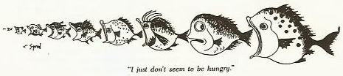

15 Eat with your mind
\Eat to live, not live to eat." Unless you eat for the sake of your body and not for the sake of your appetite, you do not show any control over your mind. An ancient statement says: \Eat so little as it would keep you on the brink of survival". The author Luigi Coronaro in his famous 16th century classic boook, \How to live long" said: \My basic rule was never to eat more than 14 ounces of food per day." To be free of all bodily sickness is to eat only what the mind has wisely selected. When the mind is governed from above, the body is governed by the mind.
Investigate the true nature of hunger, that will begin the long struggle \to fall out of love with eating."
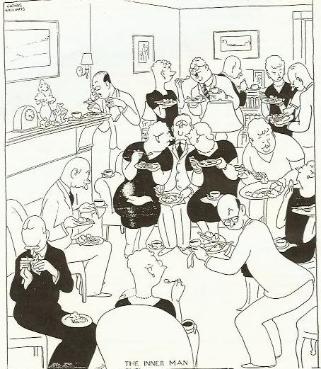

16 Toleration is a slow death
If a man's body would always rebel with a vomiting the moment he ate something wrong he would learn a lesson, but instead the body learns to put up with the poison. This is toleration.
Man has a choice, he can use his time to straighten out other people or he can straighten out himself; and when he chooses the rst he will pay with his own failure.
Man tolerates increasingly sickening conditions whether in his food habits, his relationships, or in his everyday activities. That starts the decaying process. Although death does not come right away, it makes itself known a little bit more every time. The losing of the \Paradisical Life" has been a step by step procedure.

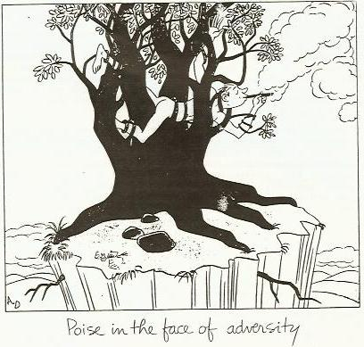

Someone may ask: \When the body is poisoned with wrong foods, why does it learn to keep up with the poison?" Well, it does not. Man is ignorant of this because he suppressed the upcoming pain by wandering deeper into the dark realms of matter, energy, space and time .
When man violates nature, the nervous system signals with pain whenever the body as a whole unit is threatened. At this moment all activity, all food intake, all curing must cease at once.
The intelligence of the body does something very remarkable when it has been poisoned. It concentrates its elimination process to just one body part. The system actually blocks the usage of the most abused and therefore weakest organ or limb and uses it as a target for elimination. (Just as a predator chooses the weakest animal.) At rst it enlists pain to stop activity and next it draws poison ladened (???) into its objective. This inames the body-part and it starts ulcerating. When the system is clean again the symptom of disease disappears and the total harmony of the body is restored.
Man does not heed this process of restoration, instead he overrides it with his own healing practices. He always has to meddle with nature because he is a God unto himself. Whenever his conscience says: \Man, stop and rest - wait until the symptom of disease has done its work," he employs the enemy instead and expects him to ght o his elimination processes. His intent is to escape paoin. The enemies are his strife for cures (exercises, travels, socializing), his mental activities (hypnotism, suggestions, worrying), his foods (special diets, medicines, herbs, vitamins and drugs). The escapes seem to work because the pain stops and the sickness retreats. But it is a treachery. Man in his doing always does a suicidal job when he allies himself with the enemy. The symptom disappears at the cost of a faster deteriorating body.
What really happened when diseased was suppressed is this: all of man's remaining vital resources had to be mobilized to cope with the new intruder, the medicines, the exercises and the anxieties. The nervous system released the former pain-blockade, the inammation receded and all seemed to be well again. But the poison has remained inside in addition to the new ones. The body merely resigned itself to a lower level of functioning.
All this leads to a logical conclusion: A man's body may die while his dulled spirit remains addicted to wrongness beyond the body's death. That explains the appearance of all the sick people on earth. Due to nature's recreating force the entity simply hides itself in a new body. Sick spirits inherit bodies and minds with a lowered functioning capability. Nature demands payment. Only a man who practices self-responsibility has a chance to redeem himself. If not, earth will be populated with an increasingly lower form of life.

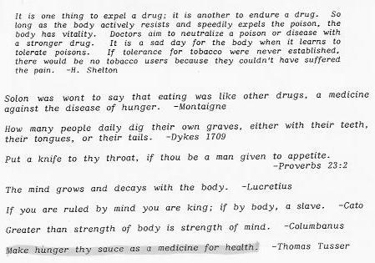

17 Endorphins
The physical body has been given a way to subdue pain naturally in the form of a built-in chemical. This pain killing system is a supply of endorphins located inside the body and which have more power over the nervous system than the strongest opium. These pain-killers are released naturally whenever pain becomes unbearable. hey make it possible for man to remain comfortable in his body in an otherwise unendurable condition of pain. Endorphins block pain from reaching the brain, but do not heal the disease. All this happens without help from the individual himself because they are provided by nature and are under the control of the body.
Man is damaging himself immensely when he takes the escape from pain in his own hands by using drugs, or when he employs the help of emotion, mind and activity. Neither must he seek relief in food, sex, thoughts, and activities.
The ego has a false drive to defend itself. It demands to be treated with drugs or other cures, which make man's \body-given" endorphins dwindle and eventually vanish altogether. When outer means take over the suppression of pain instead of endorphins, their natural production atrophies. Now man is forced to depend on his self-created cures as they have become his masters.
Man's rst aim ought to be to stay away from all cures, and his second aim to correct his additions. This will enable healing pains to surface which should be welcomed. They should never be feared because they appear only as the nerve center become alive again. But if pain becomes intolerable, they will be naturally subdued by a reestablished endorphin release.
When you choose the lesser of two evils, always remember that it is still an evil.
| Max Lerner

18 The mind cannot save the glutton
No matter how securely a harmful habit has jailed the glutton, there is absolute healing by not suppressing withdrawal pains. With the reasoning mind, a man can know all about his dangerous condition and still be incapable of having control over them. The mind does not save, only the constant denial to suppress withdrawal pains will bring the release. The motto is: \If you want real relief, do nothing."
Reasoning does not produce newness. Instead of reasoning things out, a man must remain with the problem. This puts a higher seed of truth into the soil of his being. A patient waiting for it to grow is necessary, and in time it will bear fruit. This is a metamorphosis; a transformation ot a higher place that can never be reached through reasoning.

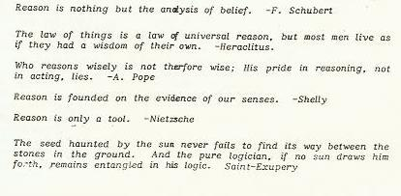

19 Pain is a heavenly guide
Man has turned away from God and escaped into a physical body. His perception of his surroundings has become equally physical. This world can never be a happy world because it has the presenece of pain in it. But pain is only a fence that guards the road to Heaven. It appears as a warning whenever man is straying o the path. Pain says: \stop here and turn around!" But instead, man ignores pain by doing more wrong. He uses stimulating practices to dull the awareness of pain so that he may continue doing wrong.
Man's spirit is terribly sick and has been sick before it entered earth. Everyone needs to be healed. Sick people are in career of conquest; they are the leaders in every eld of human life. They do not know their fatal condition because they have buried it; only a drive for survival has remained. To be somebody has become man's meaning of life.
Sooner or later people may have a glimpse of their fatality, and depression settles in. The truth becomes so horrifying that, instead of retracing their wrong steps, they choose suicidal practices as the way out. They escape into more activity, more drugs and more excitement until unawareness has overtaken them again.
Every creature on earth lives a painful life. They all have an enemy outside themselves and do battle with it. Survival is lord and every microbe, plant, and animal partakes in it.
If a man is told that he does not have to survive in his world, he answers with hostility. He must do so because his only possessions are his physical senses, and he feels doomed whenever he stops carrying out their deadly commands.
Eternal life comes into vision with a conviction that says:
If I am in pain, I must do nothing about it but suer it through to the very end
The symptom of every disease has to be dissolved into pain.
An emotion ceases to be a passion as soon as we form a clear and distinct idea of it.
| Spinoza
We hear and apprehend only what we already half know.
| Thoreau

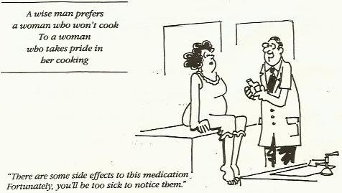

20 Disease is a soul saver
Every symptom of a disease has one purpose: to throw out accumulated poisons. A disease is a house cleaning, and is thereby life restoring. If this is a fact then not a single disease is dangerous, nor has it ever done any harm, whether it had appeared on the physical, mental or spiritual level.
The above statement needs explanation: There are poisons that have accumulated in man's psychological make up as well as in his body. The psychological body is healed through a catharsis. In a crisis, abberrations surface and purify the system.
A healthy condition of the body eliminates poisons through physical channels; such are the digestive tract, the body membranes and other legitimate organs. But when the body is overburdened with poisonous substances, its intelligence takes on emergency measures of elimination. This results in an inammation. At the most vulnerable spot in the body, a reddening of body tissue is experienced which eventually ulcerates. This is an emergency elimination. Every disease of the body starts with body-saving attempts such as colds, tumors and other inammations. But when the body energy is exhausted this process will switch to body-destroying chronic diseases such as arthritis, cancer, aids and others. As shocking as it may sound, a body-destroying disease is equally a life-saving disease. It is man's inner body, his soul, that has to be saved. Life protects integrity be sacricing the physical body. A body-destroying disease safeguards a man from falling into a lower form of life. Under no circumstances must a body-destroying disease be suppressed with medicines and treatments so that it may exist a few days longer in a state that corrupts body, mind and soul. To smother the awareness of pain with drugs degrades the integrity of life.
Diseases perpetuate with the eating of undigestible foods that ferment and putrefy in the digestive tract. This produces alcohols and acids. These in turn are absorbed into the inner body system. Even fruits ferment when eating in large quantities or when digestive power is weakened. Anger and frustration are other disease builders. They produce indigestion regardless of the quality of foods eaten. Drugs enter the bloodstream directly and do the greatest harm.
It is man's surrender to a hostile living condition which makes him sick and not the hostile condition. Conditions have no power unless fought against; and to ingest stimulating but indigestible foods to mask the pain of detoxication is only one example of a false surrender. Now they become addictive. Because man lives by false principles on all levels of life, he strives to survive at all cost in his hostile world until all of his rejuvenating life-force has been dissipated. Most humans never return to the naturalness of a well functioning mind and body, although at one time they could have dont it. But it is too late then the clearness of mind is gone. Toxicity has done its work.
Sick people see sick people as healthy people. They don't know what health is and much less of hot it is attained. Health depends on the availability of vital energy, and if depleted, poisons remain hidden and man remains in his zombie state. Therefore, a detoxication process, (which is the apperance of a disease) as well as a catharsis must never be suppressed. A disease can only happen when vitatlity is present and if not, the body keels over and dies. Only vital energy can push out poison and restore health, and for that it needs rest. Drugs, cures and mental self-esteeming do just the opposite. Any help other than the removal of harmful obstructions does tremendously greater damage than the original trespassing. Any treatment causes the symptom (the inammation, tumor or insanity) to retreat only temporarily, because the intrusion or exertion which any interference from outside represents is a greater threat to body and mind. The body always acts intelligently because, if vital energy is not yet depleted, more important things are at stake. The remaining vitality must hold the new intruder in check and postpone its house cleaning until new energy becomes available again.
Any treatment that has the intention to heal body and mind is not only wrong, it intensies destruction. A medicine is a deadly substance; it kills a man's soul.
Due to the agitation of a treatment, a symptom recedes and the organ seems to function again. (The organ was never sick in the rst place, it just so happened that it served as a target for elimination.) This \Un-healing" came about because neutralization of the new intruder comes rst. As they are poisons, they must be stored inside the body's cell structure in order to be processed at a later time. The remaining vital energy makes the body active again, but - and here is the tragedy - with less functioning power. This proves the fact that any treatment suppresses only the symptom of a disease while the poison remains inside. Never again does body and mind function with their full capacity.
To gain back health, there must be a detoxication. This causes a rejuvenation of every cell. This process is consistent with nature and is accomplished without any interference from a man's eort in exercising, in positive thinking, or emotional concerns; only rest with its stillness is required.
Every man can learn to stop his indulgence in perverted lifestyles. He can thrive on the simple pleasures which he may experience in fresh air, a clean environment, a calm mind, and pure foods. These must become his new love.
No man ever healed his body with his mind, nor did he heal it by eating or exercising. All these are activities that use up vital energy by stimulating the body. Only rest is invigorating, all else is a wasting away of energy.
The existence of death is proving the fact that every living thing on earth is sick. Man has made his home in an incinerator. Ancient philosophers knew this world better than we do today when they called it \Underworld."
The idea that foods do something good is one of the greatest fallacies. Eating fruits is good only because they are not oending the system. While drawing the least energy in their digestion, it is used for other purposes.
Drugs are supposed to ght a problem, but it is self-evident that they cause death. Francis Bacon must have known all this when he said \Cure the disease and kill the patient." Now you as the suerer will have a new responsibiity. Never again can you ask anyone to heal you, because if you do, your help becomes a partner in your own suicide.

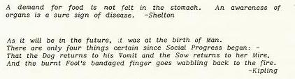

21 Old wive's tales
The illogic of old wife's tales is unfathomable. One of their ideas is that any sickness, like tooth decay or hair loss, has its source in a deciency of some kind; that the body didn't get enough vitamins, minerals or proteins. This is a great lie because the real cause of a sickness likes in an exact opposite direction. The body has been bombarded with too much foodstu, especially with elements of destroyed cell structures. Any chemical taken into the body that is not predigested by the plant kingdom becomes a poison. The body can eliminate a substance only when it is bound inside a living cell. A sickness appears when dead substances have been added instead of taken away.
Every time a man wanders away from health a symptom of sickness appears. The early ones are colds, ulcers and tooth decays. They act as check points that warn him that any further advancement in this direction will bring greater harm.
A sickeness shows that the health of the body as a whole unit has been violated. Unnatural foods draw vital substances from all of the bodys tissues and bones for their neutralization. The body replaces the resulting voids with morbid sludge which now clogs up the system. The body deteriorates as a whole unit and only the presence of vital energy can start a cleaning process for which the weakest or most abused part of the body is chosen. This is the appearance of disease.
Ignorant people must always plot and plan to bring on a healing instead of letting the body heal itself. Originally, the tale of missing substances was invented in a voodoo kitchen with the purpose of getting gullible people under the voodoo priest's control. The victim is sold the right elixir that overpowers pain. And then's when he comes under his control.
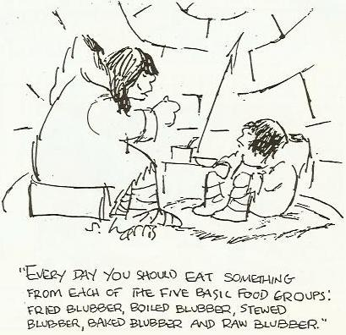

22 Not doing but resting heals
The body heals itself only when nothing from outside interferes. A complete rest is all that is needed. The more a person stays away from foods, mental stimulations and activities of the body, the more energy can be utilized by the body for self-healing. But humans are so run down mentally, emotionally and physically that they cannot remain in that restful state. That's why less energy wasting practices are allowed, like eating fruits only, moving around sparingly and entertaining the mind moderately. The road back to health is to engage in progressively less damaging habits.

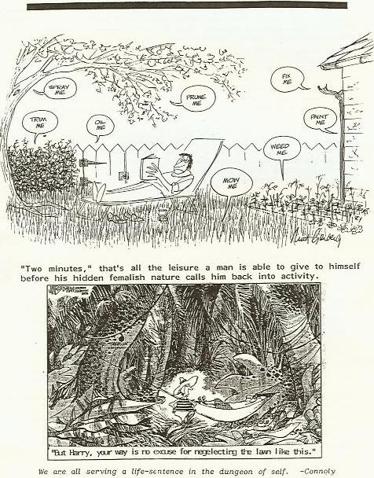

23 The house of health
Every man can move into a healthy body, a good feeling, a peaceful mind and a pleasant activity as he would move into a beautiful new home. But the spiritual home demands a dierent way of purchasing because it cannot be mortgaged. The spiritual home has to be paid in cash before hand. But how is this money acquired? Isn't it by giving up the old method of saying \I already know what's good for me and I only have to do something to get it!" It has never worked. All this has to be replaced with a daily practice of: \I do not know what is good for me, therefore I will do nothing. I will suer the full pain of my inner condition until it is lifted by a higher source!"
Man has to die so that he may live.
You do not exist and that's why not doing anything for yourself can restore health on all levels of existence, whether it is on the physical, emotional or mental level.
To do nothing leads back to a state that does not exist on those levels. It is the home of the soul from where all subsequent levels receive their rules. \You believe that you exist and to conrm it to yourself, you start with all of your doing."
Health is a \do it yourself" aair, but in a special way. All falsehoods are taken away and all riches are added by \Self-Observation" combined with \Doing Nothing." The Bible makes the same request when it states in Matthew 17:21 \but this kind does not go out except through prayer and fasting." It does not say that man may fall asleep. The special way consists of: \be nothing, think nothing, feel nothing and do nothing." Only by his own eort to stick with that can he be helped and it is exactly this eort which he shuns. Do nothing and wait! This is all the knowledge a man needs. Only that will make the new house appear.

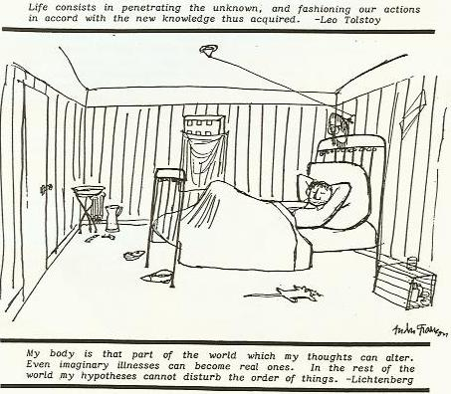

24 Crystallized wants
In God's world there are no humans. Nothing that truly exists would ever die. Humans are chased by an equally non-existent outside world and it is only a matter of time when both have cancelled each other out and disappeared.
A man who knows the truth about himself recognizes that everybody wants to make himself real. They are driven to take experiences from the past to build a future. But this \presence" has no reality at all in God's eyes. It is a \bubble" that is active in a non-existent state. God cannot exist in its world either other than through the law of cause and eect.
There is the example of the man who borrowed a dinner to keep himself alve and his hunger-pain subdued. Going into debt is never right, instead this man should have remained hungry until his pain disappeared, because all healings come by non-interference. He had refused to see that \EVERY DEBT HAS TO BE PAID BACK." Instead he borrowed more dinners.
Man shall not live on borrowed substance! What would happen if a man starts to pay o the future to the past to the past and keep nothing for the present? He becomes less and less until one day he would disappear. He simply is returning to his natural state.
Only a self-created entity can die. A new being will emerge that is real. This is the true meaning of being born again.

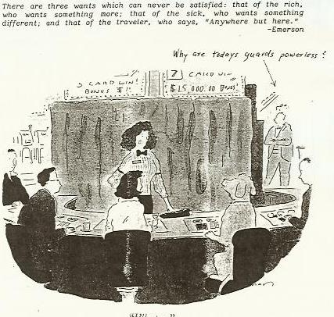

25 Hershey bars
When we were children we loved Hershey bars but as we became older this craving grew and turned into sexual love. Sex is so much more stimulating than food.
Man is on a wrong journey that leads him away from God and into matter, energy, space and time , and instead of getting his sustenance from God he derives it from these factors. And the more he feeds himself the deeper he travels into them. This journey uses up his inherited spiritual energy and thereby he extinguishes his self-awareness. An universe that can be grasped with the intellect belongs to Lucifer and represents death to anyone who has entered into it. It depends only on the speed he is travelling and of how long vital energy holds out that determines the time of death.
Before man entered earth he already had a developed cannibal nature otherwise he would refuse to eat mother, because that's what every new born entity is doing. As soon as the infant matures a little it begins to feed on her emotional nature. Soon mother won't satisfy and man escapes into his sexual nature.
A need for sex is completely unnecessary for any man who wants to return to his sane nature. But the procreation game is too great a pleasure to miss out on, so the paycheck for received pleasures is pushed deeper into time.
To cancel time man must turn away from all hungers. But they have to be resolved in an orderly fashion. It is impossible to stay away from enticing foods or tight love relations if man is caught up in his intellect. Since it was formed last in the line of descent, (it lays on a deeper time level), it has to be resolved first.
Every vice has been spilling over into the next vice and had delayed the death of the physical body. When anger was tolerated in his Soul nature, it went into hiding by creating the ego with its body, but the body soon could not handle the anger and emotions came into being. Emotions seek an outlet in food. But food soon is outdone by a need for sex. Procreation appears when two people consume each other in a sex-embrace. Competition for companionship develops the intellect which then is driven to exploit the environment. Pollution is the result. This activates whole new chains of perversion until destruction is completed.
To gain back life is to curb hunger on all levels. The whole thinking process of man has to be reversed, so that survival in the physical realm is seen as being wrong.

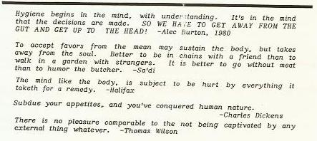

26 The barroom
A bar that serves no alcohol and has no sexual attractions or other excitements would lose all of its attraction. Planet earth is such a bar because in it man thrives on stimulating substances, is depending on procreation and indulges in senseless activities. Their sudden disappearance would mean the end of human life and since there is a huge universe, man would appear somewhere else to have fun. The physical body came into existence because man needed a barroom to escape from facing God.
Man's life is not real. He should never be afraid to walk out of this world, which of course does not mean committing suicide. There certainly is a life that lies above the physical body, but what his new body may look like need not be his concern. A physical body is very limited, it can only see, hear, taste, touch and smell. If man became aware that he lives by its domain and only indulges in sex, emotionalism and egogratications, he would get out fast. Giving up coarse, crude, vulgar, gross, lewd, obscene, oensive sensations has to become the purpose of his life. It is his duty to walk out while he is still alive.
Sow a thought and you reap and act. Sow an act and you reap a habit. Sow a habit and you reap a character. Sow a character and you reap a destiny. It's so simple is it not?
What is right can never be destroyed, so do only right and you shall live forever.

27 The castle in the air
A man had a heavenly vision that resembled a castle in the air. He directed his whole life to build a foundation under it. Other people sensed that this man had a happy and purposeful life so they sought him out for advice. The visionary was happy to help along. He gave classes on how to attain the Higher Life. His students became successful. One turned into a great artist but the teacher was dismayed because he saw no application of his vision in his unfoldment. Another student became a successful leader of society but again there was no vision. Another became a philosophical teacher but he also was empty of vision. Many became successful in business but their lives remained empty. Almost no one sought the teacher's gift. Eventually the visionary completed the foundation to his castle and ascended into invisibility. He left no fame of his life behind. And the students were aghast.
When something \is," it must have always been. Something that has become visible we call creation, like gas that has become a uid and a uid that turns into ice or vice versa. Everything that disappears from our sight becomes visible on another level. If this world fades away it did not fade away of its own but by a withdrawal from - or an addition to - an outside source. No man can go higher except that he gives himself up to the life principle that governs the whole universe. He does not have to use mind or body for that.
You may lose your old nature either by fasting from yourself or indulging yourself. The rst takes you out of the physical world, the second binds you to the physical world.
You either can let nature take care of you or you can struggle and do it yourself. The rst rebuilds body, mind and soul and the second destroys body, mind and soul.

28 All food is destructive
Food keeps man in a limited physical existence where he can hide from God. But man's purpose of life is to choose rightly and face God again. This will dissolve his body. To start this process is to disconnect from all lower desires. That will return him to the higher and follows a certain order which can be learned. Every level of life draws its own kind of food. A warrior must eat meat to arouse anger so that he may face his enemy. But the enemy can be any life-situation. A fruit eater cannot be taken to war nor will he meet with the successes of this world, as he sees no reason to ght. A grass eating dear does not kill, he has no drive for it. Over time man has constantly travelled deeper into his body thereby he became increasingly more hostile and his food intake became coarser. From the harmless entity living in the paradisical world he changed into a predator. Eating destroyed foods, he has taken on the nature of a vulture and a pig. Only Satan himself could have taught man to go deeper and use re to prepare his food. But re turns food to ashes. Man lives cleanest from living cells and not from dead matter. Busted cells become minerals and like every medicine, are a poison.
Presently man is a self-harming animal that still has a choice to return to a harmless state and transcend animal nature. He can climb up to his higher body which are his heart and mind. If he does not, his fate is sealed. He is a branch that is cut o from the vine and is consumed by re. Here is a fundamental approach to life:
Matter is the end of creation and all of it turns into dust. Build your life on matter and you will experience unending pain that will last as long as matter exists. Direct all your aim to return to your spiritual home and you will come back to life again.
A return to a higher world is orderly and follows a perfect sequence. Being stuck in the lower parts of the body is like living inside the legs and the excretory organs. All of a man's thinking and acting is connected to these centers. The ego symbolizes the excretes of the human entity. To live there destroys him fastest and requires a digestive environment that has turned acidic to cope with. Man still can stop that process and travel upwards into his heart and mind. On the way he has to disconnect from the sex center (procreation) and the solar plexus (emotion). Withdrawal takes away the wind to a re and his coarse nature disappears.
The false desire to survive in a material universe permeates every sphere of life. A long life in the physical body is needed for learning how to give up one's life for righteousness sake. Instead, man does everything to survive in this hellish surrounding. That degrades his God-given integrity so that he may remain there. But instead, man's life becomes shorter in consciousness. Today's bodies are goaded into life with medical knowledge at the cost of integrity of life.
The rst religious teachings on this earth probably was the knowledge that man had no right to life there. This has meant a journey to a complete dissolution of his material existence. Every successive religion has increasingly compromised with this goal until it got mixed up with procreation.
Man never evolved out of a beast, but he can become the beast by his own choice. Man was a spark of light that has wandered away from God and joined itself with matter, increasingly losing his essence. Every time a man makes himself more comfortable in this world, he becomes a little more saturated with matter.
All of man's foods are stimulants by which he draws a fake life to himself. Man's true food is life and it does not come from food. The deeper a man dives into his body, the more lifeless the substance of his food becomes and the greater the quantity of it he must eat. This enables him to cope with his degenerating outside world. The rst man must have lived by breath alone. Then came a heavier food that took the form of fruits. They just oered themselves to man by having beautiful colors and a sweet aroma and taste. Fruits are enticing to the eye, smell fragrantly and taste wonderfully. Eating them involves no killing. But as man became emotional, he needed coarser foods and he began to eat roots, stalks and leaves. Next he digressed to grains and nuts. But these substances were created to beget new life and eating them became a violation. Suddenly he realized that he had cast himself out of paradise and he blamed God for it. The deeper he sunk into his body the heavier in substance became his food. To the degree he killed his food he also killed himself. He had to cope with pain that came from his choice to turn away from God. Today man feels nothing wrong when he kills life.
Man made himself a servant of re. The consuming of meat is a consummation of self. But by using re to destroy his food, he speeded up this process. Cells are alive and give life to the body, but when they burst by re they turn into lifeless minerals. Minerals are equal to sand and dust. Lifeless matter goads essence into exhaustion.
Food never builds like but destroys life and it is the density of the food that determines the speed. The further man travels away from his paradisical life the heavier his food becomes and the shorter is his life. Today's food is saturated with ashes and the application of re was the cause of it. It turned organic substances into minerals and chemicals. Man has become so coarse that mineral substances must give life. Fruits give no satisfaction and he craves for proteins, carbohydrates and minerals. They are still able to draw out life.

29 The world of duality
Every living thing that appeared in a universe of matter, energy, space and time became encased in a body that equals the nature of its surrounding. It is the world of duality in which the highest entity, which is represented in man, still has a choice. A human being can return to his higher body. But he also can burn himself out and become the dust of the universe. This world of duality gives man two eyes, two legs, two brain halves, etc. Man can go the right way or the wrong way. He can be happy or sad, negative or positive, dull or alert, right or wrong. His stomach can be empty or full. What he is inside he experiences outside. It is the world of high and low, cold and hot, dark and light, sweet and bitter, pleasant and unpleasant. Man experiences the real light of the sun and an articial light of the moon. The purpose of this universe is to give man a choice. He either can go up or down. When he returns willingly to his home he will be happy. But he really has no choice because when he goes down, he still will be made to return forcefully by serving as building blocks for the universe. He has to serve until he has paid back all he has done wrong. He will be ground to dust. Unless man is under spiritual guideance he inevitably will become entangled in matter (building up karma). If a man wants to survive in this world he has to be more cruel than his surrounding. Going to heaven means not to learn to lose. A good exercise is to undertake a job in this world and let yourself be defeated by it. The point is to remain content. Then go on to the next job and do it all over again.
One can live only so long as one is intoxicated, drunk with life; But when one grows sober one cannot fail to see that it is all a stupid cheat. What is truest about it is that it is not funny but cruel stupidity.
| Tolstoy

30 The body is a child of the mind
Above a man's existence is awareness that lters into the brain. With the mind one becomes aware of a body. Actually, the mind made the body (with God's help) because it needs a place to hide from pain. And therefore it is responsible for the condition of the body. If the mind is mixed up, the body is mixed up too. A change of body has to start in the mind. As the mind becomes whole again, the old body falls away. When there is right instruction from above, the mind will take the lead and the body will change to a higher form. It will escape the \trap of earth."
What is the right kind of food for the body? It can only be a food that has living cells, as found in fresh fruits. It maintains a clear thinking mind and keeps the body healthy. All other foods taken in come as a suggestion of an evil source and drug the brain. Foods that are destroyed by re (cooking) act as a drug and the mind cannot think clearly. The proteins in meats and dairy products putrefy in the intestines, they give up the acids to the blood which carries it to every cell in the body. It courses through the brain and drugs it with the same force as any other acid would do. Man eats carbohydrates as found in breads and potatoes that ferment in the body which produces alcohol that narcotizes the mind. Earth sure is a dangerous place and few there are that see it.
Destroyed cells are heavy with matter, and like everything dead that is eaten, poison the body. It has to be expelled at the cost of vital energy. Only living food produces healthy body functions and keeps all parts of the brain working harmoniously.
Humankind is kept alive by a fear for the death of their bodies. A wrong voice is saying, \save your physical body and take the medicine!" The higher voice says: \you don't have to compromise to keep your body alive." To goad the body into health is to lose the soul. Only God gives life. Investigate for yourself what life is all about!
All humans can be divided into two groups, those that worship their bodies and hang on to it all cost, and those that strive for detachment, not knowing what comes next. It is not the physical death that is at stake, it is spiritual death that is the real tragedy. Therefore, it is proper to save the soul and let a false life fall away.
The lower body consists of:
- every emotion, either good or bad
- sex and the struggle for companionship
- the building of the intellect and its activities
These centers, which all are located below the lowest rib from which the woman is made out of, are entirely unnecessary for experiencing the real life. They came into existence as man chose to turn away from God and needed a companion. Of course man may attend to their necessities temporarily, because the desire for them is strong. An unhealthy muscle can atrophy, and thereby become unable to do harm. Let all of your lower centers atrophy because they are liars, and when they seem to give something to you it is for the purpose of harming you. They use tricks to fool you. Attain this attitude, \I won't even listen to them because I won't believe what they say!"
To close your life to foolish conduct deserves integrity. Do the exercise to never discuss \lower body" desires. A mature man does not insist on keeping an open mind, he closes it to anything vulgar and which promotes lowness. He works on closing o the exit to his lower body. In contrast, a fanatic mind has locked himself tightly inside of it, unable to escape.
If all of this makes sense to you, \Do Nothing but see it." This invites rescue. It comes like a gushing well that is reviving a garden. This is the only correct science because it is a renewal of life.
The way out begins with this statement: \he who indulged in wrongness until he has become sick must withdraw from it until he is well again." Every healing starts with a withdrawal from destructive habits which were devised to suppress pain. Do not run away from God any longer, but face the habit's uncomfortableness. Remaining with withdrawal pain brings more suppressed pain to the surface. But when it is not freshly subdued but suered until release from a higher source has arrived, healing occurs.
But old habits are not easily forgotten and pull the student back into their power again. Luckily, due to his attained healing, the student has become sensitive to pain again like a child when given alcohol. He has become acutely sensitive to the new pain. As a matter of fact, a fresh indulgence will multiply the pain. This is just what he needs to keep clean. And now he is destined to wake up healed. With this struggle a higher life is attained that will never make him go downwards again.

