**Moroccan Eggplant with Garbanzo Beans**

[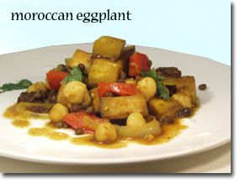](http://whfoods.org/genpage.php?tname=recipe&dbid=52&utm_source=daily_click&utm_medium=email&utm_campaign=daily_email)

**Prep and Cook Time: 35 minutes**

**Ingredients:**

* 1 large onion, cut in half and sliced thin
* 5 medium cloves garlic, pressed
* 1 medium red bell pepper, cut in 1-inch squares
* 1 medium eggplant, cut into 1-inch pieces
* pinch of red pepper flakes
* 2 tsp turmeric
* 1/2 tsp garam masala
* 2 cups or 1 15 oz can garbanzo beans (BPA Free)
* 1 15 oz can lentils, drained
* 1/2 cup tomato sauce
* 1-1/4 cups + 1 TBS vegetable broth
* 1/2 cup raisins
* 1 TBS chopped fresh cilantro
* salt and black pepper to taste

**Directions:**

1. Slice onion and press garlic and let sit for at least 5 minutes to bring out their health-promoting benefits.
2. Heat 1 TBS broth in a 10-12 inch skillet. Healthy Sauté onion in broth over medium heat for 5 minutes, stirring frequently. Add garlic, red bell pepper, eggplant, garam masala, and turmeric. Stir to mix well for a minute, and add broth and tomato sauce. Stir again to mix, cover, and cook over medium low heat for 15 minutes, stirring occasionally, or until peppers and eggplant are tender. This is our Stovetop Braising cooking method.
3. Add garbanzo beans, lentils, red chili flakes, and raisins. Simmer for another 5 minutes. Season with salt and pepper. Top with chopped cilantro.

**Serves 4**

**Serving Suggestions** Serve with