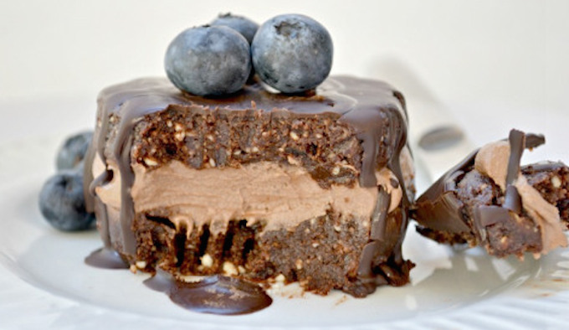

**Raw Chocolate Mousse Cake**

By [Fork and Beans](http://www.forkandbeans.com/2013/01/17/raw-chocolate-mousse-cake/)

Yield: 1 whole cake

* 1 1/2 cups soaked cashews, drained
* 1/3 cup raw cacao powder (or regular cocoa powder)
* 2 teaspoon vanilla
* 1/4 cup agave or sweetener of choice
* 1 1/4 cup water
* 1/4 cup melted coconut oil
* 1 cup cashews, soaked for 2 hours
* 1 cup macadamia nuts, soaked for 2 hours
* 1 cup almond or oat flour
* 1/2 cup raw cacao powder
* 2 medjool dates, chopped
* 2 tablespoons agave or maple syrup
* 2 teaspoons coconut oil

1. For the mousse: Combine the first six ingredients into a high speed blender until smooth and thick. Cover and freeze so it can set while you make the cake.

2. Mix the cashews and macadamia nuts in a food processor until crumb-like. You might have to do this in 2 batches, depending on your food processor size.

3. Add the remainder of ingredients into the processor and pulse until a smooth dough forms.

4. Line a loaf pan with wax paper. Place dough in pan and with hands, pat down until dough forms into pan. Freeze for 25 minutes.

5. Take cake out of pan and gently cut into 1/2″ slices.

6. Top with chocolate mousse and cover with another cake slice.

7. Freeze again.

8. Enjoy!