Roasted Cauliflower

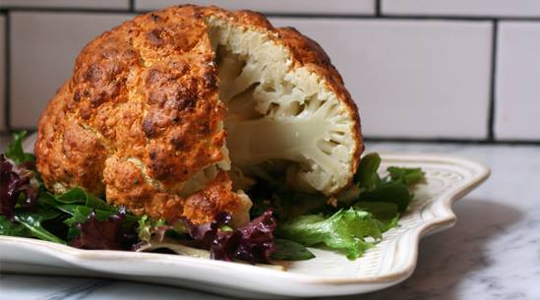

Ask Dr. Nandi with Heralline Daluddung G and 10 others
Roasted cauliflower? A whole head of cauliflower? This recipe has you slathering cauliflower in a spicy yogurt marinade and roasting it at a high temperature. The result is an amazingly delicious dish that’s as dramatic in presentation as it is easy in preparation. Serve it with a big green salad (we suggest lime juice and olive oil for the dressing) for an easy weeknight supper.
Spicy Whole Roasted Cauliflower
Ingredients
1 tablespoon vegetable oil
1 head cauliflower
1½ cups plain Greek yogurt
1 lime, zested and juiced
2 tablespoons chile powder
1 tablespoon cumin
1 tablespoon garlic powder
1 teaspoon curry powder
2 teaspoons kosher salt
1 teaspoon black pepper
Directions
1. Preheat the oven to 400° and lightly grease a small baking sheet with vegetable oil. Set aside.
2. Trim the base of the cauliflower to remove any green leaves and the woody stem.
3. In a medium bowl, combine the yogurt with the lime zest and juice, chile powder, cumin, garlic powder, curry powder, salt and pepper.
4. Dunk the cauliflower into the bowl and use a brush or your hands to smear the marinade evenly over its surface. (Excess marinade can be stored in the refrigerator in an airtight container for up to three days and used with meat, fish or other veggies.)
5. Place the cauliflower on the prepared baking sheet and roast until the surface is dry and lightly browned, 30 to 40 minutes. The marinade will make a crust on the surface of the cauliflower.
6. Let the cauliflower cool for 10 minutes before cutting it into wedges and serving alongside a big green salad.
Thank you to PureWow for this wonderful photo http://www.purewow.com/…/Forget-florets--roast-the-whole-da…

