Happy Meatless Monday!   
Dressing at Seeds of Life:  
 sesame seeds, sesame oil, olive oil, apple cider vinegar

**Stir Fried Thai Basil with Tofu and Eggplant**

[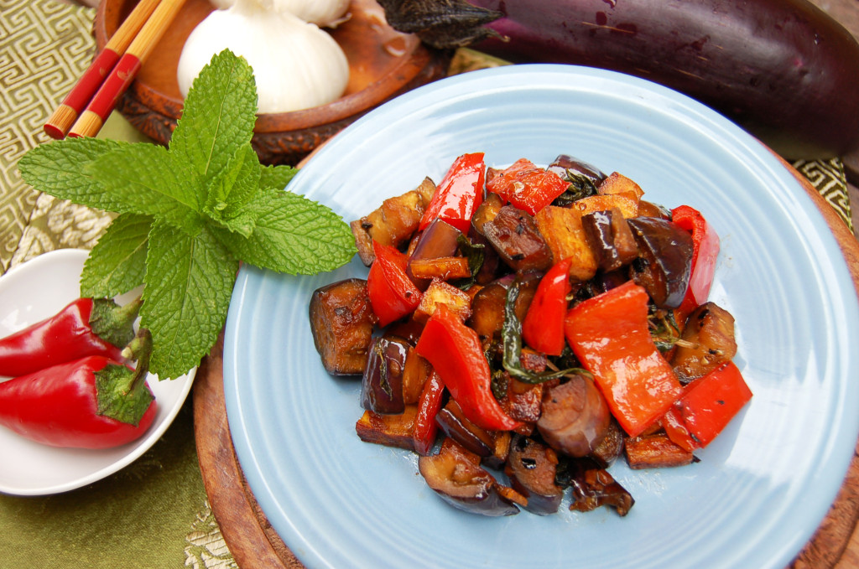](http://www.happycow.net/blog/wp-content/uploads/2013/04/stir_fried_thai_basil_tofu_eggplant.jpeg)

If you freeze the tofu and then thaw it out, it will become like sponge and really absorb the flavors of the sauce. This is a bit more work but if you have the time, I highly suggest trying it.

 Serves 2 – 4

Gluten free if using gluten free soy sauce

Nut free

**WHAT YOU WILL NEED**

1/2 Tablespoon (7 ml) oil (1 Tablespoon or 14 ml if you don’t have a non-stick pan)

2 cups (290 g)  firm tofu, rinsed, drained and cut into 1 inch cubes.

1 Tablespoon (10 g) fresh red chili, minced (take out seeds if you don’t want it spicy)

5 cloves garlic, minced

2 cups (145 g) Japanese Eggplant, cut into 1 inch rounds and then cut into quarters

1 cup (150 g) Red Bell Pepper, cut into 1 inch chunks

1 cup (25 g) Thai basil leaves

**Sauce**

2 Tablespoons (30 ml) Soy sauce

2 teaspoons (10 g) Sugar

1 Tablespoon (15 ml) Sesame oil

2 Tablespoons (30 ml) water

**HOW TO DO IT**

* Make sauce by whisking all 4 sauce ingredients together. Set aside.
* Heat oil on medium/high in a large non-stick skillet.
* Add tofu and red chili and cook for 5 minutes.
* Add garlic and cook for another 2 minutes.
* Add eggplant, red peppers and basil and cook for an additional 3 minutes.
* Add sauce and stir to combine.
* Cook for 2 more minutes, turn off heat and cover.
* Covering the dish will allow the steam to make the eggplant a little softer.
* After 3 or 4 minutes, take off the lid and serve.
* Garnish with fresh Thai basil and serve with brown or jasmine rice.
* [George Mateljan](https://us-mg5.mail.yahoo.com/neo/launch?.rand=5l7buasj61qcn)
* Today at 6:18 PM

To

* me

|  |
| --- |
|  |
| The George Mateljan Foundation, a not-for-profit foundation with no commercial interests or advertising, is a new force for change to help make a healthier you and a healthier world. |
| healthy food tip and recipe  November 14, 2014 |
| **Check Out What's New On Our Website**  [**Vitamin D**](http://whfoods.org/genpage.php?tname=nutrient&dbid=110) **- the Sunshine Vitamin!** Unlike any other nutrient, we have the ability make our own vitamin D when exposed to the sun. When it comes to food, Vitamin D is a nutrient particularly dependent on very specific foods such as higher-fat fish like salmon.  **Today's Recipe**  **If you don't know what to serve for dinner tonight ...**  Combine this tasty lentil dish with rice for a hearty meatless meal to add to your Healthiest Way of Eating. It will provide you with a complete protein as well many other health-promoting nutrients.  **Indian-Style Lentils**  **Prep and Cook Time: 20 minutes**  **Ingredients:**   * 1 medium size onion, diced * 1 TBS vegetable broth * 2 cloves garlic, minced * 1 tsp ginger * 1/2 tsp turmeric * 1/2 tsp salt * 1 cup canned diced tomatoes * 2 cups or 1 15-oz can (BPA free) lentils * 1 cup frozen spinach   **Directions:**   1. Dice onions and mince garlic and let sit for at least 5 minutes to bring out their health-promoting properties. 2. Healthy sauté onion in 1 TBS broth for 3 minutes. 3. Add garlic, ginger, turmeric, salt, tomatoes and lentils. 4. Simmer **covered** for 5-7 minutes. 5. Add 1 cup frozen spinach and continue simmering for 2 more minutes.   **Serves 2**  Serve over brown rice.  **Printer Friendly Version** of [Indian-Style Lentils](http://whfoods.org/genpage.php?tname=recipe&dbid=232&pfriendly=1&utm_source=daily_click&utm_medium=email&utm_campaign=daily_email)  **In-Depth Nutritional Profile** for [Indian-Style Lentils](http://whfoods.org/genpage.php?tname=recipeprofile&dbid=318&utm_source=daily_click&utm_medium=email&utm_campaign=daily_email)  **Healthy Food Tip** Do watermelon and other fruits/vegetables continue to ripen after they are picked? Some fruits and vegetables continue to ripen during transportation and while in the store. For example, while bananas, apples, apricots, pears and cantaloupe continue to ripen after being picked strawberries, raspberries, citrus fruits and pineapple do not.  But recent studies have confirmed the nutritional importance of allowing fruits such as watermelon to fully ripen. Research has shown that the biggest jump in lycopene content occurs at the time when a watermelon's flesh turns from white-pink to pink. Yet when that flesh continues to ripen, resulting in a color change from pink to red, the lycopene content becomes even more concentrated. Prior to ripening, when the flesh of a watermelon is primarily white in color, its beta-carotene content is near zero. Even when allowed to ripen to the white-pink stage, a watermelon still contains very little of its eventual beta-carotene content. But as it moves from white-pink to pink to red, the beta-carotene content of a watermelon steadily increases. Like lycopene and beta-carotene, total phenolic antioxidants in a watermelon also increase consistently during ripening, all the way up until the appearance of fully red flesh. The bottom line: eating a fully ripe watermelon can really pay off in terms of nutrient benefits.  As background, all of our food articles feature a section on how to select and store for optimal nutrition. Learn more about [selecting and storing watermelon](http://whfoods.org/genpage.php?tname=foodspice&dbid=31#purchasequalities).  **Printer Friendly Version** of [Do watermelon and other fruits/vegetables continue to ripen after they are picked?](http://whfoods.org/genpage.php?tname=answeredquestion&dbid=212&pfriendly=1&utm_source=daily_click&utm_medium=email&utm_campaign=daily_email)  **If you have any questions about today's Healthy Food Tip** [**Ask George Your Question**](http://whfoods.org/sendask.php)  *Your site is fantastic. I love it and have given copies of your book to several friends. - ST*  Visit our homepage at [http://whfoods.org](http://whfoods.org?utm_source=daily_click&utm_medium=email&utm_campaign=daily_email)  Copyright © 2014 The George Mateljan Foundation, All Rights Reserved |

George Mateljan Foundation, PO Box 25801, Seattle, Washington 98165   
  
[Unsubscribe](http://www.aweber.com/z/r/?LKzMrGyMtKxsHKzMjEwctEa0TKwsDCxsbEw=) | [Change Subscriber Options](http://www.aweber.com/z/r/?LKzMrGyMtKxsHKzMjEwctEa0TKwsDCxsbEw=)