* Zuchinni Nachos

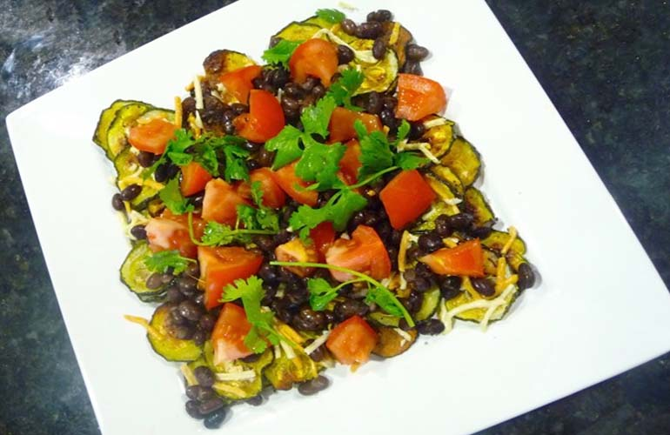

* [Share](http://www.facebook.com/sharer.php?u=http://upenn.spoonuniversity.com/cook/healthy-zucchini-nachos/?utm_source=buzzfeed&utm_medium=referral&utm_campaign=content-partnerships)
* [Pin It](http://pinterest.com/pin/create/button?url=http://upenn.spoonuniversity.com/cook/healthy-zucchini-nachos/?utm_source=buzzfeed&utm_medium=referral&utm_campaign=content-partnerships&media=http://upenn.spoonuniversity.com/wp-content/uploads/sites/5/2013/10/Screen-Shot-2013-11-18-at-12.32.50-PM.jpg)

Who doesn’t love nachos as an appetizer with friends? As satisfying as fried chips are, they are also heavy and full of fat and grease. Try this recipe that uses zucchini as an alternative base for nachos. They’re easy and surprisingly delicious–some might even argue that they are better tasting than their fried alternative. Baking zucchini chips can add complexity to classic nachos and make them a tasty snack that won’t kill your diet.

Easy

**Prep Time:** 5 minutes  
**Cook Time**: 45 minutes  
**Total Time:** About 50 minutes

**Servings:** 3

**Ingredients:**  
3 large green zucchinis  
2 large tomatoes  
¼ cup of Daiya shredded cheese  
½ cup of black beans  
¼ cup chopped cilantro  
Spray olive oil  
Garlic powder  
Salt and pepper  
Optional: non-fat Greek yogurt (as a substitute for sour cream)

**Directions:**

1. Preheat oven to 400°F.
2. Cut zucchini into “chips” (about ¼ inch slices– thinner for crispier chips, thicker for more hearty nachos).
3. Line a baking sheet with foil and spray it with olive oil.
4. Place zucchini chips in one flat layer and sprinkle with salt, pepper and a little garlic powder. Spray another even layer of olive oil on top.
5. Place in oven and allow them to bake for 40 minutes.
6. Remove from oven, sprinkle with cheese and put back in the oven for an additional 5 minutes.
7. Take out of the oven and let cool. Once cooled a little, dice the tomatoes and toss on top.
8. Drain black beans and add them too.
9. Garnish with cilantro and add a dollop of non-fat Greek yogurt if desired, then enjoy!

Tip: For a sweet spin on these nachos, dice up fresh mango and avocado and add to the plate.