Jon Barron
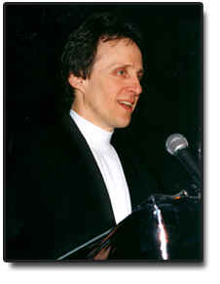 | Jon Barron is one of the world's foremost authorities in cutting edge nutritionals. Starting almost 30 years ago when he walked away from a pre-med major, Jon has been involved in much of the pioneering work in the study of nutrition and anti-aging. He has been editor and publisher of both the LifeStyle Resources Newsletter and the Barron Report, has lectured internationally, and has continued for well over 25 years to be involved in the research and development of some of the most powerful formulations in the world today. Jon is listed in the
Who's Who of Global Business Leaders, has twice been featured in magazines as one of America's top entrepreneurs, and currently serves on the Medical Advisory Board of the prestigious Health Sciences Institute.
Ron Manwarren, President, Royal Botanicals
On Jon Barron
"Many people who have subscribed to his newsletters over the years already know that Jon is probably the best writer on alternative health in the world today. Lessons From the Miracle Doctors can only serve to cement that reputation even further. What far fewer people know, however, is that Jon is also one of the great researchers and innovators in the field today.
It just so happens that Jon is the person who solved the mystery behind why brewing herbal tinctures to the phases of the moon actually produces stronger tinctures. He was then able to develop a process that incorporates this "Barron Effect" into the brewing process -- but at a strength dozens of times stronger than the moon itself. The net result is herbal tinctures that are 50-100% stronger than anything that has ever been seen in the history of the world. At Royal Botanicals, we now brew all of our tinctures using this process. I guess what I'm trying to say is that even though this effect has been known by all of the great healers and herbalists for over a century, only Jon could figure it out and harness it."

