Dale Holmes sent this info in via Ole´s FB msgs on 23rd June 2020:

Melbourne Eastern Freeway Truck crash to Novak Djokovic

Not sure if you are aware but there was a truck that killed four police in Melbourne a couple days ago on the eastern freeway. They had stopped a man driving a Porsche ‘911’. They police were really being exposed in Australia prior to this and now we have the police minister telling us to praise our hero’s the police. It’s number one story here in Aus now even bigger than corona. The man driving the porche is now in demand as he left the scene of the crime. He had friends in the Australia federal police (our FBI) that he sent video to about the crash apparently. Not sure if the Canadian gun attack had any clues but it did involve also police being killed. They painted the town blue the other day to show our respect to the police and all the usuals Facebook marketing with changing profile pics. Daniel Andrea the state premier did an interview days before talking about the eastern freeway. Lastly I don’t know if this is a clue but this is the main imagine they are pumping out. This is the porche driver. He is wearing a top with crossed tennis rackets. This may be a clue. Interesting he does look a lot like Novak dojvcich who has just recently publicly gone agaisnt vaccines and had been doing live videos on Instagram about alternative health. Novak also won the Australia open tennis championship which was the last tournament before corona

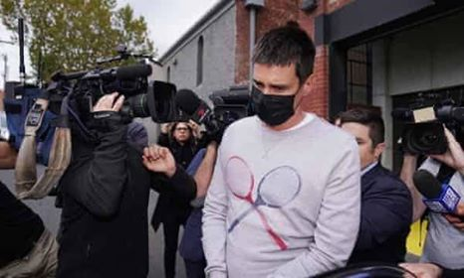

Now Novak has covid

This video has been copied and added to Ole´s list
https://youtu.be/MS0VvEce-sE

Dammegarding - Melbourne Eastern Freeway Truck crash

