**Joel E Arem PhD and , in 1976, became the first American ever to**

**win the Tully Medal, the "Nobel Prize" of gemology, 1943-**

Joel Arem  PO Box 5056  Laytonsville  MD   20882

Phone 212-758-3420 or ([301) 774-7130](tel:13017747130) or [(240) 401-1101](tel:12404011101)

[joelarem@gmail.com](mailto:joelarem@gmail.com)

[www.joelarem.com](http://www.joelarem.com)

<https://www.joelarem.com/about-1>



Dr. Joel E. Arem has more than 60 years of experience in the world of gems and minerals. After obtaining his Ph.D. in Mineralogy from Harvard University, he has published numerous books that are still among the most widely used references and guidebooks on crystals, gems and minerals in the world.

Co-founder and President of numerous organizations, Dr. Arem has enjoyed a lifelong career in mineralogy and gemology. He has been a Smithsonian scientist and Curator, a consultant to many well-known companies and institutions, and a prolific author and speaker. Although his main activities have been as a gem cutter and dealer, his focus has always been education.

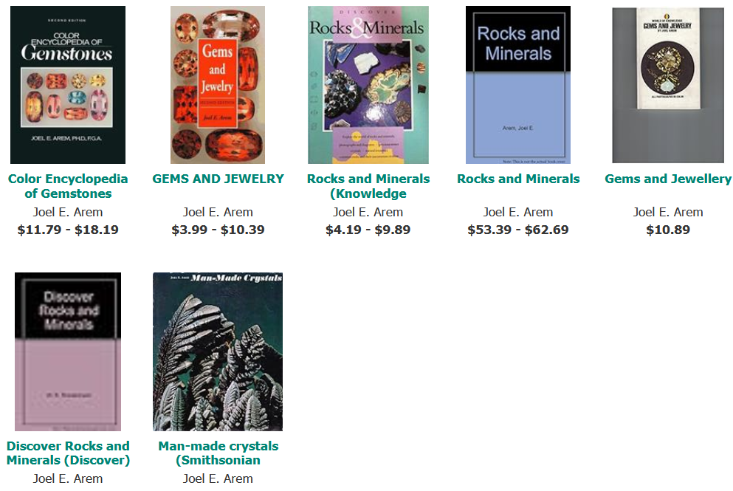

# BOOKS

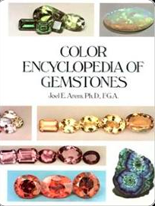

### COLOR ENCYLOPEDIA OF GEMSTONES, 1ST ED. ISBN: 0442203330

Although the literature on gemstones dates back thousands of years, no-one had ever produced a comprehensive, fully-color illustrated summary of all known gemstone species and color varieties, with relevant data on physical properties, record stone sizes and name origins. This became Arem's fourth and most ambitious book project. From 1974-76 Arem researched the entire literature on gemstones and made three trips across the U.S. with portable studio equipment to capture on film examples of extremely rare gemstones in private collections. Arem perfected several new and revolutionary gem photography methods, culminating in more than 300 new photos.In 1977, after Arem’s full-time three-year effort, Van Nostrand-Reinhold published the COLOR ENCYCLOPEDIA OF GEMSTONES. This highly acclaimed book quickly became a cornerstone work in the gemstone field.

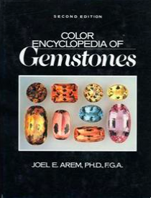

### ****COLOR ENCYLOPEDIA OF GEMSTONES, 2ND ED.**** ****ISBN: 9780442208332****

In 1987, after a second massive (2-year) full time commitment, Arem published the second edition of the COLOR ENCYCLOPEDIA. The new book had far better color reproduction than the first and more than 200 completely new photos. In addition, the text was 100 pages larger and included chapters on synthetic gemstones and thermal measurements. The second edition also contains the first comprehensive tabulation in the gemological literature of precise, machine generated measurements of the color of nearly all gemstone species and varieties. As the only full-color gemstone encyclopedia ever published, the Color Encyclopedia of Gemstones (2nd ed.) has often been called the most-used reference book in its field.

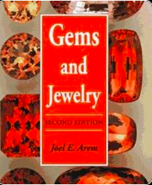

### GEMS AND JEWELRY: ALL COLOR GUIDE (2ND ED.) ISBN: 0945005091

The first edition of this book appeared in 1975 and was part of a huge series of Bantam paperbacks on natural history subjects. Over a period of several years it sold more than 1 million copies, and was printed in 4 languages. The 2nd ed. quickly became a basic textbook in many gemstone education courses around the world. In 1999 Amazon awarded this book as “Category Best Seller” in its Crafts & Hobbies: Lapidary section. A third edition, totally revised and greatly expanded, is currently in preparation. It is planned as an e-book for publication in 2014. Several chapters from this new work can be found on this website.

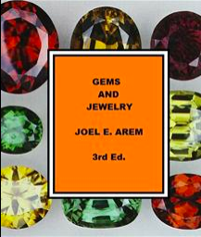

### GEMS AND JEWELRY (3RD ED.) - TO BE PUBLISHED AS E-BOOK - FORTHCOMING

Significant changes in the gemstone market have prompted Joel Arem to create a 3rd edition of "Gems and Jewelry", and he began this work in 2011. The 3rd edition is planned as an e-book that will be available on this website in 2014. Excerpts are viewable now by clicking on the buttons on this page. Arem especially wanted to make immediately available the most ambitious chapter in the new book, dealing with synthetic and treated gemstones, because there is so much confusion about these subjects in the current marketplace. The Federal Trade Commission (FTC) is planning a large-scale revision of its guidelines for gemstone-related terminology, changes that will affect the gem trade for years to come. It is Arem's view that public education, and a true understanding of the technical issues involved, is more important than any set of regulations having to do with labeling. Please click on the link provided below to view this chapter in its entirety.

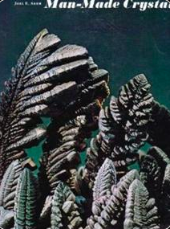

Buy the book [HERE](https://www.amazon.com/Man-made-Crystals-Joel-E-Arem/dp/0874741416/ref=la_B001HMPE74_1_5?s=books&ie=UTF8&qid=1382116008&sr=1-5)

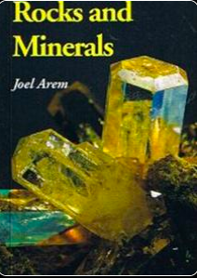

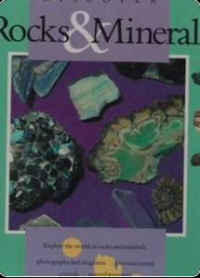

**MAN MADE CRYSTALS  
ISBN: 0874741416**

In 1972, Dr. Arem founded and curated the National Synthetic Collection at the Smithsonian Institution in Washington, DC. In 1973 he wrote and produced a major exhibition of synthetic crystals that was displayed in the lobby of the Smithsonian’s Natural History Museum. The Smithsonian Press asked Arem if he would write a book for them on the subject, and it appeared in 1973 in conjunction with the exhibit. This book was (and remains) the first and only fully illustrated popular book on the subject of man-made crystals and gems.

### 

### ROCKS AND MINERALS ISBN: 0945005067

Like Gems and Jewelry, this book originally appeared (in 1974) as a Bantam paperback in its “Knowledge Through Color” nature series, and was an instant best-seller with 200,000 copies distributed in its first printing. One of the first-ever pocket guides to minerals fully illustrated with color photos, Rocks and Minerals became the first-choice for young collectors worldwide and was printed in 4 languages. The English-language version was reprinted by Geoscience Press in 1991 and remains a classic introduction to its subject.

### 

### 

### DISCOVER ROCKS AND MINERALS ISBN: 1561734616

Publications International, a major distributor of popular books, asked Arem if he would write childrens’ book on Rocks and Minerals for their “Discover” series, and it was published in 1991. Only about 1/3 of the manuscript was actually used in creating this book, which has long been out of print. Arem is currently working on an e-book for young readers, using the entire (fully revised) original text and hundreds of new photos.

**JOEL E. AREM, Ph.D, F.G.A BIOGRAPHY**

<https://static1.squarespace.com/static/5a45138512abd98855424f43/t/5b3c545a562fa782f9d01fd6/1530680410935/Joel+Arem+Biography++.pdf>

Dr. Joel E. Arem has been involved with minerals and gemstones for 60 years. Born

and raised in Brooklyn, New York, he first became interested in minerals in grade school. A

long-standing commitment to a scientific career matured through High School and led to a

major, first in chemistry, and then in geology, at Brooklyn College. Arem graduated Magna

Cum Laude, elected to Phi Beta Kappa and Sigma Xi, and with Honors in Geology, and also

the highest graduating average in the history of the BC Geology Dept. During this time period

he was a part-time instructor and Director of the Geology program at the famous Brooklyn

Children's Museum. He also became interested in the art of gemstone cutting, started

collecting faceted gemstones and became active in gem cutting (lapidary). In the early 1960s

Arem served as Secretary of the New York Lapidary and Gem Society, and started to become

acquainted with museums and curators around the country. Academic success resulted in

admission to the Harvard University Graduate School of Arts and Sciences in the Fall of 1964.

Graduate work included a wide diversity of courses. A series of circumstances and changing

interests led Arem to take many more courses than are required in a normal PhD program. A

Masters degree (Geology) was awarded to him in 1967 and a PhD (Mineralogy) in 1970.

During his six years at Harvard Arem was the recipient of a Harvard University Scholarship

and a National Science Foundation Fellowship. He was a Teaching Fellow in the Geology

Department, giving instruction in such diverse fields as crystallography, mineralogy and

economic geology. Arem also served as a Research Assistant in the Department, and worked

part time for one of the professors doing gemstone identification for local jewelers.

The research Arem conducted at Harvard resulted in numerous publications in major

scientific journals. These, plus his reputation in the mineral collecting world, led to his selection

to fill the newly-created position of staff Crystallographer at the Smithsonian Institution in

Washington, D.C. During this three-year term appointment Arem founded and curated the

National Synthetics Collection, the world's first systematic collection of man-made crystalline

materials. He also wrote and produced a major display of these materials that was exhibited in

the lobby of the National Museum of Natural History during the summer of 1973, a display that

received national press coverage.

While at the Smithsonian, Arem lectured extensively and also taught mineralogy for

the Smithsonian Docent Program. He became a consultant to the Eastman Kodak Company,

in the field of mineral photography, and developed unique photographic techniques for

minerals and gemstones. Some of his photos were published by Kodak in the 9th "Here's

How" book of photographic methods. Arem also acted as a consultant to National Geographic

Society and provided photographs and teaching materials for their use. He was also the

primary photo source for the fledgling publication, "The Mineralogical Record".

In 1971 Arem was contacted by the well-known mineralogist and collector Arthur

Montgomery and asked if he would help to create a new mineral conservancy organization to

be called "Friends of Mineralogy". The three founders, Montgomery, Arem and Carl Francis

(later to become curator at the Harvard Museum) then invited a well-known mineralogist,

Richard Bideaux, to join the group. The regional structure of FM was drawn up by Arem and

Bideaux in John White, Jr.'s home in Bowie, Maryland. Arem served as an officer and Director

of FM for several of its formative years, created its first Logo, and arranged field trips that

allowed for the recovery of many unique and important mineral specimens. Friends of

Mineralogy is still very active and has become a major voice in mineral conservation efforts.

From 1971-73 Arem also served as Secretary of the Mineral Museums Advisory Council, the

first international organization of mineral museum curators.

In 1972 Arem was given the opportunity to write a book on minerals, part of a large

series of all-color books on natural history subjects called “Knowledge Through Color”. These

books were published by Bantam Books and featured color photos, and were specifically

designed to replace the well-known series of “Golden Guides” (with color illustrations) that had

long been a staple learning base for young readers. Arem created the paperback ROCKS

AND MINERALS and shared the responsibility for all the color photos with famous

photographer Lee Boltin. Then in 1973 Arem produced a book at the request of the

Smithsonian Institution Press, to appear in conjunction with his major exhibit of synthetics in

the National Museum of Natural History. This book, MAN-MADE CRYSTALS, was the first

color-illustrated popular book ever published dealing with the subject of synthetic crystals and

associated technologies. The book remained in print until 1988.

Arem left the Smithsonian at the end of his three-year term in order to pursue business

interests and gain experience in other fields. He had already begun to plan a career involving

the marketing of minerals and gemstones. However, he became temporarily sidetracked by

the challenge of a unique assignment. For a brief 7-month period (1973-74) Arem was

employed at the Atomic Energy Commission. The combination of a good physics background

and recognized writing skills made Arem ideal as a technical writer for the Rasmussen Report,

the largest and most comprehensive study of nuclear reactor safety undertaken to that time.

When funding for the writing staff was withdrawn in 1974 Arem made a full commitment to

gemstone marketing. In March he started his first corporation, Multifacet, Inc. and began

traveling across the country lecturing, meeting clients and displaying fine gemstones. The gem

collection he started in 1962 now became part of an initial sales portfolio. Contacts made in

the New York Lapidary and Gem Society, and later at Harvard and the Smithsonian, now

became useful in a business context. By 1974 Arem was already well known in the lapidary

and gem field. His existing publications were augmented by articles in such prestigious

publications as the Saturday Review of Science, Science Digest and the Smithsonian

Magazine.

The 1972 Bantam book, ROCKS AND MINERALS, was doing extremely well. Arem

felt a companion volume, on gemstones, would have a much wider audience. His proposal to

Bantam was accepted, and another book in the "Knowledge Through Color" series, GEMS

AND JEWELRY, was published in 1975. This landmark book was the first all-color, popular

introduction to the world of gemstones ever published. It was an immediate "best seller" with

more than 200,000 copies created in its first 3 printings. And with well over a million copies in

print in 4 languages it has become the all-time best selling popular introduction to gemstones

in the world.

Despite his gemstone marketing commitments Arem remained scientifically active. In

the period 1975-77 he became a consultant to the U.S. Department of Commerce, the

Encyclopedia Britannica Educational Corporation and the Jeweler's Circular-Keystone

magazine.

Arem had noted that although the literature on gemstones dates back thousands of

years no-one had ever produced a comprehensive, fully-color illustrated summary of all known

gemstone species and color varieties, with relevant data on physical properties, record stone

sizes and name origins. This became Arem's fourth and most ambitious book project. From

1974-76 Arem researched the entire literature on gemstones and made three trips across the

U.S. with portable studio equipment to capture on film examples of extremely rare gemstones

in private collections. This project fully utilized all of Arem's academic training, knowledge of

gemstone properties and localities, examples in museums and private collections and a

general ability to sort massive amounts of raw data into a readable format. But the book also

required extremely accurate color reproduction. Arem therefore perfected several new and

revolutionary gem photography methods. The Encyclopedia ultimately required more than 300

new photos, some of them extremely challenging.

In 1977, after Arem’s full-time three-year effort, Van Nostrand-Reinhold published the

COLOR ENCYCLOPEDIA OF GEMSTONES. This highly acclaimed book quickly became a

cornerstone work in the gemstone field. In 1987, after a second massive (2-year) full time

commitment, Arem published the second edition of the ENCYCLOPEDIA. The new book had

far better color reproduction than the first and more than 200 completely new photos. In

addition, the text was 100 pages larger and included chapters on synthetic gemstones and

thermal measurements. The second edition also contains the first comprehensive tabulation in

the gemological literature of precise, machine-generated measurements of the color of nearly

all gemstone species and varieties. The COLOR ENCYCLOPEDIA OF GEMSTONES is still

generally regarded as the most authoritative and comprehensive book of gemstone data in

existence, and is widely used as a reference text within the jewelry trade. It is also one of the

most frequently quoted books in the gemstone literature.

Arem decided in 1976 that if he required formal credentials in the field of gemology the

Gemmological Association of Great Britain would provide the most prestigious accreditation.

The procedure required 3 full days of examinations. The first was the Preliminary exam,

passing of which is a prerequisite for the 2-day Diploma examination. These examinations are

given every year in June, and simultaneously administered in as many as 40 countries. Those

who successfully complete the Diploma exam are granted the title of Fellow of the

Gemmological Association (FGA). Of more than 400 people (worldwide) taking the Diploma

exam in 1976 only 116 passed; of these, 4 received a grade of "A" and passed "with

distinction". Arem's paper was one of these. Moreover, if a Diploma examination paper is also

of sufficiently high caliber the examiners may, at their discretion, award a prize created by the

widow of Bond Street jeweler B.J. Tully in 1922. This prize is not awarded if the examiners feel

no paper of sufficient worth was turned in. Arem, in 1976, became the first American ever to

win the Tully Medal, the "Nobel Prize" of gemology. To this date he remains one of only two

Americans so honored, and one of only about 50 that have ever been awarded the Medal.

In 1975 some local Washington DC gemologists had organized a study group for

graduates of the British gemology course, under the guidance of well-known DC gemologist

Anthony Bonanno. Arem suggested that the group expand its horizons to include international

membership and also admit GIA graduates. This new entity, created by Arem and named by

him as the ‘Accredited Gemologists Association’, was the first organization of professionally

accredited gemologists in the world. Arem served as President of the AGA during its first three

years. He also produced and edited the AGA Newsletter. During his term membership rose

nearly 500%, and Arem's office became internationally recognized as a clearinghouse for

gemological information. Although his excellent teaching had inspired the students who

formed the initial study group, Bonanno strongly opposed its transformation into the AGA, and

during its first 3 years he refused to come to a single meeting. Eventually, however, he saw

the potential value of the organization, and agreed to become its second President. The AGA

is still extremely active and well known today, and is a significant force in assuring that gem

and jewelry appraisals are done by professional people with adequate skills.

In 1979 Arem organized and ran the first International Conference on Gemstone

Investments in Washington, D.C. He later became an organizer of and adviser to subsequent

conferences in Los Angeles and New York. From 1978 to 1980 Arem Co-Founded and served

on the editorial board of the PreciousStones Newsletter. He wrote numerous articles for the

PSN dealing with a wide range of gemological subjects. In 1982 Arem was invited to be the

Keynote Speaker at the First International Colored Gemstone Conference in Colombo, Sri

Lanka. During this time period he was also active as Chairman of Turamali, Inc., a leading

gemstone marketing firm. In 1985 Arem designed a massive pendant consisting of baroque

pearls, rubies, sapphires, emeralds and diamonds. He submitted the piece to the American

Gem Trade Association Spectrum Award competition for jewelry design. In 1985 it won

second place in the ‘top-value’ category, firmly establishing Arem as a jewelry designer of

international caliber.

A long-planned fifth book, a childrens' book on minerals and rocks (DISCOVERING

ROCKS AND MINERALS) was published in 1991. Also in 1991 came a much improved

reprint of the 1973 work ROCKS AND MINERALS, which had gone out of print in 1989. In

1992 Arem published a fully-revised, expanded, and updated second edition of GEMS AND

JEWELRY. The new books all received excellent reviews. The market for colored gemstones

"came of age" in the 1980s, and there is little doubt that Arem's paperback, first appearing on

the scene in 1975, had significantly enhanced the education of students and consumers about

the world of colored gemstones, and provided thousands of people with their first non-

technical view of this fascinating subject. This educational impact continued unabated. In 1999

Amazon.com, the world’s largest bookseller, recognized “Gems and Jewelry: 2nd ed.” with a

Certificate of Acknowledgment as the year’s ‘best-selling title in its subject category’.

In the year 2000, in recognition of his many contributions, Arem was inducted into the

Education Division of the Rockhound and Lapidary Hall of Fame. From 2008 until 2010 (when

it ceased publication) Dr. Arem was Science Editor of Colored Stone Magazine, the only

publication in the world devoted exclusively to providing current market and educational

information about colored gemstones. Arem also wrote extensively for this magazine.

Between 2012 and 2016 Arem organized and ran a new marketing company called

“Sapphires of Montana”, designed to sell gemstones from a mining property in which he had

partial ownership since 1988. This company successfully re-popularized Montana sapphires,

which were sold by Tiffany & Co. as early as 1900, and which are the only “precious”

gemstones commercially produced in the U.S.

From 2000 onward Dr. Arem has devoted himself to the challenge of creating and

funding a humanitarian Foundation. He is also actively involved with 2 animal rescue groups

and other philanthropic activities. Meanwhile, he is working on a completely re-written and

updated 3rd edition of Gems and Jewelry.

Dr. Joel E. Arem has a combination of experience and education that is unique in the

gemstone field. He has been involved with gems and minerals for more than 60 years. He

holds two advanced degrees from the most prestigious of the world's universities, as well as

global recognition of the highest academic achievement in gemology. He has delivered

hundreds of lectures on gems, minerals, crystals, synthetics and mining localities to

professional scientists, consumers and students. He has extensive experience as a collector,

curator and teacher, and his long list of publications includes both the all-time most-popular

best-selling introduction and the world's most relied-upon reference book on gemstones, as

well as dozens of technical and popular journal articles.

Dr. Arem is an internationally recognized and award-winning jewelry designer, lecturer

and trader who has traveled to more than 37 countries on 5 continents. As a lapidary since

1962, he has a hands-on familiarity with gemstone rough and the intricacies of cutting both

cabochons and faceted gems. As a gemstone dealer, he handled many of the world’s largest

and rarest collector gems, developed and trademarked a series of unique gemstone cuts, and

has overseen the production of tens of thousands of carats of cut gemstones.

This unique perspective of a trained scientist, teacher, lapidary, trader, museum

curator, collector, designer and author has provided Arem a widely-held reputation as one of

the world's foremost gemstone authorities and educators.

9-17

**DR. JOEL E. AREM CURRICULUM VITAE**

<https://static1.squarespace.com/static/5a45138512abd98855424f43/t/5b3c548c8a922db5a52b1d62/1530680460710/JOEL+AREM+CV++.pdf>

CONTACT P.O. Box 5056 Laytonsville, MD 20882 website: www.joelarem.com

Tel: (301) 977-0335 FAX: (833) 270-1180 email: joelarem@gmail.com

B.S. (1964) Brooklyn College (Geology)

M.A. (1967) Geology; PhD (1970) Mineralogy – Harvard University

EDUCATION F.G.A. (1976) Fellow, Gemmological Association of Great Britain

F. C. Gm. A. (1984) Fellow, Canadian Gemological Association

PROFESSIONAL President – Joel E. Arem Co. (1974-present)

ACTIVITIES Science Editor – Colored Stone Magazine (2009-2010)

Founder/President - Accredited Gemologists Association (1977-79)

Co-Founder/Editorial Board - PreciouStones Newsletter (1978-84)

Consultant - Jewelers' Circular-Keystone (1978-96)

Consultant - Encyclopedia Britannica Educational Corp. (1975-76)

Consultant - U.S. Dept. of Commerce (1975-76)

Consultant - Eastman Kodak Co. (1971-75)

Consultant - U.S. Atomic Energy Commission (1973-74)

Consultant - National Geographic Society (1971-80)

Crystallographer, Dept. of Mineral Sciences, Smithsonian Institution, Wash. DC (1970-73)

Instructor - Smithsonian Docent Program (1970-73)

Founder & Curator - National Synthetics Collection, Smithsonian Institution (1971-73)

Research Assistant - Geology Dept., Harvard University (1969-70)

Teaching Fellow - Geology Dept., Harvard University (1966-69)

Director, Geology Program - Brooklyn Children's Museum (1963-64)

PUBLICATIONS: "Rocks and Minerals" (1972, Ridge Press/Bantam; 1991, Geoscience Press)

"Man-Made Crystals" (1972, Smithsonian Institution Press)

"Gems and Jewelry" (1975, Ridge Press/Bantam; 1993, Geoscience Press, 2nd ed.)

(2nd ed . was “Best Seller in Category” – Amazon.com, 2002)

"Discovering Rocks and Minerals" (1991, Publications International)

"Color Encyclopedia of Gemstones" (1977, Van Nostrand-Reinhold;

2nd ed. 1987, Chapman & Hall)

"Crystal Chemistry & Structure of Idocrase: (1970 - PhD Dissertation)

Articles on gems, minerals, crystals, crystal growth in: Saturday Review of Science; Smithsonian

Magazine; Science Digest; Mineralogical Record; Mineralogy & Petrology; American

Mineralogist; Physician's Investment Digest; The Gemstone Investor; PreciouStones Newsletter;

Robb Report; Rock & Gem; Rocks & Minerals; Colored Stone Magazine, Independent Living,

InColor (ICA),…..others.

HONORS B.S. awarded with Honors in Geology; Magna Cum Laude

& AWARDS: National Honor Societies: Phi Beta Kappa (Liberal Arts); Sigma Xi (Science)

National Science Foundation Scholarships (1966-68) Harvard Univ. Scholarships (1964-65)

Tully Memorial Medal - Gemmological Association of Great Britain (1976);

First American Recipient; Diploma awarded with Distinction.

Winner - Spectrum Jewelry Design Competition - AGTA (1985)

Rockhound/Lapidary Hall of Fame - Inductee: Education, Year 2000

BIOGRAPHY: Who's Who in U.S. Executives; Who's Who in the East; Who's Who in the Jewelry

Industry; Who's Who of Emerging Leaders in America; Who's Who in Society; Men

of Achievement; Contemporary Authors; Distinguished & Admirable Achievers 2005; Outstanding

Scientists of the 21st Century.

PROFESSIONAL Fellow, Gemmological Association of Great Britain (F.G.A.)

SOCIETIES: Fellow, Canadian Gemological Association (F.C.Gm.A.)

Mineralogical Society of America - Life Member

American Association for Crystal Growth (Charter Member)

Mineral Museums Advisory Council (Co-Founder/VP)

Friends of Mineralogy (Co-Founder/VP)

Accredited Gemologists Association (Founder, President)

OTHER: Keynote Speaker, First Int’l. Gem Conference, Colombo, Sri Lanka (1982)

Lecturer - International Soc. of Appraisers International Appraisal Conference

Organizer & Chairman - First International Gem Investment Conference (1978)

More than 200 lectures to popular and scientific groups (1968-2011)

PUBLIC SERVICE Director – All Breed Rescue and Referral, Inc. (501-c-3 Nonprofit Animal Rescue)

Volunteer – MASR (Mid-Atlantic Samoyed Rescue (501-c-3 Nonprofit Animal Rescue)

Founder – The Arem Foundation (1995- present) 9-17