SOIL REACTION (pH)
AND
BALANCED PLANT NUTRITION
More evidence of the importance of the element calcium in the soil in connection with (cationic) balanced plant nutrition, irrespective of humid or arid soils.

WM. A. ALBRECHT
DEPARTMENT OF SOILS
UNIVERSITY OF MISSOURI
DECEMBER 1967

Soil Reactions (pH)
and
BALANCED PLANT NUTRITION ¹
William A. Albrecht
Soils Department, University of Missouri
¹ This paper was prepared for an illustrated lecture in Alamosa, Colorado, sponsored by the County Agricultural Extension Service in the College Auditorium August 31, 1967, and for a seminar at Canon City Colorado, under invitation of the Western Soils Company, Waterloo, Iowa. September 1-2, 1967.
Soils differ widely according as they are developed from different rock minerals under decreasing annual rainfalls when one goes west from the humid Mid-Continent to the arid regions, west of about the 95th meridian of W. Longitude. The annual rainfall in this Colorado area1 of 32.5° N. Latitude, and 105° W. Longitude is low enough to be but 20 percent of the annual evaporation from a free water surface. Professor Transeau's map of the United States has isobars showing the rainfalls as percentages of the evaporation. It outlines the areas of efficient rainfall for growing crops, without irrigation, in a very telling way. (Illustration 1 See "Appendix" of assembled illustrations.)
I
Soils and Their Fertility, According
to Their Climatic Settings
Coupled with the soil tests of exchangeable cations (reported by Missouri Experiment Station), bases (cations) soluble in dilute acid, along a nearly latitudinal line of constant temperature and between the longitudinal lines of near 10 and 40 inches of annual rainfalls, we have graphs of (a) the saturation capacities, or cation exchange capacities; (b) exchangeable cations, or bases; and (c) the exchangeable hydrogen of the soils, according to the above variable annual rainfalls. They picture for us, in terms of available fertility, the geo-climatic settings for arid agricultural production. (Illustration 2).
If simultaneously with the West, in the preceding graph, we include the humid East from the 97th meridian to the East coast, we have a modernized curve of products and properties of the soils of the United States (Illustration 3) when that simplified curve is placed on Professor Marbut's soil map of the United States with the mid-line of the former of 25 inches of rainfall running from the northwestern corner of Minnesota and pointed toward the southern tip of Texas. That line is roughly the 97° + meridian of longitude and likewise Marbut's line dividing the "pedalfer" soils of the East from the "pedocal" soils ² of the West, or the line bisecting the country. (Illustration 4) That arrangement also divides the country with the most efficient radio reception along that mid-continental line, but less efficient reception as one goes east to moist soils leached of their nutrient cations as conductors, or west to plenty salts as conductors but absence of moisture to make them ionically active as conductors; according to the map as reported by the Radio Corporation of America. (Illustration 5)
² "Pedalfer" is a combination of "pedo"= soil, "al"=alum inium, and "fe"=iron; meaning soils with active or more iron and aluminum. "Pedocal" is a combination of "pedo"=soil, and "cal"=calcium, meaning soils with more calcium, in the profile.
II
Crop Compositions Differ According
as Soils are Under Construction or Destruction
The western half of our country represents soils under construction with salts accumulating in the profile. The eastern half has soils under destruction with the cations, or active salts, being leached, or washed, out, but some of them adsorbed on, and exchangeable from, the silicon residue of rock weathering, namely, the colloidal clay and, similarly, the accumulated humus from the organic matter grown by more abundant rainfalls. The clay-humus colloid holds also soil acidity, or ionic hydrogen (a non-nutrient cation from soil for plants), along with calcium, magnesium, potassium, and sodium as major elements given in the order of decreasing forces by which they are adsorbed, or held, by the clay molecule. The trace element cations are also held, namely, manganese, copper, zinc, and cobalt. But the anions of either the trace elements, boron, chlorine and molybdenum, or of the major nutrients sulfur, phosphorus, nitrogen and carbon are not adsorbed by the clay-humus colloid because the latter also is negatively charged, or anionic.
The amounts of these several nutrients in our humid soils are listed as present in (a) the soil, (b) the vegetation, and (c) the warm-blooded, human body in the Table I, (Illustration 6).
The crops common in low rainfall areas, especially under irrigation, and so in this region, are sugar beets, potatoes and vegetables. Let us limit our crop considerations to these for their most commonly neglected fertility needs which are not among the common N-P-K, commercial fertilizer triumvirate. Let us consider calcium, sulfur and the several trace elements as completely as time will allow.
III
Applying Limestone to Remove Soil Acidity,
Lead Our Fertility Thinking Astray
But we need to remind ourselves of the importance of these neglected nutrients, not so much in their boost of production yields of bulk and luscious green vegetative mass. Starting with calcium, let us emphasize also sulfur and trace elements for their importance as tools and components In production of proteins, the living mass, creating growth, giving self-protection and fecund reproduction of very species of life. In the humid area, calcium Is considered necessity for legume plants, and for the nodule-producing bacteria on their roots, by which symbiosis those plants use extra nitrogen from the atmosphere to help them be protein supplements to grasses and grains in animal feeding--to say nothing of their building up the soil's supply of organic matter, when used as green manures.
Limestone has long been applied to soils in eastern United States as the compound calcium carbonate, or the mineral calcite, and as a natural combination of that with magnesium carbonate in dolomitic limestone. That treatment on humid soils was considered necessary because the carbonate anion served in removing soil acidity, sourness, by the soil's hydrogen cation reacting with the limestone's carbonate anion to produce carbonic acid. This is a very mild acid we enjoy in soda drinks. But it is unstable. It immediately breaks up into water and a gas, carbon dioxide, the latter of which escapes to the atmosphere and no acid remains. Thus, on humid soils, limestone's carbonates of calcium (and magnesium) were considered ammunition in a war on soil acidity.
IV
Soils Need Limestone for Calcium's
(and Magnesium's) Sakes on Many Soils
That emphasis on soil acidity seemingly prohibited our realizing that pulverized limestones were effective in growing better legumes because they serve as calcium (and magnesium) fertilizers to grow those bone-building, protein-rich feeds which the animals seek out as protein supplements in balancing their own diets where choice by them is permitted. If tons of limestone per acre need be applied on humid soils for fertilizing legumes with calcium as plant nutrition, we may well ask the question do we not need to concern ourselves about calcium (magnesium) as fertilizers in arid soils? But, first, let us establish the fact that larger amounts of exchangeable or available calcium were natural, and requisite also, when the virgin soils were producing protein-rich forages, and, doubtless, high calcium supplies are requisite for any legume crop (possibly non-legumes) when they grow on arid soils as well as when on humid ones.
Studies on plant compositions of crops grown on partly-developed soils (Western U.S.); moderately developed soils (Mid-continent); and on highly developed soils (Eastern and southern U.S.), revealed the narrowing ratios in the above order of contents of calcium related to potassium in their dry matter. There was a shift from a ratio of six to one to the ratio one to one in going from Western to Eastern U.S., or with increase in degree of soil development under our higher rainfalls giving more clay residues and higher ionic losses through leaching the soils, shown in Table 2. (Illustration 7)
V
The Soil's Rapid Calcium Loss Lowers Ratio of Calcium to Other Cations,
Suggesting Plant's More Imbalanced Nutrition
As confirmation, soybeans were set up with the pure sand-colloidal clay technique as controlled plant nutrition of three ratios of available calcium to potassium, when other items were constant, to note that more vegetative bulk (tops and roots) was grown with the narrowing calcium-potassium ratio, but larger amounts of calcium relative to the potassium were required if the soybean plants were to be protein-rich and mineral-rich as forage feeds. This exhibited the disturbing observation that quality as animal nutrition was running in the converse of increasing vegetative bulk. Table III (Illustration 8)
But a soil study, exposing a very fertile soil to high speed weathering by incorporating increasing amounts of elemental sulfur to become an acid rapidly under controlled watering to bring on leaching, the soil demonstrated the narrowing ratio of calcium to the potassium left in the soil, and of calcium to the other cations as shown in the figure. (Illustration 9) Accordingly, humid soils become acid, or sour, largely by (a) some loss of clay or of total exchange capacity, (b) but mainly by loss of calcium held in such larger amounts on the colloids, to let so much hydrogen come in to be held, and more firmly, by the soil. Thus, the rapidly shifting supply of calcium is possibly the first problem of productivity of a soil in the process of its development from weathering minerals.
Extensive studies established the calcium of the soil as a plant nutrient resulting as the benefit from limestone applications rather than the carbonate's value in reducing soil acidity or increasing the pH value. Those two effects were nicely separated when (a) calcium chloride, making the soil more acid; (b) calcium nitrate leaving no acidity after the nitrate was either taken by plants or leached out by rainfall; and (c) calcium hydroxide neutralizing the soil acidity; were drilled from the right half of the fertilizer attachment of the machine while drilling the seed; only to find all three treatments supplying the same amount of calcium as a fertilizer in seed contact and giving the same improvement in the growth of the crop and nodule production on the roots. Whether acidity was removed or not was of no consequence. (Illustration 10)
VI
Calcium's Physiological Importance,
Emphasized by Its Closer Contact with Seed
Tests have demonstrated calcium much more helpful in the early life of soybean seedlings than were magnesium and potassium, when the three were separately applied with the seed as chlorides and calcium also as an acetate, with this organic anion. Calcium also hastened germination, and increased the stands by cluster seeds, like the sugar beet. In contact with the seeds, there was no injury by the divalent calcium as often happens with the monovalent cations of sodium and potassium and the nitrogen salts as chlorides. (Illustration 11)
By extensive tests using the refined acid-clay colloid on which various cations in varied quantities were adsorbed as plant nutrition in conjunction with about ten percent of the clay's exchange capacity occupied by hydrogen, it was demonstrated that the nutrient cations especially the increasing amounts of calcium offered were taken into test vegetable plants with a much higher efficiency than when the colloid clay carrying them was near neutral and had no hydrogen as their company (pH 7.0 or higher). These facts tell us that some acidity in the soil is beneficial in mobilizing the nutrient cations into the plant roots. It reminds us to ask then, are not arid soils of neutral reaction a case of deficiencies of calcium, magnesium, potassium, sodium and trace element cations? Would any added extra cations present in low supply, or as imbalance, not be beneficial if located nearer the seed for early use by the plant? (Illustration 12)
As evidence that soil acidity is not harmful to plant growth when ample nourishment is present, a simple demonstration with refined colloidal clay originally saturated completely with hydrogen, to give its customary pH of 3.6, was titrated to pH 4.4 by calcium hydroxide to give an exchange capacity's saturation by calcium of 23.5 percent and 76.5 percent by hydrogen. This was set up with pure quartz sand with the original acid clay as a check, then three other clear glass jars were included with clay increments of which the second one was the double and the third one the quadruple of the starting one, and all four planted to a like number of soybean seeds. The accidental and initially disturbing fungus attack, suggesting "damping off" disease, registered about complete injury in calcium absence on the clay, but complete immunity in the largest increment of total calcium by largest amount of clay in the sand, even on clay saturated with but 23.5% and with it at pH of 4.4. This was the demonstration telling that "to be well fed (even by calcium) is to be healthy". (Illustration 13)
VII
Nutrients' Services According to Total
Amounts Exchangeable or to Degree of Soil's Saturation
One can vary the test soil's amount of a cation offered the plants by two procedures, namely, (a) having a higher or lower clay content of the soil at any degree of the clay's saturation by the cation in question, or (b) having the soil's constant amount of clay more or less highly saturated by the chosen cation. The latter suggested itself in the absence of organic matter, as the more efficient, in a series of soybean plant tests. Those were set up by using the refined clay titrated by increasing amounts of calcium hydroxide to give a clay, pH, series of 4.0, 4.5, 5.0, 5.5, 6.0, and 6.5. Those clays were used to make up one series of the above six in which the amounts of clay were put into sand so as to offer but 0.05 milligram equivalents (ME) of calcium per plant; another series offering 0.10 ME of calcium per plant by doubling the amount of clay per pan; and the third series offering 0.20 ME of calcium per plant by quadrupling the intial amount of clay per pan.
The plants demonstrated growth responses to pH values with a visible division in the series of poorer and better plants between pH 5.5 and 6.0 respectively, for total calcium per plant at 0.05 ME; with a division similarly between pH 5.0, and 5.5 for total calcium per plant at 0.10 ME; and with a division similarly between pH 4.5 and 5.0 for total calcium per plant at 0.20 ME. (Illustration 14)
Here by increasing the offered total calcium four times, the disturbing effect of the low pH was offset by ten times. The effect of the degree of saturation of the clay is shown from left to right in each row of plant sets, apt to be interpreted as due to increasing pH values. But more significant were the changes in the pH of the clays or the power of the plants in exhausting the clays of their cations or vice versa, viz: the clays taking cations from the plants.
During the growth of the crops, the clays of initially low pH values moved to higher ones, and those clays of initially higher pH values moved to lower ones. Many were apparently stabilized near pH 5.5. Chemical analyses of the crops showed that the plants had lost nitrogen, phosphorus and potassium (tested for only those three elements) back to the soil in seventeen of the eighteen sets of plants. The exception was the one at pH 6.5 and 0.20 ME of calcium per plant, the highest in both saturation of the clay by calcium and the highest total calcium per plant offered by the largest amount of clay in the soil.
All this emphasizes the high requirement from the soil for calcium as a nutrient, with little significance of the pH or degree of reaction of the soil as to acidity or alkalinity, for this study of sand-clay media, without organic matter.
VIII
Competition or Cooperation by Combinations
of Adsorbed-Exchangeable Cations
Other extensive researches have studied combinations of the cations adsorbed on the clay to observe their more nearly fitting balances as nutrition of soybean plants and others for their efficient nitrogen fixation. As the result, we have arrived at the degrees of saturation of the soil's exchange capacities suggesting balanced plant nutrition on humid soils with naturally favorable hydrogen also on the exchange complex as the fifth major cation in the group, namely, hydrogen, calcium, magnesium, potassium, sodium and others to include trace elements and even some non-nutrients, found in some soils. As a working code, we have suggested and used the following percentages saturation to represent balanced plant nutrition: hydrogen l0% calcium 60-75%; magnesium 10-20, (7-15)%; potassium 2-5%; sodium 0.5-5.0%; and other cations 5%.
While the above ratios are guide lines, they have been found most helpful for humid soil treatments as more nearly balanced plant nutrition for legumes.They are also a sound reasoning basis for better growth of non-legumes. Those same ratios between the nutrient cations, emphasizing calcium almost ten times higher, and more, than others among the five, should make us believe that one is apt to find the calcium the more commonly deficient nutrient element for crops, too long covered in our belief that soil acidity calls for a cheap carbonate, being taken as limestone. It should likewise list the calcium as possible first nutrient deficiency on arid soils, if not for removing acidity., then on the often gross chance that a small increase in sodium, potassium, and magnesium should upset the balance against the calcium. That can then be equivalent to that element's deficiency in the plant's diet from the soil. Arid soil tests interpreted on the above premises have lead to improved crop production in quantity and quality, demonstrated nicely by sugar beets and potatoes.
There is plenty of evidence for possible imbalance against calcium by excessive magnesium, potassium, or sodium, along with the complete absence of any adsorbed hydrogen, as shown by the soil's pH above 7.0. Large areas of the United States have soils burdened by high magnesium disturbing the crop's intake of calcium, but which can be improved by applying calcium sulfate with the seeding, (Illustration 15)
IX
Soil Activities by Anions Suggest The Latter's Close
Association With, Possibly Control By, Soil Organic Matter
So far we have spoken only about the five major nutrient cations, and for a very simple reason. We have a far clearer vision of possible chemical and biochemical dynamics of the soil and plant root by which the cations seem logically to be held, yet be mobile in the soil; how they may pass through possibly the calcium-membrane of the root hair (if the soil's higher saturation by calcium maintains that controlling cell wall); and the possible movements within the plants in molecular compounds and ions. We are not so well informed, even in our visions, about the major nutrient anions, i.e. carbon, nitrogen, phosphorus and sulfur, though lately we are considering their mobility connected with the organic fraction of the soil with which most all microbial processes are also connected.
Some studies at the University of Missouri have shown radioactive phosphorus, fed to a barley crop used as green manure plowed under for soybeans, to deliver that radiating nutrient element with an efficiency just 100 times that of phosphorus delivery by the soil fraction testing "high" in total phosphorus.
Professor Midgeley of Vermont has demonstrated better plant growth and its higher uptake of the phosphorus from mixing that with manure before putting the mixture into the soil, than when the two components were mixed separately into the soil before planting the seeds. (Illustration 16)
The refined clay, in the researches using it as the medium with quartz sand for plant nutrition studies, carried 1.50 percent carbon and 0.15 percent nitrogen, so we dare not say the growth medium was completely free of organic matter. But never the less, when the organic cation, methylene blue, was adsorbed on the colloidal clay as companion for the calcium, the former was not a competitor or reducer of the nutritional effects of the latter for the soybean crop as was true for potassium, or hydrogen, when they were adsorbed companions on the clay feeding soybeans the calcium. In case of the latter two, paired with calcium, the uptake and growth by the soybean plants were controlled by the degree of saturation of the clay by calcium. But in case of calcium and methylene blue, the calcium uptake and growth by the soybean plants were controlled for better growth by the total exchangeable amount of calcium offered by the soil. (Illustration 17)
X
Neglected Sulfur and Trace Elements, Suggest
Themselves as Reasons for the Low Protein Values We Grow
The supply of the anionic nutrient, sulfur, is becoming seriously short in our soil, especially when it, like calcium and the trace elements, is connected with synthesis of proteins, suggested by the alfalfa crop. The shortage has been brought on because gas fuel is replacing coal, when burning the latter puts sulfur dioxide into the atmosphere to let the rainfall distribute it back on the soil. Also, soluble phosphate fertilizers, like the early acid phosphate, put as much calcium sulfate, unwittingly, on the soil as fertilizer as it did phosphates. But that calcium sulfate is now separated from the soluble phosphates during their manufacture and the former is piled on the "dump" to let our soils reduce the crops' protein put in that part made up of the sulfur-carrying amino acid, methionine. It, along with lysine and tryptophane, has been the triple protein deficiency in grains and forages for the feeding of which protein supplements have been demanded. Also, the shortage of sulfur, in the growing plant, upsets the entire amino acid array put out by sulfur-starved alfalfa and soybeans according to research reports from Missouri. (Illustration 18 and 19)
XI
Trace Elements and the Amino Acids
in Protein Production
Of course, the trace nutrient elements and the major ones, whether cations or anions, in their varying ratios to each other, as possible balance or imbalance not yet so delicately decided, will modify the processes of protein syntheses in plants. This is shown by the nitrogen in bromegrass distributed differently between the essential and scarce amino acid, lysine, and a non-essential plentiful one, aspartic acid. (Illustration 20)
Very significantly, calcium in its varied amounts on soils growing red top hay increased the concentration of the essential amino acid, tryptophane, commonly deficient in feeds, according as the amount of calcium was offered this non-legume, whether the accompanying phosphorus supply in the soil was medium or high. (Illustration 21)
As for the trace elements, the boron increased the tryptophane in the legume hays, soybean and alfalfa, when increased in limited parts per million as plant nutrition offered. (Illustration 22)
In those same two hays, the withholding of any one of the three trace elements, boron, manganese or iron, reduced the production of tryptophane by these legumes as compared with the fuller list of trace element application. (Illustration 25)
Summary for Practices
In summary and for the practices of soil management, what do the facts suggest?
- Since any cultivated soil's organic matter is declining so rapidly under its neglect, calcium is becoming the first deficiency as a plant nutrient, and for its services in mobilizing, from the soil into the plant roots, all the other nutrient elements, regardless of soil pH, whether humid and acid of low pH; or arid and neutral and alkaline of high pH.
- Under deficient soil organic matter, the imbalances of the nutrient elements are becoming more serious and are seriously disturbing the crop's final chemical composition. This emphasizes the needed soil treatments as both soil-building of fertility reserves, and as regular cropfeedings with safe but effective placement of fertilizer materials in seed proximity.
- The balance of all nutrient ions, both major and "trace" ones in the soil's stock, needs to be measured by highly accurate soil tests for quantitative values as to degrees of the cationic saturations of the soil's exchange capacity, and for other nutrients as to extraction of them in amounts approximating more nearly the equivalents of their uptake by plant roots from the soil. Soil tests must be regular guides for cropping practices under soil fertility treatments.
- In balancing plant nutrition, the cations required in lower degrees of saturation, and which are held to the colloid with least energy, are apt to be excessively present and often so applied in case of soils less-buffered by ample organic matter. This emphasizes their so-called "antagonism", for example, against calcium uptake by plants, required by the soil's higher degree of saturation or in the higher calcium ratio to other cations. Accordingly many soils are imbalanced by "excess" of sodium, potassium and magnesium.
- The calcium deficiency holds widely for two non-legume crops on arid soils, namely, sugar beets and potatoes. The latter must grow their tops as rich in the element calcium as red clover, and both sugar beets and potatoes respond when the "antagonism" of the preceding three cations on many neutral soils in balanced by calcium-feeding of them. Balanced nutrition has been shown to be the prevention of potato scab, regardless of the pH of the soil.
- The essential principles of plant nutrition are the same for any crop wherever grown on humid or arid soils, regardless of pH as detriment but rather according to the balance of the elements active (favored by moderate acidity) in the soil according to the physico-chemical and biochemical requisites in control at the points of root-soil contacts.
- The plant's struggle is one for its synthesis of proteins, its living tissues giving growth, self-protection and reproduction. Humans and all other warmblooded bodies are struggling similarly for adequate proteins. Those are synthesized from the elements as the starting point of creation by only plants and microbes; hence the soil, its microbes (centered about soil organic matter) and Its crops, are the quality control of man's nutrition and of all the animals supporting him. In our management of the soil we are not yet the equal of what Nature was before man's advent on the scene to take over that responsible part of creation.

APPENDIX
The preceding ten pages of discussion of the subject of soil reactions (pH) and balanced plant nutrition cite cuts, graphs, tables, etc, as twenty-three major cases of significant illustrative matters. These are collected in sequence in the following twenty-three pages as an appendix to the preceding text.

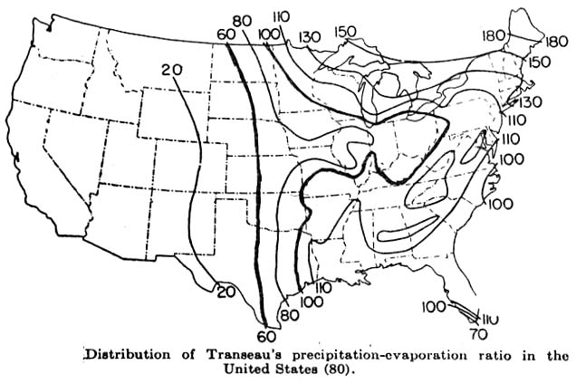
Illustration 1. Annual rainfalls are distributed as longitudinal belts in the western half of the United States, but on latitudinal ones in the eastern half, to give us our West and our East and to divide the latter into our North and our South.
Constant ratios of precipitation to evaporation (as percentages) plotted as isobars to represent effective rainfall serve to map out the varied degrees of constructive or destructive soil development. They delineate the ecologies of crops, livestock, percentages of land in farms, efficiency of radio reception, and problems of defective health via problems in nutrition.

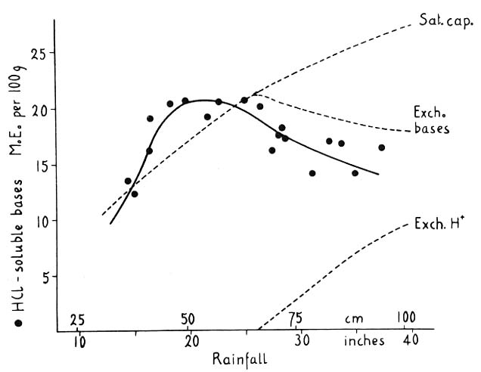
Illustration 2. Tests of soils for soluble salts (in dilute acid) across a section of Kansas and Missouri, along a line of constant temperature, suggest soil construction in the western part (rainfall less than 25 inches) and soil destruction in the eastern part (rainfall more than 25 inches).

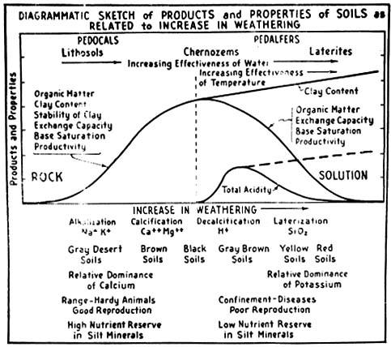
Illustration 3. A diagrammatic representation of development of soil under increasing forces of rock weathering by rainfall and temperature. The maximum of its breakdown, giving clay saturation by nutrient cations and only small amounts of acidity, represents the fertile soils for protein production and good nutrition of higher forms of life near the midline of this sketch.
Note the various soil processes, kinds of soils, dominance of either calcium or potassium, and animal health characteristics from the West to the East, or according to higher rainfalls and more soil development.

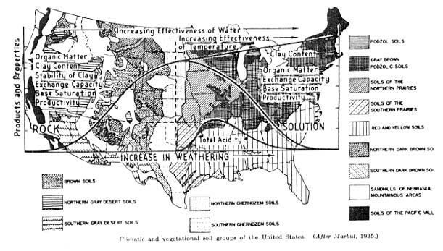
Illustration 4. As a theoretical curve of increasing weathering of rock, soil construction follows the rising curve of clay production until precipitation exceeds evaporation to give soil destruction, or a falling curve of the soil's productivity associated with the decline of soil organic matter, exchange capacity and cationic saturation of that.

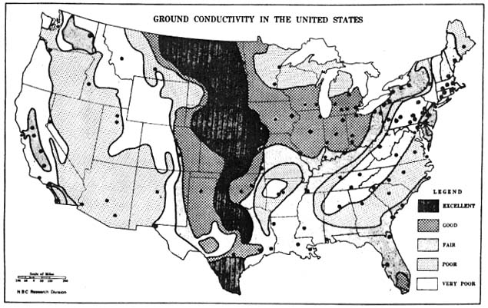
Illustration 5. The soil's electrical conductivity of the United States. The soil as one of the conductors in the radio circuit requires both moisture and fertility salts for effectiveness in radio reception. Note how areas of excellent and good radio reception combined correlate with areas of most productive mid-continental soils between rainfall-evaporation percentages of 60 and 100. (See Illustration 1 ). (Courtesy Radio Corporation of America)

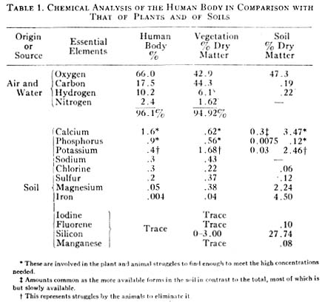
Illustration 6. Table I. The inorganic chemical composition of the human body (warmblooded) in comparison with that of plants, coupled with such of the soil, the triumvirate which provides our food. Note that calcium coming from the soil is the highest inorganic soil requisite for our bodies.

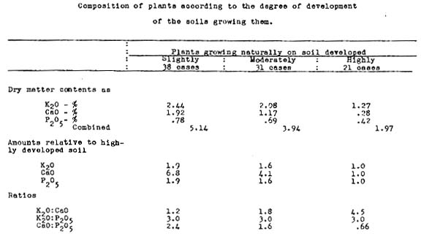
Illustration 7. Table II. The tabulated data of chemical compositions of crops grown on (a) "slightly" developed soils (38 cases): (b) "moderately" developed ones (31 cases): and (c) "highly" developed ones (21 cases) show the decrease from the wider calcium-potassium ratio (6.8:1.0) dwindling down to the narrower one (1.0:1.0) as the vegetation is grown toward eastern and southeastern United States under increasing degrees of soil development to make crops more carbonaceous and less proteinaceous.

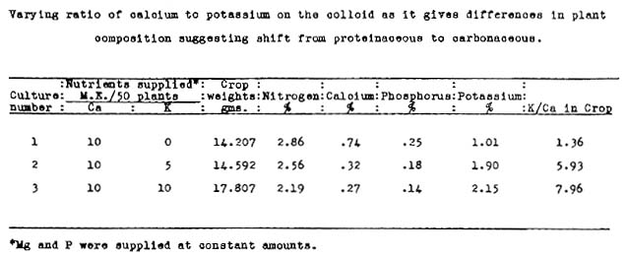
Illustration 8. Table III. Soybean plants, grown to test their concentrations of protein, phosphorus, and calcium, as well as their yields of vegetative mass, confirmed the natural array of decreasing concentrations of protein in crops according as the ratio of exchangeable calcium to potassium becomes narrower to give higher yields of bulk but those of lower concentrations of nutritional values.

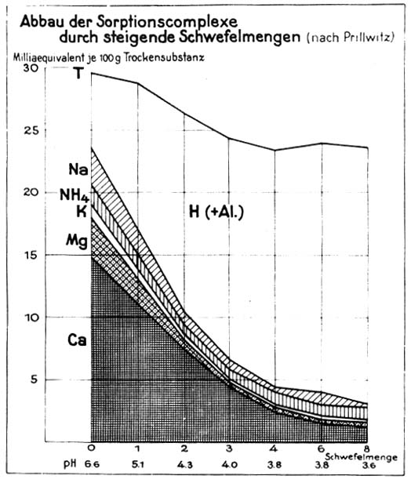
Illustration 9. Laboratory tests of weathering the soil at high rate, by incorporating increasing amounts of elemental sulfur to be oxidized and leached out by high rainfall, show the narrowing ratios of calcium to all tested nutrient elements according as the amount of applied sulfur (Schwefelmenge) is increased (left to right) and the pH figure becomes smaller. Note that the lowered top line indicates loss of clay also and a decreasing total exchange capacity with weathering.

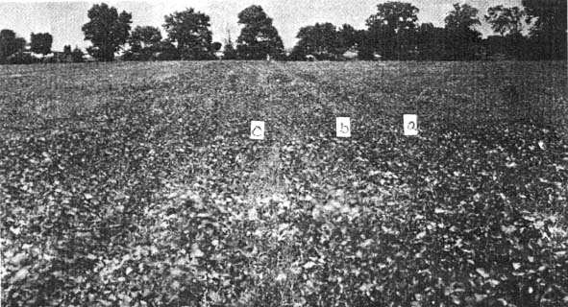
Illustration 10. Streaks of better growth of soybeans in the field resulted (right to left) from drilling (a) calcium chloride, making the soil more acid; (b) calcium nitrate, making no change in final acidity; and (c) calcium hydroxide, reducing the acidity; yet these soil treatments were all alike in bringing about better bean crops with fuller nodulation of the roots due to like amounts of the element calcium applied as better and early plant nutrition.

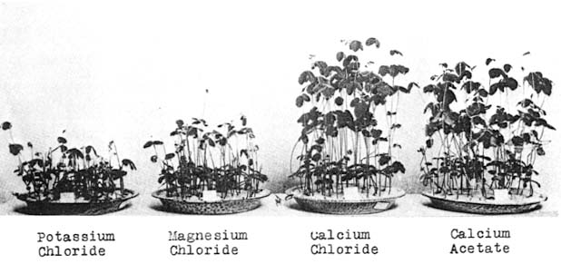
Illustration 11. One cannot reform the entire soil volume against acidity (two million pounds per plowed acre). But one can nourish the seeding with applied calcium for better germiniation and early plant growth. Thereby the root searching through the inimical soil will have been born with root hairs equipped with calcium-membranes which can control intake and out-go, even within that disturbed, deeper feeding area, to give normal, healthy nodulation by nitrogen-fixing bacteria. Calcium is much more affective in the plant's early life than are potassium and magnesium.

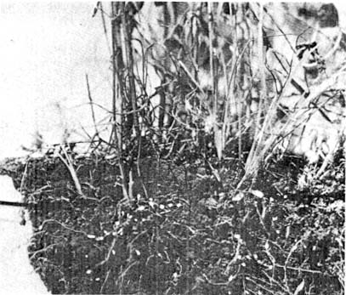
Illustration 11,(a) Note line of limestone, drilled into soil between arrows, but nodules profuse outside that limed soil line.

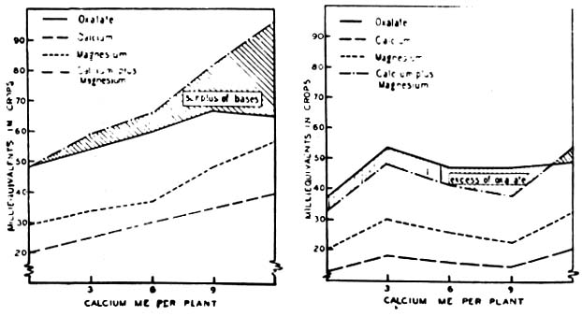
Illustration 12. Spinach is a mineral-rich vegetable, especially in calcium and magnesium. But much of each is combined as oxalate compounds to be insoluble and indigestible, save a small reaction. (See left graph, shaded area of acid soil, left pH 5.2) .
Spinach grown on the same soil, near neutral, (pH 6.8) has lower concentrations of calcium and magnesium and with enough oxalate to make more than both of them insoluble and indigestible. (See right graph, shaded area. The acid soil made the spinach much more mineral-rich, as the soil offered more of that nutrient).

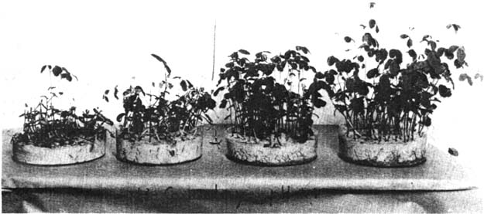
Illustration 13. Soybeans grown on the clay mixed into quartz sand, as described in the text discussion, demonstrated that "to be properly fed (by calcium) is to be healthy" for soybeans on an acid soil, pH 4.4, and at a saturation degree of only 23.5 percent, when ample clay was mixed into the sand to supply required calcium.

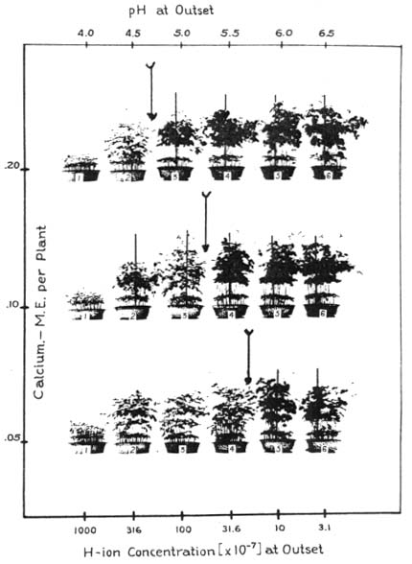
Illustration 14. Increasing the degree of saturation of the clay by calcium (clay mixed into quartz sand, left to right) grew healthier soybeans in that order, pH from 4.0 to 6.5, in all three series.
Increasing the amount of clay, or total calcium offered per plant in the three series, 0.05, 0.10 and 0.20 M.E. from bottom to top series, offset ten times the acidity by this quadrupling of total calcium, moving the division lines in the series to a lower pH by 1.0 pH unit.
The crops of all pans, save the upper right hand one, had less nitrogen, phosphorus and potassium in their total crops (tops plus roots) than was originally present in the planted seeds.

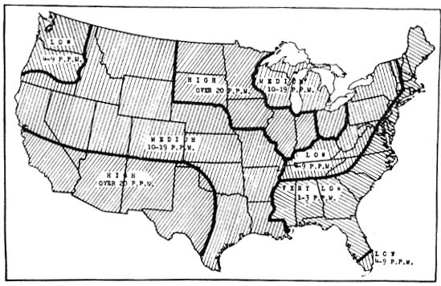
Illustration 15. The balanced plant diet of cations exchangeable in the soil calls for approximate percentages saturation of its exchange capacity by, (a) hydrogen--10 to 15%; (b) calcium--60 to 70%; magnesium--10 to 20%, or 7 to 15%; potassium 2 to 5%; and sodium 0.2 to 5%.
When the arid soils are not acid, but are saline and alkaline in reaction (pH), the elements of commonly lower saturations become too high relative to the calcium, making the latter deficient as plant nutrition.
The map of magnesium in the drainage waters shows large areas of excessive magnesium, relative to calcium, particularly the areas of "high" (>20 p.p.m.) magnesium in the drainage waters. (Charted by S. B. Detweiler, Soil Conservation Service).

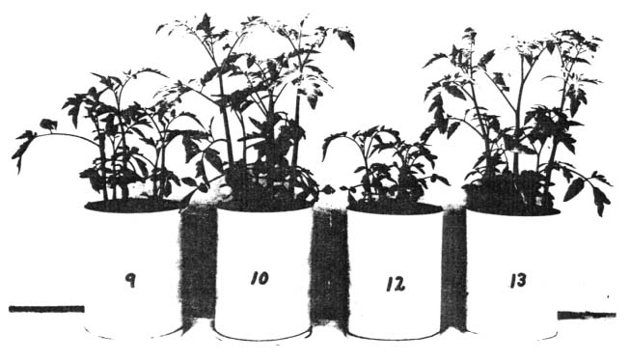
Illustration 16 . By mixing pulverized farm manure into the upper three inches of soil before seeding and then doing likewise for superphosphate (Pot 9), the plant growth was much less than when the phosphate was first combined with the manure and the mixture put into the soil similarly (Pot 10).
Mixing the comparable two different treatments into the upper six inches of soil demonstrated similarly (Pots 12 and 13, on the right) . Mixing the phosphate with active organic matter made it much more efficient for better plant growth.

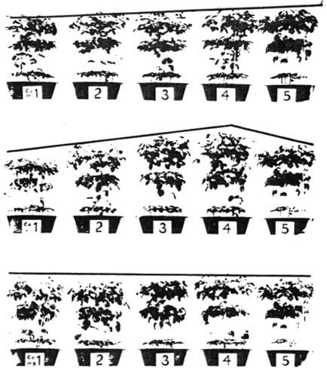
Illustration 17. When the highly inorganic cations in the soil vary in their ratios, illustrated by increasing calcium saturation and decreasing hydrogen, or acidity, (left to right, upper row); or by calcium similarly matched with potassium (middle row) then the plant growth varied widely (left to right) in spite of a constant total of calcium by soil test.
But when calcium was similarly matched with the large organic cation, methylene blue, then the latter buffered out the effects of variable saturation to make the effects by calcium a constant one according to its total available supply in the soil (lower row).

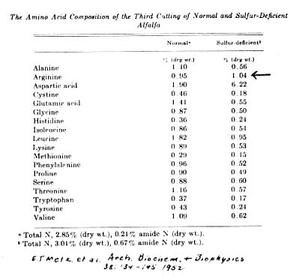
Illustration 18 Table IV. Analysis of alfalfa for eighteen of its different amino acids, when grown on a soil with normal content of sulfur in contrast to the alfalfa grown on the same soil deficient in respect to that nutrient anion (associated commonly with organic matter), the amounts of the amino acids were lower for the sulfur-deficient soil in all but one of the amino acids, namely asparagine, not commonly deficient in home-grown feed materials.

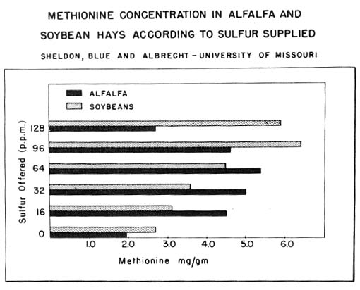
Illustration 19. Lower amounts of sulfur offered by the soil for growing alfalfa and soybeans, lowered the concentration in these two legumes of the commonly deficient amino acid, methionene.

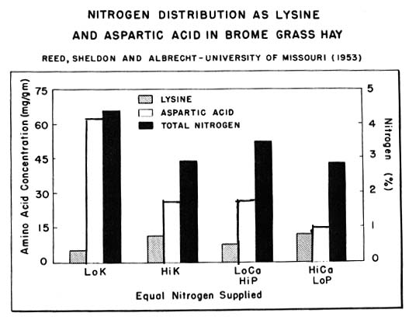
Illustration 20. The total nitrogen in a non-legume hay, like bromegrass, may vary without correlation to some of the amino acids, especially the commonly deficient lysine. Total nitrogen as the measure of "crude" protein does not give any suggestion as to the quality of protein in terms of its respective amino acids, (Lo = low, Hi = high, Ca = calcium, P = phosphorus, and K = potassium).

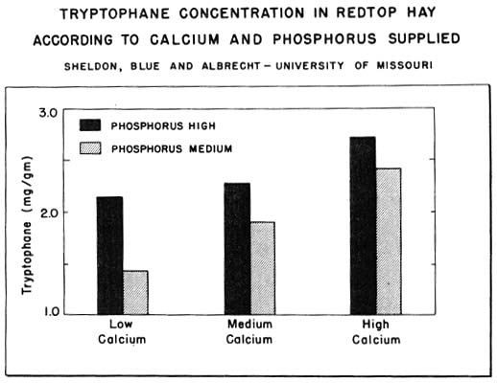
Illustration 21. The soil's major nutrient elements in their relations to each other modify the synthesis and concentration of tryptophane in non-legumes. When the phosphorus offered by the soil was low, the increased offerings by calcium did not give as high a concentration of this essential amino acid as when the soil phosphorus was also high.

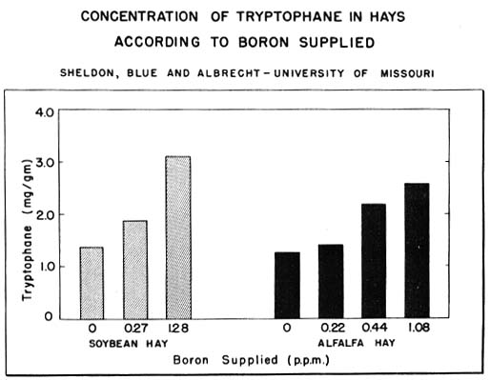
Illustration 22. Boron, as a nutrient offered to the soybeans and alfalfa in higher amounts served to give higher concentrations of the commonly deficient amino acid, tryptophane, in these two legumes.

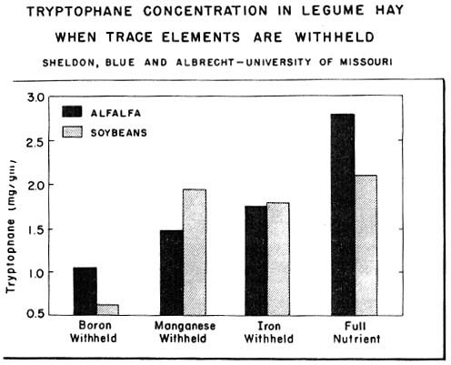
Illustration 23. Withholding any one of the four trace elements tested, held down the concentration of tryptophane in the two legumes, alfalfa and soybeans. The wide variation in this essential amino acid suggests possible protein deficiencies in the hays as feed when the soil is deficient in trace elements required by these crops.

