# Bahir Dar University

# Institute of Technology

**School of Computing and Electrical Engineering**

**Department of Computer Science and Engineering**

***E-commerce***

# System Design Document

Company Name: ethioSale Inc. [e-commerce]

Group Members.

Mulugeta Ayele………………………………….267/2000

Mulugeta Muche……………………………….268/2000

Nebiyou Samuel ………………………………..279/2000

**Table of Content**

1. Introduction 2

2. System Business Objectives 3

3. System Functionality 4

1. Logical and Physical Design 5

Logical Design 5

Physical Design 6

2. System Budget and Architecture 7

Budgeting 7

System Architecture 8

3. Hardware Requirement 9

4. Tools and Software 9

5. Future Works 9

# Introduction

**Electronic commerce**, commonly known as **e-commerce** or **e-Commerce**, consists of the buying and selling of [products](http://en.wikipedia.org/wiki/Product_%28business%29) or [services](http://en.wikipedia.org/wiki/Service_%28economics%29) over electronic systems such as the Internet and other [computer networks](http://en.wikipedia.org/wiki/Computer_network). The amount of trade conducted electronically has grown extraordinarily with widespread Internet usage. The use of commerce is conducted in this way, spurring and drawing on innovations in [electronic funds transfer](http://en.wikipedia.org/wiki/Electronic_funds_transfer), [supply chain management](http://en.wikipedia.org/wiki/Supply_chain_management), [Internet marketing](http://en.wikipedia.org/wiki/Internet_marketing), [online transaction processing](http://en.wikipedia.org/wiki/Online_transaction_processing), [electronic data interchange](http://en.wikipedia.org/wiki/Electronic_data_interchange) (EDI), [inventory management](http://en.wikipedia.org/wiki/Inventory_management) systems, and automated data collection systems. Modern electronic commerce typically uses the [World Wide Web](http://en.wikipedia.org/wiki/World_Wide_Web) at least at some point in the transaction's lifecycle, although it can encompass a wider range of technologies such as [e-mail](http://en.wikipedia.org/wiki/E-mail), mobile devices and telephones as well.

Electronic commerce is generally considered to be the sales aspect of [e-business](http://en.wikipedia.org/wiki/E-business). It also consists of the exchange of data to facilitate the financing and payment aspects of the business transactions. There are different types of e-commerce based on nature of market relationship and we chose the consumer-to-consumer (c2c) type.

**Consumer-to-consumer** (C2C) (or *citizen-to-citizen*) [**electronic commerce**](http://en.wikipedia.org/wiki/Electronic_commerce) involves the electronically-facilitated transactions between consumers through some third party. A common example is the [online auction](http://en.wikipedia.org/wiki/Online_auction), in which a consumer posts an item for sale and other consumers bid to purchase it; the third party generally charges a [flat fee](http://en.wikipedia.org/wiki/Flat_fee) or [commission](http://en.wikipedia.org/wiki/Commission_%28remuneration%29). The sites are only intermediaries, just there to match consumers. They do not have to check quality of the products being offered.

We’ve tried to develop an e-commerce web site called ethioSale.com .It is a **Consumer-to-Consumer (C2C) E-commerce** type web site in which the site provides a way for consumers to sell to each other, with the help of an online market maker it also allows consumers to make an auction through the site .It has different functionalities with user friendly environment which makes it very interactive with the end users. Consumers registered to the site and can post what they want to sell and we deal with them in terms of payment for using our site and the other customers who really need the posted items deal with the customer who owns the item may be by sending him a message using the system or he/she can chat with the seller if they are both online so the system provides a means to make a communication channel between the two sides( buyers and sellers ) and the remaining process is done when they contact one another physically.

# System Business Objectives

The main goal of this web site is communicating customers remotely for any business activities and it has great contribution for ICT development of our county. In general it addresses the following issues for user of this site.

* It reduces the time that wastes for buying and selling of market product
* It saves human resources
* It provides easy and fast access of products that are available on the market
* It minimizes the cost of long journey for human being and materials

Consumers specifically sellers at different place of the country can post what they have got for sell and consumers now buyers from different sites can access what the sellers post on the web site . This provides introduction of culture from one area to the other for example a seller from Bahir Dar posting different items like cultural clothes then a buyer from Addis or any other place can actually see the item without moving to Bahir Dar and if they actually need it considering the cost, they can have the item easily. This indicates that the creation of this web site has a great impact on different perspective may be in terms of introducing culture as explained above, in terms of saving the precious time , additional cost for transportation or any other related things, the ability to get every single item in one place .

# System Functionality

##### The system has the following functions in general.

* Customer registration and login

Receiving customer information based on name ,phone no ,address ,city then authentication of a customer.

* Product registration

Registering products based on item name, item model , item code/serial , item quality ,item type (used or new)

* Searching products

Customers can search any products as long as the item is a registered one in the system.

* Posting products(buying Product suggestion and selling)

In addition to the previously chosen products, the system suggests other products to buy.

* Electronic auction (bidding)

The system provides a bidding (auction) system for customers an electronically held sale at which property or goods are sold to [the](http://dictionary.reference.com/browse/the) highest bidder.

* Chatting

A chatting application for customers. Online customers can have a word with the one on the other side. This helps a better way of communication for the customers and the system to provide additional functionalities to users and get the ability to be competent and stay alive in the business world

* Advertizing area

A portion on the different parts of the page is left for advertisement .this is important for both users (i.e. company hosts and normal users). The company advertises its products using the system and the users can see and may response for the displayed advertisement from the system therefore both parties are beneficial from the system.

# Logical and Physical Design

## Logical Design

As like any commercial web site ethioSale.com is expected fulfill the following main issues in logical design of its content.

* Security: Mainly the site must insure that customers money must be transact in highly secure processes including hppts protocol.
* Simple for Loading: During logical design the system must insure that there is no loading unnecessary resources and the code structure and components must be easy.
* Free Account: Customers can create free account for themselves and their relatives and they can easily use the site for promoting their business and get paid for their product.
* Help Content: The web site includes help system about how to buy, how to sell, how bid and in general hot use the web site.

In general the logical design of the web site is drown as follow.

Customer Database

Customer information

Accept or

reject customer reject customer

HTTP request

Product Database

## Physical Design

Physically the web site starts from the index page and all the other functionalities will follow the index page. Users first start their work from index page and continue using the site for different functionalities. But still now we used the normal folder structure. We will apply this structure while we will develop this site. The following diagram shows this scenario.

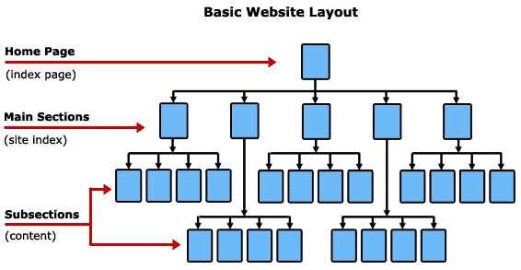

Home page Main Section

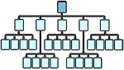 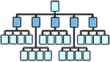

Sub-section

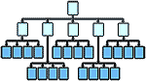

The layout design of web site including customer, internet and database is shown as follow.

Database

Server

ethioSale.com

512k ADSL

2Mbps

Solaris Web Server 2 dual processor, 500 GB storage

Mail Server

Chat Server

Auction Server

# System Budget and Architecture

## Budgeting

We will spend money for the following cases. First we will promote this web site in different media. Even if we are developers of this web site we wills spend for different reasons. The system needs computers and other hardware. After all we will spend for web hosting.

Hosting

20%

Marketing

15%

Hardware

30%

System Dev’t and Maintains

35%

## System Architecture

The system is two-tier architecture. The users request the page from the web server for performing their activity on the web site. Then the web server will send and accept row data from the database.

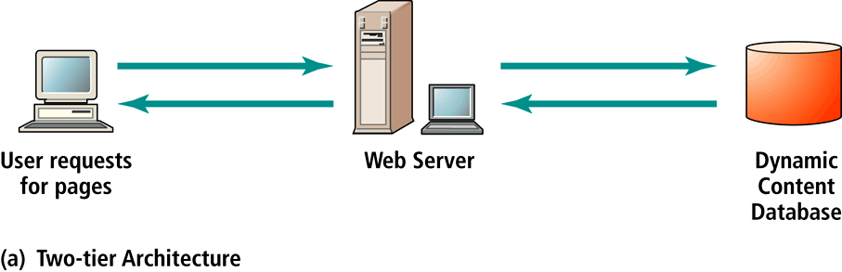

# Hardware Requirement

For hosting our website we have pick out some minimum specification.

* + - **Web application server** - 2 GHz processor, 1 GB RAM, 30GB disk
    - **Database server** - 2 GHz processor, 1 GB RAM, 100 GB RAID 4 + disk
    - **File-server** - 2 GHz processor, 512 MB RAM, RAID 5 storage with appropriate disk space
    - **Web application server software**: Apache Tomcat 5.0.28

On the client side some of the minimum specifications will be.

* + - 1 CPU at 1.2 GHz or faster (a faster processor on the client side is required to view complex and large page.)
    - 512 MB RAM
    - 5 MB of disk space
    - 1024x768 resolution screen resolution( monitor)
    - Windows XP Professional, Service Pack 1 or higher, or Microsoft Windows 2000, Service Pack 4
    - Microsoft Internet Explorer 7.0, Service Pack 1 or higher

# Tools and Software

For developing our website we are using the following tools.

* + - * + Notepad ++;
        + Dreamweaver;
        + Browsers;
        + Firebug;

We are also using the following software:

Wamp server;

# 

# 

# Future Works

Now we are working on the basic frameworks of our website. That means we are building the basic functionalities of the website. Plus we are working according to the electronics market law of our country which limits many things to work the full feature of e-commerce. But we hope that this will not continue as our country technology is developed. When we reach that time we are planned to change/upgrade to do buy/sell transaction. That means we will upgrade the website to enable customers to sell their products online and buy products online by paying money online. That means any customer can sell its products from where ever and any customer can order and buy things from anywhere.

By considering some situations and laws of the country we will also give shipping services. But this we be after we analysis many things.

Before these things there are some works, actually they are features, we are going to include to our website.

* + - The first thing is zooming effect of items. We have get that this is best feature for customer to view items online in any direction and very closely. By the nature of commerce many customers want to see the item very closely. So we will do that in near future.
    - Adding templates of some products which we have left it out now. Because of constraint of time we are now limit the posted products to our products.