# Security Model Even if there is no real money transaction in our web site, there are some secure processes that needs the system to perform its function for authenticated users. In general, this e-commerce web site expected to fulfill the following security issues.

# Customer login:

# There are some services that can be done without customer login to our web site. Like item search, view item detail, item price comparison, browse for item and help system. Except all these functionalities customers are obliged to login to the site for other services including item posting, message and chat service, bid for items and product advertizing.

Internet

Web Server



SSL channel

Encrypted data

Password, SHA1 encryption

User name and password

Database

1. Customer Message Security Issues

Sellers and buyers will get the following security advantages from this web site.

* Privacy

When customer login into the site, it provides SSL service for secure data transmission through their work. Their prepaid card number, login password and user name are kept from unauthorized users.

* Integrity

The messages send by sellers and buyer and also their instant message(chat) is kept from external attacks; it must not altered or tempered before the message reaches its destination.

* Authentication

Sellers and buyers can communicate each other if they only provide their identity each other. This helps them from unauthorized attacks.

* Non-repudiation

The system notifies weather the message received by a customer or not, so that senders will check their information is secure from external attacks.

1. Customer Payment Security Issues

Our e-commerce web site mainly concerned on communicating sellers with buyers for the item that the seller posts on our site. The seller pays for the commission for us when he/she posts the item. The payment mechanism depends on the type of post (for bid or for only view), duration of post and price of the item to be posted. This payment needs highly secure information flow between us and our customer. When the customer fills the payment form, the information filled on the site should be processed securely. For this purpose we use SSL channel and SHA1 encryption algorithm for encrypting sensitive data like prepaid card number.

Internet

Web Server



SSL channel

Encrypted data

SHA1 encryption

Prepaid card info

Database

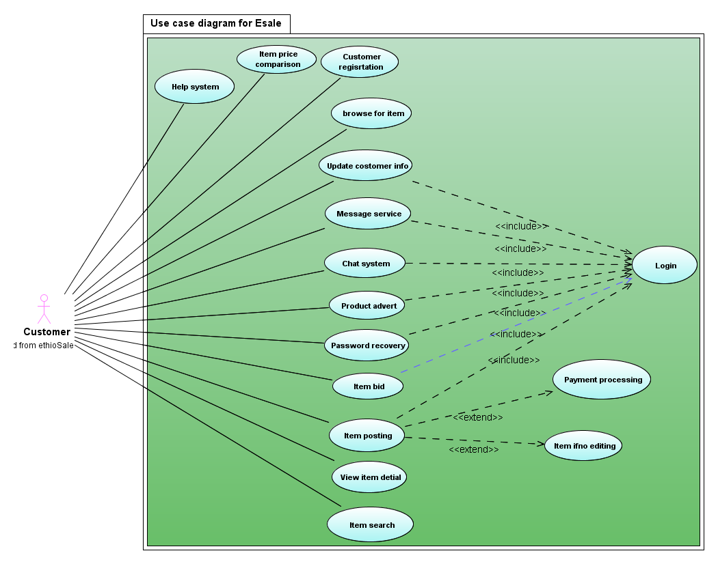

## Use Case Description

Use case 1: Help system

The site gives complete help system for customers. They can get help how to sell, bid, post and search items. The payment system is also part of the help; they can view how to pay, how much they will pay for the item they post, and from where they will buy prepaid cards.

Use case 2: Item price comparison

If there are list of related item which may be displayed from search or any other case, they can compare their price. This helps them which one is better to buy.

Use case 3: Customer registration

Any new customer to the system must register to post item, bid item, advert their products. It is free and simple.

Use case 4: Browsing item

The site has link for all categories in which each category has many sub-category and each sub-category also composed of a number of items. By using all these hierarchies the user can browse for an item.

Use case 5: Update customer information

After the user has register to the site, if they need to update their personal profile they can update their detail information

Use case 6: Message service

Sellers and buyers can send a message each other after they login into the system. The message service is available

Use case 7: Chat service

If both the seller and the buyer are both online they can chat with each other.

Use case 8: Product advert

Any user can advert their product on our site if they are registered. During advert process the customer is expected to pay for us according the commission.

Use case 9: Item post

If a customer is registered user he/she can post the item that he want to post for bid or just for view.

The general flow of secure data is shown as follow.

# Network Topology

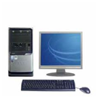

Customer

Internet

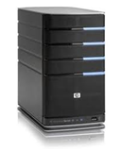

ethioSale Sever

SSL enabled

HTTP

Database



Card distributer

SHA1 encryption algorithm and payment transaction are processed