Design Documentation
Library System

Designer: Vlasenko Konsantin
Russkolahdenkatu 13-15 D17, 5385 Lappeenranta, FINLAND
Telephone: + 358 (0) 50 365 7238
http://www.lut.fi/~vlasenko
Email: vlasenko@lut.fi

Table of Contents

1. Introduction.................................................................................3
1.1. Purpose...................................................................................3
1.2. Abbreviations...........................................................................3
1.3. Summary.................................................................................4
2. System Overview..........................................................................4
3. Design Considerations..................................................................5
3.1. Assumptions and Dependencies..................................................5
3.1.1. Related software and hardware………………………………………………….5
3.1.2. End-user characteristics………..……………………………………………………5
3.1.3. Possible and/or probable changes in functionality...................5
3.2. General Constraints……..……………………………………………………………………..6
3.3. Goals and Guidelines……………………………………………………………………………6
3.4. Development Methods…………………………………………………………………………7
4. Architectural Strategies……………………………………………………………………….…7
5. System Architecture…………………………………………………………………………………8
5.1. Sub-System architecture…………………………………………………………….12
6. Policies and Tactics……………………………………………………………………………14
7. Detailed System Design……………………………………………………………………14
References……………………………………………………………………………………………………23

- Introduction
  - Purposes
This document was made on basis of Requirements Documentation so all requirements of customer was taken into account. However some changes concerning design of developed LMS can be brought after studying by client of Design Documentation (DD). Main goal of DD is description of design and structure of LMS system’s interface. The document is intended first of all for reporting about implemented work to customer, and also for final coordination with him of questions connected to design of developed system. Last version of document will be given to developer for realization of chosen structure.

  - Abbreviations
- LMS – Library management system
- SRS – Software requirements specification
- PC – Personal Computer
- HDD - Hard Disc Drive
- RAM – Random Access Memory
- LUT – Lappeenranta University of Technology
- IE – Microsoft Internet Explorer
- LSE – Library System Engine
- UIE – User Interface Engine
- SQL – Structured Query Language
- RD – Requirements Documentation
- DD – Design Documentation

  - Summary
This version of design document consist next parts:
Design Considerations – general description of the software system including its functionality and matters related to the overall system.
Architectural Strategies – this part describe design decisions and strategies that affect the overall organization of the system and its higher-level structures.
System Architecture – this part gives high-level overview of how the functionality and responsibilities of system were partitioned and then assigned to subsystems.
Policies and Tactics – in this part of design document we describes design policies and tactics which affect on details of the interface and implementation of various aspects of the system.

- System Overview
The Dream Team Corporation was invited to develop College Library Management System for National Innovation Foundation (N.I.F). The software will reflect all the requirements defined by the customer.
College Library Management System will allow to perform all necessary procedures for librarians and patrons. According to customer requirements the software to be developed will consist of three databases:
- Item’s database (books, journals, magazines, newspapers, diploma thesis, etc)
2) Patron’s database
- Small Access-based database with information about digital items, that College has (software, music) integrated with Item’s database
LMS will also provide all necessary services for databases such as creating, deleting, updating and searching information. Patrons will be able to access to the library site (web-based) through the Internet or through the library’s LAN-connected computers, scattered throughout the library for sending request, receiving information about current status of the books or renewing them. The design of product interface to be developed will be supported by Microsoft IE, Netscape Navigator and Opera browsers. User interfaces will be ergonomical and easy-to-use.

3. Design Cinsiderations
3.1 Assumptions and Dependencies
3.1.1 Related software, hardware and operating system
Library Management System will be executed on Intell/AMD based platoforms and under following systems: MS WindowsXP, MS Windows 2000.
3.1.2 End-user characteristics
There is no special requirements for users because of LMS system will be quite easy in apply. Only knowledge of English (all interface is going to be represented in this language) and ordinary skill of different web-browsers’ (such as Netscape Navigator, MS Explorer and Opera) using are required.
3.1.3 Possible and/or probable changes in functionality
All new customer’s requrements will be taken into account. But since performance’s term is insignificant so probability of changes in functionality without shifting deadline is very low.

3.2 General constraints
Next items must be used to verify software:
    - For user home PC and library workstation
Hardware
- IBM-compatible PC with PentiumΙ processor and higher
- 50Mbytes free space on HDD
- 32Mbytes RAM
- Internet connection
Software
- MS Windows 95/98/2000/NT/XP
- MS IE, Netscape or Opera browsers with Java2 support
- For Server
Hardware
- IBM-compatible PC with Pentium ΙΙΙ and higher
- 256Mbytes RAM or higher
- 80Gbytes free space on HDD
3) For LMS’s interface
- Interface will be implemented in English
- To each user status shuld be appropriated
- LMS should be implemented as web-based software

3.3 Goals and guidelines
Main principle of creating LMS sytem is develop it according to customer’s requirements. It has to be available from the web and be online 24 hours a day so user could use it anywhere and anytime he need. Design of LMS system will be very simple because of two reasons:
    - LMS’s interface has to be similar to ordinary search systems in Internet;
    - Implentation term is quite compact.

3.4 Development Methods
In initial stage of LMS developing all requirements were studied by Requirements engineer (Andrey Paklin) after consultation of Project manager (Fabian Garrido-Martinez) with customer. All requirements documentation was passed to Designer (Vlasenko Konstantin) for developing interface. After its implementation Design Documentation will be delivered to Tester (Alex Kanavin) for completion work on project. One of the main development methods is that design of system is made using Object Oriented Design technique.

- Architectural Strategies
- All data (students, books, newspapers, magazines, CD’s, loans, reservations) will be stored in a NIF-database (SQL server will be used for storing data);
- User Interface Engine will provide interactions of LMS with user through Internet;
- LMS database management (everyday revising LMS database, generating e-mails for users and staff) is carried out by Library System Engine;
- All components of LMS system easily can be modified so it is possible to extend developing system in future;
- It is possible to install new special hardware for users’ serving (for example, barcode scanner to facilitate getting information about certain book or user if library use library cards with barcode);
- Interfaces in system is not very complex so there is no need some special technical skill for work with its.
- As mentioned in section 3.2 for best performance system need 256 MB of physical memory for central database for server and 32Mbytes RAM for user home PC or library workstation;
- Administrator will have all necessary functions and instructions for controlling database;
- System will communicate with users and staff, through the interfaces and e-mail notifications;
- If user delayed the book then system will send email notices to user;
- For librarian system provide additional functions and interfaces such as: detailed information about all registered users, detailed information about books, CDs, and other items, that stored in NIF LMS database. Also librarian status allows him to modify this information. System will have special function for administrator (he can modify information about users and staff accounts, change passwords and additional information in database);

- System Architecture
Library management system has three main components:
  - Database for storing different types of data such as users, books etc managed by an SQL database server.
  - Library System engine (main core of LMS system implemented in Java).
  - User Interface Engine (by means of this server user interact with database through the web).
Figure 1 represents main structure of LMS system

Database

SQL server
Library functions database

Windows Applications

Library system engine (Java)
Library’s workplaces

User Interface Engine (PHP)

Web browser
Web browser
Web browser

Figure 1
Users’ personal computers

Above there is description of main components of LMS system represented on fig. 1.
Database. Database is intended for storing different types of data such as users, books etc.
SQL server. This server is intended for Database management. It receives commands from Library System Engine and according its demanding take data from database.
Library System Engine (LSE). This is the core of LMS system. It is intended for processing of client’s inquires and has standard library of functions. By means of this functions LSE connects to database server (SQL server) and generate requests for data issue, data renew, deleting data, etc from database. Requests are made on standard language named Structured Query Language (SQL). LSE can be implemented by different ways. In this LMS system it will be implemented in Java.
LSE consist of several modules (every module response for certain operation): authorization module, search module, e-mail module (intended for e-mail distribution) and others (fig. 2)
Authorization module

Search module

Library System Engine

E-mail module

Figure 2
………………………

User Interface Engine (UIE). UIE allows to work with LMS system by means of Web-browser (through the web). It can be implemented in PHP script language for connection between server database and user web interface. UIE interacts with LSE by means of byte stream protocol. This protocol allows to provide interaction between programs realizing user interface (Web or Windows) and core of LMS. Byte stream protocol consist from set of messages of certain types such as request for registration, registration’s result, request for search, result of search and others.
Windows Application. This allows to work with LMS system directly without applying web browser on basis of Windows operation system.
LMS system can be divided into two main parts. The first part is User side and the second is a Server side.
User side usually consist from personal computer with the Web-Browser connected to Internet (if user apply LMS system by means of Internet) or PC with installed LMS software connected to Library System engine (if user apply LMS system by means of library’s computers). According to Logon data user can obtain two different statuses: “ordinary user” or “librarian staff”. LMS system provides users with next possible actions (for library staff and for library users):
Library staff will be able to perform the following operations:
- Login to the system
- Add, modify or remove information about the book
- Check availability of the book using book’s library number;
- Add, modify or remove information about the library users
- View the list of all library users, their details and accounts;
- Generate report, about users of library, and books they overdue
- Search the book by author or book title
- Change login password

Library users can perform next actions:
- Login to the system;
- Search the book by author or book title
- View the information about his/her status
- View information about his/her account
- Change login password

5.1 Subsystem Architecture
LMS database will have the following structure: there are will be three tables for storing different kinds of data.
First table will store information about library’s resources
Table1 (Items)
Field name | Data type | Description
Type_of_Item | Char(10) | Type of item (book, magazine, CD, etc)
Library_Number | Long | Item’s Library number
Author | Char(50) | Item author
Title | Char(100) | Item title
Published_Date | Date | Date of Item publicity (optional)
Location_in_Library | Char(10) | Location of Item in library
Status | Char(10) | Status of item (home, library using, etc)
Number_of_Copies | Integer | Number of items that library has
Number_of_Free_Copies | Integer | Number of items available in library
Brief_Description | Varchar(100) | Brief description of book
Keywords | Char(50) | Keywords

Second table will store information about users.
Table2 (Users)
Field Name | Data type | Description
User_IN | Long | User identification number
User_First_Name | Char(10) | User first name
User_Pass | Varchar(10) | User logon password
User_Address | Varchar(100) | User address (optional)
Name_Surname | Char(50) | User Name and Surname (optional)
E-Mail | Char(30) | User’s e-mail address
Status | Integer | If 1 it is a library staff otherwise user
User_Telephone_ Number | Char(15) | Telephone number

Third table will store information about loans.
Table3 (Loan)
Field name | Data type | Description
Item_Library_Number | Long | Item library number
User_IN | Long | User Identification number
Initial_Date | Date | Initial date of using
Final_Date | Date | Final date of using
Maximum_duration | Integer | Maximum duration of using

6. Policies and Tactics
LMS system is developing according to requirements. Main functionality and logic of system are provided by Web Server and SQL server. LMS provide end users with friendly interface and library staff with easy installation methods.
After it will be implemented it’s going to be tested by tester. In initial stage of LMS using system will be serviced by programmers from “Dream Team” company. If some problems occur during software applying library staff should address to technical support service.

7. Detailed System Design
“Dream Team” company has developed all interfaces for NIF Library Management System. After consulting “Dream Team” company Project Manager with customer this variant of interface’s design was accepted for implementation. In Design document represented only main interfaces.
On the figure 3 it is illustrated first page of NIF Library Management System. All operations with library database will start from this page. For use LMS system first of all user has to login. This also can be done from this page. According to the log data user obtain his/her status (user or librarian).

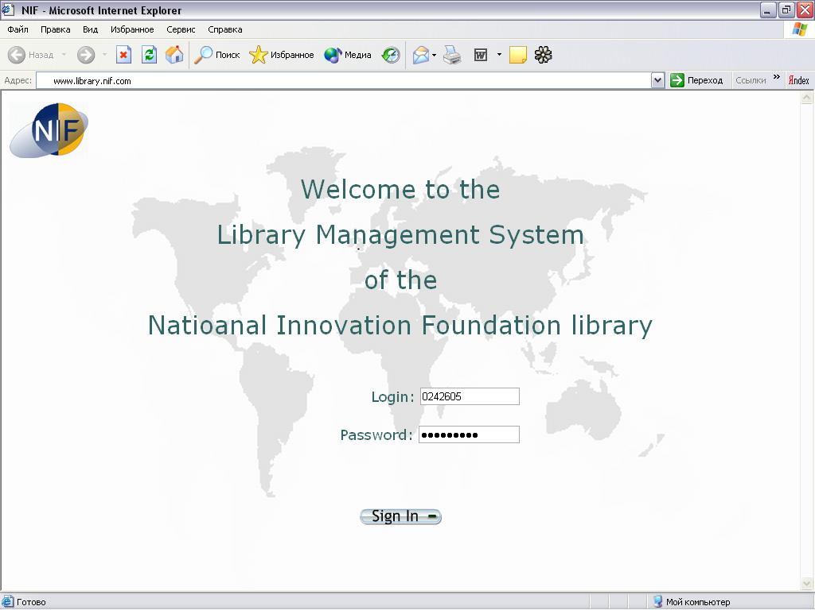

Figure 3. First page of LMS system

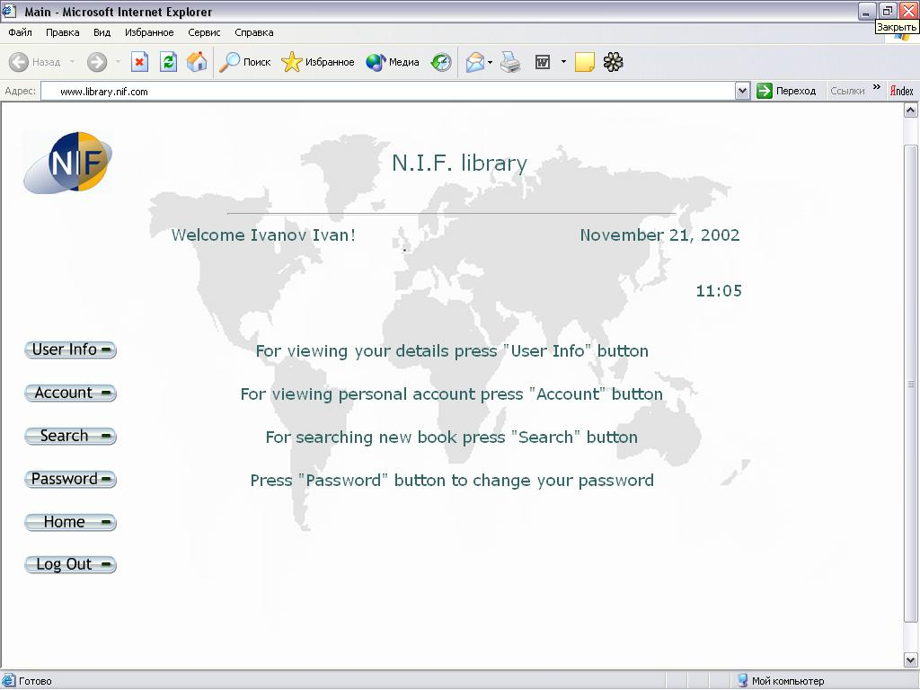
User status

Figure 4. Main user’s page

User status
If according to log data user have “user” status then after logon he/she will see main window showed on the figure 4.
Main user’s menu consists:
- Users Info: here user can find his personal data (fig.5);
- Account: information about loans (fig.6);
- Search: provide detailed search through the library (fig. 7);
- Password: this function intended for changing user’s password;
- Home: return user to main window (fig.4);
- Log Out: this function is intended for exit from user’s settings.
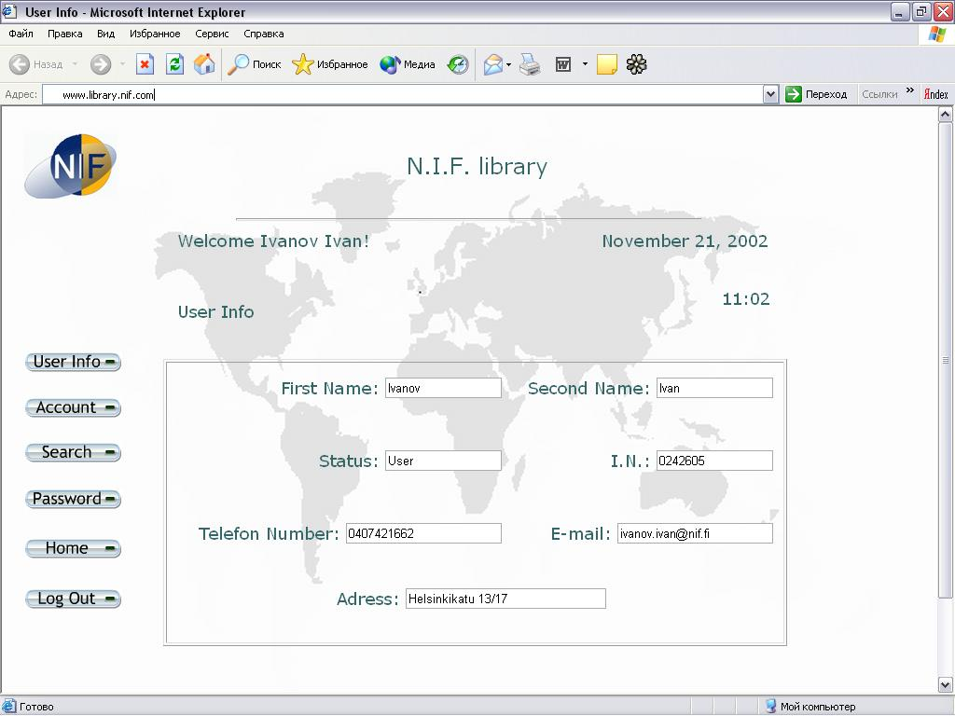
Figure 5. User’s Info

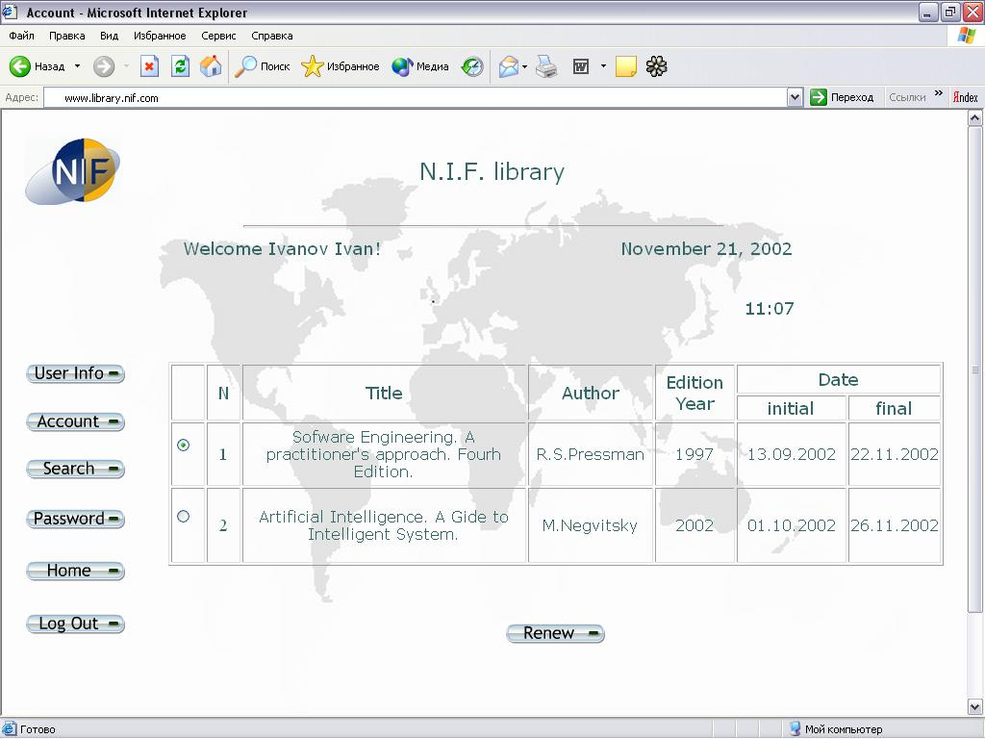

Figure 6. Account information
As you can see it is possible to renew loans through the web.
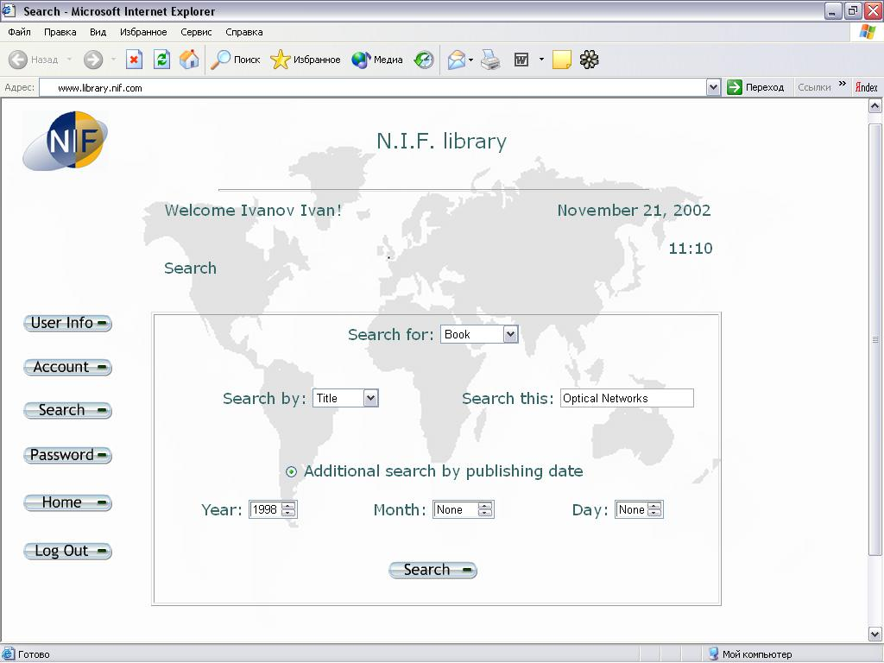
The search page, shown on figure 7, provides next functions to users (students, stuff and etc.):

Figure 7. Request for search

Here you can see field “find this”, in this field user should enter information about book, CD or journal. It is possible to select different type of search, such as search by “Keyword”, author, title. Also in this page is available additional search by publishing date.
For example, user wants to find book in which title there is expression “optical networks” and which was published in 1998. Result of this search you can see on the figure 8.
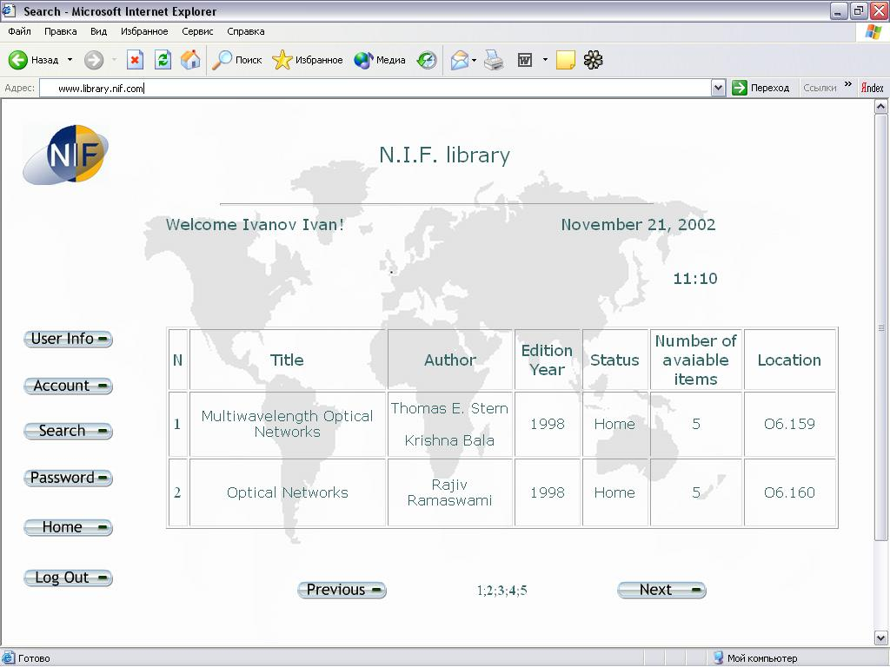

Figure 8. Search Result

Librarian status
If according to log data user have “user” status then after logon he/she will see main window showed on the figure 9.

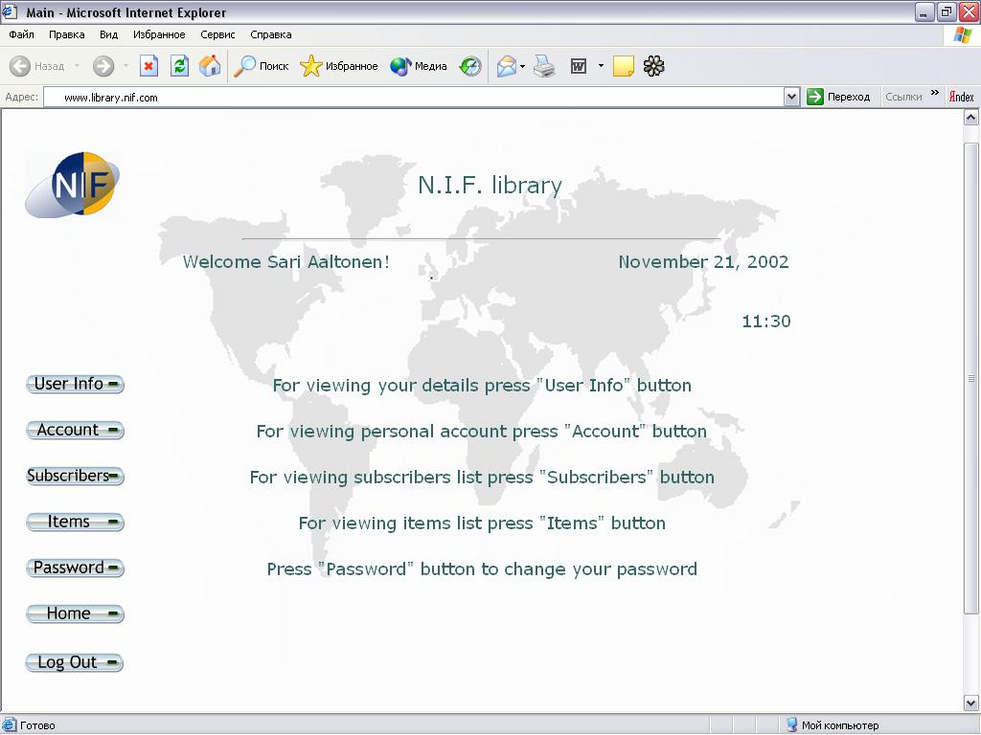
Figure 9. Main librarian’s page
Main librarian’s menu consists:
- Users Info: here user can find his personal data (fig.5);
- Account: information about loans (fig.6);
- Subscribers: provide detailed information about all users;
- Items: provide detailed information about all library’s resources;
- Password: this function intended for changing user’s password;
- Home: return user to main window (fig.9);
- Log Out: this function intended for exit from user’s settings.
Main difference from ordinary user interface is presence of “Subscribers” and “Items” buttons.
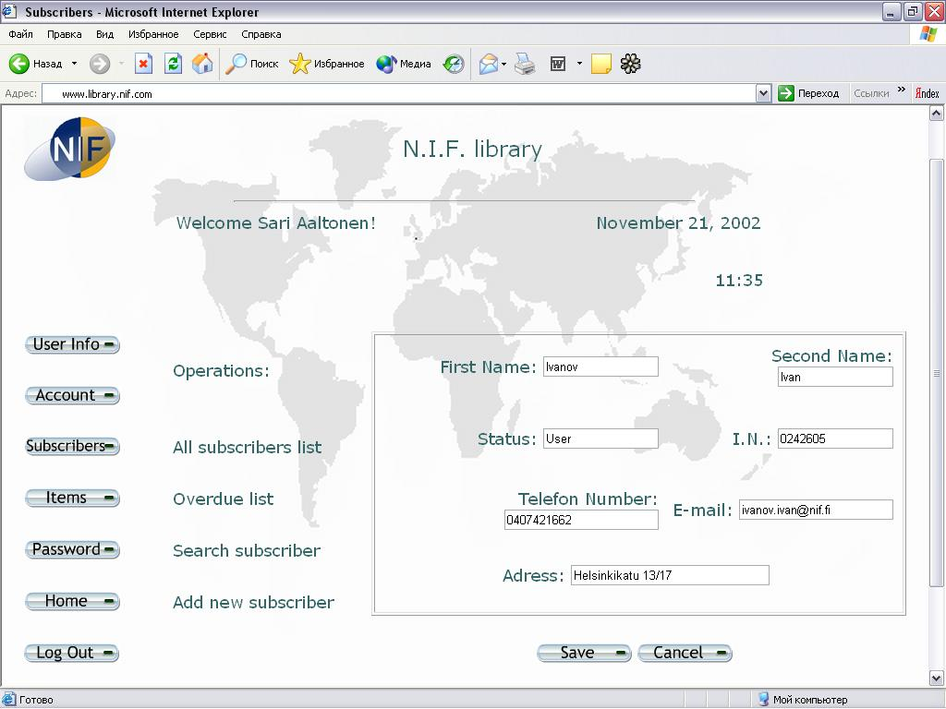
In “Subscriber” section librarian can watch all users and overdue users’ reports. Also he/she can add new user, delete old one and modify information about selected from list user. Special “Search” function is available in this section. After user was found librarian can see his/her account, user’s information and account. Also it is possible modify user’s data and delete user. Search window practically is similar to adding new user window (fig. 10). If librarian wants add new subscriber then he/she has to fill all gaps in form illustrated on figure 5 (this operation is illustrated on the fig. 10).

Figure 10. Adding new user window

In “Items” section librarian can search necessary item (book, newspaper, magazine, etc), add new item and delete old one. Search page of librarian differs from ordinary user’s page by function’s presence of modifying information about item and deleting item from library database. Process of adding new item illustrated on figure 11.
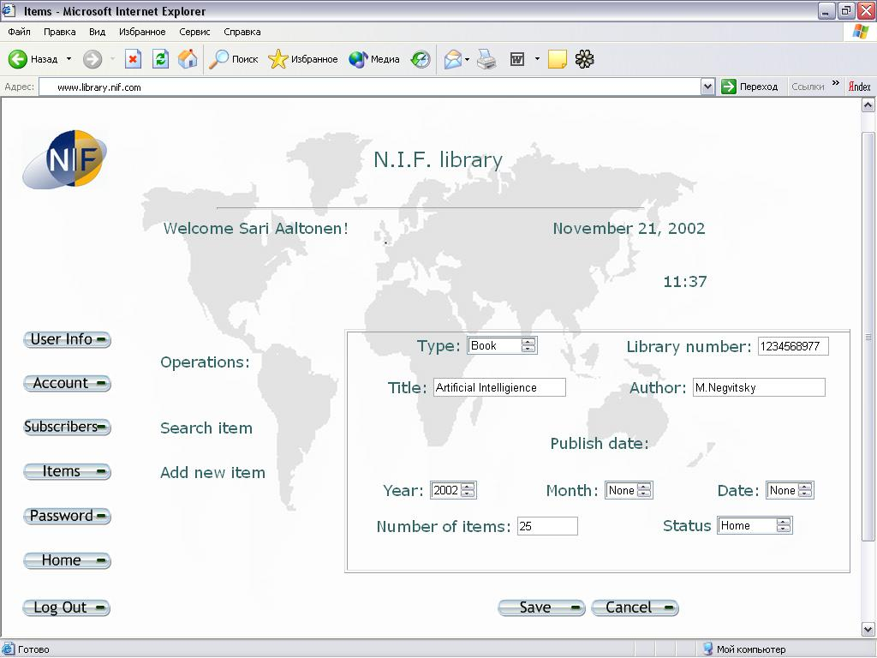
Figure 11. Adding new item window

In chapter 7 was presented main windows of Library Management System.

References
[1] Design specification template
http://www.construx.com/survivalguide/desspec.htm
[2] Information about the Team project on Software Engineering course.
http://www.it.lut.fi/kurssit/02-03/010752000/description.pdf
[3] Dream Team Company. Requirements Documentation,
version 1.1 Author: Andrei Paklin
http://www.sensi.org/~ak/impit/pbswe-team/
[4] Innovative technologies laboratories. Design Documentation,
http://www.it.lut.fi/kurssit/02-03/010752000/projects1/team4/index.html

