Amhara Region HIV/AIDS Prevention &Control Coordination Office (Amhara HAPCO)
Objective of Project
This project aims to automate the company’s work for fast, easy and reliable task execution for employees. It address the current problems of the company, like boring and long works for single task, inefficient and
In general, the following are the main objective of this project.
- Managing employee’s of the company in their day to day activity for successful work
- Managing any finance related cases including payroll system
- Managing budget allocation for company’s sub-branches, weredas and kebels

Background of Organization
The National HIV/AIDS prevention and control council (NACS) was established in 2000. Following this the Amhara Regional HIV/AIDS prevention and Control Council Secretariat(ARACS) has been established under proclamation number 17/1993, revision 73/1994.
Later on during Business Process Reengineering, it is named as Amahara region HIV/AIDS Prevention, Control and Coordination Office (HAPCO). Currently it is aggressively playing its mandated role in coordinating the HIV/AIDS prevention and control activities in the region whoever the implementer is.
Vision
To see Amhara Region free of HIV/AIDS
Mission
Coordinate HIV/AIDS prevention and control activities of Government sectors NGOs, CBOs, FBOs PLWHA Association and other implementers, build their capacity, leveraging resources from different sources, facilitate Networking and Partnership, establish monitoring and Evaluation system to strengthen & intensify the multi-sectoral HIV/AIDS Prevention and Control responses.
Goals
- Support institutions to mainstream HIV/AIDS in their development agenda
- Establish and strengthen partnership and networking among different institutions to promote concerted efforts and enhance experience sharing
- Promote the establishment associations of PLWHAs and build their capacity in response to HIV/AIDS
- Promote advocacy among all levels of government administrations through opinion and religious leaders
- Advocate and design system to mobilize the community to participate and own the response especially in provision of care & support.
Strategic Response Areas
The regional HIV/AIDS response has two major strategic areas, namely creating enabling environment & priority programmatic thematic areas.
1. Creating enabling environment:
- Capacity building,
- Community mobilization & empowerment,
- Leadership and governance,
- Mainstreaming,
- Coordination, and
- Partnership & networking.
2. Priority programmatic thematic areas :
  - Intensifying HIV prevention,
  - Increasing access & quality of chronic care & treatment,
  - Strengthen care & support, and
  - enhance generation & use of strategic information.
Working Principles
- Sense of Urgency
- Gender Sensitivity
- Better Collaboration with PLWHAs
- Result Oriented
- Sense of Owners hipness
- Multi-Sectionalism
- Partnership/Collaboration
The existing Structure
ANRS HAPCO is a operating body directly accountable to the regional president as any other government bureaus & offices. At the same time HAPCO serves as a secretariat of the HIV/AIDS Prevention &Control Council (HAPCC) and HAPCC board follows & supervises the progress of HAPCO’s implementation of decision made by HAPCC.
HAPCC is a structure that constitutes all the three sectors, namely government, civil and private sector and established to design & provide overall guidance on regional response to HIV/AIDS. HAPCC also has a structure at zone, woreda & Kebele levels.
HAPCO established offices at region, zone and woreda levels. Each structure has a regular reporting, monitoring & programmatic technical relationship.
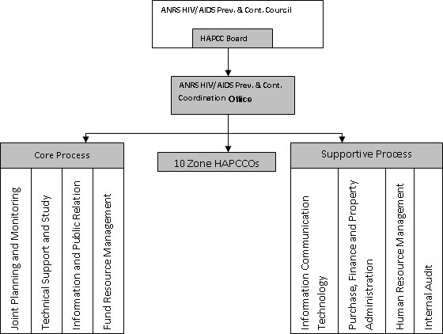
The proposed BPR-To Be Documents to replace existing BPR Process shown on the above structure
1. Joint Planning, Monitoring & Evaluation core process
2. Public Relation Core Process
3. Intensifying Multispectral Response Core process
4. Fund Resource Management Core process
5. Internal Audit Supportive process
6. Human Resource Management Supportive process

