Bahir Dar University
Institute of Technology
School of Computing and Electrical Engineering,
Department of Computer Science and Engineering

Requirement Specification Final Document
ANRS council in FDRE (RSD-ANRS)
Delivered to: Instructor Esubalew.A
Wednesday, June 15, 2011

Group members:-
Biruktite Fikre ------------------086/2000
Selamawit Yilma ---------------302/2000
Solomon Getenet---------------310/2000
Tsion Ketema-------------------355/2000
Wondimagegnehu Tsegaye ---504/2000

Contents
1. Introduction 6
1.0 Purpose 6
1.1 Document Conventions 6
1.2 Intended Audience and Reading Suggestions 6
1.2.1 Project Scope 7
1.3 Definition, Acronyms & Abbreviations 8
1.3.1 Actors list and definition 8
2. Overall Description 9
2.1 Product Perspective 9
2.2 Product Features 9
2.3 User Classes and Characteristics 10
Personal manager: 10
Ticker: 10
Manager/ Administrator: 10
Registered employee: 10
Cashier: 11
2.4 General constraints 11
2.4.1 Operating Environment 11
2.4.2 Design and Implementation Constraints 11
2.5 User documentation 11
3. Requirement 12
3.1 User requirements 12
3.1.1 Functional User requirements 12
3.1.2 Non-Functional requirements 16
3.2 System Requirements 17
3.2.1 Priority leveling 17
3.2.2 Use case description 19
4. External Interface Requirements 34
4.0 User Interface Design 34
4.1 Software Interfaces 44
4.2 Communications Interfaces 44
5. Analysis Models 45
5.1 Sequence diagram 45
5.2 Data flow diagram 56
6. Conclusion 61
7. Glossary 62
8. Reference 63

List of figures
Figure 1 User registration page 34
Figure 2 Employee registration form 35
Figure 3 leave registration form 36
Figure 4 Salary increment management page 37
Figure 5 termination of user 38
Figure 6 organizational structure registration form 40
Figure 7 Disciplinary measures registration form 41
Figure 8 Vacancy notices registration form 42
Figure 9 Report generation form 43
Figure 10 Sequence diagram for search an employee 45
Figure 11 Sequence diagram for generate report 46
Figure 12Sequence diagram for print report 47
Figure 13Sequence diagram for record attendance 48
Figure 14Sequence diagram calculate annual leave 49
Figure 15 Sequence diagram for calculate net salary 50
Figure 16Sequence diagram for transfer annual leave 51
Figure 17Sequence diagram for update employee 53
Figure 18Sequence diagram for manage allowance 54
Figure 19 Sequence diagram for employee registration 55
Figure 20 DFD of General entity interaction 56
Figure 21 level 0 DFD 57
Figure 22 process employee 58
Figure 23 DFD of general report and search 59
Figure 24 DFD record daily attendance 60

List of tables

Table 1: registering new employee 19
Table 3: delete employee 21
Table 5: record daily attendance 22
Table 5: calculate annual leave 23
Table 6: transfer annual leave 24
Table 7: calculate net salary 25
Table 8: record operation 26
Table 9: generate leave report 27
Table 10: generate resign report 28
Table 12:manage deduction 30
Table 13: generate pay check 31
Table 14: print report 32
Table 15: search 33

Introduction

Purpose
The purpose of this software requirements specification (SRS) is to establish the major functional and non-functional requirements which are necessary to develop Human Resource Management System for ARC. It also has additional purpose such as providing a feedback to the ARC (CUSTOMER), facilitating other documentation; the SRS forms the basis for a load of other important documents such as the Software Design Specification.

Document Conventions
while writing this software requirement documentation , bold face and numbering with no indentation and with 14 font size is used for the general topics of the document. The description for each general topic will be written using a standard font which is a new times Romans theme font ,with a 12 font size and 1.5 line spacing .

Intended Audience and Reading Suggestions
This document is intended to be read by the customer of the ARNS council. The primary audience is human resource management staffs, especially the human resource management administrative, personnel manager, and the ARNS Information Technology staff. Ultimately, all members of the HRMS Project Team are the intended audience. This is a technical document and the terms should be understood by the customer.

Project Scope
This software is a human resource management system of the ANRS council in FDRE which manages the organization organizational structure which includes the organization units, the positions in each organization unit and the job grades of each position; the recruitment information which includes the management of vacancy notices, the criteria for the vacancies, the applicants and the applications of the vacancies; the management of the personnel which includes the management of employees, their employment document, their education, their discipline measures, their awards, their salary changes, their experience, their medical information, their employment information and their termination; the leave management which includes list of the leaves taken, leave settings/ rules, annual leave calculations, transferred leaves and other types of leaves which are not calculated in the normal annual leave calculation (like sick leave, birth leave, funeral leaves and so on); the system security which includes the management of operations and their permissions, and the overall system audit (i.e. keep track of all the operations performed and who has performed the operations); and the management of allowance and deduction which includes calculation for the deduction or allowance. The system also generates reports for the above operations and managements performed.
When we generally see the system it has the following functionalities
- Organization management system
- Recruitment
- Personnel management system
- Leave management system
- Security management system and
- Allowance and deduction management system

By managing all this functionalities the system provide the organization the following advantages
- Reduce the cost of management
- Reduce the access time for a certain file
- Gives well organized management of files
- Reduce time for performing a task
- Reduce expenditure for a task
- Helps to have a good management

Definition, Acronyms & Abbreviations
- Ticker: creaks the employee attendance
- Unregistered employee:- people who are employed but not registered
- Manager:-a position defined by the company
- Registered employee: employee that are added to the system as an employee
- personnel manager: responsible for administering the system

Actors list and definition
- Ticker: creaks the employee attendance
- Unregistered employee:- people who are employed but not registered
- Manager:-a position defined by the company
- Registered employee: employee that are added to the system as an employee
- personnel manager: responsible for administering the system
- cashier: responsible for providing the employee salary

Overall Description

Product Perspective
The function of Human Resources departments is generally administrative and common to all organizations. The HR function consists of tracking existing employee data which traditionally includes personal histories, skills, capabilities, accomplishments and salary. HRMS of ANRS council provides the functionalities described in the Product functions section of this document. It includes all subsystems needed to fulfill the software requirements. The system will consist of a DBS (for storing persisting data) and the HRM system.

Product Features
The major product features of HRMS system are:-

- Register / Add and save new employee: The system registers an employee in the systems database.
- Search employee information: The system search will display the employee personal information based on search criteria so that the user views the employee information that she/he wants.
- Update employee information: The system update employee information that should be changed
- Delete employee: The system discharges or remove employee’s information from the currently employee list when the employee leave the company will be deleted from the current employee list
- Record daily attendance: The system store daily attendance of the employee who is absent and who is present in her/his work place.
- Perform some operations: The system calculate annual leave, transfer annual leave , calculate net salary
- Generate and print report: The system generates different types of reports such as leave report, resign report ,
- Record operation: The system Record every operation done by the system and who did the operation, calculate allowance provided to the employee
- Manage allowance: The system Manage the allowance provided to the employee when Employee perform a field work / who works over time
- Manage deduction: The system manage deduction performed on the employee salary such as tax , disciple measures
- Generate paycheck: the system generate paycheck for each month

User Classes and Characteristics
There are four primary users in HRMS and these are:-

Personal manager:
These users control and manage the overall system, responsible for administering the system. She/he should be able to submit issues, edit issues, and perform queries on the database. Responsible to Registering new employee, update employee, delete employee, calculate annual leave and manage deduction.

Ticker:
Responsible for recording employee’s daily attendance.

Manager/ Administrator:
Responsible for Generating leave report, Generating resign report, managing allowance, searching the necessary employee

Registered employee:
Responsible for transferring annual leave, Print out the generated report

Cashier:
Responsible for providing the employee salary, Generating pay check

General constraints

Operating Environment
The system will be applicable in a networked environment (LAN). it includes a client/server architecture .the administrator will act as a server side and the other employees of the government will act as a client side. Since the system is a desktop application system ,it needs to be installed on every employee’s desktop which are included in the LAN system. So that everyone in the LAN system who has permission or who can access the system will be able to get every benefit from the system. This product can operate on operating system like windows 7 and vista.

Design and Implementation Constraints
If there is no LAN system in the customer organization it will be hard to implement the system. on the other hand since every employee are not able to understand English language as well and every employee in the organization is expected to be computer aided ,the developers will be forced to add Amharic language to the system to let the users to understand the system briefly.

User documentation
To make our system easy to use we have included some features so as enable user to adapt easily the system to be deployed .so the system make part of the following feature:
- Search option, both text and menu search
- Help page

Requirement

User requirements
The function of Human Resource Department is generally administrative and it is common to all organizations. Organizations may have formal way of recruitment, evaluation and payroll process. Efficient and effective management of Human Capital has progressed to an increasingly imperative and complex process.
The HRMS function consists of tracking existing employee data which traditionally includes personal history, skill, capability, accomplishment and salary. To reduce the manual work load of these administrative activities of ANRS council, we began to electronically automate many of this process by introducing specialized Human Resource Management System.

Functional User requirements
Maintain Employee History
- The system shall store the educational information of the employee.
  - the system shall store the primary school where he/she finished
  - the system shall store the secondary school where he/she finished
  - the system shall store the preparatory school where he/she finished
  - The system the system shall store university name of the employee that he/she is graduated from.
  - The system shall store the employee’s field of study.
  - The system must shall the employee’s level of education.
- The system shall store the employee’s work experience.
2 .1 the system shall store the list of organization where the employee has been working
2.2 The system shall store the list of departments where the employee has been working
2.3 The system shall store the number of years of experience.

- The system shall store employee’s address information.
  - The system shall store employee’s phone number
  - The system shall store employee’s city.
  - The system shall store employee’s sub city.
  - The system shall store employee’s kebele.
  - The system shall store employee’s Email address.

Manage Employee information
- The system shall store the date when the employee got joined the company.
  - The system must shall the year when the employee has joined the company.
  - The system shall store the month when the employee has joined the company.
  - The system shall store the date when the employee has joined the company.
- The system shall store the department of the employee where he /she got assigned.
- The system shall store the full name of the employee.
  - The system shall store the first name of the employee
  - The system shall store the middle name of the employee
  - The system shall store the last name of the employee
- The system shall store the age of the employee.
- The system shall store the sex of the employee
- The system will provide unique id for each employee.
- The system shall store the employee’s current work position.
- The system shall keep track of the change in work position of the employee.
  - The system should keep track of the previous position of the employee.
  - The system should keep track of the new position of the employee
- The system shall store the employee’s monthly salary.
- The system shall store the allowance for each employee.
13.1 The system should store the type of allowance.
- The system should record the recruitment information.
  - the system shall store the Curriculum vitae of the employee
    - the system shall the name of the employee
    - the system shall store the CGPA of the employee
    - system shall store the field of study of the employee
    - system shall store the birth date of the employee
    - system shall store the educational background of the employee
  - The system should store the initial monthly salary of the employee
  - The system should store the initial position of the employee
  - The system should store the date of recruitment
- The system shall record the discipline measures taken to punish employee.
  - the system shall store the type of discipline measure
  - the system shall store the reason of discipline measure
  - the system shall store the approver of the discipline measure
  - The system shall store the name of person who penalized the employee.
- The system should store an employee’s job grade.
- The system shall provide the user with different report generation option to choose from it.
- The system shall generate a work experience report for an employee when resign the company
  - The system should include the service time of the employee in the work experience report.
  - The system should store the reason for resignation.
- The system should provide an option for printing out employee information.
- The system will generate periodic pay checks
  - The system shall include the tax deduction in periodic pay checks report
  - The system shall include the pension deduction in periodic pay checks report
  - The system shall include the net salary in the periodic pay checks report
- The system will generate employee tax report.
- The system shall provide an option for printing out employee’s annual leave report.
  - the report shall include the type of the leave taken
  - the report shall include the reason for leave
  - the report shall include start date of the leave
  - the report shall include end date of the leave
Manage allowance/deduction
- The system will calculate the tax deduction of a salary.
- The system will calculate the penalty deduction of a salary.
- The system will calculate the pension deduction of a salary.
- The system should calculate the salary increment per year.
Manage leave and attendance
- The system will provide an option for storing the daily attendance status.
  - The system should register the name of the employee who is absent.
  - The system should register the name of the employee who is present.
  - The system should record the date of daily attendance.
- The system will calculate the annual leave taken.
- The system should store absent day of the employee.
- The system shall store the reasons of the absence.
- The system will allow the employee to request for the annual leave.
- The system should transfer the rest of the previous leave to the next annual leave.
- The system should store the number of leave days that can be taken by an employee with respect to the number of year she/he has worked.
- The system should alert an employee whose pension date arrives.

Operations
- The system will provide a search option to search for an employee using the employee’s id.
- The system will provide an option for adding a new employee.
- The system will provide an option for deleting an employee record.
- The system will provide an option for editing already existing employee information.
- The system should record every operations performed.
- The system should record who has done the operations.

Non-Functional requirements
- The system should give access privilege to each user.
- The system will identify the users using user name and password.
- The system will give response for each click to navigate from one page to the other page with in 1 micro second.
- The system shall operate for at least 6 months without failure.
- All users of the system will understand the system within 2 weeks training.
- The system will operate on different operating system.
- The system shall store an additional of 10,000mb of data in addition to the current data.
- The system will not need any additional plug in software.
- The employee’s personal info will only be accessed by an authorized person.
Organizational information
- The system should records annual meeting schedule.
  - The system will store the kind of meeting.
  - The system will store the date of meeting plan.
  - The system will store lists of participant of the meeting.

System Requirements

Priority leveling
Use case name | transfer leave
Description | Transferring the annual leave for the consecutive years.
Priority | High

Use case name | manage salary
Description | Keeping track of the salary of employee
Priority | High

Use case name | generate resign report
Description | Making report for an employee that is going to resign
Priority | High
Use case name | generate leave report
Description | Making report for an employee that is going to leave for a specified period of time
Priority | High

Use case name | generate pay check
Description | Making report for an employee that is
Priority | High

Use case name | update employee
Description | Updating the previously stored information of an employee
Priority | High

Use case name | manage allowance
Description | Calculate the net allowance for an employee
Priority | High

Use case name | search for an employee
Description | Searching for specific employee information using the employee name.
Priority | High

Use case name | print report
Description | Producing hard copy of a stored report, of different kind.
Priority | High

Use case name | transfer leave
Description | Transferring the annual leave for the consecutive years.
Priority | High

Use case description
Use Case Number: | EU01
Name: | Registering new employee
Description | Registering new employee in the systems database
Preconditions | The employee must not be registered previously.
Actors | Unregistered employee, personnel manager
Basic course of Action: | User action | System response
Basic course of Action: | - The use case begins when a new employee join the company.  - The personnel manager requests the system to sign in a new user.  - The personnel fill the required information of the employee via the page registration page provided. | 3. The system provides a registration form to the personnel.  4. The system checks whether the user fills all the required information[alt course: A]  5 The system confirms that the employee is successfully registered.  6. The use case ends.
Alternative Course of Action ‘A’ : | The personnel did not fill all the required information:  A.5. The system displays an error message saying “all the filled need to be filled for the registration.”  A.6. The course of action continues from “4”.
Post condition | A new employee will be registered to the company.

Table 1: registering new employee
Use Case Number | EU02
Name | Update employee
Description | Employee information that should be changed by another value is updated by the personnel.
Preconditions | An employee should be a member of an employee
Actors | personnel , registered user(employee)
Basic course of Action | User action | System response
Basic course of Action | - The use case begins when the personnel needs to update the employee information.  2. The personnel search for the employee profile using employee id.  4. The personnel fill the new value on the previous value that is needed to be updated.  5. The personnel select the update option.  8. The use case end | - The system displays the employee’s information in editable format. [alt course A]  6. The system checks whether the personnel fills all the updated information correctly [alt course: B]  7. The system successfully saves the updated value.
Alternative Course of Action ‘A’ : | The personnel did not fill the employees id correctly  A.7. The system displays an error message saying “no employee found”  A.8. The course of action continues from user action “4”.
Alternative Course of Action ‘B’ : | The personnel did not fill all the required information:  A.5. The system displays an error message saying “all the filled need to be filled for the registration.”  A.6. The course of action continues from user action “4”.
Post condition | The new value will be saved instead of the old one.
Table 2: update employee information
Use Case Number: | EU03
Name: | Delete Employee
Description: | An employee who leave the company will be deleted from the current employee list
Preconditions: | An employee should be a member of an employee
Actors: | Personnel , Registered user(employee)
Basic course of Action: | User action | System response
Basic course of Action: | - The use case begins when the employee leave the company.  - The personnel manager chooses to delete an employee from database.  4. The personnel manager fills the employee’s information needed for deletion.  8. The use case end when the user successfully deleted from the database. | `  3. The system will display a form to delete an employee.  5. The system checks whether the administrator fills all the required information[alt course: A]  6. The system checks the employee from the database. [alt course: B]  7. The system deletes the employee from the database.
Alternative Course of Action ‘A’ : | The personnel manager do not fill all the required information:  A.5. The system displays an error message saying “all the filled need to be filled for the registration.”  A.6. The course of action continues from user action “4”.
Alternative Course of Action ‘B’ : | The system did not find the required employee:  A.7. The system displays an error message saying “no employee found”  A.8. The course of action continues from user action “4”.
Post condition | An employee is deleted from the current employee list.

Table 3: delete employee
Use Case Number: | EU04
Name: | record daily attendance
Description: | Record daily attendance of the employee who is absent and who is present in her/his work place.
Preconditions: | The day must be working day.
Actors: | Ticker
Basic course of Action: | User action | System response
Basic course of Action: | - The use case begins when the ticker need to record the daily attendance report to the database.  - The ticker enter information of each employee who is present or who is absent to the database from the manual attendance. | - The system checks that the appropriate values are entered.  - The system saves and stores the attendance information to the database.  - The use case ends.
Alternative Course of Action ‘A’ : | The ticker did not fill all the required information:  A.3. The system displays an error message saying “all information are not entered”.  A.4. The course of action continues from “2”.
Post condition | The system will record the attendance of the employee.

Table 5: record daily attendance

Use Case Number: | EU05
Name: | calculate annual leave
Description: | The number of days of the annual leave that one employee can take will be calculated with respect the service time of the employee in the company.
Preconditions: | an employee must be a member of an employee
Actors: | personnel
Basic course of Action: | User action | System response
Basic course of Action: | - The use case begins when the personnel need to calculate the annual leave of an employee  - the personnel select the annual leave option  - The personnel fill the name of employee.[ alt course A]  - the personnel fill the id of the employee [alt course A]  - the personnel fill the department of the employee  - The personnel select the calculate option. | - the system displays the annual leave form  7. The system displays the total day of the annual leave.  8 the use case ends
Alternative Course of Action ‘A’ : | The user did not fill all the required information:  A.4. The system displays an error message saying “no employee with this name”.  A.5. The system displays an error message saying “no employee with this id”.  A.6. The course of action continues from “3”.
Post condition | the total day of the annual leave of an employee will be calculated

Table 5: calculate annual leave
Use Case Number: | EUO6
Name: | transfer annual leave
Description: | An employee will transfer annual leave remain to be added to the next annual leave.
Preconditions: | A user has to be the employee of the organization.
Actors: | employee
Basic course of Action: | User action | System response
Basic course of Action: | - The use case begins when the employee need to transfer the annual leave remaining to the next annual leave. | - The system calculate the annual leave and used remain for a particular employee.  - The system checks whether there is a remaining annual leave. [alt course: A]  - The system adds these remaining days to the next annual leave.  - The system alerts a successful leave transfer message to the employee.  6 .the use case ends
Alternative Course of Action ‘A’ : | The system check that there is no more leave  A.4. The system displays an error message saying “there is no more annual leave”.  A.5. The course of action ends.
Post condition | An employee will be able to transfer annual leave to the future leave.

Table 6: transfer annual leave
Use Case Number: | EU07
Name: | calculate net salary
Description: | Calculating a net (finally delivered) salary for employees.
Preconditions: | A user has to be the employee of the organization.
Actors: | employee , cashier, personnel manager, manager,
Basic course of Action: | User action | System response
Basic course of Action: | - The use case begins when the monthly salary of employee need to be delivered.  - The cashier enter the employee unique ID to the system in order to return the net. | - The system calculates the tax deduction.  - The system checks that the employee id is correct or not. [alt course: A]  - The system retrieves the salary from database.  - The system calculates all employee deduction in to one.  - The system calculates the pension deduction.  - The system checks any of the employee deduction.  - The system calculates the final net salary.  - The use case ends
Alternative Course of Action ‘A’ : | The cashier provide wrong employee id :  A.4. The system displays an error message saying “wrong employee id” to the cashier.  A.5. The course of action continues from “2”.
Post condition | The system will calculate net monthly salary of the employee.

Table 7: calculate net salary
Use Case Number: | EU08
Name: | record operation
Description: | Record every operation done by the system and who did the operation.
Preconditions: | The user must be employee of the company and must have privilege to access the system.
Actors: | employee, personnel manager, cashier, ticker
Basic course of Action: | User action | System response
Basic course of Action: | - The use case begins when any operation invoked. | - The system record who is user (who is logged in).  - The system record when he/she logged on.  - The system keeps track of operations performed and records it.  - The system record when did the operations are performed.  - The system record when the user logged out.  - The use case ends
Post condition  Table 8: record operation | The system will record every information’s about operations performed.

Use case No | EU09
Name | Generate leave report
Description | Generating leave report for the employee
Pre condition | Issuing leave report
Actors | employee, administrator
Basic course of action | User action | System response
Basic course of action | - Use case start when the employee request for leave.  - The administrator choose to generate report  - The administrator chooses leave report from report list.  - The administrator fills the employee information on the generated resign form and chooses to store the form.  - The administrator chooses to print the copy of the leave form. | - The system will display list of report type.  - The system displays leave report form.  - system checks whether the administrator fills all the required information[alt course: A]  - the use case ends
Alternative Course of Action ‘A’ : | The user administrator not fill all the required information:  A.7. The system displays an error message saying “all the filled need to be filled for the registration.”  A.8. The course of action continues from “6”.
Post condition  Table 9: generate leave report | The system generates a leave report to the employee.
Use case No | EU10
Name | Generate resign report
Description | Generating resign report of the employee when he/she resign from the organization
Pre condition | Employee resign from the organization
Actors | employee, personnel manager
Basic course of action | User action | System response
Basic course of action | - Use case start when an employee resigns from the company.  - The personnel manager choose to generate report  4. The administrator chooses resign report from report list.  6. The administrator fills the employee information on the generated resign form and chooses to store the form.  9. The administrator chooses to print the copy of the resign form.  11. The use case ends after the administrator choose to exit. | - The system will display list of report type.  5. The system displays resign report form.  7. system checks whether the administrator fills all the required information [alt course: A]  8. The system generates and displays the resign report.  10. The system prints the report.
Alternative Course of Action ‘A’ : | The user administrator not fill all the required information:  A.7. The system displays an error message saying “all the filled need to be filled for the registration.”  A.8. The course of action continues from user action “6”.
Post condition | The employee will have a resign report.  Table 10: generate resign report

Use case No | EU:11
Use case name | Manage allowance
Description | Manage allowance provided to the employee
Pre condition | Employee who have done a field work / who works over time
Basic course of action | User action | System response
Basic course of action | - The Use case begins when there is a need to calculate the allowance for specific employee.  - The personnel manager chooses to calculate the allowance of a specific employee.  4.The personnel manager choose the allowance type  6.The personnel manager fill the form  10.use case ends when the personnel manager wants to exit | 3.The system displays list of allowance type  5.The system display the form to be filled to calculate the allowance  7.The system checks whether the form is filled correctly[alt course: A]  8.The system calculate allowance  9.The system saves the allowance
Alternative Course of Action ‘A’ : | When the form is not filled correctly  A8: The system displays the form is not filled correctly message  A9: the basic course of action continues at user action step 6
Post condition | The system will compute any allowance of a particular employee.

Use case No | EU:12
Use case name | Manage deduction
Description | Manage deduction performed on the employee salary
Actors | Registered user (employee), personnel manager
Pre condition | The employee has to be registered
Basic course of action | User action | System response
Basic course of action | - The Use case begins when there is a need to calculate the deduction for specific employee.  - The personnel manager chooses to calculate the deduction of a specific employee.  4.The personnel manager choose the deduction type  6.The personnel manager fill the form  10.use case ends when the personnel manager wants to exit | 3.The system displays list of deductions type  5.The system display the form  7.The system checks whether the form is filled correctly[alt course: A]  8.The system calculate deduction  9.The system saves the deduction
Alternative Course of Action ‘A’ : | When the form is not filled correctly  A8: The system displays the form is not filled correctly message  A9: the basic course of action continues at user action step 6
Post condition | The system will compute any deduction of a particular employee.

Table 12:manage deduction
Use case No | EU:13
Use case name | Generate pay check
Description | Generate pay check on each month end for the employee
Actors | Cashier ,system
Pre condition | Reach salary payment time
Basic course of action | User action | System response
Basic course of action | - Use case start when the cashier wants to generate pay check  - The cashier requests for pay check generation  4 The cashier fills the form | - The system displays the pay check generation form  5 The system checks whether the form is filled correctly(A alternative course of action)  6 The system generate the pay check  7 the use case ends
Alternative course of action | When the form is not filled correctly  A6: The system displays the form is not filled correctly message  A7: the use case continues at step 3 in the basic course of action
Post condition | The system generate pay check

Table 13: generate pay check

Use case No | EU:14
Use case name | Print report
Description | Print out the generated report
Actors | Employee, system
Pre condition | Reach salary payment time
Basic course of action | User action | System response
Basic course of action | - Use case start when the user wants to print the generated report  - The user requests to print the generated report | - The system prints the generated report
Alternative course of action | When the form is not filled correctly  A6: The system displays the form is not filled correctly message  A7: the use case continues at step 3 in the basic course of action
Post condition | The system print out the generated report

Table 14: print report

Use case No | EU:15
Use case name | Search
Description | Search out the necessary employee
Actors | Administrator, system
Pre condition | Whenever the user want to search an employee
Basic course of action | User action | System response
Basic course of action | - Use case start when the user wants to search for an employee  - The user requests for search option  5 The user enters the employee ID | 3 The system displays the search page  4.The system requests the user to enter the employee ID  6.The system displays the employee  7 The use case ends.
Alternative course of action | When the system does not found the ID  A6: The system displays the error message  A7: the use case continues at step 3 in the basic course of action
Post condition | The system displays the employee

Table 15: search

External Interface Requirements

User Interface Design
User form registration page
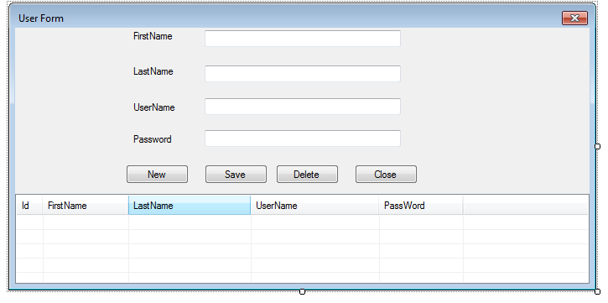
Figure 1 User registration page
This is system users/ registration form which we can register, delete and edit users. The grid view below the registration form is used to display registered users. And when we click on one of the employee lists in the grid view it will be displayed in the registration form so that we can edit and save it. Registering employees is active for the human resource manager. But deleting registered employee is dedicated only for the administrator of the organization.

Employee registration form
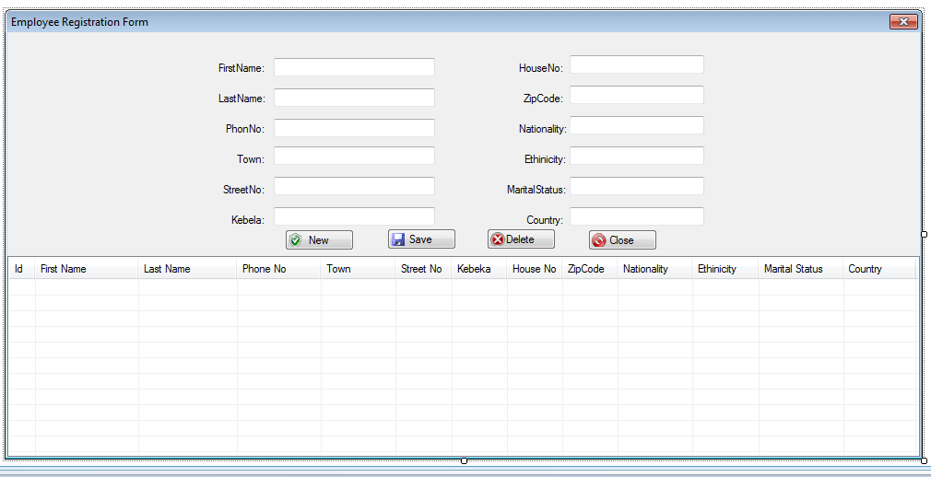
Figure 2 Employee registration form

This is an Employee registration form under which we can register, delete and edit employees. The grid view below the registration form is used to display registered employees. And when we click on one of the employee lists in the grid view it will be displayed in the registration form so that we can edit and save it. Registering employees is active for the human resource manager. But deleting registered employee is dedicated only for the administrator of the organization.
Leave registration form

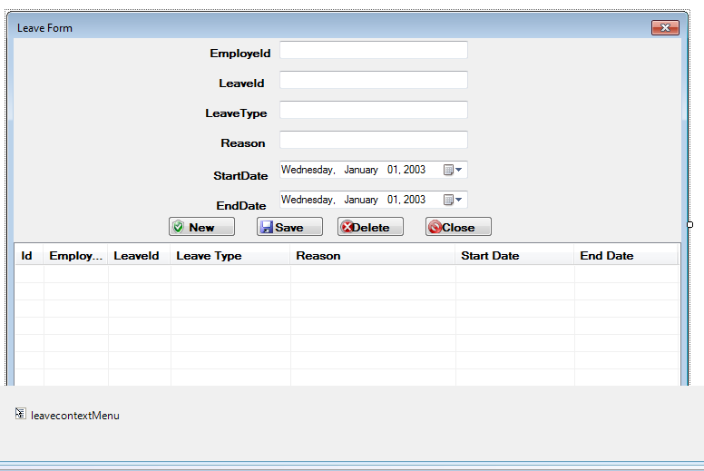
Figure 3 leave registration form
This is a leave registration form under which we can register, delete and edit employees. The grid view below the registration form is used to display registered leaves and the employee who had taken the leave. And when we click one of the lists in the grid view it will be displayed in the leave registration form so that we can edit and save it. This operation is dedicated to the personnel manager only

Salary increment management page
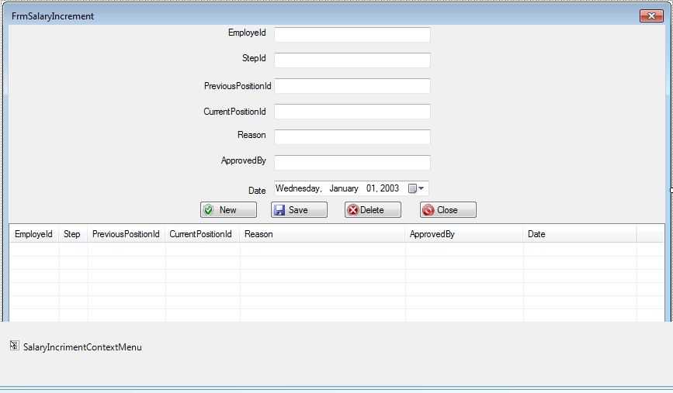
Figure 4 Salary increment management page

This is a salary increment manager page form under which we can register, delete and edit any salary increment on the employee salary. The grid view below the registration form is used to display registered salary increments. And when we click one of the lists in the grid view it will be displayed in the salary increment registration form so that we can edit and save it. This operation is dedicated to the personnel manager only and a copy of it will be sent to the salary cashier.

Termination user interface
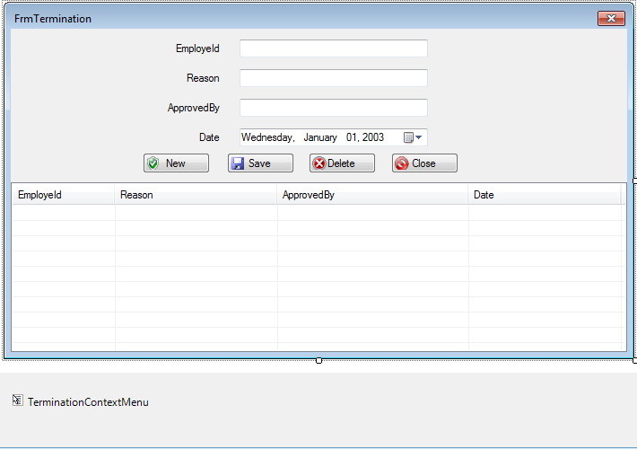
Figure 5 termination of user
This is an employee termination registration form under which we can delete and edit any change on the terminated employee. The grid view below this form is used to display terminated employees. And when we click one of the lists in the grid view it will be displayed in the terminated employee registration form so that we can edit and save any change on the termination information. This operation is allowed only to the administrator. And list of terminated employees will be sent to the department the employee works, the human resource manager, the personnel manager and to the salary cashier.

Leave setting form
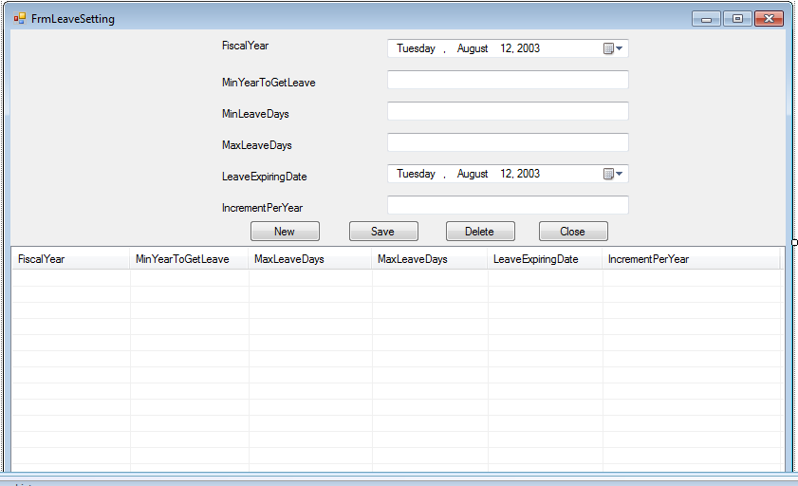
This is the organization leave settings or leaves rules registration form under which we can delete and edit any change on the leave setting or rule. The grid view below this form is used to display list of leave settings. And when we click on one of the lists in the grid view it will be displayed in the leave setting registration form so that we can edit and save any change on the setting. This operation is allowed only to the administrator of the organization.
Organization structure registration form
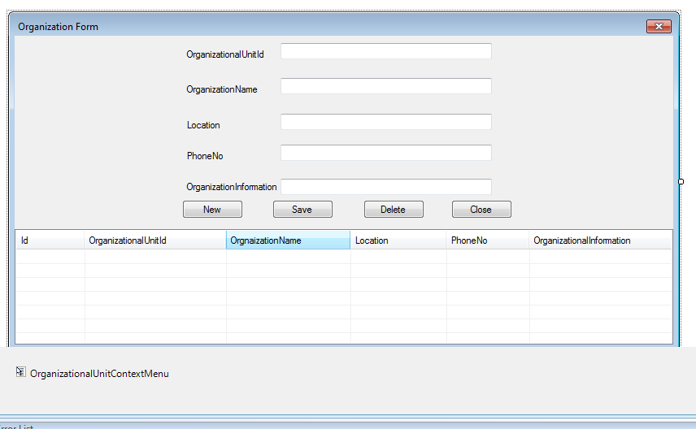
Figure 6 organizational structure registration form
This is the organization structure registration form. Any change on the organization structure will be done/ edited by the organization administrator.

Disciplinary measures registration form
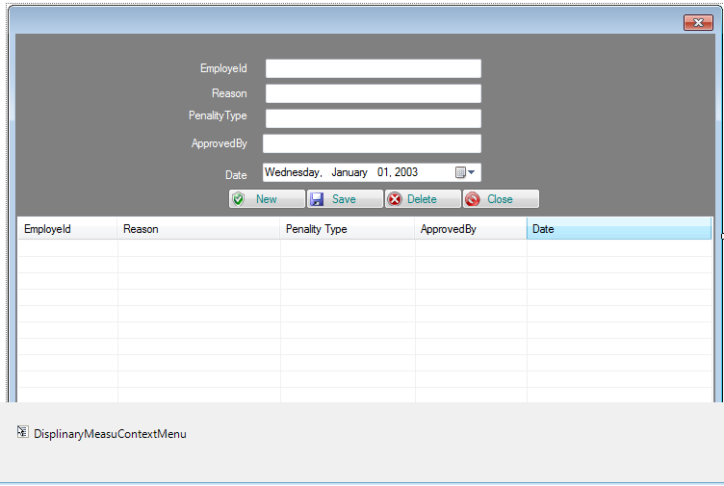
Figure 7 Disciplinary measures registration form
This is the disciplinary measures taken registration form under which we can delete and edit any change on the disciplinary measures. The grid view below this form is used to display list of disciplinary measures. And when we click on one of the lists in the grid view it will be displayed in the disciplinary measures registration form so that we can edit and save any change on the setting. This operation is allowed only to the administrator and the discipline committees of the organization.

Vacancy notices registration form
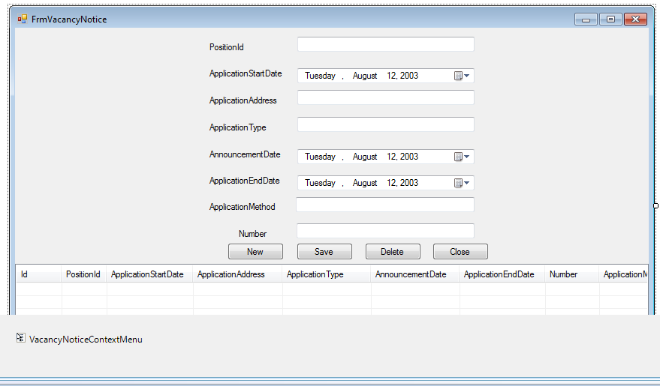
Figure 8 Vacancy notices registration form

This is the Vacancy notices registration form under which we can delete and edit any change on the Vacancy notices. The grid view below this form is used to display list of disciplinary measures. And when we click on one of the lists in the grid view it will be displayed in the Vacancy notices registration form so that we can edit and save any change on the vacancies. This operation is allowed only to the administrator and the human resource manager of the organization.

Report generation form
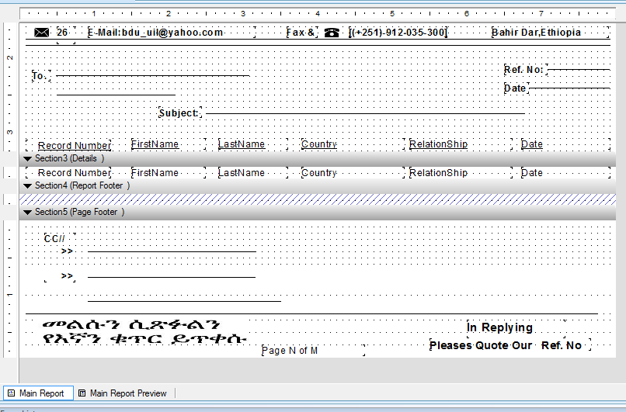
Figure 9 Report generation form
This report generation format is used to generate a report for the following report elements Resignation report
Experience report
Pay check report
Leave report

Hardware Interfaces

Monitor screen – the software shall display information to the user via the monitor screen
Mouse – the software shall interact with the movement of the mouse and the mouse buttons. The mouse shall activate areas for data input, command buttons and select options from menus.
Keyboard – the software shall interact with the keystrokes of the keyboard. The keyboard will input data into the active area of the database.

Software Interfaces
This product will be produced by using a programming language called java. So that JDK and net beans software will be required to complete the production of the system. On the other hand in order to perform the saving, deleting and updating tasks on the database in the system .SQL or oracle software is preferable. After the development of the system, this product will be applicable in any desktop computers, which are connected in the companies LAN system, with any kind of operating system.

Communications Interfaces
The system uses an internet connection to connect to the database. Since the system is a client server based system, there is a need to have a connection among the client computer which is the employee’s computer and the server which is the administrative computer. The system uses a centralized database, which can use different users with different privileges. In order to control concurrent transaction, there need to manage a communication among users .All communication will be done over standard communication protocols.

Analysis Models

Sequence diagram
Figure 10 Sequence diagram for search an employee

This diagram describes actions included in order to search an employee. The personnel managers first initiate/start the HRM system and then he/she enters the id number of an employee that he/she needs to search. The system crosses check with the database if there is an employee with the specified id. Then it will return an error message if the employee is unknown or the required employee’s information.

Figure 11 Sequence diagram for generate report

This sequence diagram implements the actions required to generate report. After initiating the HRM system, the system provides a page containing options to generate a report. The personnel choose among the options that he/she need to generate for the employee. This may be leave report, resign report. The personnel fills information needed to generate report. Finally the system generates the required report and save it in database.

Figure 12Sequence diagram for print report

This sequence diagram is an extension of sequence diagram 2, generate report. This adds some functionality; it includes an option to print out reports generated for an employee. After finalizing the actions listed in the report generation the personnel choose to print out the report from the ‘report page’. The system will print out the required report.

Figure 13 Sequence diagram for record attendance
The ticker initiates the system. Then the ticker enters the id of the employee whom attendance needed to be recorded. The system validates the id of the employee. If the validation is successful the n the system will store the generated attendance report of an employee. The ticker will update the information each day and store it in the system database.

Figure 14Sequence diagram calculate annual leave
This use case is usually initiated by the personnel manager. The personnel enter the id of the employee who needs to calculate the net annual leave. The system validates the id and if the employee exists, the system will display the net annual leave of an employee
Figure 15 Sequence diagram for calculate net salary
This sequence diagram includes actions required to calculate net salary. The use case is initiated by personnel manager. The system validates the id of the employee entered by the personnel. The system calculates the net deduction first and then it will calculate the net salary by subtracting the deduction from the monthly salary.

.

Figure 16Sequence diagram for transfer annual leave
This sequence diagram shows the graphical description of the use case called transfer annual leave, in brief .it tries to explain every steps of the action of transferring the annual leave.
Sequence diagram for delete employee
This diagram shows the sequence of deleting an employee, who is no longer the member of the company, out of the current employee list.

Figure 17Sequence diagram for update employee
This diagram is the graphical description of the use case called update employee and shows the sequence of updating an employee whenever there is change that need to be updated. It shows the interaction or the actions that the user performs with the user interface that is displayed for updating purpose.

Figure 18Sequence diagram for manage allowance
This diagram is the graphical description of the use case called manage allowance and shows the sequence of calculating the allowance of an employee whenever there is a condition that am employee has a chance to be paid an allowance. It shows the interaction or the actions that the user performs with the user interface that is displayed for managing allowance.

Figure 19 Sequence diagram for employee registration

This diagram is the graphical description of the use case called employee registration and shows the sequence of registering a new employee whenever there is a condition that a new employee has a chance to be a member of the company. It shows every step that an employee user performs on the user interface that is displayed for registering an employee.

Data flow diagram
The Data Flow Diagram is commonly used also for the visualization of structured design data processing. The normal flow is represented graphically. We typically draw context level DFD first showing interaction between the system and the outside entities. Then this context level DFD will then be exploded in order to further show the details of system being modeled.
- General entity interaction
Figure 20. General entity interaction

- Level 0 DFD

Figure 21 Level 0 DFD

Figure 22 process employee
Figure 23 DFD of general report and search

Figure 24 DFD record daily attendance

Conclusion
This document included the very most important requirement that we collect from the stakeholders of ANRS council in FDRE (RSD-ANRS). This helps to develop a desktop application for the human resource management system of ANRS council. We define the basic functional ,non functional and external interface requirement as well as the constraint of the system using use case description , sequence diagrams , and data flow diagram, which are further used for the design phase plus the other phases of developing this software.

Glossary
HRMS: Human Resource Management System refers to the systems and processes at the intersection between human resource management (HRM) and information technology.
SQL: stands for Structured Query Language and it are a standard language for accessing and manipulating databases.
LAN: A local area network (LAN) is a computer network that connects computers and devices in an office building.
Java Development Kit (JDK) is a Sun Microsystems product aimed at Java developers. It consists of the Java compiler and related tools which enable users to create applications in Java.

Reference
Books and articles
- Software & Systems Requirements Engineering - In Practice by Brian Berenbach,Daniel J.Paulish,Juergen Kazmeier,Arnold Rudorfer
- A Practical Guide To User Requirements - Catherine C & Kathy B
- Managing Software Requirements, 1St Edition by Addison Wesley , Leffingwell & Widrig
- Writing better requirements by lan F. Alexander Richard Stevens
- Requirement Engineering 3rd edition by Elizabeth Hull , Kin Jackson and Jeremy Dick

Web reference
http://groups.yahoo.com/group/csed4:provided

