Introduction to Digital Signal Processing

What is DSP?
DSP, or Digital Signal Processing, as the term suggests, is the processing of signals by digital means. A signal in this context can mean a number of different things. Historically the origins of signal processing are in electrical engineering, and a signal here means an electrical signal carried by a wire or telephone line, or perhaps by a radio wave. More generally, however, a signal is a stream of information representing anything from stock prices to data from a remote-sensing satellite.

Analog and digital signals
In many cases, the signal is initially in the form of an analog electrical voltage or current, produced for example by a microphone or some other type of transducer. In some situations the data is already in digital form - such as the output from the readout system of a CD (compact disc) player. An analog signal must be converted into digital (i.e. numerical) form before DSP techniques can be applied. An analog electrical voltage signal, for example, can be digitized using an integrated electronic circuit (IC) device called an analog-to-digital converter or ADC. This generates a digital output in the form of a binary number whose value represents the electrical voltage input to the device.

Signal processing
Signals commonly need to be processed in a variety of ways. For example, the output signal from a transducer may well be contaminated with unwanted electrical "noise". The electrodes attached to a patient's chest when an ECG is taken measure tiny electrical voltage changes due to the activity of the heart and other muscles. The signal is often strongly affected by "mains pickup" due to electrical interference from the mains supply. Processing the signal using a filter circuit can remove or at least reduce the unwanted part of the signal. Increasingly nowadays the filtering of signals to improve signal quality or to extract important information is done by DSP techniques rather than by analog electronics.

Development of DSP
The development of digital signal processing dates from the 1960's with the use of mainframe digital computers for number-crunching applications such as the Fast Fourier Transform (FFT), which allows the frequency spectrum of a signal to be computed rapidly. These techniques were not widely used at that time, because suitable computing equipment was available only in universities and other scientific research institutions.

Digital Signal Processors (DSPs)
The introduction of the microprocessor in the late 1970's and early 1980's made it possible for DSP techniques to be used in a much wider range of applications. However, general-purpose microprocessors such as the Intel x86 family are not ideally suited to the numerically-intensive requirements of DSP, and during the 1980's the increasing importance of DSP led several major electronics manufacturers (such as Texas Instruments, Analog Devices and Motorola) to develop Digital Signal Processor chips - specialized microprocessors with architectures designed specifically for the types of operations required in digital signal processing. (Note that the acronym DSP can variously mean Digital Signal Processing, the term used for a wide range of techniques for processing signals digitally, or Digital Signal Processor, a specialized type of microprocessor chip). Like a general-purpose microprocessor, a DSP is a programmable device, with its own native instruction code. DSP chips are capable of carrying out millions of floating point operations per second, and like their better-known general-purpose cousins, faster and more powerful versions are continually being introduced.

Applications of DSP
DSP technology is nowadays commonplace in such devices as mobile phones, multimedia computers, video recorders, CD players, hard disc drive controllers and modems, and will soon replace analog circuitry in TV sets and telephones. An important application of DSP is in signal compression and decompression. In CD systems, for example, the music recorded on the CD is in a compressed form (to increase storage capacity) and must be decompressed for the recorded signal to be reproduced. Signal compression is used in digital cellular phones to allow a greater number of calls to be handled simultaneously within each local "cell". DSP signal compression technology allows people not only to talk to one another by telephone but also to see one another on the screens of their PCs, using small video cameras mounted on the computer monitors, with only a conventional telephone line linking them together.
Although the mathematical theory underlying DSP techniques such as Fast Fourier and Hilbert Transforms, digital filter design and signal compression can be fairly complex, the numerical operations required to implement these techniques are in fact very simple, consisting mainly of operations that could be done on a cheap four-function calculator. The architecture of a DSP chip is designed to carry out such operations incredibly fast, processing up to tens of millions of samples per second, to provide real-time performance: that is, the ability to process a signal "live" as it is sampled and then output the processed signal, for example to a loudspeaker or video display. All of the practical examples of DSP applications mentioned earlier, such as hard disc drives and mobile phones, demand real-time operation.
The major electronics manufacturers have invested heavily in DSP technology. Because they now find application in mass-market products, DSP chips account for a substantial proportion of the world market for electronic devices. Sales amount to billions of dollars annually, and seem likely to continue to increase rapidly.

Introduction to DSP
Most DSP applications deal with analog signals.
- the analog signal has to be converted to digital form
The analog signal - a continuous variable defined with infinite precision - is converted to a discrete sequence of measured values which are represented digitally.
Information is lost in converting from analogue to digital, due to:
- inaccuracies in the measurement
- uncertainty in timing
- limits on the duration of the measurement
These effects are called quantization errors.
The continuous analog signal has to be held before it can be sampled.
Otherwise, the signal would be changing during the measurement.
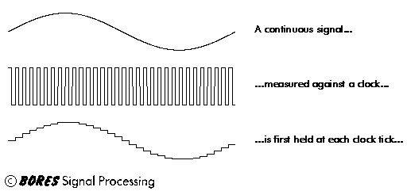
Only after it has been held can the signal be measured, and the measurement converted to a digital value.
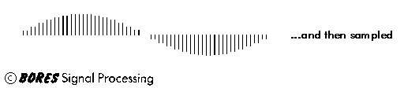
The sampling results in a discrete set of digital numbers that represent measurements of the signal - usually taken at equal intervals of time.
Note that the sampling takes place after the hold. This means that we can sometimes use a slower Analogue to Digital Converter (ADC) than might seem required at first sight. The hold circuit must act fast - fast enough that the signal is not changing during the time the circuit is acquiring the signal value - but the ADC has all the time that the signal is held to make its conversion.
We don't know what we don't measure.
In the process of measuring the signal, some information is lost.
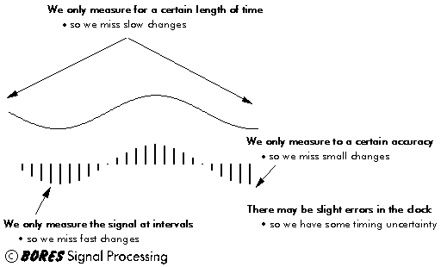
Sometimes we may have some a priori knowledge of the signal, or be able to make some assumptions that will let us reconstruct the lost information.

