**plot - 2-D line plot**

**Syntax**

plot(Y)  
plot(X1,Y1,...,Xn,Yn)  
plot(X1,Y1,LineSpec,...,Xn,Yn,LineSpec)  
plot(X1,Y1,LineSpec,'*PropertyName*',PropertyValue)  
plot(axes_handle,X1,Y1,LineSpec,'*PropertyName*',PropertyValue)  
h = plot(X1,Y1,LineSpec,'*PropertyName*',PropertyValue)

**Description**

plot(Y) plots the columns of Y versus the index of each value when Y is a real number. For complex Y, plot(Y) is equivalent to plot(real(Y),imag(Y)).

plot(X1,Y1,...,Xn,Yn) plots each vector Yn versus vector Xn on the same axes. If one of Yn or Xn is a matrix and the other is a vector, plots the vector versus the matrix row or column with a matching dimension to the vector. If Xn is a scalar and Yn is a vector, plots discrete Yn points vertically at Xn. If Xn or Yn are complex, imaginary components are ignored. If Xn or Yn are matrices, they must be 2-D and the same size, and the columns of Yn are plotted against the columns of Xn. plot automatically chooses colors and line styles in the order specified by [ColorOrder](http://www.mathworks.com/help/techdoc/ref/axes_props.html#ColorOrder) and [LineStyleOrder](http://www.mathworks.com/help/techdoc/ref/axes_props.html#LineStyleOrder) properties of current axes.

plot(X1,Y1,LineSpec,...,Xn,Yn,LineSpec) plots lines defined by the Xn,Yn,LineSpec triplets, where [LineSpec](http://www.mathworks.com/help/techdoc/ref/linespec.html) specifies the line type, marker symbol, and color. You can mix Xn,Yn,LineSpec triplets with Xn,Yn pairs: plot(X1,Y1,X2,Y2,LineSpec,X3,Y3).

plot(X1,Y1,LineSpec,'*PropertyName*',PropertyValue) manipulates plot characteristics by setting [lineseries properties](http://www.mathworks.com/help/techdoc/ref/lineseriesproperties.html) (of lineseries graphics objects created by plot). Enter properties as one or more name and value pairs.

plot(axes_handle,X1,Y1,LineSpec,'*PropertyName*',PropertyValue) plots using axes with the handle axes_handle instead of the current axes ([gca](http://www.mathworks.com/help/techdoc/ref/gca.html)).

h = plot(X1,Y1,LineSpec,'*PropertyName*',PropertyValue) returns a column vector of handles to lineseries objects, one handle per line.

**Examples**

Plot a sine curve:

x = -pi:.1:pi;

y = sin(x);

plot(x,y)

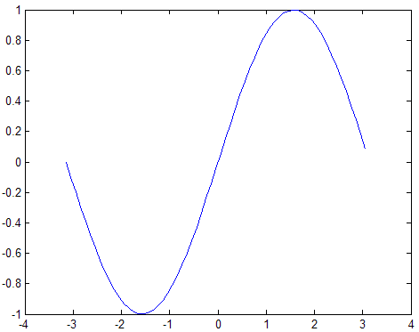

|  |
| --- |
| http://www.mathworks.com/help/techdoc/ref/pixelclear.gif |
|  |

Create line plot using specific line width, marker color, and marker size:

x = -pi:pi/10:pi;

y = tan(sin(x)) - sin(tan(x));

plot(x,y,'--rs','[LineWidth](http://www.mathworks.com/help/techdoc/ref/lineseriesproperties.html#LineWidth)',2,...

'[MarkerEdgeColor](http://www.mathworks.com/help/techdoc/ref/lineseriesproperties.html#MarkerEdgeColor)','k',...

'[MarkerFaceColor](http://www.mathworks.com/help/techdoc/ref/lineseriesproperties.html#MarkerFaceColor)','g',...

'[MarkerSize](http://www.mathworks.com/help/techdoc/ref/lineseriesproperties.html#MarkerSize)',10)

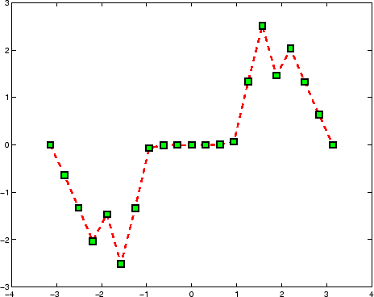

|  |
| --- |
| http://www.mathworks.com/help/techdoc/ref/pixelclear.gif |
|  |

Modify axis tick marks and tick labels:

x = -pi:.1:pi;

y = sin(x);

plot(x,y)

set(gca,'XTick',-pi:pi/2:pi)

set(gca,'XTickLabel',{'-pi','-pi/2','0','pi/2','pi'})

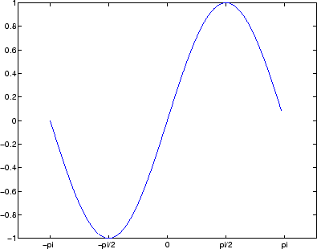

|  |
| --- |
| http://www.mathworks.com/help/techdoc/ref/pixelclear.gif |
|  |

Add a plot title, axis labels, and annotations:

x = -pi:.1:pi;

y = sin(x);

p = plot(x,y)

set(gca,'XTick',-pi:pi/2:pi)

set(gca,'XTickLabel',{'-pi','-pi/2','0','pi/2','pi'})

xlabel('-\pi \leq \Theta \leq \pi')

ylabel('sin(\Theta)')

title('Plot of sin(\Theta)')

% \Theta appears as a Greek symbol (see [String](http://www.mathworks.com/help/techdoc/ref/text_props.html#String))

% Annotate the point (-pi/4, sin(-pi/4))

text(-pi/4,sin(-pi/4),'\leftarrow sin(-\pi\div4)',...

'HorizontalAlignment','left')

% Change the line color to red and

% set the line width to 2 points

set(p,'Color','red','LineWidth',2)

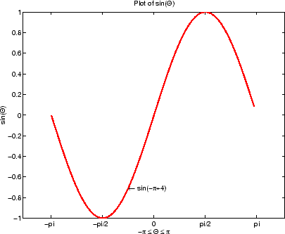

|  |
| --- |
| http://www.mathworks.com/help/techdoc/ref/pixelclear.gif |
|  |

Plot multiple line plots on the same [axes](http://www.mathworks.com/help/techdoc/ref/axes.html):

plot(rand(12,1))

% hold axes and all lineseries properties, such as

% ColorOrder and LineStyleOrder, for the next plot

hold all

plot(randn(12,1))