Creating a Database
Using Access 2003 for Windows 2000/Me/2003

Created: 25 September 2003

Starting Access 2003
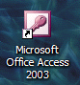

Double click on the Access 2003 icon on the Windows desktop (see right), or click-on the Start button in the lower left corner of the screen, then click-on Programs, and then click-on Microsoft Access.

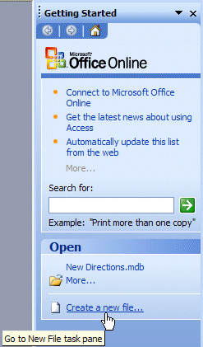

The following Access 2003 Getting Started Task Pane will appear on the right side of your Access 2003 screen.

For Access 97 and 2000 users, the Task Pane is something new in Office XP/2002 and 2003. It is used in all of the Office modules. It replaces many of the Microsoft Menu Screens, Wizards, and Catalogs that were a part of the Office 97 and 2000 screens. Once you get used to the Task Pane, and its flexibility, we think you’ll like it. There are a lot of Task Panes in PowerPoint 2003, FrontPage and Publisher 2003 – because they are so “graphic” in nature. There are few Task Panes in Excel and Access 2003.

In the Open area of the Access 2003 Getting Started Task Pane, click the left mouse button on Create a new file.

Left Mouse Button

In this tutorial, whenever we indicate that you need to click the mouse, it will mean to click the left mouse button – unless we indicate that you should click the right mouse button. So, always “click left” unless we tell you otherwise.

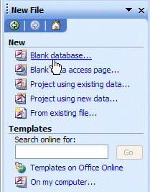

The New File menu screen at the on the right will appear when you click the left mouse button on Create a new file.

Click–on Blank database.

Saving your work

One of the unique things about Access database is that it requires you to save your database as soon as you enter the program.

You can save your work on a floppy diskette in the A: Drive, or on your C: Hard Disk, or in some other drive, please save to these areas and substitute your Drive in the instructions.

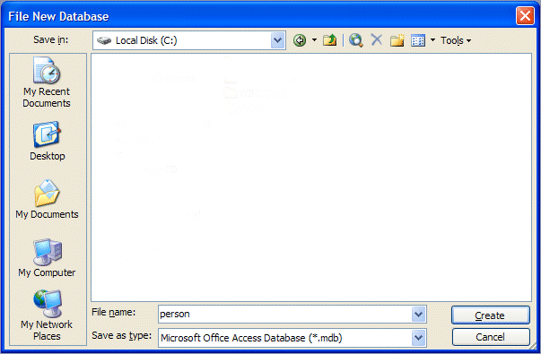
A File New Database menu screen, similar to the one below, will be on your screen. We’ll have to do several “things” to set-up this screen to save your database.

In the upper left corner of the File New Database menu screen that appears, you will see a Save in: area (see upper left arrow above). Click-on the small down arrow on the right and it will show you the various disk drives available on which you can save (see right upper arrow above). Point to the drive on which you want to save your database, and click-on it. If you choose the 3½ Floppy (A:), make sure you have a formatted disk in the A drive. If you choose the C: drive, choose the folder in which you want to save by double clicking on the folder. Your selection should now appear in the Save in: area

Next click-in the area to the right of File Name:. Delete any text that is entered in the area and then type-in the word PERSON as shown at the bottom of the above image (see lower left arrow).

Now click-on the Create button or tap the Enter key as shown on last page (see lower right arrow on last page).

The following person: Database menu screen should now appear.

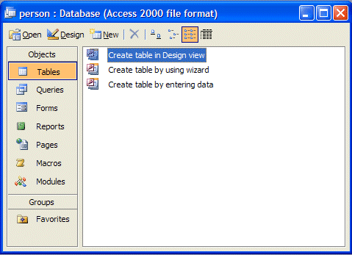

Creating a Table

You will notice, in the person:Database menu screen, in the left border: Tables, Queries, Forms, Reports, Pages, Macros, and Modules. You will notice at the top of the screen: Open, Design and New. You may create multiple Tables (Databases), as well as multiple other items associated with the items in the left border. As you create them, they will be shown in the "white" area. In other words, the PERSON database can be made-up of, or contain, many other databases (tables), reports, queries, etc.

For now, we'll do a basic database (table) creation. Later, you can try Table Wizards when you have the "feel" for creating a table.

To begin designing the database, please click-on the Design “button” at the top of the person: Database menu screen (see arrow on last page).

You should now see a Table1: Table design screen similar to the one below. If the Table: Table1 image does not “fill” the screen, click-on the small square between the “minus and the X” in the upper right hand corner of the screen (see arrow and image on right).

Notice, under the Blue Bar at the top of the design screen that there are (3) things: Field name, Data Type, and Description, and, in the lower half of the window; Field Properties (see arrows in image below).

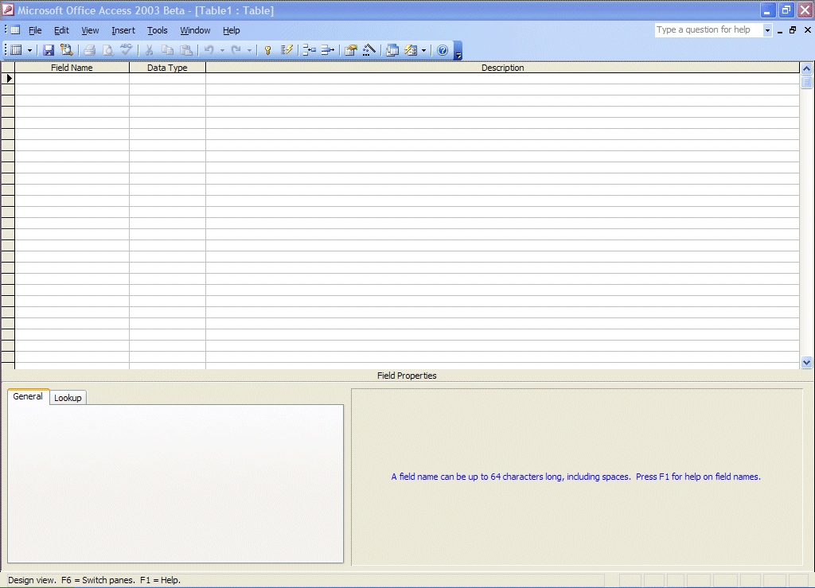

Next you will be creating the fields that make up a database. This is similar to creating a blank personnel form (on paper) that will be "filled-in" for each employee (Name, Address, Phone Number, etc – are called fields in a database). These "forms" are called records in a database. There will be a record, or form, for each employee. All the forms, together, make up a Table (database). So let’s create a personnel database.
Significant Note: When creating a database it is always best to “break down” a field into its “smallest parts.” For example – Name would break down into First Name, and Last Name (you could also have Middle Initial, Title, etc.) Address would break down into Street Address, City, State, and Zip (you could also have Apartment Number, etc). Because we are working in Access 2003 it will be very simple to “put the fields back together” with a few mouse clicks when we need to do this. Trust us. This will save you a lot of time later on.
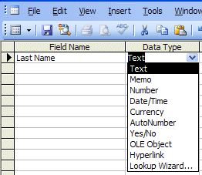

Look at the image on the right. Click-in the area or space under Field Name and type-in Last Name. Tap Enter or click-in the area to the right under Data Type. The cursor now moves to the right under Data Type. Notice, that Text appears as the default (and a box with a down-arrow appears in the right side of the box). Click-on the down arrow. Your design screen should look like the one on the right.

Now we’ll talk about Data Type.

Data Type

Text You may type in any alphabetical/numerical data that you desire - up to a maximum of 255 characters. As indicated, this is a text field, so you can't do mathematical calculations. Examples of Text data are: names, addresses, stock numbers, room numbers, zip codes, etc.

Memo This field is for lots of text. You can have up to 32,000 characters.

Number This field is for numbers where you want to add, subtract, multiply, divide, average, and do numerical calculations. This field can be a very large size, so when we get to Field Properties, we'll talk about "sizing" this field so it doesn't take up to much "space" in storage.

Date/Time Dates and Times. You may format these later, as you may desire.

Currency Dollars ($). You may format these later, as you may desire.

AutoNumber This field is an "automatic" counter that assigns a number each time you put data into a new field.

Yes/No This is a "True/False" or "Yes/No" type of field.

OLE Object This means "Object Link Embedding" which indicates you can insert a graphic, picture, sound, etc. Pretty neat to put a photograph in a personnel record or a picture of an inventory item in the stock record (advanced stuff).
We'll leave Last Name as a Text Data Type. To the right under Description you may make any remarks you feel are appropriate to someone who may want to know how/why you designed the field as you did.

Now notice in the lower part of the screen, under Field Properties, that a box appeared when you selected the Text Data Type. This box is "tailored" to the Text Data Type that you selected above. Your Field Properties should look like the one below when you finish doing the steps indicated below.

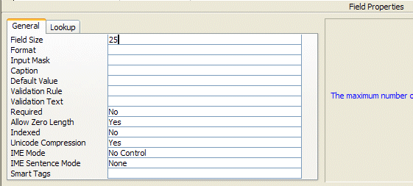

Field Properties

Click-in each area (to the right of the words) as you read about it below

Field Size Is currently set to 50 characters. That's pretty large for a name. So, click-
in this area and change the number to 25 (you can make this larger or smaller later if you have to).

Format Now click-in the Format Area. Next tap the F1 function key to activate Help.

Since you are in the Format area, Help will be "tailored to" this area. When the Help Window appears, click-on Text and Memo Data Types (Notice that you click-on different Data Types, depending on the Data Type you select). This gives you an idea of some formats. We'll use one later. Now click-on the “X” in the upper right corner of the Microsoft Access Help – Format Property Window to close it.

Input Mask We'll come back to this feature later.

Caption Look at the Gray Help area to the right. It explains about Caption.

Default Value We'll come back to this feature later.

Validation Rule We'll come back to this feature later.

Validation Text We'll come back to this feature later.

Required Look at the Gray Help area to the right.

Allow Zero Length Look at the Gray Help area to the right.

Indexed Look at the Gray Help area to the right and tap F1 (Help)

Unicode Compression Look at the Gray Help area to the right.

IME Mode Look at the Gray Help area to the right and tap F1 (Help)

IME Sentence Mode Look at the Gray Help area to the right and tap F1 (Help)

Smart Tags Look at the Gray Help area to the right and tap F1 (Help)

Now we’ll repeat this process and create different Field Names and Data Types (as necessary). Type-in the Field Names as indicated below and set them to the Data Types and Sizes indicated.

Field Name Data Type Size

Last name Text 25 (Already Completed)
First name Text 20
Social Security # Text 15

We'll use an Input Mask for our Social Security Number. Click-in the Input Mask area in the Field Properties area at the bottom of the screen (see left arrow below).

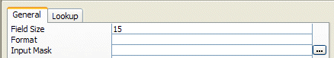

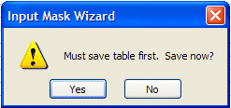
Notice there are three "dots" (...) in a box on the right. Click-on the three dots (see right arrow above). An Input Mask Wizard will appear: "Must Save Table First. Save Now?".

Click-on Yes.

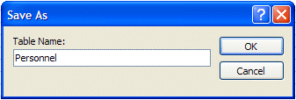
A Save As Window will now appear. We'll save our Table as Personnel, so type-in Personnel in the area under Table Name:, and click-on OK.

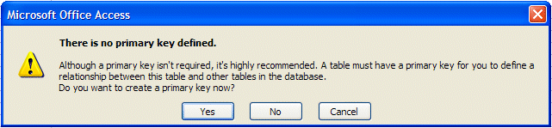
Next, a Microsoft Access menu box will appear indicating There is No Primary Key defined.

Click NO. (Keying, or indexing, is somewhat advanced. You can get a good description by searching in Help for Keying.)

The Input Mask Wizard will show you some Sample Masks (you may scroll up/down to view them). We'll use Social Security Number, so click-on it. Your screen should look like the one below.
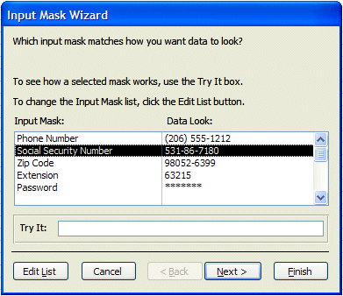

Now click-on Next at the bottom of the Input Mask Wizard screen.

You will now see a default number of 000-00-0000 using dashes (-) between the numbers. You can use anything you want.

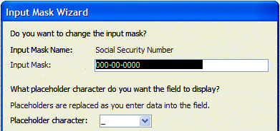

We'll leave it as is, so click-on Next> again (at the bottom of the Input Mask Wizard screen).

On this Input Mask Wizard screen you’ll see two choices. Click-in the little circle to the left of With symbols in the mask, like this:. Sometimes, when we use Access data as a part of mail merges or in labels, if we don’t save the dashes, they won’t appear in our document. So, it always a good idea to save dashes.
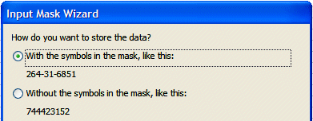

Click-on Next> again.

Now click-on Finish. You will see some “special” numbers written in the Input Mask area for Social Security #. When you begin to enter data in this field, you’ll see how this works. Your Field Properties area should look like the one below.

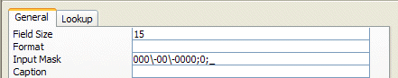

Now continue entering the following information in the Field Name and Data Type areas as we did above.

Street address Text 25
City Text 20
State Text 2

Here we'll use a Format. First make the Field Size 2 then click-in the area to the right of Format.

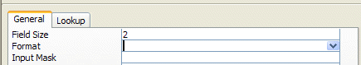

A down pointing arrow, like the one above (see arrow), will appear on the right side of the Format area. If you click-on the arrow, the area will appear blank (that's because we haven't entered a Format). Tap the F1 key in the row of Function Keys at the top of the keyboard. A Help menu screen “tailored” to Format will appear )like the one below).

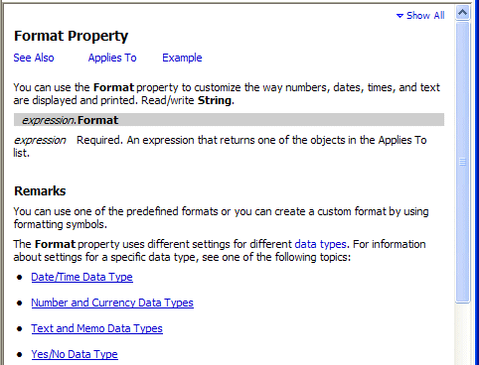

Since we are working with a Text Data Type, click-on Text and Memo Data Types (see arrow above).

Notice that a > will change any alphabetic character you type into all upper case letters. Now point and click the “X” in the upper right hand corner of the Format Help Screen (notice that the Help Window closes "automatically").

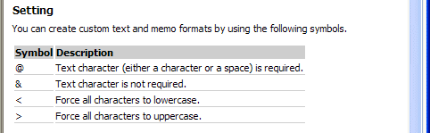

Now type a > in the Format area. Your Field Properties area should look like the one below.

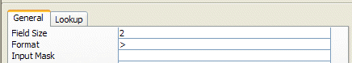

Continue entering the following information in the Field Name and Data Type areas as we did above.

Zip Text 5
Gender Text 1

Insert a > in the Format area to make all gender entries become capitals (like you just did for State).

Favorite Number Number (Note: this is the first Number field)

Here we'll learn about Numbers, the Validation Rule and Validation Text. We'll limit the person's favorite number to a number between 1 and 999. Leave the Field Size set to Long Integer (Tap the F1 Function Key [Help] to view the different Number Field Size descriptions). After you have viewed the Number Help screens, click the small “X” in the upper right hand corner of the Help screen to close the Help screen.

Now click-in the area to the right of Decimal Places. It currently indicates Auto. When you click there you will see a little down arrow on the right side of the area. Click-on the little arrow. Select “0.” This indicates that decimal places are not allowed in the Favorite Number.

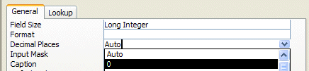

Next, click-in the Validation Rule area. We'll "build" a mathematical expression that will only allow numbers from 1 to 999. Type in the following expression (in the area to the right of Validation Rule):

> 0 and < 1000

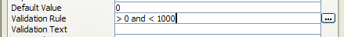

This tells Access that the number entered must be between 1 and 999.

You’ll notice that when you click-in the Validation Rule area that three periods (…) appear just like they did in Input Mask. If you want to click-on the three periods they will bring up an Expression Builder which you can use to create the mathematical formula above. Please note that frequently, if you are really not great at math, the Expression Builder can cause problems. Sometimes, the Expression Builder will “insert” an <<expr>> in the formula. If it does this, delete the <<expr>>. This will confuse Access, and will frequently cause the program to “stop” until you remove <<expr>>. So, if you want to look at Expression Builder, please do so. But – be careful.

If someone does not enter a number correctly, an error message will appear. Now we'll create an appropriate error message. Click-in the Validation Text area and type-in:

Favorite Number must be between 1 and 999.

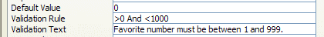

When you finish all of the above, your Field Properties should look like the one below.

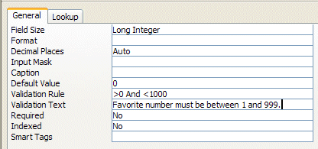

Continue entering the following information in the Field Name and Data Type areas as we did above.

Date hired Date/Time

In Format click-on the small down arrow on the right side of the Format area and choose Short Date. In the Input Mask area click-on the three dots (...), save the table, and again choose Short Date, click Next>, click Next> again, then click Finish. (This will insert a / between the day, month, year).

Your Field Properties should look like the image below.

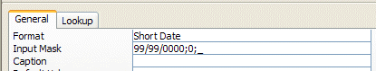

Salary Currency

In the Decimal Places Field Properties area click-on the small down arrow on the right side and select 0 (zero) – this indicates “no cents.” Notice the Default Value of 0 income will be inserted if no Salary figure is entered. We'll leave it at zero. Your Field Properties screen should look like the one below.

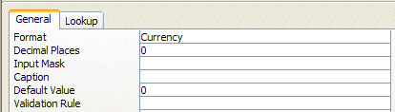

Application Received Yes/No

We’ll make this a “Yes/No” or “check box” field. When we begin entering data in the database, you’ll see how this “box” works.

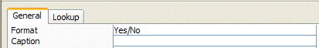

Point to and click on File in the Menu Bar then click on Save As. The Save As Window will appear and Personnel should appear under Table Name: Click-on OK. You could also click-on the small diskette Save Button if you desire.

Entering data in the database

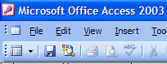
At this point you will still be in the design window. You have two choices. If you look at the Button Bar just below the Menu Bar Area (File, Edit, View, etc.) you will see that the first button on the left that has a small sheet of paper with some data on it (see arrow on the right). Point to this button with the mouse and pause, you will see a "Tool Tip" that indicates that this button is the View Button. This is logical because you have been designing your table and now want to view the data that you have placed in the database (table). If you are familiar with spreadsheets it looks like a tiny version spreadsheet. You can click-on the View Button and go right into entering data in your table. However, it might be good to see how to enter data when we first open Access.

So, point and click-on File in the Menu Bar, then click-on Close. You will return to the main database window where we started (PERSON: Database).

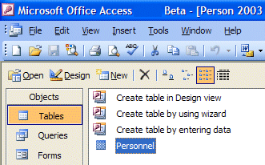
You should see the Tables choice highlighted and Personnel Table highlighted. Notice that there are three Buttons at the top portion of the window which indicate: Open, Design, New. If you click-on New you can add another table to the Person database. If you click-on the Personnel Table (make sure that it is “blue”) and then click-on Open you will open the table you created. You can now enter data. If you click-on Design, you will be back in the design window and can alter your design. Note: if you find, as you’re entering data, that if you made a field too small, you can go to Design View and make the field a larger width at any time you desire.
So let's click-on Open. The Personnel Table will appear on the screen. If the window does not fill the screen, point to the Expansion “square” in the upper-right corner directly to the right of Personnel: Table in the blue bar. This will expand your Table to fill the desktop.

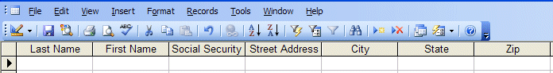

Move the cursor arrow over the buttons below menu bar. As you do, notice that the "Tool Tips" will tell you what each button does.

Notice, below the Button Bar, that the fields you created in your Personnel Table are displayed in what is called Datasheet View (see above). Notice the small “button” under File in the menu bar. It shows a small blue triangle, pencil, and a ruler (like the one on the right). This is a “toggle” which will take you back to Design View - if you need to make design changes while you are in Datasheet view. If you go back to Design View, you can then “toggle” back to Datasheet view when you have made your corrections. Under Last Name you will see a flashing cursor; this means that you are ready to begin entering data. You may type the data and tap Enter, or click with the mouse in each field. If you make a mistake you may retype the data. If you see a mistake later you can come back at any time and correct it.

Under each field, type the following in the area below the Field Name:

Field Name To be typed

1. Last Name Butler
2. First Name Greg
3. Social Security # 123-45-6789
4. Street address 100 Main Street
5. City Lynchburg
6. State va
7. Zip 24501
8. Gender m or f (your choice)
9. Favorite Number 2003
10. Date Hired 7/01/1993
11. Salary 40000
12. Application Received Point the mouse to the little square and click the left mouse button. You will see a check mark appear in the square. A click in the square indicates that the application has been received. If you do not click, then that will mean the application has not been received.

As you are entering this data you will notice several things.

Social Security Number and Date Hired – You’ll “see” your Input Mask work.

State and Gender – you typed in small letters – notice how the Format ( > ) forced the letter(s) to be capitals.

Favorite Number – since the Favorite Number is “too big” you will see your error message appear. Click-on OK in the message screen and then create a Favorite number that will work.

Salary - notice how your Currency formatting created a $, commas and periods.

When you have completed typing the information, tap Enter so the cursor will move down to the next record. You are now ready to insert your second entry.

Note: When you tapped Enter, Access automatically saved your first record. This can be confirmed by the display of the hourglass.

Also note: As you began typing your first record a small pencil appeared in the left margin. This indicates that you are "writing to" this record (editing). Below the pencil an * (asterisk) also appeared. This indicates that your next record will go below the first.

There are (2) methods for entering data into the database:

1. The method you just used is called Datasheet View method.

or

2. You can use the Form View method (we’ll create a Form in a bit later in the tutorial).

Exiting and Saving

Note: Anytime you want to take a break and exit Access, simply point to File in the Menu Bar, and click-on Exit. If it asks Do you want to save?, click-on Yes. If it gives you a save file screen, give it a name of your choice and click on OK. You should then exit to the Windows Screen with no problems. Since you have already named everything for this exercise, you should not have to name any files as you exit.

Opening Access Database

If you decide to Exit Access 2003, and then return to continue the tutorial, refer to the instructions at the beginning of this tutorial (Page 1).

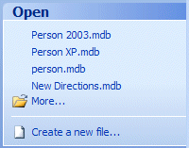
A neat thing about Access 2003 is the Task Pane on the right side of the screen. We used the Task Pane at the beginning of the tutorial (Page 1) to create a new database. Once you have created a database, you will see your database in the Open portion of the Task Pane (see arrow and image to the right). You can simply click-on the file, in this tutorial Person, and it will open.

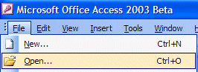

Or, you can open the database the way you open many files. When Access 2003 opens, click-on File in the Menu Bar, and click-on Open.

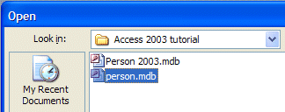
When the Open menu screen appears, click-on the small down arrow to the right of the Look in area and choose the drive on which you saved your database (A: 3 ½ Floppy or your C: Hard Disk Drive). Then click-on the name of your database (e.g. person.mdb) and then click Open (at the bottom of the menu screen).

Now follow the instructions at the bottom of Page 14 to open your personnel table and to continue entering data.

You are now ready to continue entering the data.

Form View and Datasheet View

In the Button Bar (just below the Menu Bar, to the right of Help, is a button with a lightening bolt and a small form. This is the New Object: AutoForm Button. Point to it - make sure you have the correct button - then click-on it (see image below). A New Data Entry Form will automatically be created and appear.
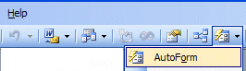

New Object: AutoForm

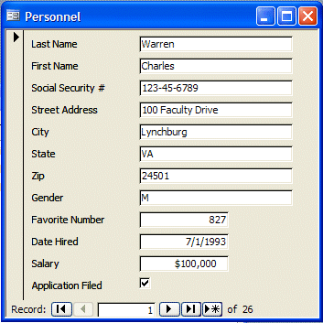

The Personnel Form should look something like the one on the left.

Since you are in the Personnel Table, the form will “automatically” be created, just like the Personnel Datasheet. You will now see a data entry form window. If the form does not fill the screen, click-on the expansion square (see arrow above) to increase the size. Notice your first record appears.

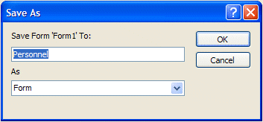
You may enter data in Form View the same as in Datasheet View. To save this form click-on File in the Menu Bar, then on Save As. The Save As screen will appear with Personnel already in the Save Form ‘Form1 To: area (see image to the left). Click-on OK.
The data entry form is now saved as Personnel, just like the Table. Notice, at the bottom of the Form screen, that there is a status area (see below) that tells you what record you are on. You can use the arrows to “move” from one record to another, or select a new record in which to enter data. Click-on each of the arrows to see how they work. Some will take you forward are back to the next or previous record, and some will take you to the beginning or end of your records. The arrow with an asterisk will take you to a new blank record. Enter a few records to see how the Form View works.

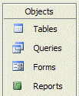

When you first “open” your Person Database, you may choose your favorite screen to enter data: The data Form or Datasheet. Click-on either the Tables selection or Forms selection on the left of the window. Then, click-on Personnel, and then click Open to begin entering data in your choice. You can switch back and forth from the Datasheet entry to the Form entry by clicking on Window in the Menu Bar.

At the lower left corner of the menu screen, you will see some text that indicates that you are either using Form or Datasheet View to enter your data.

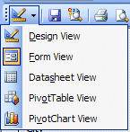
This text indicates that you are currently in Form View (or Datasheet View) using the Personnel database. You can “shift” back and forth between Datasheet View and form View by using the View button in the upper left corner of the Access screen.

The View button on the right indicates what “view” you are using: Design View, Form View, or Datasheet View. You can move back-and-forth between views by clicking-on the down triangle to the right of the button (see arrow and image to the right) and then choosing either Form or Datasheet to enter your data.

Note: When you are finished entering data and preparing to exit Microsoft Access, or Close the form, if you did not save before exiting, the program will ask if you want to Save the Form. This is up to you. You may save it with your choice of names and it will then show-up as a form when the Person Database Main Window appears. Or, you can indicate No, and re-create the form again with the Wizard.

Important

To record enough information so that you can see what a database does enter 24 or more records now. You may use either Form View or Datasheet View.
Querying the Database

This is what a database is designed for: finding specific information about some of the data in the table(s) very quickly. A query is a search for general or specific data in a field or fields in your database (e.g. the first and last names and birth dates of all employees, just the Jones’s, the people from CA, salaries > $10,000, etc.). In order to do this, we need to click on the fields we want to query. So, let’s start by finding just Last Names in our table.

If you are not in the Database: PERSON screen which shows the Tables, Queries, etc., go there by clicking-on Window in the Menu Bar and then on PERSON: Database. Also, if you have the Personnel Datasheet or Personnel Form open (to add data), close them before you begin your queries. The Access program sometimes becomes logically confused when you try to do queries when it “thinks” you also want to add data. You may see “error” messages if you leave the Form or Datasheet open.
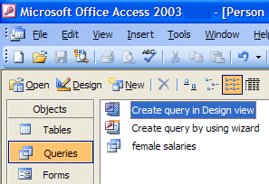

Notice, at the left of the Person: Database screen there is a selection that indicates Queries. Click-on it. Since we have not done a query before, double-click quickly on Create query in Design view or click-on Create a query in Design view and then click-on the Design button.

Two new windows will now appear: Query 1: Select Query and Show Table. You will first have to select the table(s) you desire to query. The Show Table screen should look like the one below.

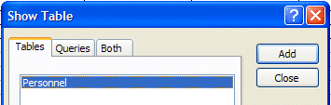

Click Add First

Then click Close

Make sure the blue highlights are on Show Table and Personnel. Click-on Add (we'll talk about Wizards later).

Then click-on Close.

The Show Table window will disappear, and the Query 1: Select Query window, behind the Show Table window, will appear by itself.

Click-on the expansion square in the upper right corner
to enlarge the Query 1: Select Query window.

Your screen should now look similar to the one below.

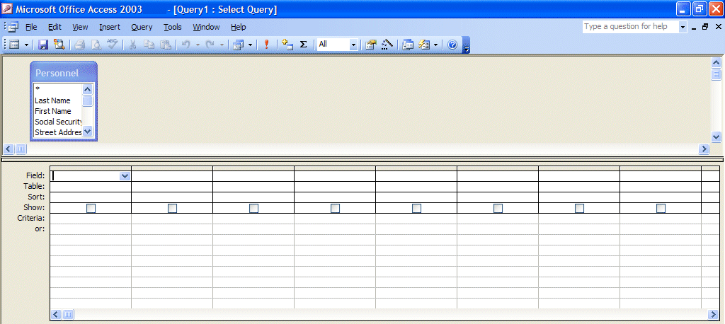
These areas are magnified below

Notice, in the upper half of the window, a small box on the left indicates: Personnel. At the top is an asterisk (* ) and below, in an elevator box, are the fields from the Personnel Table (you can move up-and-down the list as you desire).

What we need to do next is place the Fields we want to query in the lower area of the screen. Notice the lower area on the left border. The first row indicates Field:, followed by Table, Sort:, Show:, Criteria:, and or:.

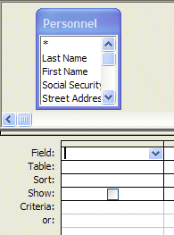
In the lower half of the screen click-in the first cell to the right of Field:. We'll start with a query on Last Name, State, Favorite Number and Salary. Now click-on the down arrow and then click-on Last Name. Notice how Last Name now appears to the right of Field: and a (check) is seen in the Show: cell (The means that you will see Last Names in your query.). Notice also that, to the right of Table:, that Personnel (the Table from which we queried) is showing.
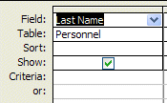

Your query screen should now look like the one on the right.

Now move to the next Field cell on the right and, using the down arrow click-on State. In the next two fields to the right, insert Favorite Number and Salary. Your Query1: Select Query screen should look like this:

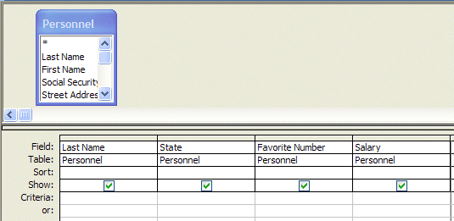

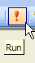
Now, look in the Button Bar at the top of the screen. In the middle of the bar you will see an exclamation mark ( ! ) like the one on the right. If you move the cursor over it, the help text box will indicate "Run." Click-on the ( ! ). This click executes your query.

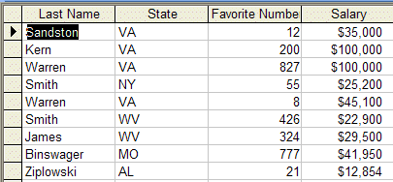
Your query screen should look similar to the one on the left.

Notice, the screen ONLY shows the four fields that you queried.

You can add or remove fields, as you desire. To do this we need to return to the Design View where we created this query. To return to Design View click-on the small button in the upper left corner of the screen that has the blue triangle, pencil, and ruler (like the one on the right). Then, simply click-in the Field area and select a new field and it will replace the old one. Or, click-on the field you want to remove and tap the Delete key. Sometimes you may have a lot of fields and it will be too large for a single sheet of paper.
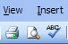
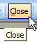
To see how your query would look, if you print it, click on the button that has a piece of paper and magnifying glass (Print Preview - like the one to the left). While you’re in the Print Preview you’ll see a little magnifying glass that you can move over your query. If you click the left mouse button once the magnifying glass will “zoom” in and enlarge the view. If you click the left mouse button again it will zoom out. To return to your query, click-on the Close button just above the print preview piece of paper. This will take you back to the Normal View of your query.

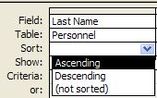
Sorting the Database

If you are not in the Query Design Screen, you’ll need to be in that view. So, go to the Design Screen. Notice that the third row, in the lower half of the screen, indicates Sort: (like the image at the right). Click-in the Sort: area under Last Name. A down arrow box appears; click-on the down arrow. Let's sort the Last Names in Ascending order. Click-on Ascending. Notice that Ascending now appears in the Sort: area. Click-on the ( ! ) to see the new query. Notice that the names you entered are alphabetized. Click-on the Design View button (triangle-ruler-pencil). Now change the Ascending under Last Name to (not sorted). On your own, try sorting some of the other fields. When you are finished remember to set the fields to (not sorted) unless you do want to sort on those fields.

You may also sort various fields in your database whenever you are in the Datasheet View, whether you are viewing the entire Table, or a Query from the Table. Notice that the Field Names are shown at the top of each column in gray cells.

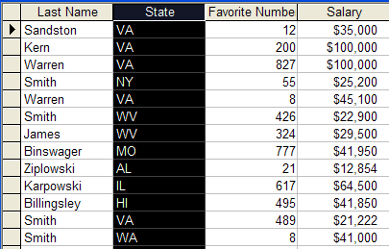

If you click-on one of the gray area field names (like State), the entire column (Field) turns “black” (like the image above). This indicates that you have “marked” the entire column (Field).
In the button bar that appears, when you are editing the Datasheet View, you will see two buttons with “down” arrows (like the image on the right). When you move the cursor over these two buttons a text help box will indicate: Sort Ascending or Sort Descending. If you click-on one of the buttons, the Field which you selected (highlighted) will be sorted in the order selected. Give this a try and see how it works.

So, there are several “ways” you can sort your Tables and Queries.

Specific Queries

So far we have listed everything under each Field Name that we selected. However, many times you will probably want to find something specific in your Table (database - e.g. people from a certain state or city, people whose favorite number is 7 or salaries between $ 20,000 and $ 50,000). This is fairly common sense, but it can get tricky.

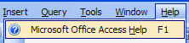
To get an idea of various criteria, you might want to use, click-on Help in the menu bar. Then, click-on Microsoft Office Access Help.

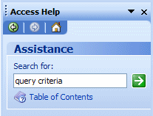
The Access Help Task Pane will appear on the right side of your screen. When your screen appears, click-in the Search for: area in the Assistance portion of the Task Pane. Type-in “query criteria.” Then click-on the Green Arrow to the right of the Search for: box. Your screen should look similar to the one on the right.

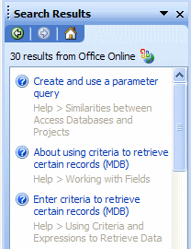

A Search Results Task Pane will now appear on the right side of your screen (like the one on the right).

Click-on the Enter criteria to retrieve certain records (MDB).

A Microsoft Office Access Help Menu Screen will appear similar to the one at the top of the next page.

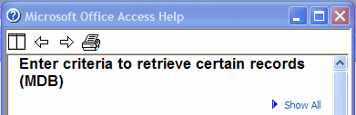
When the Microsoft Access Help screen for Enter criteria to retrieve certain records (MDB) appears, use the elevator bar on the right side of the screen to move to the bottom of the screen.

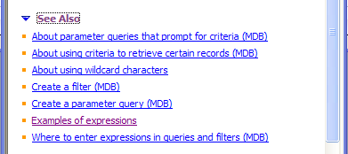
When you get to the bottom of the screen, click-on See Also.

A number of bulleted choices will appear. Click-on Examples of expressions

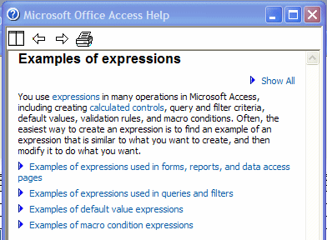

When the Examples of expressions screen appears, click-on Examples of expressions used in queries and filters.

Your screen will “expand” to a reveal a number of additional choices (see image at top of next page)

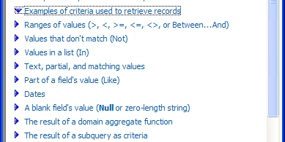
One of the new choices will be Examples of criteria to retrieve records. Click-on this selection. Your screen will expand some more, like the image on the left.

We’ll be using several of these choices in a few minutes. If you would like to see what some of the choices “do,” click on them.

Choices that we use a lot are:

- Ranges of values
- Text, partial , and matching values
- Dates
- A blank field’s value.

When you are finished, click-on the “X” in the upper right corner of the Microsoft Access Help Topics menu screen to close the screen.

Also, click-on the “X” in the right hand corner of the Search Results Task Pane.

You may return and explore more of these help screens as you become more accomplished with Access 2003 database. These help screens are like having a complete Access 2003 manual on your computer.

Now we'll try a few specific queries. First let's find a specific state.

You should now be back in the Query1: Select Query menu Design window. It should look like the one at the top of the next page. If you’re not then click the Design button in the upper left corner of the screen (like the one on the right).

Click-in the cell to the right of Criteria: in the State column. You will see a flashing cursor (Make sure you are in the State column.). Type-in the abbreviation for one of the states you entered in your Personnel Table. Your Query should look like the image below.

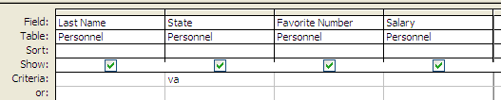

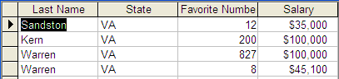
Now click-on ( ! ). A new query window will appear. Only persons from the state you selected should show.

This is a SPECIFIC query for that state.
Click-on Design View Button (triangle-ruler-pencil) to return to Design View. Now delete the state you entered.

Now we'll look for Favorite Numbers larger than 600. Type-in >600 in the Criteria cell under the Favorite Number Column. Click-on ( ! ). Everyone with a favorite number larger than 600 should show. If no one is indicated you don't have a person with a number larger than 600, or you might have typed the >600 incorrectly. Return to the Design View. Delete the >600 and run the query with no criteria. You should “see” all the fields again. Return to the Design View again.

Make sure all the Criteria: cells are empty.

Next we'll look for persons with salaries equal to or larger than $ 20,000 and equal to or less than $ 50,000. In the Salary field column, in the Criteria: cell type-in:

>= 20000 and <= 50000

Click-on the ( ! ). You should now see a specific query that indicates those persons in the range we chose. Go back to Design View. Delete the criteria you entered under Salary. Now, on your own, if you desire, add or delete some fields to your query and experiment. Don't get frustrated if no specific items appear. Frequently you might query for something that can't exist (e.g. states of VA and CA – a person can't be from both states at the same time) or there just isn't anything that matches. For fun, notice the or: just below Criteria to the left of the Design View. Try one state in the Criteria: cell under State and another in the or: cell. When you have a good feel for queries you’re ready to end your query session. First, click-on File in the Menu Bar, and then click-on Close. A Microsoft Office Access Window will appear and ask: "Do you want to save changes to the design of query 'Query1'?”

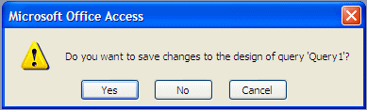

Click-on Yes and a Save As window will appear. Name the Query anything you like, we’re going to name our query “Test Query 2003.” Click-on OK. When the Query1: Select Query view closes you will return to the person: Database screen. Notice that the Query Selection is active and your new query is available to use again, as you desire. You can activate this query and change things just like you did in the tutorial. If you want a printout of your query (at anytime), simply click-on the Printer Button in the button bar or on File in the Menu Bar and Print.

Reports

Reports can be very complex. In this tutorial we'll learn the basics. A good manual or some knowledgeable assistance will be essential to mastering reports.

There are several types of reports. We'll use the Wizards to design some.

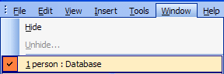
If you are not in the Person: Database main window screen with the Table, Queries, Forms, Reports, etc., click-on Window in the Menu Bar and then on Person: Database at the bottom of the menu. Also, make sure that you have closed any Tables, Forms, or Queries on which you are working.
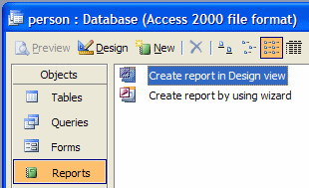

In the Person: Database widow click-on the Reports button. Then, click-on the New Button. See the arrows on the image at the right.

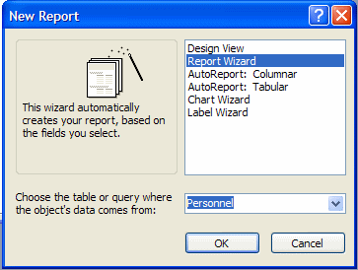

The following New Report menu window will appear.

First, click-on Report Wizard in the New Report menu screen. Then, in the area to the right of: Choose the table or query where the object’s data comes from:, click-on the down arrow and select Personnel. Then click-on OK.

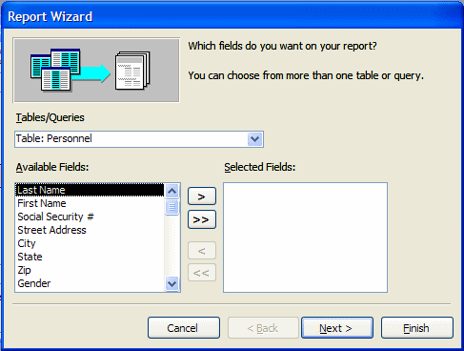

The following Report Wizard Menu screen should appear:

Read all the information in the Report Wizard screen. Only the fields you select from your table will show-in the report. To bring fields into the report individually you click-on the name of the field (in the list of fields in the area under Available Fields:) and then click-on the >. The order which you click-on the fields will be their order in the report. The >> brings over all of the fields. The < brings back one of the fields which you have selected and << brings back all of the fields. If you make a mistake, or want to start over, click the << selection to bring back all of the fields and try again.

So let's begin. Click-on First Name, then click-on > (notice how the First Name field went from the Available Fields: to Selected Fields:). Now do the same with the Last Name, State, Gender and Salary fields. These are the fields that will appear in our first report.

Your Report Wizard screen should look like the one below.

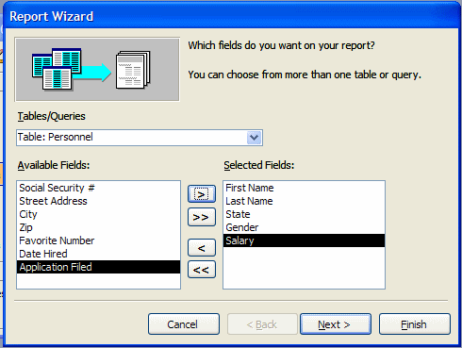

If it does, click-on the Next> Button.

Grouping in Reports

This Report Wizard menu screen asks if you want to add Grouping. Grouping simply “groups” records by an item in the report you are designing. We’ll group by state. This means that “records” from a state will be in a “group” (e.g. people from Virginia will be in one group, the folks from Washington in another, and so on). This will be easy to see when we look at the report. So, click-on State, then click-on >. If you make a mistake, no problem, just use the <. Your screen should now look like the one below.

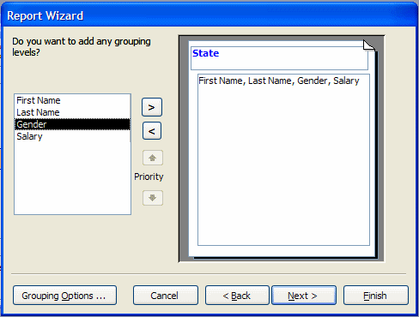

Click-on Next> again. Another Report Wizard menu screen will follow.

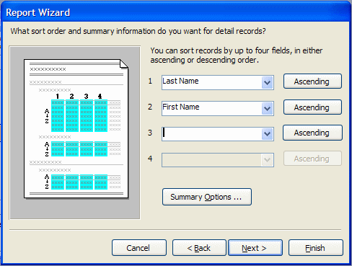

First, the above screen requests that you indicate a Sort Order. This simply means that within each “group, the alphabetic order in which you want the fields sorted. We’ll sort by Last Name and then First Name. This way you’ll have the names, grouped by state, in Last Name order and, where you have several people with the same Last Name, they’ll be sub-sorted in First Name order. Notice the Ascending button to the right of the Sort box. This indicates that the Field that you select is in A to Z or ascending order. If you click-on this button, it will reverse the order from Z to A, or descending order. So, click-on the small down arrow to the right of the first box and select Last Name. Leave the order as Ascending. Now, select First Name in the second box. When you are finished, your Report Wizard menu screen should look like the one above.

Notice a Summary Options button below the sort fields you have selected. Access 2003 is “really smart.” Whenever you see the Summary Options box it is because Access 2003 knows that you selected a number field for your report. The Summary Options box ONLY appears when a number field is selected! Click-on the Summary Options… button.

The Summary Options menu box allows you to enter calculations for numerical and currency fields if you have selected any. It will summarize these calculations by each group, and in total. So, since Salary is a currency field, we can obtain calculations. Click-in the boxes under Sum and Avg; this will furnish these calculations, as you will see in the report. If you want percentages as well, click-in the box next to Calculate percent of total for sums.

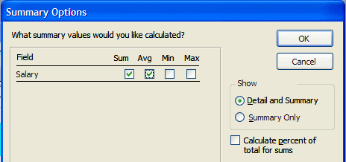

Click-on OK. This will return you to the previous Wizard screen. Click-on Next> again.

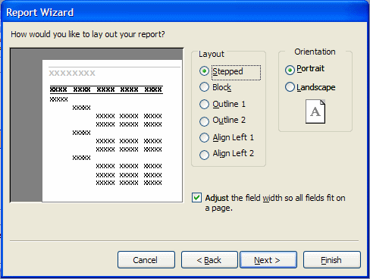

This Report Wizard screen allows you to select a layout for your report. Click-in the small circles to the left of each choice in the layout area and observe the results. For the moment, we’ll stay with the default: Stepped. So click-again it that circle. Leave the report in Portrait Orientation.

Note: At the bottom of the last Report Wizard menu screen there is a check in the small box to the left of Adjust the field width so all fields fit on a page. This is a very important check. This means that no matter how many fields you place in your report, they will all fit on one page. With a few fields in the report, this is no big deal. However, if you have a lot of fields, they will be all “scrunched” up and you’ll notice that sometimes the Field Names and data for these fields are “cut-off” a bit. As mentioned at the beginning of the Reports section of the tutorial, this is where an advanced course or manual are almost essential.

Click-on Next> again.

The next Report Wizard will appear.

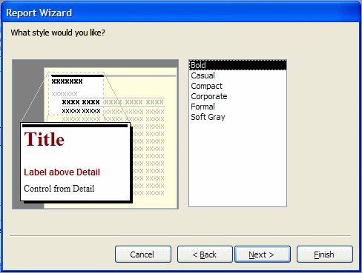

This menu screen allows you to select the Style that you would like for your report. Click-on the choices (Bold, Casual, etc.) and see what each “looks like”. Choose whichever style you desire and click-on Next> again.

The next Report Wizard screen is the last screen in the sequence. It allows you to select a title different from the name of your database - if you so choose. Note that the small circle in front of Preview the Report is “dotted”. When we click-on the Finish button Access 2003 will go to a preview copy of your report. We’ll title this report State Report. Use this name, or any name you desire, and click-on Finish.

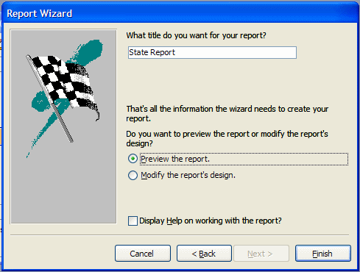

This is a report in Tabular (Columnar) format. Your screen should look something like the one below.

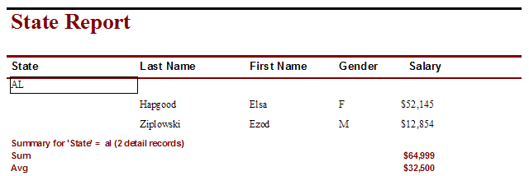

Notice in the lower left corner of the report screen that you are on Page 1 of the report.

Notice the “triangle arrow” buttons to the left and right of Page 1. These take you to the first page of the report, the previous page, the next page, and the last page. Try clicking-on them.

Notice that your cursor – in this Preview Report screen is a magnifying glass. This shows you how a page of your report will appear when you print it. Each time you click the magnifying glass you will “zoom in” or “zoom out” making your report appear larger or smaller. You will zoom to the “place” where you place your magnifying glass – just like if you were using a real magnifying glass and a real piece of paper. You’ll magnify the place where you are “holding” the magnifying glass. So, give this a try.

Notice, in the upper-left corner a button that has a small triangle, ruler and pencil. Click-on it. This takes you to Design View. This time, however, the Design View is for Reports instead of Tables or Queries. This is where the Wizard created the Tabular report design. Click-on the Design View button. Look at this screen for a few minutes – it should look similar to the image below.

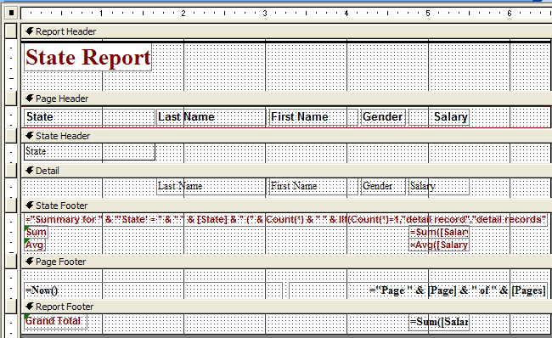

We’ll explain about what you see on the image above on the next page.
First: The Button Bar. Run the cursor arrow over the buttons to get an idea of each
button function. Just like queries, we'll be going back and forth between Design
(triangle-pencil-ruler) and Print Preview (magnifying glass).

Second: Notice, to the left, in the gray part of the screen, it indicates: Report Header, Page Header, State Header, Detail, State Footer, Page Footer and Report Footer (see arrows on the last page).

Report Header: If something shows here, it will only be shown on the first page of the report.

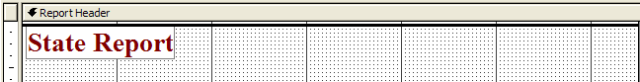

Page Header: If something shows here, it will show on each page of the report at the top of each column.

State Header This “sets-off” the State Grouping.

State Footer This “ends” the State Grouping.

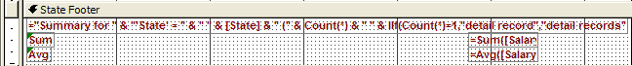

Detail: These are the field names from our database. Access will “pull” the data for the individual fields from our database records.

These are the database fields themselves. The fields print each time there is a person in the database. This field information is drawn from the database. As you enter more people in the database and run the report again, more people will be shown. The "size" of the box you see on the screen was created when we created the field sizes.

Page Footer: This is what shows at the bottom of each page.

Report Footer: This is what shows only on the last page of the report.

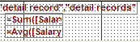

Also note, the lower right corners of the State
and Report Footer area boxes indicate:

= SUM([Salary]). This is a calculation box the Wizard created. This is what gave you the calculations for your average and the sum of the salaries in the State area and the grand total of all salaries in the Footer area.

Save Report

Let's save this report.

You can either click-on File (in the Menu Bar) and then Save, or Save As, or click-on the small diskette button in the button bar. A menu window will open which says Save As.

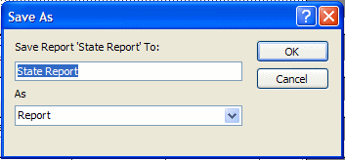

In the area under Save Report ‘State Report’ To: type-in State Report then click-on OK. Now click-on the File in the Menu Bar and then click-on Close. You could also click-on the “lower X” in the upper right corner of the screen. Be careful here. The lower “X” closes whatever you are working on (report, query table, etc.). The upper “X” closes the Access 2003 database.

You should now return to the main Access 2003 Person: Database screen. The Person: Database window should appear on the screen. If it does not, then click-on File, then Open Database. When the Open Database Window appears, click-on Person.mdb in the File Name area, then click-on OK. In the person: Database window click-on the Report area. A report named State Report will be there. Click-on it, then click on the Design button. You are now in your report design screen. Close this report again as you did previously.

Some more New Reports:

Now we'll create some other reports. This is similar, in process, to the report you just completed. In the person: Database window – make sure you have clicked-in the Reports area - click-on the New button. When the New Report Window appears, click on “down triangle” in the area to the right of Choose the table or query where the object’s data comes from:, then click-on Personnel.

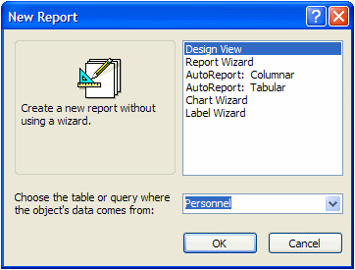

Now click-on some of the different Wizard’s choices. Try Auto Report: Columnar and Tabular, or go back to the Design Wizard again. Experiment with the different types.

As you create reports you may save or not save, as you desire.

Reports can become very complex, very quickly. This is only an introductory tutorial, which furnishes a simple guide to report design. You might want to purchase a book on Access or try a separate tutorial on reports. Our favorite book is Microsoft Access 2003 – Inside Out from Microsoft Press

Now File, Exit.

Now that you have the basics, you might want to try some things on your own. Try using the Wizards in Table, Query and Reports.

We'll, that about does it for now. If you have comments on this tutorial, simply send e-mail to the Internet address below.

Microsoft Office Tutorials

In addition to this tutorial, other Office tutorials are available at:

http://www.officetutorials.com

This site is updated frequently with tutorial revisions as well as tutorials from a number of collegiate institutions. Please feel free to visit and down load as you desire.

This has been an introduction into the basics of Access 2003. If you have any questions about Access 2003, or comments on this tutorial, please contact:

murray.t@lynchburg.edu

Thank you for your patience and good luck.

