Creating a Database
Using Microsoft Access 97 for Windows 95

Revised: 11 March 1999

Starting Access Database

Put a formatted disk in the A: drive.

Double click on the Microsoft Access 97 icon in the Windows 95 home screen, or click-on Start in the lower left corner of the screen, and then click-on Microsoft Access.

The following menu screen should now appear.

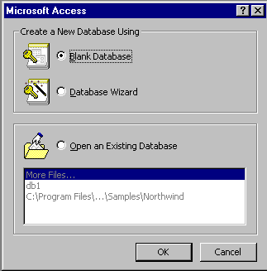

Point with the mouse to the small “circle” to the left of Blank Database and click-the left mouse button to place a “dot” in the circle (see above). Either click-on OK or tap the Enter key to begin creating the your database.

The following File New Database menu screen should now appear.

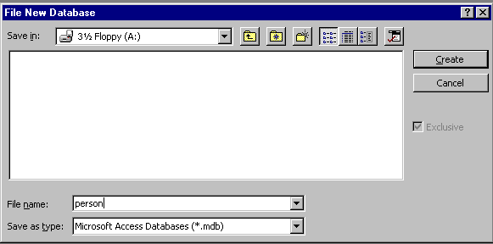

First, click-on the small triangle on the right side of the Save in: area. When the list of drives appears, point to and click-on 3 ½ Floppy (A:). The A: drive should now appear as it does in the image above. If you “get” an error message about your A: drive, make sure you have a formatted diskette in the drive. If not, insert a formatted diskette in the A: drive and try again.

Next click-in the area to the right of File Name:. Delete any text that is entered in the area and then type-in the word PERSON as shown above.

Now click-on Create or tap the Enter key.

The person: Database screen (as shown below) will now appear.

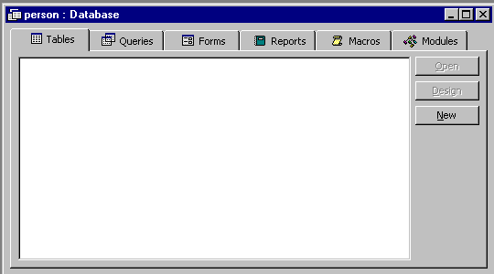

You will notice in the screen in the top border: Tables, Queries, Forms, Reports, Macros, and Modules. You may create multiple Tables (Databases), as well as multiple other items associated with the "Tabs". As you create them, they will be shown in the "white" area. In other words, the PERSON database can be made-up of many other databases (tables), reports, queries, etc.

Creating a Table:

Click-on the New button in the Database: PERSON window (see arrow in image above).

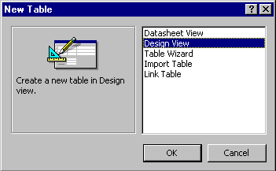

The New Table screen (shown to the left) will appear. Point to and click-on Design View (see arrow), then click-on OK.

For now, we'll do basic database (table) creation. Later, you can try Table Wizards when you have the "feel" for creating a table.

You should now see a Table: Table1 window. If the Table: Table1 image does not “fill” the screen, click-on the small set of squares between the “minus and the X” in the upper right hand corner of the screen (see arrow below). Notice, under the Blue Bar there are (3) things: Field name, Data Type, and Description, and, in the lower half of the window Field Properties.

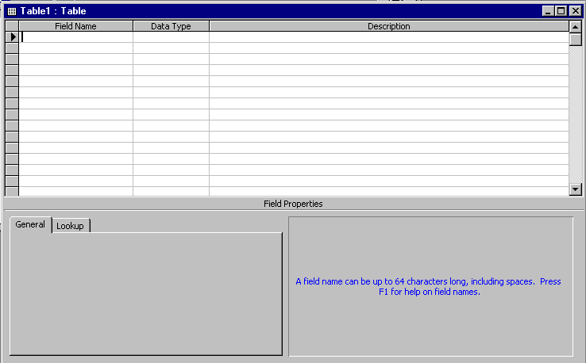

Next you will be creating the fields that make up a database. This is similar to creating a blank personnel form (on paper) that will be "filled-in" for each employee. These "forms" are called records in a database. There will be a record, or form, for each employee. All the forms, together, make up a Table (database). So let’s create a personnel database.

Click-in the area or space under Field Name and type in Last Name. Tap Enter or click-in the area to the right under Data Type. The cursor now moves to the right under Data Type. Notice that Text appears as the default and a box with a down-triangle) appears in the right side of the box. Click-on the down triangle.

Your screen should now look like the screen below. Now we’ll talk about Data Types.

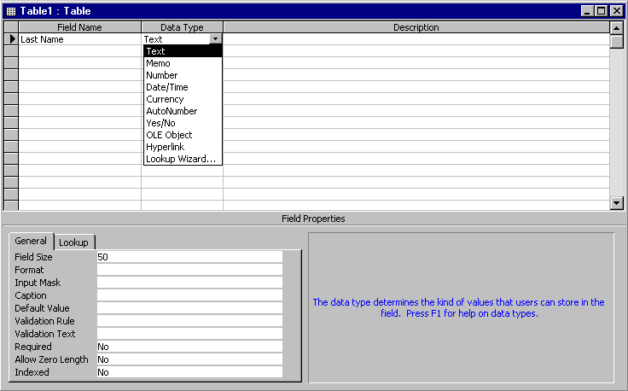
Data Type

Text You may type in any alphabetical/numerical data that you desire - up to a maximum of 255 characters. As indicated, this is a text field, so you can't do mathematical calculations. Examples of Text data are: names, addresses, stock numbers, zip codes.

Memo This field is for lots of text. You can have up to 32,000 characters.

Number This field is for numbers where you want to add, average, and do numerical calculations. This field can be a very large size, so when we get to Field Properties, we'll talk about "sizing" this field so it doesn't take up to much "space" in storage.

Date/Time Dates and Times. You may format these later, as you may desire.

Currency Good old Dollars ($). You may format these later, as you may desire.

Counter This field is an "automatic" counter that assigns a number each time you put data into a new field.

Yes/No This is a "True/False" or "Yes/No" type of field. You can make it anything you desire under Field Properties.

OLE Object This means "Object Link Embedding" which indicates you can insert a graphic, picture, sound, etc. Pretty neat to put a photograph in a personnel record or a picture of an inventory item in the stock record (advanced stuff).

We'll leave Last Name as a Text Data Type. To the right under Description you may make any remarks you feel are appropriate to someone who may want to know how/why you designed the field as you did.

Now notice in the lower part of the screen under Field Properties that a box appeared when you selected the Text Data Type. This box is "tailored" to the Text Data Type that you selected above.

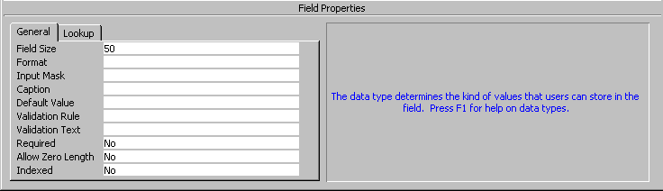

Field Properties.

Click- in each area as you read about it below

Field Size Is currently set to 50 characters. That's pretty large for a name. So, click-
in this area and change the number to 25.

Format Now click-in the Format Area. Next tap the F1 function key to activate Help.

Since you are in the Format area, Help will be "tailored to" this area. When the Help Window appears, click-on Text and Memo Data Types (Notice that you click-on different Data Types depending on the Type you selected.) This gives you an idea of some formats. We'll use one later. Now click-on the “X” in the upper right corner of the Help Window to close it.

Input Mask We'll come back to this feature later.

Caption Look at the Gray Help area to the right.

Default Value We'll come back to this feature later.

Validation Rule We'll come back to this feature later.

Validation Text We'll come back to this feature later.

Required Look at the Gray Help area to the right.
Allow Zero Length Look at the Gray Help area to the right.

Indexed Look at the Gray Help area to the right and tap F1 (Help)

Now we will repeat this process and create different Field Names, Data Types and Descriptions (as necessary). Type-in the Field Names below and set them to the Data Types and Sizes indicated.

Field Name Data Type Size

Last name Text 25 (Already Completed)
First name Text 20
Social Security # Text 15

Here we'll use an Input Mask. Click-in the Input Mask area. Notice there are three "dots" (...) in a box on the right. Click-on the three dots. A message will appear: "Must Save Table First. Save Now?". Click-on Yes. In the Save As Window we'll save our Table as Personnel, so type-in Personnel in the area under Table Name:,
and click-on OK. Next a box will appear saying No Primary Key has been defined. Click on NO. (Keying is somewhat advanced. You can get a good description by searching in Help for Keying.) The Input Mask Wizard will show you some Sample Masks (you may scroll up/down to view them). We'll use Social Security Number, so click-on it. Now click-on Next> at the bottom of the window. You will now see a default number of 000-00-0000 using dashes (-) between the numbers. You can use anything you want. We'll leave it as is, so click-on Next> again. To save space we'll store the data without dashes, so click on Next> again. Now click-on Finish. You will see some “special” numbers written in the Input Mask area for Social Security #. When you begin to enter data in this field, you’ll see how this works.

Street address Text 25
City Text 20
State Text 2

Here we'll us a Format. First make the Field Size 2 then click-in the area to the right of Format. A ( ) down arrow will appear. If you click-on it the area will appear blank (that's because we haven't entered a Format). Tap F1 key in the row of Function Keys at the to of the keyboard (Help) then click-on Text and Memo Data Types. Notice that a > will change any alphabetic character you type into all upper case letters. Now point and click the “X” in the upper right hand corner of the Format Help Screen (notice that the Help Window closes "automatically"). Now type a > in the Format area.

Zip Text 5
Gender Text 1

Now insert a > in the Format area to make all gender entries become capitals (like you just did for State).

Favorite Number Number

Here we'll do a Validation Rule and Validation Text. We'll limit the person's favorite number to a number between 1 and 999. Leave the Field Size set to Long Integer (Tapping the F1 Function Key [Help] will show you the different Number Field Size descriptions). Next, click-in the Validation Rule area and then on the three dots (...) on the right of the area. An Expression Builder Window will appear. We'll "build" a mathematical expression that will only allow numbers from 1 to 999. The cursor should be in the white area in the upper left of the window. First, click-on the > symbol at the bottom of the area. Next, type-in a 0 (zero). Now click-on And, then click-on the < symbol. Now type-in 1000 (one thousand). This is our formula: 1 to 999 is greater than 0 and less than 1000. Click-on OK. Sometimes, the Expression Builder will “insert” a <<expr>> in the formula. If it does this, delete the <<expr>>.
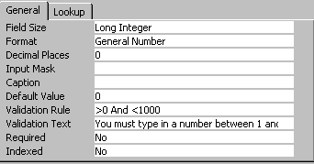

If someone does not enter a number correctly, an error message will appear. Now we'll create an appropriate error message. Click-in the Validation Text area and type-in: Favorite Number must be between 1 and 999.

Date hired Date/Time

In Format click-on the ( ) and choose Short Date. In the Input Mask area click-on the three dots (...), save the table, and again choose Short Date, then Next>, then Next> again, then Finish. (This will insert a / between the day, month, year.)

Salary Currency

In the Decimal Places area click-on ( ) and select 0 (zero). Notice the Default Value of 0 income will be inserted if no Salary figure is entered. We'll leave it at zero.
Application Received Yes/No

We’ll make this a “Yes/No” or “check box” field. When we begin entering data in the database, you’ll see how this “box” works.

Point to and click on File then Save As. The Save As Window will appear and Personnel should appear under Table Name: Click-on OK.

Now we will fill in the database:

At this point you will still be in the design window. You have two choices. If you look at the Button Bar just below the Menu Bar Area (File, Edit, View, etc.) you will see that the first button on the left that has a small sheet of paper with some data on it. Point to this button with the mouse and pause, you will see a "Tool Tip" that indicates that this button is the View Button. This is logical because you have been designing your table and now want to view the data that you have placed in the database (table). If you are familiar with spreadsheets it looks like a tiny version of one. You can click-on the View Button and go right into entering data in your table. However, it might be good to see how to enter data when we first open Access.

So, point and click-on File in the Menu Bar, then click-on Close. You will return to the main database window where we started (PERSON: Database). You should see the Tables Tab in the Personnel Table highlighted. Notice that there are three Buttons on the right portion of the window which indicate: Open, Design, New. If you click-on New you can add another table to the Person database. If you click-on the Personnel Table and then Open you will open that table and can enter data. If you click-on Design, you will be back in the design window and can alter your design. Note: if you find, as your are entering data, that you made a field too small, you can go to Design View and make the field a larger width.

So let's click-on Open. The Personnel Table will appear on the screen. If the window does not fill the screen, point to the Expansion “square” in the upper-right corner directly to the right of Personnel: Table in the blue bar. This will expand your Table to fill the desktop.

Move the cursor arrow over buttons below menu bar. As you do, notice that the "Tool Tips" tell you what each button does.

Now notice below the Button Bar that the fields that you created in your Personnel Table are displayed in what is called Datasheet View. Notice the small “button” under File in the menu bar. It shows a small blue triangle, pencil and a ruler. This is a “toggle” which will take you back to Design View if you need to make design changes while you are in Datasheet view. If you go back to Design View, you can then “toggle” back to Datasheet view when you have made your corrections. Under Last Name you will see the cursor flashing, this means that you are ready to begin entering data. You may type the data and tap Enter or click with the mouse in each field. If you make a mistake you may retype the data. If you see a mistake later you can come back at any time and correct it.

Under each field, type the following:

1. Last Name Smith
2. First Name Chris
3. Social Security # 123-45-6789
4. Street address 100 Main Street
5. City Lynchburg
6. State VA
7. Zip 24501
8. Gender M or F (your choice)
9. Favorite Number 827
10. Date Hired 7/01/93
11. Salary 40000

When you have completed typing the information, tap Enter so the cursor will move down to the next record. You are now ready to insert your second entry.

Note: When you tapped Enter, Access automatically saved your first record. This can be reassured by the display of the hourglass.

Also note: As you began typing your first record a small pencil appeared in the left margin. This indicates that you are "writing to" this record (editing). Below the pencil an * (asterisk) also appeared. This indicates that your next record will go below the first.

There are (2) ways of entering the data into the database:

1. The way you just did, called List View

or 2. Form View.

Exiting and Saving

Note: Anytime you want to take a break and exit Access, simply point to File in the menu bar, and point to Exit. If it asks Do you want to save?, click-on Yes. If it gives you a save file screen, give it a name of your choice and click on OK. You should then exit to the Windows Screen with no problems.

If you decide to Exit Access, and then return to continue the tutorial, refer to the instructions at the beginning of this tutorial. Don't forget to go to File, Working Directory, and set it to A drive. Simply point to File, Open, Table, choose your table (e.g. Person.MDB) and then Open and continue entering the data.

Form View and Datasheet View:

In the Button Bar, just below and to the right of Help (in the Menu Bar), is a button with a lightening bolt and a small form. This is the New Object: AutoForm Button. Point to it, make sure you have the correct button, then click-on it. A New Data Entry Form will automatically be created and appear.

New Object: AutoForm

Since you are in the Personnel Table, the form will “automatically” be created, just like the Personnel Datasheet. You will now see a data entry form window. If the form does not fill the screen, click-on the expansion square to increase the size. Notice your first record appears. You may enter data in Form View the same as in Datasheet View. To save this form click-on File in the Menu Bar, then on Save. The save as screen will appear with Personnel already in the Form Name: area. Click-on OK. The date entry form is now saved as Personnel, just like the Table. Notice, at the bottom of the Form, that there is a status area (see below) that tells you what record you are on and you can use it to “move” from one record to another, or select a new record in which to enter data. After you have entered a few records, give it a try.

When you first “open” your Person Database, you may choose your favorite screen to enter data: The data Form or Datasheet. Click-on either the Tables tab or Forms tab at the top of the window. Then, click-on Personnel, and then Open to begin entering data in your choice. You can switch back and forth by clicking on Window in the Menu Bar. At the bottom of the menu that appears, you will see Personnel with a  (check) to the left. This indicates that you are currently in Form View using Personnel. You can click-on Table: Personnel and you will go to Datasheet View.

There is another way to do this. Always inspect the Button Bar (it changes with different screens). Drag you mouse arrow over the buttons and see what the help tips indicate. The button on the left indicates what “view” your are in: Design, Form, or Datasheet View. You can also move back-and-forth between view by clicking-on the down triangle to the right of the button.
Note: When you are finished entering data and prepare to exit Microsoft Access, or Close the form, if you did not save before, the program will ask if you want to Save the Form. This is up to you. You may save it with your choice of names and it will then show-up as a form when the Person Database Main Window appears. Or, you can indicate No, and re-create the form again with the Wizard.

To record enough information so that you can see what a database does enter 24 or more records now. You may use either Form View or Datasheet View .

Querying the Database:

This is what a database is designed for: finding specific information about some of the data in the table(s) very quickly. A query is a search for general or specific data in a field or fields in your database (e.g. the first and last names and birth dates of all employees, the Jones’s, the people from CA, salaries > $10,000, etc.). In order to do this, we need to click on the fields we want to query. So, let’s start by finding just Last Names in our table.

If you are not in the Database: PERSON window which shows the Tables, Queries, etc., go there by clicking-on Window in the Menu Bar and then on Database: PERSON. Also, if you have the Personnel Table or Personnel Form open (to add data), close them before you begin your queries. The Access program sometimes becomes logically confused when you try to do queries when it “thinks” you also want to add data. You may see “error” messages if you leave the Form or Table open.

Notice, at the top of the top of the Person: Database window there is a tab that indicates Query. Click-on it. Since we have not done a query before, click-on New.
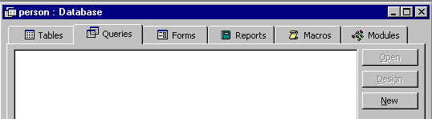

A New Query window will open.
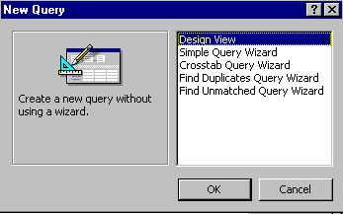

Make sure the blue highlight is on Design View. Then click-on OK (we'll talk about Wizards later).

Two new windows will now appear: Query 1: Select Query and Show Table. You will first have to select the table(s) you desire to query.

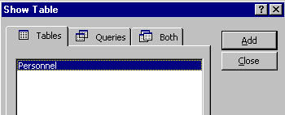
If your Personnel Table is not highlighted in blue, click-on Personnel, then click-on Add, then, click-on Close. The Show Table window will disappear, and the Query 1: Select Query window, behind the Show Table window, will appear by itself.

Click-on the expansion square in the upper right corner
to enlarge the Query 1: Select Query window.

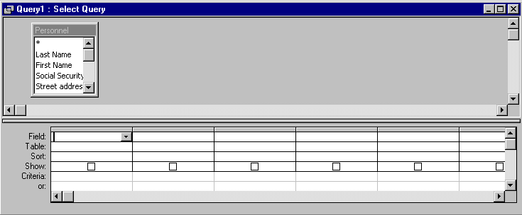
Notice, in the upper half of the window, a small box on the left indicates: Personnel. At the top is an asterisk (* ) and below, in an elevator box, are the fields from the Personnel Table (you can move up-and-down the list as you desire). What we need to do next is place the Fields we want to query in the lower area of the screen. Notice the lower area on the left border. The first row indicates Field:, followed by Table, Sort:, Show:, Criteria:, and or:.

In the lower half of the screen click-in the first cell to the right of Field:. We'll start with a query on Last Name, State, Favorite Number and Salary. Now click-on the down triangle and then click-on Last Name. Notice how Last Name now appears to the right of Field: and a   (check) is seen in the Show: cell (The  means that you will see Last Names in your query.). Now move to the next Field cell on the right and, using the down triangle click-on State. In the next two fields to the right, insert Favorite Number and Salary. Your Query1: Select Query screen should look like this:
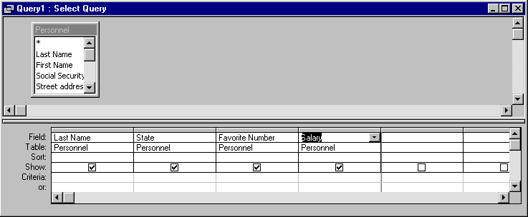
Now look in the Button Bar. In the middle of the bar you will see an exclamation mark (! ). If you move the cursor over it, the help text box will indicate "Run." Click-on the (! ). This now executes your query. Notice the screen ONLY shows the four fields that you queried. You can add or remove fields as you desire. Simply click-in the Field area and select a new field and it will replace the old one. Or, click-on the field you want to remove and tap the Delete key. Sometimes you may have a lot of fields and it will be too large for a single sheet of paper. To see how your query would look if you printed it, click on the button that has a piece of paper and magnifying glass (Print Preview). To return to your query, click-on the button, in the upper left, which shows a small blue triangle, a ruler and a pencil (View or Design View). This will take you back to the Design View, where you started your query.

Sorting the Database:

Notice that the second row in the lower half of the screen indicates Sort:. Click-in the Sort: area under Last Name. A down arrow box appears; click-on it. Let's sort the Last Names in Ascending order. Click-on Ascending. Notice that Ascending now appears in the Sort: area. Click-on the ( ! ) to see the new query. Notice that the names you entered are alphabetized. Click-on the Design View button (triangle-ruler-pencil). Now change the Ascending under Last Name to (not sorted). On your own, try sorting some of the other fields. When you are finished remember to set the fields to (not sorted) unless you do want to sort on those fields.

You may also sort various fields in your database whenever you are in the Datasheet View, whether you are viewing the entire Table, or a Query from the Table. Notice that the Field Names are shown at the top of each column in gray cells. If you click-on one of them, the entire column (Field) turns “black.” This indicates that you have “marked” the entire column (Field). In the button bar that appears when you are editing the Datasheet View, you will see two buttons with “down” arrows: . When you move the cursor over these two buttons a text help box will indicate: Sort Ascending or Sort Descending. If you click-on one of the buttons, the filed which you have selected (highlighted) will be sorted in the order selected.
So, there are several “ways” you can sort your Tables and Queries.

Specific Queries:

So far we have listed everything under each Field Name that we selected. However, many times you will probably want to find something specific in your Table (database - e.g. people from a certain state or city, people whose favorite number is 7, or salaries between $ 20,000 and $ 50,000). This is fairly common sense, but it can get tricky. To get an idea of various criteria, you might want to click-on Help in the menu bar. Then, click-on Contents and Index. Click-on the Index “Tab.” Next type-in the word criteria (your menu screen should look like the one below). You will notice that, as you are typing, the lower half of the window is moving “toward” the word you are typing. When you have finished typing you will notice, in the lower half of the window, that "criteria for finding files” is showing. Click-on queries, entering below and then click-on the Display button. You will now see a number of topics associated with query criteria. Click-on several of them and review the information. Click-on Help Topics in the Menu Bar to return to the Menu Screen Below. When you are finished, click-on the “X” in the upper right corner of the Help Topics menu screen to close the screen.
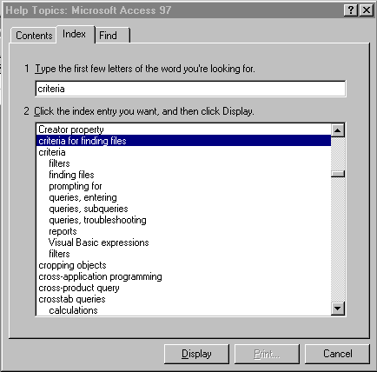

Now we'll try a few specific queries. First let's find a specific state.

You should now be back in the Query1: Select Query menu window. Click-in the cell to the right of Criteria: in the State column. You will see a flashing cursor (Make sure you are in the State column.). Type-in the abbreviation for one of the states you entered in your Personnel Table. Your Query should look like the below picture.

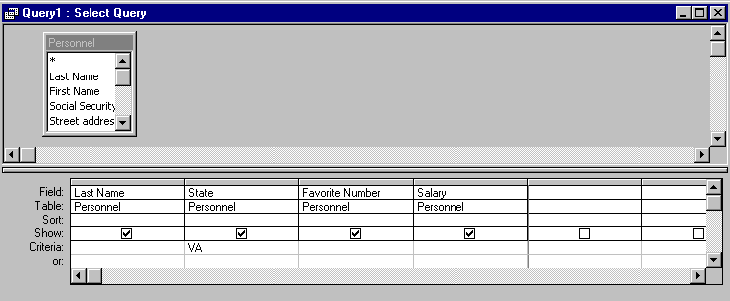
Now click-on ( ! ). A new window will appear. Only persons from the state you selected should show. This is a SPECIFIC query for that state. Click-on Design View Button (triangle-ruler-pencil) to return to Design View. Now delete the state you entered.

Now we'll look for Favorite Numbers larger than 600. Type in >600 in the Criteria cell under the Favorite Number Column. Click-on ( ! ). Everyone with a favorite number larger than 600 should show. If no one is indicated you don't have a person with a number larger than 600, or you might have typed the >600 incorrectly. Return to the Design View. Delete the >600 and run the query with no criteria. You should “see” all the fields again. Return to the Design View again.

Make sure all the Criteria: cells are empty. Next we'll look for persons with salaries equal to or larger than $ 20,000 and equal to or less than $ 50,000. In the Salary field column, in the Criteria: cell type-in: >= 20000 and <= 50000. Click-on the( ! ). You should now see a specific query that indicates those persons in the range we chose. Go back to Design View. Delete the criteria you entered under Salary. Now, on your own, if you desire, add or delete some fields to your query and experiment. Don't get frustrated if you no specific items appear. Frequently you might query for something that can't exist (e.g. states of VA and CA – a person can't be from both) or there just isn't anything that matches. For fun, notice the or: just below Criteria to the left of the Design View. Try one state in the Criteria: cell under State and another in the or: cell. Have fun.

When you have a good feel for queries your ready to end your query session. First click-on File in the Menu Bar, and then click-on Close. A Microsoft Access Window will appear and ask: "Do you want to save changes to the design of query 'Query1'?” Click-on Yes and a Save As window will appear. Name the Query anything you like, and click-on OK. When the Query1: Select Query view closes you will return to the person: Database screen. Notice that the Query Tab is active and your new query is available to use again, as you desire. You can activate this query and change things just like you did in the tutorial. If you want a printout of your query (at anytime), simply click-on the Printer Button in the button bar or on File in the Menu Bar and Print.

Reports:

Reports can be very complex. In this tutorial we'll learn the basics. A later advanced tutorial or a good manual will be essential to mastering reports.

There are several types of reports. We'll use the Wizards to design some.

If you are not in the person: Database window screen with the Table, Query, Form, etc., click-on Window in the Menu Bar and then on person: Database at the bottom of the menu. Also, make sure that you have closed any Tables, Forms, or Queries on which you are working.

In the person: Database widow click-on the Report tab. Now click-on the New Button. The following New Report menu window will appear.

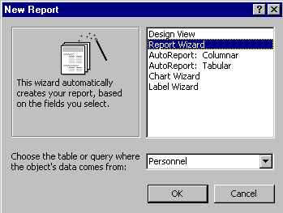
First, click-on Report Wizard in the New Report menu screen. Then, in the area to the right of: Choose the table or query where the object’s data comes from:, click-on the down triangle and select Personnel. Then click-on OK.

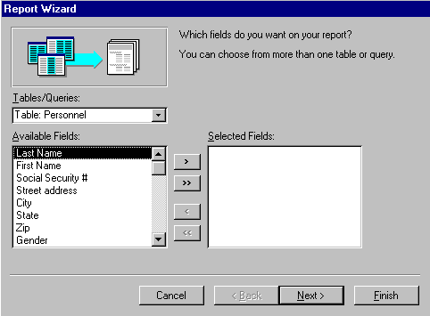
Read all the comments in the window. Only the fields you select from your table will show-in the report. To bring fields into the report individually you click-on the name of the field in the list of fields in the area under Available Fields: and then click-on the >. The order, on which you click-on the fields, will be their order in the report. The >> brings over all of the fields. The < and << brings back one or all of the fields, if you make a mistake, or want to start over. So let's begin. Click-on First Name, then click-on > (notice how the First Name field went from the Available Fields: to Selected Fields:). Now do the same with the Last Name, State, Gender and Salary fields. These are the fields that will appear in or first report.

Your Report Wizard screen should look like the one below.

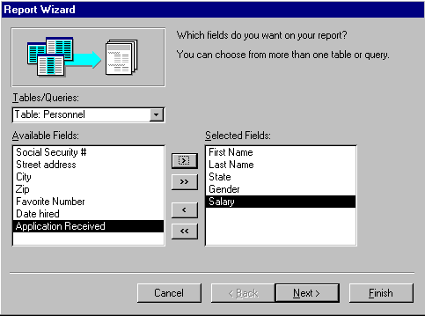

If it does, click-on the Next> Button.

Grouping in Reports

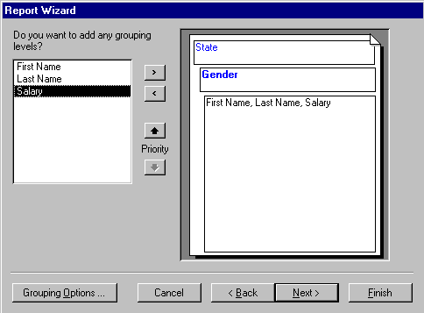
This Report Wizard menu screen asks if you want to add Grouping. Grouping simply “groups” records by an item in the report you are designing. We’ll group by state. This means that “records” from a state will be in a “group” (e.g. people from Virginia will be in one group, the folks from Washington in another, and so on). This will be easy to see when we look at the report. So, click-on State, then click-on >. If you make a mistake, no problem, just use the < or <<. Your screen should now look like the one below.

Click-on Next> again. Another Report Wizard menu screen will follow.

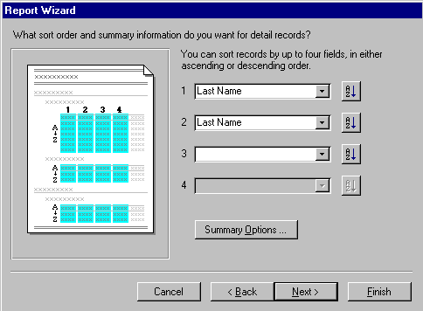
First, the above screen requests that you indicate a Sort Order. This simply means, that within each "group”, the alphabetic order in which you want the fields sorted. We’ll go with sorting by Last Name and then First Name. This way you’ll have the names, grouped by state, in Last Name order and, where you have several people with the same Last Name, they’ll be sub-sorted in First Name order. Notice the AZ button to the right of the box. This indicates, that the Field that you select is in A to Z or ascending order. If you click-on this button, it will reverse the order from Z to A, or descending order. So, click-on the small down triangle to the right of the first box and select Last Name. Leave the order as AZ. Now select First Name in the second box. When you are finished, your Report Wizard menu screen should look like the one above.

Notice a Summary Options button below the sort fields you have selected. Click-on it.
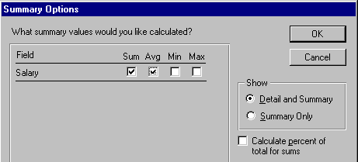

This menu box allows you to enter calculations for numerical and currency fields if
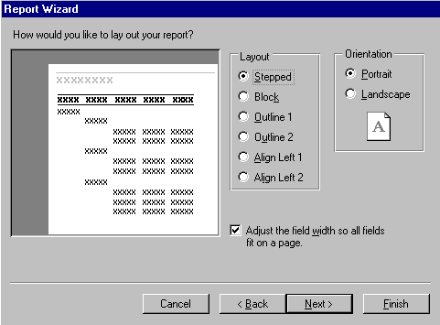
you have selected any. It will summarize these calculations by each group, and in total. So, since Salary is a currency field, we can obtain calculations. Click-in the boxes under Sum and Avg, this will furnish these calculations, as you will see in the report. If you want percentages as well, click-in the box next to Calculate percent of total for sums. Click-on OK and then, click-on Next> again.

This menu screen allows you to select a layout for your report. Click-in the small circles to the left of each choice in the layout area and observe the results. For the moment, we’ll stay with the default: Stepped. So click-again it that circle. Leave the report in Portrait Orientation. Click-on Next> again.
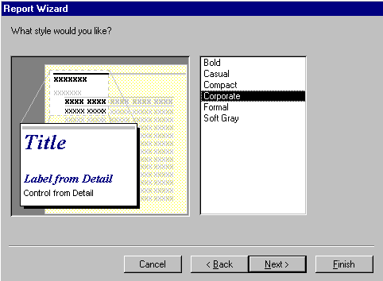

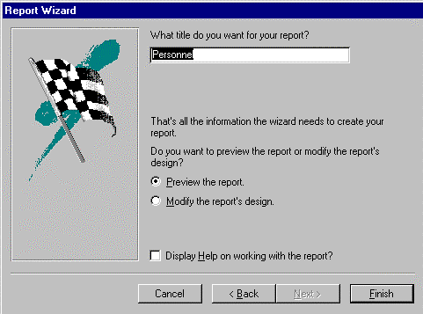The next menu screen allows you to select the Style that you would like for your report. Click-on the choices and see what each “looks like”. Pick Corporate for now and click-on Next> again.

The next menu screen is the last screen in the sequence. It allows you to select a title different from the name of your database if you so choose. Note that the small circle in front of Preview Report is “dotted”. When we click-on the last button Access 97 will go to a preview copy of your report. We’ll stay with Personnel, so now click on Finish.

This is a report in Tabular (Columnar) format.

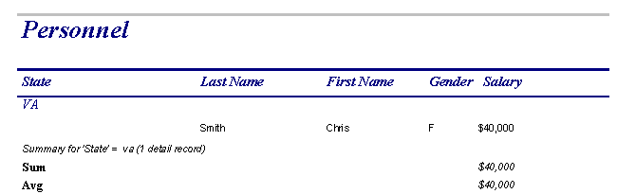

Notice in the lower left corner of the report screen that you are on Page 1 of the report.

Notice the “triangle arrow” buttons to the left and right of Page 1. These take you to the first page of the report, the previous page, the next page, and the last page. Try clicking-on them.

Notice in the button bar at the top of the screen a small magnifying glass. When you place the cursor on it, a text help box which says "Zoom" appears. Click-on the magnifying glass. This shows you how a page of your report will appear when you print it. Click-on the magnifying glass again and you will return to your original view. You might have noticed that when the cursor was "in" the report it changed to a magnifying glass. When it looks like this, a click-on the left mouse button will cause the view to zoom in or out.
Notice in the upper-left corner a button that has a small triangle, ruler and pencil.
Click-on it. This takes you to what is called Design View. This is where the Wizard created the Tabular report design. Look at this screen for a few minutes.

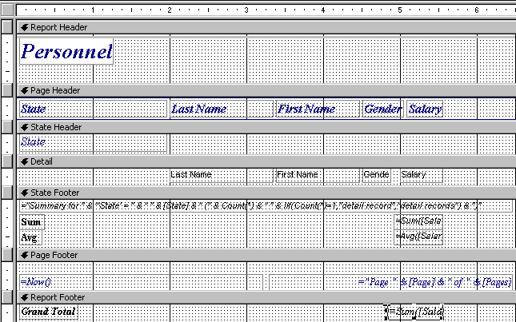

First: the Button Bar. Run the cursor arrow over the buttons to get an idea of each button function. Just like queries, we'll be going back and forth between Design (triangle-pencil-ruler) and Print Preview (magnifying glass).

Second: Notice to the left, in the gray part of the screen, it indicates: Report Header, Page Header, State Header, Detail, State Footer, Page Footer and Report Footer.

Report Header: If something shows here, it will only be shown on the first page of the report.

Page Header: If something shows here, it will show on each page of the report at the top of each column.

State Header This “sets-off” the State Grouping.

State Footer This “ends” the State Grouping.

Detail: These are the field names from our database. Access will “pull” the data for the individual fields from our database records.

These are the database fields themselves. The fields print each time there is a person in the database. This field information is drawn from the database. As you enter more people in the database and run the report again, more people will be shown. The "size" of the box you see on the screen was created when we created the field sizes.

Page Footer: This is what shows at the bottom of each page.

Report Footer: This is what shows only on the last page of the report.

Also note, in the lower right corners of the State and Report Footer area boxes which indicate: = SUM([Salary]). This is a calculation box the Wizard created.

Save Report:

Let's save this report.

You can either click-on File (in the Menu Bar) and then Save or Save As, or click-on the small diskette button in the button bar. A menu window will open which says Save As. In the area under Report Name type-in Tabular then click-on OK. Now click-on the File in the menu bar and then click-on Close. You could also click-on the “lower X” in the upper right corner of the screen. Be careful here. The lower “X” closes whatever you are working on (report, query table, etc.). The upper “X” closes the Access 97 database.
You should now return to the main Access 97 Window. The person: Database window should appear on the screen. If it does not, then click-on File, then Open Database. When the Open Database Window appears, click-on Person.mdb in the File Name area, then click-on OK. In the person: Database window click-on the Report tab. A report named Tabular will be there. Click-on it then click on the Design button. You are now in your report design screen. Close this report again as you just did by clicking-on the minus, etc.

Some more New Reports:

Now we'll create some other reports. This is similar, in process, to the report you just completed. In the person: Database window click-on the New button. When the New Report Window appears, click on “down triangle” in the area to the right of Choose the table or query where the object’s data comes from:, then click-on Personnel. Now click-on some of the different Wizard’s choices. Try Auto Report: Columnar and Tabular, or go back to the Design Wizard again. Experiment with the different types.

As you create reports you may save or not save, as you desire.

Reports can become very complex, very quickly. This is only an introductory tutorial which furnishes a simple guide to report design. You might want to purchase a book on Access or try a separate tutorial on reports.

Now File, Exit Access 97.

Now that you have the basics, you might want to try some things on your own. Try using the Wizards in Table, Query and Reports.

We'll, that about does it for now. If you have comments on this tutorial, simply send an e-mail to the internet address below.

murray.t@lynchburg.edu

Thank you for your time, effort and patience.

