Microsoft Excel Tutorial
(Revised – 7/22/99)
How to Build An Income Statement Using a Microsoft Excel Spreadsheet

To begin building an Income Statement using Microsoft Excel, click on the Excel icon on your desktop to start Excel.

You should have already completed a tutorial called Creating a Spreadsheet. You can refer to that tutorial if you need a refresher on completing basic tasks in Microsoft Excel.

At the back of this tutorial, there is a copy of what your completed income statement should look like. Feel free to use this copy to check your spreadsheet as you move through the tutorial.

Before beginning this tutorial, be sure you have a formatted disk in the A drive

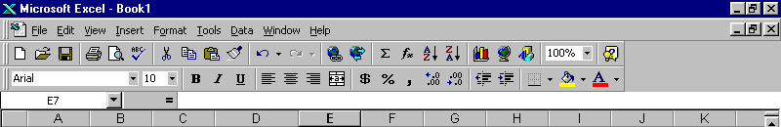
Now before we get started, let’s review some of the features of Microsoft Excel.
1
2
3
5
4
6

- This is the title bar. It contains the name of the active application. If the workbook window is maximized, the name of the spreadsheet will appear in the title bar.
- These are the Window Control Functions. The top set of functions are for the Excel application itself. The bottom set of functions are for the workbook that is active. The Underscore button will minimize application or the workbook to the task bar at the bottom of the screen. The middle box that looks like two small windows or one large window is the Minimize/Maximize button. If the application or workbook is maximized, this button will appear as two small windows. This means that it can be minimized. If the application or workbook is minimized, this button will appear as a large window. This means that it can be maximized.
- This is the Menu Bar. It contains the names of the currently available command menus. Pointing and clicking the left mouse button on any of the menu names will pull down that menu.
- This is the Standard Tool Bar. It contains shortcuts for many commonly used commands.
- This is the Formatting Tool Bar. It contains shortcuts for formatting cells within a worksheet.
- This is the Name Box and Formula Bar. The Name Box is on the far left side of this bar. It displays the cell reference of the active cell. The Formula Bar displays the contents of the active cell.

Now, let’s get started building our Income Statement.

The first step of building an Income Statement is to create a title page.

In cell A10, type DAVIS SHOE COMPANY TUTORIAL
In cell A13, type Created By: Your Name

Notice that the headings do not fit in the cells. To make the cells accommodate the headings, we can widen the columns so the headings will fit.
Widen Column A to 72 characters, and widen Column B to 48 characters.

Widening Columns

Point to the A above the A column and click the right mouse button. This will highlight the entire column, and the Active Block Menu will appear.
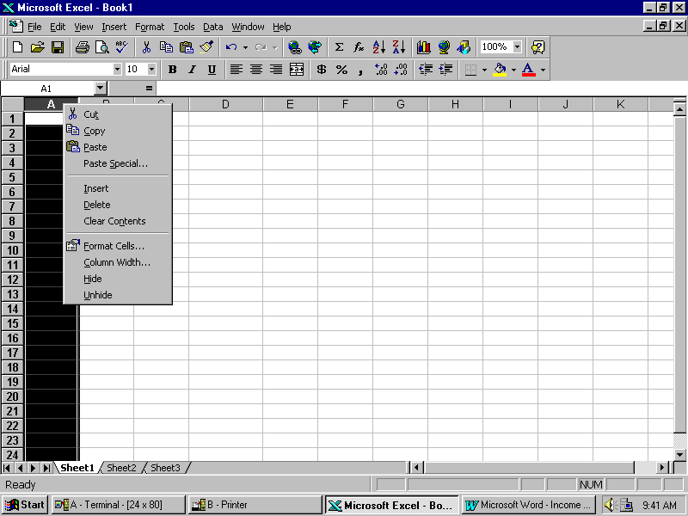

Point to Column Width and click the left mouse button.

Type in 72 and point to OK and click the left mouse button.
Now widen Column B to a width of 48 characters.

Now that the headings fit in the columns, wouldn’t it look nice if the headings were centered?

Centering Text

To center the title, point to cell A10 with the mouse. Hold down the left mouse button and drag the pointer down until cells A10 through A13 are highlighted. Release the left mouse button. Now, point to anywhere within the highlighted area and click the right mouse button. The Active Block Menu will appear again. This time point to Format Cells and click the left mouse button.

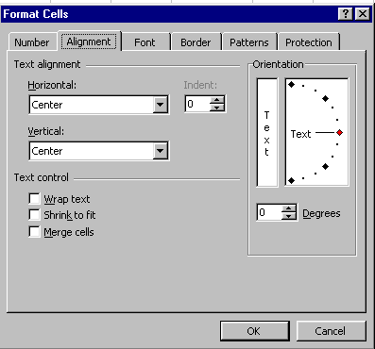

The Format Cells Box will open, point to the tab titled Alignment and click the left mouse button. Notice the small box labeled Horizontal. Point to the small arrow on the right side of the small box and click the left mouse button. A menu will drop down, point to Center and click the left mouse button. Now Center is in the box. Do the same thing for Vertical. When you have finished click on OK and click the left mouse button again.

Everything that was highlighted is now centered!

Shortcut for Centering Text:

Look on the Formatting Toll Bar to find the button that looks like text that is centered on the page or point to each button on the tool bar until you find the one labeled Center. To use this button, simply highlight the text as before and click on the center button.

Remember, both methods produce the same results, so use the one you feel most comfortable with.

Now that our title page is complete, save your work to the disk in the A drive. Be sure to choose a logical name for your file, and remember to save periodically while you work on your balance sheet.

Next, we need to produce the input section of our income statement. The numbers in the input section will be used to build the income statement. This way if a number in our input section changes, the numbers in our income statement will change too!

Save this spreadsheet as: INC

In cell B1, type INPUT SECTION.
Now center the text in the cell using either method we used earlier.

Now type the following text in the appropriate cells.

CELL TEXT
B4 INPUT SECTION:
B6 Sales
B7 Sales discounts
B8 Sales returns and allowances
B9 Net sales
B10 Cost of goods sold
B11 Gross profit
B12 Payroll expense
B13 Payroll tax expense
B14 Bad debts expense
B15 Travel and promotion expense
B16 Office supplies expense
B17 Utilities expense
B18 Insurance expense
B19 Depreciation expense, building
B20 Depreciation expense, warehouse
B21 Depreciation expense, trucks
B22 Deprecation expense, office equipment
B23 Maintenance and repairs expense
B24 Miscellaneous selling expense
B25 Total operating expenses
B26 Net operating income
B27 Interest expense
B28 Total other expenses
B29 Income before taxes from continuing ops.
B30 Other income
B31 Income tax expense
B32 Income after taxes from continuing ops.
B33 Net Income

Widen Column C to 12 characters wide the same way we did earlier.

Next, input the following numerical values in the appropriate cells.

CELL VALUE
C6 42100
C7 130
C8 500
C10 18010
C12 5100
C13 550
C14 315
C15 375.50
C16 320
C17 150
C18 210
C19 162.50
C20 90
C21 150
C22 65.25
C23 390
C24 260
C27 215
C30 0
C31 300

These are dollar values, so we must add dollar signs and decimal points.

Formatting Numbers

Point to cell C6. Hold down the left mouse button and drag the arrow down until you have highlighted cells C6 through C31. Release the left mouse button. Point anywhere in the highlighted area and click the right mouse button. The Active Block Menu will appear. Point to Format Cells and click the left mouse button. Point to the Number tab and click the left mouse button. Point to Currency and click the left mouse button. Indicate 2 decimal places for cents. Point to OK and click the left mouse button. Dollar signs and decimal points will be added to our numbers.

Shortcut for Formatting Numbers:

Once again we can use a button on the formatting tool bar to shorten our task. Highlight the area as indicated above. Now look for the button with a dollar sign on it. Click on the dollar sign with the left mouse button. This automatically adds dollar signs and two decimal places to the numbers.

Finally, we are ready to begin actually building the income statement. In order for the account titles and the numerical values to fit, we need to widen the columns before we get started.

Widen the following columns as you did before to the widths indicated below.

COLUMN WIDTH
D 12
E 40
F 15
G 15

Now, we can insert a three line heading for the income statement.
Go to the following cells and type in the appropriate text.

CELL TEXT
E1 DAVIS SHOE COMPANY
E2 INCOME STATEMENT
E3 FOR THE MONTH ENDED DECEMBER 31, 1997

Highlight cells E1 through E3 and center the text as we did earlier.

Now, we will begin copying the account titles and numerical values from the input section into the actual income statement.

Copying Text

Point to cell B6 and click the left mouse button. Point to Edit on the top menu bar and click the left mouse button. Point to Copy and click the left mouse button. Notice that there is a dotted line moving around cell B6. Now, point to cell D6 and click the left mouse button. Now point to edit again and click the left mouse button. Point to Paste and click the left mouse button. The title in B6 is now copied to D6. Notice that because we copied the title to the new cell, the title remained in the old cell as well. If we had selected cut instead, the title would have been removed from the old cell and placed in the new cell.

Shortcut for Copying Text:

Like before, there is a button on the Formatting Tool Bar that will make copying text much quicker. Look for a button that looks like a pair of scissors. This is the Cut button. Next to it on the right is a button that looks like two small sheets of paper. This is the Copy button. To the right of that button is a button that looks like a clipboard and a small sheet of paper. This is the Paste button. Instead of going to the menu bar and clicking on Edit, Copy, Edit, Paste each time; you can select the cell you want to copy, then click the Copy button, then move to the cell you want to copy to and click the Paste button. This really speeds up copying!

Go to cell D7 and type in the word Less.

Now, copy the titles in cells B7 and B8 to cells D8 and D9. Point to cell B7, hold down the left mouse button until B7 and B8 are highlighted. Click on Edit-Copy or click on the Copy button. Now move to cell D8, hold down the left mouse button and drag until D8 and D9 are highlighted. Click on Edit-Paste or click on the Paste button.

To improve the appearance of our income statement, we need to edit a few cells.
Point to cell D8 and click the left mouse button, tap the F2 key to begin editing the cell. Use the arrow keys to move the cursor in front of the word Sales. Insert four spaces in front of the word.
Repeat this for cell D9.

Next we must copy the numerical values from the input section to the actual income statement. However, because we want the numbers in our income statement to change when we change the numbers in the input section, we cannot copy them the same way we copied text.

Copying Numerical Values

There are two ways to copy numerical values:

1. Plus-Point Method.
To use this method, simply type a plus sign (+) in the new cell, then point to the cell where the number currently is and click the left mouse button. You will see the current cell address appear in the new cell. When you press enter, the numerical value will appear in the new cell. Notice that if you move back onto the new cell, the original cell address is still there.

2. Type-In Method
To use this method, simply type a plus sign (+) in the new cell, then type in the original cell address. Once again, when you press enter, the numerical value will appear in the new cell, but when you move back onto the new cell, the original cell address remains.

In the left column below, the destination cell addresses are listed. These are the cells where the specified task will be performed. In the right column below, the task is listed. For each row, this is the task we must perform on the destination cell. For tasks we have not yet discussed, instructions on performing the task will follow the task description.

For example: In the first row, F6 is listed as the destination cell and the task is to Copy C6. This means that you must copy C6 to F6. Using the Plus-Point Method, you would go to cell F6, then type a plus sign and point to cell C6. Using the Type-In Method, you would go to cell F6, then type a plus sign and type ‘C6’.

Destination Cell Task

F6 Copy C6

F8 Copy C7

F9 Copy C8
Underline F9: Point to F9 and click the right mouse button. Select Format Cells using a left mouse click, then select the Border tab using a left mouse click. Point to the bottom of the cell within the box and left mouse click. A line should appear along the bottom of that cell. Click on OK with a left mouse click. There should be a line along the bottom of cell F9.

D11 Copy the text from cell B9
Begin editing D11, Insert seven spaces before Net Sales
D12 Copy the text from cell B10

G11 Calculate Net Sales Using Plus-Point Method. Start with F6, subtract F8 and then subtract F9. Type a +, point to F6, type a -, point to F8, type a -, point to F9. Press Enter.

D14 Copy the text from cell B11

G12 Copy C10
Underline G12

G14 Using the Plus-Point Method, subtract G12 from G11.

D16 Type: Operating Expenses

D17 through D29 Copy the text from cells B12 through B24
Indent D17 through D29 four spaces

F17 through F29 Copy C12 through C24
(one at a time)
Underline F29

D31 Copy the text from cell B25

F30 Add F17 through F29 using AutoSum and place total in F30
To use AutoSum: Point to F17, click and hold down the left mouse button and drag down until cells F17 through F30 are highlighted. Point to the Σ (Sigma) sign in the Standard Tool Bar and click the left mouse button. The total of F17 through F29 will be placed in F30.

G31 Move the contents of F30 to G31
To do this, click on cell F30 so that it is highlighted. Point to the bottom of the cell so that the cursor is an arrow. Click the left mouse button and drag the cell to G31. The outline of the cell will move with the cursor.
Underline cell G31.

D33 Copy the text from cell B26

G33 Using the Plus-Point Method, subtract cell G31 from G14 and place the answer in G33.

D35 Type: Other Expenses

D36 Copy the text from cell B27
Insert four spaces at front of cell D36

F36 Copy C27
Underline F36

D38 Copy the text from cell B28

Insert seven spaces at the front of cell D38

G38 Copy F36

D40 Copy the text from cell B30

D42 Insert seven spaces, then type:
Total Other Income

G42 Copy C30
Underline

D44 Copy the text from cell B29

D45 Copy the text from cell B31

G44 Using the Plus-Point Method, subtract G38 from G33 and place the answer in G44.

G45 Copy C31
Underline

D47 Copy the text from cell B32

G47 Using the Plus-Point Method, subtract G45 from G44.
Double Underline cell G47.
To Double Underline: Do this the same way you underline, except before clicking on the bottom of the cell to place the line there, click on the double underline from the choices to the right of the cell within the box.

D49 Copy the text from cell B33

G49 Copy G47

We have successfully transformed our input section into an income statement in proper format.

Now, all we need to do is print our spreadsheet.

Printing a Spreadsheet

The first thing we need to do is look at a preview of our spreadsheet to see if there are any adjustments that must be made to it. We will view and print the title page, the input section, and the income statement separately.

To print the title page, highlight A1 through A40. Point to File and left mouse click. Find Print Area and point to it, notice that a small menu appears out to the side. Find Set Print Area and left mouse click. This sets the print area to only cells A1 through A40. This way we can just print the title page. Now, let’s preview what our printout would look like. To do this, point to File and left mouse click. Find Print Preview on the menu and left click on it. A print image of our document will appear. Notice that things are a bit off center.

To center the title page, while you are in Print Preview, left mouse click on Setup, then click on the Margins tab.
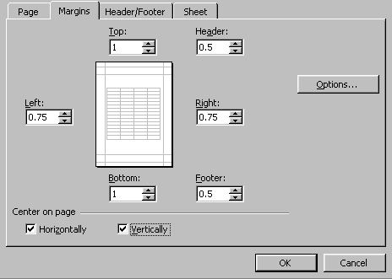
In this box, you can set the margins for the spreadsheet.
However, you can also choose to center the text horizontally and/or vertically on the page. Notice these options are near the bottom of the box under the heading Center on Page. Point to the small box beside Horizontally and left mouse click. Notice that a check will appear in the box.

Now, do the same thing for the box beside Vertically. Left mouse click on OK. This takes care of centering our title page. In the Print Preview box, left mouse click on Print to print the title page. When you are finished printing, left mouse click on Close to exit Print Preview.

Now, we must print the input section. This time highlight B1 through C40 and set this as our print area. Repeat the above process for the input section. However, notice that you do not have to center the text on the page again. The center alignment we set for our title page will carry over each time we print.

When you have printed the input section, redefine the print area to D1 through G50 and print the income statement.

You should have a title page, an input section, and an income statement like the ones that follow this tutorial. Don’t forget to save your work to your disk.

When you have completed the tutorial and saved your spreadsheet, exit Excel by clicking on File and selecting Exit.

CONGRATULATIONS!!!

You have successfully used Microsoft Excel to build an income statement.

If you have any questions or comments please send them to:

murray.t@lynchburg.edu

