Creating a Web Page and Web Site
Using Microsoft FrontPage 2000 for Windows 95/98/2000

Revised: 1 May 2000

Starting Microsoft FrontPage 2000

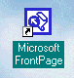
In this tutorial we’ll first create a single web page using Microsoft FrontPage 2000. Then, we’ll create a web site, which consists of multiple, linked web pages. For the single web page you can save your work on a formatted 3 ½ inch diskette. For the web site it would be prudent to save the data on your hard drive. Or, you can save them both on your hard drive.

To load the Front Page 2000 program, Double click on the FrontPage 2000 icon on the main Windows screen, or click-on Start in the lower left corner of the screen, then click-on Programs, and then click on Microsoft FrontPage.
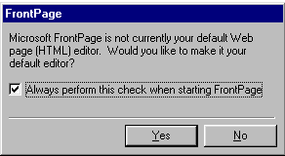
You should now be in the Microsoft FrontPage 2000 main screen. If you have not used FrontPage 2000 before, a small menu screen, like the one at the right, will appear. This little menu asks if you want to make FrontPage 2000 your Editor. This is up to you. If you’re advanced enough to understand this, you can choose your default editor later. If this doesn’t mean anything to you, then you are new to web pages, and the Editor you will learn about in this tutorial will, logically, be Microsoft FrontPage 2000. So, I would answer Yes. If you’re in FrontPage 2000, you’ll see, in the upper left corner of the screen, a title that looks like the one just to the right.

Click-on all of the Titles in the Menu bar (like the one below) and familiarize yourself with what they do. As you click-on each Title, look at the items in the menus that “drop” down when you click-on each Title.

When you have finished this task, slowly move the cursor over the buttons in the button bars (like the one below) and read the text help’s that appear. You’ll need to pause a few seconds on each button to let the text help time to appear. Notice that the buttons “do” the same “things” as many of the drop down menu items.

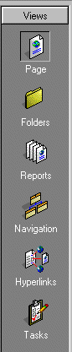
Now, observe, down the left side of the screen, under Views, there are a number of icon buttons (like the picture at the left). Notice that the Page button seems to be “depressed.” This indicates that you are in the Microsoft FrontPage 2000 Editor view. We’ll spend a lot of time here creating and editing our first web page. When we have finished creating a single web page, we’ll then create a web site consisting of multiple web pages. Click-on each of the icon buttons on the left. Start with Folders and continue down until you have clicked-on Tasks at the bottom. Each button shows you a different view of your web site. Again, the first button, Page, shows you what a single web page look’s like. As we create our first web page, you’ll see all of the changes here. Folders, shows you your web site in “file” form. You can’t see anything at the moment because we haven’t created a web site. Reports will show you the status of all the pages in your web site as we create them. Navigation will show you, as you create your web site pages, a little organization chart. The lines connecting the boxes (as shown in the Navigation icon button), will indicate the hyperlinks between the pages. Hyperlinks shows the actual links, once we create them, between the web pages. Tasks is a little word processor that let’s you maintain a list of “things to do,” once you begin creating your web site. Most of these won’t show you much now, but later you will be amazed at the web site you have created. We’ll return to all of these buttons when we begin creating our web site. Finally, click-on Page one more time. This is where we’ll begin.

Creating a single web page

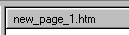
We’ll start this tutorial by placing a title on our first personal web page. You should be in Page and your cursor should be flashing on the left-hand side of the white area. The Page button should look depressed and at the upper left corner above the white area it should indicate: new_page_1.htm (like the picture below right). If it does not, click-on the Page button again, and look for the flashing cursor and new_page_1.htm.

Text

Type something like: Your first name (’s) Home Page (e.g. Janies’s Home Page). Then tap the Enter key once. Notice that when you tapped the Enter key that the cursor moved down two lines. This is just the way the Editor works. If, later on, you desire a single line between your text, simply Hold Down the Shift key and, while you are holding down the Shift key, tap the Enter key.

Now click to the left of your name and hold down the left mouse button and drag across all that you have typed, and release the button. This will highlight your title. It should look something like the picture below.

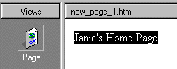

With the text highlighted, click-on Format in the Menu bar and then click-on Font. A Menu screen similar to the one below will appear (I’ve made some changes – you’re Font menu will look similar to this one when we finish the font).

2. Font style

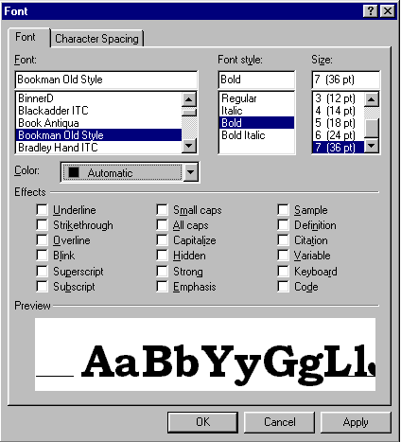

1. Font

4.

3. Size
4. Color

We’ll refer to each numbered item as we proceed below. There are several unique things that occur when you are working in web pages. If you are familiar with word processing, then you know that you can make your font size just about as big as you desire. However, when working in web pages, you are limited in the number of font sizes that you are allowed. In web terminology these are called headers. We are going to “snazz-up” our title font a bit. First, you will notice that a Sample of how the font currently appears is located in the lower Preview area of the Font menu screen. As we alter the appearance of the font, each change will appear, as we make it, in the Preview area.

First ( 1.), click-on several of the fonts in the Font area (1. Font in the picture on the previous page). Notice that, as you click, the fonts appear in the Preview area below. Click-around until you discover one you like.

Second ( 2.), click-on Font style - Bold. Watch the Preview area.

Third ( 3.), click-on one of the Sizes. Notice that, when you do, the Preview changes to that size. Also, notice to the left of the font size there is a 1, 2, 3, [e.g. 4 (14pt)]. In web pages this is the size of the header. Since we are creating our web page in a program called Hypertext Markup Language (HTML) you will find that in a number of word processing like functions we are limited in what we can do on our web page. FrontPage tries to take care of these. In the case of Fonts however, we are still limited to 7 font sizes – called headers. In the “old” days, a few years ago, you would indicate a font size by typing in something like <h7> to do the same thing we’ll do to make our font the largest size. When we finish this web page we’ll click-on the HTMK tab at the bottom of the screen to see the “programming code” that we have created by simply using good new FrontPage 2000. In our case, move down and choose the largest size: 7 (36 pt).

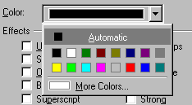
Fourth ( 4.), click-on the down triangle to the right of Color. A list of colors appears (like on the right). Click-on More Colors. When you do, the following Menu screen appears.

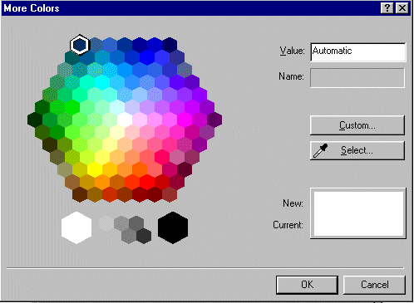

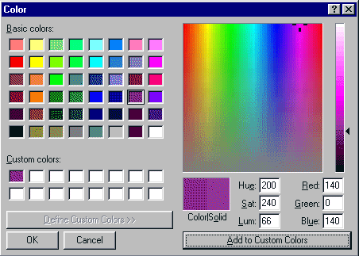
When the above menu screen appears, click-on Custom. The below menu screen will now appear.

Click-on one of the Basic Colors (arrow on the left). Notice that, when you do, a small marker appears in the color pattern (arrow on the right). Notice that a small triangle appears on the right of the pattern. You can click-on the triangle, hold down the left mouse button, and drag the triangle up and down. As you do, you will see changes in the color. Try this. For now choose a favorite dark color. If, you want to use this color again later, click-on Add to Custom Colors. You will see your choice appear in Custom colors on the left. This color will always appear whenever you want it for other text in this web page. When you are satisfied, click-on OK once, again and a third time.
You will notice that when you return to your web page that the area you highlighted is still highlighted (and you won’t see your color as you selected it). You will need to point away somewhere in the white area of the page and click the left mouse button. This will remove the highlight and show you the color of your text. If you don’t like the color, try again.

Saving your web page

It’s wise to save your web page periodically so that you don’t lose your hard work. There are several ways to do this. First, click-on File in the Menu Bar and then click-on Save.

The following Menu Screen will appear.

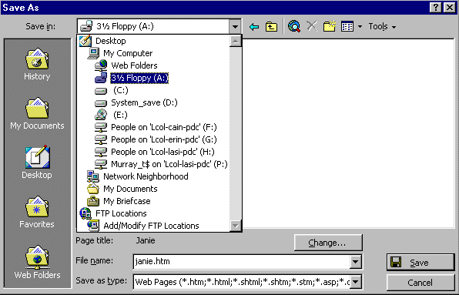

We will be saving this web page on a floppy disk in the A Drive. So, insert a formatted High-Density disk in the A Drive. When the disk is in place, click-on the small triangle to the right of the Save in: box. A “drop down” menu will appear. Click-on the 3 ½ Floppy (A:). If you don’t have a floppy disk, as indicated at the beginning of the tutorial, you can click-on the C Drive and save on it, or in one of the folders on the C Drive.

The drive you choose will now appear in the Save in: area. You will need to give your web page a File name under which it will be saved. FrontPage will try to guess one for you. Be careful here. FrontPage will try to use your title for the name. If it is more than 8 characters long, some older computer systems and servers might not work well with the name. Also, the name should not have an apostrophe (’) as this is a reserved character and could cause later problems as well. So, create a logical name for your web page like the one above.

Inserting a Photograph

At this point we’d normally insert your picture in the web page. If you know how to use a scanner, scan a picture of yourself. If at all possible, scan the picture as a GIF or JPEG. These will load faster in your page. If you don’t know how to do this, have someone who does, scan a photo for you. Or, if you have access to a digital camera, have someone take a digital picture of you. Photograph your picture directly to the disk, which your page is saved, or transfer the image to the Hard disk where your web page is located.

Something really important in web pages

You need to have all of the “parts” of the web page in the “same place”. In order for the page to load correctly, the text, pictures, animations, video files, photos, sounds, etc., all need to be on the A drive (for a small web page) or in a folder on the hard drive. If the web “page” can’t find the various items, you will not be able to see them in your page.

Before you insert your picture, make sure that your cursor is flashing a couple of spaces below the title. Then click-on Insert in the Menu bar and then click-on Picture, and then click-on From File. The following Menu screen will appear.
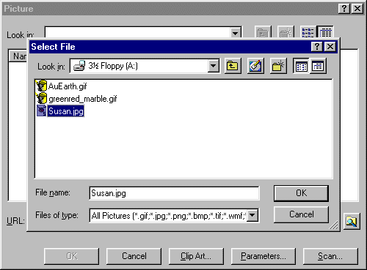

In the Look in: area of the Menu screen, click-on the small triangle and select the disk drive where your photograph is located. It is assumed that the location is the A drive. Again, make sure that all of the “items” are in a single location (like the A drive or a folder on the C drive) so that the web page can locate them. Next click-on the file name for your photograph in the area below the Look in: area. When you do, it will appear in the File name: area. When it does, click-on OK.
Your web page should look something like the sample below.

Corner Sizing Square

Your picture might be larger or smaller than the one above. To “size” the picture, point to the picture and click the left mouse button. This will “activate” the picture. You will see small “squares” at each of the corners and in the middle of the top, bottom, and side edges. If, you move the mouse over one of the corner “squares,” a small two-headed arrow will appear. When this occurs, click and hold down the left mouse button, and drag the corner in or out to make your photograph larger or smaller. If you click-on one of the top, bottom or side square’s and do this you will get a “fat” or “thin” picture. By clicking-on the corners, the picture holds its normal size ratio or perspective.

After something this significant, it’s a good idea to Save again. From now on, when you save, you can simply click-on the small diskette in the button bar if you desire. Or, you can click-on File in the Menu bar and then on Save as you did previously. Your choice.

You may want text to “wrap” around your photograph. And, you may also want your photograph to be somewhere other than on the left side where it “defaulted” when you inserted it.

If the flashing I-bar cursor is not below your picture, click-below your picture and it should appear. If it doesn’t, point with the mouse, to the right of your photograph and click the left mouse button. Then, tap the Enter key and the cursor I-bar should be just below your photograph.

Now type the following: This is where the text appears for this option.
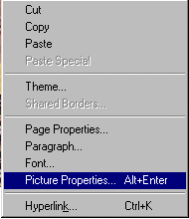
To observe where the text appears, we’ll illustrate each of these “appearances” below. To do this, point in the picture and click the right mouse button. Whenever you right-click on any area or “thing” in Windows, a “tailored” menu will appear for that area/thing. When you right-click in your photograph, the following Menu will appear (as shown on the right). Click-on Picture Properties.

The following Picture Properties menu screen will appear. Click-on the Appearance “tab” at the top of the menu page. Then, click-on the small triangle to the right of Alignment: Default.

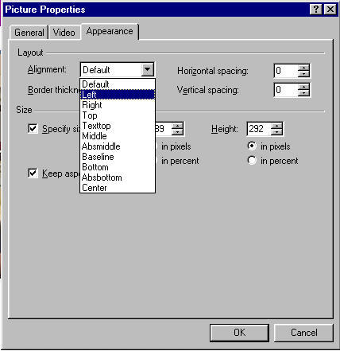

Notice the choices that appear below Default. We’ll now illustrate each of these choices.

Click-on Left, and then click-on OK. You will see a new display similar to the one below. If you desire to duplicate the below illustrations, repeat the above process for each of the choices indicated. If you do not, simply observe the illustrations.
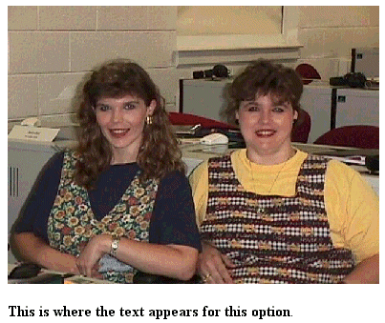

This is the Default.

This is the left appearance choice.


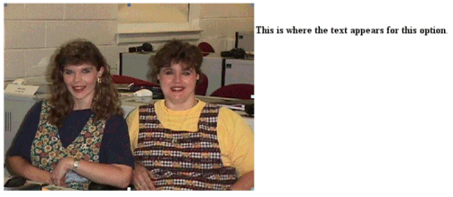
This is the right appearance choice.
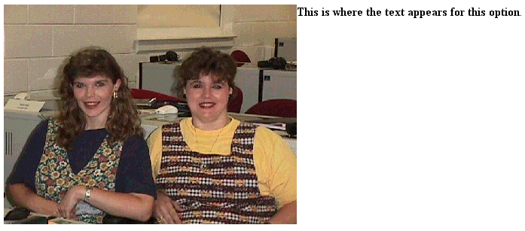
These are the top and text top appearance choices
These are the middle, center and absmiddle appearance choices
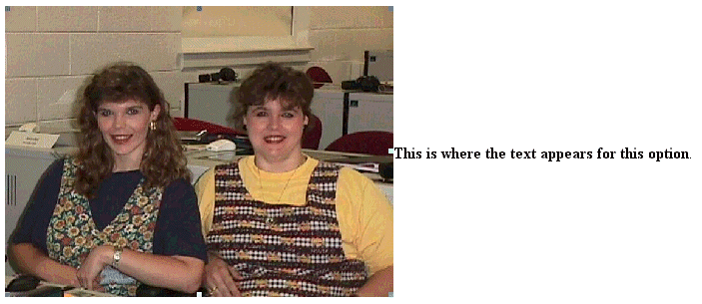

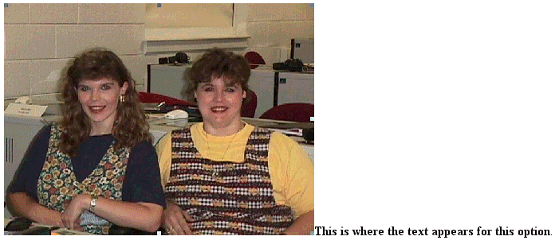
These are the bottom, baseline, and absbottom appearance choices

Let’s reset the picture back to the Default. The text you typed should be just below the picture.

Now is a good time to save again.

Background

Our web page looks a bit drab at this point, so let’s add a colorful background, an animation, a sound and a link to a really neat college.

Viewing web pages in a browser

So far we have been working only in the Microsoft Editor. We have not really seen how the web page will look to the “world” in a browser. In the button bar, below the Menu bar, there is a button ( see below) that will load our web page in a browser (e.g. Microsoft Explorer, Netscape).
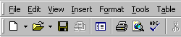

Now, click-on the browser button in the button bar. Or, you can click-on File in the Menu bar and then click-on Preview in Browser. If you do click-on Preview in Browser, Explorer will ask you to choose a browser that is saved on your computer. We normally use Microsoft Explorer, as it has proven more reliable of late. However, if you are a Netscape or other browser user, then choose your favorite if this is important to you.

Microsoft Explorer browser, or Netscape, will load in your computer and your web page will appear. It will look just like it would if someone looked at it on-line.

We’ll use the Microsoft Explorer, or the browser of your choice, to find a background, animation and link. You’ll actually “copy” a background color/pattern of your choice, as well as an animation, sound and link to your web page. To do this we’ll use a couple of handy sites on the World Wide Web.
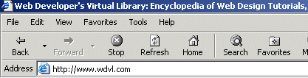

Notice that an Internet “address” has been typed-in the Address: area above. Click-in the Address area of the Microsoft Explorer on your screen and type the following: http://www.wdvl.com. This will link you to a web site that contains a lot of neat things. When you have completed typing, simply tap the Enter key and Microsoft Explorer or Netscape will load this site.
Your browser should now load the web site stars.com. The screen should look similar to that below. This screen has changed several times in the past year, so if it does not look just like this, don’t despair. Trust me, you’ll be OK. The screen should indicate at the top that you are in the Web Developer’s Virtual Library. You’ll just have to be flexible to find the next correct link.


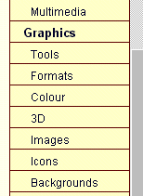

We want to add a background, and an animation from the Web Developer’s Virtual Library. To do this we’ll start by clicking-on the Graphics button. This button/link has also moved several times. At this time it is in a scroll down list on the right side of the screen. Run down until you see the word Graphics. When you see it, move your cursor over Graphics, you will see the little pointy hand. Click-on the word Graphics. Your screen should look something like the one to the left, when you are ready, click-on Graphics. If your screen does not look just like this, look around for Graphics.


Microsoft Explorer or Netscape will now load the next web page. It should look something like the one below.

Use the “elevator bar” on the right side of the screen to move down slowly until you see a link to a backgrounds web page. It should look like the one below.
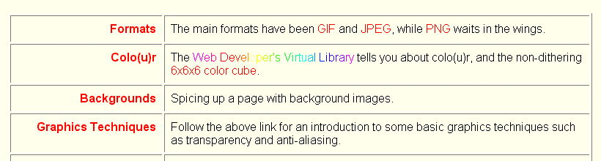
When you move your cursor over the word Backgrounds above you will see the “little pointy hand”. When you do, click the left mouse button. Microsoft Explorer will now take you to the next web page.

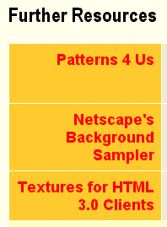

Again, use the elevator bar on the right to move down until you see an area on the web page that looks similar to the one on the left.

We’ll use the Netscape’s Background Sampler to select our first background. Click-on this and you will go to a web page with a nice number of basic backgrounds. The top of the web page should look something like the one below.



The above title will appear at the top of this web page. Again use the elevator bar on the right side of the page to run down until you see some backgrounds. Earlier, it was suggested that you use a dark color for your title. It is now suggested that you use a light color for your background. This is to assist you in “seeing” your text against the background. As you become more proficient in text and backgrounds, you can experiment and attain some really “interesting” combinations. We chose this background for the tutorial since text is easy to “see” against it. We also use this tutorial in our computer labs, this image projects well with computer projectors on movie screens.

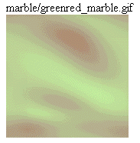

This is a good background as it is light enough to show your text, but also has some color to it. You choose a light background that you like. When you have chosen your background, point in the middle of the background with your mouse and click the RIGHT mouse button. A tailored menu screen will appear. This is a technique that we’ll use from now on to “capture” any “object/picture” that we’d like to use in our web page from the Internet.

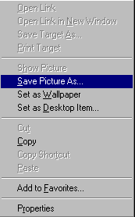

When this menu appears run down and click-on the Save Picture As… item in this menu screen. This will take you to the menu below.

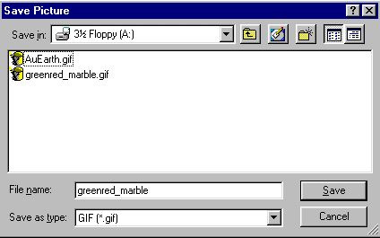

It is assumed that for this exercise we will continue to use the A drive. So, click-on the 31/2 Floppy [A:] in the Save in: area. Notice that the name of the background appears in the File name: area. When you see the correct drive and file name, click-on Save.

You now have this background in your “folder” and available when we return to Microsoft Editor to insert into your web page.

Animation

Next we’ll “capture” a famous animation by Dan Austin. In the upper left corner of Microsoft Explorer is an arrow that indicates “Back” when you move the cursor over it. Click-on the back arrow two times. This will take you back to the graphics page. It has a black background. Run down the page a bit more until you see:

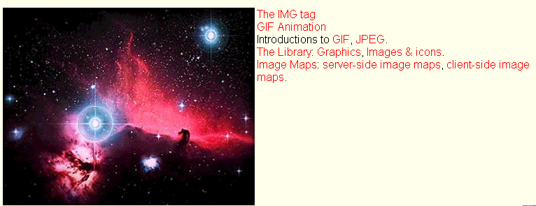

The next web page we’ll visit is GIF Animation. Move your mouse over GIF Animation and when you see the “little pointy hand” click-on GIF Animation. This will take you to:

As we have done before, use the elevator bar on the right side of this page to run down until you see:
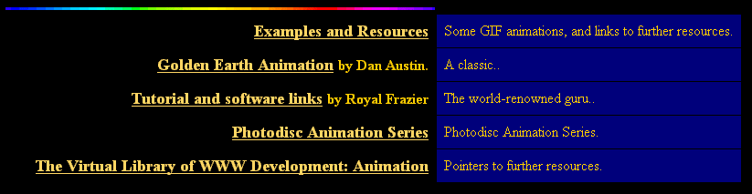


We’re, as indicated, going to select an animation by Dan Austin. So, Move the cursor over Golden Earth Animation, and when you see the “little pointy hand” click the left mouse button. This will take you to a web page with a rotating earth. Move down the page a bit until you see the rotating earth.

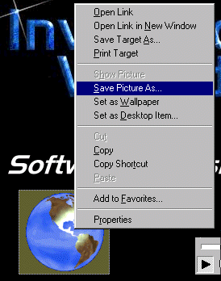
You need to be careful here. When you run the mouse over the rotating earth. You’ll notice the “little pointy hand.” This indicates that there is a web page link associated with the earth. If you accidentally click-on the earth and go to another page, click the back arrow to return to this page.

Carefully move the cursor over the earth and click the right mouse button. The save screen will again appear.

Click-on the Save Picture As.., just like you did before.

A Save as menu screen will appear and you can again save this picture to the A drive. The AuEarth will appear in the File name and you can click-on Save.

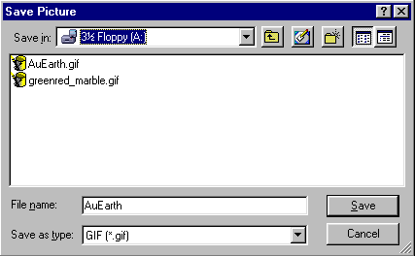

Web Plagiarism


Note: when you look at Dan Austin’s web page you will notice that he has a copyright. This is becoming a larger and larger topic: web plagiarism. To use things you copy from folks like Dan Austin, you need to show his copyright. Some objects you click-on will not have a Save Picture As associated with them. This indicates the person who created this object does not want you to have it. There are numerous web sites that address this topic. A major site we recommend is: http://www.georgetown.edu/honor/plagiarism.html. Please be careful and aware of web plagiarism
Sound

You now have a background and animation to add to your web page. Now let’s “capture” a sound. If you don’t have a sound card and speakers or earphones, you will not be able to hear the sound and may get an error message when you do the below procedure. You may not want to attempt “capturing” the sound until you have these “things.”

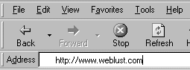
Now we’re going to go to an entirely new web site. So type-in: http://www.weblust.com in the Address area of Microsoft Explorer or Netscape. Then tap Enter. You will now proceed to a marvelous “sound” site.



Click-on Fred’s Digital Universe and you will be “surfed” to:


Run down this page utilizing the elevator bar on the right until you see:

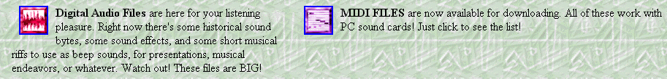

You will want to visit many of “Fred’s” areas. However, we’ll visit the MIDI FILES to “capture” a sound. So click-on the small square to the left of MIDI FILES.



Once again, run down the page until you see:

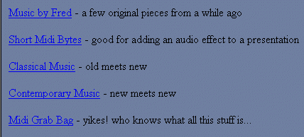

Let’s get some “class” and click-on Classical Music. You can choose one of the other groups if you desire. When you, again, run down the Classical Music page, of the one your chose, you will see a number of selections.
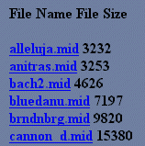

I’ll choose the bluedann.mid for the sound file. Later, I’ll insert this sound into my web page. When I left click-on bluedann.mid a sound “player” screen will appear. What you see on the screen will vary in a appearance depending on what “player” you have installed. Mine looks like the one below. When the player has “loaded” the sound you will hear it over your speakers or earphones.

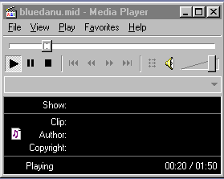

After you have listened to this tune click-on the “X” in the upper right corner of the player (see left picture) to stop the player and end the tune. You’ll have to be careful as you listen to various tunes. If you keep clicking on tunes and not closing the player you can have a “ton of tunes” showing on the Task Bar at the bottom of the screen. So, keep choosing tunes, listening to them and closing the player until you find one you like.

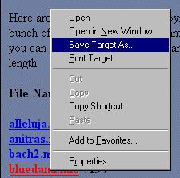
When you have a song you like (in my case I chose the bluedann.mid), carefully, again, move the cursor over the song you want to save in the song menu until you again see the “little pointy hand”. When you do, carefully click the right mouse button and a drop down menu will appear.

Move to and click-on Save Target As… and you will see a normal Save As screen appear. Save this sound as you did your animation and background.

bluedann.mid

Inserting a Background in your Web Page

In the status bar at the bottom of the view screen you will see the Microsoft FrontPage 2000 icon displayed in the task bar (see right). We will now return to the Microsoft FrontPage 2000 to insert the background, animation and sound we just captured and saved. So click-on the Microsoft FrontPage 2000 button.

When the Microsoft FrontPage 2000 screen returns, make sure that, on the left side you have clicked-on the Page button. Your cursor should be flashing is below the text you typed in earlier. If you do not see it there, run down the screen and click below the text. If the cursor appears to the right of the text, tap Enter to move the cursor down below the text.

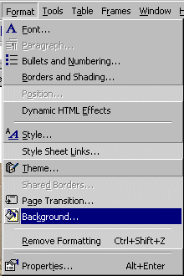

Now it’s time for our background. Click-on Format in the Menu bar and then click-on Background.

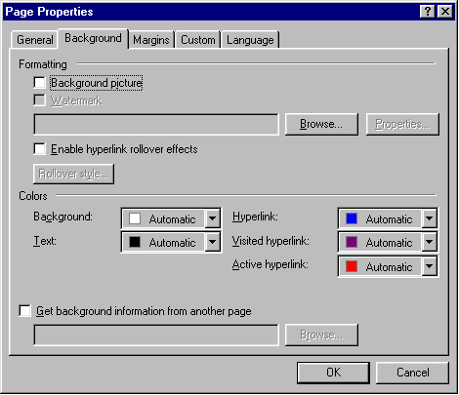

The following screen will appear. Click-on Browse which is under Formatting on the right side of the menu (see the arrow).

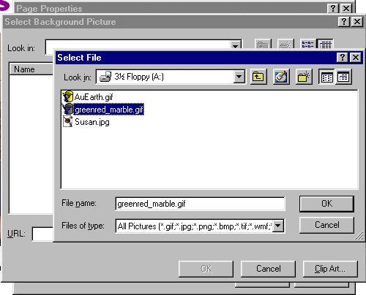
Now you will see:

Make sure you are on the A drive. or the folder where you have saved all of your “things.” For the background, click-on the background you chose earlier. When you click, the file name will appear in the File name area. Now click-on OK.

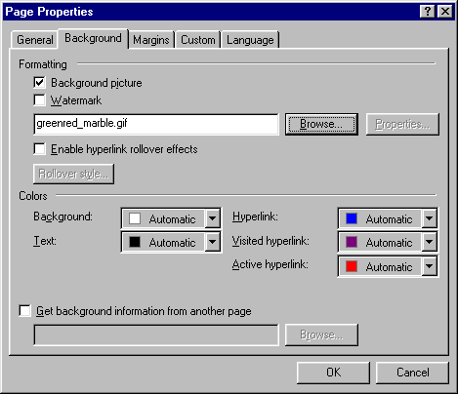
You will return to the Page Properties screen where we began this process (under File in the Menu bar).

Notice that the background you chose is now indicated in the Background Image area. Click-on OK again.
WOW! What a difference!

Inserting an animation in a web page

Since we previously saved the earth, we’ll insert the earth in our web page! Sounds rather awesome.
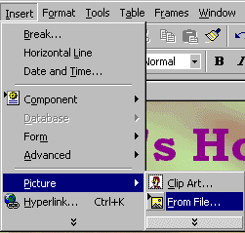
Make sure that you can see your cursor below the text. Inserting the animation is exactly the same as inserting your photograph.

Click-on Insert in the Menu Bar and then click-on Picture and then on From File.

When the following screen menu appears, click-on AuEarth and then click-on OK. The earth will appear below the text in your web page!

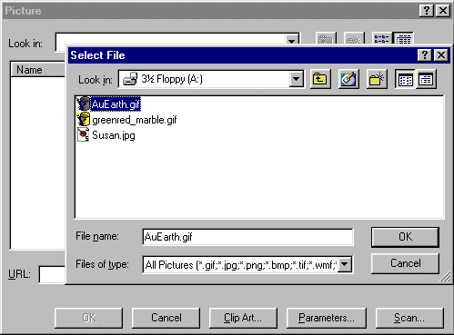

Something seems to be wrong! The earth’s not rotating! There really is no problem, you just don’t see the animation effects in the Microsoft Editor. You have to go to the Microsoft Explorer to see these effects.
So….. Save your file and then click-on the Browser button in the button bar and you will go back to Microsoft Explorer or Netscape. Now you see your background and the rotating earth.

Now back to Microsoft FrontPage 2000 (click-on the FrontPage 2000 icon in the Task bar at the bottom of the screen as you did before) to insert the sound.

Inserting sound into the web page

The cursor should be flashing to the right of the earth. Tap Enter once to move the cursor below the earth.

Sound is a bit unique. We could put the sound in the “background” of the page and it would begin playing when the page is opened if we were using only Microsoft Explorer. However, other browsers can’t “play” the sound when you do this. So we’ll insert the sound with a “link.” This is what web pages are all about: links.

Type-in something that would indicate that if you clicked on it, you would hear a sound. I’m going to type in: Listen to the Blue Danube. Then tap Enter one time to move the cursor down for the next item.

Click in front of the text, and, holding down the left mouse button, drag the cursor over the text to highlight it (just like you did when you started the web page title).
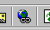
Now, with the text high lighted, click-on the Hyperlink button in the Menu bar.

The following Create Hyperlink screen will appear.
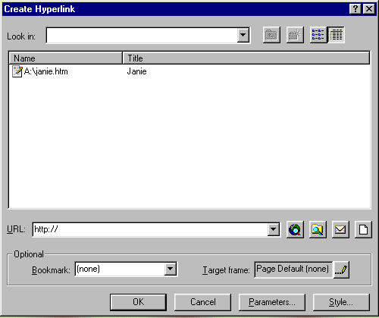

Folder Button

Since the music we saved is on a disk or disk drive in the computer we’ll click-on the folder button in the screen above to locate our sound.

The Select File screen will now appear. Make sure you are on the A drive or folder where you saved your sound. Click-on your sound, and then click-on OK.
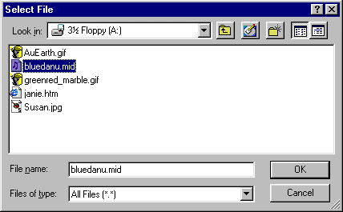

After you click-on OK and return to your web page, click-under you’re the area where you highlighted your sound (to turn off the highlight). You will notice that the text you highlighted has now “turned blue” and is underlined. This is the universal “symbol” for a “link.” You are now “linked” to your sound. This is why it is so important that all of your images and sounds are in one location.

Save your work and then click-on the Browser button again. Run down, when your page appears in the browser, and click-on your sound link. Sounds great.

Links to other sites on the Internet

Now we’ll link, using the Internet, to a great small college in Virginia. Make sure that you are below the sound link. If you are not, click-below the sound link and see if the flashing cursor appears. If it does not, tap Enter.

Now type-in something like: Visit Lynchburg College.

High light what you just typed-in (just like with the sound), and click-on the link button again.

This time, when the Create Hyperlink screen appears, we’ll click-on the web hyperlink button

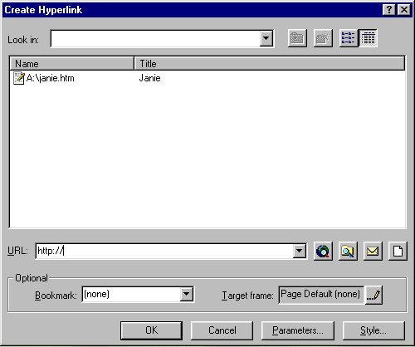

Hyperlink Button

The Microsoft Internet Explorer or Netscape appears with the following statement:

So, in the Address box, type the Internet address for Lynchburg College:

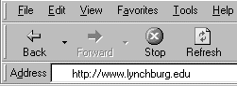
http://www.lynchburg.edu

Now tap Enter and you will “go” to the home web page for Lynchburg College.

To complete the link, carefully click-on the minus “ – “ sign in the upper right corner of the screen. This will take you back to the Create Hyperlink screen and will place the address for the Internet site in the URL (Uniform Resource Locator) area of the screen. Click-on OK. and the “link” will be established. You’ll notice that the Lynchburg College link is now “blue and underlined” just like the sound link.
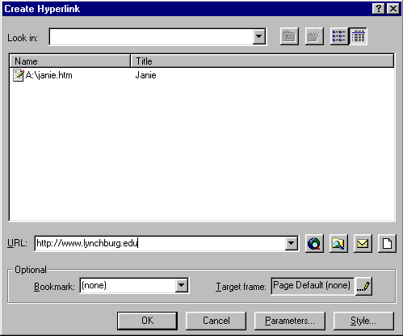

Save again.

Now click-on the Browser button again to go to Microsoft Explorer or Netscape and see your completed web page. Try the links. If you “go” to Lynchburg College and want to “get back” to your page, simply click-on the back button as you have done in the past.

One more thing – HTML

So far you have been working in a program very similar to a word processor with some limitations. Actually, FrontPage 2000 has been “converting” your work into the Hypertext Markup Language (HTML). To “see” the computer program code you have created we’ll do two things.

First, go back to FrontPage 2000 again by clicking-on the FrontPage icon in the Task Bar at the bottom of the screen.

When you are in FrontPage you’ll notice the Page, Folders, Navigation, buttons on the left side. At the bottom of the screen, on the left side, you’ll see some “tabs.” One of them indicates HTML. Click-on the HTML tab. This will take you to a screen that shows you the HTML code you have created. Your screen should look something like the one below.

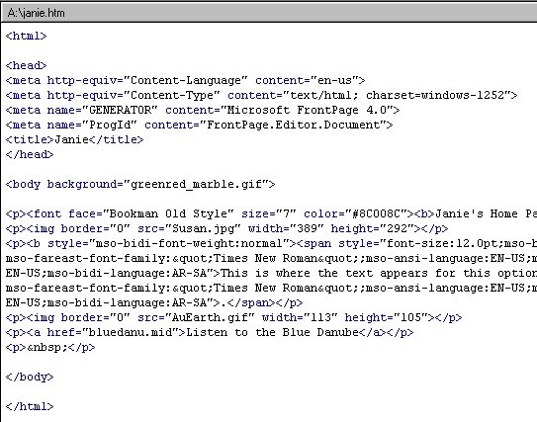

Wow! You created all of this computer programming code and most of you don’t know anything about programming. Neat program, FrontPage.
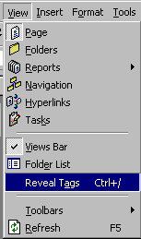
Congratulations. You have now successfully completed a web page.

One more really neat thing in FrontPage 2000, which is new over older versions, is that you can “see” this HTML code on your web page as you edit it.

To do this click-on View in the Menu bar, and then carefully go down to the bottom of the menu, you will see and choice Reveal Tags appear. Click-on it.

Your web page screen will “change a bit” and you will see HTML “things” called “tags” appear. Your web page will look similar to the one below. As you become more proficient and advanced this can be a real help. “Old time HTML folks” had to create all of their web pages by coding them as you just saw. That was a task. But, every now and then, you might find these codes will assist you.

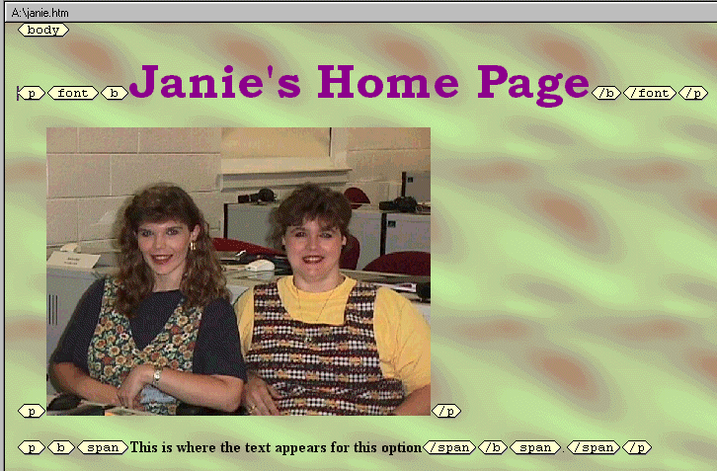
If you have any questions or comments please contact:

MURRAY_T@MAIL.LYNCHBURG.EDU

Thank you for your time and patience.

Now we’ll create our web site. You may want to take a break and relax before you begin.
Creating a Web Site
Using Microsoft FrontPage 2000 for Windows 95/98

Created: January 9, 2000

Starting Microsoft FrontPage 2000

In this tutorial we’ll create a small web site using Microsoft FrontPage 2000. If you have not completed the tutorial: Creating a Web Page Using Microsoft FrontPage Editor 2000 for Windows 95/98 you should do so prior to attempting this tutorial. This Tutorial explains how to create and edit a single web page; this knowledge is pretty essential prior to your attempting this tutorial. In the previous tutorial it explains how to hyperlink or link to other web pages. The really neat thing about this tutorial is that it creates these links “automatically” for you.
To “start” the program, Double click on the FrontPage 2000 icon (looks like the one on the right), or click-on Start in the lower left corner of the screen, then click-on Programs, and then on Microsoft FrontPage. You should now be in Microsoft FrontPage 2000.

If you are in FrontPage 2000, you will see, in the upper left corner of the monitor screen (it looks similar to the one at the right).

Take a few moments to go back to pages 1 and 2 of this tutorial - Creating a Web Page and Web Site Using Microsoft FrontPage 2000 for Windows 95/98 – Starting FrontPage 2000.
Review what the screen should look like and re-familiarize yourself with the various buttons on the top and left side of the screen.

If you still have your single web page on the screen, click-on File in the Menu bar, and then click-on Close. If you are prompted to Save your changes – click-on Yes.

Creating a web site (with multiple-linked pages)

In the button bar along the left side of your screen the Page button should be depressed.

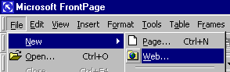
To create a web site, click-on File in the Menu bar and then click-on New and then on Web (should look like the picture on the right).

The New (FrontPage Web) menu will appear (see below). It will not look exactly like this. You will need to do a couple of simple things to create a “place on your hard disk” for your web pages.

First, make sure that the upper left icon “One Page Web” is highlighted. If it is not, click- on it.

Second, in the “white area” under Options – Specify the location of the new web: type-in the following: c:\webtest. Your New menu screen should look like the one below. When it does, click-on OK.
1.

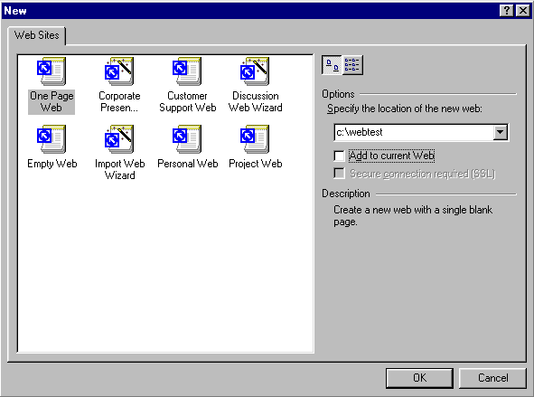
2.

This will take you back to the FrontPage 2000 main screen. However, you will notice there are some changes to the appearance of the screen. On the left side you will notice that two additional “columns” have appeared: Folder List and index. tm.

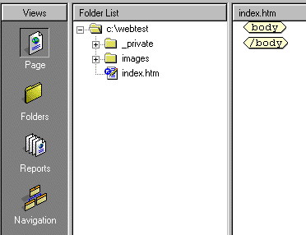
The Folder List (arrow above) indicates that your new web site is located on the C: drive in the Folder webtest. Notice also that two new folders have been created by FrontPage – private and images. FrontPage has also created your initial home page called index.htm (arrow above). When we finished the single web page in the last tutorial, we clicked-on Reveal Tags. In the index.htm screen you are in the Page (edit) “mode,” just like you were when we created the initial single web page.

To create our web site we’ll want to be in the Navigation View. So, click-on the Navigation button as indicated by the arrow above.

A little web page and a world globe will appear with an arrow circling the page and the globe. This indicates that your web site is being created as you requested. When this process is complete you will see your initial Home Page of the web site in the center of the screen. Take a few minutes to look at all of the “stuff” on the screen. In the center of the screen you will see:

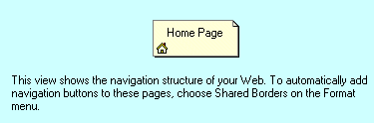

Take note of the words below the Home Page, they’re important. We’ll come back to this in a moment.

Saving your web site

If you haven’t already, you’ll notice that there is no “Save” option under File in the Menu Bar. Nor is there a little “Save diskette” in the button bar. One of the neat things in FrontPage is that it automatically saves your web site as you make each change. To prove this, click-on File in the Menu Bar and then click-on Exit. FrontPage will close. Now open FrontPage as you did at the beginning of this tutorial. When FrontPage appears, click-on File and then click-on Open. The Open File menu screen (on the next page) will appear. You will need to first click-on the small triangle to the right of the Look in area, then when the menu appears below, click-on the C: drive.

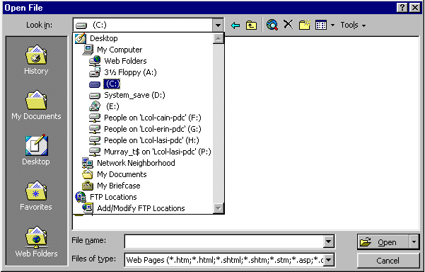
Now the above screen will change to look like the one below.

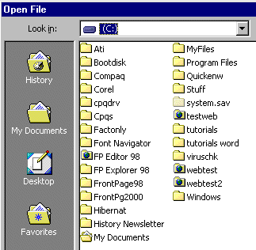
Click-on webtest and then click-on OK, and when your web site opens, click-on Navigation so we can get started creating our web site.

A webtest screen will now appear. Click-on index.htm and then click-on OK again. This will open your web site with the Home Page.

Note: you will still have to save individual web page changes in Editor as you work on them.

Creating your web site

We’ll create a small personal web site to get you started. You should be in Navigation View.

First, left click-on the Home Page in the middle of the screen. Prior to your click, it will appear as a light yellow icon, when you click-on it, the page will turn blue. This indicates to FrontPage which page you desire to work on. In this case we’ll add, and automatically link, three additional pages below our main home page.

If you accidentally double-clicked on the Home Page icon, this indicates to FrontPage that you want to edit this page in FrontPage Editor, so FrontPage loaded your page in the Editor. We’ll do this a lot after our pages are created. And, it’s not a big deal now. Simply click-on the Navigation button on the left and you’ll be back where you want to be.

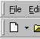
Again, make sure the Home Page icon is blue. To add the first page under our home page, you will notice, in the upper left corner of the screen, a small button that indicates New Page. Click-on this New Page button.
As soon as you do, the following FrontPage Explorer assistance menu may appear. If it does, click Yes. If it does not you’ll create a new page below the Home Page.

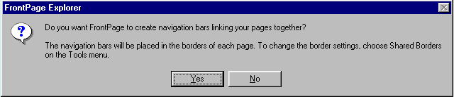

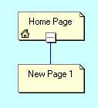
This is where FrontPage really does its work. When you click-on Yes, all of the pages you create in FrontPage will automatically be hyper linked by FrontPage. Your screen should now look like the one at the left. We’ll come back and “name” our pages later, after we have created our little web site.

Now we’ll add two more pages under our Home Page. Each time, click-on the Home Page to turn it blue, and then click-on the New Page button. Your screen should now look like the one below.

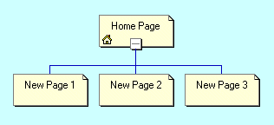

Next, we’ll add two pages under New Page 3. The process is similar to what we just did. First, click-on New Page 3, to turn it blue, and then click-on the New Page button. Do this twice. Our web site should now look like the one below.

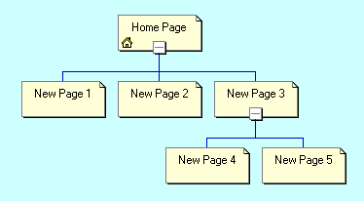

If you happen to make a mistake, as you are adding new pages, you can simply left click-on the erroneous new page and tap the Delete key, or right click-on the page and then left click on Delete when the menu appears. The following menu screen will appear.

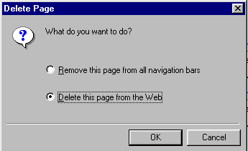

At this point you’ll want to click-in the little circle to the left of Delete this page from the Front Page web. This will totally remove the page from the web site. Later you may want to keep a page to use at a later time. In this future case you‘ll use the other choice. We’ll look at this again when we return from our preview in a browser.

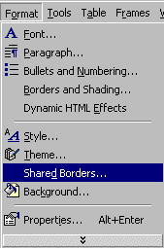
You now have the beginning of a small web site. Before we attempt to look at it we need to do a very important task. Remember the words below the Home Page that I indicated that we would come back to? We need to “tell” FrontPage “what” we want to “see” on our web pages in our web site. To do this we first have to follow the instructions below the Home Page. They tell us to select Shared Borders in the Format menu. To do this click-on Format in the Menu bar and then on Shared Borders. The menu to the right shows this.

This will bring up the following menu.
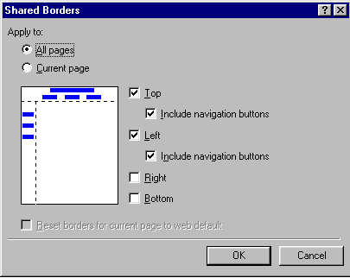

To show the titles of each web page and the links to the other pages you will need to click-in the small squares to the left of: Top, Include navigation buttons, Left, and Include navigation buttons. Your Shared Borders screen should look exactly like the Shared Borders at the left. When it does, click-on OK.

To “see” what the site would look like, at this point, on the World Wide Web double click-on quickly on the Home Page icon. You can also click the right mouse button while the cursor is on the Home Page and, when the menu appears, left click on Open. This will load the Home Page in Microsoft Editor (Page view).

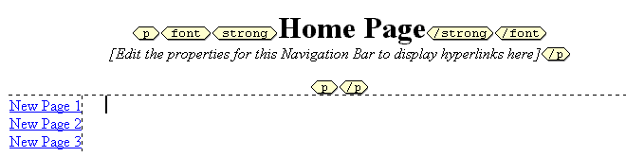
Before we open the web site in a browser, take a few moments to look at the top of the page in the Editor. It should look like the view below. Notice two things. First, observe that the title Home Page appears at the top of the page in the Editor – just as it did when Front Page Explorer created it. Second, note the New Page 1, 2 and 3 on the left side of the view below. These are links to pages below the one you are editing in the Editor. We’ll, as indicated earlier, return to the Explorer and re-name these pages so that they make more sense to your web site. Again, these are the automatic hyperlinks created by the Editor. Don’t worry about the “dashed lines” you see. These are simply to assist you later in the Editor. You’ll see that they “disappear” when you view your web site in a browser.
1.

1.

Viewing web pages in a browser
2.

Now, in the Editor, click-on the browser button in the button bar. Or, you can click-on File in the Menu bar and then click-on Preview in Browser. If you do click-on Preview in Browser, Explorer will ask you to choose a browser that is saved on your computer. We normally use Microsoft Explorer, as it has proven more reliable of late. However, if you are a Netscape or other browser user, then choose your favorite if this is important to you.

Now you’re in a browser and your “blank” web site will respond like any web site. When you move the cursor over New Page 1, 2 and 3, you will notice that the “little pointy hand” appears indicating a hyperlink. Click-on New Page 1. Your New Page 1 should look like the one below.
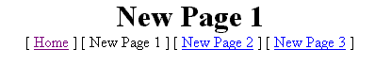

Notice that all of the “text buttons” are on the “line” below New Page 1. Notice the [Button] “buttons” below New Page 1. If there are web pages created by Front Page Explorer that are ABOVE or on the SAME Navigator level as the page, which you are editing in the Editor, the names of the pages will be shown where [Button] is located. It does not matter if there are more than three pages above, or on the same level as the current page, all the pages will show with their names. These are part of the automatic hyperlink that we mentioned earlier. As indicated earlier in the tutorial, this means that all of the pages are either above [Home] or on the same Navigator level as New Page 1 [New Page 2 and 3].

Now click-on New Page 3 in the browser, remember that we created two new pages below New Page 3. Your browser should now look like the image below.

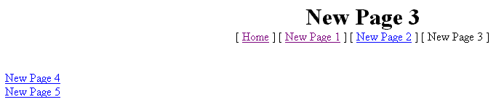
Notice that in the line below New Page 3 contains the text buttons above or on the same Navigator level, and on the left are the pages below New Page 3.

Titles for web pages in your web site

Now let’s go back to FrontPage 2000 and “name” our web pages. We’ll be doing the following process frequently, so it’s good to make sure that you understand the process of moving from one program to another. At the bottom of your screen there is an area which shows/indicates what programs are active. This is called the Task Bar. Since we are using FrontPage 2000, as well as a browser [in my case I’m using Microsoft Explorer]. Your Task Bar should look similar to the one below.

The icon for FrontPage 2000 has a white arrow on blue. On my Task Bar the icon on the right is for Microsoft Explorer and indicates that it is “browsing New Page 3.” If you are unsure which icon is which, you can “run” your arrow cursor over an icon, pause on it for a few moments, and text help will appear to indicate the name of the program (e.g. FrontPage, etc.). Click-on the FrontPage 2000 icon (indicated by the arrow above) to return to the FrontPage. In the upper left corner of the screen it should indicate that you are in FrontPage (like below).

If you’re not in the FrontPage, try again. When you do return to the FrontPage make sure that you are in the Folders view. If not, click-on the Folders button on the left. You should see the view below.
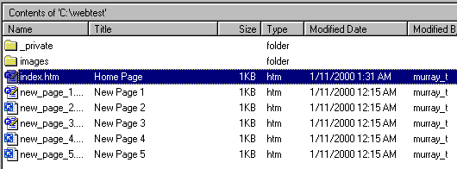

Along the left side, under the Name column you see the “web page names (.htm) for each page. Under the Title column you see the Names as shown in the Navigation web page “boxes.” When we rename the pages the “new” names will appear in the Title column. So let’s get started.

Carefully click once on the Home Page box title. The box will turn blue once again. Now click-on Home Page one more time and wait a few moments. The title will now be highlighted in blue. In a Windows program this indicates that you are able to edit the text. You may start typing immediately. What you type will replace Home Page, or you can delete the text and then type. For now, type-in your first name (with an apostrophe) and then an “s,” and then the words Home Page (I’ve typed-in the name of a person who has assisted wonderfully with these tutorials). When you are finished, tap the Enter key. Now click-on View in the Menu bar and then click-on Refresh. Click-on the Folders button. You will now see that the Title of the page has changed to your name. Your “box” in the organization chart and in the Title column at the bottom should look similar to those below.
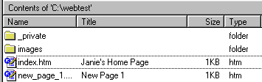
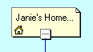

Now we’ll place some titles in the other “boxes.” We’ll use some “basic” titles for a general personal web. Once you get the idea of this you can change the titles to anything you desire, add more pages, etc.

For each page type-in the following:

- New Page 1: About Me
- New Page 2: About My Family
- New Page 3: My Hobbies
- New Page 4: Type-in the name of a hobby
- New Page 5: Type-in the name of another hobby

When you have completed these titles, click-on View in the Menu bar and then click-on Refresh. The upper and lower portion of the Navigation view should look like those below.
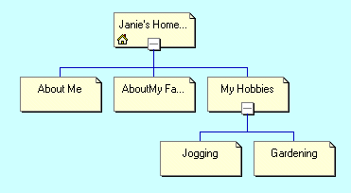
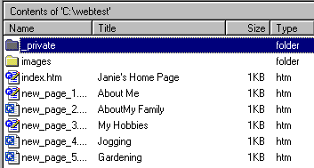
Let’s look at what we’ve accomplished by looking at our web pages in the browser. We’ll repeat what we did previously. You should still be in FrontPage. To “see” what the site looks like at this point on the World Wide Web double click-on quickly on the Your Home Page icon. You can also click the right mouse button while the cursor is on the Home Page and, when the menu appears, left click on Open. This will load the Home Page in Microsoft Editor. In the Editor, click-on the browser button in the button bar. Or, you can click-on File in the Menu bar and then click-on Preview in Browser.

Click around your web site. You will notice that Explorer and Editor have automatically changed all of your pages and buttons.

Themes

If you'll remember, in the Microsoft Editor tutorial, we browsed on the Internet and found a nice, colorful, background to replace the white default background in the web page.

Now, in Microsoft FrontPage we have the neat option to have a "Theme" background throughout our web site. The theme uses essentially the same color scheme for each web page (you can change them page by page later if you desire in the Editor), its buttons and links.

Let’s try a this. First, you’ll need to be in Microsoft FrontPage. So, click-on the FrontPage r “button” in the Task Bar at the bottom of the screen, like you have done before. Don’t worry where you are in the other programs (Editor and your browser) – we’ll be OK.

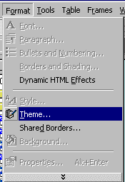

When you are back in FrontPage click-on Format in the Menu bar and then click-on Themes.

You will be taken to the Themes portion of FrontPage Explorer. When it first appears you will notice that the area on the right is blank. To view the Theme choices you’ll need to click-on a Themes (as shown by the arrow below). When you do, you’ll notice that the first Theme choice, Artsy, is highlighted in blue, and the Theme Artsy appears on the right. Click-on some of the other choices in the list below. You can try all of them if you like.

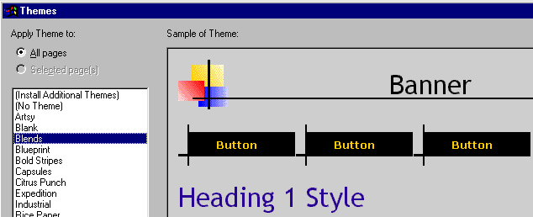

When you have decided on a Theme you like, you’ll need to click-on OK in the lower right corner to apply the theme to all of the pages in your web site.

Now click-on the Navigation button on the left side of the FrontPage screen. When you see your web site organization chart, double-click on your home page at the top of the chart. As before, this will take you to the Editor and your home page. You will now notice that the theme you chose has been applied to this page. Look at it carefully and notice the Title, buttons and links. They are now incorporated into your theme.

Next we’ll look at our pages in the browser we chose, but first click-on File in the Menu bar and then click-on Save All. Remember, when you are in the Editor you’ll need to save your changes to each page just like you did n the Editor tutorial. You can save each page individually, or all of them at the same time with Save All. Don’t forget to save frequently as you are editing your individual web pages.

Now click-on the Preview in Browser button as you did before, or on File in the Menu bar and then on Preview in Browser.

When your home pages appear in the browser notice that as you run the cursor over the links that the small pointy hand appears. Click-on the About Me text link on the left. When the About Me web page appears notice that the About Me button at the top is “highlighted” compared to the other buttons. Also note that as you move the cursor over the buttons that they become highlighted to indicated that they are active links. Browse around your web site and see how it works. Pretty awesome. Just a few clicks and look at what you have created!

Back to the Editor (Page) to place text, images and other “things” in your web pages

You have now learned all of the steps to create a web site it’s time to go back to Microsoft Editor and add the “things” you desire on each web page. This is normally a three-step process. First, click-on the FrontPage button in the Task Bar at the bottom of the screen. Second, double-click on the web page you want to edit in the Navigator view. Third, once you have typed the text, inserted some pictures and graphics, created some links, and whatever else for that page, save the page and then preview it in a browser. Then repeat the cycle as you work on your other pages.

The Creating a Web Page Using Microsoft FrontPage Editor 2000 for Windows 95/98 tutorial will show you how to do all of this if you have forgotten the process.

Using Ctrl+Click to move from one web page to another in your web site

There is another way to move around between your various web pages in the Editor if you don’t want to keep going back and forth between the Explorer Navigator and the Editor. When you are in the Editor, move your cursor slowly over one of the links and pause on the link. You will notice that a little text help box appears that indicates: Use Ctrl+Click to follow a hyperlink. This means that if you want edit the page, to which the link connects, you should hold down one of the Ctrl keys at the bottom of the keyboard and then, when you move the mouse over a link you will see the arrow cursor change to the pointy hand cursor when you are over the link. When you see this, if you click the left mouse button, in a few moments, you will go to that web page in the Editor. This takes a little skill and patience. So, if you don’t link on the first try, try again.

Copying other text documents into web pages

As you get more accomplished in your web skills, you will probably not want to recreate “things” that you have written previously – like your resume, lesson plans for courses, etc. You can either highlight the document and copy it into the selected web page. Or, you can in the word processor of your choice, save the document as a HTML file and then Open the save file in Microsoft Editor into your web page. You can also open a word-processed document directly into a web page. All of this takes a little skill and practice, so you may want to practice these techniques.

Publishing your web site

Once you have created a web site it’s logical that you’ll want to “publish” it on the World Wide Web. To do this you’ll need someone who has the technical capability to do this. There are lots of Internet Service Providers who can do this. If you are currently using an Internet service like America on Line (AOL), CompuServe, Microsoft Network (MSN), or a local company – contact them. The rates range from free or inexpensive, for a small web site, to whatever.
What now?

The two tutorials will give you a decent foundation in how to create web pages, edit them and collect them into a meaningful web site. You now have the basic information. If you desire to further your knowledge, you might want to take a web class or purchase a good advanced reference manual. The one I like best at the moment is Microsoft Press’s Running Microsoft FrontPage 2000.

Also, if you desire “instant” assistance on a feature in FrontPage there is a web connection in the program if you are “on-line.” If you click-on Help in the Menu bar and then click-on Microsoft on the Web, you will be linked to a main assistance screen for the Microsoft program in which your working. Often I find that someone else has already asked the same question – so a good first place to check is Frequently Asked Questions.

Congratulations. You have now successfully completed a small web site.

If you have any questions or comments please contact:

murray.t@lynchburg.edu

Thank you for your time and patience.

