Creating a Web Page and Web Site
Using Microsoft FrontPage 2002 for
Windows 98/2000/Me/XP

Created: 26 April 2002

Starting Microsoft FrontPage 2002

In this tutorial we’ll first create a single web page using Microsoft FrontPage 2002. Then, we’ll create a web site, which consists of multiple, linked web pages. For the single web page you can save your work on a formatted 3 ½ inch diskette. For the web site it would be prudent to save the data on your hard drive. Or, you can save them both on your hard drive.
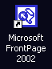
To load the Front Page 2002 program, Double click the left mouse button quickly on the FrontPage 2002 icon on the main Windows screen, or click-the left button on Start in the lower left corner of the screen, then click left-on Programs, and then click left on Microsoft FrontPage.

You should now be in the Microsoft FrontPage 2002 main screen. If you’re in FrontPage 2002, you’ll see, in the upper left corner of the screen, a title that looks like the one just to the right.

In this tutorial, whenever we indicate that you need to click a mouse button, it will mean to click the left mouse button – unless we indicate that you should click the right mouse button. So, always move the cursor over the “place” we indicate and “click left” unless we tell you otherwise.

Click-on all of the Titles in the Menu bar (like the one below) and familiarize yourself with what they do. As you click-on each Title, look at the items in the menus that “drop” down when you click-on each Title.

You’ll notice that the major portion of your screen, below the Menu Bar and Button Bars, is gray. This is because you have not created a new “blank” web page as yet. In the earlier versions of FrontPage a new page appeared when you opened the program. So that you can “see” all of the buttons in the button bar do the following to create your first web page.

You can use the Menu Bar method below or the Button Bar method at the top of the next page.
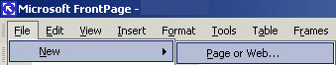
Click-on File in the Menu Bar, and when the image at the right appears, click-on New and then on Page or Web
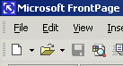
Or, you can click-on the Create a new or normal page button in the button bar below the Menu Bar (like the image on the right).

When you have finished this task, slowly move the cursor over the buttons in the button bars (like the one below) and read the text help’s that appear. You’ll need to pause a few seconds on each button to give the text help time to appear. Notice that the buttons “do” the same “things” as many of the drop down menu items.

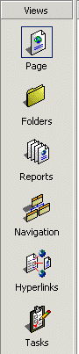
Now, observe, down the left side of the screen, under Views, there are a number of icon buttons (like the picture at the left). Notice that the Page button seems to be “depressed.” This indicates that you are in the Microsoft FrontPage 2002 Editor view. We’ll spend a lot of time, in Page View, creating and editing our first web page. When we have finished creating a single web page, we’ll then create a web site consisting of multiple web pages. Click-on each of the icon buttons on the left. Start with Folders and continue down until you have clicked-on Tasks at the bottom. Each button shows you a different view of your web site. Again, the first button, Page, shows you what a single web page look’s like. As we create our first web page, you’ll see all of the changes here. Folders, shows you your web site in “file” form. You can’t see anything at the moment because we haven’t created a web site. Reports will show you the status of all the pages in your web site as we create them. Navigation will show you, as you create your web site pages, a little organization chart. The lines connecting the boxes (as shown in the Navigation icon button), will indicate the hyperlinks between the pages. Hyperlinks show the actual links, once we create them, between the web pages. Tasks is a little word processor that let’s you maintain a list of “things to do,” once you begin creating your web site. Most of these won’t show you much now, but later you will be amazed at the web site you have created. We’ll return to these buttons when we begin creating our web site. Finally, click-on Page one more time. This is where we’ll begin.
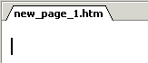

Creating a single web page

We’ll start this tutorial by placing a title on our first personal web page. You should be in Page in the View Task bar on the left, and your cursor should be flashing on the left-hand side of the white area. The Page button should look depressed (have a “square around it) and at the upper left corner, above the white area, it should indicate: new_page_1.htm (like the picture above right). If it does not, click-on the Page button again, and look for the flashing cursor and new_page_1.htm.

Text

First we’ll enter some text. Type something like: Your first name (’s) Home Page (e.g. Janies’s Home Page). Then tap the Enter key once. Notice, that when you tapped the Enter key, that the cursor moved down two lines (double spaced). This is just the way the Editor works. If you desire a single space between your text, simply Hold Down the Shift key and, while you are holding down the Shift key, tap the Enter key.
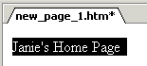
Now click to the left of your name and hold down the left mouse button, and drag across all that you have typed, and release the button. This will highlight your title. It should look something like the picture on the right.

With the text highlighted, click-on Format in the Menu bar and then click-on Font. A Menu screen similar to the one below will appear (we’ve made some changes – you’re Font menu will look similar to this one when we finish the font).

2. Font style

1. Font
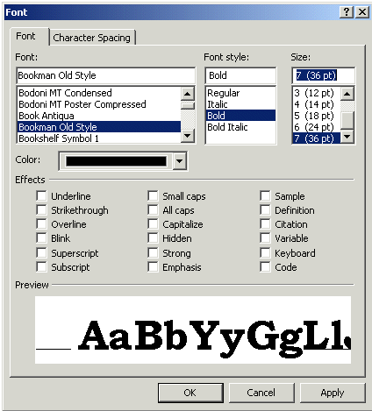

4.

3. Size

4. Color

We’ll refer to each numbered item (on the last page) as we proceed below. There are several unique things that occur when you are working in web pages. If you are familiar with word processing, then you know that you can make your font size just about as big as you desire. However, when working in web pages, you are limited in the number of font sizes that you are allowed. In web terminology these are called headers. We are going to “snazz-up” our title font a bit. First, you will notice that a Sample of how the font currently appears is located in the lower Preview area of the Font menu screen. As we alter the appearance of the font, each change will appear, as we make it, in the Preview area.

First ( 1.), click-on several of the fonts in the Font area (1. Font in the picture on the previous page). Notice that, as you click, the fonts appear in the Preview area below. Click-around until you discover one you like – we chose Bookman Old Style.

Second ( 2.), click-on Font style - Bold. Watch the Preview area.

Third ( 3.), click-on one of the Sizes. Notice that, when you do, the Preview changes to that size. Also, notice to the left of the font size there is a 1, 2, 3, [e.g. 4 (14pt)]. In web pages this is the size of the header. Since we are creating our web page in a program called HyperText Markup Language (HTML), you will find that, in a number of word processing functions, we are limited in what we can do on our web page. FrontPage tries to take care of these. In the case of Fonts however, we are still limited to 7 font sizes – called headers. In the “old” days, a few years ago, you would indicate a font size by typing in something like <h7> to do the same thing we’ll do to make our font the largest size. When we finish this web page we’ll click-on the HTML tab at the bottom of the screen to see the “programming code” that we have created by simply using FrontPage 2002. In our case, move down and choose the largest size: 7 (36 pt).

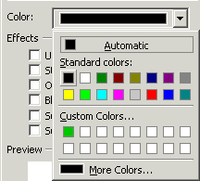
Fourth ( 4.), click-on the down triangle to the right of Color. A list of colors appears (like on the right). Click-on More Colors. When you do, the following Menu screen appears.

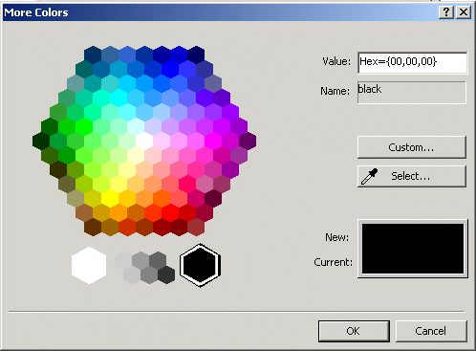

When the above More Colors menu screen appears, click-on Custom. The below Color menu screen will now appear.

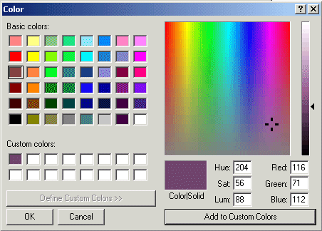

Click-on one of the Basic Colors (arrow on the left). Notice that, when you do, a small marker appears in the color pattern (top arrow on the right). Notice that a small triangle appears on the right of the pattern (middle arrow on right). You can click-on the triangle, hold down the left mouse button, and drag the triangle up and down. As you do, you will see changes in the color. Try this. For now choose a favorite dark color. If, you want to use this color again later, click-on Add to Custom Colors. You will see your choice appear in Custom colors on the left. This color will always appear whenever you want it for other text in this web page. When you are satisfied, click-on OK once, again and a third time.
You will notice that when you return to your web page that the area you highlighted is still highlighted (and you won’t see your color as you selected it). You will need to point away somewhere in the white area of the page and click the left mouse button. This will remove the highlight and reveal your the color of your text. If you don’t like the color, try again.

Saving your web page

It’s wise to save your web page periodically so that you don’t loose your hard work. There are several ways to do this. First, click-on File in the Menu Bar and then click-on Save.

The following Save As Menu Screen will appear.
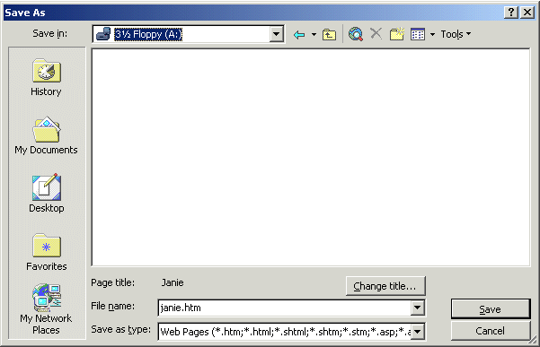

We will be saving this web page on a floppy disk in the A Drive. So, insert a formatted High-Density disk in the A Drive. When the disk is in place, click-on the small triangle to the right of the Save in: box. A “drop down” menu will appear. Click-on the 3 ½ Floppy (A:). If you don’t have a floppy disk, as indicated at the beginning of the tutorial, you can click-on the C Drive and save it on the C Drive, or in one of the folders on the C Drive.

The drive you choose will now appear in the Save in: area. You will need to give your web page a File name under which it will be saved. FrontPage will try to guess one for you. Be careful here. FrontPage will try to use your title for the name of the web page. If it is more than 8 characters long, some older computer systems and servers might not work well with the name.
Also, the name should not have an apostrophe (’) as this is a reserved Java character and could cause later problems as well. So, create a logical name for your web page like the one above (Janie).

Inserting a Photograph

At this point we’d normally insert your picture in the web page. If you know how to use a scanner, scan a picture of yourself. If at all possible, scan the picture as a GIF or JPEG file. These will load faster in your page. If you don’t know how to do this, have someone who does, scan a photo for you. Or, if you have access to a digital camera, have someone take a digital picture of you. Place your picture directly to the diskette, on which your web page is saved, or transfer the image to the Hard disk where your web page is located.

Something really important in web pages

You need to have all of the “parts” of the web page in the “same place”. In order for the page to load correctly, the text, pictures, animations, video files, photos, sounds, etc., all need to be on the A drive (for a small web page) or in a folder on the hard drive. If the web “page” can’t find the various items, you will not be able to see them in your page.

Before you insert your picture, make sure that your cursor is flashing a couple of spaces below the title. Then click-on Insert in the Menu bar and then click-on Picture, and then click-on From File.

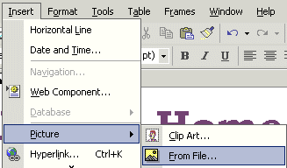

The following Picture menu screen will appear.
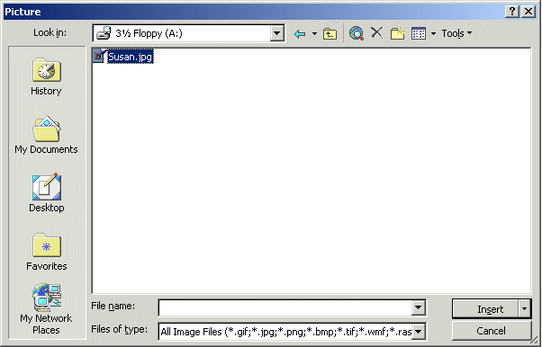
In the Look in: area of the Picture menu screen, click-on the small triangle and select the disk drive where your photograph is located. It is assumed that the location is the A drive. Again, make sure that all of the “items” are in a single location (like the A drive or a folder on the C drive) so that the web page can locate them. Next click-on the file name for your photograph in the area below the Look in: area. Then, click-on Insert.

Your web page should look something like the sample below.

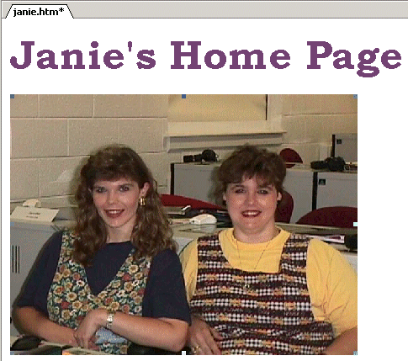
Your picture might be larger or smaller than the one on the right. To “size” the picture, point to the picture and click the left mouse button. This will “activate” the picture. You will see small “squares” at each of the corners and in the middle of the top, bottom, and side edges.

Corner Sizing Square

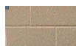
If, you move the mouse over one of the corner “squares,” a small two-headed arrow will appear (see enlarged corner on the right). When this occurs, click and hold down the left mouse button, and drag the corner in or out to make your photograph larger or smaller. If you click-on one of the top, bottom or side square’s and do this you will get a “fat” or “thin” picture. By clicking-on the corners, the picture holds its normal size ratio or perspective.

When you finish, your web page should look similar to the image below.

After something this significant, it’s a good idea to Save again. From now on, when you save, you can simply click-on the small diskette in the button bar (if you desire). Or, you can click-on File in the Menu bar and then on Save as you did previously. Your choice.

Text Wrapping

You may want text to “wrap” around your photograph. And, you may also want your photograph to be somewhere other than on the left side where it “defaulted” when you inserted it.

If the flashing I-bar cursor is not below your picture, click-below your picture and it should appear. If it doesn’t, point with the mouse cursor, to the white area to the right of your photograph and click the left mouse button. Then, tap the Enter key and the cursor I-bar should be just below your photograph. You may have to tap several times

Now type the following: This is where the text appears for this option.
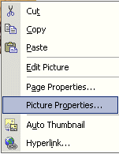
To observe where the text appears (around an image), we’ll illustrate each of these “appearances” on the next few pages. To do this, point in the picture and click the right mouse button. Whenever you right-click on any area, text or object in Windows, a “tailored” menu will appear for that area, text or object. When you right-click in your photograph, the following Menu will appear (as shown on the right). Click-on Picture Properties.

The following Picture Properties menu screen will appear. Make sure that you are “on” the Appearance “tab” at the top of the menu page. Then, click-on the small triangle to the right of Alignment: Texttop.

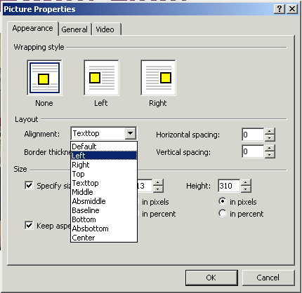

Notice the choices that appear below Default (arrow above). We’ll now illustrate each of these choices.

Click-on Left, and then click-on OK. You will see a new display similar to the one on the next page. If you desire to duplicate the below illustrations, repeat the above process for each of the choices indicated. If you do not, simply observe look at the images on the next tow pages.
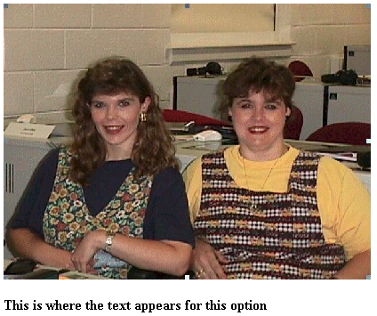

This is the Default.

This is the left appearance choice.

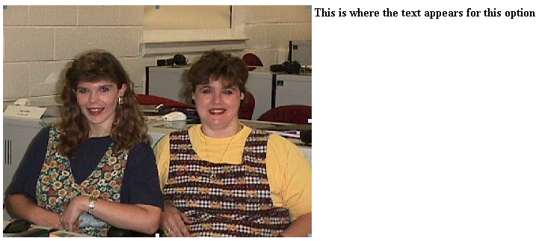
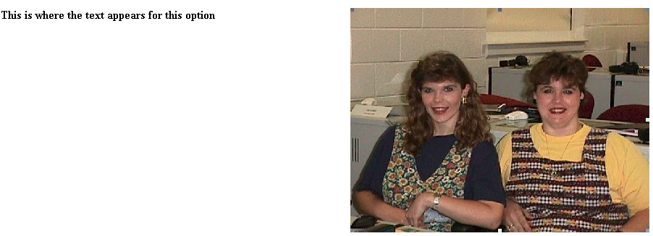
This is the right appearance choice.
This is the left appearance choice.
These are the top and text top appearance choices
These are the top and texttop appearance choices
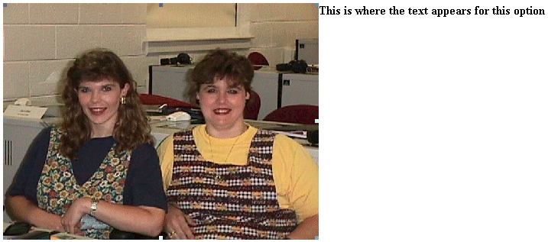
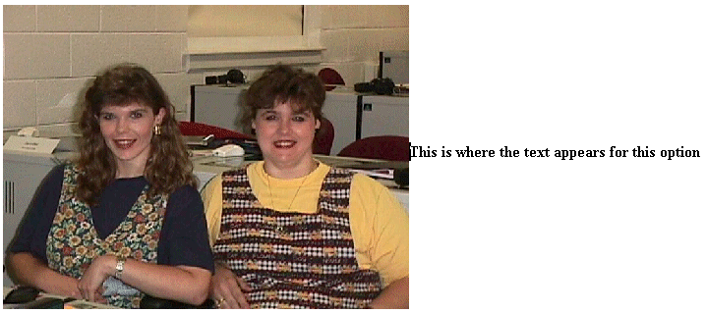
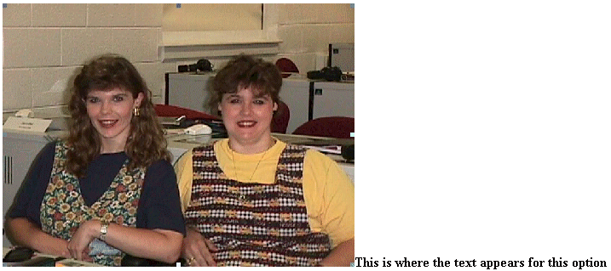
These are the middle, center and absmiddle appearance choices
These are the bottom, baseline, and absbottom appearance choices

Let’s reset the picture back to the Default. The text you typed should be just below the picture.

Now is a good time to save again.

Background

Our web page looks a bit drab at this point, so let’s add a colorful background, an animation, a sound and a link to a really neat web site.

Viewing web pages in a browser

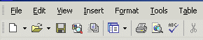
So far we have been working only in the Microsoft Editor (Page View). We have not really seen how the web page will “really” look to the “world” in a browser. In the button bar, below the Menu bar, there is a button (see below) that will load our web page in a browser (e.g. Microsoft Explorer, Netscape).

Now, click-on the browser button in the button bar. Or, you can click-on File in the Menu bar and then click-on Preview in Browser. If you do click-on Preview in Browser, Explorer will ask you to choose a browser that is saved on your computer. We normally use Microsoft Explorer, as it has proven more reliable of late. However, if you are a Netscape or other browser user, then choose your favorite if this is important to you. After you have made your choice, click-on the Preview button at the bottom of the Preview in Browser Menu Screen.

Microsoft Explorer browser, or Netscape browser, will load in your computer and your web page will appear. It will appear just like it would if someone looked at it in their browser.

We’ll use the Microsoft Explorer. You can use the browser of your choice. We’ll find a background, animation and link on the internet. You’ll actually “copy” a background color/pattern of your choice, as well as an animation, sound and link to your web page. To do this we’ll use a couple of handy sites on the World Wide Web.
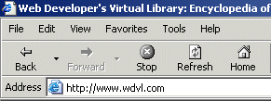

Notice that an Internet “address” has been typed-in the Address: area above. Click-in the Address area of the Microsoft Explorer (or Netscape) on your screen and type the following: http://www.wdvl.com. This will link you to a web site that contains a lot of neat things. When you have completed typing, simply tap the Enter key and Microsoft Explorer or Netscape will load this site. Once you have typed-in the address, tap the Enter key.
Your browser should now load the web site Web Developer’s Virtual Library. The screen should look similar to that below. This screen has changed several times in the past year, so if it does not look just like this, don’t despair. Trust us, you’ll be OK. The screen should indicate, at the top, that you are in the Web Developer’s Virtual Library. You’ll just have to be flexible to find the next correct link.

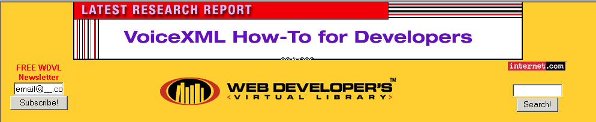

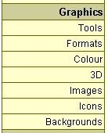
We want to add a background and an animation from the Web Developer’s Virtual Library to our web page. To do this we’ll start by clicking-on the Graphics button. This button/link has moved several times. At this time it is in a scroll down list on the right side of the screen – it could be on the left if the design changes again. Move down until you see the word Graphics. Your screen should look something like the one to the left. Click-on Graphics. If your screen does not look just like this, look around for Graphics. When you see it, move your cursor over Graphics, you will see the little pointy hand. Click-on the word Graphics.

Microsoft Explorer or Netscape will now load the next web page. It should look something like the one below.



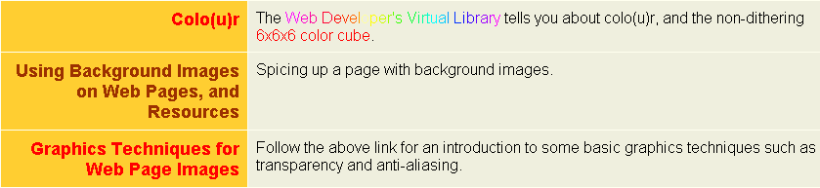
Use the “elevator bar” on the right side of the screen to move down slowly until you see a link to a background web page. The link is pretty far down the list. It should look like the one below.
When you move your cursor over the word Backgrounds above you will see the “little pointy hand”. When you do, click the left mouse button. Microsoft Explorer will now take you to the next web page. The top of the web page should look like the text below.



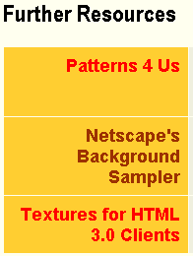

Again, use the elevator bar on the right to move down until you see an area on the web page that looks similar to the one on the left.

We’ll use the Netscape’s Background Sampler to select our first background. Click-on this and you will go to a web page with a nice set of basic backgrounds. The top of the web page should look something like the one below.



The above title will appear at the top of this web page. Again use the elevator bar on the right side of the page to run down until you see some backgrounds. Earlier, it was suggested that you use a dark color for your title. It is now suggested that you use a light color for your background. This is to assist you in “seeing” your text against the background. As you become more proficient in text and backgrounds, you can experiment and attain some really “interesting” combinations. We chose the background below (left) for the tutorial since text is easy to “see” against it. We also use this tutorial in our computer labs, this image projects well with computer projectors on movie screens.

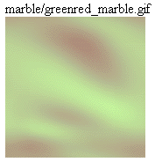

This is a good background as it is light enough to show your text, but also has some color to it. You choose a light background that you like. When you have chosen your background, point your cursor arrow at the middle of the background and click the RIGHT mouse button. A tailored menu screen will appear (like the one at the top of the next page).
This is a technique that we’ll use from now on to “capture” any “object/picture” that we’d like to use in our web page from the Internet.
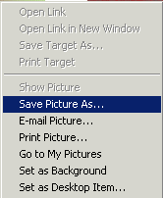
After you RIGHT click, a menu similar to the one on the left will appear. Move down and click-on the Save Picture As… item in this menu screen. This will take you to the Save Picture menu below.

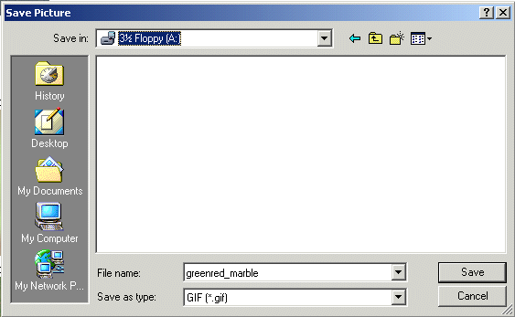

It is assumed, for this exercise, you will continue to use the A drive. So, click-on the 3 ½ Floppy [A:] in the Save in: area. Notice that the name of the background appears in the File name: area. When you see the correct drive and file name, click-on Save.

You now have this background in your “folder” and available when we return to Microsoft FrontPage 2002 to insert into your web page.

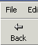
Animation

Next we’ll “capture” a famous animation by Dan Austin. In the upper left corner of Microsoft Explorer is an arrow that indicates “Back” when you move the cursor over it. Click-on the back arrow two times. This will take you back to the graphics page. Run down the page a bit more until you see the image at the top of the next page.

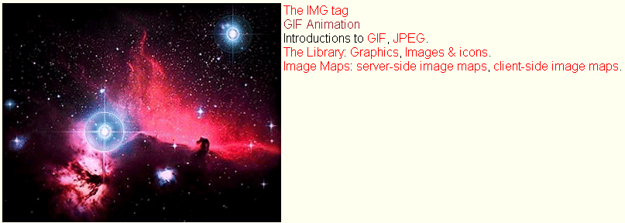

The next web page we’ll visit is GIF Animation. Move your mouse over GIF Animation and when you see the “little pointy hand” click-on GIF Animation (see arrow above). This will take you to:

As we have done before, use the elevator bar on the right side of this page to run down until you see:


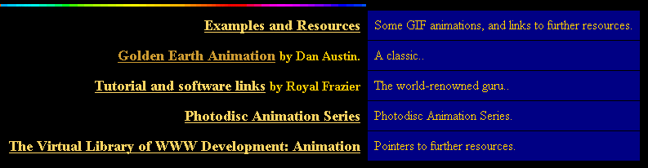

We’re, as indicated, going to select an animation by Dan Austin. So, Move the cursor over Golden Earth Animation (see pointing hand graphic above), and when you see the “little pointy hand” click the left mouse button. This will take you to a web page with a rotating earth. Move down the page a bit until you see the rotating earth.

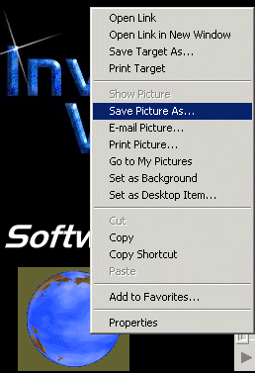
You need to be careful here. When you move the cursor over the rotating earth, you’ll notice the “little pointy hand.” This indicates that there is a web page link associated with the earth. If you accidentally click-on the earth and go to another page, click the back arrow to return to this page.

Carefully move the cursor over the earth and click the right mouse button. A drop down menu screen will again appear.

Click-on the Save Picture As.., just like you did before.

A Save as menu screen will appear and you can again save this picture to the A drive. The AuEarth will appear in the File name and you can click-on Save.
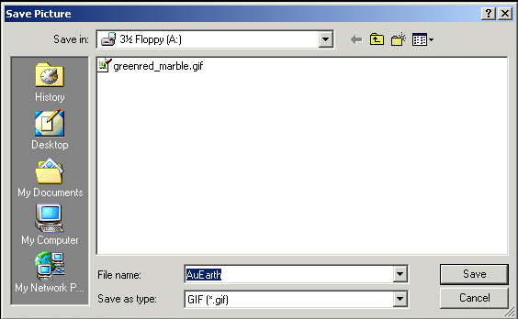

Web Plagiarism
Note: when you look at Dan Austin’s web page you will notice that he has a copyright. This is becoming a larger and larger topic: web plagiarism. To use things you copy from folks like Dan Austin, you need to show his copyright. Some objects you click-on will not have a Save Picture As associated with them. This indicates the person who created this object does not want you to have it. There are numerous web sites that address this topic. A major site we recommend is: http://www.georgetown.edu/honor/plagiarism.html. Please be careful and aware of web plagiarism
Sound

You now have a background and animation to add to your web page. Now let’s “capture” a sound. If you don’t have a sound card and speakers or earphones, you will not be able to hear the sound and may get an error message when you do the below procedure. You may not want to attempt “capturing” the sound until you have these “things.”

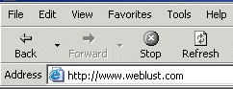
Now we’re going to go to an entirely new web site. So type-in: http://www.weblust.com in the Address area of Microsoft Explorer or Netscape. Then tap Enter. You will now proceed to a marvelous “sound” site.


The top of your monitor screen should look similar to the image on the right.


Click-on Fred’s Media Universe and you will be linked to:

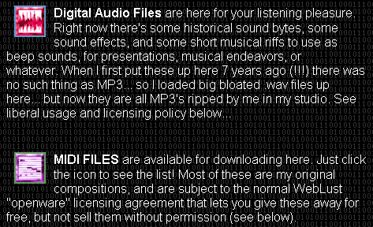
Move down this page, utilizing the elevator bar on the right, until you see the image on the right.

You will want to visit many of “Fred’s” areas. However, we’ll visit the MIDI FILES to “capture” a sound. So click-on the small square to the left of MIDI FILES.


At the top of the screen you will see:

What is a MIDI? MIDI stands for Musical Instrument Digital Interface. If you want to learn more about MIDI a nice site to visit is: http://www.midiworld.com. When you arrive at the site, click-on the MIDI Basics link at the bottom of the web page. This will give you a nice background in MIDI sound.

Once again, move down the page until you see:

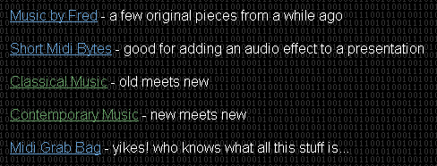

Let’s get some “class” and click-on Classical Music (see arrow above). You can choose one of the other groups if you desire. When you arrive at your selected web page, move down the Classical Music page, or the page of the one your chose. You will see a number of selections. We selected Classical Music for our musical masterpiece.

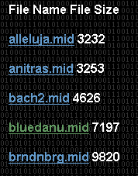

We’ll choose the bluedann.mid for the sound file. Later, we’ll insert this sound into our web page. When we left click-on bluedanu.mid a sound “player” screen will appear. What you see on the screen will vary in a appearance depending on what “player” you have installed. Ours looks like the one at the top of the next page. When the player has “loaded” the sound, you will hear it over your speakers or earphones.

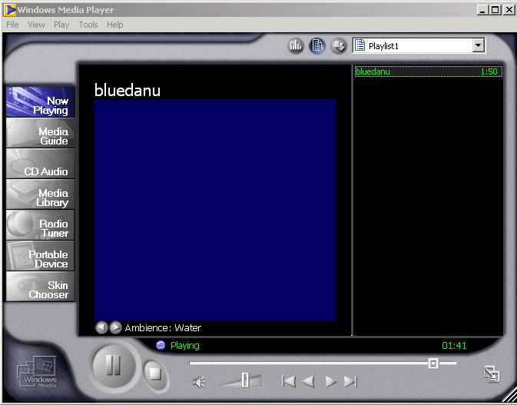
After you have listened to your tune click-on the “X” in the upper right corner of the player (see arrow above) to stop the player and end the tune. You’ll have to be careful as you listen to various tunes. If you keep clicking on tunes and not closing the player you can have a “lot of tunes” showing on the Task Bar at the bottom of the screen. So, keep choosing tunes, listening to them, and closing the player until you find one you like.
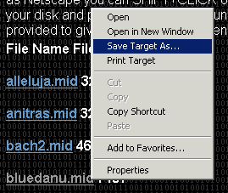
When you have a song you like (in our case we chose the bluedanu.mid), carefully, again, move the cursor over the song you want to save in the song menu until you again see the “little pointy hand”. When you do, carefully click the right mouse button and a drop down menu will appear.

Move to and click-on Save Target As… and you will see a normal Save As screen appear. Save this sound as you did your animation and background.
bluedanu.mid

Inserting a Background in your Web Page
In the status bar at the bottom of the view screen you will see the Microsoft FrontPage 2002 icon displayed in the task bar (see above). We will now return to the Microsoft FrontPage 2002 to insert the background, animation and sound we just captured and saved. So click-on the Microsoft FrontPage 2002 button. You will now return to Microsoft FrontPage 2002.

When the Microsoft FrontPage 2002 screen returns, make sure that, on the left side, you have clicked-on the Page button. Your cursor should be flashing just below the text you typed in earlier. If you do not see it there, move down the screen and click below the text. If the cursor appears to the right of the text, tap Enter to move the cursor down below the text.

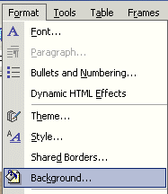

Now it’s time to insert our background in our web page. Click-on Format in the Menu bar and then click-on Background.

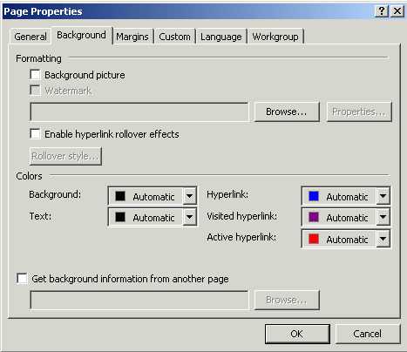

The following screen will appear. Click-on the Browse button which is under Formatting on the right side of the menu (see the arrow).

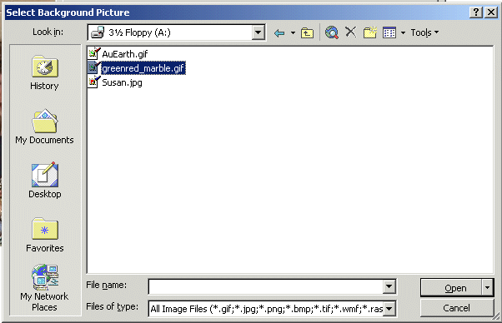
Now you will see:

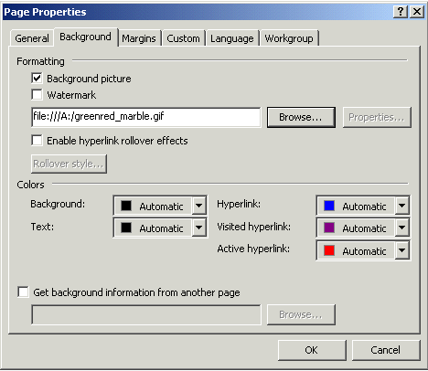
Make sure you are on the A drive. or the folder where you have saved all of your files. For the background, click-on the background you chose earlier (see arrow above). Now click-on Open.

You will return to the Page Properties screen where we began this process (under File in the Menu bar).

Notice that the background you chose is now indicated in the Formatting area. Click-on OK.
WOW! What a difference!

A good time to Save your web page again.

Inserting an animation in a web page

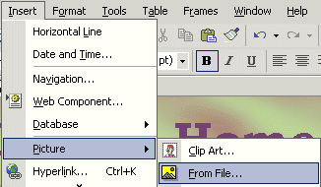
Since we previously saved the earth, we’ll insert the earth in our web page! Sounds rather awesome.

Make sure that you can see your cursor flashing below the text. Inserting the animation is exactly the same as inserting your photograph.

Click-on Insert in the Menu Bar and then click-on Picture and then on From File.

When the following Picture menu appears, make sure that you are “on” your proper drive (A: or C:, etc.) click-on AuEarth and then click-on Insert. The earth will appear below the text in your web page!
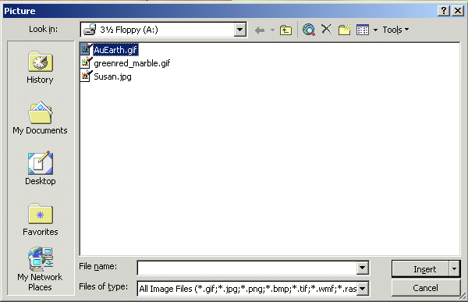
Something seems to be wrong! The earth’s not rotating! There really is no problem; you just don’t see the animation effects in the Microsoft Editor. You have to go to the Microsoft Explorer or Netscape to see these effects.
Save your file and then click-on the Browser button in the button bar (see image at right) and you will go back to Microsoft Explorer or Netscape. Now you see your background and the rotating earth.

Note: Sometimes your browser will not appear, but you’ll notice your browser button flashing-blue in the task bar at the bottom of the screen. If this occurs, simply click-on the flashing browser button and you’ll see your web page in your browser.

Now back to Microsoft FrontPage 2002 (click-on the FrontPage 2002 icon in the Task bar at the bottom of the screen as you did before – top Page 22) to insert the sound.

Inserting sound into the web page

The cursor should be flashing to the right of the earth. Tap Enter once to move the cursor below the earth.

Sound is a bit unique. We could put the sound in the “background” of the page and it would begin playing when the page is opened if we were using only Microsoft Explorer. However, other browsers can’t “play” the sound when you do this. So we’ll insert the sound with a “link.” This is what web pages are all about: links.

Type-in something that would indicate that, if you clicked on it, you would hear a sound. We’re going to type in: Listen to the Blue Danube. After you type-in your text, tap Enter one time to move the cursor down.

Click in front of the text, hold down the left mouse button and drag the cursor over the text to highlight it (just like you did when you started the web page title).
Now, with the text high lighted, click-on the Hyperlink button in the button bar.

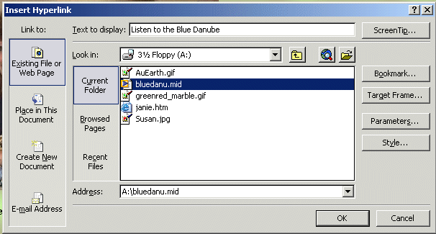
The following Insert Hyperlink screen will appear.
1.
2.
3.
First ( 1. ), in the Look in area, make sure that you have selected the drive where your web page is saved (3 ½ Floppy (A:), C:, etc.).

Second ( 2. ), in the area below the Look in area, click-on the MIDI music file that you saved. It will turn blue.

Third ( 3. ), when you have selected the correct drive and file, then click-on OK.

After you click-on OK, and return to your web page, click-under your highlighted text link (to turn off the highlight). You will notice that the text you highlighted has now “turned blue” and is underlined. This is the universal “symbol” for a “hyperlink.” You are now “linked” to your sound. This is why it is so important that all of your images and sounds are in one location.
Save your webpage and then click-on the Browser button again. Move down your web page, when your page appears in the browser, and click-on your sound link. Sounds great!

You can also hyperlink to an object (like your picture or the rotating earth) the same way you linked to your text. All you have to do is to click-on any object and then click-on the hyperlink button. Then, follow the instructions you just completed above.

As indicated earlier, you can also have sound “play” as soon as your web page opens in a browser. Also, as indicated, this may not “work” in all browsers. However, if you want to do this – here’s how.

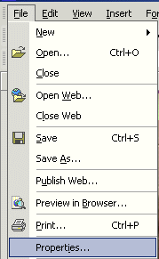

Click-on File in the Menu Bar and then click-on Properties.

The Page Properties menu screen at the top of the next page will appear.

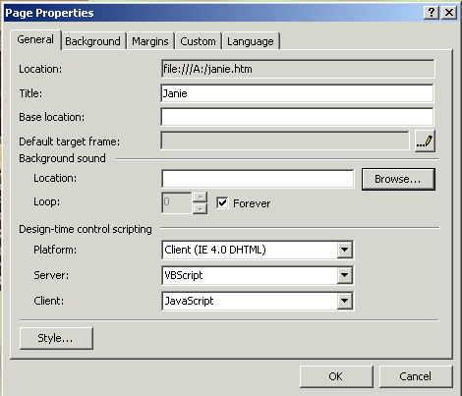

Click-on the Browse button in the Page Properties menu screen in the Background sound area (see arrow at right).

The Background Sound menu screen below will appear.

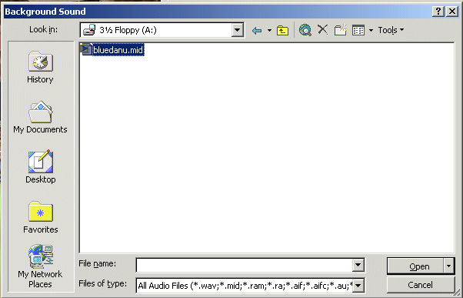
Make sure that you select the drive on which you web page is saved in the Look in area. Then click-on your sound. Finally, click-on Open.

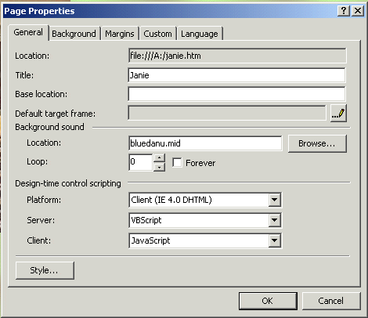

You will now return to your Page Properties menu screen.

Notice that your sound is now shown in the Background sound Location area.

Also note below your sound file, that the Forever box has a check mark in it. This means your sound will play “forever” if you don’t change this selection. We clicked-on the check and it disappeared. We noticed that to the left of Forever that a zero appeared in the Loop area. This simply indicates that the music will play only one time and not play again (will not loop). You may “set” this Loop as you desire.

When you are finished, click OK

Links to other sites on the Internet

Now we’ll link, using the Internet, to a great small college in Virginia. Make sure that you can see your cursor below the sound link. If you cannot see your curser below the sound link, click-below the sound link and see if the flashing cursor appears. If it does not, tap the Enter key.

Now type-in something like: Visit an awesome place.

Highlight - Visit an awesome place. Click in front of Visit and awesome place, hold down the left mouse button and drag over the text you typed (just like with the sound), and click-on the link button again.

The Insert Hyperlink menu screen should then appear (similar to the one below). We’ll need to make a couple of “adjustments” to this menu screen because we want to “browse” the internet to find our awesome site.

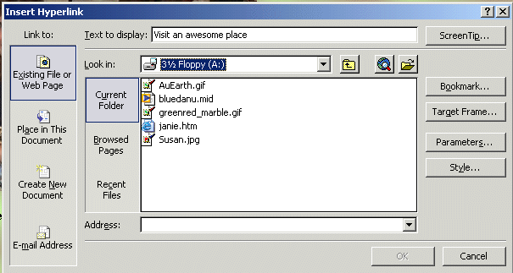
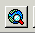
Hyperlink Button

When the above screen appears first click-on the Hyperlink button at the top of the menu screen (see image at right and the arrow and text above). A Text Help will appear indicating that this button will “Browse to the web.”

You will then be taken to the default page in your browser. When Microsoft Internet Explorer or Netscape appears, type-in the following web address – in the Address area:

http://www.lynchburg.edu
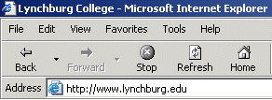

Now tap the Enter key and you will “go” to the home web page for Lynchburg College.

When you see the Lynchburg College web site click-on the Front Page button at the bottom of your screen – in the task bar.

This will take you back to FrontPage 2002 and the Insert Hyperlink menu screen (below). First, click-on the Browsed Pages button. Next, click-on Lynchburg College in the list of choices that appears (see arrows below).

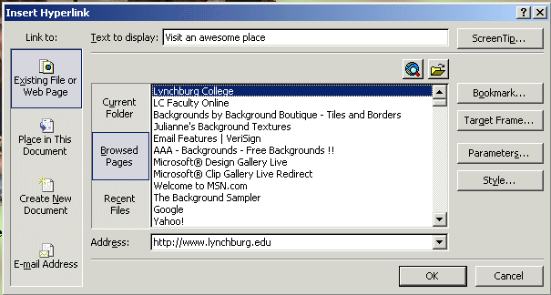
These two “clicks” will change your menu screen to look something like the one above. Notice that in the Address area at the bottom of the menu screen that it indicates the web address to which you browsed.

To complete your hyperlink, click-on OK. You will return to your web page and Visit and awesome place will be linked to Lynchburg College. You’ll notice that the link to Visit an awesome place is now the default blue-underline for a hyperlink.
Once again, when you desire to “see” how your web page “really looks,” click- on the Preview in Browser button. A message that indicates that you must save your changes will appear. Click-on Yes and you will be taken to your browser.

Remember, sometimes the browser will not “load” when you do this. If this occurs, look in the task bar at the bottom of the screen and you will see your browser blinking blue. Click-on you flashing browser button and you will once again be taken to your web sit.

One more thing – HTML

So far you have been working in a program very similar to a word processor with some limitations. Actually, FrontPage 2002 has been “converting” your work into the Hypertext Markup Language (HTML). To “see” the computer program code you have created we’ll do two things.

First, go back to FrontPage 2002 again by clicking-on the FrontPage icon in the Task Bar at the bottom of the screen.

When you are in FrontPage you’ll notice at the bottom of the screen, on the left side, some “tabs/buttons.” One of them indicates HTML. Click-on the HTML tab (see image on right). This will take you to a screen that shows you the HTML code you have created. Your screen should look something like the one below.

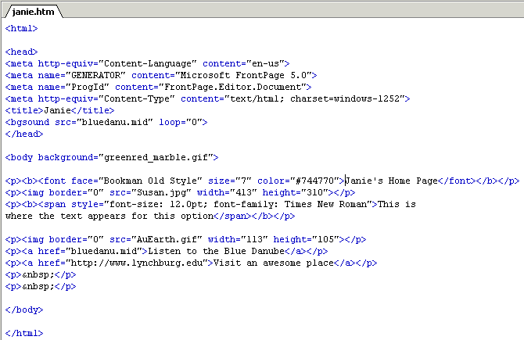
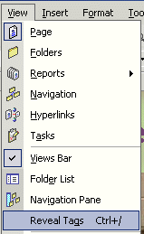
Wow! You created all of this computer programming code and most of you don’t know anything about programming. Neat program - FrontPage 2002.
Congratulations. You have now successfully completed a web page. Click-on the Normal Button to move back to the “regular/normal” view.

One more really neat thing in FrontPage 2002, You can “see” this HTML code on your web page as you edit it.

To do this click-on View in the Menu bar, and then carefully go down the menu, you will see and choice Reveal Tags appear. Click-on it.

Your web page screen will “change a bit” and you will see HTML “things” called “tags” appear. Your web page will look similar to the one below. As you become more proficient and advanced this can be a real help. “Old time HTML folks” had to create all of their web pages by coding them as you just saw in the HTML view. That was a task. But, every now and then, you might find these codes will assist you.

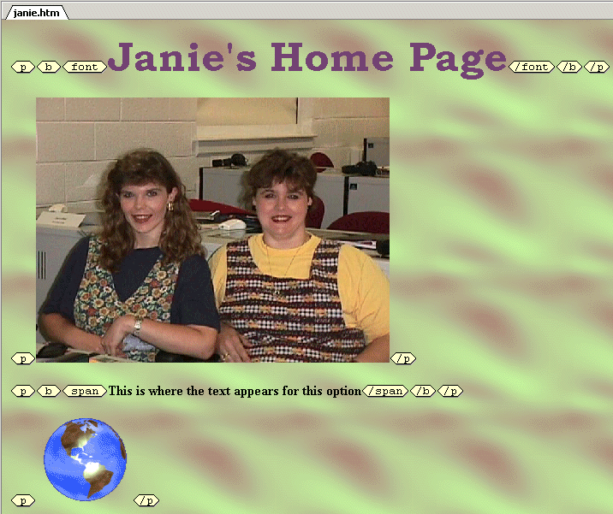

If you have any questions or comments please contact:

murray.t@lynchburg.edu

Thank you for your time and patience.

Now we’ll create our web site. You may want to take a break and relax before you begin.

Don’t forget to save your web page and close the file before you begin creating your web site.
Creating a Web Site
Using Microsoft FrontPage 2002 for
Windows 98/2000/Me/XP

Created: 26 April 2002

Starting Microsoft FrontPage 2002

In this tutorial we’ll create a small web site using Microsoft FrontPage 2002. If you have not completed the tutorial: Creating a Web Page Using Microsoft FrontPage Editor 2002 for Windows 98/2000/ Me/XP you should do so prior to attempting this tutorial. The Creating a Web Page Tutorial explains how to create and edit a single web page; this knowledge is pretty essential prior to your attempting the web site tutorial.

In the previous tutorial it explains how to hyperlink or link to other web pages. The really neat thing about this tutorial is that it creates these links “automatically” for you.
To “start” the program, Double click on the FrontPage 2002 icon (looks like the one on the right), or click-on Start in the lower left corner of the screen, then click-on Programs, and then on Microsoft FrontPage. You should now be in Microsoft FrontPage 2002.

If you are in FrontPage 2002, you will see, in the upper left corner of the monitor screen that you are in Microsoft FrontPage (it looks similar to the image at the right).

Take a few moments to go back to pages 1 and 2 of this tutorial - Creating a Web Page and Web Site Using Microsoft FrontPage 2002 for Windows 95/98 – Starting FrontPage 2002.
Review what the screen should look like and re-familiarize yourself with the various buttons on the top and left side of the screen.

If you still have your single web page on the screen, click-on File in the Menu bar, and then click-on Close. If you are prompted to Save your changes – click-on Yes.

Creating a web site (with multiple-linked pages)

In the Views button bar along the left side of your screen the Page button should be depressed and the area on the right of the button bar should be gray in color.

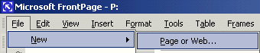
To create a web site, click-on File in the Menu bar and then click-on New and then on Page or Web (should look like the picture on the right).

Note: If you are a FrontPage 98 or 2000 user, the new Office 2002 graphics displays are very different to from those that you are used to seeing. In every module of Office 2002 there is now a new “Task Pane” on the right of the screen. Once you get used to using the task pane – especially since it has similarities in all of the Office 2002 programs, we think you’ll really like it. So, for you “old FrontPage hands,” here we “go”- with the new graphic features.

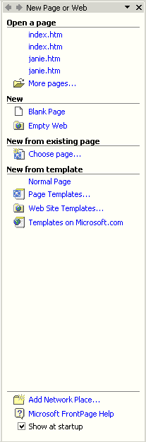

After you click-on New Page or Web, the Task Bar on the right will appear on the right side of your screen.

Place your cursor over the small yellow folder with an “earth” on it or on the text Empty Web. You will notice that the words Empty Web are now underlined in blue. You will also notice that your cursor will change to the “small pointy hand” hyperlink icon. Click-on Empty Web and the image at the top of the next page will appear.

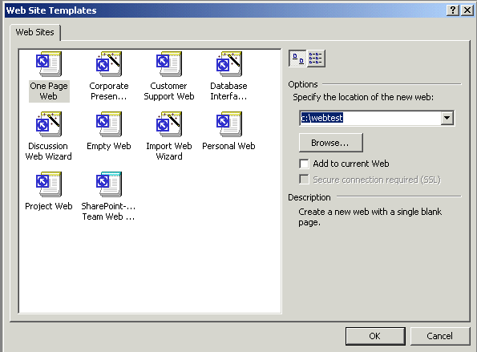
1.

2.

The New (FrontPage Web) menu will appear (see above). It will not look exactly like this. You will need to do a couple of simple things to create a “place on your hard disk” for your web pages.

First ( 1. ) , make sure that the upper left icon “One Page Web” is highlighted. If it is not, click-on it.

Second ( 2. ), in the “white area” under Options – Specify the location of the new web: type-in the following: c:\webtest. Your Web Site Templates menu screen should look like the one above. When it does, click-on OK.

This will take you back to the FrontPage 2002 main screen.

It will appear that nothing has happened. However, if you look at the upper left corner of your screen you will see that the web site c:\webtest has been created. Since this is a web site, and in the current Views Bar on the left of the screen is “set” on Page, we’ll have to select another button in the Views Bar to be able to “see” and work with our web site. We’ll show you how to do this at the top of the next page.

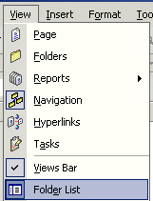

To visually “see/confirm” that your web site has been created by FrontPage 2002, click-on View in the Menu Bar. In the drop-down menu that appears, click-on Folder List.

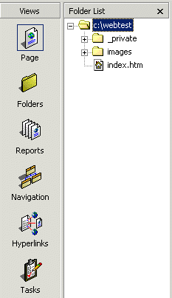

The Folder List will now appear on the left side of your screen to the right of the Views Bar.

The Folder List (arrow above left) indicates that your new web site is located on the C: drive in the Folder webtest. Notice also that two new folders have been created by FrontPage – private and images. FrontPage 2002 has also created your initial home page called index.htm (arrow above left). When we finished the single web page in the last tutorial, we clicked-on Reveal Tags. In the index.htm screen you are in the Page (edit) “mode,” just like you were when we created the initial single web page.

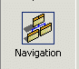
To create our web site we’ll want to be in the Navigation View. So, click-on the Navigation button as indicated by the arrows.

Earlier, when you clicked OK on the Web Site Templates screen, a little web page and a world globe appeared with an arrow circling the page and the globe. This indicated that your web site was created as you requested. This is now confirmed by the Folder List view (whick “shows” your created web site) and the image you see below (that appeared when you clicked-on the Navigation button). When this process is complete you will see your initial Home Page of the web site in the center of the screen.

Take a few minutes to look at all of the “stuff” on the screen. In the center of the screen you will see:

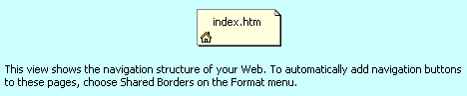

Take note of the words below the Home Page (index.htm), they’re important. We’ll come back to this in a moment.

Saving your web site

If you haven’t already, you’ll notice that there is no “Save” option under File in the Menu Bar. Nor is there a little “Save diskette” in the button bar. One of the neat things in FrontPage 2002 is that it automatically saves your web site as you make each change. To prove this, click-on File in the Menu Bar and then click-on Exit. FrontPage will close. Now open FrontPage as you did at the beginning of this tutorial. When FrontPage appears, SURPRISE! Your web site appears – just like you left it! This is a new feature of FrontPage 2002.
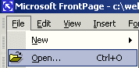

Normally, you would click-on File and then click-on Open. The Open File menu screen (below ) will appear.

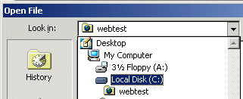

You will need to first click-on the small triangle to the right of the Look in area, then when the menu appears below, click-on the C: drive.

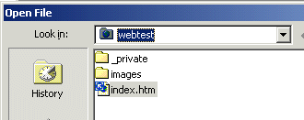
Notice that when you click-on the C: drive that you can see the webtest folder! Click-on the webtest folder and you will then see the image on the right.

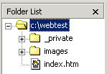
Click-on Open, and when your web site opens, click-on Navigation so we can get started creating our web site.

Your Folder List view area will still be visible. Many folks do not like to have this area showing when they are working on their web site. To “close” this area simply click-on the small “X” in the upper right corner of the Folder List view area.
Note: you will still have to save individual web page changes as you work on them.

Creating your web site

We’ll create a small personal web site to get you started. You should be in Navigation View.

First, left click-on the Home Page in the middle of the screen. Prior to your click, it will appear as a light yellow icon, when you click-on it, the page will turn blue. This indicates to FrontPage which page you desire to work on. In this case we’ll add, and automatically link, three additional pages below our main home page.

If you accidentally double-clicked on the Home Page icon, this indicates to FrontPage 2002 that you want to edit this page in FrontPage Editor (Page View), so FrontPage loaded your page in the Editor. We’ll do this a lot after our pages are created. And, it’s not a big deal anyway. Simply click-on the Navigation button on the left (in the Views area) and you’ll be back where you want to be.

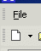
Again, make sure the Home Page icon is blue. To add the first page under our home page, you will notice, in the upper left corner of the screen, a small button (that looks like a sheet of paper) that indicates New Page (see arrow at right). Click-on this New Page button.

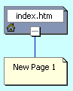
As soon as you click, your screen will change to reflect that you have just created a New Page 1 below your Home Page (index.htm).

This is where FrontPage really does its work. When you click, all of the pages you create in FrontPage 2002 will automatically be hyper linked by FrontPage. Your screen should now look like the one at the right. We’ll come back and “name” our pages later, after we have created our little web site.

Now we’ll add two more pages under our Home Page (index.htm). Each time, click-on the Home Page (index.htm) to turn it blue, and then click-on the New Page button. Your screen should now look like the one below – after you click the New Page button two more times.

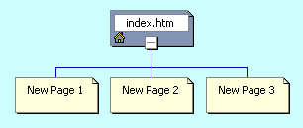

Next, we’ll add two pages under New Page 3. The process is similar to what we just did. First, click-on New Page 3, to turn it blue, and then click-on the New Page button. Do this twice. Our web site should now look like the one below.

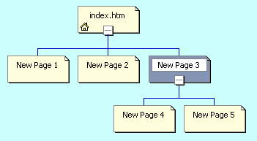

If you happen to make a mistake, as you are adding new pages, you can simply left click-on the erroneous new page and tap the Delete key, or right click-on the page and then left click on Delete when the menu appears.
Or, you could always click-on the Undo button at the top of the screen.

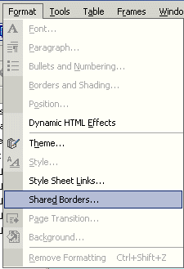

You now have the beginning of a small web site. Before we attempt to look at it, we need to do a very important task. Remember the words below the Home Page where we indicated that we would come back to naming the pages? We need to “tell” FrontPage “what” we want to “see” on our web pages in our web site. To do this we first have to follow the instructions below the Home Page (see top of Page 37). They tell us to select Shared Borders in the Format menu. To do this, click-on Format in the Menu bar and then click on Shared Borders. The image to the right shows this.
This will bring up the following Shared Borders menu screen.

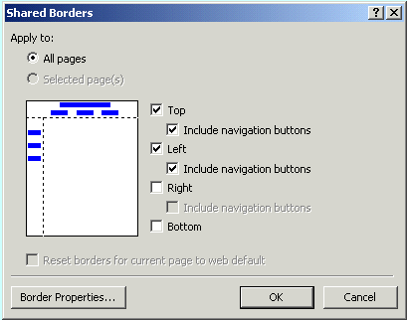
To make the titles of each web page and the links visible, you will need to click-in the small circle in front of All Pages, and in the squares to the left of: Top, and Include navigation buttons, and Left, and Include navigation buttons. Your Shared Borders screen should look exactly like the Shared Borders at the left (see arrows). When it does, click-on OK.

To “see” what the site would look like on the World Wide Web double click quickly o on the Home Page (index.htm) icon. You can also click the right mouse button while the cursor is on the Home Page (index.htm) and, when the menu appears, left click on Open. This will load the Home Page in Microsoft Editor (Page view).

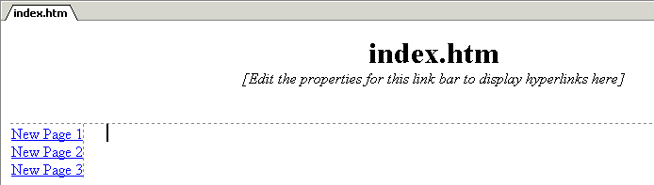
Before we open the web site in a browser, take a few moments to look at the top of the page in the Editor (Page View). It should look like the view below. Notice two things. First 1. observe that the title Home Page (index.htm) appears at the top of the page in the Editor (Page View) – just as it did when Front Page created it. Second 2. , note the New Page 1, 2 and 3 on the left side of the view below. These are links to pages below the one you are editing in the Editor. As indicated earlier, we’ll return to the Navigation View and re-name these pages so that they make more sense to your web site. Again, these are the automatic hyperlinks created by FrontPage 2002. Don’t worry about the “dashed lines” you see. These are simply to assist you later in the Page View. You’ll see that they “disappear” when you view your web site in a browser.
1.

2.

Viewing web pages in a browser
Now, in the Page View, click-on the browser button in the button bar. Or, you can click-on File in the Menu bar and then click-on Preview in Browser. If you do click-on Preview in Browser, Explorer will ask you to choose a browser that is saved on your computer. We normally use Microsoft Explorer, as it has proven more reliable of late. However, if you are a Netscape or other browser user, then choose your favorite, if this is important to you. Your initial view of your Home Page (index.htm) should look like the image below.

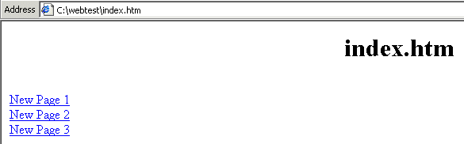

Now you’re in a browser and your “blank” web site will respond like any web site. When you move the cursor over New Page 1, 2 and 3, you will notice that the “little pointy hand” appears indicating a hyperlink. Click-on New Page 1. Your New Page 1 should look like the image below.

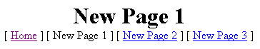

Notice that all of the “text buttons” are on the “line” below New Page 1. These are “real” hyperlinks back to the Home Page and to Pages 2 and 3. When we created our Shared Borders in FrontPage 2002, links for pages that are ABOVE or on the SAME level as Page 1, show below the page title (New Page 1). It does not matter if there are more than three pages above, or on the same level as the current page, all the pages will show with their names. These are part of the automatic hyperlink that we mentioned earlier. As indicated earlier,in the tutorial, this means that all of the pages are either above [Home] or on the same Navigator level as New Page 1 [New Page 2 and 3].

Now click-on New Page 3 in the browser, remember that we created two new pages below New Page 3. Your browser should now look like the image at the top of the next page.

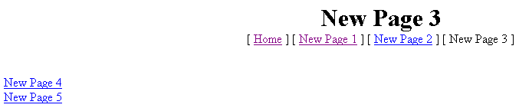
Pages Below
Pages Above and at the Same Level

Notice the line below New Page 3 contains the text links for pages above or on the same Navigator level. The text links on the left are to pages below New Page 3 (Pages 4 and 5).

Titles for web pages in your web site

Now let’s go back to the Navigation View FrontPage 2002 and “name” our web pages. We’ll be doing the following process frequently, so it’s good to make sure that you understand the process of moving from one program to another. At the bottom of your screen there is an area which shows/indicates what programs are active. This is called the Task Bar. Since we are using FrontPage 2002, as well as a browser [in our case we’re using Microsoft Explorer]. Your Task Bar should look similar to the one below.

FrontPage 2002 Internet Explorer

The icon for FrontPage 2002 has a white arrow on blue. On our Task Bar the icon on the right is for Microsoft Internet Explorer and indicates that it is “New Page 3.” If you are unsure which icon is which, you can “move” your cursor over an icon, pause on it for a few moments, and text help will appear to indicate the name of the program (e.g. FrontPage, etc.). Click-on the Microsoft FrontPage 2002 icon (indicated by the arrow above) to return to the FrontPage 2002. In the upper left corner of the screen it should indicate that you are in FrontPage (like below).

If you’re not in the FrontPage, try again.

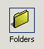
When you do return to the FrontPage make sure that you are in the Folders view. If not, click-on the Folders button on the left. You should see the view at the top of the next page.

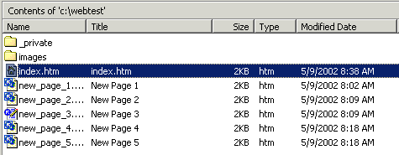

Along the left side, under the Name column, you see the “web page names (index.htm, new_page_1, etc.)” for each page. Under the Title column you see the Names as shown in the Navigation web page “boxes (index.htm, New Page 1, etc.).” When we rename the pages the “new” names will appear in the Title column. So let’s get started.

First, click-on the Navigation button in the Views bar on the left side of your screen to return to our Navigation View of all the web pages.

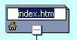
Carefully click once lightly on the title (index.htm) in the Home Page box. The box will turn blue once again. Now click lightly on the title in the Home Page box (index.htm) one more time and wait a few moments. The title will now be highlighted in blue. Your image should look like the one on the right.

In a Windows program this indicates that you are able to edit the text. You may start typing immediately. What you type will replace index.htm, or you can also delete the text and then type. For now, type-in your first name (with an apostrophe) and then an “s,” and then the words Home Page (we’ve typed-in the name of a person who has assisted wonderfully with these tutorials). When you are finished, tap the Enter key.
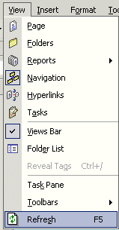

Now click-on View in the Menu bar and then click-on Refresh. This will “update” your changes to the index.htm page.

Click-on the Folders button in the Views bar on the left side of your screen.

You will now see that the Title of the page has changed to your name. Your “box” in the organization chart, and in the Title column, should look similar to those below.

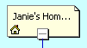
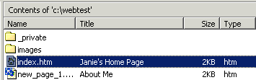

Now we’ll place some titles in the other “boxes.” We’ll use some “basic” titles for a general personal web. Once you get the idea of this, you can change the titles to anything you desire, add more pages, etc.
Return to Navigation view by clicking-on the Navigation button in the Views bar again.

For each page type-in the following:

- New Page 1: About Me
- New Page 2: About My Family
- New Page 3: My Hobbies
- New Page 4: Type-in the name of a hobby
- New Page 5: Type-in the name of another hobby

When you have completed these titles, click-on View in the Menu bar and then click-on Refresh.
Navigation view should look like the left image below. Click-again on the Folders button in the Views bar. The Folders View should look like the one on the lower right.

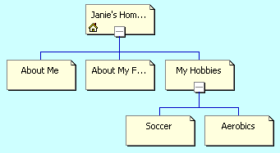
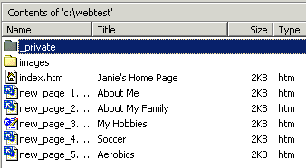
Let’s look at what we’ve accomplished by looking at your web pages in the browser. We’ll repeat what we did previously. You should be in FrontPage 2002 Navigation view. So, click-on the Navigation button in the Views bar.

To “see” what your site looks like, at this point, on the World Wide Web double click-on quickly on the Your Home Page icon. Or, you can also click the right mouse button while the cursor is on the Home Page and, when the menu appears, left click on Open. This will load the Home Page in Microsoft Page View.
In Page View, click-on the browser button in the button bar. Or, you can click-on File in the Menu bar and then click-on Preview in Browser.

Your pages may not open your browser (like before), so if your browser does not open, look in the Task Bar at the bottom of your screen. Your browser button should be “flashing” blue. If it is click-on it.

Click around your web site. You will notice that FrontPage 2002 has automatically changed all of your pages and buttons.

Themes

If you'll remember, in the Microsoft Creating a Single Web Page tutorial, we browsed on the Internet and found nice, colorful, backgrounds to replace the white default background in the web page.

Now, in Microsoft FrontPage 2002, we have the neat option to have a "Theme" background throughout our web site. The theme uses the same color scheme for each web page its buttons and links (you can change them page by page later if you desire).

Let’s try this. First, you’ll need to be in Microsoft FrontPage 2002. So, click-on the FrontPage “button” in the Task Bar at the bottom of the screen, like you have done before.

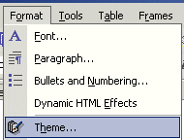
It does not matter which view you are in (Page, Navigation, etc.). We were in Page view when we returned to FrontPage.

When you are back in FrontPage click-on Format in the Menu bar and then click-on Theme.

You will be taken to the Themes menu screen in FrontPage 2002. When it first appears, you will notice that the area on the right is blank. To view the Theme choices you’ll need to click-on a Theme (as shown by the arrow below). When you do, you’ll notice that the first Theme choice, Artsy, is highlighted in blue, and the Theme Artsy appears on the right. Click-on some of the other choices in the list below. You can try all of them if you like.

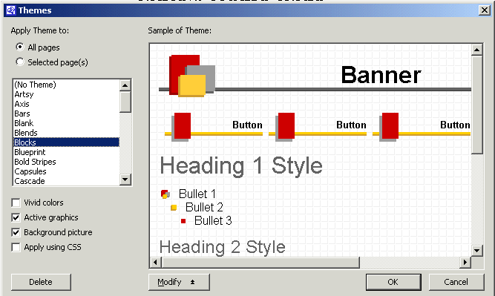

We’ve chosen the Blocks theme above (see lower arrow above).

Note: At the top of the Themes menu screen (see upper arrow above), under Apply Theme to, the choice All pages is selected. This will “apply” the theme to all of our pages. You can apply a different theme to each page, or one theme to all pages. We have chosen All pages. You can select a totally different theme at any time you desire – page by page or all pages.

When you have decided on a Theme you like, click-on OK. It will take a few seconds for the theme to be applied to all your pages.

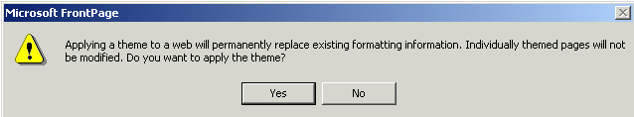
The Microsoft FrontPage choice screen below will appear. It indicates that all of your formatting will be changed to the theme you selected. Click Yes.

Now click-on the Navigation button in the Views area on the left side of the FrontPage screen.

When you see your web site organization chart, double-click quickly on your home page at the top of the chart. As before, this will take you to the Page view and your home page. You will now notice that the theme you chose has been applied to this page. Look at it carefully and notice the Title, buttons and links. They are now incorporated into your theme.

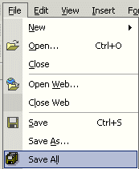
Next we’ll look at our pages in the browser we chose, but first click-on File in the Menu bar and then click-on Save All. Remember, when you are in the Page view, you’ll need to save your changes to each page just like you did in the Creating a Single Web Page tutorial. You can save each page individually, or all of them at the same time with Save All. Don’t forget to save frequently as you are editing your individual web pages.

Now click-on the Preview in Browser button as you did before, or on File in the Menu bar and then on Preview in Browser.

When your home page appears in the browser notice that as you run the cursor over the links that the small pointy hand appears. Click-on the About Me text link on the left. When the About Me web page appears notice that the About Me button at the top is “highlighted” compared to the other buttons. Also note that as you move the cursor over the buttons they become highlighted to indicated that they are active links. Browse around your web site and see how it works. Pretty awesome. Just a few clicks and look at what you have created!

Back to the FrontPage 2002 to place text, images and other “things” in your web pages

You have now learned all of the steps to create a web site, it’s time to go back to Microsoft Page view and add the “things” you desire on each web page. This is normally a three-step process. First, since you returned to FrontPage there is no need to click-on the FrontPage 2002 button in the task bar again. Second, double-click on the web page you want to edit in the Navigation view. Third, once you have typed the text, inserted some pictures and graphics, created some links, and whatever else for that page, save the page and then preview it in a browser. Then repeat the cycle as you work on your other pages. This is what you did when as you completed the Creating a Single Web Page tutorial.

The Creating a Web Page Using Microsoft FrontPage 2002 tutorial will show you how to do all of this if you have forgotten the process.

Using Ctrl+Click to move from one web page to another in your web site

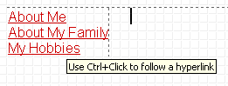
There is another way to move around between your various web pages in Page view if you don’t want to keep going back and forth between the Navigation and the Page view. When you are in Page view, move your cursor slowly over one of the links and pause on the link. You will notice that a little text help box appears that indicates: Use Ctrl+Click to follow a hyperlink. This means that if you want edit the page, to which the link connects, you should hold down one of the Ctrl keys at the bottom of the keyboard and then, when you move the mouse over a link you will see the arrow cursor change to the pointy hand cursor when you are over the link. When you see this, if you click the left mouse button, in a few moments, you will go to that web page in the Editor. This takes a little skill and patience. So, if you don’t link on the first try, try again.

Copying other text documents into web pages

As you get more accomplished in your web skills, you will probably not want to recreate “things” that you have written previously – like your resume, lesson plans for courses, etc. You can highlight the document in your word processor, and copy it into the selected web page.

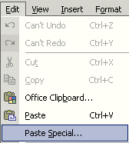
This works pretty well if you follow the next procedure. Highlight your document, in your word processor, Copy it to your clipboard by your favorite method (Edit-Copy, Copy button, etc.).

Then, go to the page, in FrontPage 2002, where you desire to insert your document. Click-on Edit in the Menu Bar and then choose Paste Special.

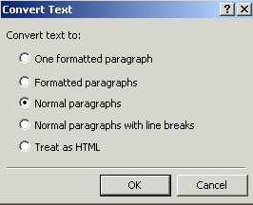
The following Convert Text menu screen will appear. We suggest that you choose Normal paragraphs. This will “hold” most of your formatting from your word processor.

Since you are “going into” HTML, you will have to do some editing to “re-center” portions of your text, and “make” some double-spaces, single-space.

When you have made your choice, click OK.

Or you can, in the word processor of your choice, save the document as a HTML file and then Copy the saved file, from your word processor, into your web page in Microsoft Page view. You can also open a word-processed document directly into a web page. All of this takes a little skill and practice, so you may want to practice these techniques.

Publishing your web site

Once you have created a web site it’s logical that you’ll want to “publish” it on the World Wide Web. To do this you’ll need someone who has the technical capability to do this. There are lots of Internet Service Providers who can do this. If you are currently using an Internet service like America on Line (AOL), CompuServe, Microsoft Network (MSN), or a local company – contact them. The rates range from free or inexpensive, for a small web site, to whatever.

What now?

The two tutorials (in this document) will give you a decent foundation in how to create web pages, edit them, and collect them into a meaningful web site. You now have the basic information. If you desire to further your knowledge, you might want to take a web class or purchase a good advanced reference manual. The one we like best at the moment is Microsoft Press’s Microsoft FrontPage 2002 – Inside Out.

Also, if you desire “instant” assistance on a feature in FrontPage there is a web connection in the program if you are “on-line.” If you click-on Help in the Menu bar and then click-on Microsoft on the Web, you will be linked to a main assistance screen for the Microsoft program in which you’re working. Often we find that someone else has already asked the same question – so a good first place to check is Frequently Asked Questions.

Congratulations. You have now successfully completed a small web site.

If you have any questions or comments please contact:

murray.t@lynchburg.edu

Thank you for your time and patience.

