Creating a Web Site
Using Microsoft FrontPage Explorer 98 for Windows 95

Created: 28 Dec 1999

Starting Microsoft FrontPage Explorer 98

In this tutorial we’ll create a small web site using Microsoft FrontPage 98 Explorer. If you have not completed the tutorial: Creating a Web Page Using Microsoft FrontPage Editor 98 for Windows 95/98 you should do so prior to attempting this tutorial. The FrontPage Editor Tutorial explains how to create and edit a single web page; this knowledge is pretty essential prior to your attempting this tutorial. In the Editor it explains how to hyperlink or link to other web pages. The really neat thing about Explorer is that it creates these links “automatically” for you.

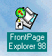
To “start” the program, Double click on the FrontPage 98 Explorer icon (looks like the one on the right), or click-on Start in the lower left corner of the screen, then click-on Programs, and then on Microsoft FrontPage. You should now be in Microsoft Explorer. If you are in Explorer, you will see, in the upper left corner of the monitor screen a “small green circle - with a red arrow in the circle - over a scroll” icon and the words FrontPage Explorer (it looks similar to the one above).

You should also see the Getting Started menu screen below. Since you will be creating a new web site, click-in the small circle to the left of Create a New FrontPage Web, and then click-on OK.

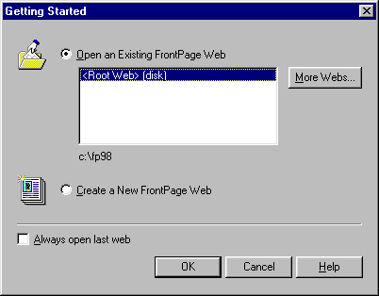

The New FrontPage Web menu will appear (see below). It will not look like this. You will need to do a couple of simple things to create a “place on your hard disk” for your web pages.
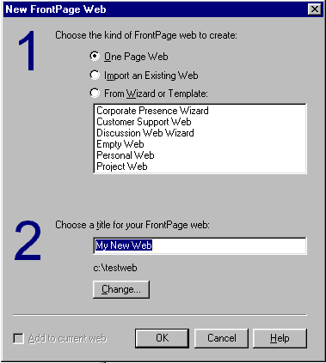

First, click-in the small circle to the left of One Page Web (as indicated below).

1.

Second, click-on the Change “button.”

2.

When the Change Location menu appears, (see below) delete whatever information appears in the “white” area and type-in c:\testweb, as shown below, then click-on OK.
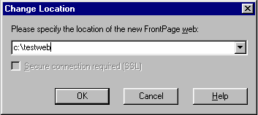
This will take you back to the New FrontPage Web menu. Your menu should look like the one above. Click-on OK to confirm all of your work. A message will appear indicting that “The folder “C:\testweb”, does not exist. Do you want to create it?” Click-on Yes.

A little web page and a world globe will appear with an arrow circling the page and the globe. This indicates that your web site is being created as you requested. When this process is complete you will see your initial Home Page of the web site in the center of the screen. Take a few minutes to look at all of the “stuff” on the screen. In the center of the screen you will see:

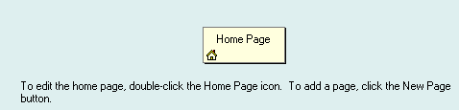

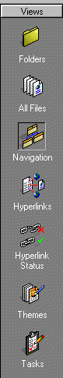
We’ll come back to this in a moment.

Now notice down the left side of the screen that there are a number of icon buttons. Notice that the Navigation button seems to be “depressed.” This indicates that you are in Navigation view. As you create your web site pages they will look like a little organization chart. The lines connecting the boxes will indicate the hyperlinks between the pages. Click-on each of the buttons. Start with Folders at the top and continue down until Tasks at the bottom. Each button shows you a different view of your web site. The first two buttons (Folders and All Files) show you your web site in “file” form. Hyperlinks shows the actual links, once we create them. Hyperlink Status tells you which links are OK, and which are broken. As you become more advanced you can “repair” the links with FrontPage. We’ll use Themes later to add backgrounds and colors to our web site. Tasks is a little word processor that let’s you maintain a list of “things to do.” Most of these won’t show you much now, but later you will be amazed at the web site you have created. Finally, click-on Navigation one more time. This is where we’ll begin in a moment. Notice, in the upper left portion of the screen that FrontPage tells you “where you are.” Notice (as indicated below) that you are in the Navigator in My New Web – just where you’re supposed to be.


Saving your web site

If you haven’t already, you’ll notice that there is no “Save” option under File in the Menu Bar. Nor is there a little “Save diskette” in the button bar. One of the neat things in FrontPage Explorer is that it automatically saves your web site as you make each change. To prove this, click-on File in the Menu Bar and then click-on Exit. FrontPage will close. Now open FrontPage as you did at the beginning of this tutorial. When it appears, FrontPage will default to Open an existing FrontPage Web. In addition, FrontPage will highlight the last web site on which you worked. Logically, it is on My New Web, just where we left off. So, click-on OK, and when your web site opens, click-on Navigation so we can get started creating our web site.

Note: you will still have to save individual web page changes in Editor as you work on them

Creating your web site

We’ll create a small personal web site to get you started. You should be in Navigation View.

First, left click-on the Home Page in the middle of the screen. Prior to your click, it will appear as a light yellow icon, when you click-on it, the page will turn blue. This indicates to FrontPage which page you desire to work on. In this case we’ll add, and automatically link, three additional pages below our main home page.

If you accidentally double-clicked on the Home Page icon, this indicates to FrontPage that you want to edit this page in FrontPage Editor, so FrontPage loaded your page in the Editor. We’ll do this a lot after our pages are created. And, it’s not a big deal now. At the bottom of the screen you should see both FrontPage Editor and Explorer “buttons” in the Task Bar. To get back to Explorer, simply click-on the Explorer button.


Again, make sure the Home Page icon is blue. To add the first page under our home page, you will notice, in the upper left corner of the screen, a small button that indicates New Page. Click-on this New Page button. As soon as you do, the following FrontPage Explorer assistance menu will appear.
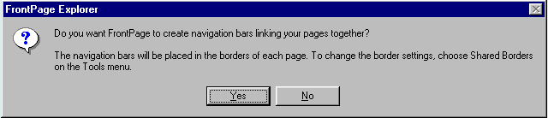
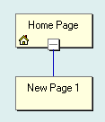

This is where FrontPage Explorer does its real work. When you click-on Yes, all of the pages you create in FrontPage will automatically be hyper linked by FrontPage Explorer. Your screen should now look like the one at the left. We’ll come back and “name” our pages later, after we have created our little web site.

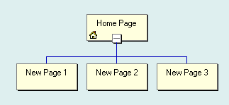
Now we’ll add two more pages under our Home Page. Each time, click-on the Home Page to turn it blue, and then click-on the New Page button. Your screen should now look like the one below.

Next, we’ll add two pages under New Page 3. The process is similar to what we just did. First, click-on New Page 3, to turn it blue, and then click-on the New Page button. Do this twice. Our web site should now look like the one below.
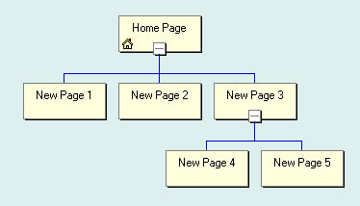

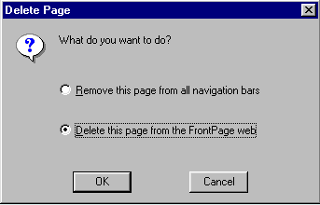
If you happen to make a mistake, as you are adding new pages, you can simply left click-on the erroneous new page and tap the Delete key, or right click-on the page and then left click on Delete when the menu appears. The following menu screen will appear.

At this point you’ll want to click-in the little circle to the left of Delete this page from the Front Page web. This will totally remove the page from the web site. Later you may want to keep a page to use at a later time. In this future case you‘ll use the other choice. We’ll look at this again when we return from our preview in a browser.

You now have the beginning of a small web site. To “see” what the site looks like at this point on the world wide web double click-on quickly on the Home Page icon . You can also click the right mouse button while the cursor is on the Home Page and, when the menu appears, left click on Open. This will load the Home Page in Microsoft Editor.

Before we open the web site in a browser, take a few moments to look at the top of the page in the Editor. It should look like the view below. Notice two things. First, observe that the title Home Page appears at the top of the page in the Editor – just as it did when Front Page Explorer created it. Notice the three [Button] “buttons” below Home Page. If there are web pages created by Front Page Explorer that are ABOVE or on the SAME Navigator level as the page, which you are editing in the Editor, the names of the pages will be shown where [Button] is located. It does not matter if there are more than three pages above, or on the same level as the current page, all the pages will show with their names. These are part of the automatic hyperlink that we mentioned earlier. Second, note the New Page 1, 2 and 3 on the left side of the view below. These are links to pages below the one you are editing in the Editor. We’ll, as indicated earlier, return to the Explorer and re-name these pages so that they make more sense to your web site. Again, these are the automatic hyperlinks created by the Editor. Don’t worry about the “dashed lines” you see. These are simply to assist you later in the Editor. You’ll see that they “disappear” when you view your web site in a browser.
1.

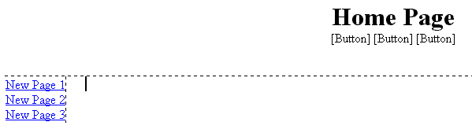
2.

Viewing web pages in a browser
2.

Now, in the Editor, click-on the browser button in the button bar. Or, you can click-on File in the Menu bar and then click-on Preview in Browser. If you do click-on Preview in Browser, Explorer will ask you to choose a browser that is saved on your computer. We normally use Microsoft Explorer, as it has proven more reliable of late. However, if you are a Netscape or other browser user, then choose your favorite if this is important to you.

Now you’re in a browser and your “blank” web site will respond like any web site. Notice, that since there are no [Button] “buttons” showing. As indicated earlier, this is becase there are no pages above or on the same level as the Home Page. When you move the cursor over New Page 1, 2 and 3, you will notice that the “little pointy hand” appears indicating a hyperlink. Click-on New Page 1. Your New Page 1 should look like the one below.
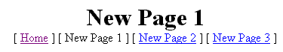

Notice that all of the “text buttons” are on the “line” below New Page 1. As indicated earlier in the tutorial, this means that all of the pages are either above [Home] or on the same Navigator level as New Page 1 [New Page 2 and 3].
Now click-on New Page 3 in the browser, remember that we created two new pages below New Page 3. Your browser should now look like the image below.

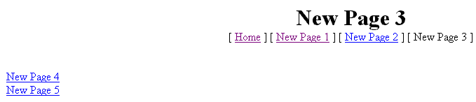
Notice that in the line below New Page 3 contains the text buttons above or on the same Navigator level, and on the left are the pages below New Page 3.

Titles for web pages in your web site

Now let’s go back to FrontPage Explorer and “name” our web pages. We’ll be doing the following process frequently, so it’s good to make sure that you understand the process of moving from one program to another. At the bottom of your screen there is an area which shows/indicates what programs are active. This is called the Task Bar. Since we are using FrontPage Explorer and Editor, as well as a browser [in my case I’m using Microsoft Explorer]. Your Task Bar should look similar to the one below.

The icon for FrontPage Editor has a red feather, the icon for FrontPage Explorer has a small green circle with a red arrow. On my Task Bar the icon on the right is for Microsoft Explorer and indicates that it is “browsing New Page 3.” If you are unsure which icon is which, you can “run” your arrow cursor over an icon, pause on it for a few moments, and a text help will appear to indicate the name of the program (e.g. FrontPage Explorer, etc.). Click-on the FrontPage Explorer icon (indicated by the arrow above) to return to the Explorer. In the upper left corner of the screen it should indicate that you are in Explorer (like below).

If you’re not in the Explorer, try again. When you do return to the Explorer make sure that you are in the Navigation view. If not, click-on the Navigation button on the left. You should see your “organization chart of web pages” again.

Notice at the bottom of the screen and area that looks like this:
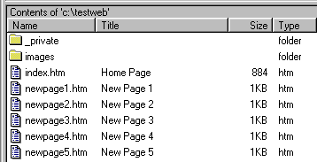

Along the left side, under the Name column you see the “web page names (.htm) for each page. Under the Title column you see the Names as shown in the Navigator web page “boxes.” When we rename the pages the “new” names will appear in the Title column. So let’s get started.

Carefully click once on the Home Page box title. The box will turn blue once again. Now click-on Home Page one more time and wait a few moments. The title will now be highlighted in blue. In a Windows program this indicates that you are able to edit the text. You may start typing immediately. What you type will replace Home Page, or you can delete the text and then type. For now, type-in your first name (with an apostrophe) and then an “s,” and then the words Home Page (I’ve typed-in the name of a person who has assisted wonderfully with these tutorials). When you are finished, tap the Enter key. Now click-on View in the Menu bar and then click-on Refresh. In the bottom portion of the screen you will now see that the Title of the page has changed to your name. Your “box” in the organization chart and in the Title column at the bottom should look similar to those below.
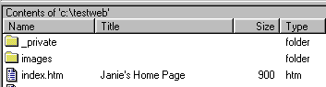

Now we’ll place some titles in the other “boxes.” We’ll use some “basic” titles for a general personal web . Once you get the idea of this you can change the titles to anything you desire, add more pages, etc.

For each page type-in the following:

- New Page 1: About Me
- New Page 2: About My Family
- New Page 3: My Hobbies
- New Page 4: Type-in the name of a hobby
- New Page 5: Type-in the name of another hobby

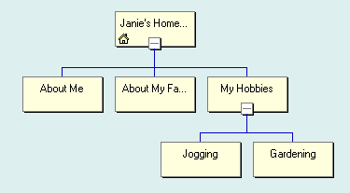
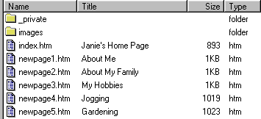
When you have completed these titles, click-on View in the Menu bar and then click-on Refresh. The upper and lower portion of the Navigation view should look like those below.

Let’s look at what we’ve accomplished by looking at our web pages in the browser. We’ll repeat what we did previously. You should still be in Explorer. To “see” what the site looks like at this point on the world wide web double click-on quickly on the Your Home Page icon. You can also click the right mouse button while the cursor is on the Home Page and, when the menu appears, left click on Open. This will load the Home Page in Microsoft Editor. In the Editor, click-on the browser button in the button bar. Or, you can click-on File in the Menu bar and then click-on Preview in Browser.

Click around your web site. You will notice that Explorer and Editor have automatically changed all of your pages and buttons.

Themes

If you'll remember, in the Microsoft Editor tutorial, we browsed on the internet and found a nice, colorful, background to replace the white default background in the web page.

Now, in Microsoft Explorer we have the neat option to have a "Theme" background throughout our web site. The theme uses essentially the same color scheme for each web page (you can change them page by page later if you desire in the Editor), its buttons and links.

Let’s try a this. First, you’ll need to be in Microsoft Explorer. So, click-on the FrontPage Explorer “button” in the Task Bar at the bottom of the screen, like you have done before. Don’t worry where you are in the other programs (Editor and your browser) – we’ll be OK.
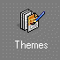
When you are back in Explorer look at the Views button bar that runs down the left side of the screen. Toward the bottom you’ll see a Themes icon like the one at the right. Click-on it.

You will be taken to the Themes portion of FrontPage Explorer. When it first appears you will notice that the area on the right is blank. To see how the Themes work you’ll need to make a “critical click.” When the Themes – My New Web appears (as shown below) you’ll notice that the small circle to the left of This Web Does Not Use Themes is “marked.” To view the Theme choices you’ll need to click-in the small circle to the left of Use Selected Themes (as shown by the arrow below). When you do, you’ll notice that the first Theme choice, Arcs, is highlighted in blue, and the Theme Arcs appears on the right. Click-on some of the other choices in the list below. You can try all of them if you like.

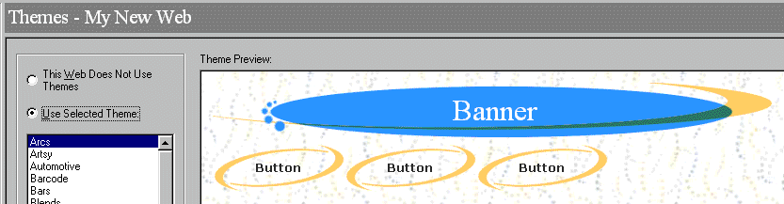

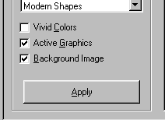
When you have decided on a Theme you like, you’ll need to Apply it to all of the pages in your web site. At the bottom of the “choices” column you’ll see an area similar to that on the right. So, logically, to Apply your theme, click-on the Apply button.

I sort of like “Sunflower,” so that will be my choice and what you’ll see when you look at “my” pages.

When I/we click-on the Apply button we’ll the following menu will appear. Read this carefully, but don’t worry too much. You’ll always be able to return to Themes and change them, as you would like. You’ll also be able to change them if you choose to do so. So, click-on Yes.

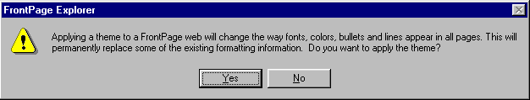
Now click-on the Navigation button on the left side of the Explorer screen. When you see your web site organization chart, double-click on your home page at the top of the chart. As before, this will take you to the Editor and your home page. You will now notice that the theme you chose has been applied to this page. Look at it carefully and notice the Title, buttons and links. They are now incorporated into your theme.

Next we’ll look at our pages in the browser we chose, but first click-on File in the Menu bar and then click-on Save All. Remember, when you are in the Editor you’ll need to save your changes to each page just like you did n the Editor tutorial. You can save each page individually, or all of them at the same time with Save All. Don’t forget to save frequently as you are editing your individual web pages.

Now click-on the Preview in Browser button as you did before, or on File in the Menu bar and then on Preview in Browser.

When your home pages appear in the browser notice that as you run the cursor over the links that the small pointy hand appears. Click-on the About Me text link on the left. When the About Me web page appears notice that the About Me button at the top is “highlighted” compared to the other buttons. Also note that as you move the cursor over the buttons that they become highlighted to indicated that they are active links. Browse around your web site and see how it works. Pretty awesome. Just a few clicks and look at what you have created!

Back to the Editor to place text, images and other “things” in your web pages

You have now learned all of the steps to create a web site it’s time to go back to Microsoft Editor and add the “things” you desire on each web page. This is normally a three step process. First, click-on the FrontPage Explorer button in the Task Bar at the bottom of the screen. Second, double-click on the web page you want to edit in the Navigator view. Third, once you have typed the text, inserted some pictures and graphics, created some links, and whatever else for that page, save the page and then preview it in a browser. Then repeat the cycle as you work on your other pages.

The Creating a Web Page Using Microsoft FrontPage Editor 98 for Windows 95/98 tutorial will show you how to do all of this if you have forgotten the process.

Using Ctrl+Click to move from one web page to another in your web site

There is another way to move around between your various web pages in the Editor if you don’t want to keep going back and forth between the Explorer Navigator and the Editor. When you are in the Editor, move your cursor slowly over one of the links and pause on the link. You will notice that a little text help box appears that indicates: Use Ctrl+Click to follow a hyperlink. This means that if you want edit the page, to which the link connects, you should hold down one of the Ctrl keys at the bottom of the keyboard and then, when you move the mouse over a link you will see the arrow cursor change to the pointy hand cursor when you are over the link. When you see this, if you click the left mouse button, in a few moments, you will go to that web page in the Editor. This takes a little skill and patience. So, if you don’t link on the first try, try again.

Copying other text documents into web pages

As you get more accomplished in your web skills, you will probably not want to recreate “things” that you have written previously – like your resume, lesson plans for courses, etc. You can either highlight the document and copy it into the selected web page. Or, you can in the word processor of your choice, save the document as a HTML file and then Open the save file in Microsoft Editor into your web page. You can also open a word-processed document directly into a web page. All of this takes a little skill and practice, so you may want to practice these techniques.

Publishing your web site

Once you have created a web site it’s logical that you’ll want to “publish” it on the World Wide Web. To do this you’ll need someone who has the technical capability to do this. There are lots of Internet Service Providers who can do this. If you are currently using an internet service like America on Line (AOL), CompuServe, Microsoft Network (MSN), or a local company – contact them. The rates range from free or inexpensive, for a small web site, to whatever.

What now?

The two tutorials will give you a decent foundation in how to create web pages, edit them and collect them into a meaningful web site. You now have the basic information. If you desire to further your knowledge, you might want to take a web class or purchase a good advanced reference manual. The one I like best at the moment is Microsoft Press’s Running Microsoft FrontPage 98.

Also, if you desire “instant” assistance on a feature in FrontPage there is a web connection in the program if you are “on-line.” If you click-on Help in the Menu bar and then click-on Microsoft on the Web, you will be linked to a main assistance screen for the Microsoft program in which your working. Often I find that someone else has already asked the same question – so a good first place to check is Frequently Asked Questions.

Congratulations. You have now successfully completed a web page.

If you have any questions or comments please contact:

murray.t@lynchburg.edu

Thank you for your time and patience.

