Introduction to
Microsoft Outlook 2000 Mail

Created: 10 September 2001

Starting Outlook 2000

In this Microsoft Outlook 2000 tutorial, we’ll discuss a number of the basic procedures used in creating, editing, sending and receiving Outlook mail messages. In addition, we’ll also introduce other features essential to managing Outlook mail messages.

Starting Outlook Mail 2000

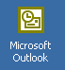
Double click on the Microsoft Outlook icon on the Windows desktop (see right), or click-on the Start button in the lower left corner of the screen, then click-on Programs, and then on Microsoft Outlook.

Inbox

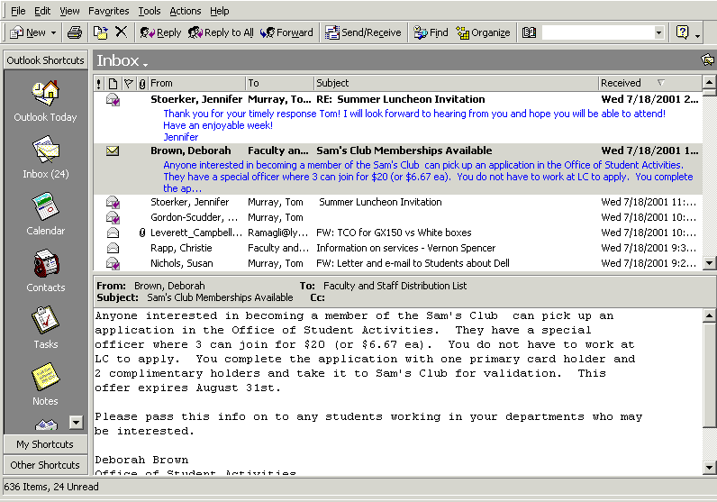
When Outlook 2000 appears, you will be in the Inbox where the mail you receive is located. Your Inbox screen should look something like this:

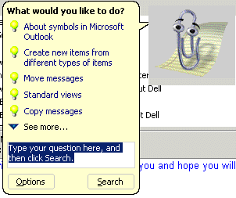
The first time you load Outlook 2000 the Office Assistant (A Paper Clip, or the assistant you chose) may appear. You can click-on the various choices to view the material, or if you do not want to view the material now, you can right click-on the Assistant and then click on Hide and the Assistant will go away. Anytime you desire to use the Assistant for help, you can click-on the “?” and the Assistant will appear. The Assistant is always located in the upper right part of the portion of the button bar.

The mail messages that you receive will be listed in chronological order.

Different Views in Outlook

When you first open Outlook 2000 you will notice that you can see a small portion of your incoming e-mail in the top portion of the screen and a greater portion in the lower area of the screen. There are several different “ways” to set-up a “view” that you like best. This first view is called Preview Pane (the name for the lower portion of the screen). The first page of this tutorial shows this Preview Pane view. Most users like this a lot – it seems to be the most popular view – that’s why it’s the default. However, many prefer to view each e-mail, individually, without the Preview Pane.

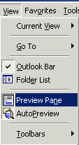
We’ll show you how to set several different views and you can choose the one you like best. First, we’ll simply turn-off the Preview Pane. To do this you’ll need to click-on View in the Menu Bar. When the drop down menu appears you’ll see a selection called Preview Pane. This is called a “toggle” button as it can either be “on” or “off.” Click-on the Preview Pane button. When you do, the Preview Pane will disappear from the bottom of your screen.

Your screen should now look like the one below.
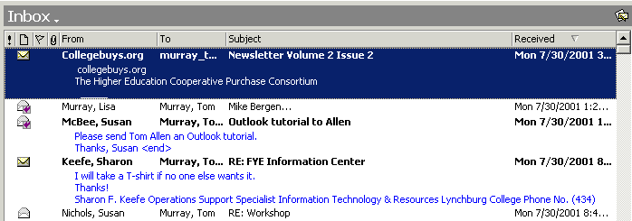

Notice that there is no Preview Pane on the bottom of the Inbox screen. Also notice that for some of the incoming e-mails that you can see a “mini-preview” just below the name of the person who sent you the e-mail. This is called Auto Preview. Many people like this view.

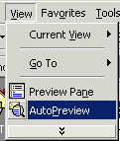
Still, others just want to see as many incoming e-mails as possible. So, they even “turn off” Auto Preview, just like we did with the Preview Pane. To do this click-on View in the Menu Bar as we have done before and when you see the selections, click-on Auto Preview to “toggle” it off. Now your screen should only show incoming messages with no “preview” of any kind. It should look like the one below.

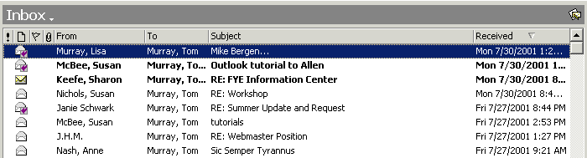

So, now you can “personalize” your Outlook Mail 2000, as you desire. You’ll need to do this for each “box” – Sent Items, etc. So, have some fun and make your Outlook mail yours.

Reviewing messages in the Inbox

To view a message, simply double-click on the message and the following screen will appear. You could also, just like other programs, click-once on a message and then click-on File (in the Menu bar), then click-on Open, then click-on Selected Items.

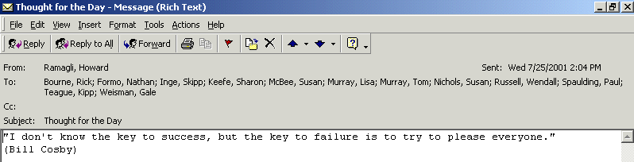

This screen is designed to review and respond to mail messages received.

If this is the first time that you are looking at this Outlook screen, it would be a good idea to click-on each item in the Menu and Button bars. So go ahead and click-on File, and then Edit, etc. Now, run the cursor over each of the buttons below the Menu bar.

Replying to a message

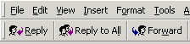
Look at the button bar at the top of the screen. Notice that you can click-on Reply, and, automatically reply to the person who sent the message, or Reply to All (everyone included in the To: or Cc:). When you click-on Reply and Reply to All, you will notice that Outlook 2000 “automatically” completes the To: and/or Cc: in your outgoing message.

You may click-in the “white” message area below, and supplement the original message with any additional comments you desire to make regarding the message to which you are replying.
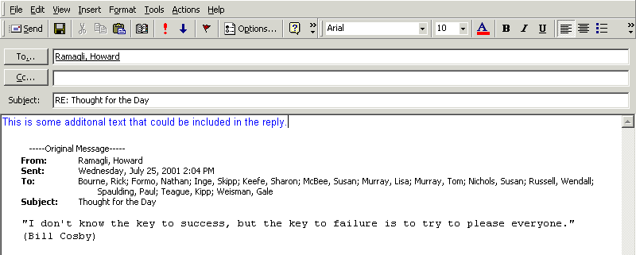
After you have made any comments, you can click-on the small “Send” box below File in the Menu bar and your Reply will be “mailed.”

Forwarding a message

If you desire to forward a message to someone or others, click-on the Forward button (next to the Reply and Reply to All buttons), then click-in the To: or Cc: areas. We will be covering Address Books later in this “tutorial.” At this point, type-in the e-mail address or addresses of those to whom you want to forward the mail message. If you have more than one address, separate them with a semi-colon (;). You can move down to the Address Book section if you desire (page 7).

When you reply to or forward a message in Outlook 2000, you will notice, when you view the message again in Inbox, or Sent Items, it will now have a small arrow attached to a small box by the message. These arrows indicate that the message has been forwarded or replied to. The arrows will be the same as on the Reply, Reply to All, and Forward buttons.

Deleting unwanted messages
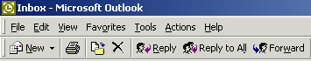

If you do not want to keep the message, you can click-on the “X” button, in the button bar, to send the message to a “Delete folder.”

Note: This is NOT the “x” button in the upper right corner of the screen. If you do click-on the upper right corner X, it will simply close the message and return you to the Inbox, etc.

We’ll discuss this in more detail later in Folders. When you delete a message in the Inbox, it is sent to the Deleted Items folder to be “really deleted” or “recovered” later.

Moving from message to message in the Inbox

Notice the large blue Up and Down arrows in the button bar below the Menu bar. They are only visible when you are “in a message.” These allow you to move forward and backward (Previous Item and Next Item) between messages in the Inbox. Click-on these arrows to see how they work.
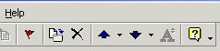

Printing a message

If you desire a “hard copy” of the message you can click-on the Printer in the button bar.

Or, you can click-on File in the Menu Bar and then on Print.

Creating and sending a new e-mail message

If you are in the Inbox and desire to send a new e-mail message to a person or group of persons click-on the New Mail Message button in the button bar.

If you are in some other part of Outlook 2000 and do not see the New Mail Message button, you can always (in the Inbox as well) click-on File in the Menu Bar, then click-on New,
and then click-on Mail Message. In both cases, the following screen should appear.

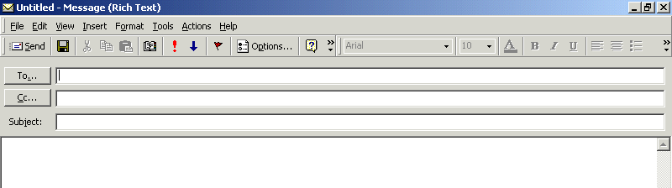
First, click-in the area to the right of To:. For now, type-in the e-mail address of the person, or persons, to whom you desire to send this e-mail message. Next, click-in the area to the right of Cc:. Again, type-in the name or names of others whom you would like to receive copies of this message. If you type-in more than one e-mail address, separate the addresses with a semi-colon (;). If you desire to use the Address Book, move down to the Address Book section (page 7).

Now click-in the area to the right of Subject:, and type-in a subject for your e-mail message if you desire. You do not need a Subject description if you do not desire one.

Finally click-in the white area below Subject:, and type-in your e-mail message as you would any memo to someone. You may move around, edit and change your message just like you would do if you were in a word processor. Later in this “tutorial,” we will show you how you may use Microsoft Word as your “e-mail editor,” with all the Microsoft Word features, if you choose to do so.

When you have completed your e-mail message, click-on the Send button in the upper left hand corner of the screen.

Quick note on folders

This is simply a quick note to tell you what happens when you send an e-mail message. When a message is sent, a copy of your e-mail is automatically sent to your Sent Items folder. So, you can access your sent message (by clicking-on the Sent Items folder – then opening your message), edit it, forward it, etc., until you decide to delete it later on. If you desire to keep the e-mail you will be able to move it to another folder if you desire. We’ll go into detail on all of this later. For now, just be aware that you have not “lost” your message. You do not need to “copy yourself” in Outlook unless you want to get an additional copy of your e-mail.

Address Books

When you have clicked-on Reply, Reply to All, or Forward as indicated on pages 4 and 5 or Creating an new e-mail message, page 6, you will see a screen similar to the one below:

If you are Replying or Replying to All on an e-mail message in your Inbox, then the addresses from that e-mail will automatically appear in the To and Cc areas. If you don’t want to send the e-mail to some of these addresses, you can simply click-on them and tap the Delete key. If you are Forwarding a message from the Inbox or Sending a new e-mail message, then you can either type-in the address in the To or Cc area, or use the Global Address List or Personal Address Book.

There are several Address Books in Outlook 2000 that you can utilize to send and respond to e-mail messages. In addition, there are a number of options for entering e-mail addresses into an Address Book. You will, in all probability, use two address books: Global Address List and Personal Address Book.

To access these address books/lists click-on the To: or Cc: “buttons” (see arrows on the picture above). The Global Address List menu box (below) will appear.
Global Address List

We’ll look at several Address Lists and explain how each is utilized. First, we’ll look at the Global Address List. When you have clicked-on either the To: or Cc: buttons the below screen will appear:

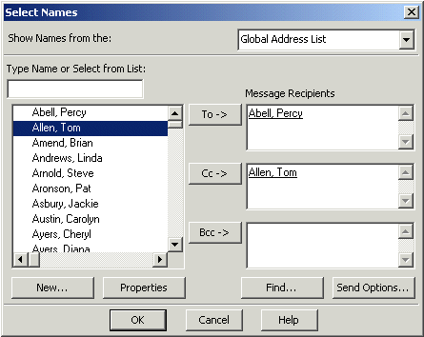

When you are in the Reply, Reply to All, Forward or create a New e-mail message screen, and need to add additional e-mail addresses, you can still type-in the addresses or use a Global Address List like the one above.

The Global Addresses List that you see above is created, and updated, when a person at the institution/business selects to use Outlook mail. The Information Technology Staff places the new user in the Global Address List. Thus, this address list is a current list of all Outlook mail users (and it may also include other users who are not on Outlook – depending on your on campus/business).

To use this list, simply click-on the person whom you want to receive the e-mail (their name will “turn blue” – see arrows above). Or, you can type their name in the area below “Type name or Select from list,” and you will notice that the list of names below where you typed the name moves to all of the persons with that name. Most systems are in last name order. Some are in first name order. By looking at the name list you can determine how your system is set-up. Then, click-on the To, Cc or Bcc (Blind copy) buttons. This will add the address to those already in the e-mail (you will see it appear in the area to the right). You can do this for as many addresses as you desire. When you have finished, click-on OK, and you return to your message. Arrows in the image above point to each of these items.
Contacts (in older versions of Outlook – Personal Address Book)

How can you create your own “automatic” address list for someone who is not on the campus/business Outlook 2000 mail system (especially off campus/business addresses)? There is a feature called Contacts to take care of this. Contacts is just what it indicates. You create your own Contacts (like a personal address book). First we’ll show you how to get to Contacts and then how to add and delete addresses.
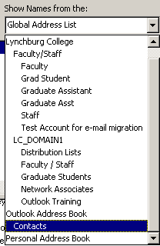

When you click-on the To: or Cc: buttons (page 7) the Global Address List appears. In the upper right corner of the Show Names from the: you will see an area that indicates that this is the Global Address List. To the right of the title is a small triangle, click-on the triangle and a menu screen similar to the one at the right appears.

Now, click-on Contacts, and the following screen appears, which contains the addresses that YOU have already placed in your old Personal Address Book – if you had one.

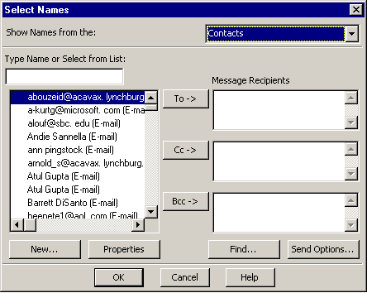

Notice, the Select Names menu screen to the right now indicates Contacts in the upper right corner. Also, notice the e-mail addresses on the left side of the menu screen. These are e-mail addresses that you have added to the list.

To add the addresses in Contacts to an e-mail message simply repeat the procedure outlined in the Global Address List. Click-on the name to whom you desire send the e-mail (on the left side), then click-on the To or Cc buttons to add that name to these areas. Again, you can add as many names as you wish. When you have finished, click-on OK and you will be taken back to the e-mail that you want to send. You can then continue to creating a new e-mail or editing the contents of one that you are working with.

Adding Names to Contacts (like Personal Address Book in older versions)

There are many ways to add names to Contacts. We’ll show you several of the more popular procedures. You will also discover other methods, as you become more familiar with Outlook 2000.

Adding names as you type the e-mail addresses in the To or Cc areas of the message

If a person’s e-mail address is not currently in your Global Address List or Contacts, you can add it while you are in the process of sending them a message. In the area to the right of To or Cc, type-in the e-mail address for the person or persons you wish to receive your e-mail. If you type-in several addresses, separate them with a semi-colon ( ; ). Click away (somewhere else) from the address you typed. You will notice that, in a few moments, the addresses will become underlined.

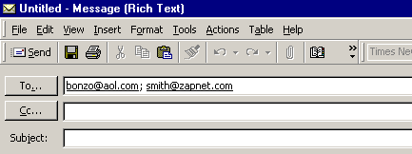
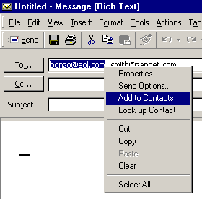

To add an address to your Contacts, simply right-click on a name, that you typed, and a menu box will appear similar to the one on the right.

Click-on Add to Contacts and the name will be automatically added to the address book.
The following screen will appear.

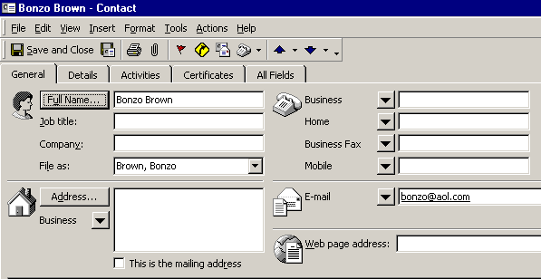
Normally, the first part of the e-mail address you entered before the “@” symbol will appear in the full name box. To change this to a logical full name click-on the Full Name… button (as indicated by the arrow above).
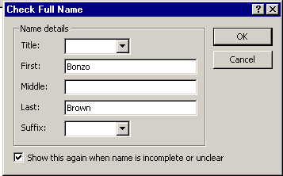

When the Check Full Name box appears (like the one on the left) you can then fill in the entire name by filling in the appropriate areas (First:, Middle:, Last:, etc.)

When you are finished, click-on OK.

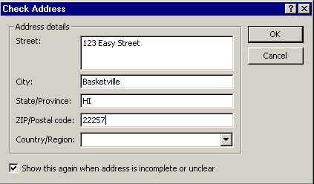

You can now fill in the applicable areas for the person’s mailing address if you desire. To do this click-on the Address…button (see arrow above)

When you are finished, click-on OK.

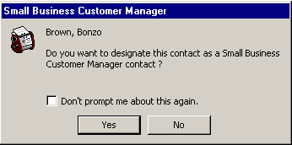
When you have completed everything, you can click-on the Save and Close button (see arrow on last page).

The screen to the right will now appear. You can click-on the Yes or No button as you desire.

When you are in the Contact screen (at the top of the last page) – notice that there are a lot of other tabs and areas which may also use to enter information about a person (Details, Activities, Certificates and Business, Home, FAX and Mobile Phones).

To observe that the contact you just entered has been added to your Contacts, click-on either the To or Cc buttons. When you have clicked-on one of the buttons, you will go to the Global Address List screen again – as before. Click-on the triangle in the upper right corner again, and then move down to and click-on Contacts. You will see the address you added. When you have a lot of addresses, you will have to use the up and down elevator bar to view your addresses. Outlook automatically alphabetizes the names as you enter them.

Your Contacts screen should look something like this:

Adding Names to your Contacts as you receive e-mail in your Inbox

Big Note: The right-click on an e-mail address also works when you receive a message from someone! If you know that this address is not in your Contacts, right-click on the address and add it as you did above. This really saves a lot of time. You know it’s a good address, because you received their message.

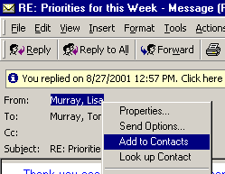
To the left is an image of the address area of an e-mail in the Inbox. We simply right clicked-on the person and then moved down the pop-up menu to Add to Contacts – just like we did when we typed-in and address in our New Mail To: area.

Once you have clicked-on Add to Contacts you will go back to the same process that is outlined above on pages 10 – 12.

Manually adding e-mail address to your Contacts

Many time friends will write you (the old fashioned way) or call you on the phone and furnish you their e-mail address. So, there is still another way to add to e-mail address to your Contacts. In the button bar below the Menu bar you will notice a “small book” (like the one on the right). When you run your cursor over the book it will indicate: Address Book. You can click-on it and also add names to your Contacts. So, click-on the “book” and the following screen will appear.

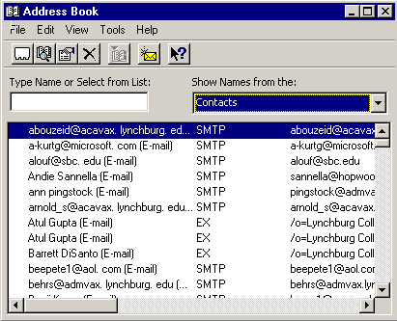
Click-on the triangle on the right of the Address Book screen (see the arrow on the right) and select Contacts from the drop down menu that appears.

Next, click-on the small “Rolodex like” button, in the button bar below the Menu bar (a small text help will appear indicating New Entry).
A New Entry screen will appear.
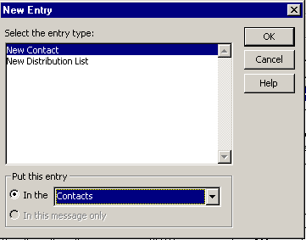
It should look similar to the one on the right. Make sure that New Contact is highlighted in blue in the Select the entry type: in the top portion of the screen.

And, also make sure that Contacts is highlighted in the Put this entry area in the lower part of the screen. If Contacts is not the choice, click the down triangle on the right side of Put this entry and select Contacts from the choices that appear.

When everything looks like the screen above, click-on OK.

An Untitled – Contact screen like the one below will appear.

Notice that the Untitled - Contact screen is similar to the one you used to enter e-mail addresses as you typed them into messages, or used when you copied addresses from you Inbox again appears – with a notable exception – there is no name in Full Name… or E-mail address in E-mail.

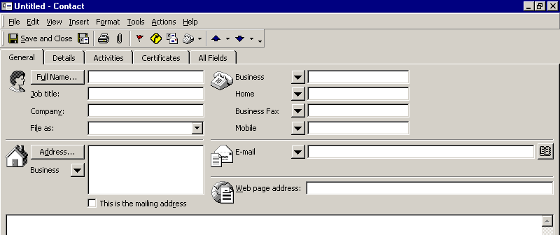
So, fill in the name of the person in Full Name… and enter their e-mail address in the E-mail area. You can enter other information as you did previously, as you desire.

When you have entered the information you screen should now look similar to the one below. Notice that we only entered a name and e-mail address. We did not enter a full mailing address, or other contact information. You can do this whenever you desire. When you have the information you desire entered in the appropriate areas, click Save and Close to add this person to your Contacts list.

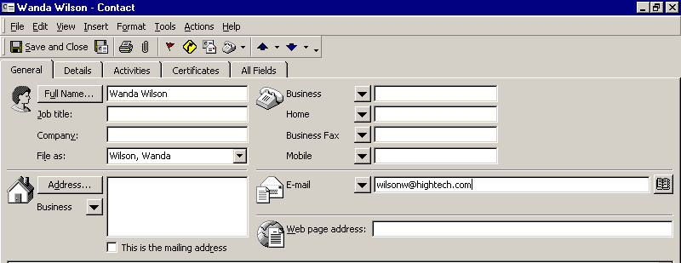

Note on viewing e-mail addresses

Once you begin using Outlook 2000 Mail you can check on a person’s “information” by right-clicking the mouse on their name in the To or Cc areas. In the pop-up menu that appears, click-on Properties. If they are in your Global Address Book you will “see” how the system administrator entered the information. If they are in your contacts list, you will see the Contacts screen similar to the one above. This is very handy if you desire “quick” information about a person in your system.

Personal Distribution Lists

Now that you have an idea of how to add individual names to Contacts, and are familiar with the Global Address List, you may want to create a group of addresses to which you frequently send e-mail. In Outlook 2000 this is called a Personal Distribution List. To create a Distribution List, you will follow several similar steps to those above.

To create a Personal Distribution List you will need to be in the Inbox, Sent Items, or Deleted Items (you can be in other main screens when you are more familiar with Outlook 2000). You will need to be in a main screen where you can see the little Address Book button, click-on it.

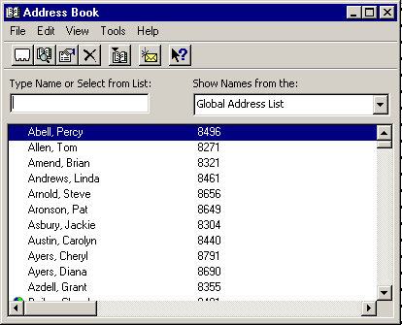
When the Address Book screen appears, click-on the New Entry “Rolodex card” button.

Just like you just did previously.

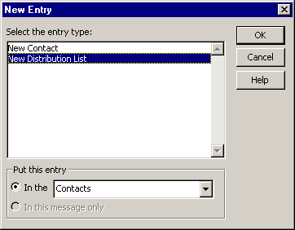

The New Entry screen appears, click-on New Distribution List in the area below Select the entry type.

Make sure that Put this entry is set on Contacts. If it is not set on Contacts, click-on the small down triangle to the right of this area and select Contacts.

Then, click-on OK.

The following screen will now appear:

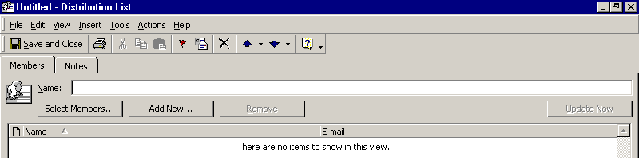

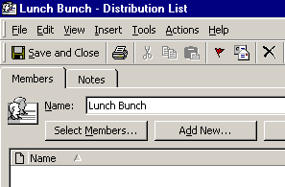
In the area to the right of Name:, type-in a name for your Distribution List (e.g. Lunch Bunch).

Next, click-on the Select Members… button.

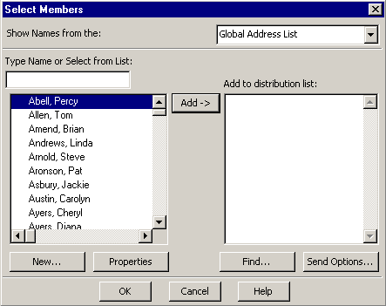
This will display the Select Members screen.

You’ll notice that this screen looks almost exactly like the Select Names screen you used to address your messages. You’ll notice that the Select Members screen only has an Add-> button. So, you can, at this moment, only add persons you desire to be in your Distribution List to the group. Later we’ll show you how to remove and add members as you update your list.

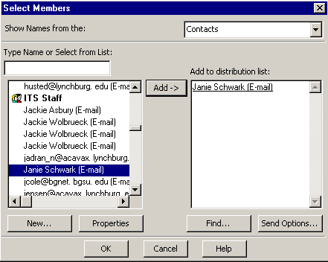

By using either the Global Address List, or your Contacts (click-on the small down triangle in the upper right corner of the Select Members screen and select the group you want) you can create your Distribution list.

In the example on the right we chose our Contacts group, and the person you see highlighted on the left.

We clicked-on the Add-> button they were added to our Distribution list on the right. You may “switch between” the various “lists” as often as you like and add as many names as you like.

Note: You do not need to have someone in either the Global Address List, Contacts or another list to have them in your Distribution List. If they are in neither, simply type a semi-colon (;) at the end of the last address on the right side, and then type-in the person’s e-mail address. They will be included in your list.

When you have added all the names you desire, click-on OK.

Note for Outlook 98 users who upgraded to Outlook 2000.

When you upgraded, you should have saved a file called a PAB (Personal Address Book) and incorporated it in your Outlook 2000 setup. This file contained all of the names that you placed in your Personal Address Book in Outlook 98. So, for you “old hands,” you may use not only all of the files in your Global Address Book and Contacts, you may also use your Personal Address book that you used previously. If you did not save it and replace the file that comes with Outlook 2000, the Personal Address Book names will not be available.

You should now return to the Distribution List screen. Your screen should look similar to the one below. You’ll see the name of your Distribution List in the Name: area and the names of the Members in the area below. Notice that the Remove button is now “active.”

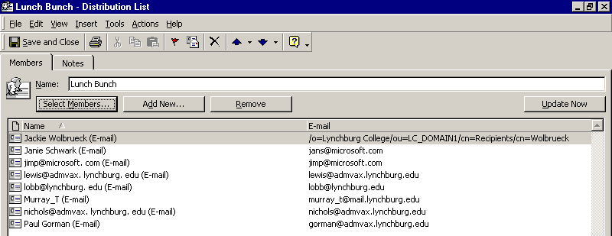
To remove members from the list simply click once on the member and then click-on the Remove button. You’ll notice that they are removed from your list.

To add new members, simply repeat the steps on pages 17 and 18, where you click-on the Select Members button and add them as you did before.

When you have made all the changes you desire, click-on the Save and Close button in the screen above.
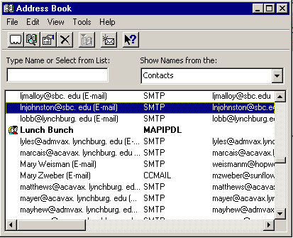
The next time you “visit” your Contacts your screen will look something like the one on the right.

You’ll notice that your Distribution List will look something like the one at the right. The name will be in bold, and there will be a “teeny” icon of a woman and a man on the left.

Any time you desire to make changes to this Distribution List, just double-click quickly on a list and you’ll be taken to that Distribution List screen that you used to create the list.

Folders

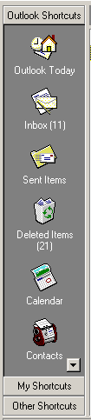
When you first opened Outlook 2000, the area to the left of the screen looked something like this. The icons you see take you to different features of Outlook (Calendar, etc.) or contain e-mail.

The icons we are concerned with in this tutorial are the ones that pertain to e-mail and hold messages (e.g. Inbox).

Notice that all of the icons are large. Also note that at the bottom right of the Outlook Shortcuts area that there is a small down triangle. This triangle indicates that there are more icons below the last icon shown.

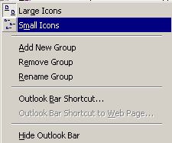
If you move your mouse cursor over any of the “open gray area” in the Outlook Shortcut area, and click-the right mouse button, a pop-up menu will appear (like the one on the right). If you would like to make your icons smaller, so that you can see more or all of them, click-on Small Icons.
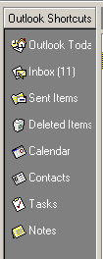

Your Outlook Shortcuts icons will now appear smaller – similar to the image on the right.

Notice at the bottom of the Outlook Shortcuts screen to the left, that it indicates My Shortcuts. Click-on this phrase.

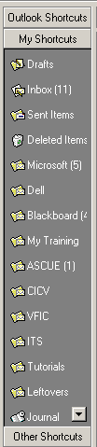
This will take you to a screen similar to the one on the right. Notice that there are a number of icons, which “hold” e-mail in some form. There are boxes for your incoming mail (Inbox), mail you have sent (Sent Items) and mail you have deleted (Deleted Items).

You can create special folders (Personal Folders) for various “groups” of e-mail (some of these on the right are – Dell, Blackboard, My Training, etc). As you receive or send e-mail related to this “group” you can move the e-mail to that folder so that you can find the items easily, without having to search all of your mail. You can still delete these items when they no longer apply and delete the folder when you are finished with it.

Creating Personal Folders

To create a Personal Folder in the My Shortcut Area, do the following:

Click-on File in the Menu Bar, then point to New, and then click-on Folder…

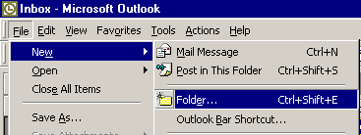
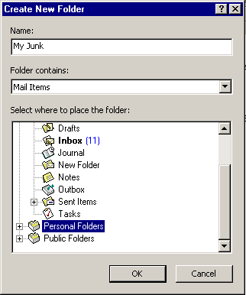

The following Create New Folder screen will appear:

First, select a logical name for the folder. For this exercise we’ll use the title “My Junk.” Type this name in the Name: area.

Next, move down the Create New Folder screen with the elevator arrows on the right of the menu screen until you see: “Personal Folders.” Click-on Personal Folders.

Now, click-on OK.
This will place the created folder in your My Shortcuts area.

The following menu screen will appear.
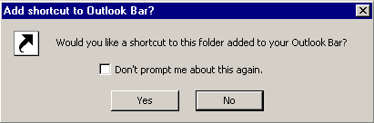

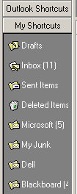
Click-on Yes.

Notice that a new Personal Folder(My Junk) has been added to your My Shortcuts folder area.

Placing e-mail messages in your Personal Folders
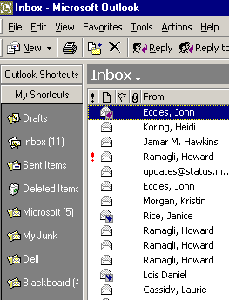

Moving a single message

You will notice, that when you are in the Outlook 2000 My Shortcuts area, that when you click-on Inbox, Sent Items, or Deleted Items, that the Personal Folders you created can still be seen in the My Shortcuts area down the left side of the screen.

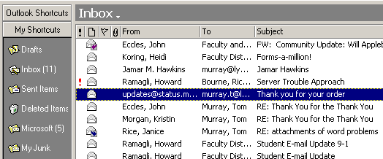

To “move” an e-mail from one folder to another folder, you simply click-on the e-mail message, you want to move to your Personal Folder, hold down the left mouse button, and drag the message to the Personal Folder. In the image above we clicked-on the highlighted message, held down the left mouse button, and dragged the message from the Inbox to the My Junk folder. You will notice, as you are “dragging” your e-mail message, a small box appears “attached” to the cursor arrow. The cursor changes to a circle with a line through it (when you are over a gray area), and then changes again to the box with the arrow when you have the cursor over a Personal Folder icon. When you have the box symbol over your Personal Folder, release the left mouse button. This will move the message from one folder to another. Try this with one of the messages in your Inbox.

Moving Several Messages

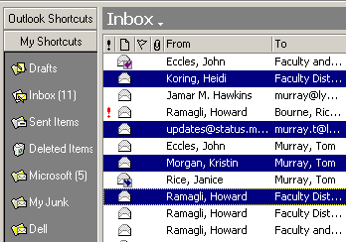
You can also move several messages with this drag technique.

To highlight several messages you need to learn a new skill. If you hold down one of the Ctrl keys (at the bottom of the keyboard – one either side of the Space Bar) and then click-on several messages, you’ll notice that as you click each message it is highlighted.

When you are ready to move the group of messages you highlighted, simply click-on any of the highlighted messages, and hold down the left mouse button immediately, and drag to the folder where you want the messages. If you click-on one of the messages and don’t drag the cursor immediately, this will “turn-off” the selections of the several messages and you’ll have to start again. It’s kind of tricky the first time that you try this.

If you ever desire to “turn-off” the multiple highlights, you simply click- on any message and that will remove the highlights and select the message on which you clicked.

You can still delete the messages when you no longer desire to retain them.

Moving, Deleting, and Recovering Mail Messages

You should now have a “feel” for Outlook 2000. Having just completed folders, you can see that we can move a message from any folder to any folder simply by clicking-on it and dragging the message to another folder. You could also click-on a message and, either using Edit (in the Menu Bar), then Copy or Cut in the Menu bar, and then Paste, to move or copy a message in this manner. You can also use the Cut, Copy and Paste buttons in the button bar.

To delete a message, you have already learned that you can click-on the message and then on the “X” in the button bar (not the X in the upper right hand corner). If you click-on the upper right hand corner X this will simply close the message and return you to the Inbox, etc.

When you delete an e-mail message in your Inbox, Sent Items, or a Personal Folder, this places the message in the Deleted Items “trash can.” You can “drag” an item from Deleted Items to any folder to retrieve it, or use the methods above to recover a message to a folder.

“Really” Deleting Messages

To “really” delete an e-mail message in the Deleted Items trash can, you can click-on the message and click-on the “X” button, or tap the Delete key. Outlook 2000 will ask you if you “really” want to delete the message. When you say “yes,” it’s gone. To delete several individual messages at once, click-on the first message, then hold down the Ctrl key, and while holding down Ctrl, click-on the other items. You will see that they turn “blue,” indicating that you are “marking” them (just like we covered before). Now click the “X” button or tap the Delete key. If you want to delete ALL of the items in the Delete Items trash can, click-on Edit in the Menu bar and then Select All. Then, click-on the “X” button or tap the Delete key.

Adding, Sending, Receiving, Viewing, and Saving Attachments

There are many times when you want to send a document, spreadsheet, PowerPoint presentation, picture, or file of some type to someone, or be able to receive one. Outlook 2000 makes this relatively simple. The items indicated above are sent as “attachments” to your e-mail.

When you are sending an e-mail message and want to “include” an attachment it’s relatively easy. When you are in the Untitled-Message, the Forward or Reply screens, you will notice a “paperclip” in the button bar.

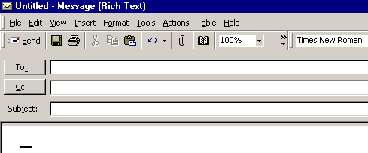
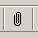

To add a file (attachment) to you message you must be in the “text” area to do so. You cannot add an attachment if you are in the To…, Cc…, or Subject areas. You will see your cursor “flashing” in the text area so you will know you are in the correct area. If you are in the To…, Cc…, or Subject areas, you will not “see” the paperclip clearly. You will see a definite outline of a paperclip (like the one above) when you are in the text area.

This paperclip is the button that allows you to insert an attachment in your e-mail message. Go to the place, in your e-mail message, where you want the attachment located. Most often, people place attachments at the beginning or end of their messages. When you are at the point where you want the file (attachment) located, click-on the paperclip. The following Insert File menu screen will appear.

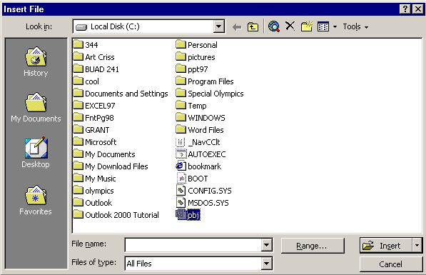

When this Insert File screen appears, choose the location of your file (attachment) on your computer (A or C drives, etc., or on a network drice) by using the Look in: area (see the arrow above – we have chosen our C: disk drive). Then choose the file by clicking-on it (we chose a PowerPoint file called PBJ for our attachment). Click-on OK. Your e-mail message, with attachment, will look similar to the screen below.
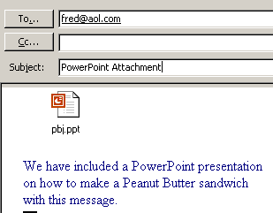

When you or, another person, receives this attachment, all you have to do is double-click on the attachment and it will load into the proper program! Or, you can right click the mouse on the attachment, and a menu will appear that you can use. Once you have the document in its normal “environment” you can save it, etc. Pretty neat!

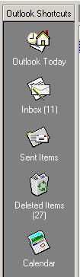
Calendar

There is a personal calendar you can use that is included with Outlook 2000. You can access the calendar by clicking-on the calendar icon in Outlook Shortcuts area on the left of your Outlook screen. You can learn how to use this calendar by clicking-on Help or the Office Assistant.

A small “addendum tutorial” for the Calendar will be created soon.

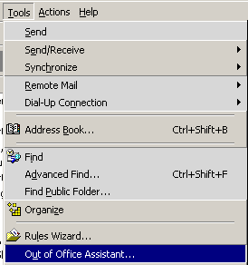
Out of Office Assistant

If you are going to be away from your office computer for a period of time, and you want to leave a message for folks to let them know this, you can use the Out of Office Assistant to do this. To activate the Out of Office Assistant click-on Tools in the Menu bar and then on Out of Office Assistant…

You will need to be in the Inbox, Sent Items, Deleted Items or one of your folder screens to do this.

The following menu screen will appear.

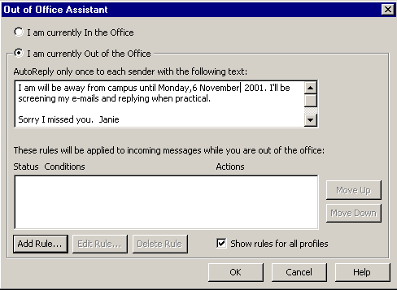

Type the message that you want others to receive when they send an e-mail message to you. Then click-in the small circle to the left of I am currently out of the Office. This message will be sent to each person the first time that they send you an e-mail message telling them that you are away from the office. When you return, and load Outlook 2000, you will see a screen prompt reminding you that Out of Office Assistant is active. You can “turn off” the assistant when you see this message.

Auto-Signature
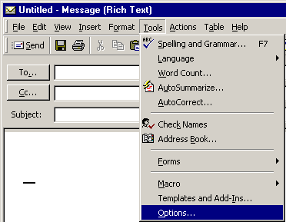
There is an Outlook 2000 feature, which allows you to place a “designed” signature at the end of your e-mail messages. You will need to be in the text area of a New Mail message, or one that you are replying to or forwarding. If you are not in the text area, where you type your message, click-in that area. To activate this feature, click-on Tools in the Menu Bar. When the drop down menu appears, click-on Options.

The following screen will appear.

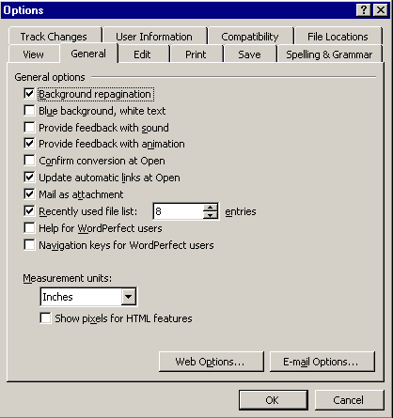

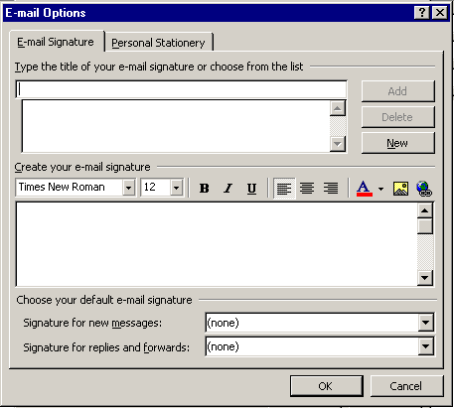
When the above screen appears click-on the General “tab” – if it is not already “active.” At the bottom of the General area you will notice a button that indicates E-mail Options… Click-on the E-mail options button.

The following screen will appear.

Instructions on what to do next are furnished below.

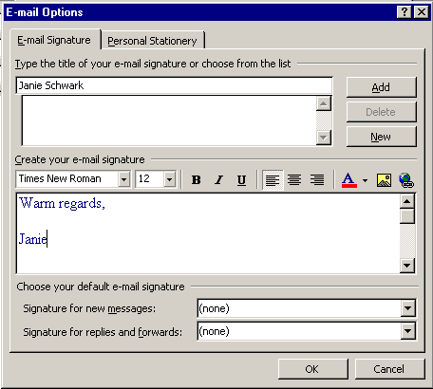

When the E-mail Options screen above appears, type a “name” for your signature in the area under Type the title of your e-mail signature or choose from the list (see the top left arrow – we used Janie Schwark). Next, type the signature, just as you want it in the area under Create your e-mail signature (we used Warm regards, Janie – see the lower left arrow). Notice below Create your e-mail signature that there is a “line” of options for “formatting” your signature. This is from Microsoft Word. So, you can change the font, size, color, or make the signature bold or italic, and even align the signature if you wish. When you have completed the signature, click-on the Add button (see the upper right arrow).

Now click the OK Button twice.

From now on, when you create a new message, reply to one, or forward one, you will see that you signature is automatically added at the end of the message.

Using Microsoft Word as your e-mail Editor
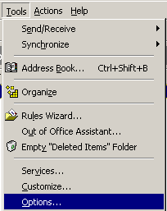

You may use Microsoft Word, if you have it installed on your computer, as your e-mail editor, if you desire. To activate Word, make sure that you are in the Inbox, Sent Items or Deleted Items screen. Click-on Tools in the Menu Bar, then click-on Options in the drop down menu that appears.

When the Options screen appears, click-on the Mail Format tab

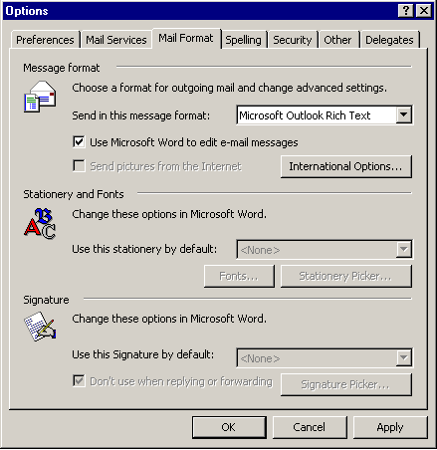
Notice, before we start setting Word as our editor, the bottom two sections of the screen: Stationary and Fonts and Signature.

If you are not using Word as your editor you may enter these two sections and create your signature and fonts.

If you do want to use Word as your editor – with all of the full word processing features then, in the screen that appears, click-in the box to the left of Use Microsoft Word to edit e-mail messages.

Then click-on the Apply button and then click-on the OK button. The next time you create a new e-mail, or reply or forward an e-mail you will see a little message appear that indicates that Word is being loaded as your editor. At the top of the screen you’ll see additional, new toolbars for using Word.

When you are typing your e-mail messages you will have all of the power that is inherent in Microsoft Word.

Accessing you e-mail at home through a web browser

If you desire to access your Outlook e-mail at home, using a modem and an on-line service provider (e.g. AOL), go to the following web address: http://mail.lynchburg.edu.

A tutorial for Outlook Web Access will soon be available to assist you.

This has been an introduction into the basics of Outlook 2000 mail. If you have any questions about Outlook 2000, or comments on this tutorial, please contact:

murray.t@Lynchburg.edu

Thank you for your patience and good luck.

