Introduction to
Microsoft Outlook 2003 Mail

Created: 19 September 2003

Starting Outlook 2003

In this Microsoft Outlook 2003 tutorial, we’ll discuss a number of the basic procedures used in creating, editing, sending and receiving Outlook 2003 mail messages. In addition, we’ll also introduce other features essential to managing Outlook 2003 mail messages.

Starting Outlook Mail 2003
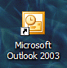
Double click on the Microsoft Outlook icon on the Windows desktop (see right), or click-on the Start button in the lower left corner of the screen, then click-on Programs, and then click-on Microsoft Outlook.

New Look

The first thing you’ll notice, if you have used Outlook mail previously (any version), is a whole new visual appearance. Gone is the Outlook Bar on the left with the various icons. You’ll also notice that there are more “items” where the Outlook Bar used to be. You’ll also notice the screen is more colorful. If you have never used Outlook before, this won’t cause any problems as we proceed through this tutorial.

Left Mouse Button

In this tutorial, whenever we indicate that you need to click a mouse button, it will mean to click the left mouse button – unless we indicate that you should click the right mouse button. So, always move the cursor over the “place” we indicate and “click left” unless we tell you otherwise.

Inbox

When Outlook 2003 appears, you will be in the Inbox where the mail you receive is located. Your Inbox screen should look something like the image at the top of the next page.

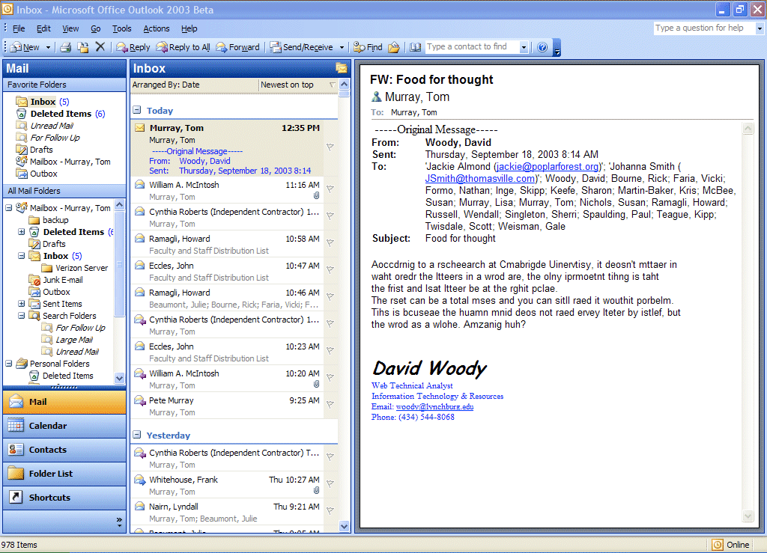

The mail messages that you receive will be listed in chronological order.

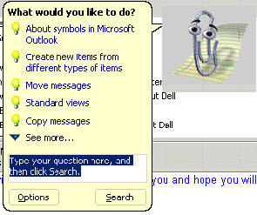

The first time you load Outlook 2003 you may see the Office Assistant (A Paper Clip, or the assistant you chose) may appear. You can click-on the various choices to view the material, or if you do not want to view the material now, you can click the right mouse button on the Assistant and then click on Hide and the Assistant will go away.

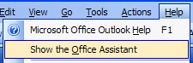
Anytime you desire to use the Assistant for help, you can click-on Help in the Menu Bar and then click-on Show the Office Assistant.

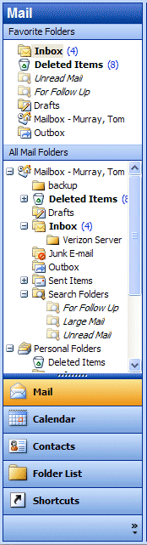
Different Views in Outlook 2003

Navigation Pane

When you first open Outlook 2003 your screen will normally look like the one at the top of Page 2. As indicated earlier, this is much different than previous versions of Outlook. We’ll start with the left side of the screen and work to the right. On the left side of the screen you’ll see an image similar to the one on the right. This is called the Navigation Pane. You’ll notice in the top area that it indicates Mail. Below Mail there are two areas: Favorite Folders and All Mail Folders. We’ll show you how to change things around in these areas, if you desire to, in a little while

Below the Mail area you’ll see a series of Buttons: Mail, Calendar, Contacts, Folder List and Shortcuts. Notice that the Mail button is orange. This means that this button has been selected (when you opened Outlook Mail).

If you click the left mouse button on Calendar, the Calendar will appear on the right side of the screen and the Calendar button will turn orange. The same thing will happened when you click-on Contacts, Folder List and Shortcuts.

Give this a try. When you are finished, click-on Mail once again.

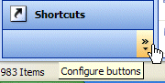
The next logical question is how to change this Navigation Pane so that it looks like you want it to. The secret is in the lower right corner of the Navigation Pane. You’ll see two >> symbols. When you move your mouse over the symbols your screen will look like the image on the right. Your cursor will change to a little pointy hand and a Configure buttons choice will appear. Click on the >>.
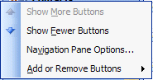

When you click, the drop down menu to the right will appear. You’ll notice the choices: Show Fewer Buttons, Navigation Pane Options, and Add or Remove Buttons.

First, if you don’t want as many buttons to appear, click-on Show Fewer Buttons. Watch what happens. You’ll notice your buttons “leave” from the bottom of the Navigation Pane. You’ll have to click-on the >> each time you desire to get this menu again. To bring the buttons back to the Navigation Pane, click-on Show More Buttons. Give this a try and set your Navigation Pane as you desire.

Now we’ll see what occurs when we click-on Navigation Pane Options… Click-on Navigation Pane Options and the below Navigation Pane Options menu screen will appear.

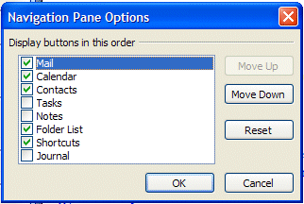

There are a number of choices with this screen. First, notice that there are little green “check marks” in some of the boxes. These are the buttons that currently appear in the Navigation Pane. If you don’t want a box to appear, click the check mark and it will disappear – and the box won’t show.

If you want to change the order of the buttons, notice the Move Down and Move Up choices on the right side of this menu screen. If you click-on one of the buttons (like Mail above –which is blue), and click the Move Down button, you will see Mail move down your button list.

Give both of these options a try and set your buttons as you desire. Most folks who use the Show Fewer Buttons and Navigation Pane Options like the Navigation Pane Options better, as it allows you to set your buttons just like you desire.

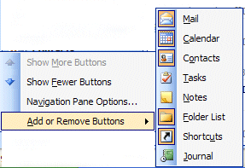
Now we’ll choose the last option in the Configure Buttons list – Add or Remove Buttons. Click-on the Add or Remove Buttons choice and you will see a pop-up menu appear to the right of the choice. Here again, you can click on a button (like Mail) and it will disappear, or appear when you click. This is called “toggling.” It’s like a light switch – On or Off. Each time you click, the button appears or disappears.

You have a lot of choices on how to show/add, hide/remove buttons from your Navigation Pane. You choose the method you like best from the ones we have just shown you.

Now we’ll concentrate on viewing you e-mail messages.

Different Views in Outlook 2003

Mail Views

You will notice that you can see a small portion of your incoming e-mail in the middle portion of the screen and a greater portion in the right side area of the screen. This is the default view – depending on how you set up your Outlook 2003. There are several different “ways” to set-up a “view” that you like best. The image you see at the top of Page 2 on this tutorial is the one that someone thought you’d like best. It is a combination of two things - Preview Pane (the name for the middle portion of the screen), and Reading Pane (the name for the right side of your screen). NOTE: depending who set up your Outlook 2003 program, your screen may not look like this. This is not a problem, as we’ll now show you how to set up the view that you like the best. The first page of this tutorial shows this Preview Pane and Right Side Reading Pane. Most users like this a lot – this seems to be the most popular view – that’s why it’s the default. However, many prefer to view each e-mail message, individually, without the Preview Pane, Reading Pane or anything else.

We’ll show you how to set several different views and you can choose the one you like best. New in Outlook 2003 is a combination of Auto Preview and Reading Pane.

First, we’ll work with the Reading Pane. To view the Reading Pane selections, click-on View in the Menu Bar and then click Reading Pane. You will see three suggestions to the right of Reading Pane – Right, Bottom, and Off. Normally, Right is the default. The choice for your Outlook mail will be highlighted a bit – you can see in our image (below) that Right has a little square around it.

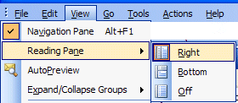
We’ll start with Right. Click-on Right. Microsoft added this view to Outlook 2003 as another way to read your messages. You will see the text of a message displayed on the right side of your screen like the image at the top of the next page.

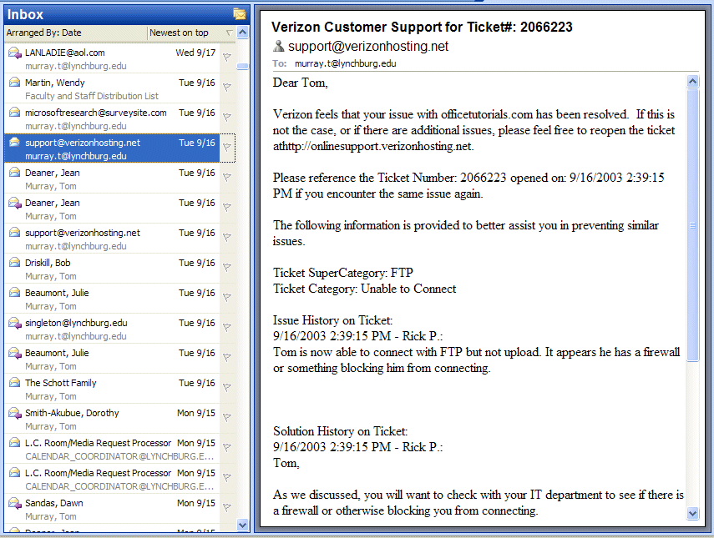

Message on Left

Text on Right

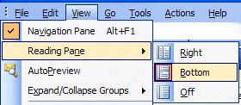

Now we’ll repeat what we did on the last page, but place the reading page on the Bottom.

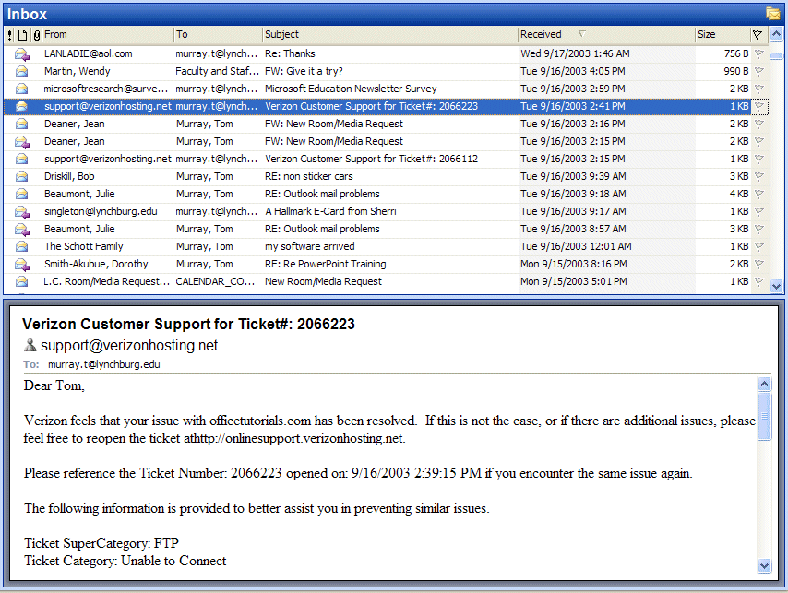
Text on Bottom
Message on Top

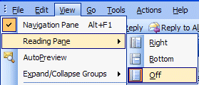

Now for the last choice. Repeat what you did on the last two pages, but choose Off.

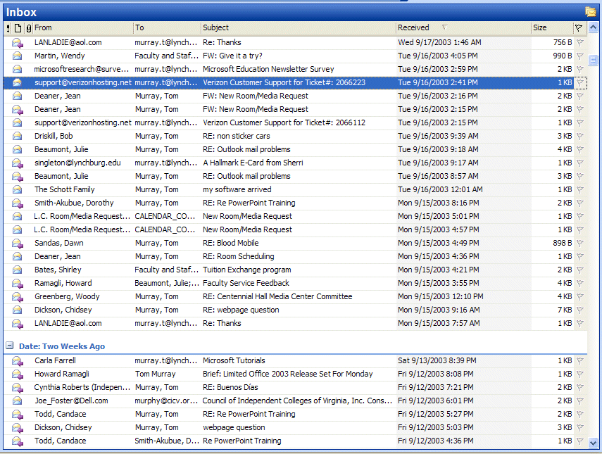

All of your messages on one screen – NO Reading Pane

You choose the Reading Pane that you like the best.

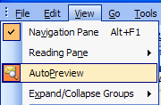
Next, we’ll work with the Auto Preview. To do this you’ll need to click-on View in the Menu Bar. When the drop down menu appears you’ll see a selection called Auto Preview. This is called a “toggle” button as it can either be “on” or “off.” Click-on the Auto Preview button. When you do, Auto Preview will appear or disappear from your screen.

On the next page we’ll show you examples of Auto Preview working with Reading Pane – Right, Bottom and Off views.
The below image has Auto Preview on the left and Reading Pane on the right. You can see a few lines of the message in “Auto Preview,” below the incoming message data.

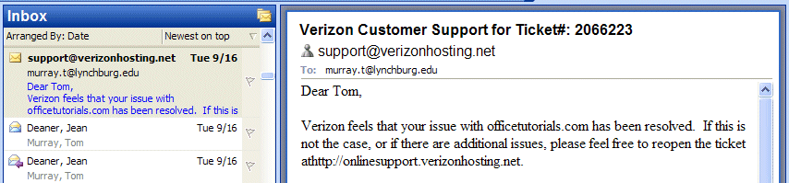

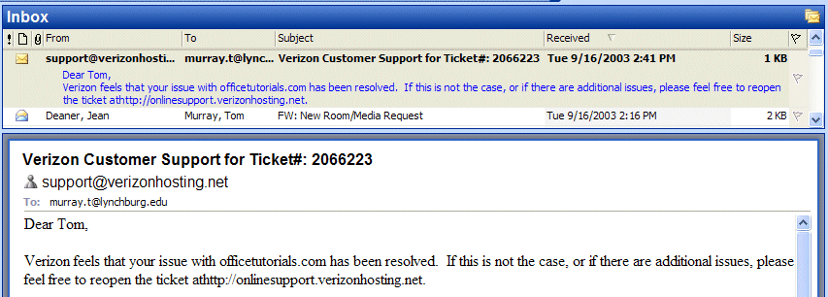
The below image has Auto Preview on the top and Reading Pane below the message. You can see a few lines of the message in “Auto Preview,” below the incoming message data.

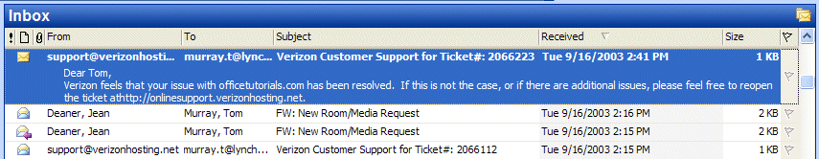
The below image has Auto Preview ONLY – no Reading pane. You can see a few lines of the message in “Auto Preview,” below the incoming message data.

As you can see, there are a great number of combinations for reviewing your messages using the Reading Pane and Auto Preview together. Experiment and choose the combination you like the best.

Reviewing messages in the Inbox

To view a message, simply double-click quickly on the message and the following screen will appear.

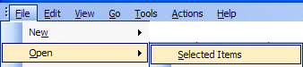
You could also click-once on a message and then click-on File (in the Menu bar), then click-on Open, then click-on Selected Items.

You will now see a screen similar to the one below.

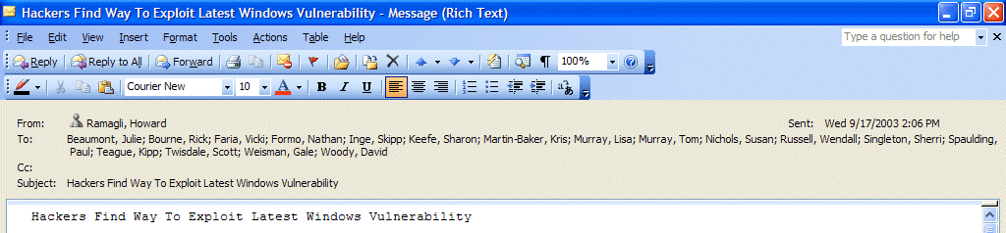

This screen is designed to review and respond to mail messages received.

If this is the first time that you are looking at this Outlook screen, it would be a good idea to click-on each item in the Menu bar. So go ahead and click-on File, and then Edit, etc. Next, move the cursor over each of the buttons below the Menu bar.

Replying to a message
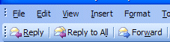
Look at the button bar at the top of the screen (it will look like the image on the left). Notice that you can click-on Reply, and, automatically reply to the person who sent the message, or Reply to All (everyone included in the To: or Cc:). When you click-on Reply and Reply to All, you will notice that Outlook 2003 “automatically” completes the To: and/or Cc: in your outgoing message.
You then click-in the “white” message area below the To, Cc, and subject, and supplement the original message with any additional comments you desire to make regarding the message to which you are replying.

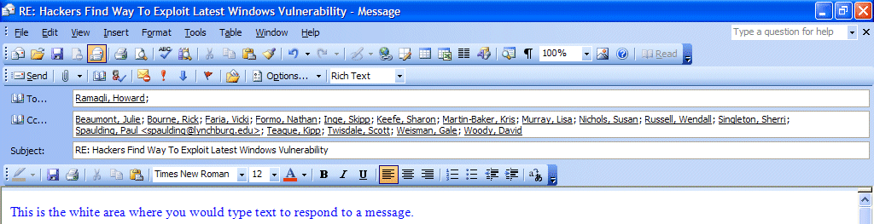

After you have made any comments, you can click-on the small “Send” box below File in the Menu bar and your Reply will be “mailed.”

Forwarding a message

If you desire to forward a message to someone or others, click-on the Forward button (next to the Reply and Reply to All buttons), then click-in the To: or Cc: areas. We will be covering Address Books later in this “tutorial.” At this point, type-in the e-mail address or addresses of those to whom you want to forward the mail message. If you have more than one address, separate them with a semi-colon (;). You can move down to the Address Book section if you desire (Page 13).

Envelopes

Now that you have the “feel” for looking at messages in your Inbox, replying to and forwarding them, please take a moment to look at the “little envelops” next to each message. When a message first arrives in your Inbox, and has not been read, you’ll notice that the envelope is closed.
Once you have read the message, but not replied, the envelope will appear opened.
When you reply to or forward a message in Outlook 2003, you will notice, when you view the message again in Inbox, or Sent Items, it will now have a small arrow attached to a small box by the message. These arrows indicate that the message has been forwarded or replied to. A purple arrow pointing to the left indicate you have replied to a message, a blue arrow pointing to the right indicates that you forwarded that message. The arrows will be the same as on the Reply, Reply to All, and Forward buttons.

Deleting unwanted messages

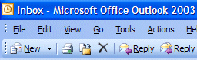

If you do not want to keep the message, you can click-on the “X” button, in the button bar, to send the message to a “Delete folder.”

Note: This is NOT the “x” button in the upper right corner of the screen. If you do click-on the upper right corner X, it will simply close the message and return you to the Inbox, etc.

We’ll discuss this in more detail later in Folders. When you delete a message in the Inbox, it is sent to the Deleted Items folder to be “really deleted” or “recovered” later.

Moving from message to message in the Inbox

Notice the large blue Up and Down arrows in the button bar below the Menu bar. They are only visible when you are “in a message.” These allow you to move forward and backward (Previous Item and Next Item) between messages in the Inbox. Click-on these arrows to see how they work.
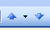

Printing a message

If you desire a “printed copy” of the message you can click-on the Printer in the button bar.

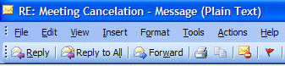

Or, you can click-on File in the Menu Bar and then on Print.

Creating and sending a new e-mail message

If you are in the Inbox and desire to send a new e-mail message to a person or group of persons click-on the New Mail Message button in the button bar.
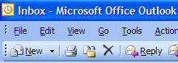

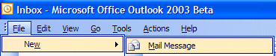
If you are in some other part of Outlook 2003 and do not see the New Mail Message button, you can always (in the Inbox as well) click-on File in the Menu Bar, then click-on New, and then click-on Mail Message.

In both cases, the below screen should appear.

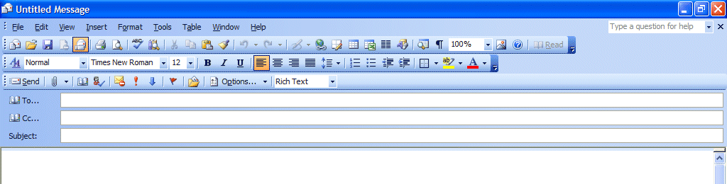

First, click-in the area to the right of To:. For now, type-in the e-mail address of the person, or persons, to whom you desire to send this e-mail message. Next, click-in the area to the right of Cc:. Again, type-in the name or names of others whom you would like to receive copies of this message. If you type-in more than one e-mail address, separate the addresses with a semi-colon (;). If you desire to use the Address Book, move down to the Address Book section (Page 14).

Now click-in the area to the right of Subject:, and type-in a subject for your e-mail message if you desire. You do not need a Subject description if you do not desire one.

Finally, click-in the white area below Subject:, and type-in your e-mail message as you would any memo to someone. You may move around, edit and change your message just like you would do if you were in a word processor. Later in this “tutorial,” we will show you how you may use Microsoft Word as your “e-mail editor,” with all the Microsoft Word features, if you choose to do so.
When you have completed your e-mail message, click-on the Send button in the upper left hand corner of the screen.

Quick note on folders

This is simply a quick note to tell you what happens when you send an e-mail message. When a message is sent, a copy of your e-mail is automatically placed in your Sent Items folder. So, you can access your sent message (by clicking-on the Sent Items folder – then opening your message), edit it, and forward it, etc., until you decide to delete it later on. If you desire to keep the e-mail you will be able to move it to another folder if you desire. We’ll go into detail on all of this later. For now, just be aware that you have not “lost” your message. You do not need to “copy yourself” in Outlook unless you want to get an additional copy of your e-mail.

Address Books

When you have clicked-on Reply, Reply to All, or Forward as indicated on pages 9 and 10 or created a new e-mail message, page 12, you will see a screen similar to the one below:

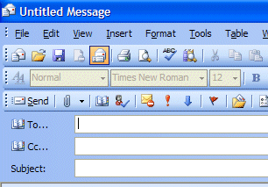

If you are Replying or Replying to All on an e-mail message in your Inbox, then the addresses from that e-mail will automatically appear in the To and Cc areas. If you don’t want to send the e-mail to some of these addresses, you can simply click-on them and tap the Delete key. If you are Forwarding a message from the Inbox or Sending a new e-mail message, then you can either type-in the address in the To or Cc area, or use the Global Address List or Contacts Address Book.

There are several Address Books in Outlook 2003 that you can utilize to send and respond to e-mail messages. In addition, there are a number of options for entering e-mail addresses into an Address Book. You will, in all probability, use two address books: Global Address List and Contacts Address Book.

To access these address books/lists click-on the To: or Cc: “buttons” (see arrows on the picture above). The Global Address List menu box (at the top of the next page) will appear.
Global Address List

We’ll look at several Address Lists and explain how each is utilized. First, we’ll look at the Global Address List. When you have clicked-on either the To: or Cc: buttons the below screen will appear:
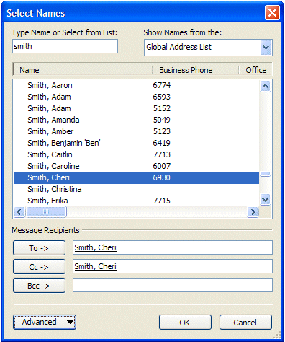

When you are in the Reply, Reply to All, Forward or create a New e-mail message screen, and need to add additional e-mail addresses, you can still type-in the addresses or use a Global Address List like the one above.

The Global Addresses List that you see above is created, and updated, when a person at the institution/business selects to use Outlook mail. The Information Technology Staff places the new user in the Global Address List. Thus, this address list is a current list of all Outlook mail users (and it may also include other users who are not on Outlook – depending on your on campus/business).

To use this list, simply click-on the person whom you want to receive the e-mail (their name will “turn blue” – see arrows above). Or, you can type their name in the area below “Type name or Select from list,” and you will notice that the list of names, below where you typed the name, moves to all of the persons with that name. Most systems are in last name order. Some are in first name order. By looking at the name list you can determine how your system is set-up. Then, click-on the To, Cc or Bcc (Blind copy) buttons. This will add the address to those already in the e-mail (you will see it appear in the area to the right). You can do this for as many addresses as you desire. When you have finished, click-on OK, and you return to your message. Arrows in the image above point to each of these items.
Contacts (in older versions of Outlook – Personal Address Book)

How can you create your own “automatic” address list for someone who is not on the campus/business Outlook 2003 mail system (especially off campus/business addresses)? There is a feature called Contacts to take care of this. A contact is just what it indicates. You create your own Contacts (like a personal address book). First we’ll show you how to get to Contacts and then how to add and delete addresses.
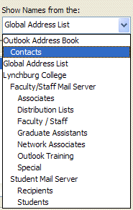
When you click-on the To: or Cc: buttons (Page 13) the Global Address List appears. In the upper right corner of the Show Names from the: you will see an area that indicates that this is the Global Address List. To the right of the title is a small down arrow, click-on the down arrow and a menu screen similar to the one at the right appears.

Now, click-on Contacts, and the screen below appears, which contains the addresses that YOU have already placed in your old Personal Address Book – if you had one.

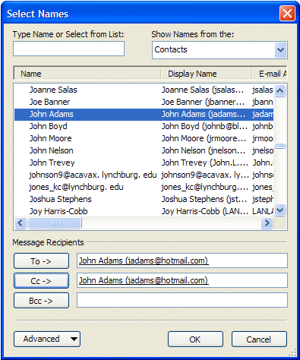

Notice, the Select Names menu screen (left image) now indicates Contacts in the upper right corner. Also, notice the e-mail addresses on the menu screen. These are e-mail addresses that you would add to your Contacts list.

Now we’ll show you how to add Contacts.

To add the addresses in Contacts, to an e-mail message, simply repeat the procedure outlined in the Global Address List. Click-on the name, to whom you desire send the e-mail (on the left side), then click-on the To or Cc buttons to add that name to these areas. Again, you can add as many names as you wish. When you have finished, click-on OK and you will be taken back to the e-mail that you want to send. You can then continue to creating a new e-mail or editing the contents of one that you are working with.

Adding Names to Contacts (like Personal Address Book in older versions)

There are many ways to add names to Contacts. We’ll show you several of the more popular procedures. You will also discover other methods, as you become more familiar with Outlook 2003.

Adding names as you type the e-mail addresses in the To or Cc areas of the message

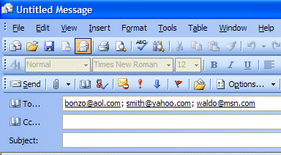
If a person’s e-mail address is not currently in your Global Address List or Contacts, you can add it while you are in the process of sending them a message. In the area to the right of To or Cc, type-in the e-mail address for the person or persons you wish to receive your e-mail. If you type-in several addresses, separate them with a semi-colon ( ; ). Click away (somewhere else on the screen) from the address you typed. You will notice that, in a few moments, the addresses will become underlined.

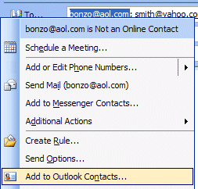

To add an address to your Contacts, simply right-click on a name, that you typed, and a menu box will appear (image at left).

Click-on Add to Outlook Contacts and the Contacts entry menu screen will appear (image at top of next page).
The Contact entry menu screen appears below.

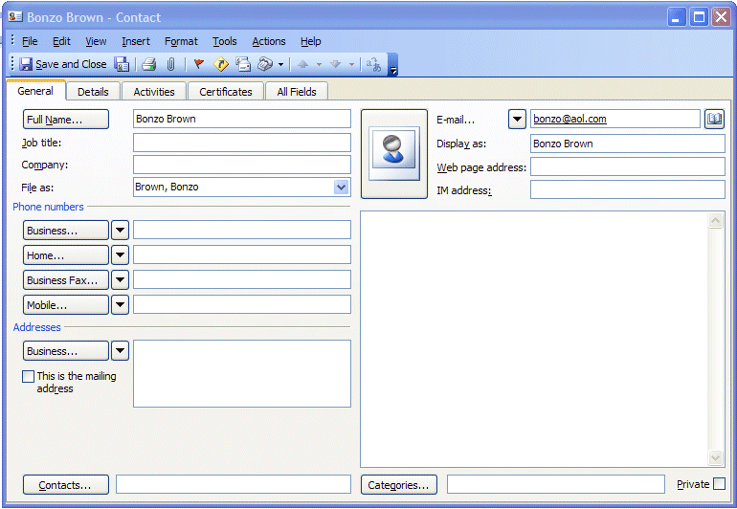

Normally, the first part of the e-mail address you entered before the “@” symbol will appear in the full name box. To change this to a logical full name click-on the Full Name… button (as indicated by the arrow above).

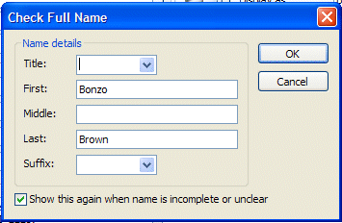

When the Check Full Name box appears (image on left) you can then fill in the entire name by filling in the appropriate areas (First:, Middle:, Last:, etc.)

When you are finished, click-on OK.

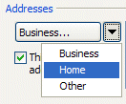
You can now fill in the applicable areas for the person’s mailing address, if you desire. To do this click-on the

Address down triangle (see arrow at right). Click-on Business, Home or Other.

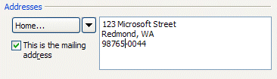
You will notice that your Address area changes to your selection (we chose Home…). After you make your selection (Business, Home, Other), type the address in the small box to the right of your selection.

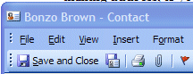
When you have completed everything, you can click-on the Save and Close button (arrow on right).

You will not return to your message. To add additional names to your Contacts Address Book repeat the above process again.

When you are in the Contact screen (at the top of the last page) – notice that there are a lot of other tabs and areas which may also use to enter information about a person (General, Details, Activities, Certificates and All Fields).

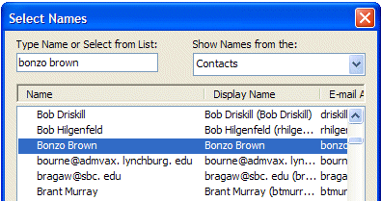
To observe that the contact you entered has been added to your Contacts, click-on either the To or Cc buttons in your message screen. When you have clicked-on one of the buttons, you will go to the Global Address List screen again. Click-on the down arrow in the upper right corner, and move down the menu and click-on Contacts. You will see the address you added. When you have a lot of addresses, you will have to use the up and down elevator bar to view your addresses. Outlook automatically alphabetizes the names as you enter them.

Your Contacts screen should look something like this:
Adding Names to your Contacts as you receive e-mail in your Inbox

Big Note: Right-click on an e-mail address also works when you receive a message from someone! If you know that an address is not in your Contacts, right-click on the address and add it as you did above. This really saves a lot of time. You know it’s a good address, because you received their message!

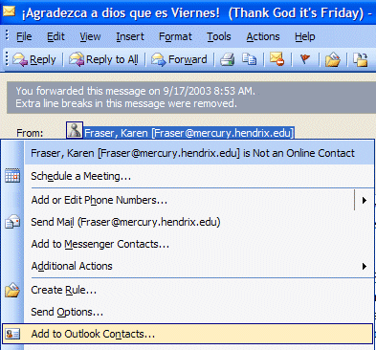

To the left is an image of the address area of an e-mail in the Inbox. We simply right clicked-on the person and then moved down the pop-up menu to Add to Contacts – just like we did when we typed-in and address in our New Mail To: area.

Once you have clicked-on Add to Contacts you will go back to the same process that is outlined above on pages 17 & 18.

Manually adding e-mail address to your Contacts

Many times, friends will write you (the old fashioned way) or call you on the phone and furnish their e-mail address. So, there is still another way to add their e-mail address to your Contacts. In the button bar below the Menu bar you will notice a “small book” (like the one on the right). When you run your cursor over the book it will indicate: Address Book. You can click-on it and add names to your Contacts. So, click-on the “book” and the following screen will appear.

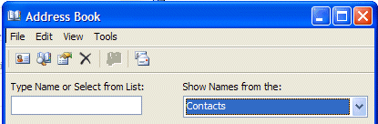
Click-on the down arrow on the right of the Address Book screen (see arrow) and select Contacts from the drop down menu that appears.

Next, click-on the small “Calling Card” button, in the button bar below the Menu bar (a small text help will appear indicating New Entry).
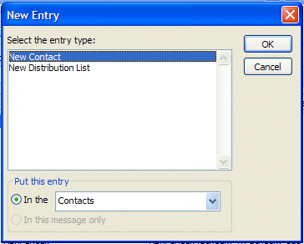
A New Entry screen will appear.

It should look similar to the one on the right. Make sure that New Contact is highlighted in blue in the Select the entry type: in the top portion of the screen.

And, also make sure that Contacts is selected in the Put this entry area in the lower part of the menu screen. If Contacts is not the choice, click the down arrow on the right side of Put this entry and select Contacts from the choices that appear.

When everything looks like the screen above, click-on OK.

An Untitled – Contact screen like the one below will appear.

Notice that the Untitled - Contact screen is similar to the one you used to enter e-mail addresses as you typed them into messages, or used when you copied addresses from you Inbox again appears – with a notable exception – there is no name in Full Name… or E-mail address in E-mail.

So, fill in the name of the person in Full Name… and enter their e-mail address in the E-mail area. You can enter other information as you did previously, as you desire.

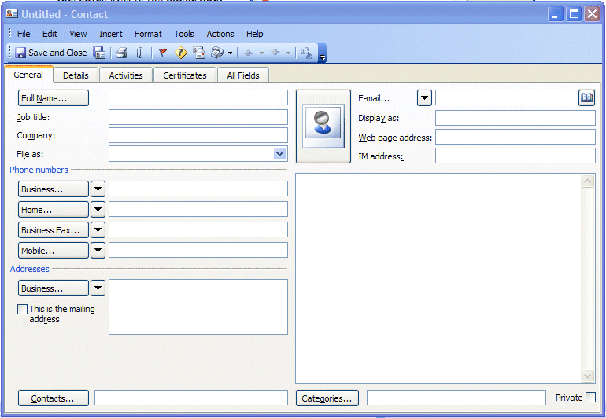

When you have entered the information, your screen should look similar to the one below. When you have the information you desire, entered in the appropriate areas, click Save and Close to add this person to your Contacts list.

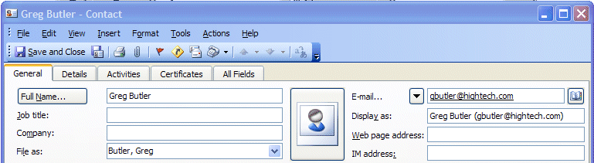

Note on viewing e-mail addresses

Once you begin using Outlook 2003 Mail you can check on a person’s “information” by right-clicking the mouse on their name in the To or Cc areas. In the pop-up menu that appears, click-on Properties. If they are in your Global Address Book you will “see” how the system administrator entered the information. If they are in your contacts list, you will see the Contacts screen similar to the one above. This is very handy if you desire “quick” information about a person in your system.

Personal Distribution Lists

Now that you have an idea of how to add individual names to Contacts, and are familiar with the Global Address List, you may want to create a group of addresses to which you frequently send e-mail. In Outlook 2003 this is called a Personal Distribution List. To create a Distribution List, you will follow several steps, similar to those above.
To create a Personal Distribution List you will need to be in the Inbox, Sent Items, or Deleted Items (you can be in other main screens when you are more familiar with Outlook 2003). You will need to be in a main screen where you can see the little Address Book button, click-on it.

When the Address Book screen appears, click-on the New Entry “Calling card” button,
just like you just did before.

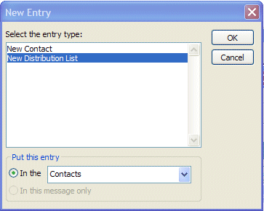
The New Entry screen appears, click-on New Distribution List in the area below Select the entry type.

Make sure that Put this entry is set on Contacts. If it is not set on Contacts, click-on the small down arrow to the right of this area and select Contacts.

Then, click-on OK.

The following screen will now appear:

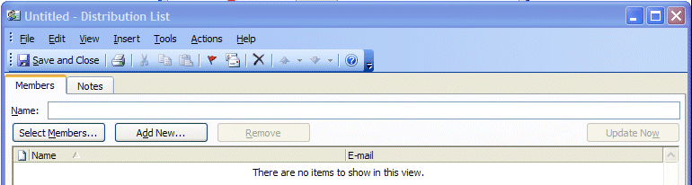

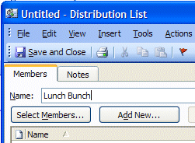
In the area to the right of Name:, type-in a name for your Distribution List (e.g. Lunch Bunch).

Next, click-on the Select Members… button.

This will display the Select Members screen.

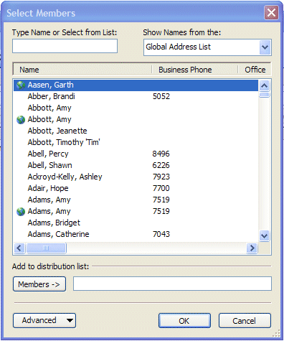

You’ll notice that this screen looks almost exactly like the Select Names screen you used to address your messages. You’ll notice that the Select Members screen only has a Members - > button. So, you can, at this moment, only add persons you desire to be in your Distribution List to the group. Later we’ll show you how to remove and add members as you update your list.

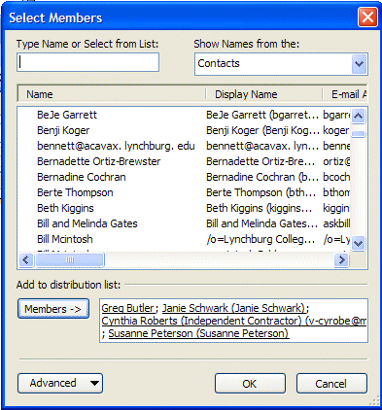
By using either the Global Address List, or your Contacts you can create your Distribution list. Click-on the small down arrow in the upper right corner of the Select Members screen and select the group you want.

In the example on the right we chose our Contacts group, and selected the person you see highlighted at the bottom of the Menu screen.

We then clicked-on the Members-> button – this person was added to our Distribution list on the right. You may “switch between” the various “lists” as often as you like, and add as many names as you like.

Note: You do not need to have someone in either the Global Address List, Contacts or another list to have them in your Distribution List. If they are in neither, simply type a semi-colon (;) at the end of the last address on the right side, and then type-in the person’s e-mail address. They will be included in your list.

When you have added all the names you desire, click-on OK.

Note for Outlook 98/2000 users who upgraded to Outlook 2003

When you upgraded, you should have saved a file called a PAB (Personal Address Book) and incorporated it in your Outlook 2003 setup. This file contained all of the names that you placed in your Personal Address Book in Outlook 98/2000. So, for you “old hands,” you may use not only all of the files in your Global Address Book and Contacts, you may also use your Personal Address book that you used previously. If you did not save the PAB file and replace the PAB file that was loaded with Outlook 2003, the Personal Address Book names will not be available. Your technical staff may have also indicated that they removed the Personal Address Book option and included these addresses in your Contacts. If you have a question here, ask you technical staff for assistance.

You should now return to the Distribution List screen. Your screen should look similar to the one below. You’ll see the name of your Distribution List in the Name: area and the names of the Members in the area below. Notice that the Remove button is now “active.”

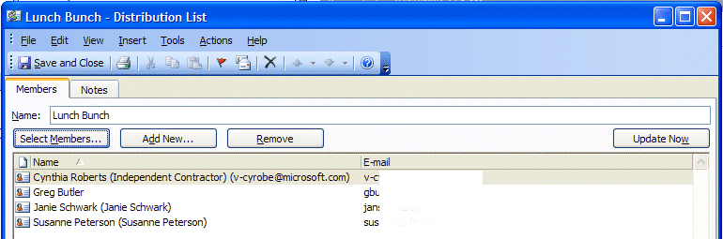

To remove members from the list simply click once on the member and then click-on the Remove button. You’ll notice that they are removed from your list.

To add new members, simply repeat the steps on pages 21 to 24. Click-on the Select Members button and add them as you did before.

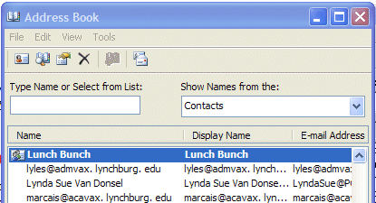
When you have made all the changes you desire, click-on the Save and Close button in the screen above.

The next time you “visit” Contacts, your screen will look something like the one on the right.

The name will be in bold, and there will be a “teeny” icon of a woman and a man on the left.

Any time you desire to make changes to this Distribution List, just double-click quickly on a list and you’ll be taken to that Distribution List screen that you used to create the list.
Sending Messages using your Distribution List

To send a message to everyone on your Distribution Lists, use the same steps that you used for sending a message to a single person. Either type in the name of the Distribution List in the To: or Cc: areas of your message (e.g. Lunch Bunch), or use the Select Names box, like you did on pages 13 to 15, but select your Distribution List like you would select a name.

Folders

NOTE: For Outlook 98, 2000 and XP/2002 users, you probably noticed that the Outlook Bar, on the left of the screen, had been replaced by a whole new folder and icon area (Navigation Pane). No longer are there Outlook Shortcuts, My Shortcuts and Other Shortcuts areas. The prior Outlook Today icon has been replaced by a mailbox with your name on it. We’ll review the new Navigation Pane, that we introduced at the beginning of the tutorial, that replaces the Outlook Bar.

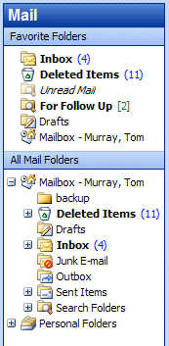

When you first opened Outlook 2003, the area to the left of the screen looked something like the image to the left. The icons you see take you to different features of Outlook (Calendar, etc.) or contain e-mail.

The icons we are concerned with in this tutorial are the ones that pertain to e-mail and hold messages (e.g. Inbox, Sent Items, Deleted Items).

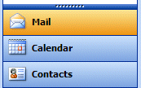
When your Technical Support staff set-up your Outlook 2003 account, they create limits for the amount of mail messages you can have in your Inbox, Sent Items, and Deleted Items folders. When you get near this limit, you will receive a cautionary message, indicating that you need to delete messages that are no longer needed. Frequently, you have certain messages that are related to a topic or group, and you would like to retain them for some period of time, and not have them “count” against your size limit. The next area of this tutorial will address this situation

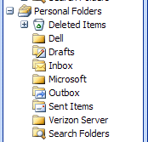
You can create special folders called Personal Folders for various “groups” of e-mail (some of these on the right are – Microsoft, Dell, Verizon Server, etc). As you receive or send e-mail related to this “group” you can move the e-mail to that folder so that you can find the items easily, without having to search all of your mail. You can still delete these items when they no longer apply and delete the folder when you are finished with it.

Creating Personal Folders

To create a Personal Folder, do the following:

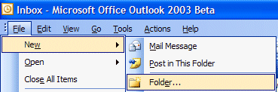
Click-on File in the Menu Bar, then click-on New in the drop down menu, and then click-on Folder…

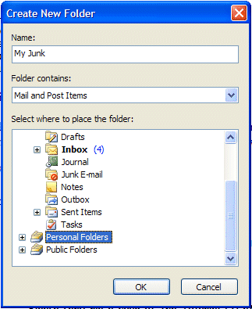
The following Create New Folder screen will appear:

First, select a logical name for the folder. For this tutorial we’ll use the title “My Junk.” Type the name you desire in the Name: area.

Next, move down the Create New Folder screen with the elevator arrows (on the right of the menu screen) until you see: “Personal Folders.” Click-on Personal Folders.

Now, click-on OK.

This will place the created folder in your My Shortcuts area.

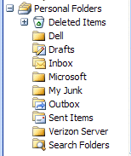

Notice that a new Personal Folder (My Junk) has been added to your Personal folder area.

Placing e-mail messages in your Personal Folders

Moving a single message

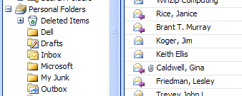
You will notice, in the Preview Pane – All Mail Folders area, that when you click-on Inbox, Sent Items, or Deleted Items, that the Personal Folders you created can still be seen in the Preview Pane on the left side of the screen.

To “move” an e-mail from one folder (Inbox, etc.) to another folder (Personal Folder), you simply click-on the e-mail message, you want to move, hold down the left mouse button, and drag the message to the Personal Folder.

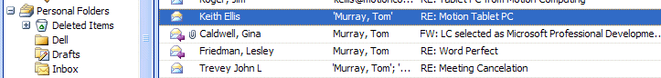

In the image above we clicked-on the highlighted message, held down the left mouse button, and dragged the message from the Inbox to the Dell folder. You will notice, as you are “dragging” your e-mail message, a small box appears “attached” to the cursor arrow. The cursor changes to a circle with a line through it (when you are over an area where you can’t drop your mesage), and then changes again to the box with the arrow when you have the cursor over a Personal Folder icon. When you have the box symbol over your Personal Folder, release the left mouse button. This will move the message from one folder to another. Try this with one of the messages in your Inbox.
Moving Several Messages

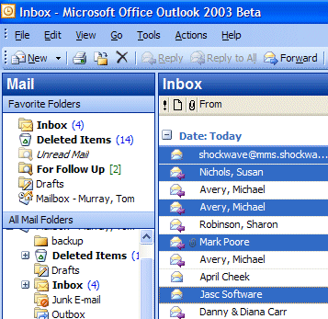

You can also move several messages with this drag technique.

To highlight several messages you need to learn a new skill. If you hold down one of the Ctrl keys (at the bottom of the keyboard – one either side of the Space Bar) and then click-on several messages, you’ll notice that as you click each message it is highlighted (like image on left).

When you are ready to move the group of messages you highlighted, simply click-on any of the highlighted messages, and immediately hold down the left mouse button, and then drag all the messages to the folder where you want the messages. If you click-on one of the messages and don’t drag the cursor immediately, this will “turn-off” the multiple message selections and you’ll have to start again. It’s kind of tricky the first time that you try this.

If you ever desire to “turn-off” the multiple highlights, you simply click-on any message and that will remove the highlights and select the message on which you clicked.

You can still delete the messages when you no longer desire to retain them.

Moving, Deleting, and Recovering Mail Messages

You should now have a “feel” for Outlook 2003. Having just completed folders, you can see that we can move a message from any folder to any folder simply by clicking-on it and dragging the message to another folder. You could also click-on a message and, either using Edit (in the Menu Bar), then Copy or Cut in the Menu bar, and then Paste, to move or copy a message in this manner. You can also use the Cut, Copy and Paste buttons in the button bar.

To delete a message, you have already learned that you can click-on the message and then on the “X” in the button bar (not the X in the upper right hand corner). If you click-on the upper right hand corner X this will simply close the message and return you to the Inbox, etc.

When you delete an e-mail message in your Inbox, Sent Items, or a Personal Folder, this places the message in the Deleted Items “trash can.” You can “drag” an item from Deleted Items to any folder to retrieve it, or use the methods above to recover a message to a folder.

“Really” Deleting Messages

To “really” delete an e-mail message in the Deleted Items trash can, you can click-on the message and click-on the “X” button, or tap the Delete key. Outlook 2003 will ask you if you “really” want to delete the message. When you say “yes,” it’s gone. To delete several individual messages at once, click-on the first message, then hold down the Ctrl key, and while holding down Ctrl, click-on the other items. You will see that they turn “blue,” indicating that you are “marking” them (just like we covered before). Now click the “X” button or tap the Delete key. If you want to delete ALL of the items in the Delete Items trash can, click-on Edit in the Menu bar and then Select All. Then, click-on the “X” button or tap the Delete key.

A message box will appear asking if you really want to delete all the items. If you do, click-on Yes.

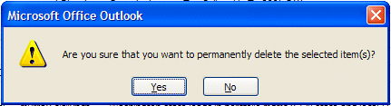

Adding, Sending, Receiving, Viewing, and Saving Attachments

There are many times when you want to send a Word document, Excel spreadsheet, PowerPoint presentation, picture, or file of some type to someone, or be able to receive one. Outlook 2003 makes this relatively simple. The items indicated above are sent as “attachments” to your e-mail.
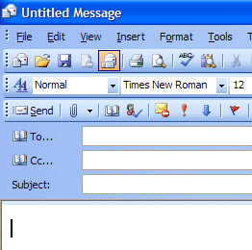
When you are sending an e-mail message and want to “include” an attachment it’s relatively easy. When you are in the Untitled-Message, the Forward or Reply screens, you will notice a “paperclip” in the button bar.

Text Area - Cursor

To add a file (attachment) to you message, you must be in the “text” area to do so.
You cannot add an attachment if you are in the To…, Cc…, or Subject areas. You will see your cursor “flashing” in the text area so you will know you are in the correct area. If you are in the To…, Cc…, or Subject areas, you will not “see” the paperclip clearly. You will see a definite outline of a paperclip (like the one above) when you are in the text area.

This paperclip is the button that allows you to insert an attachment in your e-mail message. Go to the place, in your e-mail message, where you want the attachment located (in the Text Area). Most often, people place attachments at the beginning or end of their messages. When you are at the point where you want the file (attachment) located, click-on the paperclip. The following Insert File menu screen will appear.

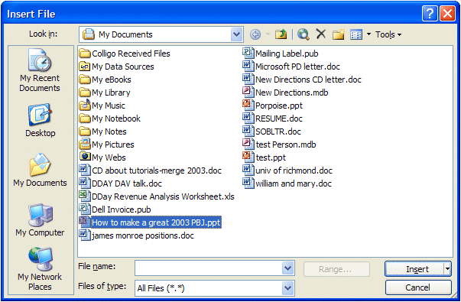
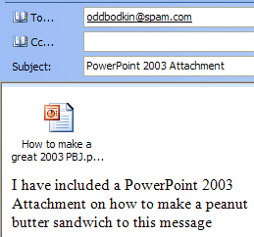

When this Insert File screen appears, choose the location of your file (attachment) on your computer (A or C drives, etc., or on a network drive) by using the Look in: area (see the arrow above – we have chosen My Documents on the C: disk drive). Then choose the file by clicking-on it (we chose a PowerPoint file called How to make a great 2003 PBJ for our attachment). Click-on OK. Your e-mail message, with attachment, will look similar to the image on the right.

When you or, another person, receives this attachment, all you have to do is double-click on the attachment and it will load into the proper program! Or, you can right click the mouse on the attachment, and a menu will appear that you can use. Once you have the document in its normal “environment,” you can save it, etc. Pretty neat!

Calendar

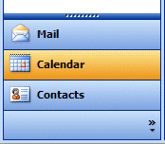
There is a personal calendar you can use that is included with Outlook 2003. You can access the calendar by clicking-on the calendar icon in Outlook Shortcuts area on the left of your Outlook screen. You can learn how to use this calendar by clicking-on Help or the Office Assistant.

A Calendar tutorial has been created for Outlook. You can receive a copy of this tutorial by sending an e-mail to the address at the end of this tutorial.

Out of Office Assistant

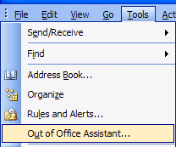
If you are going to be away from your office computer for a period of time, and you want to leave a courtesy message for folks to let them know that you’ll be away, you can use the Out of Office Assistant to do this. To activate the Out of Office Assistant click-on Tools in the Menu bar and then click-on Out of Office Assistant…

You will need to be in the Inbox, Sent Items, Deleted Items or one of your folder screens to do this.

The Out of Office Assistant menu screen at the top of the next page will appear.

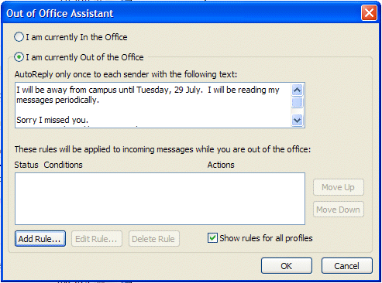

Type the message that you want others to receive when they send an e-mail message to you. Then click-in the small circle to the left of I am currently out of the Office. This message will be sent to each person the first time that they send you an e-mail message telling them that you are away from the office.
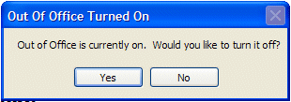
When you return (to your office), and load Outlook 2003, you will see a screen prompt reminding you that Out of Office Assistant is active. You can “turn off” the Assistant when you see this message.

Auto-Signature
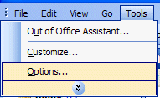
There is an Outlook 2003 feature, which allows you to place a “designed” signature at the end of your e-mail messages. You will need to be in one of the Main areas of Outlook 2003 to create a signature (Inbox, Sent Items, Deleted Items, etc.).

To activate this feature, click-on Tools in the Menu Bar. When the drop down menu appears, click-on Options.

The Options menu screen at the top of the next page will appear.

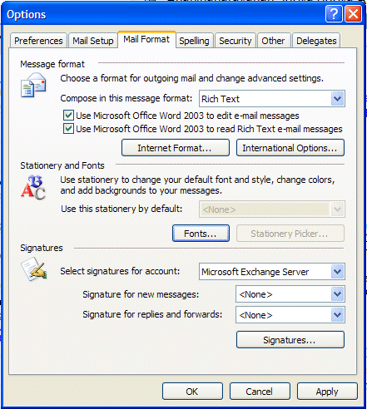

When the above screen appears click-on the Mail Format “tab” (see upper arrow above). In the lower portion of the Options menu screen you will see and area called Signature. Click-on the Signatures… button in this area (see lower arrow above).
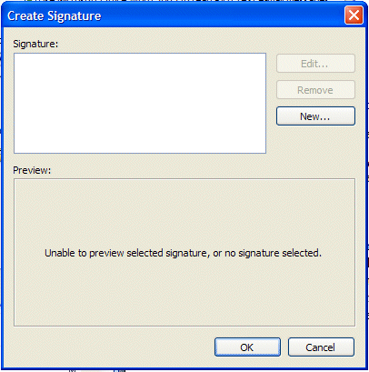

The following Create Signature menu screen will appear.

Click-on the New button in this screen (see arrow to the right).

The Create New Signature menu screen at the top of the next page will appear.
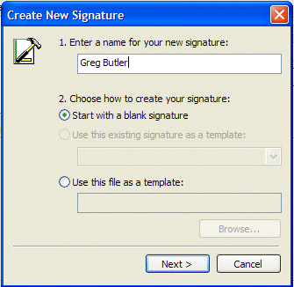
When the Create New Signature screen appears, type a “name” for your signature in the area under - 1. Enter a name for your new signature: (see the top right arrow – we used Greg Butler).

We’ll leave 2. Choose how to create your signature as the default choice – Start with a blank signature (see middle left arrow).

Now click-on the Next Button (see lower left arrow).

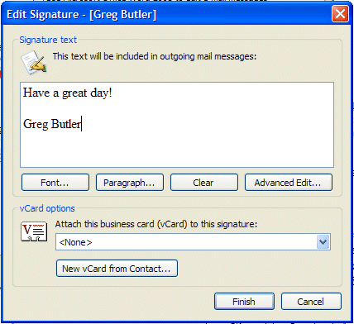
When the Edit Signature menu screen appears, type your Signature in the space under Signature text – like we have done on the right.

You can type anything you desire for your signature. You can type just your name, or name, title, phone, FAX, etc. It’s your signature.

Notice that there are several buttons below the Signature text – Font, Paragraph, etc. If you desire to change the font of your signature, highlight the text that you desire to change, and then click-on the Font button and select your font – then click OK in the Font menu screen. You can have several different fonts in your signature if you desire – as well as color.

When you have the signature you desire, click the Finish button.

This will take you back to the Create Signature menu screen. Click OK. The bottom portion of your Options menu screen should look similar to the image below.

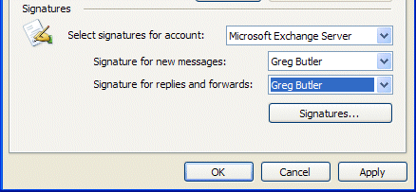

From now on, when you create a new message, reply to one, or forward one, you will see that you signature is automatically added at the end of the message.

If you desire to edit your signature or create a new one follow the process above, an choose the logical buttons to Edit, Remove, or create a New signature.

When you are satisfied with your signature, click OK.

Using Microsoft Word as your e-mail Editor

You may use Microsoft Word, if you have it installed on your computer, as your e-mail editor, if you desire. To activate Word, make sure that you are in the Inbox, Sent Items or Deleted Items screen. Click-on Tools in the Menu Bar, then click-on Options in the drop down menu that appears.

When the Options menu screen appears, click-on the Mail Format tab

If you want to use Word as your editor (with all of the full word processing features), in the Options menu screen that appears, click-in the boxes to the left of Use Microsoft Word 2003 to edit e-mail messages and Use Microsoft Word 2003 to read Rich Text e-mail messages (see arrow on left of the image).

Then click-on the Apply button and then click-on the OK button.

The next time you create a new e-mail, or reply or forward an e-mail you will see a little message appear that indicates that Word is being loaded as your editor. At the top of the screen you’ll see additional, new toolbars for using Word.

When you are typing your e-mail messages you will have all of the power that is inherent in Microsoft Word 2003.

Accessing you e-mail at home through a web browser

If you desire to use your Outlook e-mail at home, using a modem and an on-line service provider (e.g. MSN, AOL), check with your Technology Department and see if they have this service available.

If you do, an Outlook Web Access tutorial has been created –similar to this one – to assist you. Simply send an e-mail to address below to request a copy.

Other interesting features in Outlook 2003

Multi-colored Flag selection

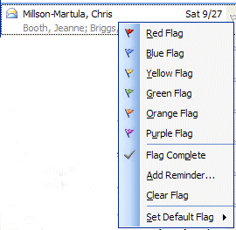

In Outlook 2003 you can mark each message, individually, as you desire, with a different colored importance flag. You can then view your flags by color groups.

In the preview screen, simply click the RIGHT mouse button on the small “blank” flag on the right of the message. A “flag list” will appear as a drop-down menu.

Click-on the flag color you desire.

Multi-colored flag grouping and Message Order

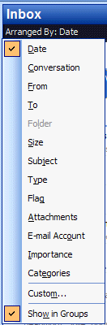
You can group/arrange your messages by Date, From, To, Subject, Flag and many other choices. In one of you folders (Inbox, Sent Item, a folder you have created) look just below the folder title (Inbox, etc.), and you will see an area that defaults to Arrange By: Date.

Place your cursor over Arrange By: Date and click the RIGHT mouse button. A drop-down Arrange menu (like the one on the right) will appear. You can click-on any choice. If you click-on Flag, your messages will be placed in Flag order (from the colors in the above Flag menu). Anytime you desire to change how your messages are arranged, simply RIGHT click on the Arranged By: area and choose another order (Date, Flag, etc.).

Microsoft Office Tutorials

In addition to this tutorial, Outlook tutorials for Outlook Calendar, Outlook Folder Size, and Outlook Web Access, as well as other Office tutorials, are available at:

http://www.officetutorials.com

This site is updated frequently with tutorial revisions as well as tutorials from a number of collegiate institutions. Please feel free to visit and down load as you desire.

This has been an introduction into the basics of Outlook 2003 mail. If you have any questions about Outlook 2003, or comments on this tutorial, please contact:

murray.t@lynchburg.edu

Thank you for your patience and good luck.

