Managing Outlook Mail Attachment
Images and other file types

Created: 16 July 2003

Outlook mail is capable of sending and receiving attachments – images, PowerPoint presentations, Word files, and many other file types. Normally the Outlook Mail Server is set-up to “guard” the entire Outlook Mail system from viruses, and overly large messages. On many e-mail systems, technology personnel set a limit for the “size” of outgoing and incoming mail messages. Many e-mail systems restrict incoming messages to a file size of 1 megabyte or less. Others restrict outgoing messages in a similar manner. You should be aware of the restrictions on your Outlook Mail Server.

This tutorial will assist you in determining the size of the files you wish to attach to your messages, and determine the size of attached files on you incoming messages.

Overview of Microsoft Outlook

The following Microsoft Outlook tutorials explain how to attach a file (image, Excel, Word, etc.) to your message.

Introduction to Outlook Mail 98 pages 19 and 20
Introduction to Outlook Mail 2000 pages 25 and 26
Introduction to Outlook Mail XP/2002 pages 26 and 27

The Outlook 98, 2000, and XP/2002 tutorials also explain how to reduce the “amount” of mail in you mailboxes by either deleting unwanted messages, or moving them to Personal Folders.

The Outlook Mail Folders Tutorial explains how to check your “Outlook Mailbox” to determine if you are near capacity.

If you need copies of these tutorials, please contact the e-mail address at the end of this tutorial.

Determining Image File Sizes

When you photograph an image with a digital or regular camera, you should be sensitive to the file size of that image. We will use the image below to illustrate image sizes.



This image was originally scanned from a photograph. It was 5.65 inches wide and 3.81 inches high. The below table indicates the computer storage space required by this image, in several different file formats.

Image Size and Type of file | Scanner or Camera Resolution | Storage Required
Bitmap (.bmp) | 600 dpi | 22.74 MB
Tag Image File Format (.tif) | 600 dpi | 15.82 MB
Joint Photographics Expert Group (.jpeg) | 600 dpi | 1.22 MB
Graphics Interchange Format (.gif) | 600 dpi | 5.16 MB
Bitmap (.bmp) | 300 dpi | 5.75 MB
Tag Image File Format (.tif) | 300 dpi | 4.58 MB
Joint Photographics Expert Group (.jpeg) | 300 dpi | 424 KB
Graphics Interchange Format (.gif) | 300 dpi | 1.41 MB

You can see, from the above table, that the resolution (.dpi) at which you scan an image, and the file type make a HUGE difference in the amount of storage space required. Only one image in the above table is below 1 MB.

We resized the image to 3 inches wide and 2 inches high. The table below furnishes the same information for the smaller image.

Image Size and Type of file | Scanner or Camera Resolution | Storage Required
Bitmap (.bmp) | 600 dpi | 6.40 MB
Tag Image File Format (.tif) | 600 dpi | 4.27 MB
Joint Photographics Expert Group (.jpeg) | 600 dpi | 387 KB
Graphics Interchange Format (.gif) | 600 dpi | 1.43 MB
Bitmap (.bmp) | 300 dpi | 1.58 MB
Tag Image File Format (.tif) | 300 dpi | 1.14 MB
Joint Photographics Expert Group (.jpeg) | 300 dpi | 111 KB
Graphics Interchange Format (.gif) | 300 dpi | 396 KB

By making the image smaller, and reducing the resolution you can see that the .jpeg and .gif images are now much smaller than the original, scanned images. If your recipient, or yourself, were restricted to a 1 MB attachment size, only 4 of the 16 images above would be allowed to enter or leave their e-mail server. Needless to say, the image at the bottom of Page 1 is the 3 inch by 2 inch, 300 .dpi, .jpeg file.

Determining Image File Sizes
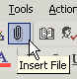
Follow the Adding, Sending, Receiving, Viewing and Saving Attachments instructions for the Outlook Mail version you are using. They are listed on Page 1 of this tutorial. When you click-on the “little paper clip” to attach a file to you e-mail message (see image on right), an Insert File Menu Screen like the one below will appear.

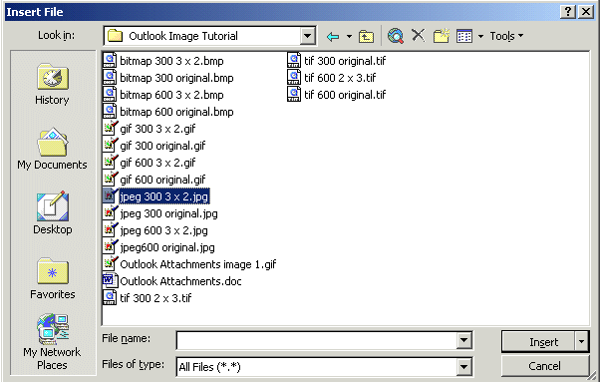
We desire to check the file size of the jpeg 300 3 x 2.jpeg image indicated above (see arrow).

Move your cursor over the image and CLICK the RIGHT MOUSE BUTTON. This will cause a pop-up menu, similar to the one at the top of the next page, to appear

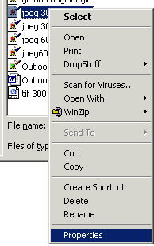

When the pop-up menu appears, move your cursor to the bottom of the menu and click the left mouse button on Properties (see arrow).

This will cause a Properties window to appear similar to the one below. Notice, at the top of the screen, that the “name” of the image on which you Right Clicked appears. This confirms that you selected the correct image.

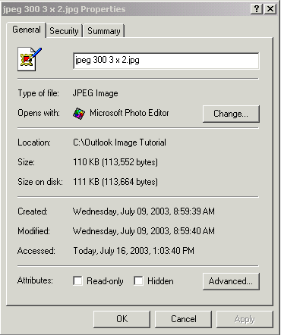

Notice, in the image at the left, that the size of the image file is shown in the Size portion of the screen.

This is the image we used on the first page of the tutorial.

If this size is too large, you will need to re-size the physical size of the image, or save it in a file type that will not require as much space (such as .gif or .jpeg). You can do this using an image program such as Microsoft Photo Editor (which is part of the Windows “package”), Paint Shop Pro, Adobe Photo Shop, or any other similar program.

When you have finished looking at the properties window above, click the Cancel button.

If you are unfamiliar with using an image editing program, like those mentioned, contact your Technology Services department and they will assist you.

Determining Other File Sizes

You can also attach other files to your e-mail messages – word-processing, spreadsheet, data base, presentation, etc. The procedure we used on pages 3 and 4 will work for all attachments.

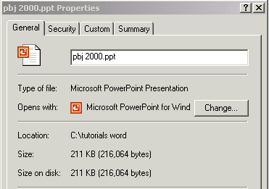
In the two images below, we checked the size of an Excel spreadsheet (on the left) and a PowerPoint presentation (on the right).
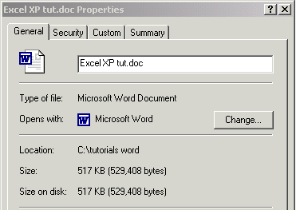

If your other files are too large, as discussed earlier, you willl either have to transmit the files as “pieces” of the larger file, or place them on a web site where your recipient can download them.

Incoming Attachment Size

When you receive an attachment to an incoming e-mail message, you will normally see a small paper clip next incoming message in the Inbox. To check the size of a message with an attachment, or the size of any message, you can set the Fields Bar, at the top of the Inbox screen to show message sizes.
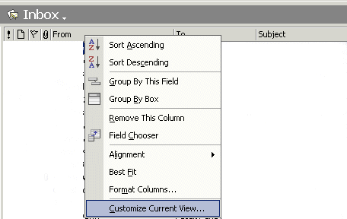
To do this, move the cursor arrow over the Fields Bar at the top of the Inbox screen and CLICK the RIGHT MOUSE BUTTON (see image at right)
RIGHT Click on this Fields Bar

A drop down Menu Screen will appear. Click the left mouse button on Customize Currnet View.

The following View Summary menu screen will appear. Click on the Fields button.

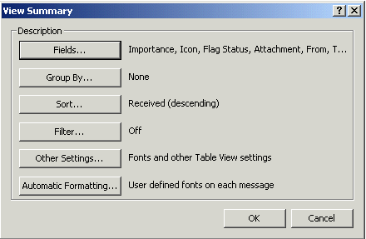

The Show Fields menu screen will appear. Move the elevator bar down on the left window in this screen, and click on Size (see left arrow below). Then click on the Add -> button. You will see Size move to the Show these fields in this order in the right window.

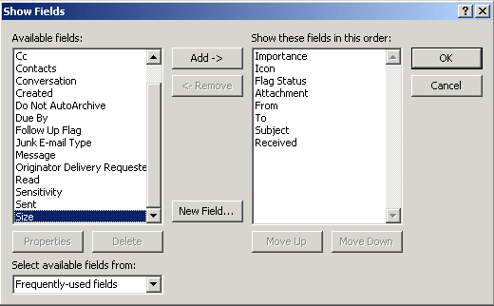

The right window of the above screen should now look like the image at the top of the next page.

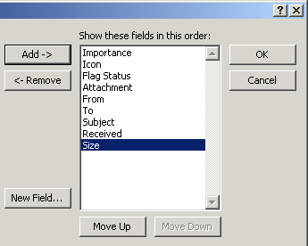

Notice, that the Size field has now been added to the fields you will see at the top of your Inbox.

You can “arrange” your fields any way you desire at the top of the screen by using the Move Up and Move Down buttons at the bottom of the screen.

When you have the fields arranged as you desire, click the OK button.

You will return to the View Summary Menu screen, click on the OK button again.

The top of your Inbox screen should look something like the image below.

Notice, that the above e-mail has an attachment (paper clip – left arrow) and the size of this message is available on the right side of the screen under Size (right arrow).

You can use this View Summary technique to arrange your Fields Bar at the top of any Outlook Mail screen (Inbox, Sent Items, Deleted Items, etc.)

Conclusion

This has been an introduction into the basics of managing file sizes in Outlook Mail. If you have any questions or comments on this tutorial, please contact:

murray.t@Lynchburg.edu

Thank you for your patience and good luck.

