Outlook Mail Calendar

Created: 18 March 2002

Accessing the Outlook Calendar

Normally, you will be in the Inbox, Send Items, or Deleted Items functions. To access your Outlook Calendar, look at the left side of your screen. You will see something like the image on the right.

Look for the Calendar button (see arrow below).

Click on the Calendar button.

Your monitor screen should now look similar to the one below.
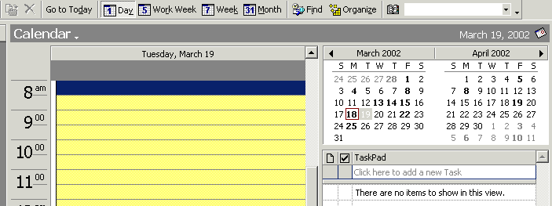

Notice on the last page and on the image above, that you are looking at a single day (normally today) when you first activate the Calendar. Click on each of the day, week, and month buttons above and notice the different displays.

When you click on the 5 Work Week button, you will see an image similar to the one below.

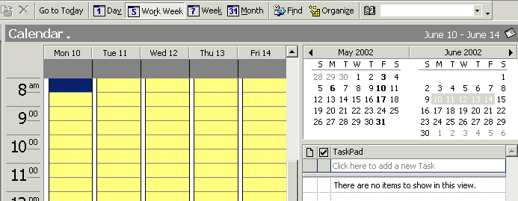

When you click on the 7 Week button, you will see an image similar to the one below.

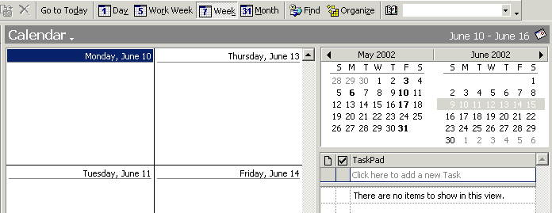

When you click on the 31 Month button, you will see an image similar to the one below.

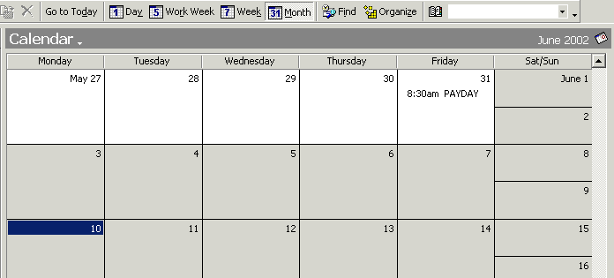

Now click again on either the 1 Day or 5 Work Week buttons.

Making an Appointment

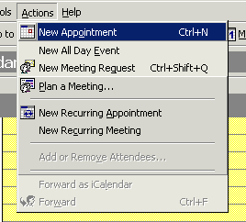

STEP 1--There are several ways to make an appointment. The first one would be to click on Actions in the Menu Bar and then New Appointment.

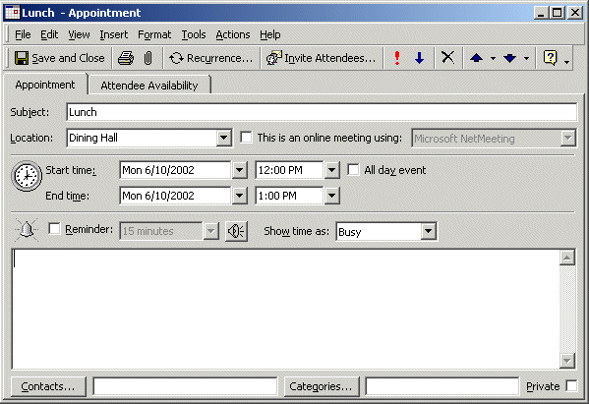

STEP 2--You will then see this dialogue box.
Fill in the appropriate information.

When all of the desired information is entered (see arrows above), click the Save and Close tab and you will see the following on the date you have chosen for you meeting:

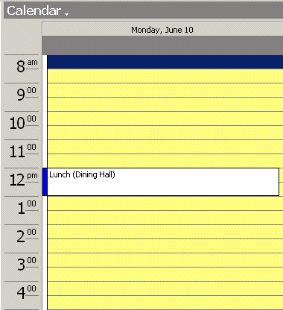

Making an Appointment with Attendees

To make an appointment and invite others, follow Steps 1 and 2 in “Making an appointment” and then click on the Attendee Availability tab. You will see the following:

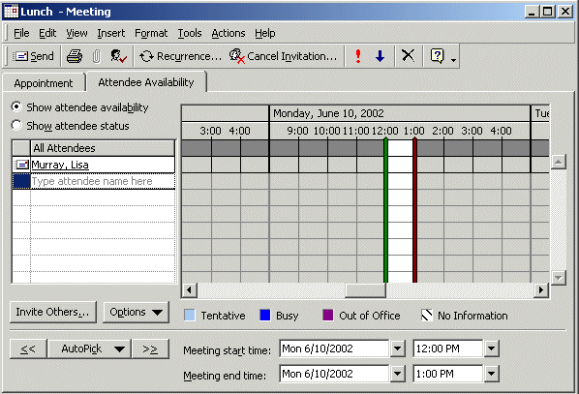

After deciding who will be invited to this meeting, click on the “Invite Others…” button in the bottom left corner.

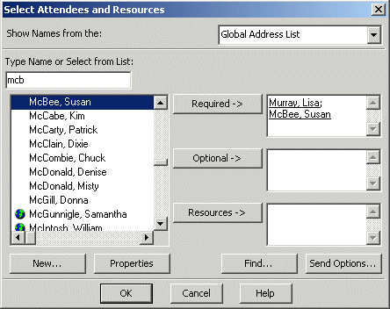

The Select Attendees and Resources box will open. Put the cursor in the “Type Name or Select From List:” box. Type the first few letters of the attendee’s last name. Click on the desired name to highlight it, click on the required or optional button. Their name will appear in that box. After choosing all attendees, click OK.
You will then be able to see if there is a conflicting schedule with any of your attendees and you can change your agenda if necessary. **
(**See “Enabling others to see Free/Busy Information)

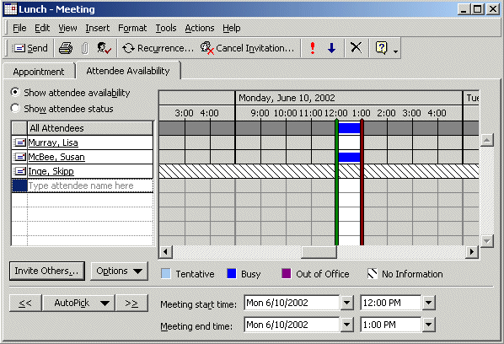

Click the Appointment tab and you’ll see the box below. Click on the Send button.

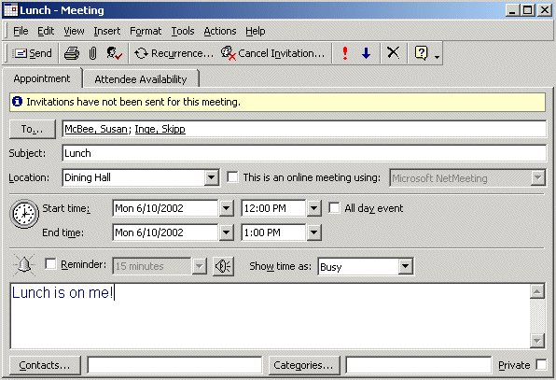

Once the attendees receive and open the email for “Lunch”, they can accept or decline your offer.

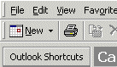
As mentioned before, there are several ways to make an appointment. Another would be to click on the “New” button. Follow the steps mentioned previously.

**Enabling others to see Free/Busy Information

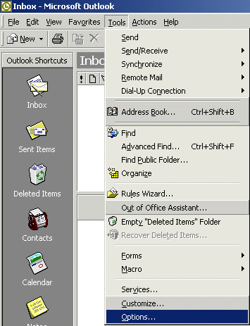

To allow others to see if you are free or busy without viewing your Calendar, you must enable this feature.

To do so, you must be in your Inbox section of Outlook.

Click on Tools, then on Options.

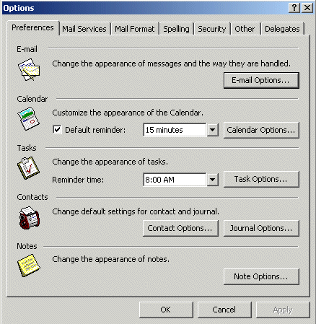

Click on Calendar Options.

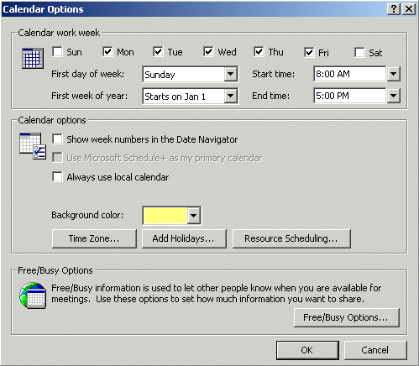

Click on
Free/Busy Options.

Once the Free/Busy Options box opens, enter the number of months you wish to have available, how often you want it updated and make sure to check the box next to “Publish my free/busy information”. No other information is required. Click OK.

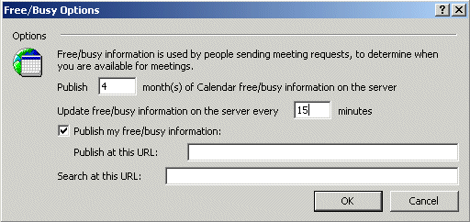

This will now allow others to see if you are available without seeing your Calendar.

New Recurring Meeting
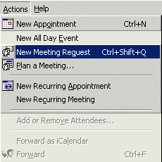

The first way to plan a meeting is to click on Actions, then New Meeting Request

The meeting dialogue box, similar to the appointment dialogue box, will appear on your screen. Follow the steps for making an appointment to make a meeting request, then click on the Recurrence button.

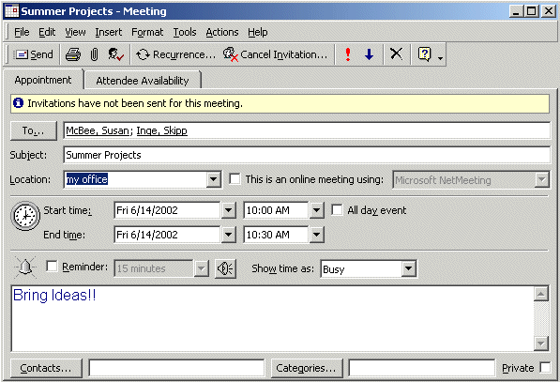

Choose the desired pattern and range and then click OK.

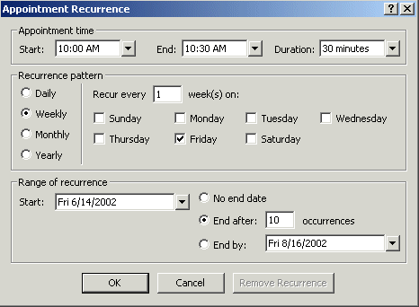

We'll, that about does it for now. If you have comments on this tutorial, simply send e-mail to the Internet address below.

murray.l@lynchburg.edu

Thank you for your time, effort, and patience.

