Outlook Mail Folders

Managing the Files in Your Outlook Mailbox

Many institutions and businesses limit the amount of mail that may be “held” in the user’s Outlook Mail mailbox (account). Outlook Mail users may determine the “amount” of mail in their mailboxes (Inbox, Sent Items, Deleted Items, etc.) by following the steps outlined below. If the user allows their mailbox to become “filled,” with too many messages, they will normally receive a cautionary message and be asked to remove messages from their account.

In order to determine “how full” your mailboxes are, follow the steps below to view your various Mailboxes/Folders.

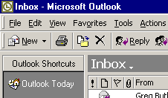
Load your Outlook Mail and look at the upper left corner of the Microsoft Outlook screen (see image on left). Make sure that you can see the Outlook Today link.

Move your cursor over the Outlook Today link and click the RIGHT mouse button.

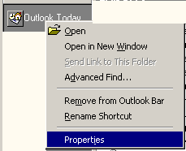

When you click the RIGHT mouse button a drop down Menu Screen (image on right) will appear. Move your cursor over the Properties selection and click the left mouse button.

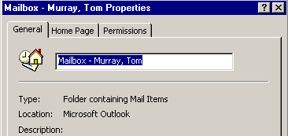

A Mailbox screen (similar to the one at the left) will appear and indicate your name.

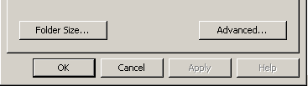
The lower portion of the Mailbox screen should look like the image to the right. Move your cursor over the Folder Size… button and click the left mouse button.

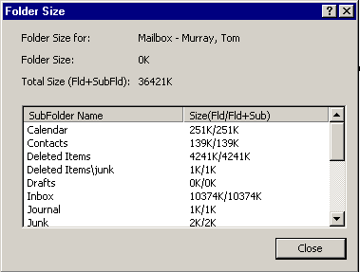
A Folder Size menu screen will appear – similar to the image on the left.

There are several areas of this screen that you’ll want to look at. First, notice the Total Size number indicated in the top portion of the screen. In this example 36,421 KB or 36.2 MB of storage has been used.

This tells you the amount of file space that you have used on the Outlook Mail Server.

Next, look at the white area below SubFolder Name (image above). You will see each of your Outlook Mail folders that are maintained on the Outlook Mail Server (Inbox, Sent Items, Deleted Items, etc.). If you were to add these individual “amounts,” you would arrive at the Total Size number. So, this SubFolder Name area gives you an idea of what folders contain the most messages.

NOTE: If you created Personal Folders and placed them in your Personal Folder they will not “count” against this total. Personal Folder messages are stored on the hard drive of your computer. To learn more about creating and using Personal Folders look at pages 20-24 of the Introduction to Microsoft Outlook 2000 Mail tutorial, or pages 16-18 in the Outlook 98 tutorial.
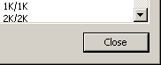

After you have viewed your various folder sizes, click the Close button in the lower left corner of the Folder Size menu screen.

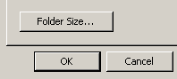
This will return you to the Mailbox menu screen. Click-on either the OK or Cancel buttons.

Once you have returned to your Outlook Mail screen, if you need to Delete some messages to increase the capacity available in your Mailbox, follow the Delete instructions in the two Outlook tutorials (Page 18 for Outlook 98 and Page 24 for Outlook 2000).

If you have any questions about these instructions please contact:

Tom Murray

E-mail: murray.t@lynchburg.edu

Phone: 544-8265

