Introduction to

Microsoft Outlook Web Access
Faculty/Staff e-mail Tutorial

Created: 26 September 2001

Accessing Outlook Web Mail

First, you’ll need to be in a browser such as Microsoft Internet Explorer or Netscape Communicator. Once you are in the browser you’ll need to contact the staff in your Information Technology group about the “web address” for your web Outlook mail.

This tutorial is being written specifically for Faculty and Staff at Lynchburg College. To access your Outlook web mail here at our college you’ll need to type:

http://mail.lynchburg.edu

Your browser should look something like the image below.

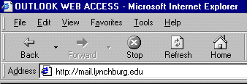

Again, at your institution or company you’ll need to ask them what you should enter.

After you enter the web address, tap the Enter key. You will now be taken to a login screen to access your Outlook e-mail account. This screen will require a login name and password – this is to protect you and your system from unwanted intrusions.

Once you tap the Enter key, you will see a log on screen that will look like the one at the top of the next page.

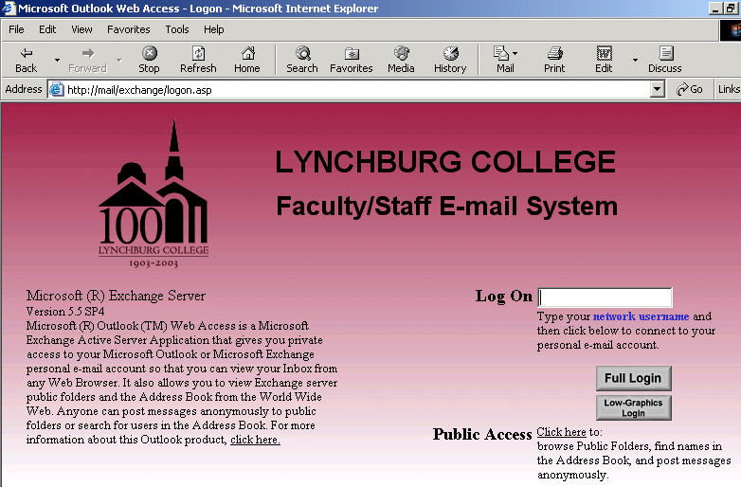

Please take a few moments to read the information on this screen. Notice the arrow that points to a highlight that can assist you with reading your Outlook Web Access e-mail.

In the lower left corner of the screen, at the end of the paragraph, you’ll see:

For more information about this Outlook product, click-here.

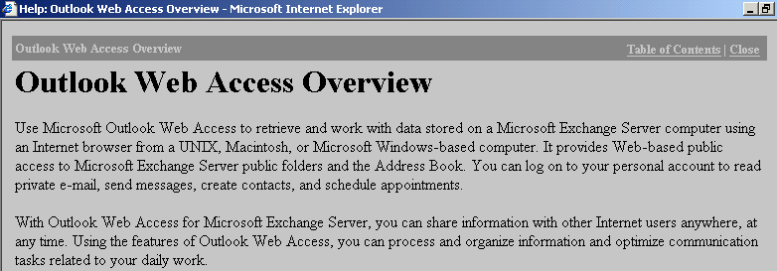
This is a “very handy click.” If you do not have this tutorial available, and need assistance with Outlook Web Access, you can click as indicated and an Outlook Web Access Overview screen will appear like the one below.

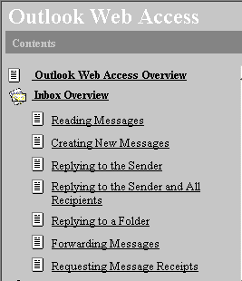
In the upper right corner (of the screen on the last page) there is a “link” to the Table of Contents for this help screen. If you click-on Table of Contents link you will see a screen appear similar to the one on the left.

You may then select a topic on which you desire assistance. If you want to print out the assistance topic simply click the RIGHT mouse button on the topic and select Print from the menu that appears.


In each “screen” of Outlook Web Access there is a small “question mark” in the upper right hand corner. If you click-on the question mark, you will be taken to the appropriate help screen from the menu on the left.

Logging-on to Outlook Web Access Mail
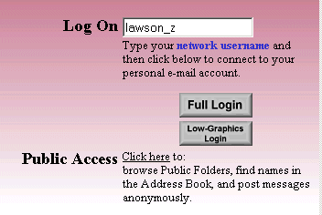

On the lower right portion of the screen you will see a Log On area similar to the one on the left. You will need to enter your network username that you received from your technology resources staff. At Lynchburg College this is normally your last name then an underscore and then the first initial of your first name (it should look something like lawson_z)

Low-Graphics Login

Notice in the image above that the arrow points to Low-Graphics Login. If you type your network username in the Log On area and click-on the Low Graphics Login button, the following screen will appear.
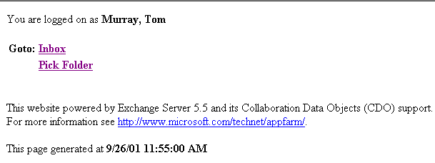

If you click-on Inbox the following screen will appear.
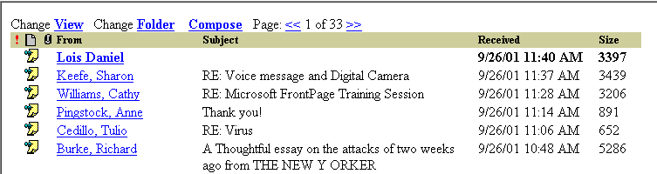

This screen allows “limited,” but quick, access to your incoming e-mail. Unread messages are highlighted in “bold” and those that you have read are in regular text. To read a message simply click-on that message. You’ll see all of the normal “buttons” – Reply, Reply All, Forward and Close the message.

BIG NOTE – you will not have a normal Address Book or Contacts List available. So, you are pretty limited in the Low-Graphics Login. If you know the e-mail address of someone you may type it in the To or Cc areas.

In the screen above, if you click-on the View link it will allow you several choices for viewing your messages. If you click-on Folder it will take you “back” to the Inbox – Pick Folder screen (at the bottom of the last page in this tutorial). If you click-on Compose you will be able to create a new e-mail message. However, your choices are very limited – there is no Address Book or Contact List available.

This Low-Graphics Login is very handy for just reading and replying to your e-mail. For a more complete control of your messages you should click-on the Full Login button (as shown on the last page of the tutorial).

Full Login

Once you enter your network username and click on the Full Login button you will be taken to an Enter Network Password screen similar to the one below.
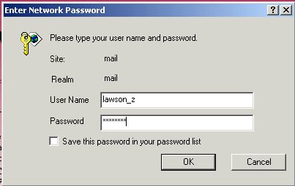

When this screen appears, enter your user name – as you just did – and then enter your password.

Click OK.

Left Mouse Button

In this tutorial, whenever we indicate that you need to click the mouse, it will mean to click the left mouse button – unless we indicate that you should click the right mouse button. So, always “click left” unless we tell you otherwise.

This should take you to your Outlook Inbox screen – similar to the one below.

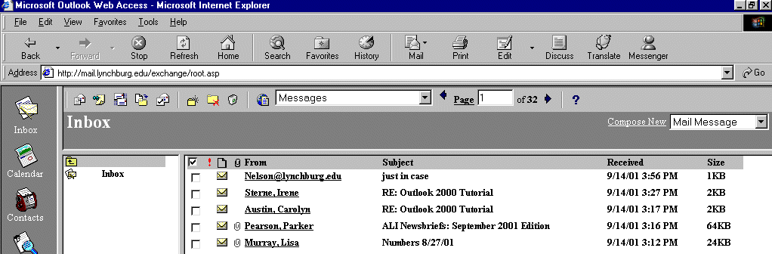

Notice that it indicates Inbox. In this Microsoft Outlook Web Access tutorial, we’ll furnish a number of the basic procedures used in reading, creating, editing, and sending Outlook mail messages.

Inbox

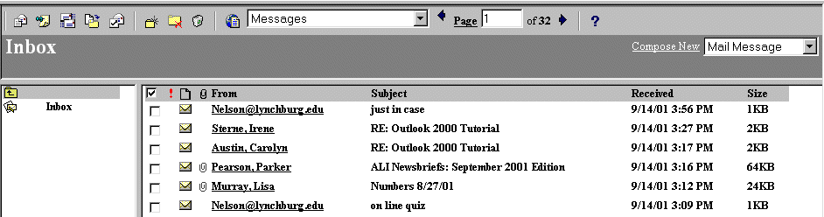
When Outlook web mail appears, you will be in the Inbox where the mail you receive is located. The screen should look something like this:

The mail messages that you have received are listed in chronological order.

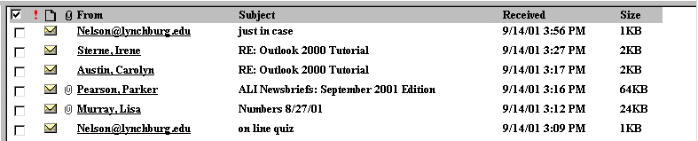

Understanding the above view

Notice in the gray “bar” at the top of the Inbox that it indicates the source (From), the Subject, time and date received (Received), and the size of the e-mail (Size).

Also note, to the left of each e-mail received, that there is an envelope, and maybe a paper clip. The paper clip indicates that the incoming e-mail contains an attachment (a picture, another document, etc.)

We’ll discuss the small square a bit later in the tutorial. It has several “uses.”

Reviewing messages in the Inbox

There are two methods you can use to view messages in your Inbox, Sent Items, Deleted Items, and various folders, which you may create.

When you first “open” Microsoft Outlook Web Access you will see Inbox messages as indicated above.

One method to read your e-mail is to click-on the from name message you desire to read. When you click the message will appear as below.

Or, you can place the cursor on the message you desire to read, click the right mouse button, and select Open from the menu that appears.
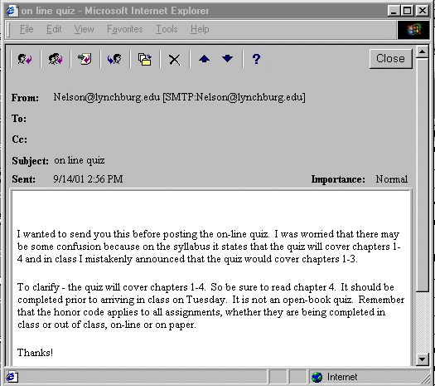

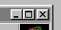
Notice that there are “elevator bars” on the right for you to move up and down the message. If you desire to have the message “fill” the screen you can click-on the “maximize” square in the upper right hand corner of the message.

Replying to a message

When you are in either the Preview Pane or have the entire message open, you will see a button bar at the top of both screens.

The button bar at the top of the message will look similar to the one below.
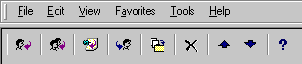

Slowly drag your mouse cursor over each of the buttons in the button bar above. You’ll notice that the first button on the left indicates Reply, the next button with two people indicates Reply to all. The fourth button (again with the single person and a blue arrow to the right indicates Forward. The button in the middle with a small yellow folder indicates that you can copy the message to a folder (we’ll cover this a little later). The “X” button is for deleting the message if you do not desire to keep it. The up and down blue arrows allow you to move up and down to the last or next message. The “?” furnishes you help with the current message screen.

You can click-on Reply, and, automatically reply to the person who sent the message, or Reply to All (everyone included in the To: or Cc:). When you click-on Reply or Reply to All, you will notice that Outlook Web Access “automatically” completes the To: and/or Cc: in your outgoing message. You may add other persons in either the To: or Cc: areas. Make sure to separate their e-mail addresses by semi-colons ( ;). You may click-in the “white” message area below the Reply e-mail addresses, and supplement (add your text) to the original message with any additional comments you desire to make regarding the message to which you are replying (see the arrow in the image below). After you have made any comments, you can click-on the small “Send” box below File in the Menu bar and your Reply will be “mailed.”

We clicked-on the reply button in our example below.

Send Button

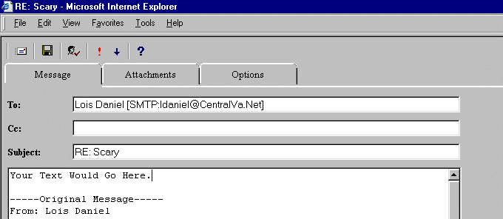
Your text goes here.

Forwarding a message

If you desire to forward a message to one or more persons, click-on the Forward button in the button bar to the right of the Reply choices. Then, in the To: or Cc: areas. We will be covering Address Books later in this “tutorial.” At this point, type-in the e-mail address or addresses of those to whom you want to forward the mail message. If you have more than one address, separate them with a semi-colon (;).

You can move down to the Address Book section now if you desire.

Deleting unwanted messages

You will notice, in the button bar that appears when you are reading a message, that there is an “X” in the button bar.

If you do not want to keep the message, you can click-on the “X” button, in the button bar, to send the message to a “Deleted Items folder.”

Note: This is NOT the “x” button in the upper right corner of the screen. If you do click-on the upper right corner X, it will CLOSE your e-mail Outlook Web Access session and you will have to login again.

When you delete a message in the Inbox (or Sent Items), the e-mail you deleted is sent to a Deleted Items folder to be “really deleted” or “recovered” later.

Deleting Deleted Messages

You will be assigned a set “amount” of “space” on the Exchange Computer Server where Outlook Mail files are stored. You will periodically need to go to your Deleted Items folder and Delete messages that you have placed there when you Deleted them from your Inbox and Sent Items Box (and any other folders you have created). If you do not do this you will receive a warning that you must do so or your e-mail will “not work” until you have created space in your area to make room for new messages.

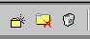
To empty the messages in your Deleted Items folder click-on the small wastebasket in the button bar. You will be asked if you really want to delete these items. Click on the Yes button and the items will be removed from Outlook file space.

Moving from message to message in the Inbox, Sent Items and Deleted Items areas

To move from message to message you simply click-on each message you desire to read or delete.

If you are currently “reading a message,” you can use the blue up and down arrows in the button bar to move from message to message.

Printing a message

If you desire a “hard copy” of the message you can click-on the Printer in the button bar of your web browser or click-on File in the Menu Bar and then on Print.

Sending a NEW e-mail message

When you first login to Outlook Web Access, you’ll see a button bar above the Inbox messages. The first button on the far left allows you to create a new e-mail message. If you move the cursor over this button you’ll see a Help Text appear that indicates Compose a new mail message. To create a new e-mail message click-on this button.

We’ll go over the other buttons in this bar later in this tutorial.

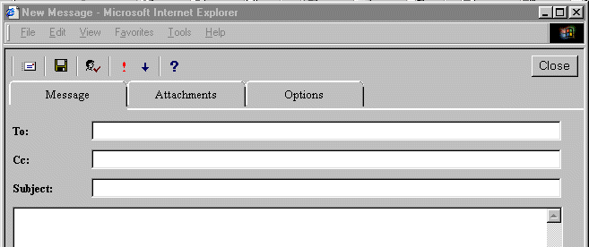
A screen very similar to the Reply, Reply to All and Forward will appear (like the one below). There will be no e-mail addresses in the To: and Cc: areas. You will need to type-in the e-mail addresses of those to whom you desire to send your new message. Don’t forget to include a semi-colon between address names.
First, click-in the area to the right of To:. For now, type-in the e-mail address of the person to whom you desire to send this e-mail message. Next, click-in the area to the right of Cc:. Again, type-in the name or names of others whom you would like to receive copies of this message. If you type-in more than one e-mail address, separate the addresses with a semi-colon (;). If you desire to use the Address Book, move down to the Address Book section.

Now click-in the area to the right of Subject:, and type-in a subject for your e-mail message if you desire.

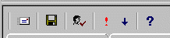
Finally click-in the white area below Subject:, and type-in your e-mail message as you would in any e-mail system. You may move around, edit and change your message just like you would do if you were in a word processor.

When you have completed your e-mail message, click-on the Send button in the upper left hand corner of the screen.

Quick note on folders

This is simply a quick note to tell you what happens when you send an e-mail message. When a message is sent, a copy of your e-mail is automatically placed in a Sent Items folder. So, you can access your message, edit it, forward it, etc., until you decide to delete it later on. If you desire to keep the e-mail you will be able to move it to another folder, you create, if you desire. We’ll go into detail on all of this later. For now, just be aware that you have not “lost” your message. You do not need to “copy yourself” in Outlook Web Access unless you want to get an additional copy of your e-mail in your Inbox.

Folder Button Bar

When you are in a Folder, a button bar similar to the one below will be available at the top of the Inbox, Sent Items, Deleted Items, or the Folders you create.

Slowly move your mouse over these buttons pausing at each one. A Help Text will display their function. As just seen, the left most button above is to Compose a new mail message.

Then next button with the pin and post it note is Compose new post message. This button will allow you to place a “note” in your Inbox, etc.

The third button, with two small envelopes is a Check new mail button that does just what it indicates – shows you your new mail.

The forth button, with the blue arrow and yellow folder lets you copy an e-mail from one folder to another. We’ll cover this button in detail later.

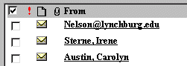
The fifth button with the little check mark is to Delete marked items. When you look at your Inbox, or any folder, you’ll see the little open square to the left of each e-mail. If click-in the square to the left of any e-mails you wish to delete, and then click this button, the e-mails you checked will be sent to your Deleted Items Folder (we explained this folder on page 7).

Note: Because this is a Web Access e-mail, you won’t see your changes “right away.” To see your changes, you’ll have to click-on the Refresh or Reload button in the Browser you are using occasionally.

The sixth button, with a yellow folder and a small star will allow you to create folders. We’ll cover this button later.

The seventh button, with a yellow folder and red “X” allows you to delete a folder.

The small trash can button allows you to delete or empty the e-mails in your Deleted Items folder.
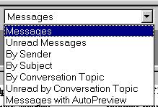

You will see an “area” with a small down triangle on the right. This area allows you to customize your messages to some extent. If you click-on the small down triangle the information to the right will appear. You can click-on any item and see the effect.

Address Books

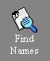
If you are Replying or Replying to All for a message in your Inbox, then the addresses from that e-mail will automatically appear in the To: and Cc: areas. If you don’t want to send the e-mail to some of these addresses, you can simply highlight them and tap the Delete key. If you are Forwarding a message from the Inbox or Sending a new e-mail message, then you can either type-in the address in the To: or Cc: area, or use the Address Book. In this version of Outlook Web Access the Address Book is located in a “task bar” on the left side of your screen. It is called Find Names. This address book contains the names of all the people using the Outlook Mail system on a campus or at a business. To find a name, click-on this button.

The Find Names screen in Outlook Web Access will make available addresses on your Microsoft Exchange Server that you can utilize to send and respond to e-mail messages. When you have clicked the Find Names Button the following screen will appear.

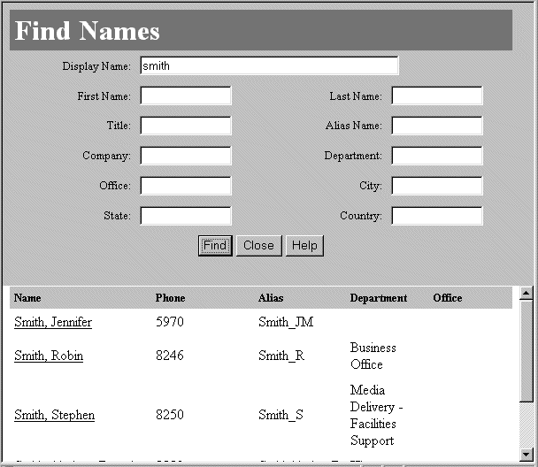
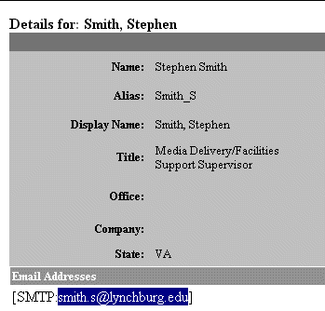

We wanted to look up the name Smith so we typed Smith in the Display Name: area above. We then clicked the Find button. The lower portion of the screen then displayed all the “Smiths” in our system. We want the e-mail address for Steve Smith. Since we are in a web browser, when we move our cursor over Smith, Stephen we notice the “little pointy hand” that indicates a link appears over his name. We then clicked-on Smith, Steve and the screen on the right appeared.

Notice at the bottom of the Steve Smith screen that there is an area titled Email Addresses. Below the title line you can see the email address for the person you want. To copy that address from this area to your e-mail, highlight the email address (as we did on the last page) and either click-on the Edit in the Menu Bar and then Copy, or carefully click-the right mouse button on the highlighted area and click Copy.

To close the Find Names screens simply click the “X’s” in the upper right corner of each screen.

When you return to your e-mail, click-in the area to the right of the To: or Cc: and then either click-on the Edit in the Menu Bar and then Paste, or carefully click-the right mouse button and click Paste

Don’t forget – if you desire to have multiple addresses – to place a semi-colon ( ; ) between each e-mail address.

Folders
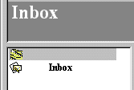
When you first opened Outlook Web Access, the area to the left of the screen looked something like this. To see all the folders that are currently available to you in your Outlook Web Access, click-on the small button above the Inbox button. You will notice that if you pause the cursor over this button it will indicate: Up one folder. Click this button.

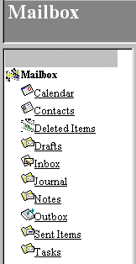

The icons (Folders) we are concerned with in this exercise are the ones that pertain to e-mail and hold messages (e.g. Inbox, Sent Items, Deleted Items and folders you create).

There are boxes for your incoming mail (Inbox), mail you have sent (Sent Items) and mail you have deleted (Deleted Items).

To see the e-mails you have sent, Click-on the Sent Items button in the area on the left. You can also click Deleted Items.

Anytime you desire to see all your folders, follow the process above.

Creating a Folder for YOU
You can create a folder (or folders) to hold e-mails that you desire to “keep” for awhile. To do this click-on the Create a new folder button in the button bar.

The following screen will appear.

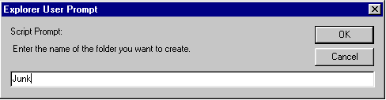

You can create folders for various “groups” of e-mail as you desire. As you receive or send e-mail related to this “group” you can move the e-mail to the folder you create so that you can find the items easily, without having to search all of your mail. You can still delete these messages when they no longer apply and delete the folder when you are finished with it.

Note: When you place messages in this folder you are still using some of your allotted computer space. So, this will count as part of your total space used. You’ll have to periodically “delete” messages from this folder if you “run into” space problems (just like you’ll have to do in the Inbox, Sent Items and Deleted Items).

We decided to create a folder titled “Junk.” So, we typed Junk as you see it above. You type the name you desire for your folder and then click-on OK.

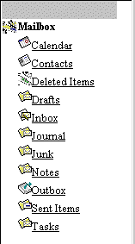

The Mailbox area you see to the left was then updated to include the new folder we created.

Don’t forget – when you place e-mail in any folder it takes up space in your e-mail area on the Outlook computer. So, don’t forget to delete – Deleted items and other unwanted e-mail frequently.

Placing e-mail messages in your Personal Folders

To place an e-mail message, that you received or sent, in a folder that you created (or any folder), do the following. First, make sure that you are “in” the folder where the e-mail message is located – we’ll go to the Inbox for our example. Once we’re in the Inbox, we’ll open the message like we did to read it. When you’re “in” the message, click-on the Move/Copy button.

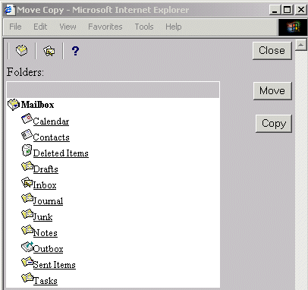

The following Move Copy screen will appear.

We want to place this e-mail in our Junk folder that we created earlier in the tutorial. You would want to place it in one of the folders you created.

So, we’ll click-on the Junk folder.

When you click-on Junk the following screen will appear.

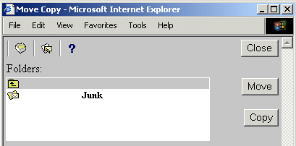
Notice that the screen indicates that Junk is the selected folder.

Most of the time you will want to move your message so, click-on Move.

If you copy a message you’ll have it in two folders, which will take up additional space in your Outlook area.
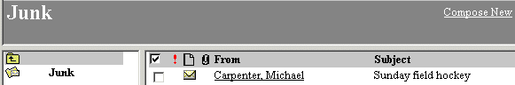
After you click the Move button, your message will move to the folder you selected. We went to our Junk folder and there was the message.

You can still delete the messages in your folders when you no longer desire to retain them.

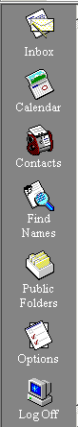
Outlook Web Access Task Bar

On the left side of your Outlook Web Access screen you will see a group of icon buttons to assist you while you are working in this program.

Anytime you desire to go to the Inbox to read new messages simply click-on the Inbox button.

There is a Calendar feature which allows you to maintain a Personal Calendar if you wish. It is a pretty logical calendar. If you click-on the button it will allow you to maintain your calendar in a daily, weekly or monthly view. You can also make appointments and have the calendar remind you of them.

We’ll cover Contacts in a few moments.

The Options choice will allow you to leave an “Out of Office (or away from campus) message for those who send you e-mail, if you wish to use it. It will also allow you to “set your time zone,” and set your calendar.

You can experiment with the Calendar and Options features as you like.

Contacts

The Find Names Address Book lists e-mail users on your campus or at your business Outlook computer system. If you would also like to create an address book for other e-mail users that are not a part of this group, Contacts is the place to do this.
If you click-on the Contacts button, the following Contact screen will appear.

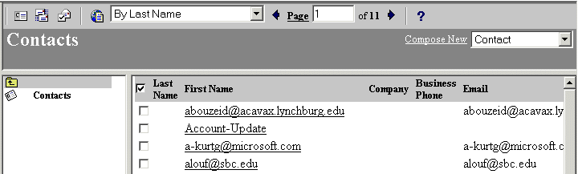

You’ll notice that there is a button bar at the top of the screen that is “tailored” to Contacts. Slowly run your cursor over the buttons to get the “feel” for Contacts.

If you desire to add persons with whom you share e-mail to your Contacts you can either click-on the first button in the button bar, or click-on Compose New Contact (see arrows above). The following screen will appear.

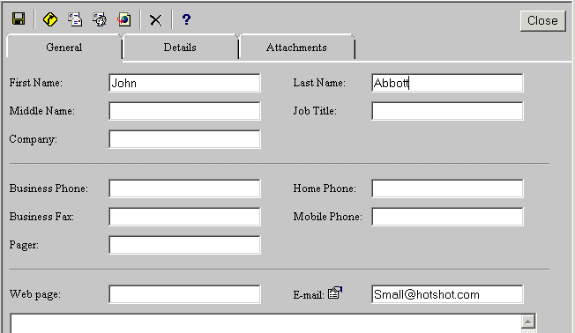

In our screen above we added John Abbott. You can fill in more information, as you desire. When you have added all your information, click-on the small diskette in the upper left corner of the screen (see arrow in view above). This will Save and Close this new Contact. The next time you are in Contacts you’ll see this additional person.
Once you have added persons to your Contacts, you may copy their e-mail addresses into your e-mail much in the same manner as you did with Find Names.

Adding Attachments to e-mail

There are many times when you want to send a document, spreadsheet, PowerPoint presentation, picture, or file of some type to someone, or be able to receive one. Outlook Web Access makes this relatively simple. The items indicated above are sent as “attachments” to your e-mail.

When you are sending an e-mail message and want to “include” an attachment it’s relatively easy. Click-on the Compose New Message button. At the top of the screen that appears, click-on the Attachments tab. A screen similar to the one below will appear.

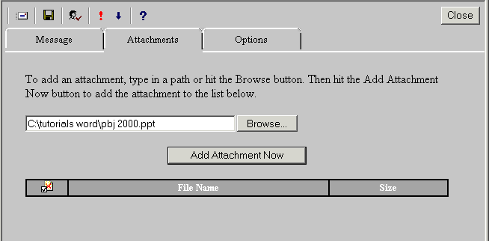

When the above screen appears, click-on the Browse button and you will be taken to a view of the disk drives on your computer. In the example above we went to our C: drive and selected a PowerPoint presentation to send with our e-mail. When you see the file that you desire to send, click the Add Attachment Now button. Your screen will look like the one below.

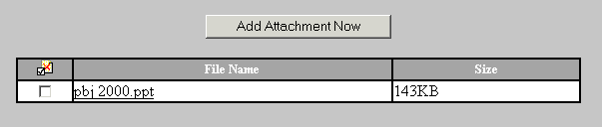

You’ll see your attachment under the File Name area.
Now click the Message tab at the top of the screen. You’ll be taken back to your original message composition screen. Notice however, that there is now a small paper clip on the Attachment tab. This indicates that your file is attached and will be sent with this e-mail.

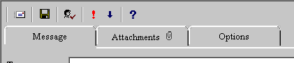

Complete your e-mail message as you would normally and then click the Send button.

When a person receives your e-mail they will see the attachment in a fashion like the two examples below.

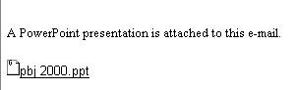
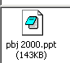

Viewing an attachment you receive

If you receive an attachment in Outlook Web Access your message will look like the one above, on the left. To view your incoming attachment, click-on the attachment. You will notice that the “little pointy hand” indicates a link. When you click you will see a selection screen that asks if you want to Open, Save the attachment, Cancel this selection, or more information. Click-on the selection you desire.

Note, if you do not have the software in which the attachment was created, on your computer, you won’t be able to open the attachment.

This has been an introduction into the basics of Outlook Web Access mail. You are the first group to utilize this tutorial. If you have any questions, comments or suggestions about this tutorial please do not hesitate to contact the below e-mail address. Any thoughts on how to improve this tutorial for future users would be greatly appreciated.

murray.t@lynchburg.edu

Thank you for your patience.

