Introduction to
Microsoft Outlook 98 Mail

Created: July 13, 1998

Starting Outlook 98

In this Microsoft Outlook 98 tutorial, we’ll furnish a number of the basic procedures used in creating, editing, sending and receiving Outlook mail messages. In addition, we’ll also introduce other features essential to managing Outlook mail messages.

Opening Outlook Mail 98

When an Information Technology Services technician installs Microsoft Outlook on your computer, they will also place an Outlook icon on your Windows desktop.

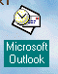
This is what the icon look’s like.

To start Outlook 98 either double-click quickly on the icon, or single-click on the icon and then tap Enter. Either method will indicate to the computer that you desire to load Outlook 98.

Inbox

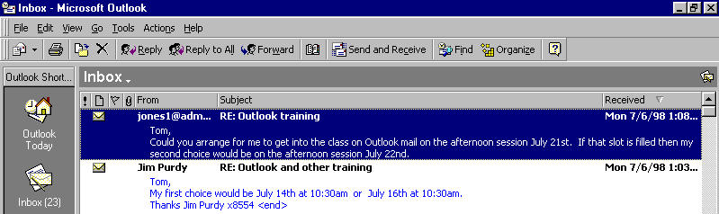
When Outlook 98 appears, you will be in the Inbox where the mail you receive is located. The screen should look something like this:

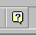
The first time you load Outlook 98 the Office Assistant (Paper Clip, or the assistant you chose) may appear. You can click-on the various choices to view the material, or if you do not want to view the material now, you can click-on OK and the Assistant will go away. Anytime you desire to use the Assistant for help, you can click-on the “?” and the Assistant will appear. The Assistant is always located in the upper right part of the portion of the button bar.

The mail messages that you have received are listed in chronological order. There are some ways to “re-sort” the messages that we can cover in later sessions.

Reviewing messages in the Inbox

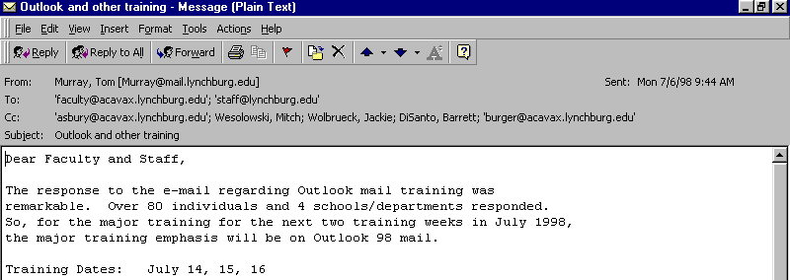
To view a message, simply double-click on the message and the following screen will appear. You could also, just like other programs, click-once on a message and then click-on File (in the Menu bar), then click-on Open, then click-on Selected Items.

This screen is designed to review and respond to mail messages received.

If this is the first time that you are looking at this Outlook screen, it would be a good idea to click-on each item in the Menu and Button bars. So go ahead and click-on File, and then Edit, etc. Now, run the cursor over each of the buttons below the Menu bar. A lot of logical information contained here.

Replying to a message

Notice that you can click-on Reply, and, automatically reply to the person who sent the message, or Reply to All (everyone included in the To: or Cc:). When you click-on Reply and Reply to All, you will notice that Outlook 98 “automatically” completes the To: and/or Cc: in your outgoing message. You may click-in the “white” message area below, and supplement the original message with any additional comments you desire to make regarding the message to which you are replying. After you have made any comments, you can click-on the small “Send” box below File in the Menu bar and your Reply will be “mailed.”

Forwarding a message

If you desire to forward a message to someone or others, click-in the To: or Cc: areas. We will be covering Address Books later in this “tutorial.” At this point, type-in the e-mail address or addresses of those to whom you want to forward the mail message. If you have more than one address, separate them with a semi-colon (;). You can move down to the Address Book section if you desire.

When you reply or forward a message in Outlook 98, you will notice, when you view the message again in Inbox, or Sent Items, it will now have a small arrow attached to a small box by the message. These arrows indicate that the message has been forwarded or replied to.

Deleting unwanted messages

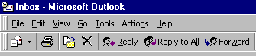
If you do not want to keep the message, you can click-on the “X” button, in the button bar, to send the message to a “delete folder.”

Note: This is NOT the “x” button in the upper right corner of the screen. If you do click-on the upper right corner X, it will simply close the message and return you to the Inbox, etc.

We’ll discuss this in more detail later in Folders. When you delete a message in the Inbox, it is sent to the Deleted Items folder to be “really deleted” or “recovered” later.

Moving from message to message in the Inbox

Notice the large blue Up and Down arrows in the button bar below the Menu bar. These allow you to move forward and backward (Previous Item and Next Item) between messages in the Inbox. Click-on these arrows to see how they work.

Printing a message

If you desire a “hard copy” of the message you can click-on the Printer.

Sending an e-mail message

If you are in the Inbox and desire to send an e-mail message to a person or group of persons click-on the New Mail Message button.

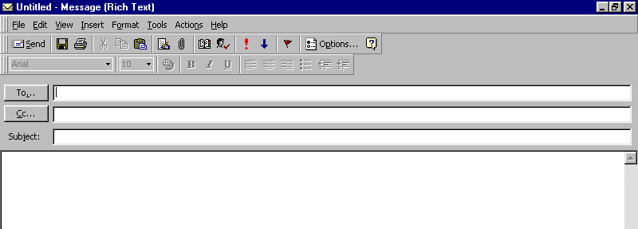
If you are in some other part of Outlook 98 and do not see the New Mail Message button, you can always (in the Inbox as well) click-on File in the Menu Bar, then click-on New,
and then click-on Mail Message. In both cases, the following screen should appear.

First, click-in the area to the right of To:. For now, type-in the e-mail address of the person to whom you desire to send this e-mail message. Next, click-in the area to the right of Cc:. Again, type-in the name or names of others whom you would like to receive copies of this message. If you type-in more than one e-mail address, separate the addresses with a semi-colon (;). If you desire to use the Address Book where you have the names “stored,” move down to the Address Book section.

Now click-in the area to the right of Subject:, and type-in a subject for your e-mail message if you desire.

Finally click-in the white area below Subject:, and type-in your e-mail message as you would any memo to someone. You may move around, edit and change your message just like you would do if you were in a word processor. Later in this “tutorial,” we will show you how you may use Microsoft Word as your “e-mail editor,” with all the features of Microsoft Word, if you choose to do so.

When you have completed your e-mail message, click-on the Send button in the upper left hand corner of the screen.

Quick note on folders

This is simply a quick note to tell you what happens when you send an e-mail message. When a message is sent, a copy of your e-mail is automatically sent to a Sent Items folder. So, you can access your message, edit it, forward it, etc., until you decide to delete it later on. If you desire to keep the e-mail you will be able to move it to another folder you create if you desire. We’ll go into detail on all of this later. For now, just be aware that you have not “lost” your message. You do not need to “copy yourself” in Outlook unless you want to get an additional copy of your e-mail.

Address Books

When you have clicked-on Reply, Reply to All, or Forward as indicated on the top of page 2 (Inbox) or on Send as indicated on the bottom of page 2 (New mail message), you will see a screen similar to that below:

If you are Replying or Replying to All on an e-mail message in your Inbox, then the addresses from that e-mail will automatically appear in the To and Cc areas. If you don’t want to send the e-mail to some of these addresses, you can simply click-on them and tap the Delete key. If you are Forwarding a message from the Inbox or Sending a new e-mail message, then you can either type-in the address in the To or Cc area, or use the Global Address List or Personal Address Book.

There are several Address Books in Outlook 98 that you can utilize to send and respond to e-mail messages. And, there are a number of options for entering e-mail addresses into an address book. You will, in all probability, use two address books: Global Address List and Personal Address Book.

To access these address books/lists click-on the To or Cc “buttons” (see the arrows on the picture above). The Global Address List menu box will appear.
Global Address List

First we’ll show you what these look like and then explain something about each. The Global Address List looks like this:
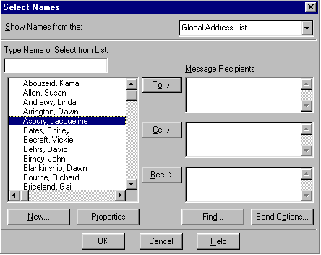

When you are in the Reply, Reply to All, Forward or Send a New e-mail message screen, and need to add additional e-mail addresses, you can either type-in the addresses or use this Global Address List menu.

The Global Addresses List that you see above is created, and updated, when a person at the college selects to use Outlook mail. The Information Technology Staff places the new user in the Global Address List. Thus, this address list is a current list of all Outlook mail users on campus.

To use this list, simply click-on the person whom you want to receive the e-mail (their name will “turn blue”). Then, click-on the To, Cc or Bcc (Blind copy) buttons. This will add the address to those already in the e-mail (you will see it appear in the area to the right). You can do this for as many addresses as you desire. When you have finished, click-on OK, and you return to your message.
Personal Address Book

How do you send an e-mail message to someone who is not on the campus Outlook mail system (especially off campus addresses)? This is where the Personal Address Book is used. The Personal Address Book is just what it indicates. You create your own personal address book. First we’ll show you how to get to the Personal Address Book and then how to add and delete addresses.

When you click-on To or Cc (page 5) the Global Address List appears. In the upper right corner of the menu screen you will see an area that indicates that this is the Global Address List. To the right of the title is a small triangle, click-on the triangle and the below menu screen appears.
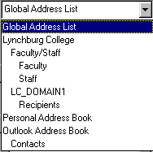

Now, click-on Personal Address Book, and the following screen appears, which contains the addresses that YOU have already placed in your personal address book.

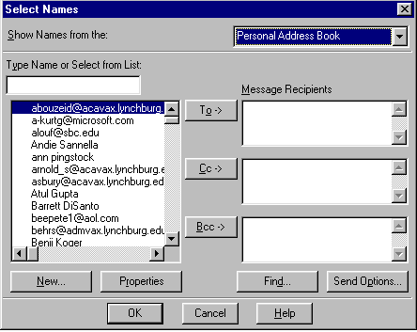

Notice, the Select Names menu screen above now indicates Personal Address Book in the upper right corner. Also, notice the e-mail addresses on the left side of the menu screen. These are e-mail addresses that were transferred over from your old mail system by Information Technology Staff personnel, or that you have added to the list.

To add the addresses in your personal address book to an e-mail message simply repeat the procedure outlined in the Global Address List. Click-on the name to whom you desire to receive the e-mail, then click-on the To or Cc buttons to add that name. Again, you can add as many names as you wish. When you have finished, click-on OK and you will be taken back to the e-mail that you want to send. You can then continue to create a new e-mail or edit the contents of one that you are working with.

Adding Names to the Personal Address Book

There are many ways to add names to the Personal Address Book. We’ll show you several of the more popular procedures. You will also discover other methods, as you become more familiar with Outlook.

Adding names as you type the e-mail addresses in the To or Cc areas of the message

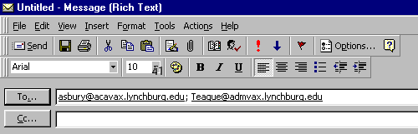
If a person’s e-mail address is not currently in your Global Address List or Personal Address Book you can add it while you are in the process of sending them a message. In the area to the right of To or Cc, type-in the e-mail address for the person or persons you wish to receive your e-mail. If you type-in several addresses, separate them with a semi-colon ( ; ). You will notice that, in a few moments, the addresses will become underlined.

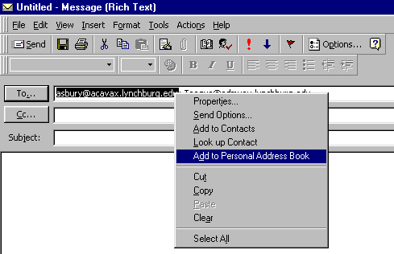
To add an address to your Personal Address Book, simply right-click on a name and a menu box will appear.

Click-on Add to Personal Address Book and the name will be automatically added to the address book. To observe that this has occurred, or to add a name where you can see the screen which enters the name in the address book, click-on either the To or Cc buttons. When you have clicked-on one of the buttons, you will go to the Global Address List screen again. Click-on the triangle in the upper right corner again, and then click-on Personal Address Book. You will see the address that you added. When you have a lot of addresses, you will have to use the up and down elevator to view your addresses. Outlook automatically alphabetizes the names as you enter them.

Your Personal Address Book should look something like this:
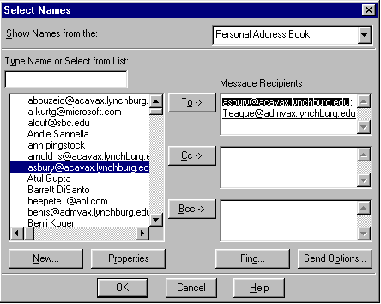

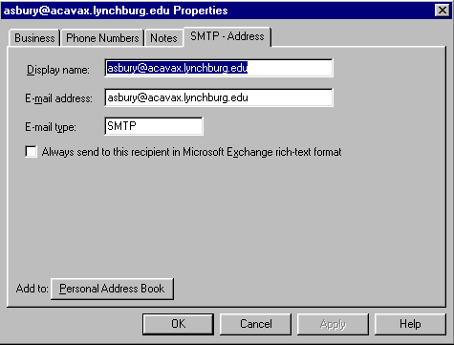
Another way to add newly typed addresses, where you can see the screen which adds the address, and do some other things, is to double-click on the address in the right side of the screen (under Message Recipients). When you double-click the following screen will appear:

There are several things that you should notice in this screen. First, the “tabs” at the top (Business, Phone Numbers, Notes) allow you to enter a number of other “pieces” of information on this e-mail address. Click-on the tabs and you will see this. You can use these “pieces” when you become more advanced in other Microsoft applications.

Second, notice the box that indicates Display name:. In this box you may type the person’s name (e.g. Jackie Asbury), and this name will now display in your messages and Personal Address Book instead of the e-mail address. This Display name: area defaults from the right-click automatic address addition, and from the double-click you just performed.

You can tell your Personal Address Book to sort by first name or last name, if you desire. If you would like to do this, let your instructor know, and he/she will show you how to do this.

Third, the E-mail address: area should remain as it is. If you made a mistake in typing the address you can correct it here.

Notice the small box to the left of: Always send to this recipient in Microsoft Exchange Rich Text format. This is a “special” way to send e-mails that assists the recipient in receiving certain e-mails. If you want to activate this box, just click-in it.

When you have completed a name, click-on OK. Repeat this process for each name you desire to add.

Big Note: The right-click on an e-mail address also works when you receive a message from someone! If you know that this address is not in your Personal Address Book, right-click on the address and add it as you did above. This really saves a lot of time. You know it’s a good address, because you received their message.

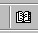
There is still another way to add to your Personal Address Book! In the button bar below the Menu bar you will notice a “small book.” When you run your cursor over the book it will indicate: Address Book. You can click-on it and also add names to your Personal Address Book. So, click-on the “book” and the following screen will appear.
New Entry
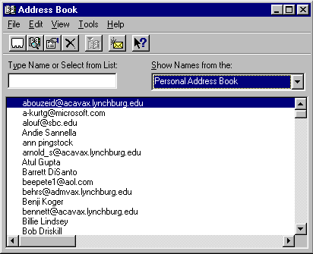

Click-on the triangle on the right of the above screen and select Personal Address Book. Your screen should then look similar to the one above. Next, click-on the small “Rolodex like” button, in the button bar below the Menu bar (a small text help will appear indicating New Entry). The following screen will appear:
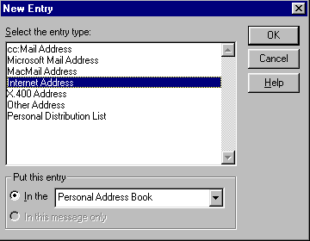

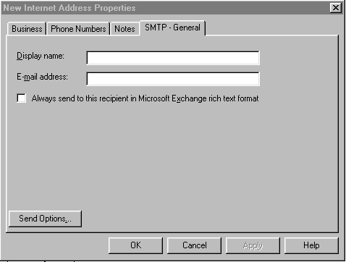
First click-on Internet Address and then click-on OK in this screen. You will now be taken to the address entry screen. This is a little different than the menu screen on page 10.

Notice that the Display name: and Display name: are blank. You will have to type-them in each of the areas. Do these, as you have done previously (Display name: is the name of the person and E-mail address: is the e-mail address).

Distribution Lists

Now that you have an idea of how to add individual names to the Personal Address Book, and are familiar with the Global Address List, you may want to create a group of addresses to which you frequently send e-mail. In Outlook this is called a Distribution List. To create a Distribution List, you will follow several similar steps to those above.

In an Outlook screen, where you can see the little Address Book button, click-on it. When the screen appears, click-on the New Entry “Rolodex card” button. Just like you just did above. This time, when the New Entry screen appears, click-on Personal Distribution List in the area below Select the entry type. Then, click-on OK.

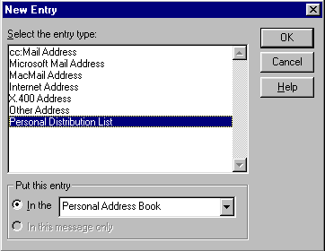
The following screen will now appear:
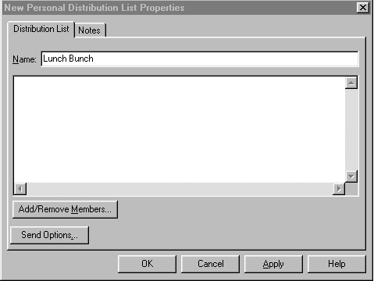

Add/
Remove
Members

In the area to the right of Name:, type in a name for your Distribution List (e.g. Lunch Bunch). Next, click-on the Add/Remove Members… button. This will display the Global Address List screen. By either using the Global Address List or your Personal Address Book (click on the triangle in the upper right corner and select the one you want) you can create your Distribution list. The following screen appeared after clicking-on Add/Remove Members and was set to Personal Address Book.

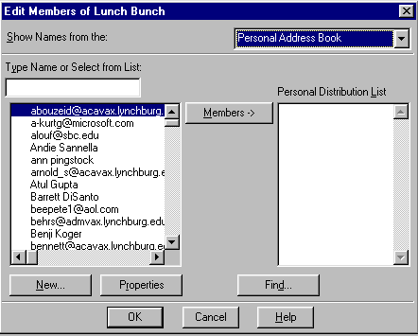

Now, click-on an address for someone in the group, on the left side of the screen, and then click-on the Members -> button in the middle of the screen. You will see that person added to the list on the right in the area under Personal Distribution List. You can go back and forth between the Global and Personal lists and add as many addresses, as you desire. When you have completed you list the screen should look somewhat similar to the one below.

Note: You do not need to have someone in either the Global Address List or your Personal Address Book to have them in your Personal Distribution List. If they are in neither, simply type a semi-colon (;) at the end of the last address on the right side, and then type-in the person’s e-mail address. They will be included in your list.
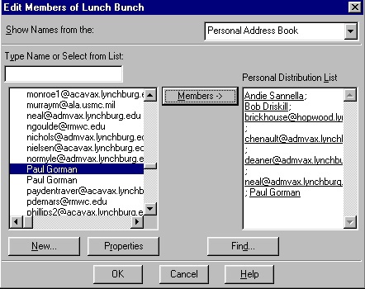
Click-on OK to confirm your list. If you see someone on the right that you accidentally placed there and want to remove them, click-on that address and tap the Delete key.
Your screen should now look similar to the one below. Click-on OK to save the list.

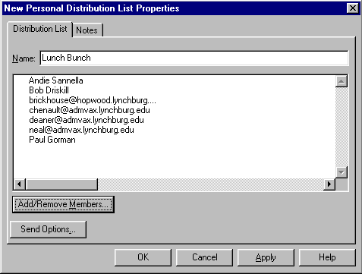

You can create as many Personal Distribution Lists as you desire. Since they are Personal Distribution Lists they will appear in your Personal Address Book as an e-mail address.

Folders

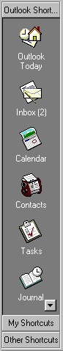

When you first opened Outlook 98, the area to the left of the screen looked something like this. The icons you see take you to different features of Outlook (Calendar, etc.) or contain e-mail.

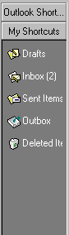
The icons we are concerned with in this exercise are the ones that pertain to e-mail and hold messages (e.g. Inbox).

Notice at the bottom of the screen to the left, that it indicates My Shortcuts. Click-on this phrase.

This will take you to a screen similar to the one on the right. Notice that there are icons which “hold” e-mail in some form. There are boxes for your incoming mail (Inbox), mail you have sent (Sent Items) and mail you have deleted (Deleted Items).

You can create special folders (Personal Folders) for various “groups” of e-mail. As you receive or send e-mail related to this “group” you can move the e-mail to that folder so that you can find the items easily, without having to search all of your mail. You can still delete these items when they no longer apply and delete the folder when you are finished with it.

Creating Personal Folders

To create a Personal Folder in the My Shortcut Area, do the following:

Click-on File in the Menu Bar, then point to New, and then click-on Folder…
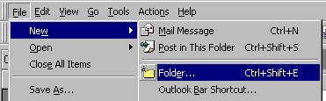

The following menu screen will appear:
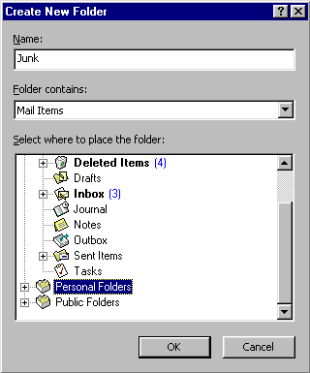
First, select a logical name for the folder. For this exercise we’ll use the title “Junk.” Type this name in the Name: area.

Next, run down with the elevator arrows on the right of the menu screen until you see: “Personal Folders.” Click-on Personal Folders.

This will place the created folder in your My Shortcuts area.

Now, click-on OK.

The following menu screen will appear.

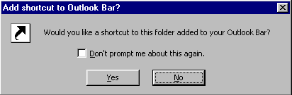
Click-on Yes.

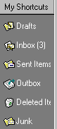

Then notice that the new Personal Folder Junk has been added to your My Shortcuts folder area.

Placing e-mail messages in your Personal Folders

You will notice, that when you are in Outlook 98 My Shortcuts area that when you click-on Inbox, Sent Items, or Deleted Items, that the Personal Folders you created can still be seen. To “move” an e-mail from one of the other folders, you simply click-on the e-mail message, you want to move to your Personal Folder, hold down the left mouse button, and then drag the message to the Personal Folder. You will notice, as you are “dragging” your e-mail message that a small box with an arrow appears, then changes to a circle with a line through it, and then changes again to the box with the arrow when you have the cursor over the Personal Folder icon. When you have the box symbol over your Personal Folder, release the left mouse button. Try this with one of your messages in the Inbox.

Click-on the Inbox. Drag a message to Junk. Click-on Junk. You will see your message. You may “drag” any message, to any folder you choose.

You can still delete the messages when you no longer desire to retain them.

Moving, Deleting, and Recovering Mail Messages

You should now have a “feel” for Outlook 98. Having just completed folders, you can see that we can move a message from any folder to any folder simply by clicking-on it and dragging the message to another folder. You could also click-on a message and, either using Edit, then Copy or Cut in the Menu bar, and then Paste, to move or copy a message in this manner. You can also use the Cut, Copy and Paste buttons in the button bar.

To delete a message, you have already learned that you can click-on the message and then on the “X” in the button bar (not the X in the upper right hand corner). If you click-on the upper right hand corner X this will simply close the message and return you to the Inbox, etc.

When you delete an e-mail message in your Inbox, Sent Items, or a Personal Folder, this places the message in the Deleted Items “trash can.” You can “drag” an item from Deleted Items to any folder to retrieve it, or use the methods above to recover a message to a folder.

To “really” delete an e-mail message in the Deleted Items trash can, you can click-on the message and click-on the “X” button, or tap the Delete key. Outlook 98 will ask you if you “really” want to delete the message. When you say “yes,” it’s gone. To delete several individual messages at once, click-on the first message, then hold down the Ctrl key, and while holding down Ctrl, click-on the other items. You will see that they turn “blue,” indicating that you are “marking” them. Now click the “X” button or tap the Delete key. If you want to delete ALL of the items in the Delete Items trash can, click-on Edit in the Menu bar and then Select All. Then, click-on the “X” button or tap the Delete key

Adding, Sending, Receiving, Viewing, and Saving Attachments

There are many times when you want to send a document, spreadsheet, PowerPoint presentation, picture, or file of some type to someone, or be able to receive one. Outlook 98 makes this relatively simple. The items indicated above are sent as “attachments” to your e-mail.

When you are sending an e-mail message and want to “include” an attachment it’s relatively easy. When you are in the Untitled-Message screen you will notice a “paper clip” in the button bar.

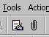

This paper clip is the button that allows you to place an attachment in your e-mail message. Go to the place where you want the attachment located in your e-mail message. Most often, people place attachments at the end of their messages. When you are at the point where you want the attachment, click-on the paper clip. The following menu screen will appear.

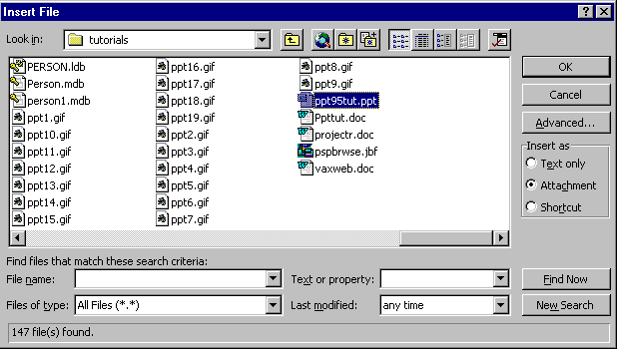

When this screen appears, choose the location of your “attachment” on your computer (A, or C drives, etc., or on the network) by using the Look in: area. Then choose the file by clicking on it. Then click-on OK. Your e-mail message, with attachment, will look similar to the screen below.
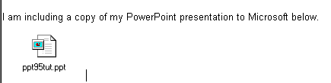

When you or, another person, receives this attachment, all you have to do is double-click on the attachment and it will load into the proper program! Or, you can right click the mouse on the attachment, and a menu will appear that you can use. Once you have the document in its normal “environment” you can save it, etc. Pretty neat!

Calendar

There is a personal calendar you can use that is included with Outlook 98. You can access the calendar by clicking-on the calendar icon in Outlook Shortcuts area on the left of your Outlook screen. You can learn how to use this calendar by using Help or the Office Assistant. If there is interest in receiving instruction on the calendar we will provide this as a part of a later workshop.
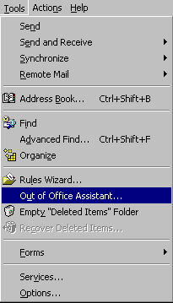
Out of Office Assistant

If you are going to be away from your office computer for a period of time, and you want to leave a message for folks to let them know this, you can use the Out of Office Assistant to do this. To activate the Out of Office Assistant click-on Tools in the Menu bar and then on Out of Office Assistant…

The following menu screen will appear.

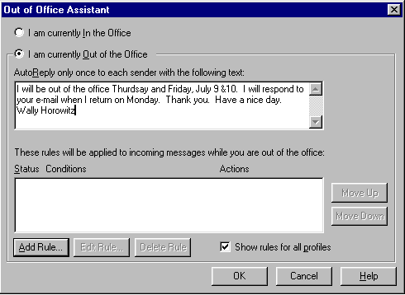
Type the message that you want others to receive when they send an e-mail message to you. Then click-in the small circle to the left of I am currently out of the office. This message will be sent to each person the first time that they send you an e-mail message. When you return, and load Outlook 98, you will see a screen prompt reminding you that Out of Office Assistant is active. You can “turn off” the assistant when you see this message.
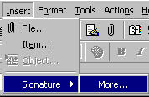
Auto-Signature

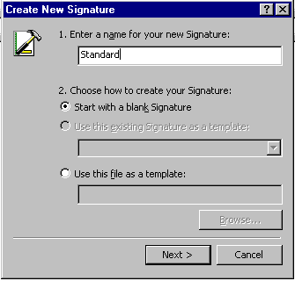
To place a “designed” standard signature at the end of your e-mail messages, there is an Outlook 98 feature, which does this. To activate this feature, click-on Insert in the Menu bar. Then point to Signature and then click-on More...

If you get a message about Rich Text Format, just go ahead and click-on Yes. The following Create a New Signature screen will appear:

Type in a name for your signature as indicated. Then click-on Next >.

In the screen that appears, type a “signature,” in the Signature text area. Change the font, etc., as you desire. Type the signature, as you would like it to appear at the end of an e-mail message.

When you have completed the signature, click-on Finish.

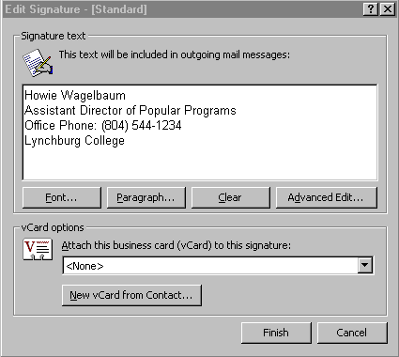
Now, at the end of each e-mail message, you can simply click-on Insert in the Menu bar, then point to Signature, and click-on the name you titled your signature. This signature will then be inserted at the end of your e-mail message. You may design several signatures if you desire. Just replicate the signature design process above for each new signature.

Using Microsoft Word as your e-mail Editor

You may use Microsoft Word 97 as your e-mail editor if you desire. To activate Word, make sure that you are in the Inbox, and then click-on Tools, and then click-on Options. In the screen that appears, click-on the Mail Format tab, and then click-in the box next to Send in this message format. Choose Microsoft Word, from the list which appears, and then click-on OK.

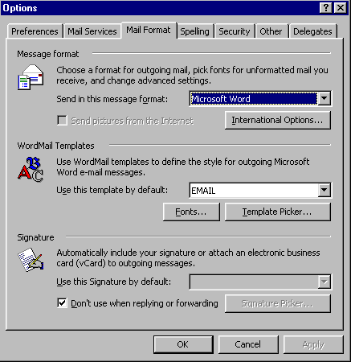

When you are typing your e-mail messages you will have all of the power that is inherent in Microsoft Word.

Accessing you e-mail at home through a web browser

If you desire to access your e-mail at home, using a modem and an on line service provider (e.g. AOL) go to the web address: http://mail.lynchburg.edu.

This has been an introduction into the basics of Outlook 98 mail. If you have any questions about Outlook 98, or comments on this tutorial, please contact Information Technology Services, or

murray.t@lynchburg.edu

Thank you for your patience.

