Creating a PowerPoint XP Presentation
Using Windows 98/2000/Me/XP

Created: 25 April 2002

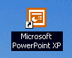
Starting PowerPoint XP

Double click on the PowerPoint XP icon on the Windows desktop (see right), or click-on the Start button in the lower left corner of the screen, then click-on Programs, and then on Microsoft PowerPoint.

In this tutorial, whenever we indicate that you need to click a mouse button, it will mean to click the left mouse button – unless we indicate that you should click the right mouse button. So, always move the cursor over the “place” we indicate and “click left” unless we tell you otherwise.

If you have used PowerPoint 97 or 2000, XP will be a whole new adventure. Almost everything is now “graphical.” So, when PowerPoint loads, the appearance of the monitor screen will be very different. Once you get used to the new XP/2002 features (which apply to all the Office modules) we think you’ll find it much easier to use as you create and edit your PowerPoint slides.
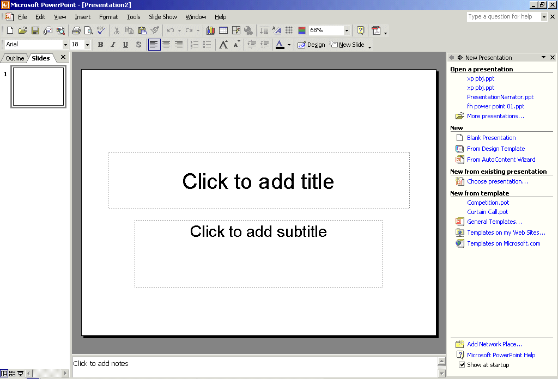
Notice that in the image on the last page that the screen is “sort of” divided into three sections. On the left (left arrow), you’ll see an area that indicates Outline and Slides at the top. When you first open PowerPoint XP you’ll notice that the Slides Tab is “white.” This means that you’ll be able to see a small version of each slide as we create it.

In the center of the screen (center arrow) you’ll see a PowerPoint Design Template. We’ll be using these templates to create our slide show. We’ll come back to this in more detail in a few minutes.

On the right side of the screen (right arrow) you’ll see a New Presentation Area. This is “really” new in PowerPoint XP. This is where you’ll select and edit all of the various screen templates, images, and sounds that you’ll use to create your slide show.

Take a few moments to look over each of these three areas.
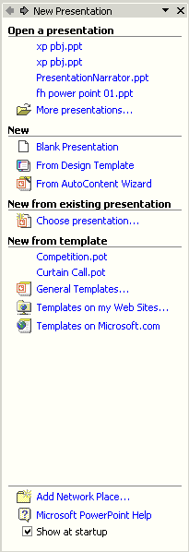

The image on the right is an enlarged view of this New Presentation portion of the screen (on the right side of your screen).

In the image on the right (New Presentation) especially notice the Blank Presentation icon in the New group (see arrow at right).

Move your cursor over the small white image to the left of Blank Presentation. When you do, you will see the “small pointy hand” that indicates that this is a link to the Template Pages. When you see the pointy hand, click the left mouse button.

The right side of your screen should look similar to the one on the next page.

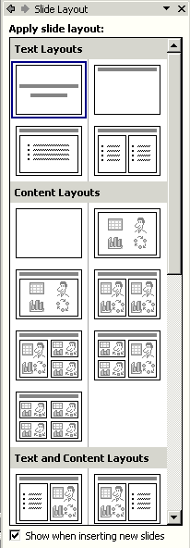

This Apply slide layout – Text Layouts will be the screen we will use to select different templates for each of our slides. As we move along through this tutorial, you’ll see how to do this.

You’ll notice in the Text Layouts area that the top left slide has a blue line around it. This marks this Title Slide as the first slide in your presentation.

In PowerPoint XP the Title Slide always appears first. PowerPoint “thinks” that you want to start your presentation with a title. So, the Title Slide appears in the middle section of the screen.

After you understand PowerPoint a bit more, you can choose any of the templates in the Apply slide layout area to be your first slide.

Beginning the presentation

Slide 1

You will notice, in the lower left corner of the screen, Slide 1 of 1 is indicated. You will also see that your screen looks like the one below.
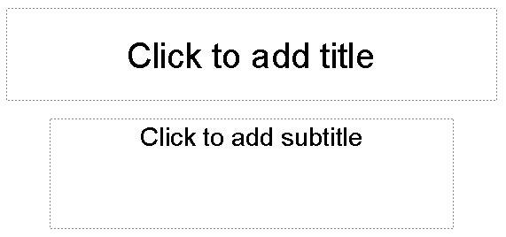

Now we’ll have some fun and create a PowerPoint 2000 presentation on how to make a Peanut Butter and Jelly sandwich.

Point cursor in the “Click to add title” box and Click the left mouse button. The text box, after you click, will look similar to the one below.

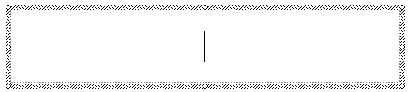

To place the text we want in this formatted text box, simply enter (type-in) the title: How to Make a Great PBJ

Now, Click on the second box “Click to add sub-title” and type:

A Gourmet Recipe (tap the Enter key)
From (tap the Enter key)
Your Name (type in your name like Janie Schwark & Greg Butler)

New Slide Button

Now it’s time to go on to the next slide in your show. To do this we’ll need to find the New Slide button.

At the top of the screen, in the lower button bar you will see a New Slide “button” which looks like this (see the button on the right):

When you move your cursor arrow over the button you will see that a Microsoft Help Text box appears that says New Slide. Click-on the New Slide Button to create your next slide.

A new slide will appear in the center section of your screen. It will resemble the slide at the top of the next page. Later, when we don’t want to use this Title and Bulleted List slide, we’ll use the Slide Layout area on the right to choose the template we want to use.

Slide 2

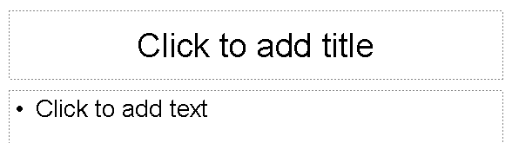

Click in the Click to add title box and type: Ingredients.

Click in the • Click to add text box and type:

Crunchy peanut butter (tap Enter)
Homemade strawberry jam (tap Enter)
Two slices of white bread (tap Enter)
Milk

Notice how each line appears with a “bullet” ( • ) in front of it.

Saving your work
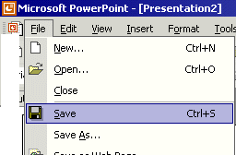
Now would be a good time to save your work for the first time. Point to and click-on File in the Menu bar. Next, click-on Save in the Drop Down Menu that appears.

When you click-on Save, will see a Menu Screen like the one at the top of the next page.
In the upper left corner of the Menu Screen that appears, you will see a Save in: (see arrow). Click-on the small triangle on to the right of the area next to Save in: (see arrow). and it will show you the various disk drives available on which you can save. Point to the one you want, and click-on it. If you choose the 3½ Floppy (A:) – like we did for this tutorial - make sure you have a formatted disk in the A drive. If you choose the C:, choose the folder in which you want to save by double clicking on the folder.

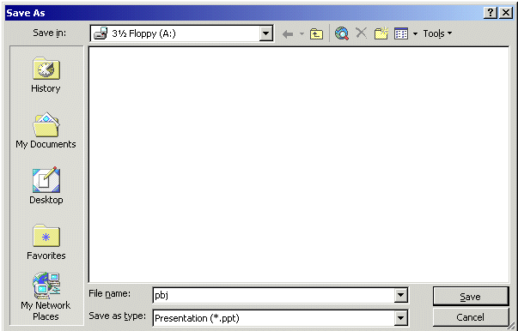

Now click in the box to the right of File name: and delete everything in the box. Then type in pbj and click-on Save (see arrows above).

Since PowerPoint XP does not have an auto-save feature, we think it’s a good idea to save your PowerPoint presentation after each slide. So we’ll remind you to do this.

Other Slide Views

You probably noticed, as soon as you saw the PowerPoint view screen, the area running down the left side of the screen, which contained “little” views of your slides as you were creating them. This first “default view that you see is called Normal View.

In the lower left corner of the screen you will see some “buttons” the look like this:

Slowly point (move) your cursor arrow over each box and pause a moment (don’t click-on any of the box’s yet). Note what the Text Help boxes indicate. The first box (which looks “depressed”) indicates: Normal View. The next: Slide Sorter View. Then, Slide Show.

Each button has its own unique use.

The Normal View gives you a view of the entire slide as well as the “mini-previews” of each slide in the area on the left. This is the one we have been using so far. You’ll also notice a Click to add notes section at the bottom of the Normal View screen. In this area you can type “speaker notes” for each slide in the lower portion of the screen. When we get to printing you will see that there is a print selection so that you can print your notes for each slide so that you can refer to them later while you are making your presentation.

Click-on Slide Sorter View.

In Slide Sorter View you can see small versions of your slides. In this view you can left click-on a slide and, while holding down the left mouse button, drag your slide to any position in your show that you desire. This view assists you in arranging your slides in the order that you desire for your presentation. This view is sort of like the old, round 35mm slide show trays where you pulled out and stuck in slides in the order you desired.

Click-on Normal View to return to your slide creation area. We’ll work with Slide Sorter View a bit later.

Save your work!

The Undo Button

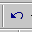
One of the really handy “things” about most Microsoft programs is the Undo Button (it looks like the image on the right). If you make a mistake – no need to panic – click the Undo button and this will remove your mistake. Then you can try again. The Undo Button is found in the Button Bar on the top of the screen. Each time you click-on the button PowerPoint will “go back” one change. If you “click too far, there is a “Redo button” that will “undo the undo.” They are both very handy when you need them.

Slide 3
Click on the New Slide button once again.

When you click the button, you will once again see the Title and Bulleted List Template Slide (in the center portion of the screen). As indicated before, we may not desire to use this slide all the time. So, we’re going to now select a template that has a Title, Bulleted List and a space for a picture (image). Look at the right side of the screen. If you screen look like the one to the right, click-on the Blank Presentation button and the image below will appear.

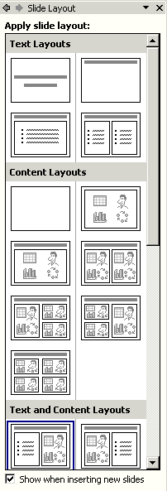

The image to the left will now appear on the right side of your screen. Look at the bottom left of this screen. We’re going to choose a Title, Bulleted List and Image Slide Template for our next slide. At the bottom of this image you will see an area titled: Text and Content Layouts. Click-on the slide indicated by the arrow to the left. As soon as you click on this choice the center portion of your screen will change to the new slide template we selected.

The center of your screen should look like the image at the top of the next page.

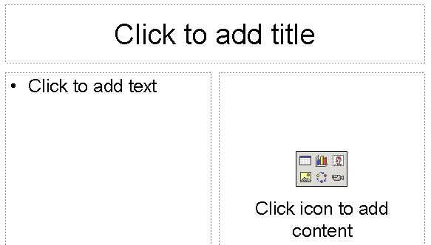

Click-in the Click to add title box and type: Tools Needed

Click in the • Click to add text box and type:

Knife (tap Enter)
Spoon (tap Enter)
Plate (tap Enter)

Glass

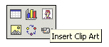
Notice the small image in the lower right portion of the new slide – the image above indicates to Click icon to add content. There are six “tiny” icons in this box that will allow you insert a table, chart, clip art, picture, diagram or a media clip. For this slide we want to insert a clip art image in this area. So, carefully, move your cursor over the tiny image in the upper right corner of this little box (see arrow above). When you do, the box will be highlighted in blue and you’ll see a small text help box appear which indicates – Insert Clip Art.

Click-on the image in the top right corner of the box (next to the arrow above). An image similar to the one on the top of the next page will appear.

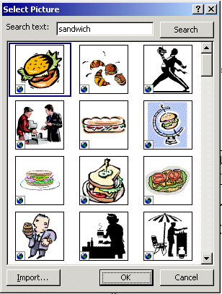

Since our presentation tells how to make a peanut butter and jelly sandwich, we typed sandwich in the Search text: box. Then we clicked-on the Search button (see arrows at the left). The Microsoft Clip Art then appeared as you see it on the left.

Notice that there are a lot of clip art sandwich images available. You can “run down” the choices by using the “elevator bar” on the right side of the Select Picture box.

Move up and down the selections until you find one you like. Don’t worry that there aren’t any selections that look just like a peanut butter sandwich. We’ll show you how to find a lot more clip art as we go through this tutorial.

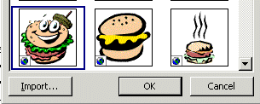
We moved down the selections until our Select Picture screen looked like the one on the right. We chose the “happy-smiley hamburger” because we thought it was cute. To select your picture click-on it and you will see a “blue square” outline your selection. Next, click-on the OK button.

The menu will disappear and you will see the image you selected on the right side of your slide.

Note: if your clip art selection does not appear, and you receive an error message, please read on below (where an explanation is given).

Microsoft XP Clip Art

As you’ve just noticed, Microsoft Clip Art XP Selection Screen is a lot different than “old” Microsoft Clip Art. There are a lot more pictures and some other unique features.

As we continue through this tutorial we’ll be using additional methods to insert images in our PowerPoint presentation. Once you “get used to” the “XP way,” you’ll see that the folks who created this neat product were trying to assist you by having everything you need in the right side area of the screen.

If you choose a slide and

Insert CD-ROM or other removable volume

message appears, this means that when the Clip Art Gallery was installed on your computer, not all of the images were loaded (to save hard disk drive space). So, if you have your installation CD you can place it in the CD drive and click a Retry button that will also appear. If you don’t have the CD, then choose another image and try again. We’ll show you a way to “get around this” dilemma later in the tutorial.

Don’t forget to save your work!

Click on New Slide button once again.

Slide 4

Slide 4 will be another Title and Bulleted List slide. So, when you clicked-on the New Slide button you should have again retrieved the template for this format.

Click on the Click to add title box and type: Directions

Click on the • Click to add text box and type:

Open jars of peanut butter and jam (tap Enter)
Spread peanut butter on one slice of bread with a knife (tap Enter)
Use a spoon to get jam and spread it on the other slice of bread (tap Enter)
Put two slices together and cut the sandwich in half (tap Enter)
Put the sandwich on a plate (tap Enter)
Pour a glass of milk (tap Enter)
Enjoy

If your text won’t fit in the box completely, click-on the box and a border will appear around the box. You will notice “little circles” at the four corners, and in the middle of the top and bottom, and on each side of you text box. Point to either the center top or center bottom circle. Click-on either circle and hold down the left mouse button and drag the top circle up or the bottom circle down a little to enlarge the larger text area so that text fits on the screen. If your “Directions” are now “mixed-in” with the text below, click-on Directions. Then click-on the “edge” of the “box” (a small up-down-left-right arrow will appear), hold down the left mouse button, and drag the box up a bit.

Time to save your work!
Click on New Slide button once again.

Slide 5
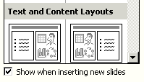
For this slide we’ll be creating a bar chart of what jam/jelly folks like the most in their peanut butter sandwiches. To create this type of slide we’ll start by clicking-on the same image we did for Slide 3. In the lower right corner of your screen you should still see the image to the right. Click-on the left image as you did before.

The center portion of your screen should look like the one at the top of Page 9.

Click on the Click to Add title text box and type: Why use strawberry jam?

Click on the • Click to add text box and type:

100 Children and adults were surveyed to find out what goes best with peanut butter. 33 Selected grape jelly, 11 honey, 46 strawberry jam and 10 sliced bananas (you don’t have to tap enter, as this is one long statement).

Now we’ll make a graph to show the survey data.

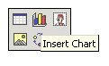
In the right side area of the slide we’ll click on the center small icon in the top row (it looks like a bar chart – see arrow at right). When you click-on this icon the images on the next page will appear.
At the top of the slide you will see an image that looks like the one below. This is called a datasheet. If you have used any spreadsheet (like Microsoft Excel) you will be familiar with this format. If not, it won’t be a problem for what we are going to do.

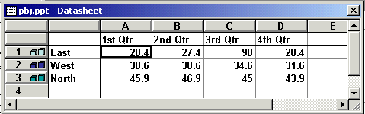

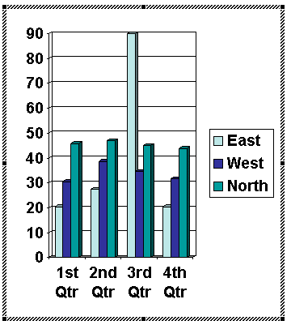

Below the above image you will see an image like the one on the right. The data in the above image created the bar chart you see to the right. As you enter data you will see the chart on the right change to reflect our data entries.

We are going to enter data for our graph in this Datasheet (at the top of this page). Your Datasheet should now look like the one at the top of the next page. Click-on the box with “East” and replace “East” with (type-in) Grape, then “West” with Honey, “North” with Straw, and in the blank cell (box) below Straw enter Banana. Now, click on “1st Qtr” and type-in Best. Now click-on the cell (box) in the “A” column next to Grape and enter 33, then by Honey enter 11, by Straw enter 46, and by Banana enter 10. After you have entered the 10, click at the top of your datasheet on the word Best.
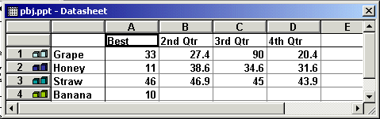

Note: As you are changing the labels and numbers you’ll see the graph that appeared with this datasheet changing to reflect the changes. This is an interactive graph. Really neat – you can see your graph “forming” as you type.

We want a simple graph that “fills” our graph area, so we need to delete the rest of the columns. To do this, put your cursor on the B in the Gray area at the top of the Datasheet. Click and hold down the left mouse button and drag right (over the Gray B, C and D) until B, C and D are highlighted (as shown below). Release the mouse button. Your Datasheet should now look like this:

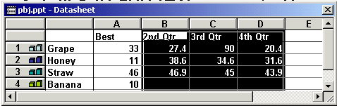

Now tap the Delete key on the keyboard and the columns you have highlighted will disappear.

Your Datasheet should now look like this:

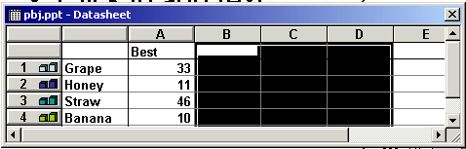

Click the small “X” in the upper right hand corner of the Datasheet.

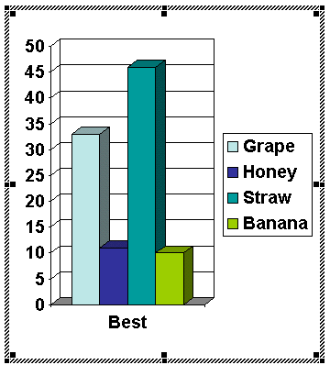

If you did everything right, your graph should look like this:

Every now and then you might make a mistake in the Datasheet. If you have “closed” the datasheet, as we did above (when we clicked-on the small X), you can get it back by clicking-on the Datasheet button below the Menu Bar.
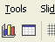

This is the Datasheet button

You may or may not desire to alter the appearance of your graph. It should be OK. However, the graph may need some adjusting, so that all of the “words” show completely. You may want to change the size of the box the graph is in, so click-on the graph. Click-on the side, using the “grabber” boxes on the side like you did previously, and drag the side until the graph gets larger. If you make the graph wider, the word “Best” will move to one line. Click-on the legend (the box with the grape, honey, etc. inside) and move that whole box to the top right hand part of the graph figure to make it more legible. Work with the various parts of the graph until it looks OK. If you make any changes, click-away from the graph to “turn off” the “box” around the graph – so you can see the new slide button.

Save your work!
Click on New Slide button once again.

Slide 6

We’ll use the Title and Bulleted List Template again.

Click on Add title text box and type: Occasions for Eating PBJ’s

Click on the • Click to add text box and type:

School lunches (tap Enter)
Birthday parties (tap Enter)
Picnics (tap Enter)
Visits from persnickety
grandchildren (tap Enter)
Late night snacks (tap Enter)
At the pool

Save your work!

Another “WOW” feature in Microsoft PowerPoint XP – Animated Images and Sounds!

In PowerPoint XP you can now have images that “move!” These are called animated images. On any slide you can insert an animated Clip Art image. Most of the time, when you get comfortable with PowerPoint, you’ll want to insert an image and then move and size the image as you desire. To do this you’ll need to click-on Insert in the Menu Bar, and then on Picture in the drop down menu, and them move over Clip Art and click on Clip Art. Your screen should look like the one below.

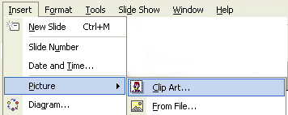

When you click-on Clip Art the first time you may see a screen that asks if you want to organize your Clip Art. This is a good idea. So, click-on OK. You will see a series of screens that indicate that this is being done.

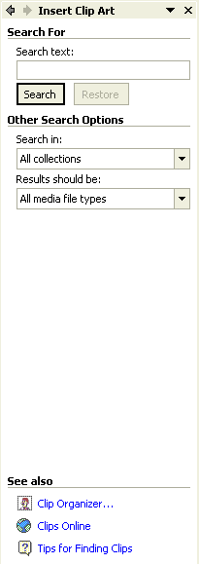

Once again you’ll notice that the area on the right side of the screen has changed to carry out the task in which we are engaged. Notice that the image on the left indicates Insert Clip Art at the top.

For those of you that have used Microsoft Clip Art 2000 this will be a noticeable change.

Notice the two selections under Other Search Options: All collections and All media file types. Click-on the small down pointing triangles on the right.

When you click on the triangle for All collections you will see:
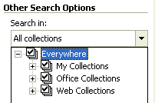

When you click on the triangle for All media file types you will see:

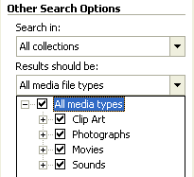

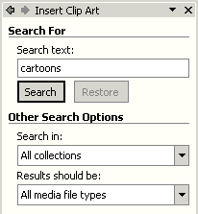
We’ll “get into” sounds later, but now is a good time to learn about Motion Clips or Animated Clips. First we’ll do a search to see if we can find a cartoon motion clip that might fit into our Peanut Butter and Jelly theme. Look at the upper portion of the right side of the screen again. First, we’ll do a Clip Art search for cartoons and “hope” we get a motion/animated image.

So, type-in cartoons in the area under Search text:

Then click-on the Search button.
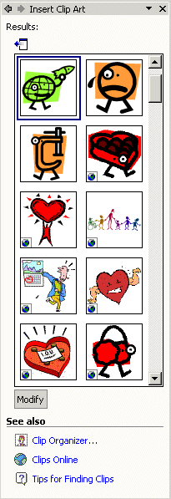

A screen similar to the one on the left will appear on the right side of your screen.

Notice in the lower left corner of each image that there is either no “symbol” or there is a “small earth symbol.” This indicates that the clip art that the search found are not animated. If you saw a “yellow star” this would indicate that the clip art is animated.

To “see” more about an image, move your cursor over the “right edge” of an image. We chose the person holding the heart (as indicated below). You will see a light blue bar appear on the right edge of the image with a small down pointing triangle. Move your cursor over the triangle and click-on it.
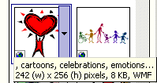

When you click-on the triangle, the image at the top of the next page will appear.

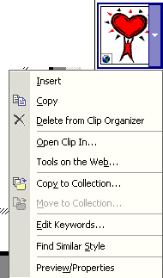

From the image on the right you can see that the drop down menu furnishes you with a number of selections.

Move your cursor over Preview/Properties and click-on this selection.

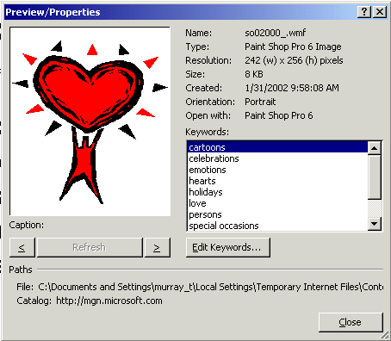
This image gives specifics on the Clip Art picture you chose. If this had been an animated image, you would see the animation moving in the left preview area.

This is a handy feature where you can check the many details of any image you select.

When you are finished looking at Preview/Properties, click-on the Close button in the lower right corner.
Another “Golly Gee” feature in Microsoft PowerPoint XP – Clips Online!

Since we did not find an animated image for this slide, let’s try something else – Clips Online.

You can go online from the Insert ClipArt Menu Screen and get even more clip art. Not only is everything in the ClipArt Gallery available – but even more!
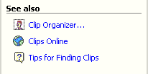

If you look at the bottom right of your screen in the Insert Clip Art area you will see the image to the right. Notice that one of the selections is Clips Online. Move your cursor over Clips Online and click-on it.

You may see an information screen similar to the one below, or you may go directly to the Clips Online Microsoft web page.
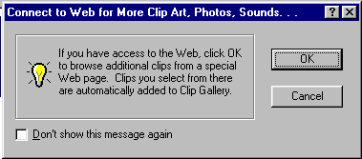

If you do see the above screen it is simply reminding you that you need to be on the Internet. When you click-on OK the browser you are using will go to the Microsoft Clips Online web page.

It will take a few moments, but the Clips Online screen below will load.

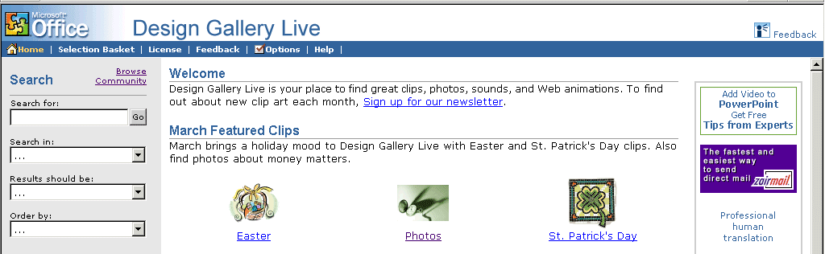

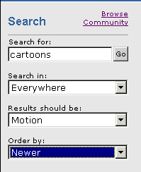

Notice that one of the arrows in the image at the right points to Search. To search for cartoons that are animated/in motion, we filled in the Search for: and Search in: boxes as indicated in the image on the right. To do this we clicked-on the small down triangles and selected the choices you see.

We then clicked-on Go. We received seven pages – 7 ! - of animated cartoon images – they all move! The top of the Design Gallery web page should look something like the one below. You can view each page by clicking on the >> at the top right of the page.

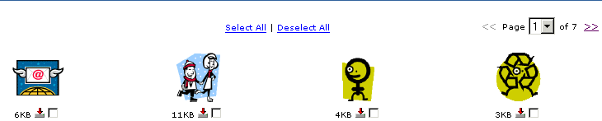

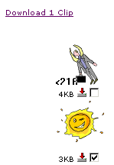
Notice the small “boxes” below each image. If you see an image, as you move through the pages, that you would like to save for your “image collection,” click-in the small box and a check mark will appear.

We chose a “small beaming sun” on one of the other pages for our selection. When we clicked-in the little box our screen looked like the image at the right. When we clicked-in the box the check mark appeared and it indicated Download 1 Clip at the top of the screen.

If you select (click) several images, you will see the Download Clip increase as you click-on each box.


When you have selected all of the clips that you desire, click-on the Download Clips link.

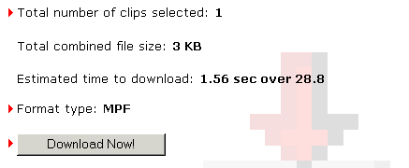
Your monitor screen should now be similar to the one on the left. It indicates how many clips you selected, how much disk space they require, and how long it will take to download them over a modem.

Click-on Download Now!

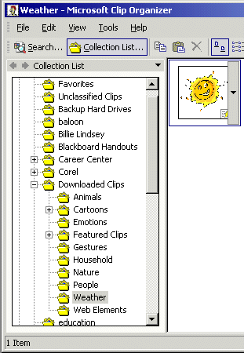

When the download is complete, a screen similar to the one on the right will appear. There are several things to notice here.

First, look at the top of the screen it indicates: Weather-Microsoft Clip Organizer. This is important – you’ll see why in a few minutes.

Next, you see the images that you downloaded. Since these are animated images, notice the “yellow star” in the lower right corner of the images. This indicates that the image is animated.

Last, notice that the Weather folder is highlighted in gray. This indicates that this downloaded image will be placed in the Weather folder under Downloaded Clips.

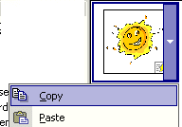
When you are ready to insert a clip in your presentation, move your cursor over the right side of the animated image you wish to insert and click-on the small down triangle.

Then, in the drop down menu that appears, select Copy.
One more “thing” about Clips Online

If you don’t want to go to Clips Online and go through the “hassle” of downloading clips you can use the procedure below. This procedure “connects” to Clips Online through the Collection List.

Make sure that you are “on-line” and logged in through your modem on network cable.
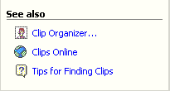
Move to the bottom of the Insert Clip Art Task Pane on the right side of your screen and click-on Clip Organizer.
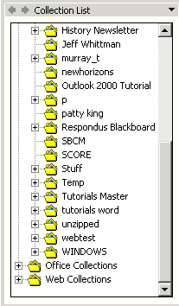

The Collection List at the left will appear on the left side of the Microsoft Clip Organizer Menu Screen. Use the elevator bar on the right side of the Collection List to move down to the bottom of the Collection List area.

At the bottom of the Collection List area you will see a Web Collections Folder. Click-on the little plus sign ( + ) to the left of the Web Collections folder.

When you click, the Collection List folder will “open” and the collection list will look like the left side of the image below.

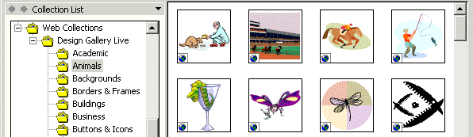
Notice below the Web Collections that a folder named Design Gallery Live now appears. And, under this folder, you see a number of selections (Academic, Animals, etc.).

We clicked on Animals in the image above and the Clip Art images on the right appeared. You can insert these images just like you did on page 22. In essence, you are “live” in the Clip Gallery since you are online. Some find this easier to use that downloading a specific clip. You choose the one you like best.

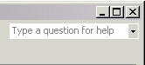

After you have clicked-on Copy, close the Microsoft Clip Organizer by clicking on the small “X” in the upper right corner of the Clip Organizer screen.

You may see a Microsoft Clip Organizer information screen appear (like the one below) which asks if you desire to retain images on your Clipboard.

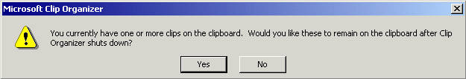

Answer “Yes” if this screen appears.

You should now be back in the last slide we worked on – Slide 6.

Move your cursor anywhere in the lower area of the Template slide (Occasions for eating a PBJ) and click the RIGHT mouse button (this simply causes a menu to appear). Click Paste. The picture you selected will now be a part of the slide. You could also click on Edit in the Menu Bar and then select Paste. The image you selected will now appear in your slide.
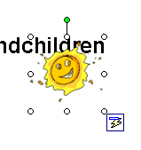
Our image looked like the one on the far right when we first pasted it into the slide. To move your image around on the slide move the cursor over the image until your cursor becomes a “four-arrow cursor.” When you see the four-arrow graphic (sort of like the one on the right), click and hold down the left mouse button and move (drag) the image to a place on your slide where you think it looks best.

To make the image larger, or smaller, move your cursor over one of the small circles on one of the corners of the image. When your cursor is over a corner you will see a two-arrow cursor (similar to the one on the right). When you see this two-arrow cursor, click and hold down the left mouse button and move (drag) the cursor out or in until you have the size you desire. If you “grab” the circles in the middle of the top, bottom and left or right sides of the image, and move them, you will either make your image “skinny” or “fat.” So, most of the time, it’s best to use the corner circles.

Save your work!
Click on New Slide button once again.

An Important Note: Anytime you desire to insert Clip Art into your presentation look at the bottom of the right side of the screen and you’ll see the image to the right. You can go to your clips in the Clip Organizer, or go to Clips Online.

Anytime you are in the Normal View screen, and you desire to move “back and forth” between Slide Layout and Insert Clip Art views in the right area of the screen, you can click-on the back and forward arrows at the top of the right side of Slide Layout.

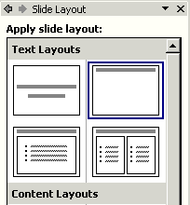
Slide 7

For Slide 7 we’ll be using a Title Only Template.

So, click-on the slide template in the upper right corner of the Apply slide layout screen (see arrow at right)

Click in the Click to add title box and type: Enjoy your sandwich!

Now, let’s make the letters larger. Highlight your title (Enjoy your sandwich!) by placing your cursor at the beginning of the first word, click and hold down the left mouse button and drag it across the words, then release the left button. The Title should be highlighted it should look like the picture below. Since you are “really” in Microsoft Word when you are working with text in PowerPoint XP, you can also place your cursor on Enjoy your sandwich! and quickly click the left mouse button three times and you will notice that the phrase is highlighted (just like the ruby slippers in Wizard of Oz!)

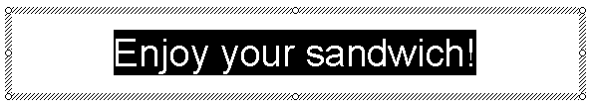

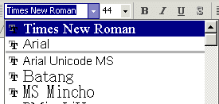
First, we’ll change the font of the text. Click-on the down triangle next to Ariel in the button bar at the top of the screen. Use the elevator bar on the right of the font screen that appears and move down and select Times New Roman (see picture and arrow at right).

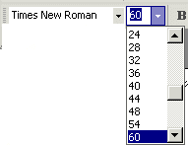
Next, place your cursor on the box under the tool bar that has a number in it (when your cursor is on it the Text Help box will indicate Font Size – see the image on the right). Click on the down triangle and scroll down to 60 and click on 60. You should now see larger text than you had before. You can do this to any text in your PowerPoint presentation.

Save your work!

AutoShapes

We’re now going to try something new – a technique for adding clever shapes and a few “secret” things to our slides.

First, point the cursor away from the Title box and click the left mouse button. This is called “clicking away.” This will “turn-off” the square “box” around the Title.

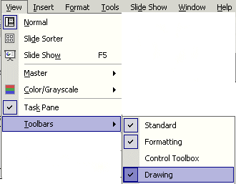
Next, point to View in the Menu Bar and click. When the menu list appears, move the cursor down to Toolbars. Look at the Toolbars drop down list. Notice that, normally, the first two selections (Standard and Formatting) have a small check mark in front of them. This indicates that these toolbars are visible on the screen. Look further down the list until you see Drawing. If you see a check mark (like in the picture on the left), then simply point away from the drop down menu, click the mouse, and look for the Drawing Tool bar (normally at the bottom of your screen).

If you do not see a check mark, click-on Drawing. The Drawing toolbar will appear at the top, side or bottom of the screen. It will look like the tool bar below.

Now click-on AutoShapes and a small box of shapes will appear.

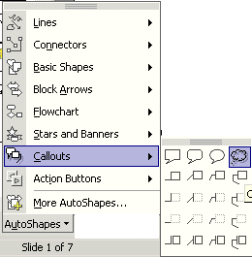
Move up and down the pop up menu box and notice the different shapes that appear next to each choice. Then, click-on Callouts. Click-on the far right callout (cloud callout) in the top row. When you have clicked, the cursor will change to “cross hairs” when you move it into the slide area.

Now move the cross hairs up into the area just below the title. Click and hold down the left mouse button, and drag down and to the right. Release the button. A cloud shape should appear similar to the one below.
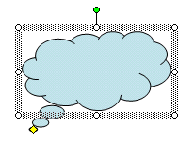

Drag this Cloud callout to the upper right corner of your screen just under your title (move your cursor over the Cloud until you see the four arrow shape, click and hold down the left mouse button and drag the cloud).

Enhancing the presentation:

Not too spectacular? Let’s spice it up!

Click-in the cloud. Then, type the word WOW! You will see WOW! appear in the cloud. It’s sort of like a “hidden” text box (this is the secret!). Click the left mouse button in front of WOW!, hold down the left mouse button, and drag across WOW! to highlight the word. Or, since you are in Word, triple-click quickly on WOW! and WOW! will be highlighted. Click-on Format in the Menu Bar and then click-on Font.

The Font Menu screen at the top of the next page will appear.
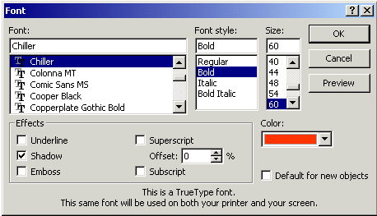

Change the Font, Font style, Size, and Color. Bold or Italicize if you want. Be as creative as you desire and then click-on OK. If WOW! is “too big” for your Cloud, simply “grab” one of the corners (as we explained on Page 23) and make the cloud larger.

From now on you can “change” any of your text using this method.

Save your work!

Now that we have a cartoon cloud box (like in the comic-funny papers) that says WOW!, we need to add a comic character (clip art) to be saying this phrase. So, back to add clip art.

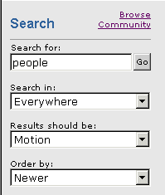
Click-on Insert in the Menu Bar and then click-on Picture and then on Clip Art. The Insert Clip Art screen (that we’ve used before - Page 16) will again appear on the right side of the screen. We’re going to go down to the bottom of the screen and choose Clips Online again. We thought we’d search for animated people, so we typed-in people in the Search for: and then chose Everywhere and Motion (as you can see in the image on the right). We then clicked-on Go and got 51 pages of images. We then went through the pages as we did before and chose several images we liked. You do the same and choose several that you like.

We then clicked on Download (so many) clips (like picture at the left), then clicked-on Download Now, we were again taken to the Microsoft Clip Organizer screen. Please look at your Clip organizer screen carefully. On the left side it will indicate the folder in which the clips will be saved.
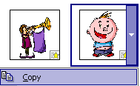

Choose a clipart image that you like and click the small down triangle on the right side of the image. When the drop down menu appears, click-on Copy.

Then close the Microsoft Clip Organizer by clicking on the small “X” in the upper right corner of the Microsoft Clip Organizer screen.

Next move your cursor over your slide and click the RIGHT mouse button. In the pop-up menu that appears, select Paste. Your image will now be somewhere on your screen. You’ll probably have to drag it down and to the left and make it larger (like we did on Page 23). Go ahead and do that now. When we finished, our slide looked like the one below.

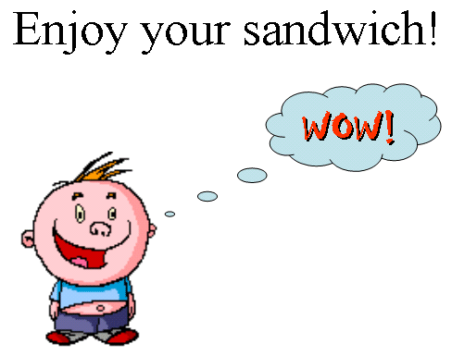

Don’t forget to save your work again.
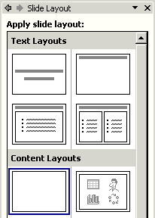

Click on New Slide button once again.

Slide 8

For this slide choose the left slide in the third row – Blank.

Text Art:

Now we’ll use some Text Art. In the Drawing Bar, which should be open, find a “blue A” that is slightly tilted (like the one on the right). When you pass your cursor over this “button,” it will indicate: insert WordArt. If the Drawing Bar is not available, click-on View in the Menu Bar, then click-on Toolbars and select Drawing by clicking-on it. Click-on the Insert WordArt button. The following WordArt Gallery menu screen will appear. Select one of the WordArt patterns by clicking on it. We chose the one indicated by the arrow below. Next, click-on OK.

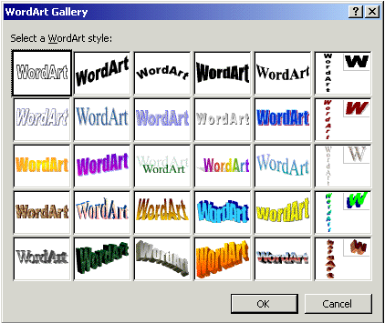

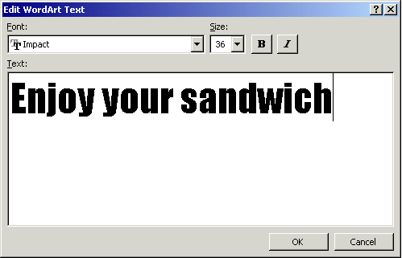
The following Edit WordArt Text screen will appear. Where the screen indicates Your Text Here, type-in: Enjoy your Sandwich. Select a different font and size, if you desire, then click-on OK.

You will return to Slide 8 and see the WordArt you created. You may use the “grabbers” (little circles on the corners) to make the text larger (like we did on Page 23). It would be a good idea to make your Text Art about three times this size. You may also move your text as you desire.


If you want to change the “look” of your WordArt, you’ll need to be able to see the WordArt toolbar. It looks like the toolbar below.

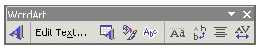

Most of the time the toolbar appears when you click on OK and the WordArt you selected appears. If the toolbar does not appear, point to the center of the WordArt and click the RIGHT mouse button. A WordArt drop down screen will appear. A choice will be: Show WordArt toolbar. Click on Show WordArt toolbar and the toolbar will appear.

We’ll click-on the different “buttons” in the WordArt toolbar to edit our text.

Insert WordArt and Edit WordArt Text

Starting from the left (in the WordArt toolbar) you already know what the first two buttons will do. The blue A will allow you to add another WordArt. The Edit Text button will allow you to change the text in your WordArt.

If, for some reason, you accidentally “click-away” from your WordArt, you’ll loose the grabbers and your WordArt toolbar. Not a big deal. To “activate” both, simply place the cursor over the WordArt and click the left button on the WordArt. Both will re-appear.

WordArt Gallery

The third button in from the left will bring up the WordArt Gallery again. If you do not like the WordArt “style” you chose, you can choose another by clicking-on this button.
Format WordArt
The fourth button in from the left will allow you to change a number of “things” in WordArt, and in other PowerPoint features. When you click on this button the menu screen to the below will appear.

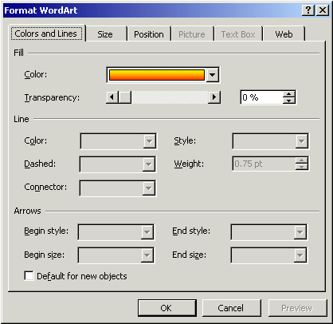

Notice that there are a number of “tabs” at the top of the menu. You can click-on the tabs and get a “feel” for what each will do. We’ll just click-on the Color choice for now (see arrow at left). We’ll click-on the small “down triangle” to bring up the menu below.

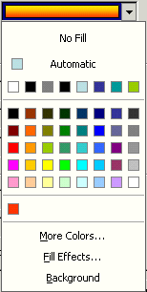

When you click-on Color the drop down menu to the left will appear. We’ll work with a similar menu later. For now, just move your cursor down to More Colors and click on it. The Colors menus will appear similar to the one at the top of the next page.

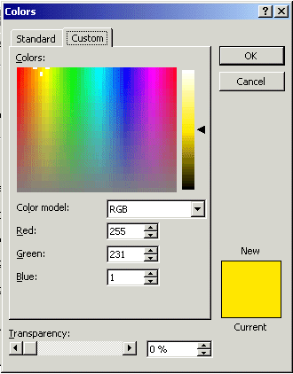

There are a lot of really unique features with the color palettes in Microsoft software. The Custom color pallet, which you see on the left, has two “neat” features. The first feature is that you can click anywhere in the pallet and the color in the area where you click will be shown in the lower right corner. After you have selected a color you can “drag” the small arrow “triangle” on the right of the screen up and down to lighten or darken the color you chose. We’ve marked where you can click to choose a color, and the “up and down” triangle, with arrows in the image on the left. Select a color and give it a try.

Once you have selected a color, click-on OK. You will see the changes in your WordArt.

WordArt Shapes
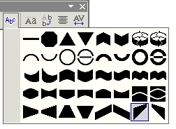
When you click-on the fifth button from the left (it has an “Abc” on it), the image at the right will drop down. If you would like to change the shape of your WordArt text to a new shape, click-on one of the shapes in the choices chart to the right. You will see your WordArt change to that shape. Give it a try.

The last four buttons on the right adjust text spacing, alignment, etc. Work with them, as you desire.

When you have finished your editing, you can close the WordArt edit toolbar by clicking-on the little “X.” in the upper right corner of the toolbar.

Save your work!

Text Box

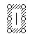
The last “tool” we’ll work with is the Text Box. The Text Box is also in the Drawing toolbar. The Text Box button will allow you to insert text in your slides if the template you chose does not have the desired Title and Bullet boxes. To insert text, click on the Text Box button. It has an “A” in the upper left corner of the button with some text below (it looks like the button above on the right). After you click-on the Text Box button, move the cursor into an “open” area of Slide 8. It will look like a “little sword.”. When you get to an appropriate place, click the left mouse button and a “text entry area” will appear (it looks like the image on the right).

Don’t worry about its size. Just type the following: THE END. The text box will automatically resize to the text entered. You may now highlight this text, and by clicking-on Format in the Menu Bar and Font, as you have done before. Edit this text – make it larger, change the font and pick a color that you like.

Our Slide 8 looks like the one below.



Save your work!
Slide 9

PowerPoint XP has some really neat new features that you might like to try. You can “trace a path” for an image to follow around or across the slide. You can have a porpoise jumping in and out of the water at the bottom of the slide, or maybe a bee flying around in the top portion. If you want to do this we’ll show you how. If not, skip to Page 37.
Click the New Slide Button.

For this slide choose the left slide in the third row – Blank.
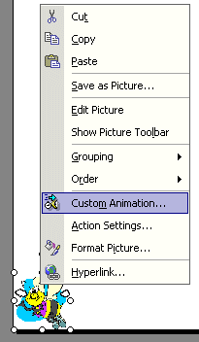

First, following the process outlined for several other slides, we went to Clips Online and found a cute bee. We then downloaded the bee into our Clip Organizer. Then, we copied the bee from the Clip Organizer and pasted it onto the blank slide template. We made the size of the bee fairly small and then moved the bee to the lower left corner of the blank slide template. We then placed our cursor over the bee and clicked the RIGHT mouse button to bring up a menu which includes Custom Animation. We then selected Custom Animation (see image at left).
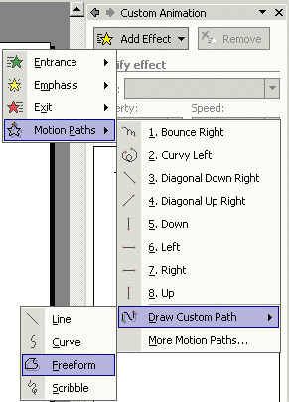

When we clicked-on Custom Animation (above) we saw the Add Effect Button appear. We clicked on the Add Effect button, and in the menu that appeared below, we clicked-on Motion Paths. In the next menu that appeared we moved down and clicked-on Draw Custom Path. In the last menu to appear we clicked-on Freeform.

After clicking-on Freeform, we moved our mouse into the template slide and noticed that our cursor image had changed to “cross hairs.” We moved the crosshairs over the bee in the lower left corner of the slide template and held down the left mouse button. With the left button held down we slowly began to move the cursor to the top of the template. We noticed that the cursor now looked like a little pencil. As long as we held down the left mouse button the pencil traced a path around the slide.

To turn off the pencil, we simply clicked the left mouse button twice – quickly – and the pencil went away. As soon as we quickly clicked twice, we also noticed that our bee flew very, very fast around the path we had drawn.

Below is what our slide looked like when we finished.
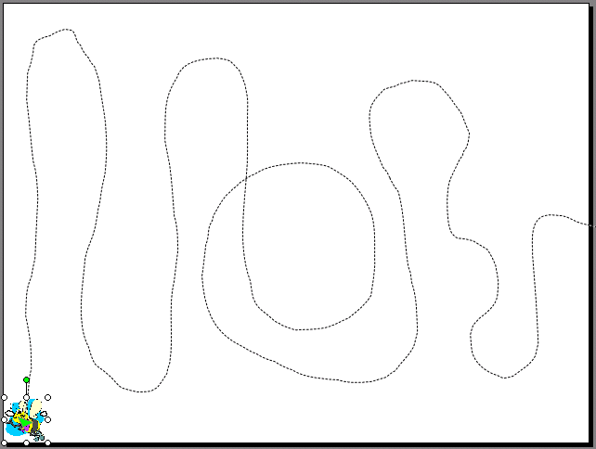

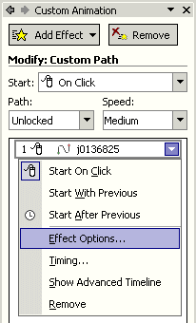
You can see the “flight path” for our bee begins in the lower left corner and goes up and down around the slide and exits at the right.

Now we’ll slow our bee down a lot and insert a buzzing sound as the bee flies around.

On the right side of the screen, in the Custom Animation portion of the screen, we noticed that when we completed that bee flight path that something new appeared.

When we clicked-on the small triangle on the right of this image selection, we saw a drop down menu similar to the one on the right. We clicked-on Effect Options and the image at the top of the next page appeared.

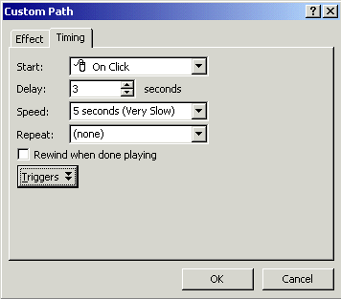
Since we selected Custom Path to create our flying bee effect, the menu screen at the right appeared when we clicked-on Effect Options. Notice, at the top of the menu, there are two tabs. We are “on” the Timing tab. Our bee flew very fast and we would like to slow it down. So, we chose 5 seconds (Very Slow). We also wanted our bee to wait a few seconds after we moved to Slide 9 to begin its flying. So, we also chose a delay of three seconds (see arrows to the right). To complete this menu screen click OK.

To slow our bee down even more we can again chose Effect Options and typed in 20 (seconds). This will really slow the path. Experiment and choose a time that you like.

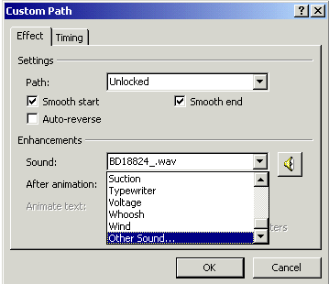
To insert a sound with our bee image (buzzing), we went to Clips Online once more and for our search topic entered “buzzing” and found a number of buzzing sounds. We downloaded these as we’ve done before.

To add a sound to your image is a bit tricky. You again click-on Event Options (bottom right Page 35) as you did before. When the menu screen appears (like the one to the left) choose the Effect tab.

Then click-on the triangle to the right of Sound and move down the menu until you see Other Sound. Click-on Other Sound. A menu screen will appear similar to the one at the top of the next page.
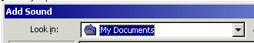
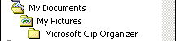
Click the small triangle to the right of Look in. When the drop down screen appears, select My Documents (double-click twice quickly on My Documents or click-on Open), then select Pictures (double-click or Open) and then select Microsoft Clip Organizer (double-click or Open).

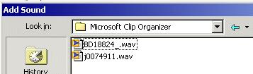
You should then see a menu screen similar to the one on the left. The “goofy” numbers you see are the “names” of the sounds you downloaded! We said this was tricky. So, click-on one of the sounds and then click-on OK. This will take you back to the menu screen at the bottom of Page 36 above. You will hear your sound play if your volume is set high enough.

To complete your menu screen click OK.

Note: if you “loose or don’t see the path” that you drew for your image, RIGHT click-on the image and choose Custom Animation like you did before. This will cause the path to reappear and the right side of your screen to again show the Custom Animation area.

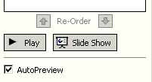
At the bottom of the Custom Animation area on the right side of the screen you will notice that the area looks like the image to the right. Anytime you are working with animation you will see this image. Notice that you can Play (again) your animation effects anytime you desire by clicking-on the Play button. If you desire to see this how this slide will “look” when you present your PowerPoint slide show, click-on Slide Show (we’re going to get to this next for the entire show).

Viewing your Slide Show

You have just completed the first stage of your presentation. Go back to Slide 1. You can do this by using the “elevator bar” on the right edge of your screen. If you click at the top of the elevator bar you will keep moving up, from Slide 8 until you come to your first slide. It will indicate Slide 1 of 9 in the status area in the lower left corner of your screen. You should recognize this slide as your first slide on how to make a PBJ.

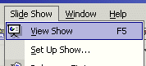
If you would like to view how your slide show will look when you project it onto a screen or a monitor, go to the tool bar at the top and click on Slide Show and click on View Show (like the image on the right).

Or, you can click-on the small Slide Show button in the button bar at the lower left of the screen.

There are several ways to advance through your slide show. You can tap the space bar, tap the Enter key, tap the right arrow key, or click the left mouse button to move forward from one slide to the next during the show. When you get to the end of the “show” the presentation will return to your slides. Anytime you want to end the show, simply tap the Esc key in the upper left corner of the keyboard or click the right mouse button and click on End Show in the pop up menu that appears. If you end your show “early” you will be on the slide you were viewing when you tapped Esc or clicked-on End Show.

To “go backward” to a previous slide, in your show, you can tap the Backspace key, or the left arrow key. If you are using the mouse to “click” through your presentation and desire to go back, click the RIGHT mouse button and you will see a menu screen appear that allows you to choose a Previous slide or Go to any slide.

Transitions:

Now we’ll add some pizzazz to our presentation. When you viewed your slide show, a few moments ago, it was simply like “flopping down” plastic transparencies on an overhead projector. Nothing really fantastic. Now we’ll add some motion, animation, sound, and color and really make our presentation something to view.

Go to the Slide Sorter button at the bottom left area of your screen. Click on the button with four white squares.

You can now see all nine slides (as shown below). Notice that Slide 9 (the one with the flying bee) does not show the path of the bee. This is because of the motion path – not a big deal. Lightly, click once on the first slide to highlight the slide (a heavy blue border will surround the slide – see arrow below). Now point in the middle of the slide and click on your RIGHT mouse button.

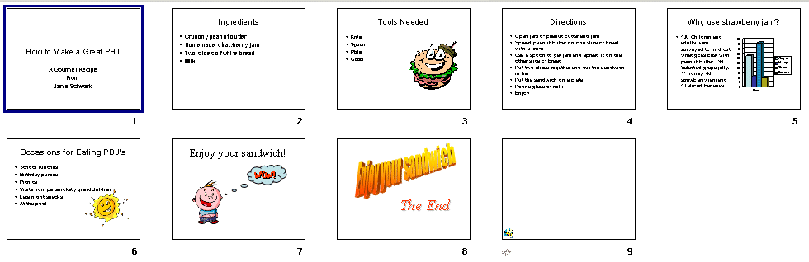

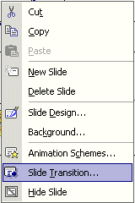
The right click will “always bring up” a menu that is “tailored” to the “place” where you click. This will work in any Microsoft Office product. You can always tell “where” you click the right mouse button because the cursor arrow will always be in a corner of the menu that appears. From the menu that appears, select Slide Transition (click-on it – see arrow below and to the right).

At the top of the next page you will see the new menu box that appears on the right side of the PowerPoint screen - Slide Transition. This menu box will allow us to create “transitions” as we go from one slide to the next.

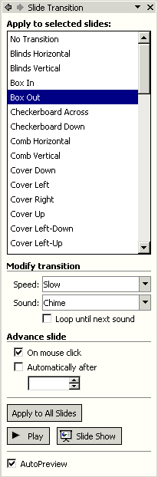
For “old” PowerPoint users, this is another “totally new” screen. It takes the place of the “old dog and key screen.”

So, let’s get started in creating some movement (transitions) as we enhance our PowerPoint slide show. Remember that we clicked-on Slide 1 to begin this process.

Notice, in the image to the right, that you have a lot of transition choices under Apply to selected slides. Go ahead and click-on one of the choices. Notice that there is an “elevator bar” on the right side of Apply to selected slides – many more choices are below.
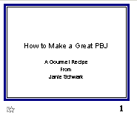
When you click, keep your eyes on Slide 1 on the left of the screen. Each time you make another selection you will see that transition effect on Slide 1.

Also notice that there is a Modify transition area below the transition choices. You may change your transition from Fast to Slow (as we have done). You may also add a Sound (as we have done – a Chime).

Finally notice at the bottom of the Apply to selected slides area that there are three additional choices.

If you like your transition, you can Apply to All Slides. We used the elevator bar to move to the bottom of all the selections and chose Random Transition. We then chose Apply to All Slides. So, when we show our slides, each slide will transition with a different effect between slides. Also, they will all “Chime” as they transition.

Note: many audiences do not like a lot of “sound” when watching a PowerPoint presentation. So, you may desire to use sound “sparingly” in your presentation.

When you return to Slide Sorter View, you will notice a small box with a star at the lower left corner of each slide. This indicates that a slide will transition. If you want to see how a certain slide will transition, click-on that slide and then click-on Play, and you will see the effect each time you click Play. You can also click-on the small star to see the transition.

Build:

Building is a term indicating how each line of the text, on a slide, will enter the screen. The lines, words, letters, pictures and charts can move in or appear from almost any direction. To Build the text on each slide, follow these directions.

Go back to Normal View. You can do this in Slide Sorter View by double clicking-on the first slide or by Clicking on the Normal View button on the lower left corner of the screen. When the Normal View screen appears, click-on the first line of text. The “box” you saw, when you first typed text in this box, will appear. This indicates that the box is “active.” It will appear as below.

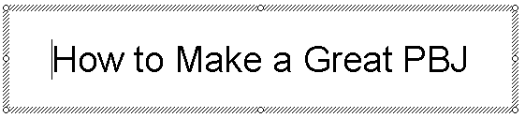

Now, right click in the box.

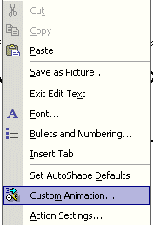

When you right-click, the following menu will appear. Click-on Custom Animation…

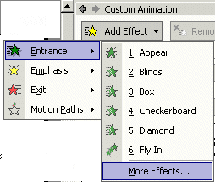
The following screen will appear in the right side area of your screen (very similar to the one we used for Slide 9). When this screen appears, first click-on Add Effect, then click-on Entrance, and finally click-on More Effects (because we want ALL of the effects).

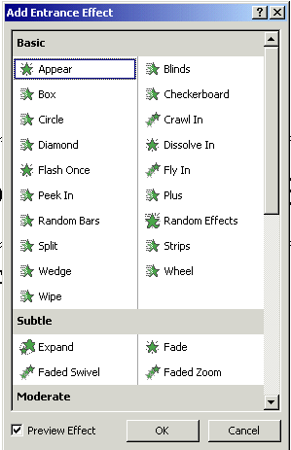
The Add Entrance Effect menu screen will now appear (like the one on the left).

Move your cursor over the blue Add Entrance Effect “bar” at the top of the menu screen. Click and hold down the left mouse button and drag the screen to the right of your screen so that you can see the text in the Title text box. After you have moved this box raise your finger from the left mouse button.

Now, choose one of the effects by clicking-on it. You will now be able to see the effect work in the text box. You may hear a Chime sound that is “part” of the Slide Transition. We’ll show you how to put in sounds for your text in a little while.

Try a lot of different effects. Notice that there is an elevator bar on the right side of this menu. As you move down the Add Entrance Effects menu screen you will notice that there are “groups” of effects – Basic, Subtle, Moderate, and Exciting. Try a “bunch” of these to see how they work. When you have an effect you like, click-on the OK button at the bottom of the menu screen.

Now click-on the lower text box and repeat the steps we outlined on the last page.
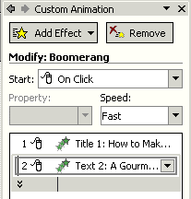

Notice – on the right side of the screen - under Custom Animation – that the Titles (on which we added effects) are shown as a part of this screen (just like when we created our flying bee on Slide 9).

Also notice that under our second title there is a small, down pointing arrow. If you click-on this arrow it will show you each line of text that you animated in the lower sub-title box.

Now we’ll enhance our text some more.

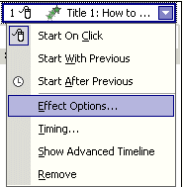
If you move your cursor over the first title and click-on the small triangle on the right side, you will see a menu screen appear that will let us enhance our title (just like we did in Slide 9). Choose (click-on) Effect Options and the menu screen below will appear.

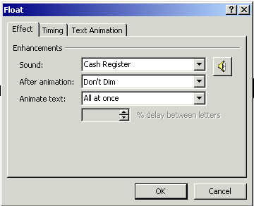

This screen is similar to the one in Slide 9, but a little different. Notice that we chose Float for our text effect and then chose Cash Register for our sound.

We’ll cover Dimming and All at once when we animate text in Slide 2.

Go ahead and experiment with Entrance Effects and Sounds for your first Slide.

Entrance Effects and Sounds for Slide 2

The question we receive the most is: “How do you get the text to enter one letter at a time and have it sound like a typewriter is typing the text?”
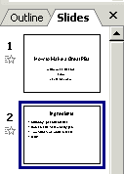
We’ll now show you how to do this.

You should be on Slide 1 in the Normal View screen. We need to move to Slide 2. Look at left portion of the Normal View screen. You will see that this area looks like the image to the right. Click-on Slide 2 in this area. A blue line will go around the slide and you will see Slide 2 in the center portion of your screen.

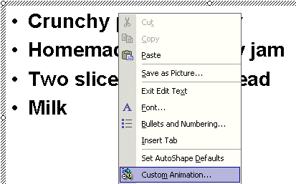
You will see a bulleted list of the ingredients for a PBJ. Move your cursor anywhere over the list of ingredients and click the RIGHT mouse button (to bring up a menu). Move down the menu and select Custom Animation.

You will see the Custom Animation area appear again on the right (as you did in Slide 1).

Select Add Effect, then Entrance and then More Effects (as you did in Slide 1).

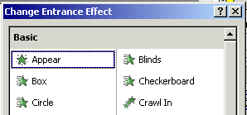
This may not seem like much, but the choice of the Entrance Effect is very important here. Notice, in the image to the right, that we chose Appear. We need the text to enter, letter-by-letter, very quickly. Appear will take care of this. Other choices may “look funny” when the animation is “running.” When you become more accomplished with PowerPoint – try all kinds of effects. Click-on OK at the bottom of this menu screen when you have selected Appear.

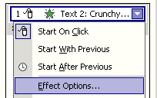
Now look further down the Custom Animation area on the right side of the screen until you see an area that looks like the image on the left. Click-on the small triangle and then select Effect Options.

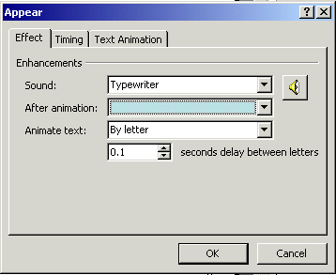

When you click-on Effect Options an Appear menu screen similar to the one on the right will materialize. We’ve gone ahead and entered the effects to make our text look and sound like an “old timey” typewriter is typing it.

We clicked-on the down triangles to the right of each feature and did the following:

Sound:

We clicked-on the triangle and chose Typewriter.

After animation (Dimming):

We noticed that before we clicked-on the triangle that the words “Don’t Dim” appeared in the area to the right of After animation. When we clicked on the triangle we chose the light blue color that appeared. When you are making your PowerPoint presentation, you might like to have the bullet, to which you are speaking, be more noticeable that the bullets about which you have already explained. By choosing the light blue color, as you move through the bulleted items, you will see the last bullet dim and the new bullet be more noticeable. In a moment, when we complete this Appear Effect menu, we’ll Play our slide and you’ll see what we mean.

Animate text:

We clicked-on the triangle and chose By letter.

Seconds delay between letters

We used the small “up and down” triangles to indicate 0.1 seconds between letters.

When you complete your Appear menu screen it should look like the one at the bottom of Page 46. Click OK.

Now, click-on Play at the bottom right of your screen. You will see the text enter like it’s being typed, hear the typewriter sound, and see the bullets dim as you proceed on to the next bullet.

Sound

Be Careful with Sound

Be careful when using sound for transitions and text animation. Sometimes, too many effects can overwhelm and detract from a presentation. As you become more experienced with sounds and web pages you will find many web pages devoted to sounds and clip art. In the Front Page 98, 2000 and 2002 tutorials there is a section on WAV sounds. If you desire a copy of either of these tutorials, simply e-mail the addresses at the end of this tutorial. You may want to experiment with some other sounds you “download and save” form the internet.

Don’t forget to keep saving your presentation often as you enhance it with these effects.

Add color

Slide Color Schemes

Now for some color!

There are a number of different methods you can use to add color. First we’ll use some basic methods and then try some “exotic” effects.

First go to Slide Sorter View by clicking-on the Slide Sorter button in the lower left corner of your screen.

Then click-on Slide 1. By being in Slide Sorter View you’ll be able to see the different color effects in several slides at the same time.

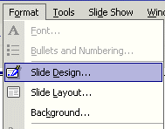

Now, click-on Format in the Menu Bar and then click-on Slide Design.

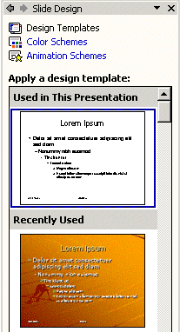

The following Slide Design menu screen will appear in the right area of your PowerPoint screen. As you can see, PowerPoint XP uses the right side of the screen for just about anything on which you’re working.

Notice at the top of this Slide Design area that it indicates Design Templates, Color Schemes, and Animation Schemes.

We’ll choose Color Schemes to begin our slide coloring process. So, click-on Color Schemes and the right area of your screen will change to the screen at the top of the next page.

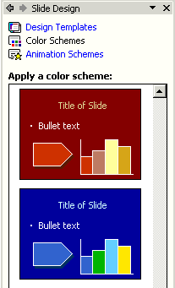
As you can see in the screen to the left, there are several color schemes from which you can choose (notice the elevator bar on the right side of the Apply a color scheme choices). We moved down the list of color schemes and are going to choose the dark blue scheme you see at the left and below. Be careful and follow the instructions just below this blue slide selection.
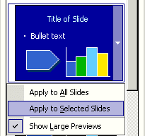

Look at the image to the upper right. Notice, once again, when you move your cursor over the right side of the blue slide, you see a small triangle. Click-on this triangle and select Apply to Selected Slides (in our case Slide 1). Notice in Slide Sorter View that Slide 1 now has this Color Scheme.

Note: If you accidentally clicked-on the blue selection Apply to all Slides in Slide Sorter view were colored with this Color Scheme. To “undo” this mistake (you may wish to do this in the future), click the Undo button at the top of the screen in the button bar. It looks like an arrow pointing in a counter clockwise direction (like the one to the right). One click-on it and you’re ready to try coloring just Slide 1 again.

Don’t forget to Save your work every now and then!

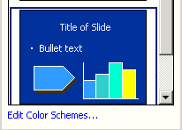
Changing Colors in Color Schemes

If you do not like the color of the blue background (or the text color, bar fill colors or arrow color) you can change them by moving your cursor over Edit Color Schemes… at the bottom of the Slide Design Task Pane. Click-on Edit Color Schemes.

In the Edit Color Scheme menu that appears (see below image), select Background (or any of the other Scheme colors) by clicking-on the “color square” to the left of the item you desire to change. Then click-on the Change Color button. Choose a color you like from the color “chart” and then click-on OK.

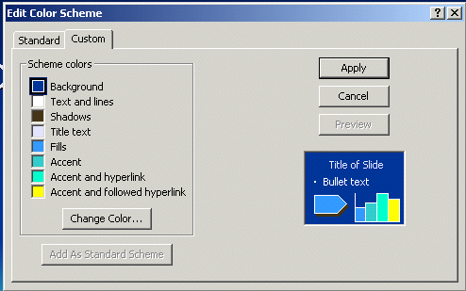

Click-on the Apply button and you will return to Slide 1 and your new colors will be visible.

Note of Caution: Be very careful when you are working with background colors. Many times color changes will make the text on the slide hard to read against a background. All of the templates in PowerPoint are OK with color and text, but when you start changing the either the background or text color, you may create a slide where the text is hard to see. So, again be careful – and remember the Undo Arrow.

You can try this on several slides, if you want. Once you have the hang of it, there are several ways you can enhance these effects.

Backgrounds

You should still be in Slide Sorter View. If you
are not, click-on the Slide Sorter button at the bottom left of the screen. Then click-on Slide 2. We’ll do something different to place a colored background in this slide.

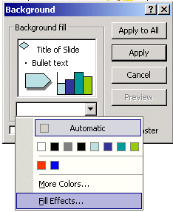
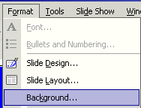
Now click-on Format in the Menu Bar again. Next, click-on Background.

The Background Menu Screen (like the one on the right) will appear. Click-on the small triangle in the bottom portion of this screen. Now click-on Fill Effects.

Notice, in the Fill Effects Screen Menu below, that there are a number of choices (tabs at the top) – Gradient, Texture, Pattern and Picture (see arrows below).

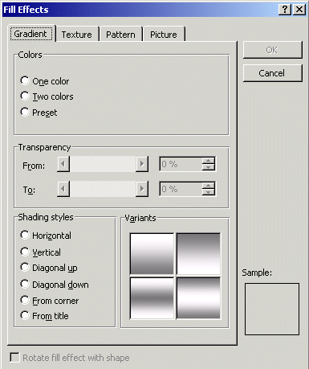

Gradient

Click-on several of the Shading Styles (Horizontal, Vertical, etc.) and observe the effects in the lower right in the Variants and Sample areas. Notice that there are four choices in the Variants area. As you click-on each of the individual “squares” the choice will appear in the Sample area. If you click on OK at any time, the Background you see in the Sample will be the background on the slide. You will return to the Background Menu screen when you click-on OK. You will see a miniature version of what your slide will look like in the lower right corner of the Background menu screen. Click the OK button to see a miniature preview of your slide. To return to the Fill Effects menu screen follow the instructions at the top of Page 51.

Note there are three color choices: One color, Two colors and Preset. If you click-on one of these, you will see the same color choices that you saw when you used them for text. So, have some fun and “click-away.”

Texture and Pattern

Also, note the other tabs at the top. Click-on Texture and Pattern and observe the effects. In Texture you use the “elevator bar” to the right of the textures to see all the selections. You then click-on the Texture of your choice. In Patterns, you simply click-on the Pattern of your choice. Click the OK button to see a miniature preview of your slide. To return to the Fill Effects menu screen follow the instructions at the top of Page 51.

Picture

If you want your entire slide to have a picture as its Background, this is what the last tab is for. You need to click-on Select Picture. This will take you to the Windows “Open File” menu screen and then you can select a picture you have saved. The FrontPage 2000 tutorial goes into this in great detail. When you have the picture you like, click-on OK and then click-on Apply.

Design Templates

Now we’ll do something that’s awesome. We’ll apply Design Templates to our slides.

If you have used an older version of PowerPoint you will see something really neat about PowerPoint XP – you can save individual Design Templates to individual slides if you desire. Something that was really tedious to do in the older versions.

For those using PowerPoint for the first time we’ll show you how to use Design Templates on individual slides or on all of the slides in your presentation.

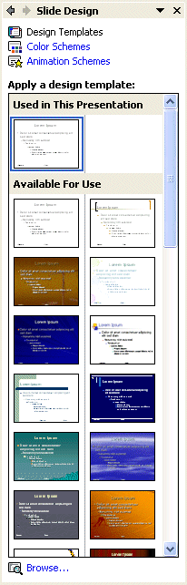
You can be in any View (Normal View or Slide Sorter View) when you select Design Templates. Click-on Format in the Menu Bar, and then Click-on Slide Design (as shown below).

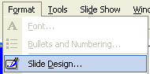

Once again the right side of your screen will look like the image to the right. Click-on Design Templates. The Apply a design template area shows you views of the various designs that you may use in your presentation.

We used the elevator bar on the right side of the Slide Design area to move up and down until we found a design that we liked.

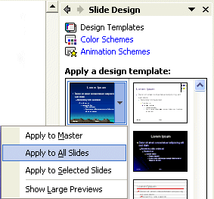
The image on the left shows our choice (see left arrow). We then moved our cursor over the right side of our design choice until we saw the small triangle (see right arrow). We clicked-on the triangle and the drop down menu to the left appeared.

You’ll notice that there are several choices. The main choices are Apply to All Slides and Apply to Selected Slides. If you are in Slide Sorter View you can click-on a slide and then click-on Apply to Selected Slides and you will see this design appear on that single slide (or multiple selected slides). If you are in Normal View and click-on Apply to Selected Slides, you will see the design appear on the slide on your screen.

This is the BIG difference that we mentioned on the last page to “old” PowerPoint users.

You can choose the view you like best when you are applying Slide Designs (Normal or Slide Sorter View).

Notice, in the image on the last page, that we selected Apply to All Slides. When we clicked-on this selection, our slides appeared (in Slide Sorter View) as you see them below.

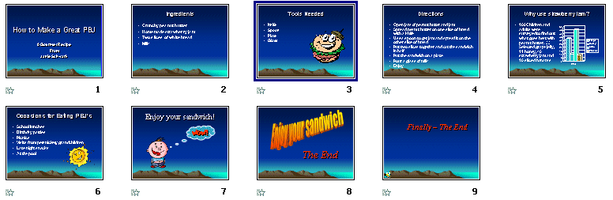

Notice that when the design was applied that in addition to the background changing, the text, formatting and colors of some of our objects also changed. In a minute we’ll look at our entire slide show again. As you go through your show, you might want to make a note of color changes that do not enhance your presentation. Most notably, when you choose Dimming for text, the Dimming often is more noticeable than the text. So, you might want to change your dimming color to work with your slide show.

Run the show:

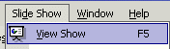
Well, now you have a real presentation. Make sure you are on Slide # 1. Go to Slide # 1 either in Slide Sorter View or Normal View. If you would like to view your show, either go to the Menu Bar at the top and click-on Slide Show, then click on View Show
Or, you can just click on the Slide Show button at the bottom of the screen (on the lower left side).

Then, to advance (go forward), either tap the left mouse button, Space Bar, Right Arrow key or Enter key. If you want to “go back” to a previous slide (or effect), tap either the back arrow key or the Backspace key on the keyboard. You can also click the RIGHT mouse button at any time and a menu will appear that will assist you to move between the slides.

If you desire to end the show, either tap the Esc key, in the upper left portion of the keyboard, or click the right mouse button and then click-on End Show.

Practice moving through your slide show a number of times to get the “feel” of how PowerPoint XP works.

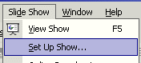
If you have set times for your slides and desire to have the show run in “automatic,” click-on Slide Show in the Menu Bar and then on Set Up Show in the Menu Bar. The following menu screen will appear.

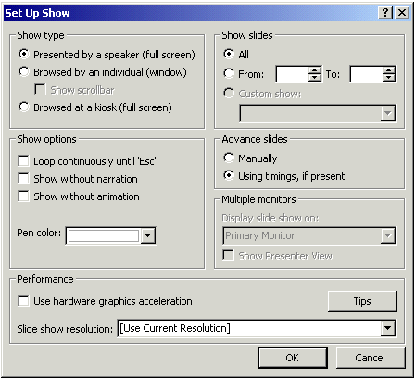

In the Advance slides box (in the image on the last page – see arrow), click-in the circular area to the left of Using timings, if present. This will then run the show with the timings you selected.

Notice that there are a lot of enhancements in this Set Up Show menu screen. Experiment, as you desire. You can always come back and change them. Click-on OK when you have made your changes. One thing people find most helpful, if they desire to have the show repeat continuously, is the Loop continuously until ‘Esc’ selection. This is indicated by an arrow to the Show options area.
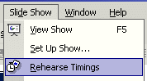
To really get precise timing for each slide transition, sound and build you can use a feature to set each movement precisely. Click-on Slide Show in the Menu bar and then select Rehearse Timings.

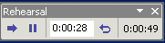
A small, rehearse timings “box” will appear( like the one on the left). It will “show” a running clock on the right side of the menu – that indicates the time for the entire show. In the center you will see another time for each “click” – transition, build, etc. When you click through your show, as indicated above, the timings will be recorded. When you then run the show, it will run at the recorded pace. You can do this as often as you like, and change the timing anytime you desire.

Now save the presentation as you did before. Then File, Exit Power Point.

These are the basics for a PowerPoint presentation. You may want to try tinkering with the color menus and the timing options.

If you have any comments on this tutorial, send an e-mail to the internet address below.

murray.t@lynchburg.edu

Thank you for your time, effort, and patience. Good luck!

