Creating a PowerPoint Presentation
Using PowerPoint for Windows 97

Modified: 28 April 1999
Starting PowerPoint

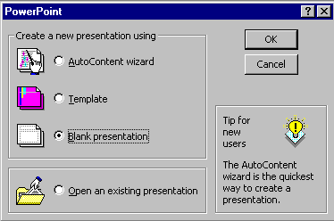
Double click on the PowerPoint 97 icon, or click-on Start in the lower left corner of the screen, then click-on Programs, and then on Microsoft PowerPoint.

In the PowerPoint window above, click-in the small “circle” to the left of Blank presentation, and then click-on OK.

NEW SLIDE

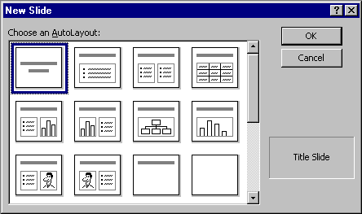
This New Slide screen shows you slide layout options. Highlight each one and notice, in turn, the type of slide shown in the box on the lower right hand box of screen. To proceed, highlight the first slide (Title Slide) by pointing cursor and clicking once. Then click on OK to select.

Beginning the presentation

Slide 1

You will notice, in the lower left corner of the screen, that it indicates Slide 1 of 1. You will also see that your screen looks like the one below.
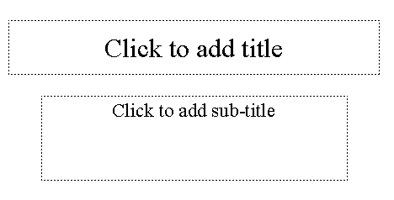

Point cursor in the “Click to add title” box and Click. Enter (type-in) the title: How to Make a Great PBJ

Click on the second box “Click to add sub-title” and type:

A Gourmet Recipe from (your name)
In the top button bar you will see a New Slide “button” which looks like this:
Click-on it to create your next slide.

Point cursor to the second slide layout in the top row (Bulleted List). Click-on it to select this layout and then click on OK.

Slide 2

You will once again see the New Slide screen. Notice, that it defaults to the second slide in the top row; Bulleted List. This is the one you want, so click-on OK.
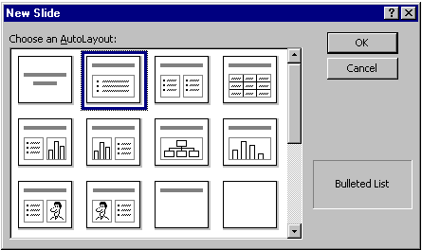

The next slide will look like the screen below:
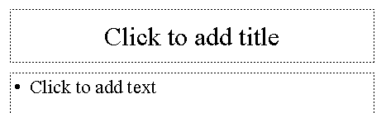

.
Click in the Click to add title box and type: Ingredients.

Click in the • Click to add text box and type:

Crunchy peanut butter (tap Enter)
Homemade strawberry jam (tap Enter)
Two slices of white bread (tap Enter)
Milk

Notice how each line appears with a “bullet” ( • ) in front of it.

Click on New Slide again.

Slide 3

Point cursor to the first slide in the third row (Text & Clip Art). Click-on it, to highlight the slide, and then click- on OK.
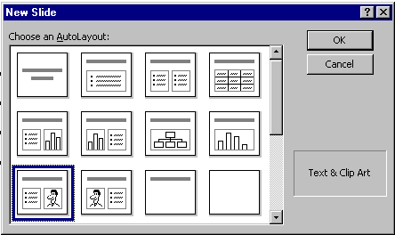

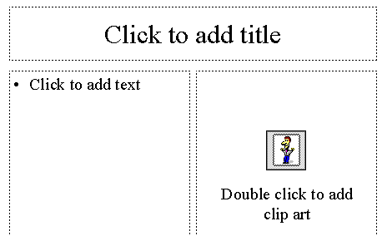
The following screen will now appear:

Click-in the Click to add title box and type: Tools Needed

Click in the • Click to add text box and type:

Knife (tap Enter)
Spoon (tap Enter)
Plate (tap Enter)

Glass

Double-click in the Double click to add clip art box. A clip art window will now appear like the one below. On the left side you will see various categories of Clip Art. Click-up-and-down until you find one you like. There may not be one you easily associate with a peanut butter sandwich, so choose one you like. Click-on it and then click-on Insert. The Clip Art now appears in your third slide. If you don’t like that choice, click on the picture and press the del key to delete the picture. Then repeat the selection process. A Drawing tool bar may appear when you insert the Clip Art. You can click-on the “little X” to close it if you don’t want to see it.
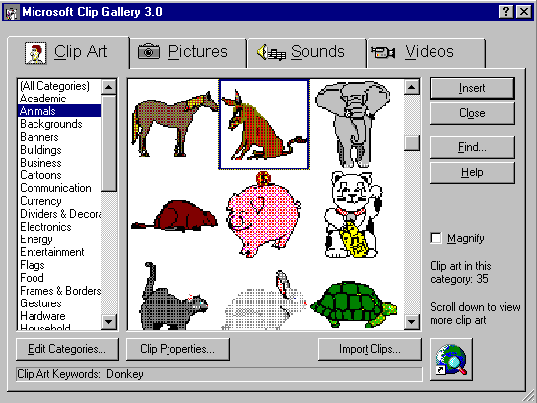

Saving your work

Now would be a good time to save your work for the first time. Point to and click-on File in the Menu bar. Click-on Save. In the upper left corner of the window that appears, you will see a Save in:. Click-on the small triangle on the right and it will show you the various disk drives available on which you can save. Point to the one you want, and click-on it. If you choose the 3½ Floppy (A:), make sure you have a formatted disk in the A drive. If you choose the C:, choose the folder in which you want to save by double clicking on the folder.
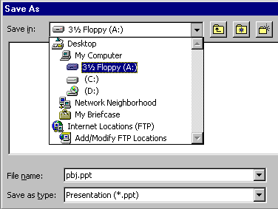
Now click in the box to the right of File name: and delete everything in the box. Then type in pbj and click-on OK.

In the lower left corner of the screen you will see some “buttons” the look like this:

Slowly point (move) your cursor arrow over each box (don’t click-on any of the box’s yet). Note what the Text Help boxes indicate. The first box (which looks “depressed”) indicates: Slide View. The next: Outline View. Then Slide Sorter View. Then Notes Page View. And, finally, Slide Show.

Click-on Outline View, then click-on Slide Sorter View, then click-on Notes Page View. Each one has its own unique use.

The Slide View gives you a view of the entire slide. This is the one we have been using so far.

The Outline view shows you an “outline” of your slides. You may edit each slide, just as you did in Slide View. Since you can see “so much” in this view, many people use this view to create their initial slide show and then go back to Slide View to put in Clip Art and other effects (sound, transitions, etc.)

In Slide Sorter View you can see small versions of your slides. In this view you can click-on, and drag, your slides to the positions you desire. This view assists you in arranging your slides in the order that you desire for your presentation.

In Notes Pages View you can type “speaker notes” for each slide in the lower half of the screen. If you do use the speaker notes, it helps a lot to increase the size of the speaker notes area. In the upper right corner of this view you will see a percentage (%) box. Increase the size to 75 % or 100 % to make it easier to type and review your notes.

Return to the Slide Sorter View. Click once on the last slide; slide 3.

Click on New Slide.

Slide 4

Point cursor to the second slide layout (Bulleted List). Click-on it to select the slide, and then click on OK.

Click on the Click to add title box and type: Directions

Click on the • Click to add text box and type:

Open jars of peanut butter and jam (tap Enter)
Spread peanut butter on one slice of bread with a knife (tap Enter)
Use a spoon to get jam and spread it on the other slice of bread (tap Enter)
Put two slices together and cut the sandwich in half (tap Enter)
Put the sandwich on a plate (tap Enter)
Pour a glass of milk (tap Enter)
Enjoy

If your text won’t fit in the box completely, click-on the box border. You will notice “little Boxes” at the four corners, and in the middle of the top and bottom, and on each side. Point to either the center top or center bottom box. Click-on (and hold down the left mouse button) either box and drag the top box up or the bottom box down a little to enlarge the larger text area so that text fits on the screen. If your “Directions” are now “mixed-in” with the text below, click-on Directions. Then click-on the edge of the “edge” of the “box” (a small up-down-left-right arrow will appear), hold down the left mouse button, and drag the box up a bit.

SAVE

It’s a good idea to save as you complete each slide. Save, as you did before or click-on the small slide button (below File in the Menu Bar).

Click on New Slide.

Slide 5

Click on the first slide in the second row (Text and Chart). Click OK.
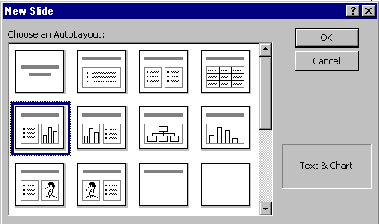

Click on the Click to Add title text box and type: Why use strawberry jam?

Click on the • Click to add text box and type:

100 Children and adults were surveyed to find out what goes best with peanut butter: grape jelly, honey, strawberry jam or sliced bananas (you don’t have to tap enter, as this is one long statement).

Now we’ll make a graph to show the survey data.
Double click-on the Click to add graph box. A Datasheet appears.
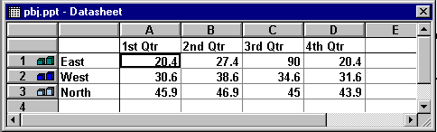

We are going to enter data for our graph in this Datasheet. Click-on the box with “East” and replace “East” with (type-in) Grape, then “West” with Honey, “North” with Straw, and in the cell (box) below North, enter Banana. Now, click on “1st Qtr” and type-in Best. Arrow down the column to box next to Grape and enter 33, then by Honey enter 11, by Straw enter 46, and by Banana enter 10. Your Datasheet should now look like this:
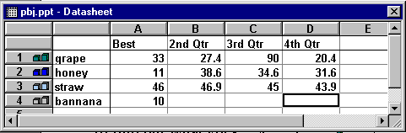
We want a simple graph so we need to delete the rest of the columns. To do this, put your cursor on the B in the Gray area at the top of the Datasheet. Click and hold down the left mouse button and drag right until B, C and D are highlighted. Release the mouse button. Your Datasheet should now look like this:
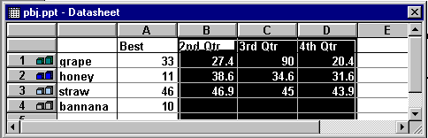

Now tap the Delete key on the keyboard and the columns you have highlighted will disappear.
Your Datasheet should now look like this:

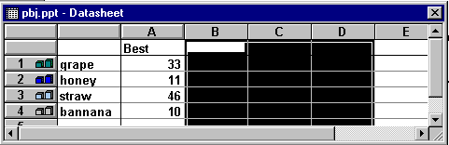
Click the small “X” in the upper right hand corner of the Datasheet.

Every now and then you might make a mistake in the Datasheet. If you have “closed” it as above, you can get it back by clicking-on the Datasheet button below the Menu Bar.
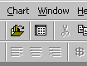
This is the Datasheet button

You may or may not desire to alter the appearance of your graph. Your graph may need some adjusting so that all of the “words” show completely. You may want to change the size of the box the graph is in, so click-on the graph. Click-on the side, using the “grabber” boxes on the side like you did previously, and drag the side until the graph gets larger. If you make the graph wider, the word “Best” will move to one line. Click-on the legend (the box with the grape, honey, etc. inside) and move that whole box to the top right hand part of the graph figure to make it more legible. Work with the various parts of the graph until it looks OK.

Click on New Slide.

Slide 6

Highlight the second slide layout (Bulleted List) again.

Click on Add title text box and type: Occasions For Eating PBJ’s

Click on the • Click to add text box and type:

School lunches (tap Enter)
Birthday parties (tap Enter)
Picnics (tap Enter)
Visits from persnickity grandchildren (tap Enter)
Late night snacks (tap Enter)
At the pool

Now move cursor to the tool bar at the top and click on Insert.

Scroll down to Picture and click. A Clip Art item will then appear. Click-on it.. Once again the Clip Art window appears. Select some picture you like. Double click and it will appear in your slide. You may need to adjust the position (click in the middle of the picture and drag) and size (by grabbing one of the black dots [grabbers]on the frame and dragging it to the desired location and to change its size).

Click on New Slide.

Slide 7

Click on the third slide, third row (Title Only) to highlight and click on OK.
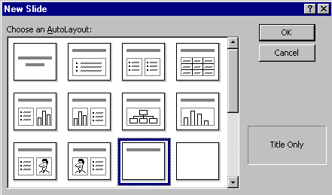

Click in the Click to add title box and type: Enjoy your sandwich! Now, let’s make the letters larger. Highlight your ending (Enjoy your sandwich!) by putting your cursor at the beginning of the first word, click and hold down the left mouse button and drag it across the words, then release the left button. The Title should be highlighted. Now, put your cursor on the box under the tool bar that has a number in it (when your cursor is on it the Text Help box will indicate Font Size). Click on the arrow there and scroll down to 72 and click.
Save your work

Now point the cursor away from the Title box and click the left mouse button. This is called “clicking away.” This will “turn-off” the box.

Point to View in the Menu Bar and click. When the menu list appears, move the cursor down to Toolbars. When the list appears, click-on Drawing. The Drawing toolbar will appear at the top, side or bottom of the screen. Now click-on AutoShapes and a small box of shapes will appear.

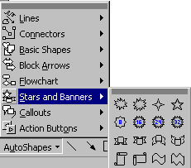
Click-on Stars and Banners. Click-on the first starburst in the top row. When you have clicked, the cursor will change to “cross hairs” when you move it into the slide area.

Now move the cross hairs up into the area just below the title. Click and hold down the left mouse button, and drag down and to the right. Release the button. A starburst should appear as

below.

Save your work.

You have completed the first stage of your presentation. If you would like to view how it will look, go to the tool bar at the top and click on View and click on Slide Show. Or, you can click-on the small Slide Show button in the view buttons bar at the lower left of the screen.

You will need to tap the space bar, Enter key or the left mouse button to move from one screen from one screen to the next during the show. When you get to the end of the “show” the presentation will return to your slides. Anytime you want to end the show, simply tap the Esc key in the upper left-hand corner of the keyboard or tap the right mouse button and click on end show.

Enhancing the presentation:

Not too spectacular? Let’s spice it up!

If you are not on Slide 7, move to it by either using the elevator bar on the right if you are in Slide View, or by double clicking on it is Slide Sorter View.

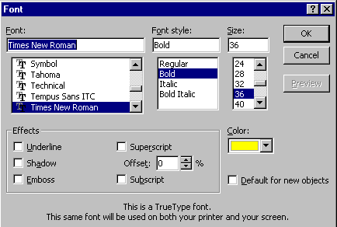
When you are in Slide View, left click-in the middle of the starburst. Then, type the word WOW! You will see WOW! appear in the starburst. It’s sort of like a “hidden” text box. Click the left mouse button in front of WOW!, hold down the left mouse button, and drag across WOW! to highlight the word. Click-on Format in the Menu Bar and then click-on Font. The following Font Menu screen will appear. Change the font style, size, and color. Bold or Italicize if you want. Be as creative as you desire and then click-on OK.

From now on you can “change” any of your text using this method.

Slide 8

For the final slide choose the tird slide in the third row – Blank.
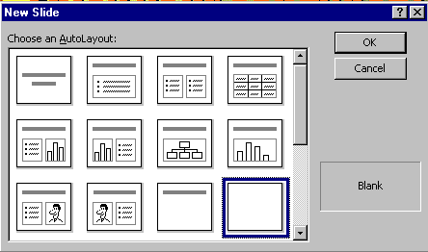

Text Art:
Now we’ll use some Text Art. In the Drawing Bar, which should be open, find a “blue A” that is slightly tilted. When you pass your cursor over this “button,” it will indicate: insert WordArt. If the Drawing Bar is not available, click-on View in the Menu Bar, then click-on Toolbars and select Drawing by clicking-on it. Click-on the Insert WordArt button. The following WordArt Gallery menu screen will appear. Select one of the WordArt patterns by clicking on it. Next, click-on OK.
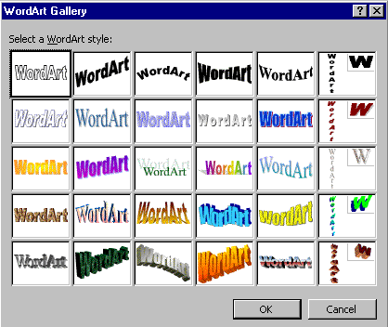

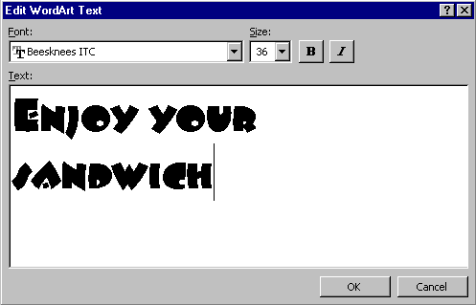
The following Edit WordArt Text screen will appear. Where the screen indicates Your Text Here, type-in: Enjoy your Sandwich. Select a different font and size if you desire then click-on OK.

You will return to Slide 8 and see the WordArt you created. You may use the “grabbers” to make the text larger. You may also move your text as you desire. If you want to change the “look” of your WordArt, point to the center of the WordArt and click the RIGHT mouse button. A WordArt edit screen will appear (see below). You may click-on the different “buttons” to edit your text. When you have finished your editing, you can close the WordArt edit window by clicking-on the “X.”
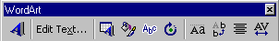
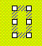
Also in the Drawing Bar is a Text Box button which will allow you to insert text in your slides if the template you chose does not have the desired text boxes. To insert text, click on the Text Box. It has an “A” in the upper left corner of the button with some text below. After you click-on the Text Box button, move the cursor into an “open” area of Slide 8. It will look like a “little sword” as you move the cursor. When you get to an appropriate place, click the left mouse button and a “text entry area” will appear. Don’t worry about its size. Just type the following: THE END. The text box will automatically resize to the text entered. You may now highlight this text, and by clicking-on Format in the Menu Bar and Font, as you have done before, edit this text.

Transitions:

Go to the Slide Sorter button at the bottom left (see top of page 7). Click on the button with four white squares.
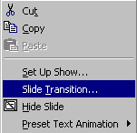
You can now see all eight slides. Click on the first slide to highlight the slide (a heavy black border will surround the slide). Now point in the middle of the slide and click on your RIGHT mouse button. The right click will “bring up” a menu that is “tailored” to the “place” where you click. From the menu select Slide transition from the menu which appears (click-on it).

You will now see the box below. Transitions determine how the slides “change” from one slide to the next. To see this, you need to watch the little dog and Key as you do the following.
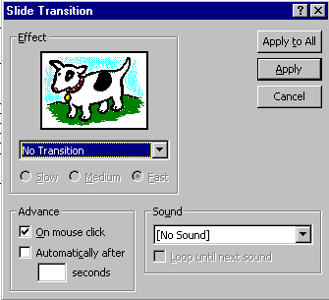

To activate a transition, click on the triangle on the right hand side of the box which indicates: No Transition, to see your choices. Scroll up and down noticing how each transition works by clicking on it and then watching the dog or key in the Effect box. If you think it is moving too fast, click in the little circle to the left of Slow.

Each time you click-on the Dog or Key you will see a transition. This screen also allows you to time you transitions from slide to slide. For now, leave it as it is. When we complete all of the enhancements, to all of the slides, you can do one of several things to “automate” your slide show. Later on, you can return here and Click on Advance Automatically After, and insert 5 to 10 (for seconds) in the box. Or, you can “rehearse times” for each slide and all of its effects. We’ll come back to this in detail at the end of the tutorial. Notice that instead of the normal OK, that Apply and Apply to All are listed for Transitions. Apply activates the transition you chose for just the slide you are “on.” Apply to All activates the transition you chose to ALL of the slides in the “show.” If you scroll down to the last choice in transition effect you will see Random Transition. This will place a different transition every time you click the mouse to go to then next slide, or if you select Apply to All, each slide will have a different transition. You can follow this procedure for each of the eight slides, or select Apply to All. To transition “each” slide individually, click on Apply, then click on the next slide to highlight the slide, click the right mouse button, select transition, choose your effect, and select Apply.

Also notice in the lower right corner the Sound area. Currently, the box indicates [No Sound]. You can click-on the down triangle and see Microsoft “Clip Sounds”. If you choose one of these sounds, the sound will be heard as your slide transitions. You can pick one now, or wait until later. Make sure that the volume on your computer, speaker or headphone is on and “up” so you can hear the sounds as the slide’s transition.

Again notice in the upper right corner of the Slide Transition box that it indicates Apply to All and also Apply. If you click-on Apply to All, PowerPoint 97 will apply the transition and sound you chose to ALL of the slides. This is wonderful if you want the same sound, each time, a slide transitions. If you don’t want this effect, click-on Apply, and the transition and sound will only apply to the slide your on. I like to hold off on the sounds here. Again, if you “run” all the way down to the bottom of the Effects box, you will see Random Transition. If you click-on Random Transition, and then click-on Apply to All, then all the slides will each transition randomly. You can alternately click-on the dog and key to view the transition effects. When you have decided which transition you want click-on either Apply or Apply to All.

When you return to Slide Sorter View, you will notice a small box with an arrow at the lower left corner. This indicates that a slide will transition. If you click-on it you will see the effect each time you click.

Build:

Building is a term indicating how each line of the text, on a slide, will enter the screen. The lines, words, letters, pictures and charts can fly in from almost any direction. To Build the text on each slide, follow these directions. Go back to Slide View. You can do this in Slide Sorter View by double clicking-on the first slide, or Clicking on the Slide View button on the lower left of the screen. When the Slide View screen appears, click-on the first line of text. The “box” you saw, when you first typed text in this box, will appear. This indicates that the box is “active.” It will appear as below.

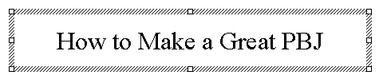
Now, right click in the box. When you right-click, the following menu will appear. Click-on Custom Animation…
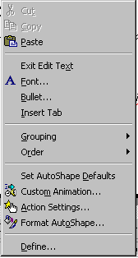

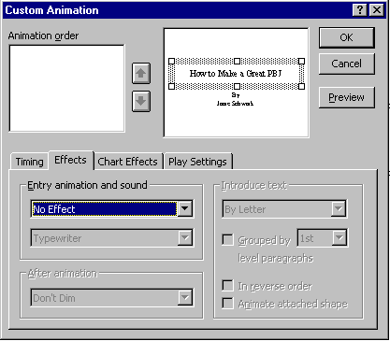
The following screen will appear:

Notice a number of “things” in this menu screen. In the upper right, you see a small picture of the “text area” you clicked-on. This confirms your “click.” In the lower half of the screen there is a “tab box.” Notice that it “defaults” to an Effects ”tab”. In a manner similar to Slide Transitions, text, graphics and pictures can also transition. Click-on the small triangle to the right of No Effect. You will see effects similar to those in Slide Transition. Click-on one. You will not see the effect immediately, as you did in the Slide Transition screen. Notice, as soon as you select an effect, several other areas of this menu screen become “active.”

Preview Button

First notice to the right an area labeled “Introduce text.” Click-on the small triangle.
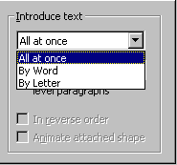
This area indicates the manner in which the text you have selected will enter the slide. All at once means what is says. The whole title will enter at once. By Word means that the text will enter word by word. By Letter means that the text will enter letter by letter. It’s a lot of fun to experiment here. Try them all. Next we’ll cover sound. It is neat to combine certain sounds with certain text introductions. For example, the By Letter introduction combined with the Typewriter sound, looks and sounds like text being typed in one letter at a time.

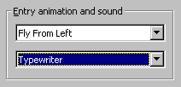
Now notice the Sound area on the left. Click-on the small triangle and select a sound from the list.

When you have selected all the effect you desire, click-on OK.

You can view these build effects by clicking on the Preview button (in the upper right corner of the Custom Animation Menu Screen – see arrow above). You can click any time you desire as you are creating text, picture or other animations. You will notice in the upper left corner of the Custom Animation Menu box an Animation Order box. Each time you click-on OK, as you complete an animation, the “thing” you animate will be added to the list, in the order in which you added it to the slide. If you desire to change the order of your animated “things,” you can click-on the thing you desire to move up or down and then, by clicking-on the arrows to the right, you can move the text or object up or down. When you have completed the first slide, move to each successive slide, click-on the various text boxes or objects, and repeat the process.

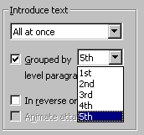
One additional area in the Custom Animation menu screen. When you click-on a text area that is a bulleted list you will see an additional effect. The Grouped by “1st” level paragraph indicates whether one line, or multiple lines, will enter. Here is another area where it is fun to experiment.

Dimming

Notice below the Sound area an area that indicates After animation:. This applies to the text in Bulleted Lists. To “highlight” the bullet, to which you are speaking, you can “dim” previous bullets by clicking-on the small down triangle to the right of Don’t Dim. After you click-on the triangle you will see a “set” of colors selected for the background which you are using. You can click-on a color of your choice and then look at the slide in Slide Show. As you click-on each successive bullet in the Slide Show you will see the “dimming” effect.

Sound

This simply reminds you not to forget sounds for Transitions and Builds that will enhance your presentation. Be careful, sometimes too many effects can overwhelm and detract from a presentation. As you become more experienced with sounds and web pages you will find web pages devoted to sounds and clip art. In the Front Page 98 tutorial there is a section on WAV sounds. You may want to experiment with some other sounds you “download and save” form the internet.

Add color:

Now for some color!

There are a number of different methods you can use to add color. First we’ll use some basic methods and then try some “exotic” effects.

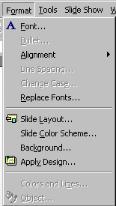
First go to Slide View and then go to Slide 1. Then click-on Format in the Menu Bar and then click-on Slide Color Scheme.

The following menu screen will appear.

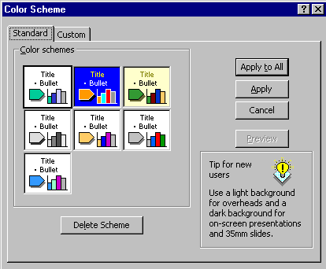

As you can see in the screen above screen, there are several color schemes from which you can choose. Click-on one, and then click-on Apply. The first slide will now have those effects. Repeat the process until you find one you like. Note: if you click-on Apply, this applies the colors to just Slide 1. And, if you click-on Apply to All, then all of the slides have the selected color scheme.

You will notice at the top of the Menu screen that there are two tabs. You are currently on the Standard tab. Click-on the Custom tab. This allows you to change specific colors in the Slide Scheme that you chose. Click-on a couple of these to see how this works.
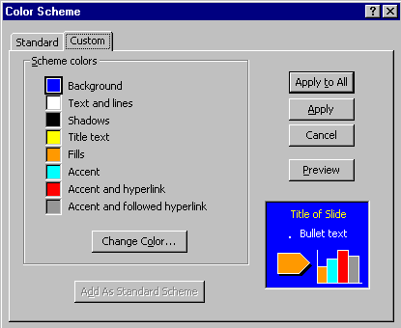

You can try this on several slides, if you want. Once you have the hang of it, there are several ways you can enhance these effects.

Now click-on Format in the Menu Bar again. Next, click-on Background. The following Menu Screen will appear. Click-on the small triangle in the bottom portion of this screen. Now click-on Fill Effects.

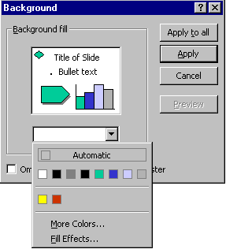

Notice, in the Screen Menu below, that there are a number of choices.
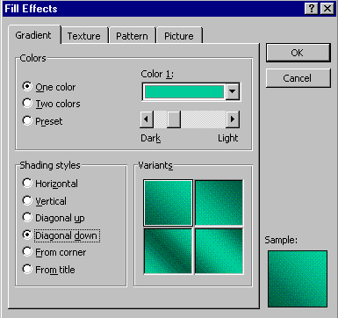

Click-on several of the Shading Styles and observe the effects on the right. Also, note the tabs at the top. Click-on Texture and Pattern and observe the effects. If you want your entire slide to be a picture, this is what the last tab is for. When you have an effect you like, click-on OK and then click-on Apply.

Designs

You can be in any View (Slide View and Slide Sorter View are preferable). Click-on Format in the Menu Bar, and then Click-on Apply Design.

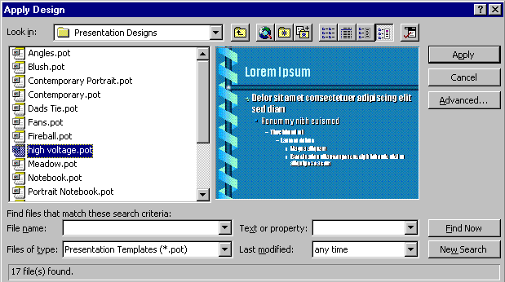
Click on the choices on the left side of the window. On the right side a special template will appear with its own formatting. Pick one you like and then click on Apply. Be sure to scroll up and down and to click on additional choices. Note: with Designs, they are automatically applied to all of the slides. You may choose additional effects for the Designs by using the
Background and Slide Color Scheme selections.

Run the show:

Well, now you have a real presentation. If you would like to view how your show will look, go to the Menu Bar at the top and click-on either View or Slide Show and then click on View Show or Slide Show, or you can just click on the Slide Show button at the bottom of the screen. Then, to advance, either tap the left mouse button, Space Bar or Enter key. If you desire to end the show, either tap the Esc key, in the upper left portion of the keyboard, or click the right mouse button and then click-on End Show.

If you have set times for your slides and desire to have the show run in “automatic,” Click-on Set Up Show in the Menu Bar. The following menu screen will appear.
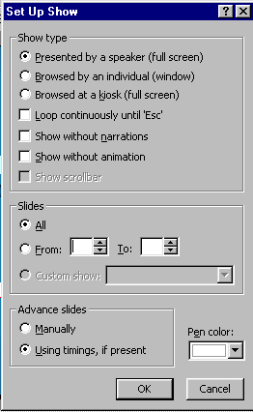

In the Advance slides box, click-in the circular area to the left of Using timings, if present. This will then run the show with the timings you selected.

Notice that there are a lot of enhancements in this Set Up Show menu screen. Experiment, as you desire. You can always come back and change them.

To really get the timing of each slide, transition, and build you can use a feature to set each of these precisely. Click-on Slide Show in the Menu bar and then on Rehearse Timings. A small, rehearse timings “box” will appear. It will “show” a running clock, and indicate the time for the show and each slide. When you click, as indicated above, the timings will be recorded. When you then run the show it will run at the recorded pace. You can do this as often as you like.

Now save the presentation as you did before. Then File, Exit Power Point.
These are the basics for a Power Point presentation. You may want to try tinkering with the color menus and the timing options.

If you have any comments on this tutorial, send an e-mail to the internet address below.

murray.t@lynchburg.edu

Thank you for your time, effort and patience. Good luck!

